Technical Orientation Programme on 22nd Earthquake Safety Day
Venue: Besisahar, Lamjung-DCC Hall
Date:2nd Magh 2076
Attendees: Masons and Contractors
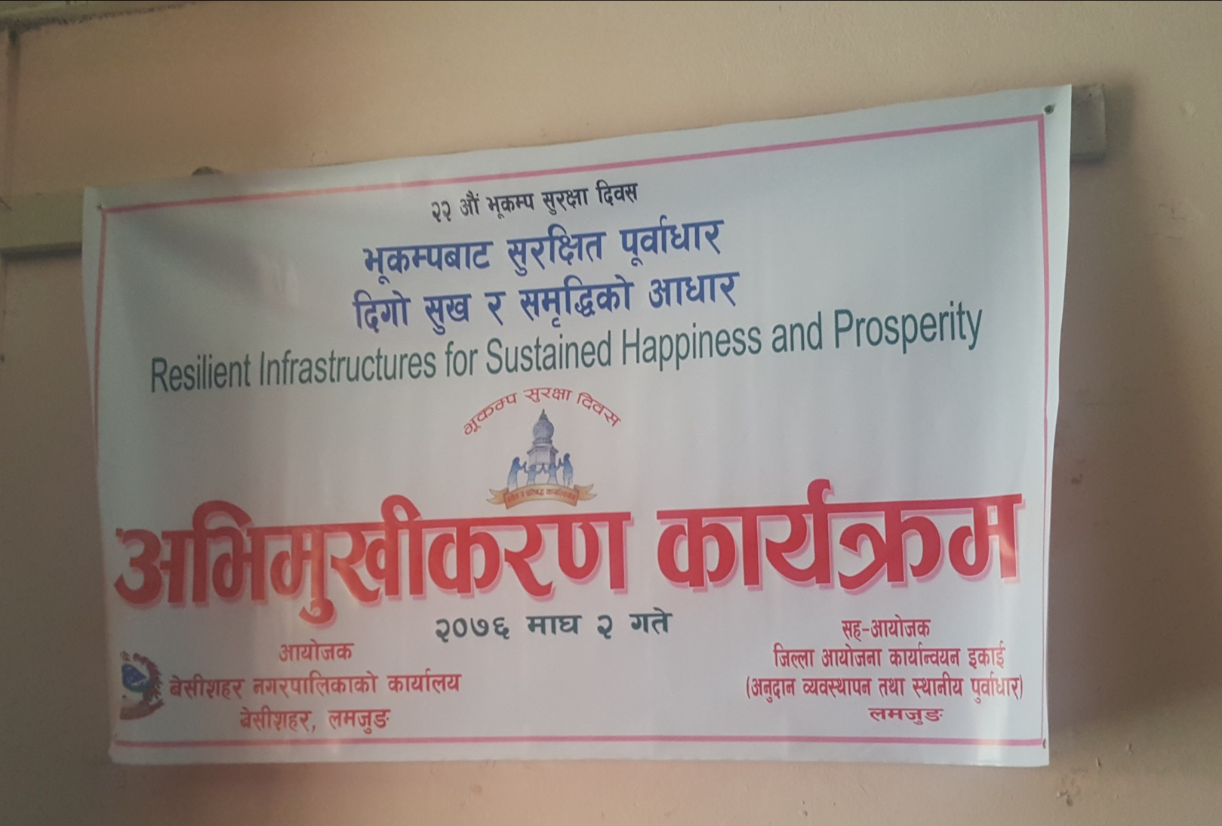

Welcome Remarks: Chief Administrative Officer of Besisahar Municipality, Lamjung Mr. Mohan Prasad Marasani welcomed all the guests, technicals, trainees and trainers with his cheerful remarks. He shared a brief introduction on Earthquake and its catastrophe to the humans and infrastructure. He emphasized that not the earthquake, but the vulnerable and weak structures kill people during Earthquake. He briefed how the 1990s and similarly 2072 Gorkha Earthquake damaged so many lives and structures. He shared that the main three components for resilient structures is proper design, its quality and implementation. Although the design is good but if the quality and implementation in the site is poor during construction, the structure will obviously fail. The role of masons is the most important in earthquake resilient building construction as they are the main people to implement those designs in the site. Therefore, this orientation would be a refresher for them in earthquake resilient building construction. He also focused on the fact that there is no progress in retrofitting due to lack of trained masons in retrofitting. The term and the methods are completely new to the masons. However, this orientation will provide an overview on retrofit and will help them to gain knowledge. Lastly, he focused on the fact that masons are the main pillars of constructing Earthquake Resilient Building Construction. So, he requested all the masons and contractors to attend the orientation with enthusiasm and ask without any hesitation if any doubt.

Remarks from GMaLI Chief: GMaLI Chief Mr. Jagdish Mishra shared the reconstruction update and said that the third tranche in reconstruction is just 45% which is very unsatisfactory. There were many problems and reasons for this low third tranche circulation. The budget was not disbursed from the central level due to which many files are pending. Now the budget has been released and we are focusing to provide tranche to the beneficiaries who constructed houses before technicas deployment. The gap between second and third tranche is high, but we ensure that we will progress in tranche distribution soon.
Remarks from Chief District Officer: Chief District Officer of Lamjung District Mr. Laxman Lal Khadka welcomed all the attendants and briefed on the geological challenges as a result of which Nepal is facing Earthquakes. He shared that Nepal lies in the very active earthquake zones and its very important for all of us to prepare ourselves for the coming hazards. He compared the construction technology of Nepal with Japan and shared that Japan is more prone and frequent to earthquakes although the damage of structures and loss of life is less in Japan. This is all because they not only believe in Earthquake Resilient structure Design but also quality and good implementation. He emphasized on the role of masons in earthquake resilient Building Construction and said that masons are the key persons to implement the safe and resilient Construction. So, they should always update themselves in order to cope with new technology and construction mechanisms.
Closing from Deputy Mayor Mrs. Laxmi Adhikari: Chief Deputy mayor welcomed all the guests, trainers and attendants in the Technical Orientation Program. She shared her past experiences of Gorkha Earthquake and said that in 15 April ,2015(Gorkha Earthquake) she was in the same seminar hall giving her speech and during the shake everyone out of fear ran outside the hall. She remembers lack of preparedness during those times. But now the scenarios are different. She emphasized that more or less we all have proper knowledge on “Duck Cover and Hold” and things we should do and should not do during earthquake times. She also shares that Earthquake is a repeating process and it will probably occur in the future, but we do not know when? The most important things we can do now is be prepared and construct resilient houses. She also shared that the masons are the leading agents in construction so they must have proper knowledge on Earthquake resilient construction. She shared that previously people used to believe that the earthquake resilient houses would be much more costly, so people had tendency to construct non-engineered houses. But after series of awareness programs now she feels happy that the concept of people has changed. Lastly, she requested all the masons and contractors to follow the guidelines and norms of Earthquake resilient construction and make the whole Besisahar community Earthquake Resilient and make it a paragon community of Nepal.

Technical Sessions
Session 1: Earthquake Resilient Building Construction by Mr. Umesh Dangol, DSE, NRA:
Key Points:
- What is an Earthquake Resilient Building?
- Sensitive and critical parts of failure in Load Bearing and RCC structure.
- Load path in Load Bearing and RCC structure.
- Building Structure and Configuration.
- Mistakes in RCC construction.
- RCC major structural components, its failure pattern and resilient construction.
- Load Bearing major components, its failure pattern and resilient construction.

Session 2: Retrofit Orientation by Mr. Biren Shah-DTC, HRRP
Key Points:
- Overview of retrofitting
- Methods of Retrofitting
- Showcase of test and Demonstration of Shake Table Videos.
- Process of Retrofit in Load Bearing Structure.

Orientation Minute:
