Monthly District Report
Kavrepalanchok
12 July - 22 August 2019

Summary of events during this period
Districts | Name of activity/event | Event date | Location (District, Municipality) | Contact Person | Reference Document
Kavrepalanchok | GMALI/DLPIU Progress Review Meeting | 12 July | Hotel Sarathi, Dhulikhel | nrakavre@gmail.com | NA
 | Introductory Meeting with GMALI/DLPIU Chief  (HRRP Kavre explained its working modality, POs work coverage and the general scenario of the district. The key contact details of the district and monthly report too were shared to GMALI/Chief) | 18 July | GMALI/DLPIU Office, Dhulikhel | reshma@hrrpnepal.org | NA
 | Introductory Meeting of GMALI/DLPIU with Caritas Nepal and ASF Nepal  (The summary of overall project was briefed along with the key challenges faced during project implementation) | 19 July | GMALI/DLPIU Office, Dhulikhel | reshma@hrrpnepal.org | NA
 | Introductory Meeting of GMALI/DLPIU with UNOPS  (The summary of overall project was briefed along with the key challenges faced during project implementation. Field visit to one of the model retrofit sites at Patlekhet was done.) | 22 July | GMALI/DLPIU Office, Dhulikhel | reshma@hrrpnepal.org | NA
 | Palika Profile Data Update | 24 July | NA | im.kavrepalanchok@hrrpnepal.org | GD
 | Contact List Update | 25 July | NA | im.kavrepalanchok@hrrpnepal.org | GD
 | 5W Update | 25 July | NA | im.kavrepalanchok@hrrpnepal.org | GD
 | Meeting with Habitat for Humanity (HfH) and GMALI/DLPIU to discuss on possible areas and topics of reconstruction for HfH’s project extension | 29 July | GMALI/DLPIU Office, Dhulikhel | reshma@hrrpnepal.org | NA
 | Palika Level Coordination Meeting, Panchkhal NP | 7 August | Panchkhal NP Meeting Hall | reshma@hrrpnepal.org | Meeting Minutes
 | MEAL Reporting | 8 August | NA | reshma@hrrpnepal.org | GD
 | Palika Level Coordination Meeting, Roshi GP | 9 August | Roshi GP, Meeting Hall | reshma@hrrpnepal.org | Meeting Minutes
 | Palika Level Coordination Meeting, Namobuddha NP | 13 August | Namobuddha NP, Meeting Hall | reshma@hrrpnepal.org | Meeting Minutes
 | Field Visit to ChalalGanesthan and RyaleBhir for retrofit stories collection | 14 August | ChalalGanesthan, Bethanchok-4  RyaleBhir, Panauti-1 | reshma@hrrpnepal.org | Field Visit Section Below
 | Housing Typology Survey | 14 August | ChalalGanesthan, Bethanchok-4  RyaleBhir, Panauti-1 | im.kavrepalanchok@hrrpnepal.org | Kobo Link
 | Palika Level Coordination Meeting, Bethanchok GP | 19 August | Bethanchok GP, Meeting Hall | reshma@hrrpnepal.org | Meeting Minutes
 | Support to Urban Working Group | 19 August | HRRP | reshma@hrrpnepal.org | NA
 | Follow-ups for Palika Profile Website Upload | 16-22 August | NA | im.kavrepalanchok@hrrpnepal.org | Links
 | Follow up with wards for PA Form collection for the digitization | 12 July-22 August | NA | reshma@hrrpnepal.org | NA
 | Updating Annex for PA Form digitization | 12 July-22 August | NA | reshma@hrrpnepal.org | NA
 | Grievance Handling Support at GMALI | 12 July-22 August | NA | reshma@hrrpnepal.org | NA

Upcoming Events & Meetings
Name of activity/event | Date, Time, and Location (District, Municipality) | Organizer | Contact Person
District Facilitation Meeting | 26 August, 8:00AM-10:00AM, DCC Hall, Kavre | GMALI/DLPIU | nrakavre@gmail.com

Tranche Status (Kavrepalanchok)
Table of Tranche Status: As of 22nd August 2019

Municipality | Reconstruction |  |  |  | Retrofit |  |  | Grievances
 | Eligible HHs | 1st Tranche | 2nd Tranche | 3rd Tranche | Eligible HHs | 1st Tranche | 2nd Tranche | Registered | Addressed
Banepa NP | 6856 | 6,499 | 3,552 | 2,899 | 276 | 77 | 0 | 2226 | 2031
Bethanchowk GP | 3824 | 3,970 | 3,005 | 2,042 | 553 | 78 | 0 | 1202 | 1202
Bhumlu GP | 6120 | 5,890 | 5,184 | 4,466 | 89 | 17 | 0 | 1038 | 971
Chaurideurali GP | 5975 | 5,735 | 4,465 | 3,529 | 442 | 46 | 0 | 1578 | 1517
Dhulikhel NP | 5638 | 5,308 | 3,180 | 2,367 | 376 | 44 | 0 | 2151 | 1919
Khanikhola GP | 2631 | 2,766 | 2,297 | 1,278 | 233 | 43 | 0 | 683 | 681
Mahabharat GP | 2738 | 2,891 | 2,505 | 1,965 | 226 | 146 | 0 | 1075 | 1055
Mandandeupur NP | 9080 | 8,618 | 7,208 | 5,572 | 157 | 25 | 0 | 2300 | 1762
Namobuddha NP | 6959 | 6,641 | 3,822 | 2,666 | 700 | 20 | 0 | 2814 | 2296
Panauti NP | 8392 | 9,137 | 6,745 | 4,824 | 404 | 111 | 0 | 2874 | 2851
Panchkhal NP | 9571 | 8,303 | 4,960 | 3,838 | 862 | 128 | 0 | 3041 | 2932
Roshi GP | 5669 | 5,727 | 4,279 | 3,023 | 764 | 131 | 0 | 2257 | 2203
Temal GP | 4255 | 4306 | 3236 | 2449 | 598 | 107 | 0 | 2101 | 2069

Graph of Tranche Status: As of 22nd August 2019

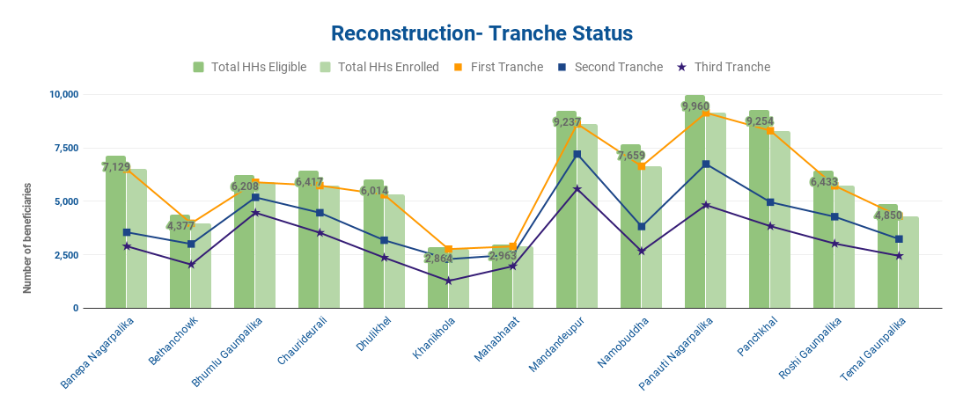

Graph for Retrofitting Status: As of 22nd August 2019

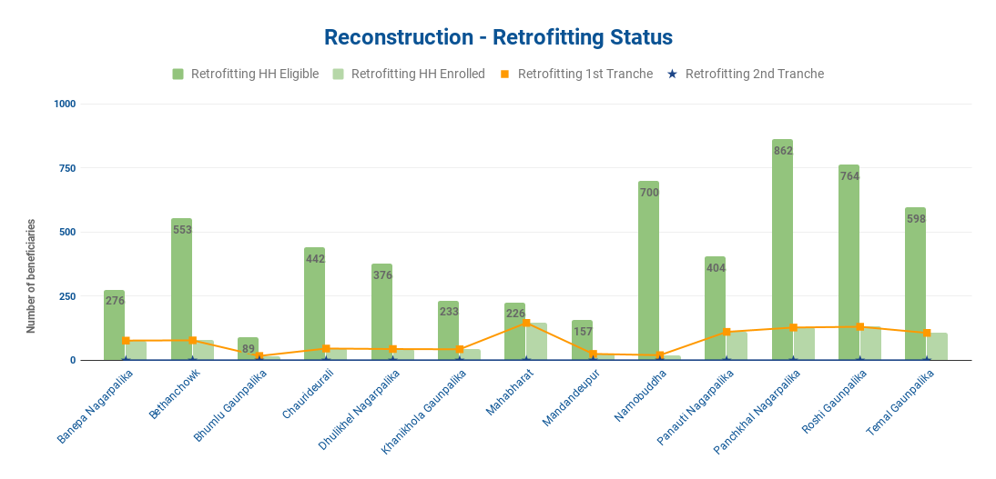

Field Visit Report (Kavrepalanchok)
Visit 1
Date |  |  |  | Location |  | Participants
14 August 2019 |  |  |  | Chalal Ganesthan, Bethanchok GP  RyaleBhir, Panauti NP |  | Reshma Shrestha, HRRP  Ishor Neupane, HRRP
Objective(s) |  |  | - Meeting with Ward Chief on retrofit status  - Visit to retrofit beneficiary reluctant to retrofit  - Visit to model retrofit house  - Housing typology collection
Why was the visit carried out in this location?

To collect various stories on retrofitting, this visit was carried out.

'If this municipality / ward was visited previously, please provide dates of previous visits and links to relevant district reports'
NA
Summary | During the visit, a brief interview with Ward Chief of ChalalGanesthan, Bethanchok-4, on the retrofit status, challenges and perception of local people towards retrofitting was conducted. Two retrofit beneficiaries at ChalalGanesthan who have received first tranche and have applied for beneficiary status change from retrofit to reconstruction too were visited.  The model retrofit house at RyaleBhir, Panauti-1 too was visited to collect the experiences of the home owner towards retrofit.
Field Visit:
- No. of HHs visited: 8
- No. of meetings with engineers: 0
- No. of meetings with local officials: 1

Meeting: NA
Challenges / Issues Identified |  |  |  |  | Solutions Provided | Decision Taken |  | Responsible | Timeframe
Long delay in switching beneficiary from RTB to RCB |  |  |  |  | Follow up with NRA and GMALI/DLPIU | - |  | Ward Officials | September 2019
Photos
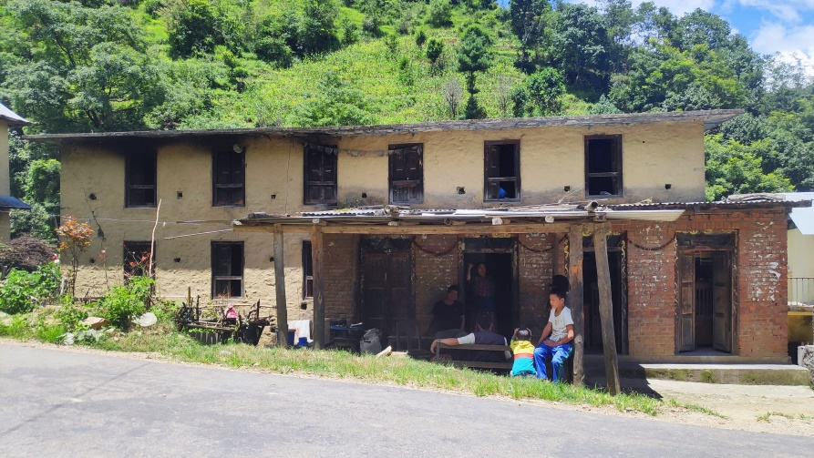 |  |  |  |  |  |  | 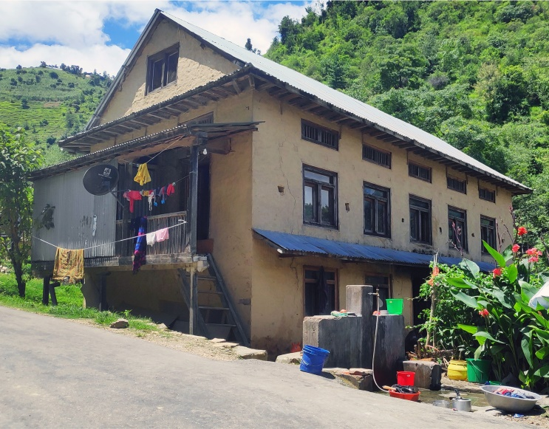
Kailash Ram Tamang of ChalalGanesthan is a retrofit beneficiary. He has enrolled and received the first tranche of government grant and has also applied for the beneficiary change from retrofit to reconstruction. His is reluctant to retrofit due to the high cost. His house does not meet the retrofit standards of UNOPS/Build Change type designs as the house has large area and is L shaped.  Photograph By: Reshma Shrestha |  |  |  |  |  |  | Kunshang Lama Tamang of ChalalGanesthan is a retrofit beneficiary. He has enrolled as a retrofit beneficiary and received the first tranche of government grant. He still lives in his damaged pre earthquake house along with his three other family members. He applied for beneficiary change to RCB on Falgun 2075 but is still awaiting the change.  He has visited the retrofit demo house at Dhunkharka and also attended the retrofit awareness program organized by the ward in coordination with UNOPS. But he is still reluctant to retrofit as he has heard that retrofit is too expensive. He also thinks one lakh support for retrofit is too less. When he gets his beneficiary switched, he is planning to construct a two roomed house in a nearby plot and also keep the pre earthquake house intact.  Photograph By: Reshma Shrestha

Housing Typology Report
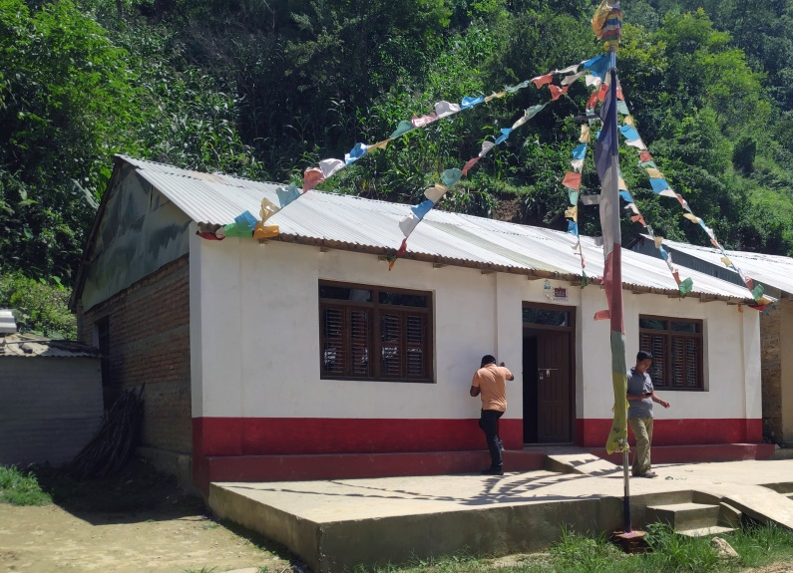 | 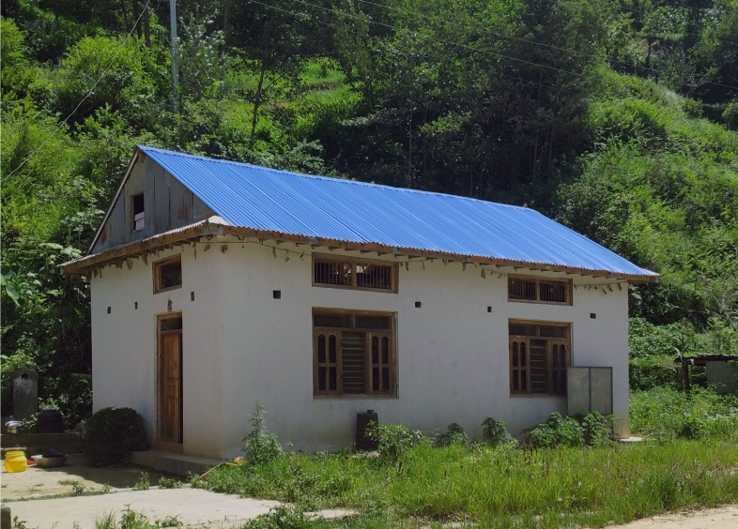
Address: Kavrepalanchok, Bethanchok-4  Building Typology: Brick in Cement  Description: Wang Dhoj Lama has received all three tranches of housing reconstruction grant. The house was constructed with an approx. NPRs. 8 lakhs.  Photographed By: Reshma Shrestha | Address: Kavrepalanchok, Bethanchok-4  Building Typology: Stone in Mud  Description: Govinda Shrestha has received all three tranches of housing reconstruction grant. He along with his wife is staying in the pre earthquake house and will be moving to this reconstructed house after fixing the window panes.  Photographed By: Reshma Shrestha
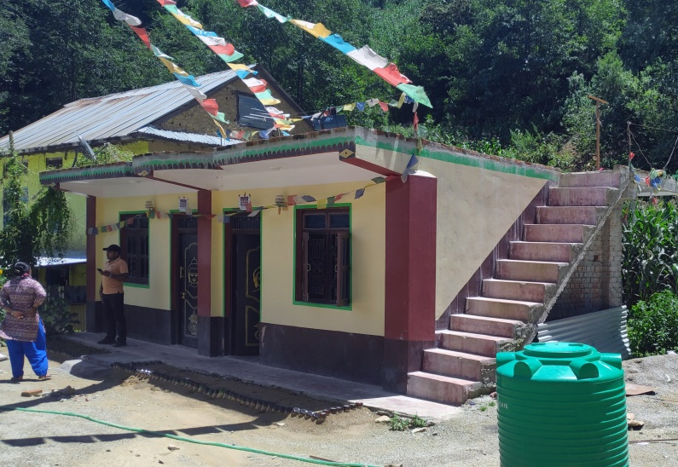 | 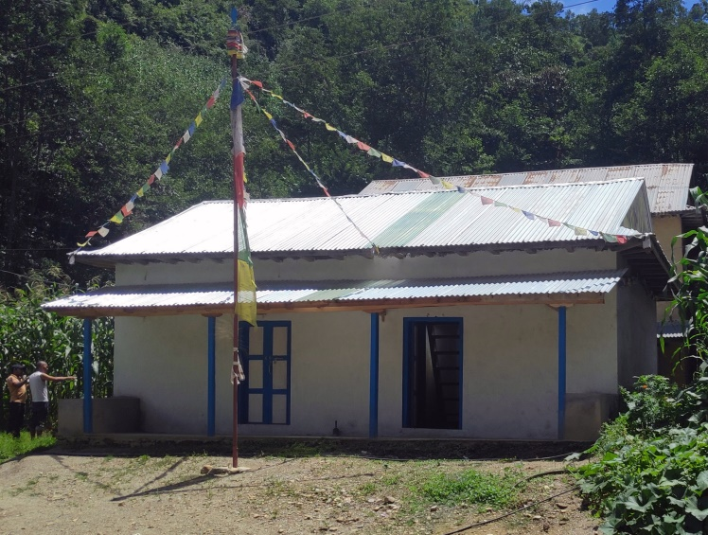
Address: Kavrepalanchok, Bethanchok-4  Building Typology: Brick in Cement  Description: This house was constructed in an approx. of NPRs. 15 lakhs. The owner has received all three tranches of housing reconstruction grant.  Photographed By: Reshma Shrestha | Address: Kavrepalanchok, Bethanchok-4  Building Typology: Stone in Mud  Description: Santa Kumar Tamang constructed his house in an approx. of NPRs. 6 lakhs. He has received all three tranches of housing reconstruction grant.  Photographed By: Reshma Shrestha

Case Research
Perspective of Local Representative towards Retrofitting
Lal Bahadur Shrestha, Ward Chief, ChalalGanesthan, Bethanchok Gaupalika-4
A total of 73 beneficiaries at Bethanchok-4 have been listed as Retrofit Beneficiaries. Only 36 beneficiaries have enrolled and received the first tranche, amongst whom 28 have applied for beneficiary change from RTB to RCB, and the remaining too have expressed their interest towards beneficiary change. Though the notice of enrolment deadline was published and communicated months before the deadline, none of the remaining retrofit beneficiaries enrolled. For the beneficiary change, all complete documents of 26 beneficiaries have been forwarded to NRA while two are yet to be sent. None of the applications have been addressed till date.
Retrofitting has always remained the major challenge of reconstruction in the ward. The concept itself was new to the rural communities and for the major time period post the earthquake, the beneficiaries idealized that stone in mud houses are impossible to be retrofitted. In the later phase of reconstruction, retrofitting too has been prioritized. At the neighboring ward Dhunkharka, demo retrofit houses were constructed and masons were trained almost one and a half year ago by BuildChange. But still, the beneficiaries of ChalalGanesthan were reluctant towards retrofitting. The regular presence of the agency and its readiness to support the retrofit beneficiaries through technical and material assistance could not influence them as they were engraved with the perception that retrofitting is way too expensive and the retrofitting grant is too less compared to the actual cost.
Owing to the large number of retrofit beneficiaries and the nearing deadlines, the ward in coordination with UNOPS/BuildChange, gathered all the retrofit beneficiaries for the retrofit awareness program which too was a no success. Instead of garnering the best of knowledge of retrofit from the program, the beneficiaries had the accusations to the ward of denying them their right to switch their beneficiary identity to RCB. For this, the ward chief highlights the weak policies as the major reason. Had the policies been strict and demolition of pre-earthquake house been made compulsory for reconstruction beneficiary, retrofit beneficiaries would hesitate to apply for beneficiary change. The error in house survey also is a reason for retrofit reluctance. Two similar houses in the same neighborhood have been categorized differently as retrofit and reconstruction. So, the retrofit beneficiaries think they have been discriminated and want similar rights. They too are unaware of the impounding risk the damaged houses pose to their family as well as their community; instead they are in a lure of keeping their damaged house along with a smaller house with the reconstruction grant.
The Ward Chief is still putting his efforts to convince at least one of the beneficiaries to retrofit. Through one demo house and different support mechanisms of UNOPS, he still hopes the ward can progress in retrofitting.

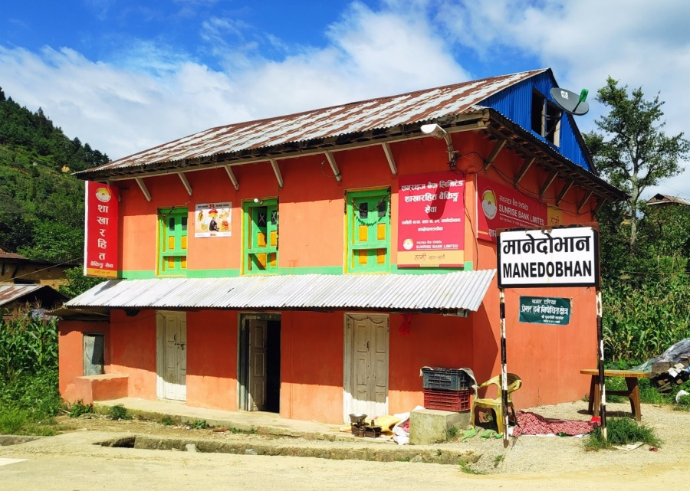
Retrofit Demo House
Mithu Lama of RyaleBhir, Panauti NP-1 has retrofitted her house as a model retrofit house through the owner driven approach and with the complete technical assistance from UNOPS/BuildChange. The retrofit was started on 1st Asadh 2075 and was completed in three months. The total material cost was estimated around NPRs. 4 lakhs. She has received the first tranche of government grant and applied for the second tranche.
She expressed her interest to retrofit her house when UNOPS/BuildChange staffs were collecting interests of probable beneficiaries. She feels lucky to have been selected for the demo house and she got to keep her pre earthquake house intact but stronger than before. Soon after her house was selected for the retrofit, there were two different groups of people; one who thought retrofit was a good idea and the next who asked to drop the idea of retrofit and instead reconstruct a new house. She stood by her initial decision of retrofitting and the ones who were against her decision appreciated her decision once the retrofit was complete. Hundreds of visitors have visited her house both during and after the retrofitting. She herself has felt the major difference after retrofitting. Previously, her damaged house shook even when she climbed the stairs while now even with the heavy vehicles moving, the house stands strong.
She is satisfied with the cost as well. With the 4 lakhs, she could have constructed only two roomed houses but with the same cost she got to strengthen her two storeys with an attic structure. Her model house has been a perfect example of model house. Many of her neighbors and visitors have expressed their interest to retrofit after visiting her house. One of her relatives at Patlekhet, Dhulikhel-11 too has retrofitted his house after observing her retrofitted house.

Questions Collected
Question | Who Asked the Question? | Response Provided (By Whom)
How long does it take to convert the beneficiary status from retrofit to reconstruction? | Ward Chief, Beneficiary | The beneficiary conversion is done by central NRA and needs to be updated in the central MIS. The time duration is not exact and the variation is 1-3 months. This long duration for conversion has been raised multiple times and GMALI/DLPIU Chief too will be taking the issue to NRA.

Challenges and Way Forward
Challenge | Way Forward
Very low rate of retrofitting | Conduct community awareness programs through the model retrofits.

