Meeting Purpose: | Palika Level coordination meeting at Bhotekoshi GauPalika
Meeting Date: | 12/08/2019
Meeting Time: | 2:30 PM
Meeting Location: | Bhotekoshi Gaupalika
Meeting Facilitator: | Pradip Sharma
Minutes Taken By: | Pradip Sharma
Summary of participants: | Total: 9 | Female: 1 | Male: 10

Discussion: (Items/Knowledge Shared)
Agendas:
- Review of last meeting/meeting minute
- Discussion about retrofit
- Grant management and tranche release updates
- Regarding the Progress till date

Decisions:
- The Chief Administration Officer and the field engineers of Bhotekoshi Rural Municipality informed that there is belief amongst the retrofit beneficiaries that they would be receiving the whole of 100,000 from the NRA at once. They were informed that there is no such provisions.

- There has been shortage of trained masons in Bhotekoshi GauPalika. Most of the masons that are currently working are the untrained ones from the western part of Nepal albeit the mason trainings have been conducted frequently in the RM. Due to this, the building standards are being neglected in many houses, and non- compliance issues raised.

- They were informed that the third tranche progress of the Palika is 47.10% and the rest is on process.

- On discussion about the tranche process on the event of death of the beneficiary, they were informed by GMALI officials that the Ward Muchulka relationship certificate and the document verifying the relationship should be provided.

- By Dwarika foundation apply their drawing to palika’s technician and they are verification to reconstruction and starting very soon.
- Once again, request for PA form digitization supports by HRRP.
- Discuses about Palika profile and its effectiveness and impressive action from District.

Miscellaneous Items / AOB:
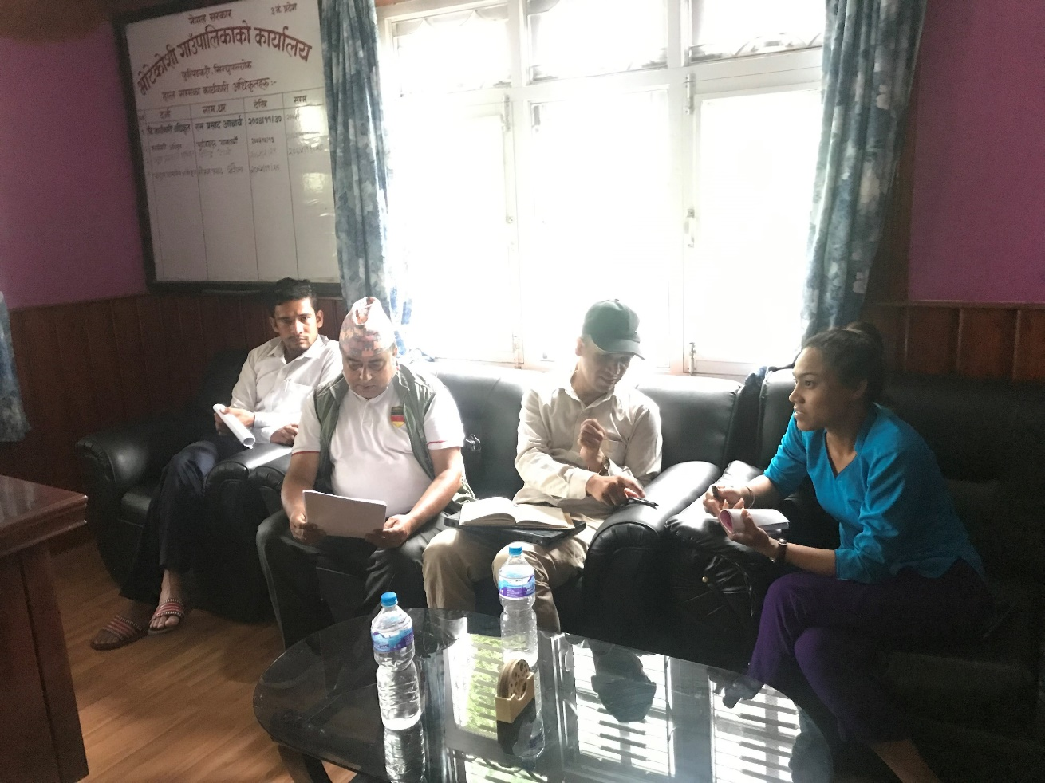

Discussion and sharing with administration officer Mohan Prasad Niraula during meeting at Bhotekoshi Gaupalika.

Decisions Made: (What, Why, Impacts)
- Palika profile upload into palika website.
- HRRP is Agree to send updated palika profile with the authentic latter from CLPUI or NRA.
- GIMaLI will always share the tranche release updates and direct communicate with the palika.

Next Steps/action points: | Person(s) Responsible | Due Date
Info pack, Palika profile sharing | HRRP IM
Tranche updates and sharing | GIMaLI office

Attendees | Gender | Organization | Designation | Phone No. | Email
Mohan Prasad Niraula | Male | Bhotekoshi Gaupalika | Chief Admin Officer | 9851147221 | mniraula.info@gmail.com
Sabin Prajapati | Male | Bhotekoshi Gaupalika | IT officer | 9841313152 | ito.bhotekoshimun@gmail.com
Tej Prasad Dhakal | Male | Bhotekoshi Gaupalika | Admin officer | 9841175586 | tejprasaddhakal@gmail.com
Bhupendra Bahadur Sah | Male | Bhotekoshi Gaupalika | HA | 9848956843
Sunita Shrestha | Female | DLPIU Building | Engineer | 9849051726 | Sunitashrestha0321@gmail.com
Sashi Sapkota | Male | Jica/EHRP | D. Finance Manager | 9851158889 | Sashisapkota2@gmail.com
Durga Prasad Regmi | Mlae | GMaLI | Finance Specialist | 9841236422 | durgaregmi012@gmail.com
Mithles Yadav | Male | Bhotekoshi Gaupalika | Engineer | 9808350674 | yadavmithles47@gmail.com
Sujan KC | Male | GIMaLI | Computer Operator | 9849767568 | sujankc16@gmail.com
Pradip Sharma | Male | HRRP | DC | 9851258254 | Techcord.sindhupalchok@hrrp.org

