Meeting Purpose: | Palika Level coordination meeting at Bhotekoshi GauPalika
Meeting Date: | 19/06/2019(19th Jun 2019)
Meeting Time: | 2:30 PM
Meeting Location: | Bhotekoshi Gaupalika
Meeting Facilitator: | Pradip Sharma
Minutes Taken By: | Ishor Neupane
Summary of participants: | Total: 6 | Female: 0 | Male: 6

Discussion: (Items/Knowledge Shared)
Agendas:
- Review of last meeting/meeting minute
- Find out the landless issues
- Discussion about the high rate of non-compliance issue
- Grant management and tranche realese updates
- Landless issues, finding and solutions from GIMALI and HRRP.
- Palika profile and upload into Palika website.

Decisions:
- The major concern of the ward chiefs is the addressing the non-beneficiaries. Most of the ward chiefs have been vocal about tranche release The delay in addressing of the grievances by the government even after 8-9 months has passed after the resurvey has been done is single major concern in almost all wards of the RM.
- There has been shortage of trained masons in Bhotekoshi GauPalika. Most of the masons that are currently working are the untrained ones from the western part of Nepal albeit the mason trainings have been conducted frequently in the RM. Due to this, the building standards are being neglected in many houses, and non- compliance issues raised.
- The delay in the tranche processing is another common issue facing the wards of the RM. Due to the lack of file tracking mechanism, the representatives would need to spend a long time to know the whereabouts of the files. Specially in ward no 3 have not getting tranche since 3 months.
- There are 30 displaced households that has taken Rs. 200,000 that the government has provided for new settlement. They have bought new lands from the money but they are still not getting amount from the GIMaLI office.

- In Bhotekoshi Gaupalika 317 venerable household were not started reconstruction due to their lack of manpower and economic condition.

- Dwarika foundation agree and made aggrement with Palika for 155 houses planning to reconstruction and starting very soon.
- NRA and Palika level agreement paper distribute with administrative officer.
- Request for PA form digitization supports by HRRP.
- CLPIU latter is better chain of work for uploading palika profile and further more action from Palika.
- Discuses about Palika profile and its effectiveness and impressive action from District.

Miscellaneous Items / AOB:
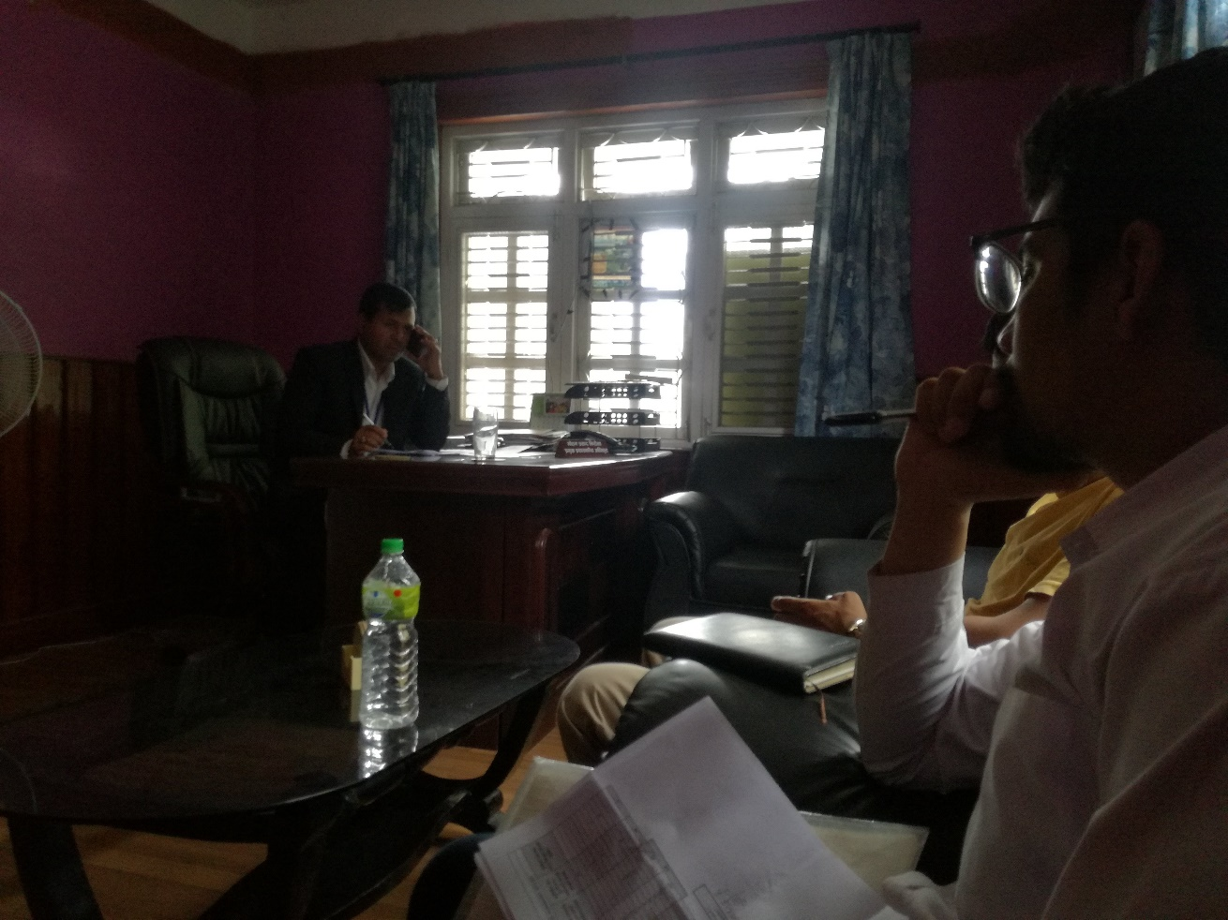

Disscusion and sharing with administration officer Mohan Prasad Niraula during meeting at Bhotekoshi Gaupalika.

Decisions Made: (What, Why, Impacts)
- Palika profile upload into palika website.
- HRRP is Agree to send updated palika profile with the authentic latter from CLPUI or NRA.
- HRRP also agree to coordinate and support for any IM related support to Palika and GIMaLI.
- GIMaLI will always share the tranche release updates and direct communicate with the palika.

Next Steps/action points: | Person(s) Responsible | Due Date
Info pack, Palika profile sharing | HRRP IM
Tranche upadates and sharing | GIMaLI office

Attendees | Gender | Organization | Designation | Phone No. | Email
Mohan Prasad Niraula | Male | Bhotekoshi Gaupalika | Admin Officer | 9851147221 | mniraula.info@gmail.com
Sabin Prajapati | Male | Bhotekoshi Gaupalika | IT officer | 9841313152 | ito.bhotekoshimun@gmail.com
Ishor Neupane | Male | HRRP | IMO | 9849572020 | Ishor.neupane@hrrpnepal.org
Pradip Sharma | Male | HRRP | DC | 9851258254 | Techcord.sindhupalchok@hrrp.org
Sujan Kc | Male | GIMaLI | Computer Operator | 9849767568 | sujankc16@gmail.com

