Meeting Purpose: | Palika Level Coordination Meeting at Sunkoshi RM, Sindhupalchowk
Meeting Date: | (13th August 2019)
Meeting Time: | 10:25 am to 12:00 pm
Meeting Location: | Chairperson’s office room
Meeting Facilitator: | Pradip Sharma
Minutes Taken By: | Pradip Sharma
Summary of participants: | Total: 8 | Female: 1 | Male: 8

Discussion: (Items/Knowledge Shared)
Agendas:
- Review of last meeting/meeting minute
- Regarding the PA Agreement Collection
- Regarding the progress in tranche disbursement
- Regarding discussion about retrofit
- others:

Decisions:
• Of the required 21000 PA in Sunkoshi Rural Municipality, 1200 has been
collected which would be sent to the GMALI office in the coming week
and the rest are in the process of collection.
• It was informed that the third tranche progress of the Palika was 84.34
and the rest are in process.
• There is belief among the retrofit beneficiaries that by mending them
walls, they could receive trances of retrofit. They were informed that
such activity is repair and not retrofit and are not eligible for receiving
tranche from the government.

Miscellaneous Items / AOB:
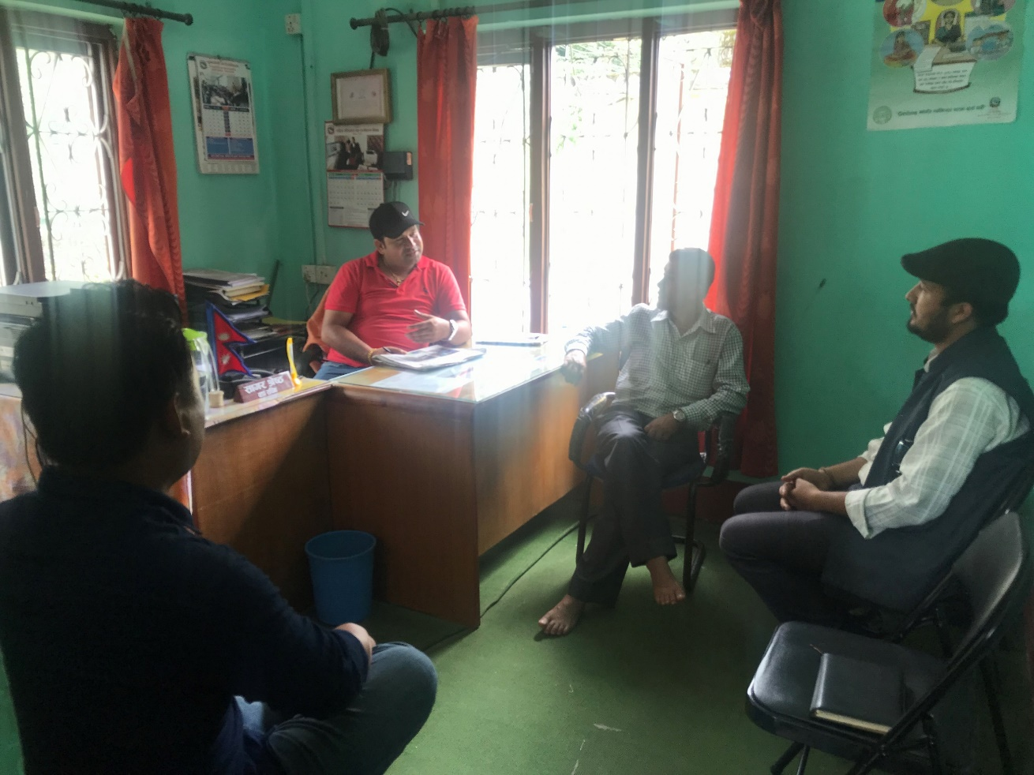

Discussion and sharing with Palika Engineers and elected body/Pos retrofit and reconstruction.

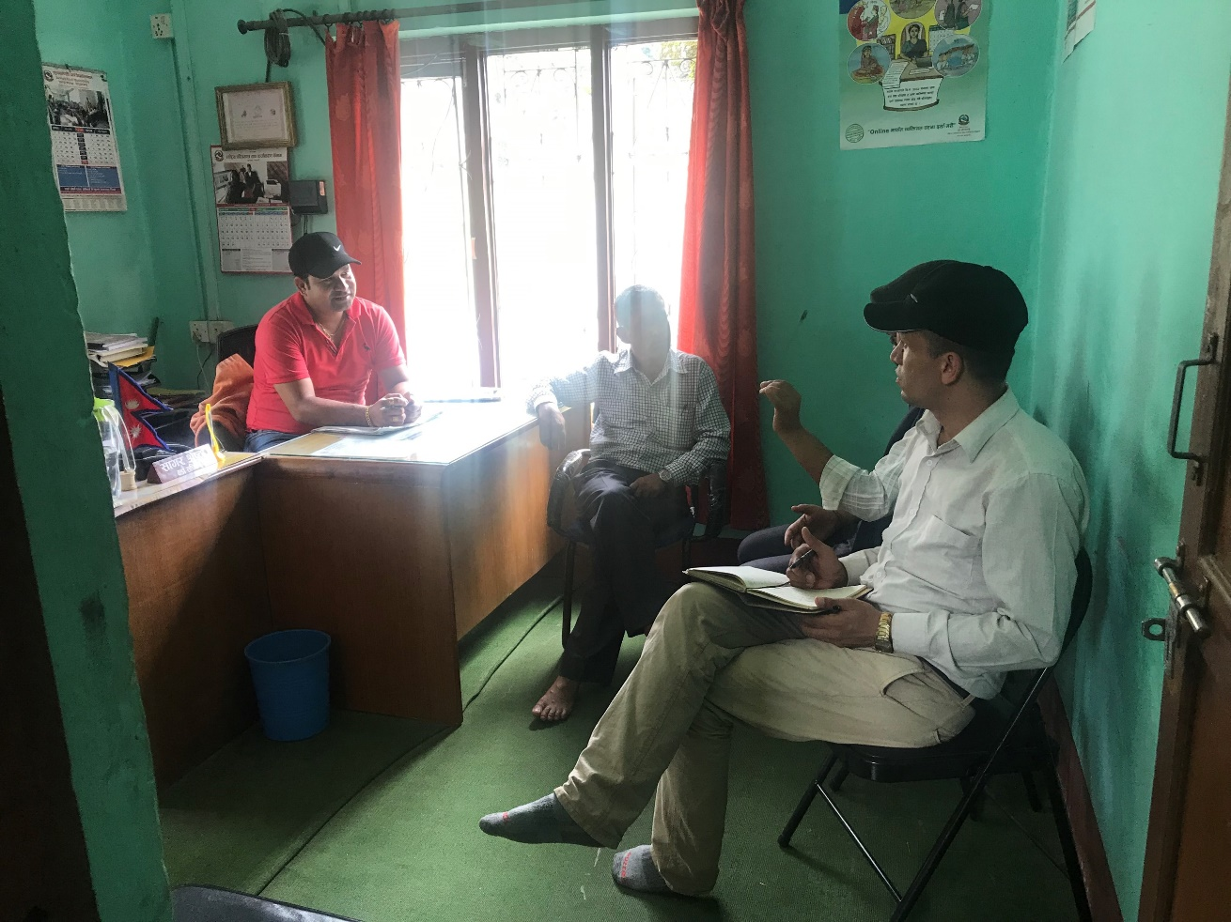

Next Steps/action points: | Person(s) Responsible | Due Date
Tranche updates and sharing | GIMaLI office

Attendees | Gender | Organization | Designation | Phone No. | Email
Bir Bahadur Basnet | Male | Sunkoshi Gaupalika | Chief Admin Officer | 9841743662 | sunkoshiruralmun@gmail.com
Bhujan Shrestha | Male | Sunkoshi Gaupalika | IT officer | 9841313152 | ito.sunkoshimunsindhupalchowk@gmail.com
Tara Prasad Niraula | Male | Sunkoshi Gaupalika | Finance officer | 985117755 | niraulatara@gmail.com
Raju Limbu | Male | Sunkoshi Gaupalika | ASE | 9842563140 | limbu.raju087@gmail.com
Sunita Shrestha | Female | DLPIU Building | Engineer | 9849051726 | Sunitashrestha0321@gmail.com
Sashi Sapkota | Male | Jica/EHRP | D. Finance Manager | 9851158889 | Sashisapkota2@gmail.com
Durga Prasad Regmi | Mlae | GMaLI | Finance Specialist | 9841236422 | durgaregmi012@gmail.com
Nirmal Basnet | Male | GIMaLI | Computer Operator | 9849337612 | nbmaila392@gmail.com
Pradip Sharma | Male | HRRP | DC | 9851258254 | techcord.sindhupalchok@hrrp.org

