Meeting Purpose: | Palika Level Coordination Meeting at Sunkoshi RM, Sindhupalchowk
Meeting Date: | (5th September 2019)
Meeting Time: | 10:25 am to 12:00 pm
Meeting Location: | Chairperson’s office room
Meeting Facilitator: | Pradip Sharma
Minutes Taken By: | Pradip Sharma
Summary of participants: | Total: 18 | Female: 1 | Male: 17

Discussion: (Items/Knowledge Shared)
Agendas:
- Review of last meeting/meeting minute
- Regarding the progress issue and challenge
- Regarding the progress in tranche disbursement
- others:

Decisions:
- Seven buildings are yet to be built in ward no.2, of which one is left in the DPC and the other is out of the beneficiary contact of the building.
- Houses like ward no.3 are often abandoned and refuse to improve.
- The height of the bugle in Oda No. 1 is 5 feet and will not improve
- In ward number 4, there were 4 buildings left to be built and they reached outside the beneficiary contact and 12 buildings were closed out of contact by DPC. Likewise, six buildings have reached the ceiling but due to non-roofing, CS is unable to entry.
- 5 Ward 33 shows the various reasons for building a building and 4 building is out of touch
- Likewise, two beneficiaries returned the tranche - Sitaram Bhandari (23-78-3-0-11) and (23-78-3-0-49) Dil Bahadur Karki
- The number seven ward does not have the land two beneficiaries to show the various reasons for the building to be built and there are no beneficiaries to build the building

- It has been decided to accelerate the reconstruction of Sunkoshi municipality at a rapid pace and distribute the completed certificates to the beneficiaries.

Miscellaneous Items / AOB:
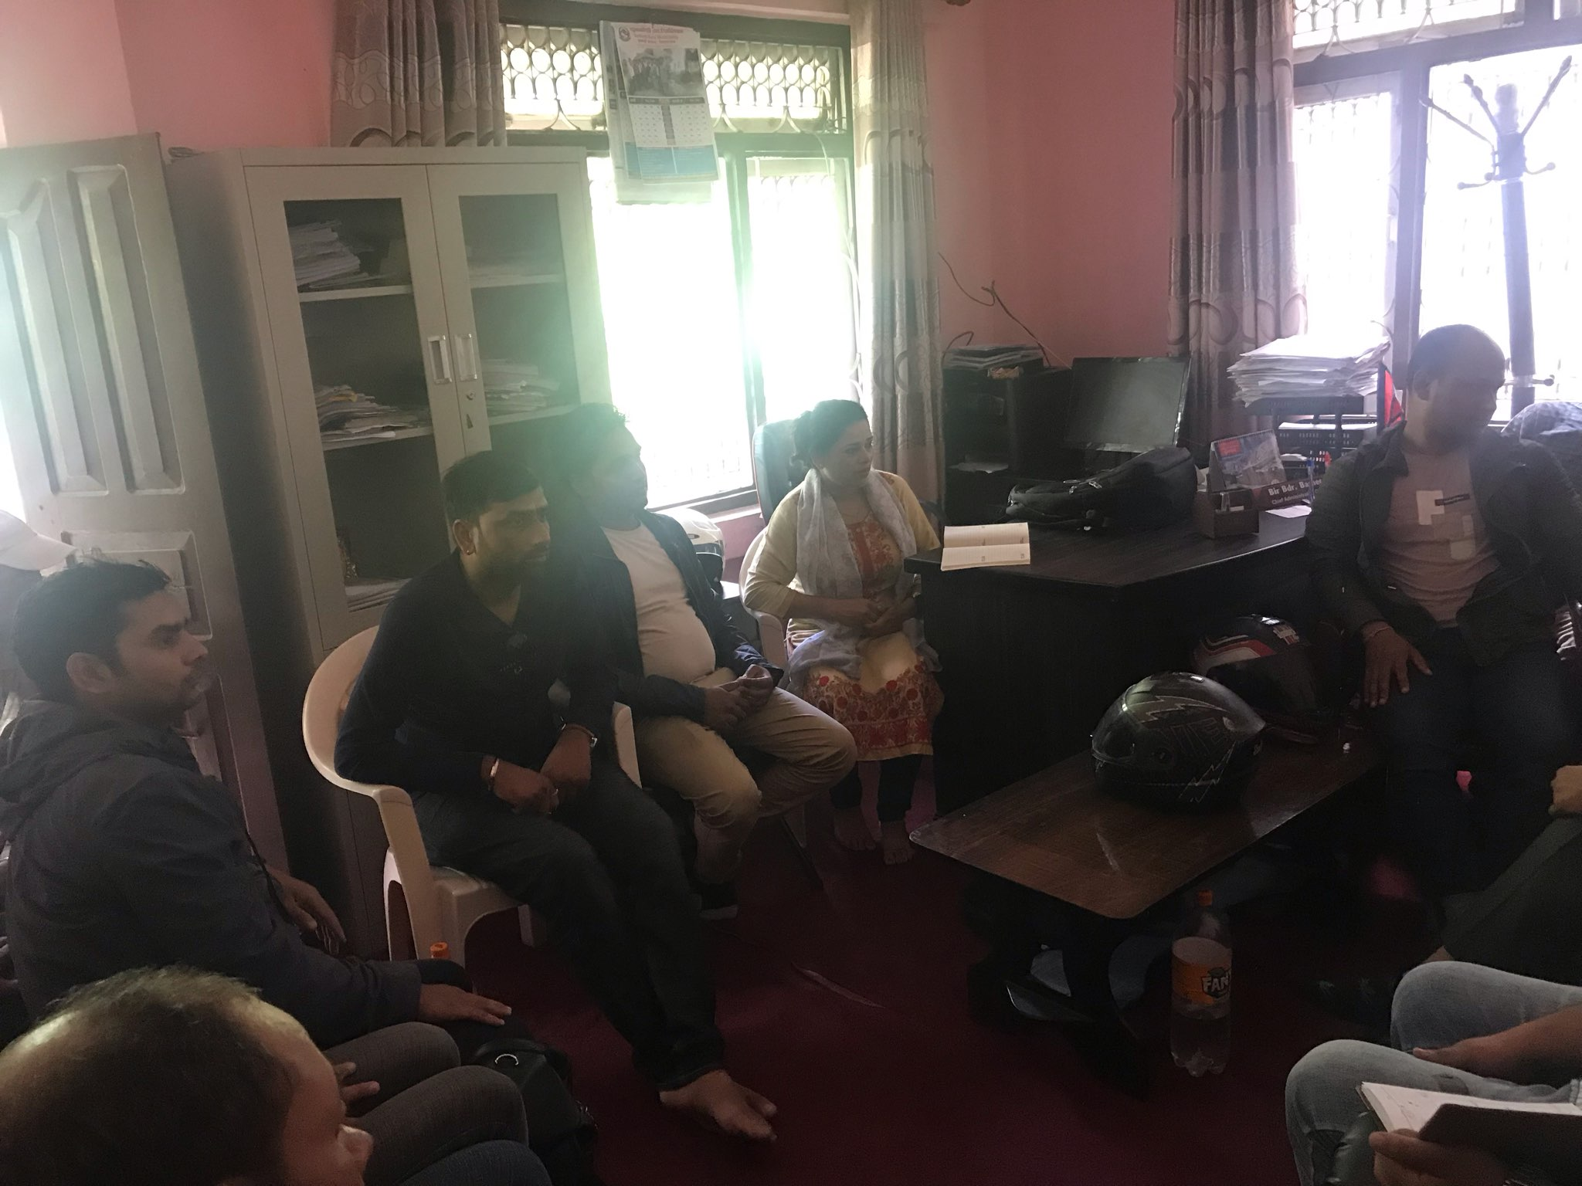

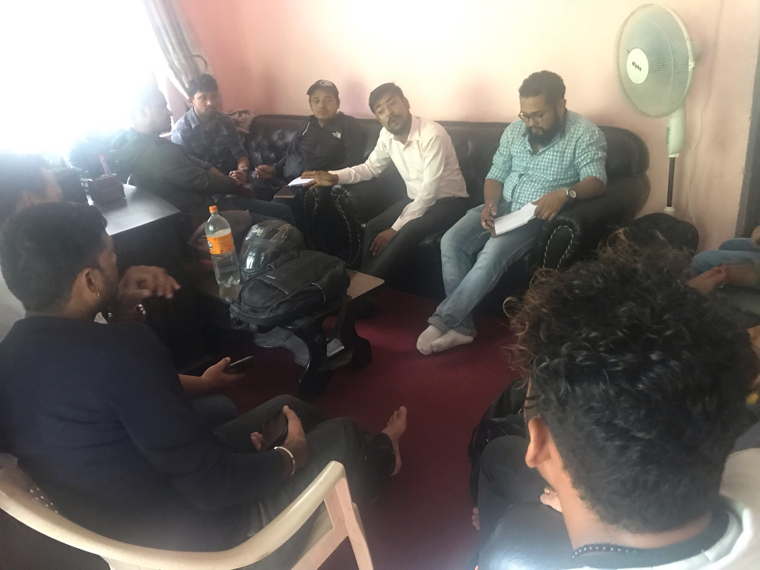

Discussion and sharing with Palika Engineers and elected body/Pos retrofit and reconstruction.

Next Steps/action points: | Person(s) Responsible | Due Date
Tranche updates and sharing | GIMaLI office
