Activity Report

Orientation on Confined masonry, Dry stone and Timber Treatment process

[09-05-2017]

Activity Date: | 08/09/2017
Report Prepared By: | Rijan Gajurel
Facilitator | Bharat Chalisa , Prabhu Ram pokheral

Discussion:
Welcome and Introduction:
- Rijan Gajurel, District Information Management officer (IMO) of Rasuwa welcomed all the participants in the Orientation of confined masonry, dry stone masonry and timber treatment process. The orientation was mainly focused for technical person and project coordinator of POs, DLPIU, NRA and other interested persons. After introduction of the entire participants program was started. After welcome and introduction round the program was started .Technical session was facilitated by HRRP DMT member Mr.Bharat chalisa and MOUD/CLPIU monitoring &evaluation process CLPIU-MOUD was facilitated by M&E specialist Mr.Prabhu Ram Pokhral .

Confined Masonry
- This presentation was focused on introduction of confined masonry and its need , its construction processes, guidelines, possible causes of failure

Dry Stone Masonry
- In this presentation mainly briefed about reason behind adopting stone masonry, its construction technology in dressed stone and random rubble stone masonry with GI wire mesh. This was quite interesting for the participants because in northern belt most of the constructions are based on such techniques.

Timber and Bamboo Treatment Process
- Timber and bamboo treatment session was mainly focused on steps involved in the chemical treatment of timber and bamboo. Chemicals like mixture of bitumen and kerosene for timber, boric-borax solution and Tim-bor solution for bamboo treatment.

MOUD/CLPIU Monitoring and Evaluation Process
- This presentation was focused on monitoring and evaluation process, its objectives, outcomes and the vision that CLPIU has taken regarding reconstruction. This event was facilitated by M&E specialist of CLPIU/MOUD Mr.Prabhu Ram Pokharel.

Mr. Sarjo kumar Yadav:
DLPIU Rasuwa focal person Mr.Saroj Kumar Yadav thanks Mr.Bharat Chalisea and Mr.Prbhu Ram Pokharel for the facilitation of the program. He request partners to follow the confined masonry, Dry stone masonry and Timber Treatment process in community. This kind of techniques support reconstruction and make this process easier in Rasuwa as well. In Rasuwa mainly in lower belt confined masonry is in practices and on northern side Dry stone masonry is in practices. So request partners to sensitized community on this kind of technique.

Closing Remarks
- Finally all the participants were thanked for their active participation. Also requested partners to support community and government on this reconstruction process by following this kind of techniques in community level. All participants to think about importance of social mobilization and technical assistance in this Reconstruction process. And for more active participation in future programs of HRRP.

Observation / Issue / Recommendation / Activity: | Reference Document
[Describe Observation / Issue / Recommendation / Activity]  - [Provide additional description of or information about the decision] | E.g. meeting minutes, photos, etc. (include google drive link for reference documents)
[Describe Observation / Issue / Recommendation / Activity]  - [Provide additional description of or information about the decision] | E.g. meeting minutes, photos, etc. (include google drive link for reference documents)

Decisions Made: (What, Why, Impacts)
- [List and describe decision made]
  - [Provide additional description of or information about the decision]

- [List and describe decision made]
  - [Provide additional description of or information about the decision]

Questions raised | Question asked by | Person(s) Responsible to answer | Answer

Attendees | Organisation | Phone No. | Email
Prabhu Ram Pokharel | CLPIU-MoUD | 9851224133 | prabhupidge@gmail.com
Mahesh Bhatt | Manakor | 9849098607 | Maxb5rk13@gmail.com
Bhimsen Shrestha | LWF-Nepal | 9851176146 | bhimsens@lwf.org.np
Prabesh Uprety | Lumanti | 9843299853 | prabesuprety@gmail.com
Ramesh Acharya | Cordaid | 9841084296 | Rameshac1920@gmail.com
Shankar Nepal | GIZ/RPN | 9849282228 | Nepalshankar@gmail.com
Pramod Neupane | GIZ/RPN | 9846008860 | Pramod.neupane@giz.de
Kumar K.c | GIZ/RPN | 9741062602 | Kumar.kc@giz.de
Sanjib Tamang | JJMS | 9843480900 | Tsanjib932@gmail.com
Rajendra Pyakurel | NRA | 9860667888 | razeenpyakurel@gmail.com
Saroj Kumar Yadav | MOUD-DLPIU | 9851212799 | Skycivil20@gmail.com
Nikan Dahal | ASF Nepal | 9801115540 | Tech.asfnepal@gmail.com
Suresh Poudel | ASF Nepal | 9801115534 | Sureshpoudel60@gmail.com
Rijan Gajurel | HRRP | 9851114937 | Im.rasuwa@hrrpnepal.org
Bharat Chalise | HRP | 9851053538

Photographs
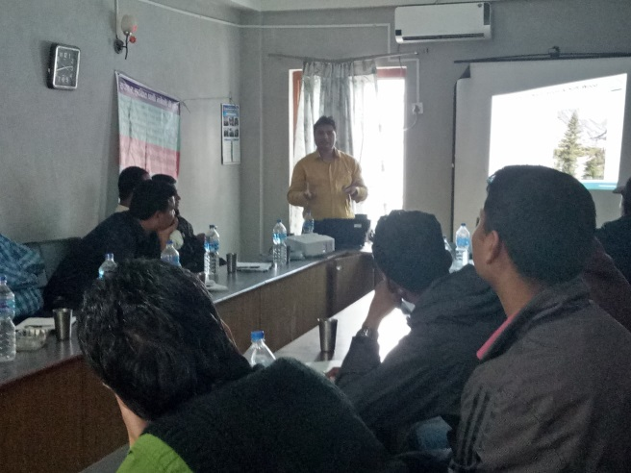 | 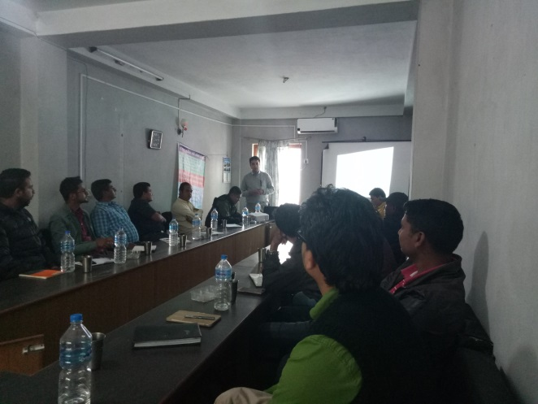
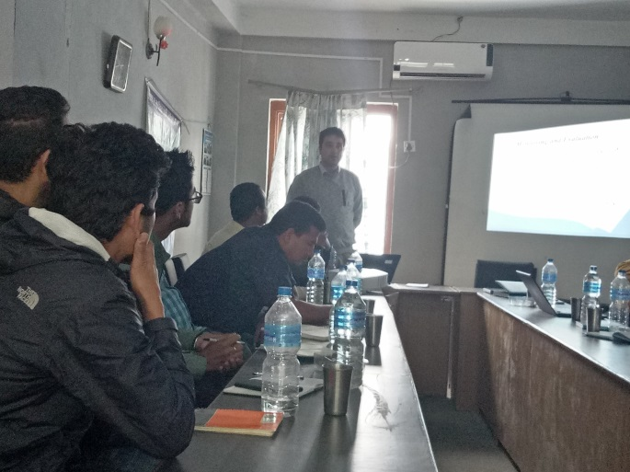 | 