Meeting Purpose: | Palika Level Coordination Meeting at Balephi RM, Sindhupalchowk
Meeting Date: | (4th September 2019)
Meeting Time: | 11:00 am to 2:00 pm
Meeting Location: | Chairperson’s office room
Meeting Facilitator: | Pradip Sharma
Minutes Taken By: | Pradip Sharma
Summary of participants: | Total: 14 | Female: 3 | Male: 11

Discussion: (Items/Knowledge Shared)
Agendas:
- Regarding the reconstruction issue
- Regarding the retrofit issue
- Regarding the progress in tranche disbursement
- others:

Decisions:
- Information was provided their Ninety percent of the tranche has been forwarded in balephi rural municipality while rest are on the process.
- Due to transfer of Engineers the two different beneficiaries took Third tranche by showing same house. The case is of ward-1 and name of the house owner is Mr. Anil Tamang.
- As per engineer, in ward no.3, the wood band of corrected houses are not good in shape.
- Due to the phased out of Save the Children (an INGO), one of the beneficiaries named Mr. Subba Tamang received first and second tranche but didn’t receive third tranche as his house has already been complete and constructed. He is roaming around either thither side to get third tranche.
- In ward no.7 a few houses are done simple maintenance, but beneficiaries pressurized engineers to inspect those houses as retrofitted.
- Due to mistakenly entry of third tranche into second tranche of ward-8 by GMaLI, the disbursement became delayed said by ward technician.
- The ward chief of ward-7, Mr. Karkel Lama is insisted and very vocal about the disbursement of all tranches of 5 houses of his ward which has constructed before engineer’s deployment.

Miscellaneous Items / AOB:
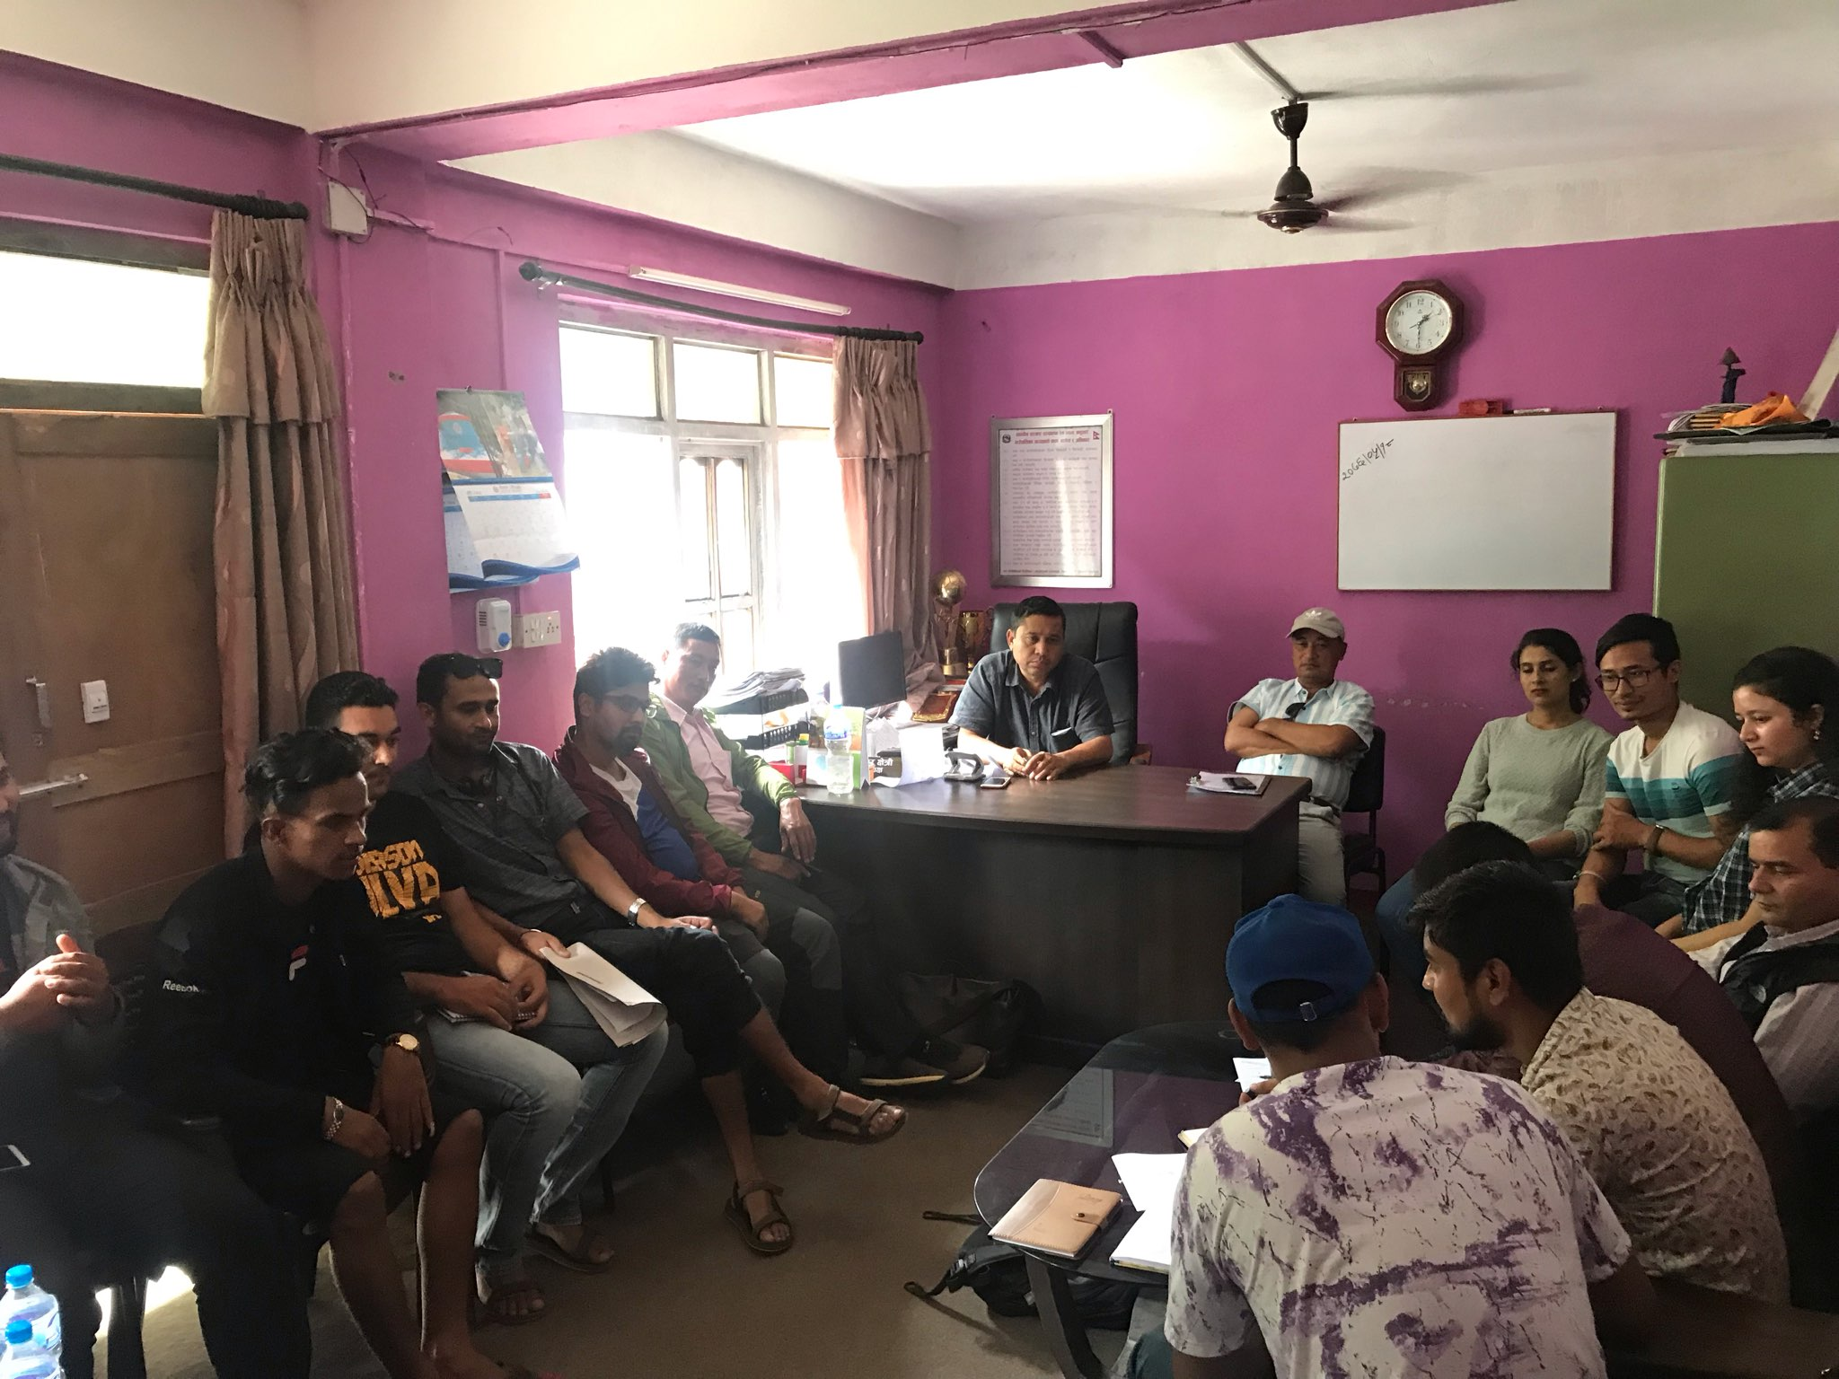



Discussion and sharing with Palika Engineers and elected body/Pos retrofit and reconstruction.

Next Steps/action points: | Person(s) Responsible | Due Date
Tranche updates and sharing | GIMaLI office

