Meeting Purpose: | General Coordination Meeting
Meeting Date: | 16th March 2018
Meeting Time: | 9:30 AM to 11:00 AM
 | NRA Hall, Simpani, Charikot, Dolakha
Meeting Facilitator: | Binod Kalauni
Minutes Taken By: | Binod Kalauni,

Discussion: (Items/Knowledge Shared)
Welcome and Introduction:
Mr. Sagar Acharya, Acting chief of NRA-Dolakha, DCCS, welcomed all the POs and GOs present in the meeting. He further started introduction session from himself.

RDTA:
Mr. Tara Pokharel from RDTA informed that have been working in Baiteshwor Rural Municipality where 7358 beneficiaries of housing grant lives and providing technical support in every ward. They have done KOBO survey of 7313 households and few are remaining because some of them are out of the district and some are out of the contact. The result of the survey has not yet come out, he promised to share the outcome of the survey once it gets out. He shared working strategy in Baiteshwor Rural Municipality in which Rural Municipality has been divided into number of clusters and further the single cluster is divided into 3 sub-clusters.
He shared some of the difficulties that beneficiaries have shared during the field visit:
- Tranche release process is late.
- Mishandling of files
TUKI has kept 2 volunteers in the bank to help bank in tranche amount release. The number of tranche release has increased after keeping volunteers. Beneficiaries who come from Gaurshankar Rural Municipality are also helped by volunteers. Those people who had received first tranche but not started construction of their shelter are identified and a letter has been send to those people illustrating why they have not started construction of their permanent shelter. He further added that RDTA is going to start campaign including locally elected representatives in the different wards of Baiteshwor Rural Municipality to encourage people in building their permanent shelter.

RDTA is also implementing WASH project in the support of Plan international. Additionally, school construction work is also going on in the support of CWIN

NSET:
NSET has targeted 56 OJTs in which 24 OJT completed and 32 ongoing from NSET itself. 230 OJT from vendor called TCN. Additionally, 12 Mason TOTS has been completed in which 386 technical staff were trained. Furthermore, 58 mason trainings have been in which 1784 people were trained. NSET has also conducted 1440 orientations in which 30202 people were oriented. Six Social mobilization training was conducted in which 179 people were trained. He shared some of the challenges in which lack of mason and poor financial status are the major. He further informed that 92% of the mason has been retained in the Dolakha trained by the NSET.

RRN:
Mr. Tanka Upreti from RRN updated about their monthly progress, in which Mirge health post has been completed, in school construction wall has been completed in Mirge, Gairimudi and Jhule, one month will be required to complete. Agriculture collection center are also in construction, 10 irrigation canals construction has been completed in the target of 24, two rusting store construction work is completed, two school construction projects are in agreement phase, shed improvement, agro-marketing works in Boach and Katakuti is ongoing, agriculture road is in progress in which 17 Km is finished, 5 Km is track opening which is ongoing and rest of the work is of repair of existing road among 50 Km.

HURADEC:
HURADEC in the support of Christian Aid has been implementing shelter project which has been completed 89% and remaining is to be expected to be completed within March. Timber treatment plant orientation has been completed.

ECARDS:
Representative from ECARDS updated that school construction in Hawa, Gairimudi and Kalinchowk is ongoing. Mason training in Melung is completed in and ongoing in Chyama and Sahare VDCs. He further added that electrical training to 20 people in Babre has been completed in the support of Plan International. Cold store construction work has been completed up to 40% in Manedanda.

CEEPARD-Nepal:
In the support of Practical Action, micro-hydro repair is in progress, improved cooking stove program is also on going. Mason training in Chilankha, Lapilang and Babare is planned. Goat shed and improved farming is also ongoing. School based TOT of 4-days is planned, in the financial support of Christian Aid first aid training at school is ongoing. Additionally, repair and WASH project is also going on. Water supply work at different school is also in progress.

HRRP/M&E Jointly:
Findings from the joint visit was presented during the meeting. In which, lack of technical assistance form DLPIU engineers, non-complaint cases, OJT issues and other issues related to reconstruction was presented.
.

District Coordination Committee(DCC):
Mr. Tika Joshi, from DCC informed that inquiry management is very difficult to manage so he requests for the staff who can support in inquiry addressing.

Education-DLPIU:
Mr. Govinda Sedai, Unit Chief of DLPIU-Education, updated that monitoring is going on at present and construction has been started of all the schools funded by ADB.

NRA-Dolakha:
Mr. Sagar Acharya chief of NRA-Dolakha requested POs in their working area to coordinate in technical inspection, tranche amount release and encouragement to construct permanent shelter. He further added that POs should have to fix a focal person who could take part in the coordination meeting so that focal can be contacted for any need. He also requested POs to do electricity, carpeting and plumbing training instead of mason training. Technical Assistance in the Kalinchowk Rural Municipality is lacking so he requested DLPIU to increase the TA. He further shared that can we flash the detail of tranche release which could help beneficiaries to know whether their tranche is deposited or not. He also told that every day detail of tranche release will be send to NRA and computer operator of NRA will upload in the website of NRA-Dolakha.

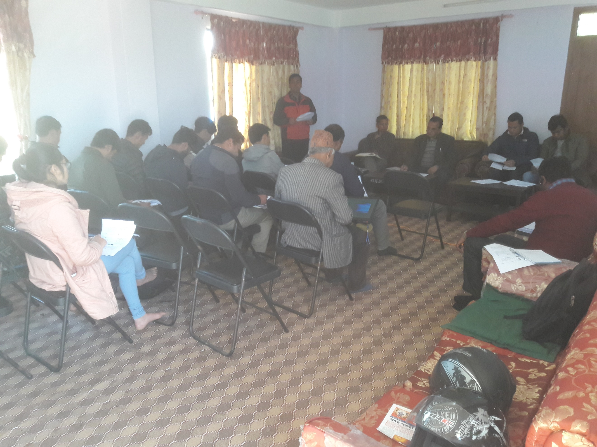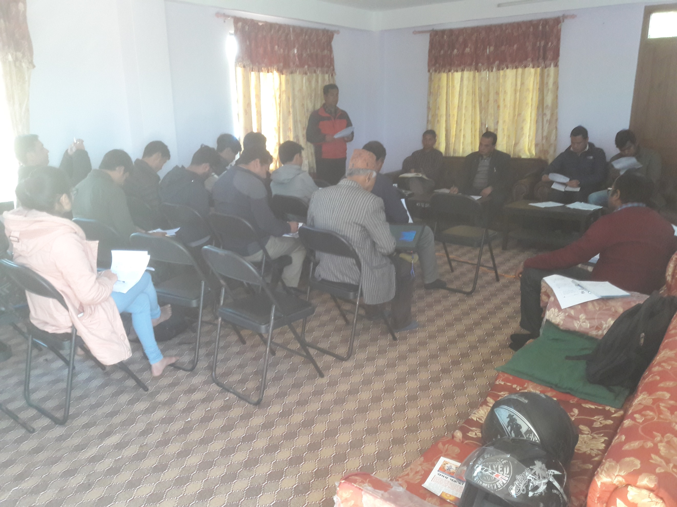

Decisions Made: (What, Why, Impacts)
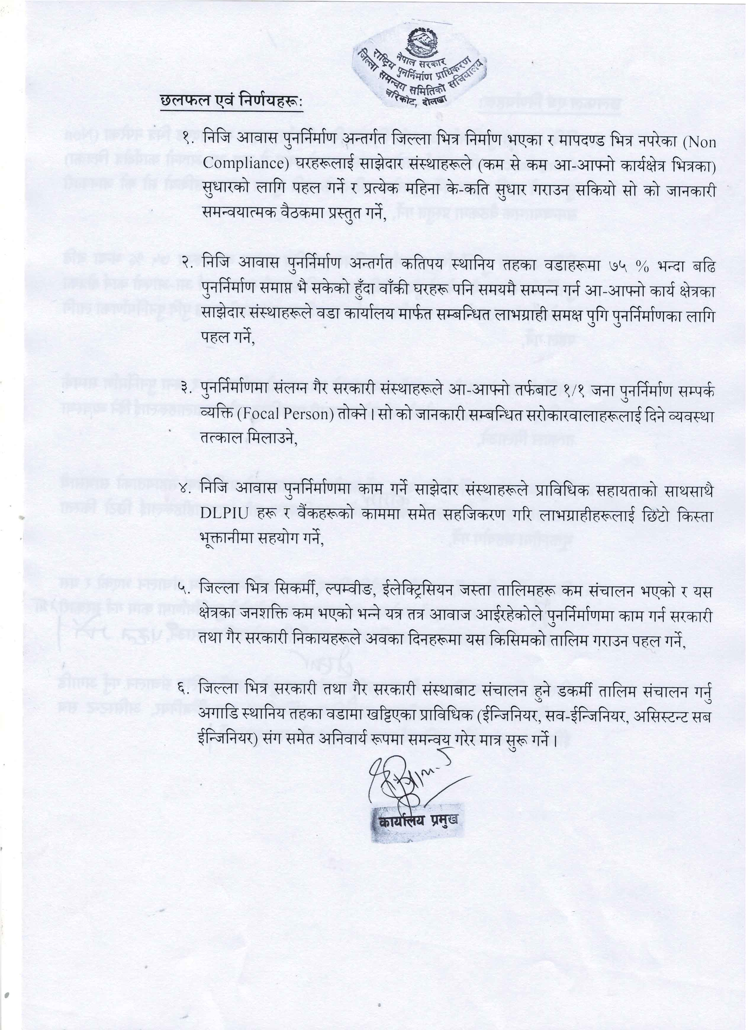

Attendees | Organisation | Phone No. | Email
Sagar Acharya | NRA-Dolakha |  | mrsagaracharya@yahoo.com
Arjun Tamang | DLPIU/DUDBC |  | Arjuntamang2048@gmail.com
Janak Raj Joshi | MoUD-CLPIU | 9851101041 | Janakjosiee@gmail.com
Rojina Deshar | NRA-Dolakha | 9849123713 | rojinadesar@gmail.com
Sudip Kafle | NRA | 9841570371 | yeskafle@gmail.com
Tara Nath Pokharel | RDTA | 9851103665 | Tara.pokharel08@gmail.com
Nischal Shrestha | RDTA | 9844307250 | Nischal1002@gmail.com
Suman Moktan | RDTA | 9860936392 | Moktansuman07@gmail.com
Santosh Rimal | ECARDS | 9851099821 | Sanrimal98@gmail.com
Kopila Shrestha | CEEPARD | 9844003362 | kopeelastha@gmail.com
Ganesh Bhattrai | NSET-Nepal | 9841820997 | ganeshbhattrai@nset.org.np
Sujan Rai | NSE-Nepal | 9744012099 | sujanrai@nset.org.np
Tanka Uprety | RRN-Dolakha | 9851180581 | tank@rrn.org.np
Govinda Sedai | DLPIU-Edu | 9851220575 | Govindaraj.sedhai@gmail.com
Bhogendra Kumar Sah | DLPIU-Engineer | 9844432509 | Bhogendrasah2014@gmail.com
Fadindra Shrestha | MoFALD-DLPIU | 9858421306 | Fanindra.shrestha@gmail.com
Nahakul Shrestha | HURADEC-Nepal |  | Pc.cbrsp.huradec@gmail.com
Bindu Kumar Jha | Concern WorldWide | 9813668360
Lila Bahadur Bhaujel | NSET-Nepal | 9843359864 | lilabhujel@nset.org.np
Tika Prasad Joshi | DCC-EHRP | 9854045167
Janak Raj Joshi | M&E, MoUD-CLPIU | 9851101041 | janakjosie@gmail.com
Binod Kumar Kalauni | HRRP | 9851240334 | Techcord.dolakha@hrrpnrpal.org

