Data Pipeline Architecture
Source-specific ingestion, shared normalisation and transformations, schema-enforced JSON exports
Core principle: Separate pipelines by source at the extraction boundary. Unify them only after raw data has been captured, because the reusable parts are the canonical record model, transformations, validation and export—not the API call itself.

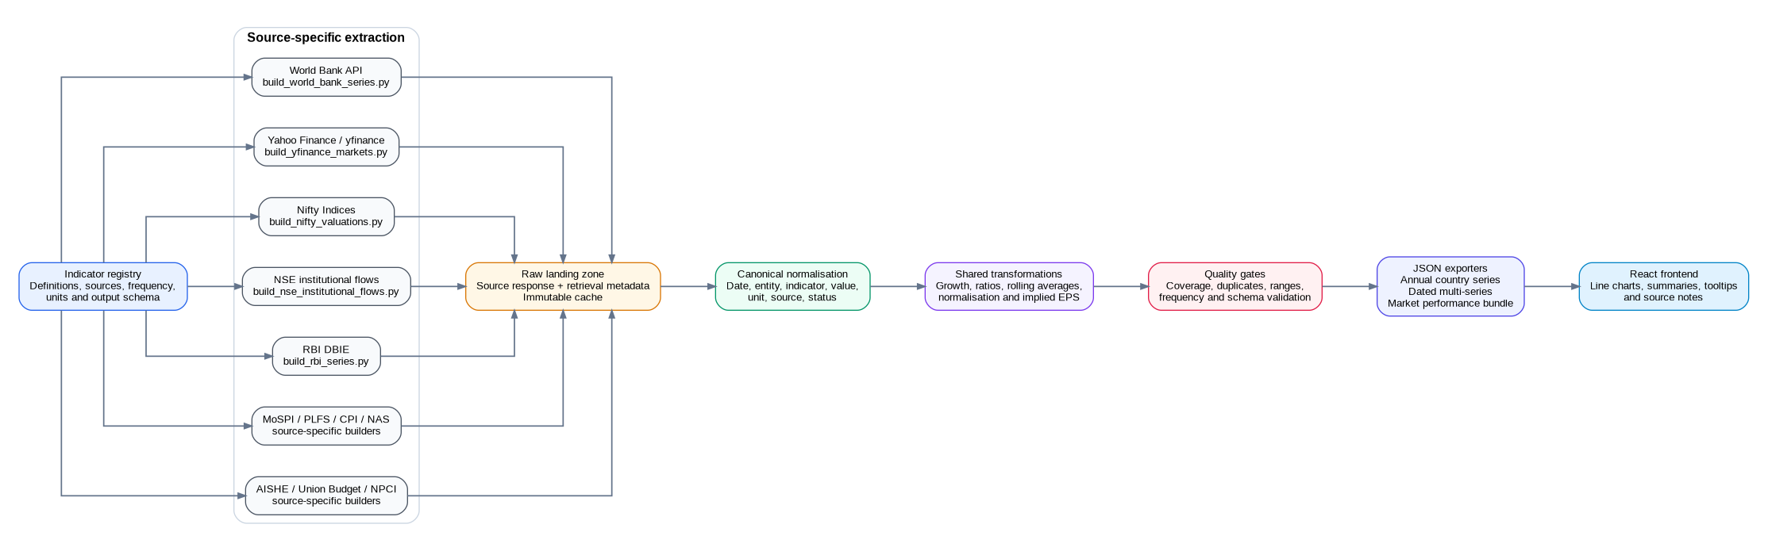
Figure 1. End-to-end architecture for the India growth dashboard.

Layer responsibilities
Layer | Responsibility | Non-negotiable outputs
Indicator registry | Single source of truth for definitions, source IDs, frequency, units, transformations, peer set and output schema. | Stable indicator key; source and methodology notes; expected schema filename.
Source extractors | Handle provider-specific HTTP sessions, headers, pagination, spreadsheets, API parameters, date parsing, caching and retries. | Raw payload/file plus retrieval timestamp and source URL.
Raw landing zone | Preserve source material before cleaning so transformations are reproducible and changes can be audited. | Immutable date-stamped raw files; checksum; extraction log.
Canonical normalisation | Convert all sources to a shared internal record without erasing source-specific provenance. | date, entity, indicator, value, unit, frequency, source, status.
Shared transformations | Apply reusable calculations such as YoY growth, ratios, rolling averages, normalised market levels, implied EPS and import cover. | Derived flag; method name/version; deterministic output.
Quality gates | Detect empty series, duplicate periods, unexpected ranges, missing coverage, frequency drift and schema violations. | Validation report; fail-fast exit code; no partial production overwrite.
JSON export | Serialise to the smallest suitable contract rather than one universal structure. | Validated annual, dated multi-series or market-performance JSON.
Frontend | Render charts and source notes without recomputing economic definitions in JavaScript. | Stable keys, explicit units, null handling and series order.

Recommended repository layout
scripts/
build_world_bank_series.py
build_yfinance_markets.py
build_nifty_valuations.py
build_nse_institutional_flows.py
build_rbi_series.py
build_mospi_national_accounts.py
build_mospi_cpi.py
build_mospi_plfs.py
build_union_budget_capex.py
build_aishe_series.py
build_npci_upi.py
extractors/ # provider-specific I/O only
transforms/ # reusable economic and market calculations
validators/ # coverage, ranges and JSON Schema validation
exporters/ # atomic JSON writers
config/indicators.py
data/raw/<source>/
data/processed/<indicator>/

Run sequence
- Load the indicator registry and resolve the source-specific job.
- Fetch and cache the source response without modifying it.
- Parse into canonical records and attach provenance and revision status.
- Apply only the transformations declared for that indicator.
- Run coverage, duplicate, range and frequency checks.
- Build the appropriate JSON object and validate it against the selected schema.
- Atomically publish the file consumed by the React frontend.

Operational rules
- A source failure should fail only that source job; it should not corrupt unrelated indicators.
- Never overwrite the latest valid JSON with an empty or schema-invalid result.
- Persist the data vintage or status when official series are revised, provisional or budget estimates.
- Keep transformations out of extractors and out of the frontend.
- Log row counts before and after each transformation so unexpected data loss is visible.

