India Structural Growth & Resilience Analysis
Focused research roadmap, data architecture and delivery plan

Central research question
Is India developing the domestic financial, physical and human capacity required for sustained growth, while remaining fiscally and externally resilient?

This document narrows the project from a broad indicator dashboard to seven connected analytical sections. Each section tests a specific mechanism, uses one primary chart and one supporting view, and ends with an explicit limitation. The purpose is to reach a defensible conclusion rather than to display every available statistic.
Prepared for implementation in the existing Python-to-static-JSON-to-React architecture
Planning version: 2026-07-21

1. Executive summary
The revised project has seven analytical sections. Six test India’s structural growth model; the seventh examines whether domestic institutions buffer Indian markets during global shocks. The sections are designed to work together, not to operate as seven independent mini-projects.
# | Section | Core question | Primary evidence
1 | Digital integration and tax capacity | Is UPI becoming embedded in everyday economic activity, and is wider digital integration accompanied by stronger tax capacity? | UPI per capita; UPI value/GDP; GST growth vs nominal GDP
2 | Government investment and execution | Is public spending shifting toward productive infrastructure, and are announced plans actually delivered? | CapEx/GDP; CapEx/total spend; execution ratio
3 | Private investment and crowding-in | Is public infrastructure investment encouraging firms to expand productive capacity? | Private GFCF/GDP; private share of GFCF; capacity utilisation
4 | Fiscal capacity and debt sustainability | Can India sustain higher investment without debt service crowding out future development spending? | General-government debt/GDP; interest/revenue; primary balance
5 | External competitiveness and resilience | Is domestic growth being achieved without a persistent deterioration in external price competitiveness? | REER; REER deviation; current account/GDP; non-oil exports
6 | Human-capital and employment conversion | Is expanding higher education translating into productive employment? | Tertiary GER; graduate unemployment; one employment-quality measure
7 | Domestic capital buffer against global shocks | Has DII growth reduced Indian equity markets’ sensitivity to foreign portfolio outflows? | DII/FPI flows; offset ratio; Nifty drawdown; event studies

Scope discipline
The project should stop at these seven sections. Supporting measures are allowed only when they test the same mechanism. They should not become additional headline chapters.

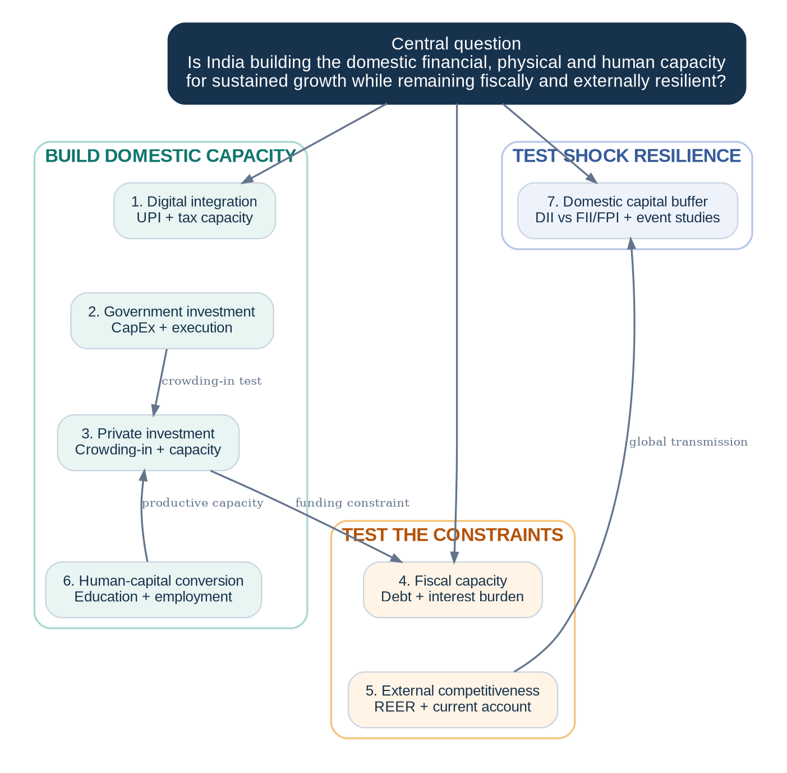
Figure 1. The seven sections are organised around domestic capacity, binding constraints and resilience to external shocks.

2. Analytical narrative
The sections form a single chain of reasoning. Digital infrastructure may deepen participation in the formal financial system. Government capital expenditure may improve physical infrastructure, but its success depends on execution and on whether private firms respond. Public investment is constrained by debt and interest costs. Human-capital expansion matters only if education converts into useful employment. REER and the current account test the external constraint. DII/FPI analysis tests whether India’s domestic capital base reduces the transmission of global financial shocks.
What a strong conclusion could look like
India may show clear progress in digital and financial infrastructure while still facing weaker private-investment response, employment conversion or external-competitiveness pressures. The analysis does not need to conclude that every dimension is improving.

Mechanism | What it may indicate | Main caution
Digital integration | Broader transaction access and lower payment friction | GST and recorded activity do not prove causation
Government CapEx | More productive public assets and infrastructure | Announced budgets can diverge from actual delivery
Private investment | Crowding-in and expansion of productive capacity | Investment may follow demand rather than infrastructure
Debt and interest burden | Available fiscal space for sustained investment | Debt stock alone misses servicing pressure
Human capital | Larger skilled labour pool | Enrolment does not guarantee quality or employment
REER and current account | External price competitiveness and funding resilience | REER is not a direct fair-value estimate
DII/FPI buffer | Lower dependence on reversible foreign portfolio capital | Stability is not immunity or correct valuation

3. Detailed section plans
Every analytical section should follow the same frontend and research template: a clear question, one primary chart, one supporting view or toggle, two or three headline values, a short interpretation, a limitations panel, and source/methodology details.

3.1 Digital integration and tax capacity
Research question
Is digital-payment adoption contributing to a broader, more integrated and increasingly formal economy?

Primary indicators
- UPI transactions per capita
- UPI transaction value as a percentage of nominal GDP
- Average UPI transaction value

Supporting evidence
- GST revenue growth relative to nominal GDP growth
- GST revenue as a percentage of GDP, if the denominator is consistently defined
Why it matters: UPI is a distinctive, high-frequency indicator of India’s digital public infrastructure. GST offers a cautious test of whether digital integration is occurring alongside stronger tax collection and recorded economic activity.
Recommended presentation: Primary line chart: UPI transactions per capita and UPI value/GDP. Supporting toggle: average transaction value and GST buoyancy proxy.
Main limitation
UPI usage is not direct proof of formalisation, and GST is influenced by tax rates, enforcement, inflation, imports and refunds. The section should present association, not causation.

Likely sources: NPCI; GST revenue publications; MoSPI nominal GDP.

3.2 Government investment and execution
Research question
Is the government redirecting expenditure toward productive infrastructure, and is that planned investment actually being delivered?

Primary indicators
- Actual government CapEx as a percentage of GDP
- Actual CapEx as a percentage of total expenditure
- Real or nominal CapEx growth, clearly labelled

Supporting evidence
- CapEx execution ratio = Actual / Budget Estimate
- Budget Estimate and Revised Estimate as separate comparison series
Why it matters: Government CapEx is the clearest policy input in the project. Separating planned and actual expenditure prevents budget announcements from being mistaken for delivered infrastructure.
Recommended presentation: Primary line chart: actual CapEx/GDP and CapEx/total expenditure. Supporting view: Budget Estimate, Revised Estimate and Actual execution.
Main limitation
Spending is not equivalent to completed or productive infrastructure. The section measures fiscal effort and delivery, not project quality.

Likely sources: Union Budget; Expenditure Profile; Economic Survey; MoSPI GDP.

3.3 Private investment and crowding-in
Research question
Is increased public investment encouraging private firms to expand productive capacity?

Primary indicators
- Private corporate gross fixed capital formation as a percentage of GDP
- Private-sector share of total fixed-capital formation
- Manufacturing capacity utilisation

Supporting evidence
- Lagged comparison between public CapEx and private investment
- Optional project completions or investment announcements, only if consistently sourced
Why it matters: This is the most important addition to the original scope. Public spending is an input; private investment is evidence that businesses expect demand and infrastructure conditions to justify expansion.
Recommended presentation: Primary line chart: private GFCF/GDP and capacity utilisation. Supporting view: public CapEx against lagged private investment.
Main limitation
Co-movement does not prove crowding-in. Private investment can respond to demand, interest rates, profitability and global conditions.

Likely sources: MoSPI National Accounts; RBI OBICUS; Union Budget for CapEx comparison.

3.4 Fiscal capacity and debt sustainability
Research question
Can India sustain higher public investment without allowing debt servicing to crowd out future development spending?

Primary indicators
- General-government debt as a percentage of GDP
- Interest payments as a percentage of revenue receipts
- Interest payments as a percentage of total expenditure

Supporting evidence
- Primary balance as a percentage of GDP
- Central-government debt as a secondary series for decomposition
Why it matters: Debt/GDP measures the stock of obligations; the interest burden measures how much budgetary flexibility remains. The pair directly qualifies the CapEx argument.
Recommended presentation: Primary line chart: general-government debt/GDP and interest/revenue. Supporting view: primary balance and central/state decomposition where available.
Main limitation
Debt sustainability depends on growth, interest rates, maturity, currency denomination and the quality of expenditure—not on one threshold.

Likely sources: Economic Survey; Union Budget; RBI state-finance and public-finance tables; MoSPI GDP.

3.5 External competitiveness and balance-of-payments resilience
Research question
Is India maintaining external competitiveness as domestic growth, inflation and capital inflows increase?

Primary indicators
- RBI trade-weighted REER
- REER deviation from a five- or ten-year rolling average

Supporting evidence
- Current-account balance as a percentage of GDP
- Non-oil merchandise export growth
- Optional services-export growth
Why it matters: REER prevents the project from becoming a sequence of positive domestic stories. The current account or export outcomes test whether changes in relative prices are economically consequential.
Recommended presentation: Primary line chart: REER and rolling historical reference. Supporting view: current-account balance/GDP or non-oil exports.
Main limitation
An REER above 100 does not automatically mean overvaluation. Interpret direction, rate of change, historical deviation and external outcomes.

Likely sources: RBI DBIE; RBI balance of payments; Department of Commerce; MoSPI GDP.

3.6 Human-capital and employment conversion
Research question
Is the expansion of education translating into productive employment and better use of India’s workforce?

Primary indicators
- Tertiary Gross Enrolment Ratio
- Graduate-and-above unemployment rate

Supporting evidence
- Choose one: regular salaried employment share, non-agricultural employment share, or formal payroll additions
Why it matters: Enrolment measures access; graduate unemployment tests whether the economy creates roles that use the additional education. The pairing is more informative than generic school enrolment.
Recommended presentation: Primary line chart: tertiary GER and graduate unemployment. Supporting view: one employment-quality metric only.
Main limitation
Enrolment does not measure learning quality or employability. EPFO payroll additions, if used, represent formal payroll activity rather than total job creation.

Likely sources: AISHE; PLFS; optional EPFO or World Bank for supporting employment share.

3.7 Domestic capital as a buffer against global shocks
Research question
Has the growth of domestic institutional investment reduced the sensitivity of Indian equity markets to foreign portfolio outflows?

Primary indicators
- Monthly DII net equity flows
- Monthly FII/FPI net equity flows
- Rolling 12-month cumulative flows

Supporting evidence
- DII offset ratio during FII/FPI selling months
- Nifty returns, drawdowns, volatility and recovery time
- Predefined global-shock event studies
Why it matters: This section tests India’s financial resilience and dependence on reversible foreign portfolio capital. A deeper domestic investor base may reduce market disruption and support corporate financing conditions during global risk-off episodes.
Recommended presentation: Primary line chart: monthly and rolling DII/FPI flows. Supporting event view: cumulative flows, offset ratio, Nifty drawdown and recovery for predefined shocks.
Main limitation
DII does not equal retail investment. Domestic buying may stabilise markets without improving fundamentals and may transfer risk to domestic savers. The defensible claim is financial resilience, not complete economic sovereignty.

Likely sources: NSE institutional activity; NSDL FPI reports; yFinance or existing market-performance pipeline.

4. Data products and schema mapping
The focused project should publish one continuous analytical bundle per section, plus a separate event-study file for global shocks. The existing dated multi-series schema becomes the default contract because it supports daily, monthly, quarterly and annual observations, mixed units, per-series labels and status fields.
Section / use | Static file | Schema | Frequency | Core fields
Digital integration | digital-integration/upi-and-tax-capacity.json | dated_multi_series | Monthly / quarterly | transactions_per_capita; transaction_value_pct_gdp; average_transaction_value; gst_growth_gap
Government investment | government-investment/capex-and-execution.json | dated_multi_series | Annual / fiscal year | capex_pct_gdp; capex_pct_total; execution_ratio; budget/revised/actual
Private investment | private-investment/investment-and-capacity.json | dated_multi_series | Quarterly / annual | private_gfcf_pct_gdp; private_share_gfcf; capacity_utilisation
Fiscal capacity | fiscal-capacity/debt-and-interest-burden.json | dated_multi_series | Annual / fiscal year | general_gov_debt_pct_gdp; interest_pct_revenue; primary_balance_pct_gdp
External competitiveness | external-competitiveness/reer-and-current-account.json | dated_multi_series | Monthly / quarterly | reer_index; reer_deviation_pct; current_account_pct_gdp; non_oil_export_growth
Human capital | human-capital/education-and-employment.json | dated_multi_series | Annual | tertiary_ger; graduate_unemployment; employment_quality
Capital resilience | capital-resilience/institutional-flows.json | dated_multi_series | Monthly | dii_net_flow; fpi_net_flow; rolling_12m; offset_ratio
Market outcomes | equities/market-performance.json | market_performance | Daily / weekly | Nifty price, normalised value, returns, drawdown, volatility and summary statistics
Shock studies | capital-resilience/global-shock-events.json | New event-study schema | Event windows | flows; offset ratio; drawdown; currency move; recovery duration

Schema rule
Use annual_country_series only when the frontend adds an explicit India-versus-peer annual comparison. Do not force annual India-only series into that country-comparison structure when dated_multi_series is more natural.

4.1 Event-study contract
The continuous DII/FPI flow file fits the existing dated-series schema. Event summaries do not: each event contains a named window and several accumulated outcomes. A small dedicated contract is justified.

{
"metadata": {
"generated_at": "2026-07-21T10:00:00Z",
"methodology": "Predefined event windows"
},
"events": [
{
"event_id": "global-risk-off-example",
"label": "Global risk-off event",
"start_date": "2022-01-01",
"end_date": "2022-06-30",
"fpi_net_flow": -100000,
"dii_net_flow": 85000,
"dii_offset_ratio": 0.85,
"nifty_max_drawdown": -0.14,
"recovery_days": 180
}
]
}

5. Pipeline architecture
The pipeline remains source-specific at extraction and shared after normalisation. This is the correct compromise for APIs, spreadsheets and reports that have materially different request parameters, dates, revisions and failure modes.
Figure 2. Source-specific extraction feeds a shared modelling, transformation, validation and promotion pipeline.

5.1 Recommended script structure
scripts/
config/
focused_indicators.py
global_shock_events.py
extractors/
npci.py
gst.py
india_budget.py
national_accounts.py
rbi_dbie.py
aishe.py
plfs.py
nse_flows.py
nsdl.py
yfinance.py
transforms/
digital_integration.py
government_investment.py
private_investment.py
fiscal_capacity.py
external_competitiveness.py
human_capital.py
institutional_flows.py
event_studies.py
builders/
annual_country_series.py
dated_multi_series.py
market_performance.py
event_study.py
validators/
quality.py
schema.py
exporters/
json_export.py
build_digital_integration.py
build_government_investment.py
build_private_investment.py
build_fiscal_capacity.py
build_external_competitiveness.py
build_human_capital.py
build_institutional_flows.py
build_global_shock_events.py
promote_processed_data.py

5.2 Responsibility boundaries
Layer | Responsibility
Configuration | Declares exact definitions, units, source codes, date windows, output names and transformation options.
Extractors | Handle source quirks only: request construction, file formats, revisions, missing values and date parsing.
Canonical models | Represent observations consistently as entity, period, value, unit, frequency, source and status.
Transforms | Implement economic calculations such as growth, rolling averages, ratios, normalisation and event windows.
Builders | Create dictionaries that exactly match the chosen JSON contract.
Quality validators | Check analytical integrity: coverage, duplicates, ordering, bounds, sign conventions and sufficient observations.
Schema validator | Checks the structural JSON contract.
Exporter | Writes a temporary file and atomically replaces the processed output after validation.
Promotion | Copies only valid processed files into the React public/data directory.

6. Static data flow and frontend presentation
There is no runtime API. Python pipelines publish validated JSON files to the React application’s public directory. The browser fetches each asset directly, adapts it into chart rows and presents the data with interpretation and methodology.
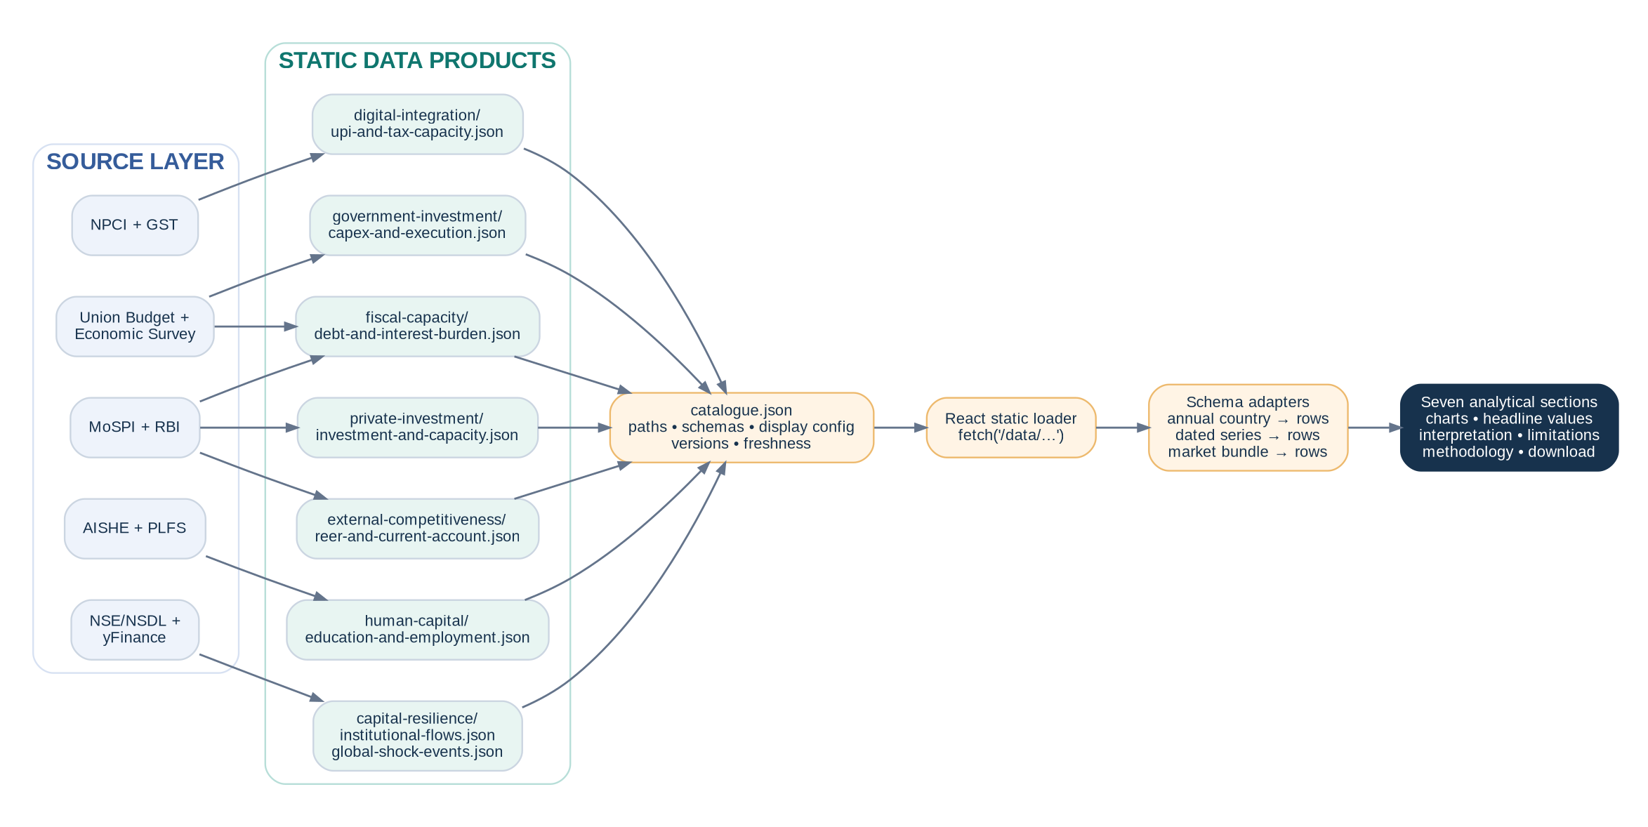
Figure 3. Official sources are converted into section-level static assets and loaded directly by the React frontend.

6.1 Public data layout
public/data/
catalogue.json
schemas/
annual_country_series.schema.json
dated_multi_series.schema.json
market_performance.schema.json
event_study.schema.json
digital-integration/
upi-and-tax-capacity.json
government-investment/
capex-and-execution.json
private-investment/
investment-and-capacity.json
fiscal-capacity/
debt-and-interest-burden.json
external-competitiveness/
reer-and-current-account.json
human-capital/
education-and-employment.json
capital-resilience/
institutional-flows.json
global-shock-events.json
equities/
market-performance.json

6.2 Standard section page
1. Research question and one-sentence thesis.
2. Two or three current headline values, including the latest observation date.
3. One primary chart with no more than three visible series by default.
4. One supporting chart, toggle or event-study view.
5. A short evidence-based interpretation that distinguishes observation from inference.
6. A visible limitations panel.
7. Source, methodology, frequency, data status and downloadable JSON.
Presentation rule
The frontend should not become a dense dashboard. One strong chart, one supporting view and a clear argument are more valuable than displaying every derived series at once.

7. Implementation roadmap
Phase | Main work | Exit condition
0. Scope lock | Freeze definitions, units, sources, frequency, start date, transformation and output key for every series. | Approved metric specification; no ambiguous terms such as “debt”, “CapEx” or “formal employment”.
1. Source feasibility | Download representative samples; test historical coverage, revisions, formats, stability and automation constraints. | Every section has at least one reproducible primary source.
2. Core extraction | Implement extractors in the order: UPI; DII/FPI; REER; CapEx/debt; education/employment; private investment. | Raw data is reproducibly fetched and normalised.
3. Transformations | Implement per-capita and GDP normalisation, YoY growth, rolling references, execution ratios, interest burdens, offset ratios and event windows. | Each derived series has tests and methodology text.
4. Build and validate | Build contract-shaped objects, run quality checks, validate schemas, export to staging and promote valid outputs. | All production JSON files validate and contain no duplicate periods.
5. Exploratory analysis | Plot every series; inspect breaks and revisions; choose windows; remove weak supporting lines. | Final chart specifications and analytical notes.
6. Frontend delivery | Implement one reusable section template, static catalogue, loaders, adapters, charts, caveats and data downloads. | Seven complete analytical pages using static JSON.
7. Interpretation and QA | Write section conclusions and an overall synthesis; verify calculations, sources, status labels and limitations. | Release-ready build with balanced conclusions.

7.1 Recommended build order
1. UPI and digital integration — regular monthly data and a clean first dated-series implementation.
2. DII/FPI continuous flows — reuses the existing market pipeline for contextual returns and drawdowns.
3. REER and current account — establishes RBI extraction and mixed monthly/quarterly handling.
4. Government CapEx and debt — shares fiscal source handling and fiscal-year status fields.
5. Human capital and employment — annual sources with clear methodology boundaries.
6. Private investment and capacity utilisation — conceptually crucial but likely the hardest series to align.
7. Global-shock event studies — only after continuous flows and market outcomes are stable.

7.2 Definition sheet required before coding
Field | Required content
Series key | Stable snake_case identifier used in JSON and frontend configuration.
Definition | Exact economic concept, population or institutional perimeter and sign convention.
Unit | Percentage points, decimal return, index, INR crore, USD, months, count per capita, etc.
Frequency | Daily, monthly, quarterly, annual or fiscal year.
Source and field | Provider, table/report and exact source column.
Transformation | Formula, denominator, rolling window, lag and treatment of missing observations.
Status | Actual, provisional, revised, estimate or budget.
Known limitation | The strongest reason the series may be misinterpreted.

8. Analytical and engineering guardrails

8.1 Analytical guardrails
- One primary question per section and one primary chart per question.
- No more than three visible series by default; secondary measures sit behind toggles.
- Do not claim causation from coincident trends. Use language such as “consistent with”, “associated with” and “suggests”.
- Keep estimates, revised figures and actual observations visibly distinct.
- Predefine event windows before examining DII/FPI outcomes to reduce cherry-picking.
- Normalise large nominal series by population, GDP, total spending, revenue or market capitalisation where appropriate.
- Every section must state its strongest caveat and any methodology break.

8.2 Engineering guardrails
- Extractors must never write directly into public/data.
- All derived fields carry is_derived=true and a methodology description.
- Reject NaN and infinite values before JSON serialisation.
- Use atomic writes and promote only files that pass both quality and schema validation.
- Run build-time checks that every catalogue path exists and every data file matches its declared schema.
- Preserve null observations as gaps; never silently convert missing data to zero.
- Version or cache-bust static assets when a pipeline publishes a new data vintage.

9. Final scope decision
The final project should consist of seven connected sections: digital integration, government investment, private investment, fiscal capacity, external competitiveness, human-capital conversion and domestic capital resilience. This is broad enough to test a meaningful thesis but narrow enough to support close analysis.
Recommended stopping point
Do not add new core topics unless one of the seven research questions cannot be answered. Household financialisation and infrastructure utilisation can remain optional supporting extensions rather than new sections.

The strongest overall conclusion will compare the evidence across mechanisms rather than score each chart independently. A plausible finding may be that India has developed strong digital and domestic financial infrastructure, while private-investment crowding-in, fiscal space, external competitiveness or employment conversion remain the binding tests of whether that progress becomes sustained productivity growth.
Immediate next action
Complete the definition sheet and source-feasibility sample for each of the seven sections before building further frontend components. This is the point at which scope should be frozen.

