SHANDA FUEL
Master Product & Engineering Blueprint
Implementation-ready logical specification • Version 1.2 • Wireframe Edition • Visual Edition
Prepared for the initial TEI Oils deployment and future multi-company commercial rollout
STATUS
Architecture, domain model, state machines, UX principles, visual wireframes, architecture diagrams, core workflows and V1 scope are frozen at logical-design level. Remaining real-world values such as tank capacities, bank accounts, supplier/customer masters and opening balances are onboarding data, not development blockers.

Business timezone: CAT / Africa/Harare • V1 currency: USD • Default shift duration: 8 hours, configurable

0. Document Control
Visual coverage in v1.2: eight architecture/process diagrams, 15 wireframe flow boards and 38 mapped V1 screens are embedded in the blueprint; the standalone V1 Wireframe Pack is the primary UX review artifact.
Field | Value
Document | Shanda Fuel Master Product & Engineering Blueprint
Version | 1.2
Product domain | fuel.shandahr.com
Product family | Shanda Fuel by ShandaHR
Initial operating customer | TEI Oils / Triumph Energy working identity; legal spelling to be verified at onboarding
Business timezone | CAT; stored/configured technically as Africa/Harare
V1 currency | USD
Shift default | 8 hours; station-configurable effective-dated templates
History migration | No broad historical migration. Approved opening positions plus selective useful recent history only.
Build style | Single-developer-friendly modular monolith with strict domain boundaries
Logical design status | Locked; changes require explicit architecture review

0.1 Source Basis
This blueprint consolidates the client requirements summary, the locked design rounds and architecture audits, the TEI/Triumph Energy resources supplied in the project, confirmed operating assumptions, the discovery/setup workbook, and the forms we have authored for the new system.
- Primary client requirement: replace handwritten daily reconciliation and management Excel re-entry with one connected system in which stock, sales, cash, creditors, customers, profitability and reporting update from the same underlying transactions.
- Client-provided working location seed: Sandawana, Hwange, Bindura, Makaha, Kwekwe, Kadoma, Gweru, Harare, Mutare, Masvingo and Bulawayo. Each location type and production status is confirmed during onboarding rather than blocking development.
- The client expects us to learn the operating process and create the recommended forms/workflows. Missing operational master data is therefore collected through onboarding forms rather than treated as a design blocker.

0.2 Decision Hierarchy
Priority | Decision source
1 | Confirmed client operating facts and legal/accounting sign-off
2 | Client-provided business requirements and resources
3 | Locked Shanda Fuel integrity, security and accounting invariants
4 | Recommended product defaults where no company-specific fact exists
5 | Pilot tuning for thresholds and operating convenience

0.3 “Do Not Reopen Casually” Decisions
- Multi-company SaaS and strict tenant isolation from day one.
- Separate Shanda Fuel operational database/project; future ShandaHR integration only through explicit APIs/identity integration.
- Modular monolith rather than microservices for V1 and early commercial scale.
- Authoritative balances derive from immutable domain movements, not editable balance fields or dashboard totals.
- Meter-derived quantity is canonical for ordinary forecourt sales; customer credit/prepaid/benefit records classify those sales rather than duplicating litres.
- Cash custody, bank money and provider settlement balances are separate domains.
- Supplier invoice quantity/commercial claim cannot rewrite physical delivery quantity.
- Tank dips are physical observations and do not silently adjust book inventory.
- Posted/locked business facts are corrected through reversal, compensation or approved adjustment rather than delete/edit.

1. Executive Product Definition
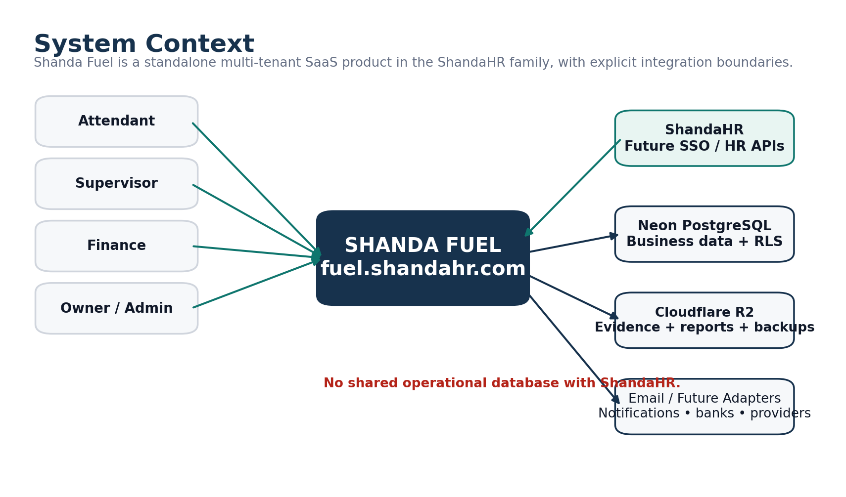
Figure 1. System context and external boundaries.
Shanda Fuel is a mobile-first service-station operations, reconciliation and management platform designed initially for TEI Oils and architected for commercial use by fuel-station businesses across Zimbabwe and Africa. The product connects the physical forecourt to inventory, cash custody, electronic settlements, suppliers, customer accounts, expenses, profitability, approvals, evidence and management reporting.
PRODUCT PROMISE
Enter operational information once, preserve physical and financial truth separately where necessary, approve it through explicit workflows, and use the same authoritative data for stock, cash, creditor/debtor, profitability and management reporting.

1.1 Business Outcomes
Outcome | How Shanda Fuel achieves it
Remove paper-to-Excel duplication | Guided mobile workflows feed the same database used by management reports and exports.
Improve daily control | Meter, payment, cash, tank and delivery variances are calculated automatically and surfaced exception-first.
Know where money is | Cash custody follows station → transit/collector → deposit pending → bank confirmation; POS/EcoCash stays separate until settlement.
Know true stock and cost | Inventory pool ledger records receipt, sale, transfer, adjustment and revaluation quantities/values with moving WAC.
Control credit and suppliers | Supplier and customer ledgers, allocations, aging, limits and approvals are explicit.
Get trustworthy profit | Revenue, COGS, operating expenses and fixed-cost recognition come from canonical movements and calculation logic.
Prepare for scale | Tenant-aware schema, granular permissions, reproducible reports, jobs, audit and onboarding are designed from day one.

1.2 Product Principles
- Simple by default. Powerful when needed. Explicit when risky.
- Physical occurrence, commercial paperwork and financial recognition may happen at different times; none is silently erased to make numbers look neat.
- One dominant action per screen where practical; normal matching data stays quiet and exceptions get attention.
- Official state changes occur through named commands and state machines, never arbitrary status updates.
- The owner has highest business authority but is not an integrity/security bypass.

1.3 V1 Scope
Area | V1 coverage
Access & setup | Tenant, legal entity, stations, users, roles, permissions, products, shifts, pumps/nozzles/meters, tanks, prices and payment channels
Forecourt | Business day, shift, opening/closing meter boundaries, attendant handover, meter segments and expected sales
Reconciliation | Attendant declarations, supervisor reconciliation, variance explanations, management approval, posting and lock
Inventory | Inventory pools, deliveries, dips/calibration, WAC costing, adjustments, transfers structure, revaluation
Money | Cash custody/counts/handovers/collections/deposits, bank tracking, POS/EcoCash/provider settlement
Suppliers | Invoices, due dates, unbilled exposure, credit notes, payments, allocations, aging/statements
Customers | Credit, prepaid value, prepaid litres, benefit, vehicle/driver controls, authorizations, payments, billing
Expenses | Daily expense workflows, cash/bank/payable effects, recurring/fixed cost recognition
Management | Profitability, operational financial position, Action Center, curated reports, PDF/XLSX exports, audit

1.4 Explicit V1 Non-Goals
- No full general ledger or statutory accounting suite.
- No invented tax engine before accountant confirmation of applicable treatment and invoice requirements.
- No microservices, event-bus platform or premature warehouse/BI stack.
- No unrestricted offline financial posting; offline support is for limited drafts only.
- No OCR/AI posting of receipts/invoices in V1; upload + manual structured entry is safer and cheaper.
- No direct bank integration required for V1; bank confirmation can be manual and auditable.

2. Users, Roles & Experience

2.1 Role Model
Role | Primary responsibility | Default scope
Owner | Business authority, high-risk approvals, company-wide management and configuration | Tenant / legal entity
Administrator | Operational administration, users/configuration according to granted permissions | Tenant / legal entity / station
Finance | Suppliers, deposits, settlements, customers, expenses and financial reporting | Tenant / legal entity
Supervisor | Operate station day/shift, meters, deliveries, dips, cash, expenses and reconciliation submission | Station
Attendant | Assigned shift/nozzle work, account fuel and payment declaration | Station / shift / nozzle

2.2 Permission Architecture
Role names are convenience templates; granular permission codes and scope are authoritative. A user may hold different scoped roles in different stations or legal entities. Temporary elevated grants are expiring and audited.
Tenant Membership
├─ Role Assignment (TENANT / LEGAL_ENTITY / STATION)
├─ Role → Permission Codes
└─ Temporary Permission Grant (scoped + expires)

- Self-approval is prohibited by default.
- Sensitive exports have separate view/export permissions.
- Owner/Admin/Finance/Supervisor strong authentication is required by default; final rollout practicality can be tuned without weakening core controls.
- Users are disabled, not deleted, after they have business history.

2.3 Navigation & Device Strategy
Experience | Primary navigation | Design emphasis
Attendant mobile | Home / Tasks / Work / More | Fast, minimal, assignment-focused; no management complexity
Supervisor mobile/tablet | Today / Tasks / Work / More | Station operations, progress, exceptions, sticky next action
Finance desktop/tablet | Sidebar + Action Center | Queue processing, allocations, reconciliation, drill-down and exports
Owner desktop/mobile | Business health + approvals | Exception-first overview, consequence-aware approvals, explainable metrics

2.4 UX Invariants
- Mobile operational workflows are first-class; desktop is not simply shrunk onto a phone.
- No giant Excel-style daily form in the app. Complex processes are broken into real operational steps.
- At least 44px-equivalent touch targets; persistent labels; tabular numerals for financial values; status never conveyed by colour alone.
- Posted records display View / Audit / Request Reversal, not normal Edit / Delete.
- Authoritative actions only show success after server confirmation.
- Weak connection state and local drafts are truthful and visible.

2.5 Critical User Journeys
Journey | Happy path
Supervisor day | Open business day → start shift → confirm meters/team → operate/deliver/expense/cash → meter close → complete operations → reconcile exceptions → submit
Attendant | View assignment → record authorized account fuel when needed → submit payment declaration → hand over nozzle if needed
Finance | Review Action Center → record/approve creditor/customer/bank/provider work → resolve exceptions → export/report
Owner | Open business health → review high-severity items → inspect consequences/evidence → approve/return → review cash/stock/profit

2.6 V1 Mid-Fidelity Wireframes
The previous conceptual UI gallery has been replaced. The screens below are mid-fidelity wireframes showing actual navigation, field hierarchy, primary actions, exception states and role-specific behavior. The complete embedded pack is in Appendix F; the standalone Wireframe Pack v1.2 is the easiest UX review artifact.
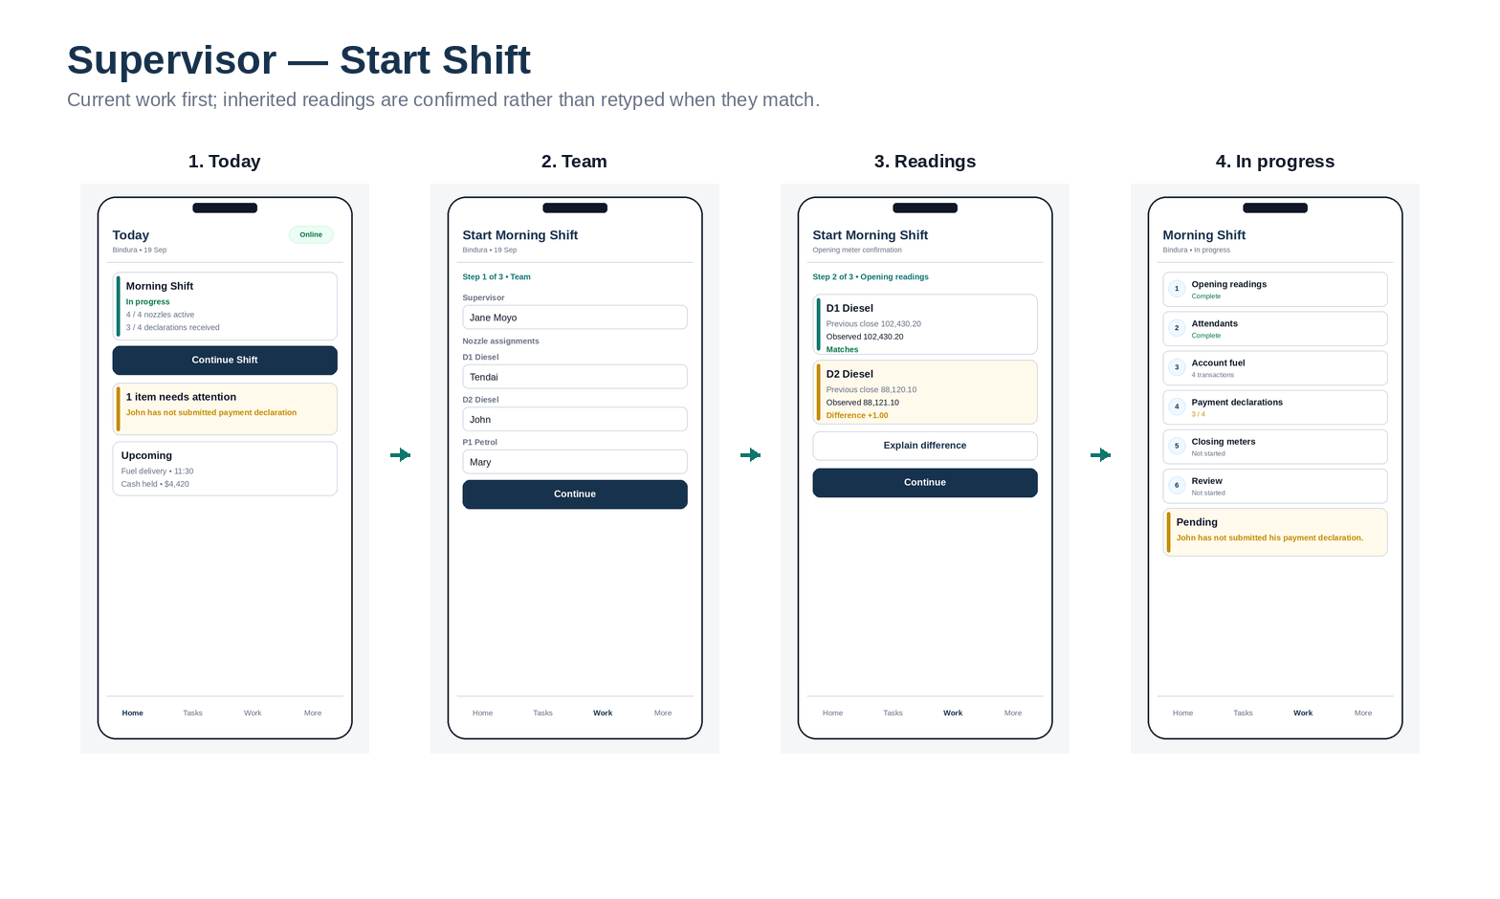
Supervisor start-shift flow.
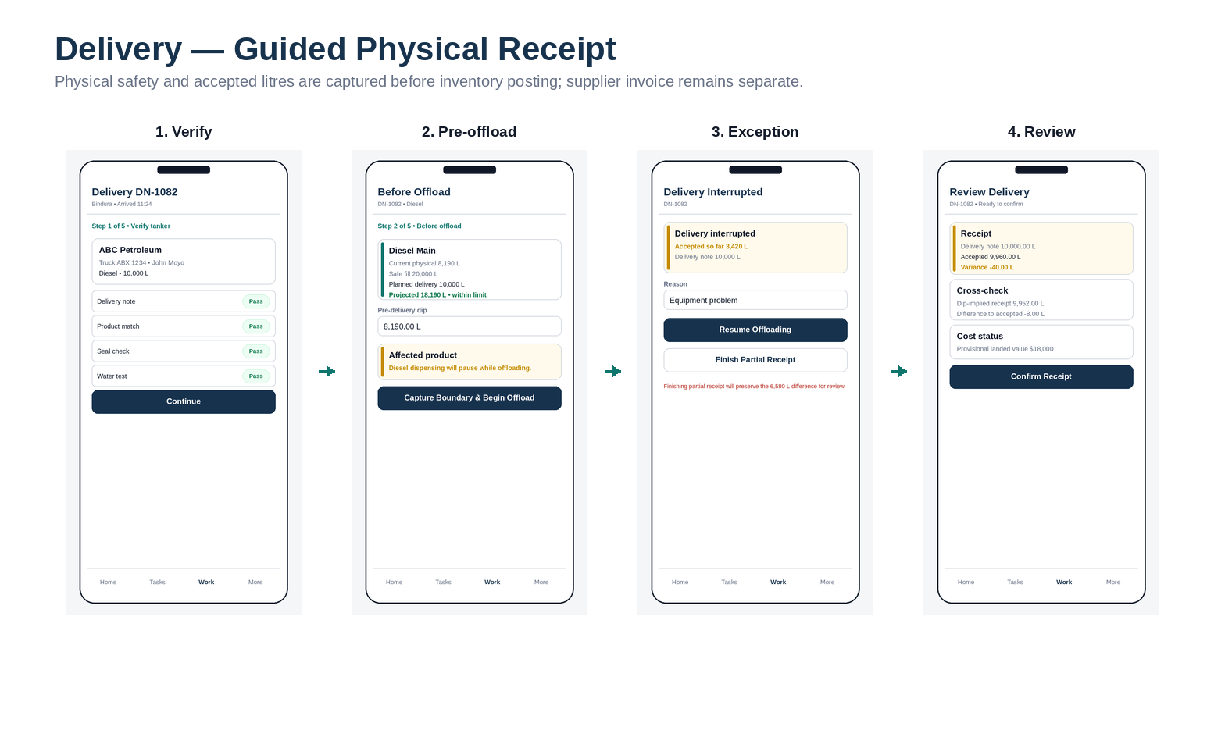
Guided delivery receipt flow.
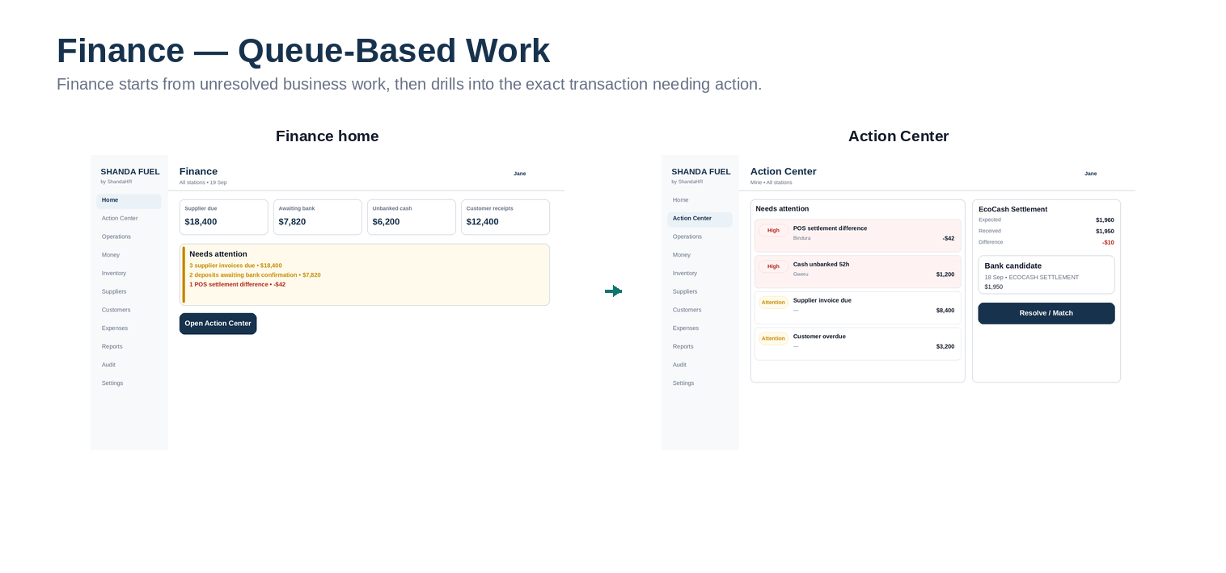
Finance queue-based desktop workflow.

3. Operating Model & Master Data

3.1 Hierarchy
PLATFORM
└─ TENANT
└─ LEGAL ENTITY
└─ STATION
├─ Business Days / Shifts
├─ Pumps / Nozzles / Meter Installations
├─ Tanks / Calibration / Dips
├─ Inventory Pools
├─ Cash Locations
└─ Payment Channels

The system is multi-company from day one. Tenant-owned tables carry tenant_id and tenant-aware foreign keys; application authorization is backed by PostgreSQL row-level security.

3.2 Confirmed / Recommended Operating Defaults
Setting | Current blueprint value | Change method
Business timezone | CAT; technical IANA zone Africa/Harare | Tenant/station configuration
Currency | USD for V1 | Currency-aware schema supports future additions
Products | Diesel and Petrol seeded | Configurable product master
Shift length | 8 hours by default | Effective-dated station shift templates
Shift clock times | Starter 00:00–08:00 / 08:00–16:00 / 16:00–00:00 only; not assumed TEI reality | Set during station onboarding
History migration | No broad migration | Opening positions + selective useful recent closed history
Cash unbanked warning | 24h warning / 48h urgent pilot default | Effective policy configuration
Manual bank confirmation | Enabled in V1 | Future integration adapter

3.3 Working Location Seed
The following locations are seeded from the client-provided Triumph Energy resource. The software does not assume every entry is a retail station until onboarding confirms its type and active status.
Location | Onboarding status
Sandawana | Type / active state to confirm; eligible pilot candidate
Hwange | Type / active state to confirm; eligible pilot candidate
Bindura | Type / active state to confirm; eligible pilot candidate
Makaha | Type / active state to confirm; eligible pilot candidate
Kwekwe | Type / active state to confirm; eligible pilot candidate
Kadoma | Type / active state to confirm; eligible pilot candidate
Gweru | Type / active state to confirm; eligible pilot candidate
Harare | Type / active state to confirm; eligible pilot candidate
Mutare | Type / active state to confirm; eligible pilot candidate
Masvingo | Type / active state to confirm; eligible pilot candidate
Bulawayo | Type / active state to confirm; eligible pilot candidate

3.4 Effective-Dated Configuration
Critical configuration is versioned and effective-dated so that current settings never rewrite history. Examples include selling prices, shift templates, tank/nozzle configuration, calibration charts, customer account policies, supplier terms, recurring costs, approval policies and station cash floats.
RULE
Configuration may make workflows more or less strict, but it cannot disable tenant isolation, ledger conservation, immutable posting, authorization checks, or other integrity invariants.

4. Source-of-Truth & Financial Integrity Model

4.1 Four Layers of Truth
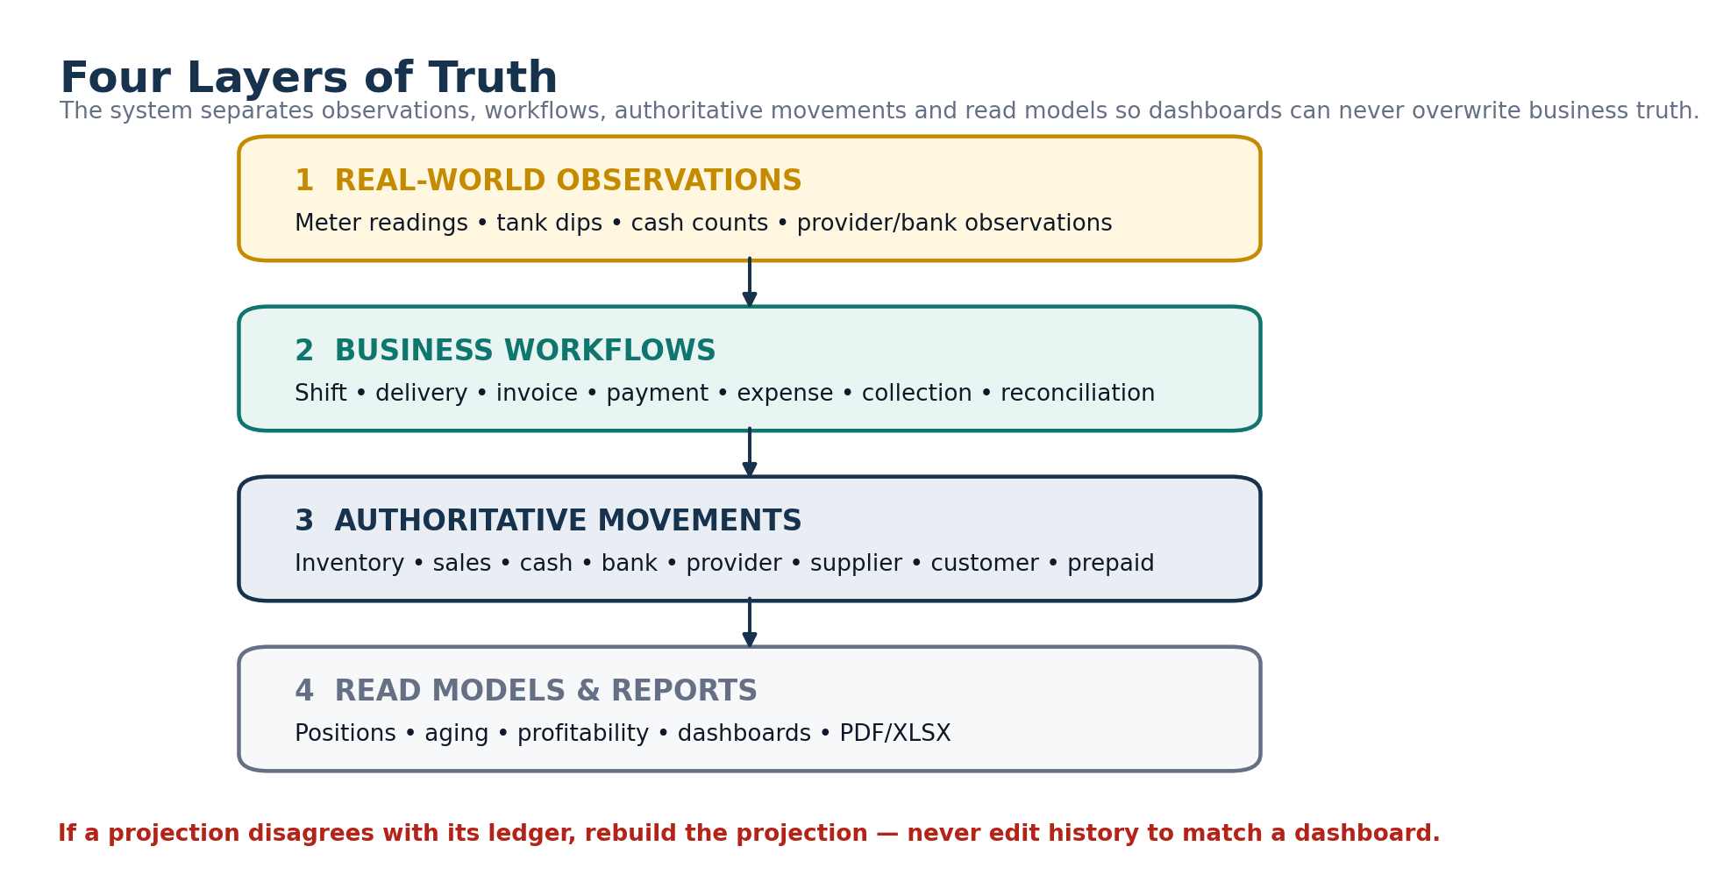
Figure 2. Four layers of truth: observations, workflows, authoritative movements, and read models.
Layer | Examples | Rule
Physical observations | Meter reading, tank dip, cash count, provider/bank observation | Record what was observed; do not automatically rewrite financial/book truth.
Business workflows | Shift, delivery, invoice, payment, expense, collection, reconciliation | Represent authorization and state progression.
Authoritative movements | Inventory, sales recognition, cash, bank, provider, supplier, customer/prepaid ledgers | Immutable after posting; corrections are compensating movements.
Projections & reports | Stock position, cash position, aging, profitability, Action Center | Rebuildable; never override authoritative history.

4.2 Canonical Ledgers
Domain | Authoritative movement source | Projection / report examples
Inventory | inventory_movement + inventory_revaluation | Inventory pool state, stock reports, COGS
Official revenue | sale_recognition_movement | Revenue/profitability
Physical cash | cash_movement | Cash position / custody aging
Tracked bank money | bank_movement | Tracked bank position
Electronic provider | provider_account_movement | Provider outstanding / settlement
Supplier creditor | supplier_account_movement | Payables, aging, statements
Customer credit | customer_credit_movement | Receivables, exposure, aging
Prepaid value | prepaid_value_movement | Available prepaid value
Prepaid litres | prepaid_litre_movement | Product-specific litre balance
Expenses | posted expense + recurring recognition | Operating/fixed cost reporting

4.3 Universal Conservation Rules
- Internal cash transfer movements sum to zero across source/transit/destination/dispute custody.
- A customer fuel transaction cannot claim more ordinary forecourt fuel than supported by meter segments within the relevant operational scope.
- Payment/credit allocations cannot exceed the source payment/credit capacity.
- Prepaid balances do not silently go below zero.
- Inventory quantity cannot go negative through normal operational commands.
- Provider outstanding equals sales receivable minus refunds/reversals/fees/settlements plus approved adjustments.
- Recurring-cost payment settles an obligation; it does not create another expense recognition.

4.4 Time Model
Field / concept | Meaning
business_date | Operational reporting date, independent of UTC timestamp. Overnight shift belongs to its start date.
effective_at | When an economic/operational fact applies.
posted_at | When Shanda officially recognized/posted that fact.
as_of | Report cutoff for what had been posted/known by a specific time.

Official historical reports use period/effective criteria plus posted_at <= as_of, allowing later corrections/restatements without silently altering what a prior report represented.

5. Forecourt, Shift & Meter Operations

5.1 Station Business Day
NOT_STARTED
└─ OpenBusinessDay → OPEN
OPEN
├─ MarkOperationsComplete → OPERATIONS_COMPLETE → FinalizeOperations → CLOSED
└─ ExceptionalCloseBusinessDay → EXCEPTIONALLY_CLOSED

Multiple unfinished business days may exist if operations span administrative boundaries, but physical nozzle exclusivity is enforced so two active processes cannot own the same nozzle at the same time.

5.2 Shift State Machine
PLANNED
├─ StartShift → OPEN
├─ MarkNotOperated → NOT_OPERATED
└─ CancelBeforeStart → CANCELLED_BEFORE_START
OPEN
├─ CloseMeters → METER_CLOSED → CompleteShift → COMPLETED
└─ ExceptionalClose → EXCEPTIONALLY_CLOSED

5.3 Meter Boundaries & Segments
One generalized boundary system handles shift open/close, attendant handover, price change, delivery, meter reset/replacement and correction. A meter segment is the interval between two confirmed boundaries under one price/configuration/attendant context.
Boundary reason | Effect
SHIFT_OPEN / SHIFT_CLOSE | Defines shift meter responsibility
ATTENDANT_HANDOVER | Ends one attendant assignment and begins the next at the same physical reading
PRICE_CHANGE | Closes old-price segment before new price activates
DELIVERY | Creates a clean chronology boundary around inventory receipt/WAC change where dispensing is paused
METER_RESET / REPLACEMENT | Prevents false negative litres while preserving physical device history
CORRECTION | Controlled pre-lock correction; after lock a compensating correction event is used

5.4 Forecourt Calculation Rules
Calculation | Rule
Litres sold | Confirmed end meter reading - confirmed start meter reading, except controlled reset/replacement paths
Expected sale value | Segment litres × effective station/product selling price version
Operational inventory issue | Created when the meter segment is sealed so stock chronology remains correct
Financial revenue posting | Created later when the approved daily reconciliation posts; inventory is not consumed twice

5.5 Price Change
DRAFT → PENDING_APPROVAL → APPROVED → SCHEDULED
→ PENDING_STATION_ACTIVATION → BOUNDARIES_IN_PROGRESS → ACTIVE
\-- FAILED_ACTIVATION / CANCELLED

During an active shift, the old server-confirmed price remains authoritative until all required affected-nozzle boundaries are captured and the server activates the new price.

6. Daily Reconciliation & Official Sales Posting

6.1 Purpose
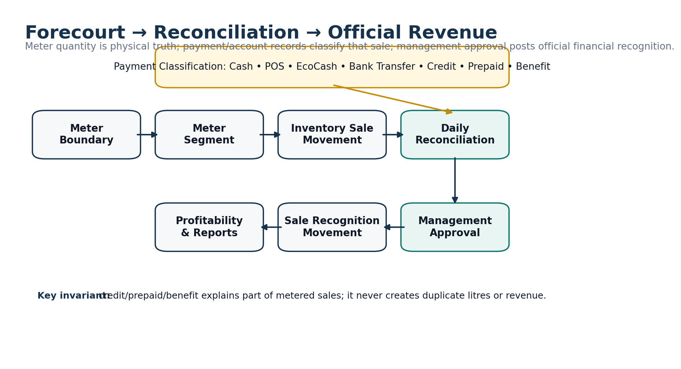
Figure 3. Forecourt quantity and payment classification flow into approved official revenue recognition.
Daily reconciliation converts the physical forecourt and operational declarations into an approved financial classification of the business day. The supervisor does not re-enter all information; the system builds the reconciliation from accepted meter segments, declarations and explicit customer/payment transactions and emphasizes only differences or missing items.

6.2 Reconciliation State Machine
DRAFT → READY → SUBMITTED → PENDING_APPROVAL
├─ Return → RETURNED → corrected READY → new revision
├─ Reject → REJECTED
└─ Approve → APPROVED → POSTED → LOCKED

Each submission creates an immutable reconciliation revision. Approval applies to one exact revision; edits or resubmission supersede the old approval request.

6.3 Payment Classification
Component | Source
Cash | Accepted cash declarations and known system cash transactions
POS / EcoCash / electronic | Accepted declaration + payment channel/provider records
Bank transfer | Explicit electronic/bank-classified sale records
Customer credit | Customer fuel transaction linked to account authorization and meter context
Prepaid value | Customer fuel transaction + prepaid value draw
Prepaid litres | Customer fuel transaction + product-specific litre draw
Benefit / internal | Fuel transaction classified as benefit/internal use with reconciliation value

6.4 Variance
CANONICAL INTERPRETATION
Reconciliation variance = accounted/classified sale value - meter-derived expected sale value. Threshold policy determines whether the difference is informational, requires explanation, or blocks normal submission/approval.

6.5 Sale Recognition
When reconciliation posts, Shanda creates official sale_recognition movements by meter segment and classification. Customer account fuel is not added on top of meter sales; it explains which portion of the meter-derived value was credit, prepaid, benefit or other classification.
Stored value | Reason
quantity_litres | Trace official financial classification back to physical fuel
reconciliation_value | Value needed to make station fuel accountability balance
recognized_revenue_amount | Actual financial revenue classification; may differ for internal/benefit fuel

7. Inventory, Tanks, Deliveries & Costing

7.1 Physical Tank vs Book Inventory
Concept | Authoritative source
Physical volume estimate | Tank dip converted using the exact effective calibration version
Book quantity/value | Inventory pool movement ledger
Available stock | Book stock adjusted for quarantine/reservations as applicable; physical overage never increases official stock automatically
Variance | Physical estimate - book quantity; becomes an exception until resolved/adjusted

7.2 Inventory Pool Model
Book stock is held at Inventory Pool/Supply Group level rather than blindly by tank because manifolded tanks can feed the same product/nozzles. Tanks preserve physical observations; pools preserve book quantity/value and moving WAC.

7.3 Delivery State Machine
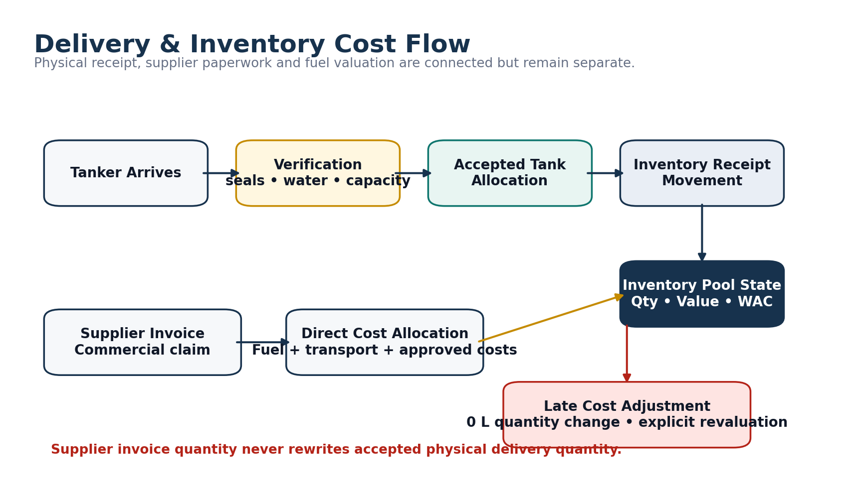
Figure 4. Physical delivery, inventory posting, supplier cost allocation and late-cost revaluation.
DRAFT → ARRIVED → VERIFICATION → OFFLOADING
├─ OFFLOADING_INTERRUPTED → resume / partial receipt
└─ RECEIVED_PENDING_CONFIRMATION → CONFIRMED → POSTED
Pre-offload failure → REJECTED Unstarted → CANCELLED Posted correction → reversal workflow

7.4 Delivery Invariants
- Physical accepted quantity is derived from accepted tank allocations at the lowest meaningful level, not from the supplier invoice.
- Delivery-note quantity remains the commercial claim and is compared with actual accepted quantity; shortage/excess is never hidden.
- Pre/post dip, seal, water test and capacity checks are structured verification facts; policy decides which are mandatory.
- Default V1 operating mode pauses affected product dispensing during offload where operationally possible, giving clean cost chronology.
- Wrong-product/unsafe receipt quarantines affected stock rather than pretending the delivery did not occur.

7.5 Moving Weighted Average Cost
Receipts add quantity and landed value to the inventory pool. The new WAC is computed transactionally from existing pool value/quantity plus the receipt. Selling price is entirely separate from cost.
Case | Treatment
Normal receipt | + quantity, + landed value; WAC recalculates
Sale | - quantity, - value at chronological WAC snapshot
Late transport/direct cost | 0 quantity revaluation plus split between remaining inventory and previously consumed COGS
Transfer | Source WAC carried to destination; approved direct transfer cost added explicitly
Stock adjustment | Approved signed movement with reason; normal negative stock prohibited

8. Suppliers, Customers & Expenses

8.1 Supplier / Creditor Model
Physical delivery, supplier invoice, supplier account movement and supplier payment are separate objects. This prevents commercial paperwork from rewriting physical stock and supports unbilled fuel exposure when fuel arrives before the invoice.
Capability | Design
Supplier invoices | Versioned workflow with due date/terms snapshot, duplicate control and supporting documents
Unbilled exposure | Posted delivery quantity/value not yet covered by posted supplier invoice allocations
Payments | Many-to-many payment ↔ invoice allocations; partial payments and unapplied prepayments supported
Credit notes | Append-only commercial reduction; paid invoices can result in unapplied supplier credit rather than negative invoice balance
Statements / aging | Movement/allocation-derived as-of reporting

8.2 Customer Account Types
Type | Canonical balance / control
CREDIT | Receivable ledger + credit limit + reservations + billing mode/terms
PREPAID_VALUE | Currency-denominated stored value; no silent negative balance
PREPAID_LITRES | Product-specific litre balance keyed by account + product
BENEFIT | Allowance/classification policy for approved non-cash/internal fuel

8.3 Customer Fuel Authorization
REQUESTED → AUTHORIZED / RESERVED → PARTIALLY_USED → COMPLETED
├─ CANCELLED
└─ EXPIRED
Policy failure → REJECTED Limit override → explicit approval request before over-limit reservation

Reservations lock exposure/prepaid capacity transactionally so two attendants cannot both spend the same remaining credit or prepaid balance.

8.4 Billing & Payments
- Credit fuel creates receivable immediately; billing documents can be immediate/daily/weekly/monthly without creating the debt twice.
- Customer payments may allocate across invoices; excess remains explicit unapplied credit unless refunded.
- Cash customer payment atomically reduces receivable and increases physical cash custody.
- Customer-specific pricing, station/product/vehicle/driver restrictions and policy versions are snapshotted for historical explainability.

8.5 Expenses & Recurring Costs
Area | Rule
Daily expense | Economic expense document plus separate settlement source (cash/bank/payable/reimbursement)
Cash paid before approval | Cash movement remains physical truth even if later expense approval fails; a resolution exception handles the business problem
Direct inventory cost | Classified separately so landed cost is not deducted twice as operating expense
Recurring fixed cost | Template → period obligation → daily recognition → payment allocation
Payroll future integration | ShandaHR remains authoritative; Fuel receives explicit API data and prevents duplicate manual recognition

9. Cash, Banking & Electronic Settlements

9.1 Cash Custody
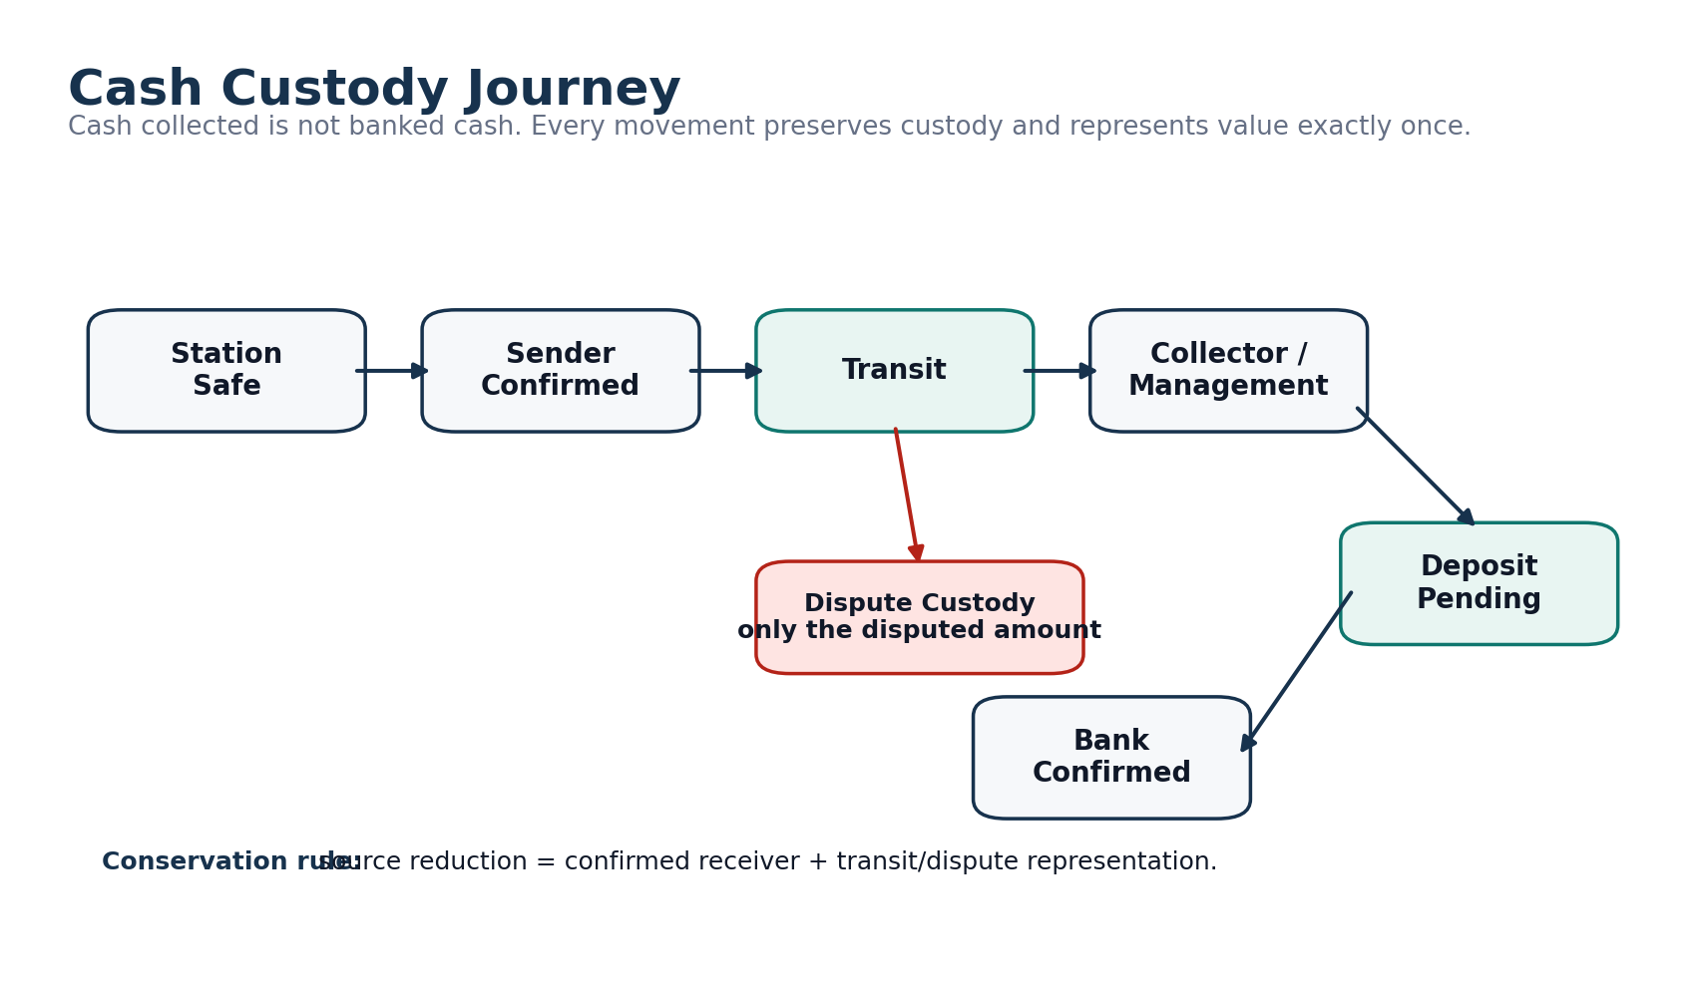
Figure 5. Cash custody from station safe to bank confirmation, including transit and dispute custody.
Physical cash is tracked by location, custodian and currency. Internal handovers conserve value and use explicit transit/dispute custody so the same cash is never simultaneously counted at two locations.
Station Safe
└─ Sender confirmation → Handover Transit
├─ Receiver agrees → Collector / Management Custody
└─ Receiver differs → Acknowledged Custody + Dispute Custody
└─ Deposit Recorded → Deposit Pending → Bank Confirmed

9.2 Expected Physical Cash
FORMULA
Expected physical cash = opening physical cash + cash receipts - cash disbursements - confirmed collections ± approved cash adjustments. “Cash sales” and “cash receipts” are not interchangeable because customer debt payments/prepaid top-ups can add cash without being same-day fuel sales.

9.3 Banking
- Bank account master data is sensitive; high-risk changes require step-up authentication and approval.
- A recorded deposit is not automatically confirmed bank money. Deposit pending and bank-confirmed stages are separate.
- V1 can use manual bank confirmation by Finance/Owner. Future statement adapters fit the existing model without changing cash custody logic.
- Tracked bank balance is only as complete as imported/confirmed bank movements; reports disclose completeness rather than claiming a true bank statement balance without evidence.

9.4 POS / EcoCash / Provider Settlement
Station Declaration
→ Provider Receivable
→ Provider Batch / Statement
→ Fees / refunds / reversals
→ Settlement
→ Bank Receipt
→ Difference? resolve via exception, not station-shortage rewrite

Metric | Definition
Expected net settlement | Gross provider sales - refunds/reversals - provider charges
Settlement variance | Actual bank settlement - expected net settlement
Provider fee | Expense + provider account reduction; never unexplained cash/sales shortage

10. Profitability, Operational Position & Reporting

10.1 Profitability
Metric | Canonical source / formula
Revenue | Posted sale recognition movements
COGS | Inventory sale movement value plus explicit later COGS revaluations
Gross Profit | Revenue - COGS
Gross Profit / L | Gross Profit ÷ applicable litres
Operating Expenses | Posted operating expense recognition
Fixed-cost allocation | Recurring cost daily recognition
Operational Profit | Gross Profit - operating expenses - fixed-cost recognition

BOUNDARY
Operational Profit is a management measure, not statutory net profit. Tax, financing, depreciation and a full general ledger are outside the confirmed V1 scope unless explicitly added later.

10.2 Shanda Operational Net Position
Assets / exposures | Liabilities / obligations
Physical cash custody | Supplier payable
Tracked bank money | Approved unbilled supplier exposure
Electronic provider receivables | Operating/unpaid expense obligations
Customer receivables | Customer prepaid-value obligation
Inventory value | Prepaid-litre estimated exposure / obligation presentation

This is explicitly labeled “Shanda Operational Net Position”, not a statutory balance sheet.

10.3 Reporting States
State | Meaning
LIVE / ESTIMATED | Current operational data including pending/provisional components, visibly labeled
POSTED | Official posted data only
RESTATED | Later approved adjustments/revaluations changed the as-of result; prior report artifacts remain intact

10.4 Curated Report Catalogue
Category | Initial reports
Operations | Daily Reconciliation, Shift Sales, sales by station/product/attendant/payment
Inventory | Stock Position, Movement History, Tank Dip History, Stock Variance, Delivery Variance
Money | Cash Custody, Collections/Banking, POS/EcoCash Settlement
Commercial | Supplier Aging/Statement/Payments, Customer Aging/Statement/Payments
Financial | Daily/Station Profitability, Operational Financial Position, expenses/fixed-cost views

10.5 Export Integrity
- Dashboard, PDF and XLSX use the same canonical calculation layer.
- Report Run stores period, as_of, filters, calculation version, data-quality status and source cutoff/checksum.
- Report Artifact is separate from Report Run; multiple PDF/XLSX artifacts may belong to one run.
- Large exports are background jobs in private storage with short-lived download links and authorization rechecks at request, generation and download.

11. Approvals, Exceptions, Documents & Audit

11.1 Approval Engine
Approval policy is effective-dated and snapshotted at submission. Current security authority is not snapshotted; it is always rechecked when a user attempts to approve.
Concept | Rule
Approval Request | Links to exact business record version
Approval Step | Required permission, scope and approver count
Decision | Approve / Reject / Return for Correction with actor/time/scope snapshot
Superseded | If source record changes, pending old approval becomes SUPERSEDED and cannot be reused
Single Authority Mode | Audited configurable exception for genuine one-owner situations, never a generic bypass

11.2 Recommended Pilot Approval Defaults
Domain | Recommended default
Daily reconciliation | Supervisor submits; Owner/authorized management approves. Self-approval off.
Supplier payment | Management approval always; step-up at USD 5,000; second approver target at USD 20,000 when organizationally possible.
Station expense | Policy-based; pilot step-up at USD 250, second approval target at USD 1,000; category rules can be stricter.
Inventory adjustment | Management approval; step-up from material litre/value threshold.
Customer limit override | Always explicit management approval.
Price / bank-account change / reversal | High-risk approval with step-up and audit.

These thresholds are configuration and pilot defaults, not hard-coded accounting truth. Tune from real TEI volumes after observing the pilot.

11.3 Exceptions & Action Center
Business exceptions record unresolved conditions such as cash shortage, delivery variance, provider settlement difference, low stock, overdue invoices and missing evidence. The Action Center is a rebuildable projection that prioritizes approvals/exceptions/tasks but never becomes financial source-of-truth.

11.4 Documents
- Private object storage; documents are versioned and never overwritten in place.
- Upload lifecycle: pending → uploaded/unverified → server verification → available / rejected / quarantined.
- Verification checks object identity, file size, MIME/magic bytes, checksum and tenant/document relationship.
- Required evidence only accepts verified AVAILABLE document versions.

11.5 Tamper-Evident Audit
- Every consequential command appends an audit event with actor, command, resource, before/after state where appropriate, reason, timestamp and request ID.
- Audit events are independently signed/HMACed with key version identifiers rather than creating one global sequential hash bottleneck.
- Periodic per-tenant signed root/Merkle checkpoints are exported to retention-protected private storage so later tampering becomes detectable.
- Security events are separate from business audit and cover login/MFA failures, recovery, elevation, cross-tenant denial, sensitive exports and break-glass access.

12. Security, Privacy & Tenant Isolation

12.1 Defense in Depth
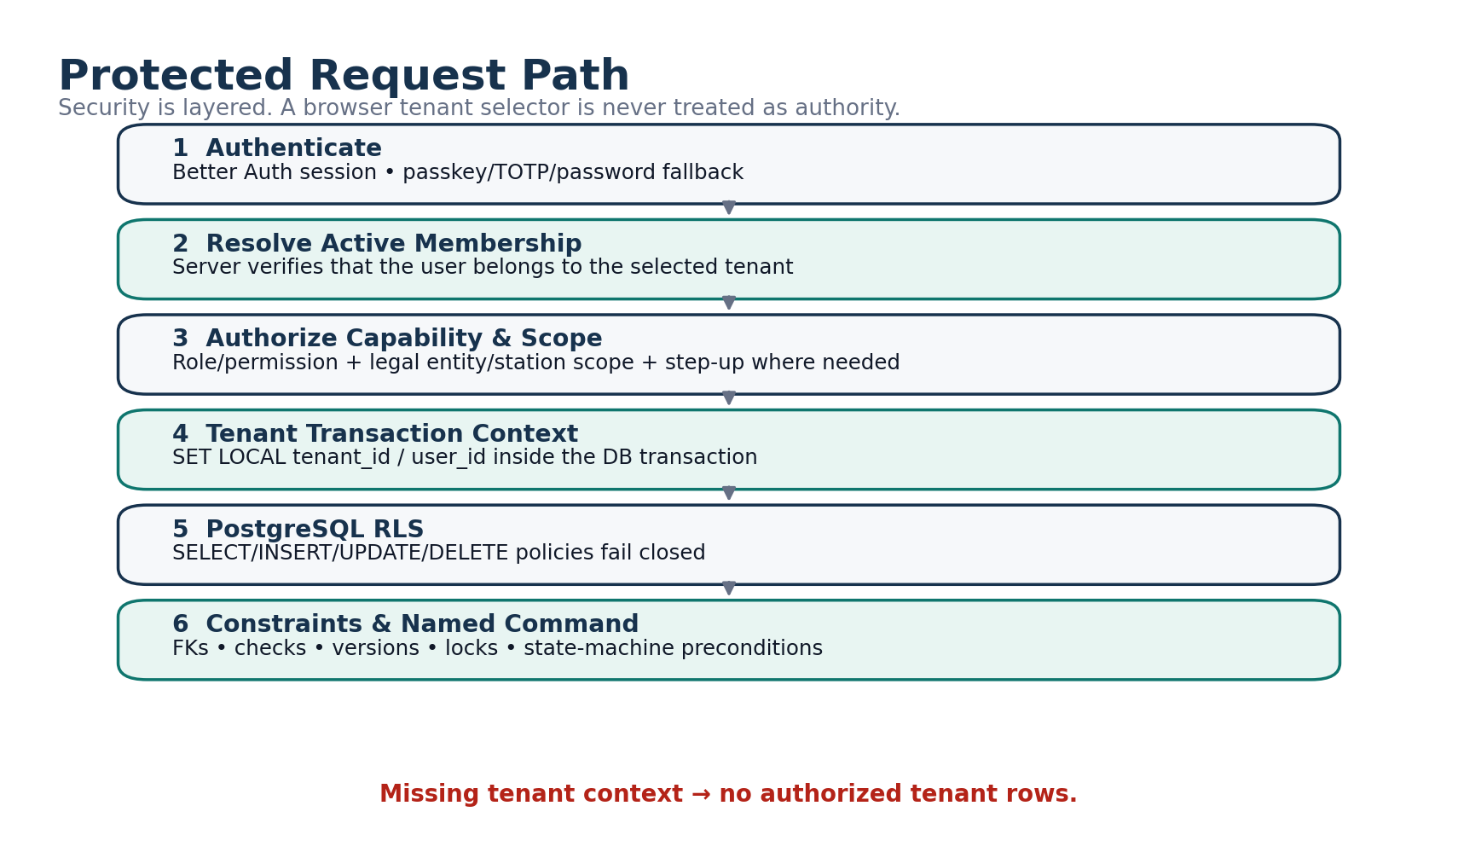
Figure 6. Protected request path from authentication through authorization, tenant context, RLS and database constraints.
WAF / TLS / rate limits
→ Better Auth session
→ Active tenant membership validation
→ Permission + scope authorization
→ Tenant DB transaction context
→ PostgreSQL RLS
→ composite tenant-aware FKs + CHECK/UNIQUE/exclusion constraints
→ domain ledgers + audit

12.2 Authentication
- Better Auth identity/session layer; Shanda owns tenant membership and business authorization.
- Passkey preferred; password + TOTP fallback; no SMS dependency initially.
- Strong authentication required for Owner/Admin/Finance/Supervisor by default.
- High-risk step-up sessions are short-lived; two step-up levels may be used for very sensitive actions.
- Disabling membership revokes sessions, grants and outstanding access while retaining historical identity.

12.3 Database Isolation
- Business tables carry tenant_id; important parent keys are unique as (tenant_id, id); child foreign keys repeat tenant_id so cross-tenant linkage fails at PostgreSQL level.
- Runtime DB role is not schema owner and cannot alter/disable RLS.
- Every normal read and write runs through a transaction-local tenant context; missing context fails closed.
- Background jobs execute under explicit tenant/source context rather than hidden bypass credentials.
- SECURITY DEFINER functions are prohibited by default unless narrowly reviewed.

12.4 Support Access
Support has no permanent unrestricted customer-data role. Access is temporary, scoped, expiring, owner-authorized where practical, read-only by default, visibly bannered in the customer UI and audited under a separate SUPPORT actor rather than impersonating the user.

12.5 Sensitive Data & Exports
- Full bank account details are encrypted/permission-controlled; UI normally uses masked identifiers.
- Logs redact sensitive content; no session replay with sensitive financial forms.
- Export authorization is rechecked at request, worker execution and download.
- Notification previews contain minimal safe information; sensitive amounts/details remain inside the authenticated app.

13. Engineering Architecture

13.1 Recommended Stack
Layer | Recommendation
Web application | Next.js 16.x, Node 24 LTS, TypeScript strict
Hosting | Separate Shanda Fuel Vercel project; core financial runtime on Node, not Edge
Database | Neon PostgreSQL with explicit RLS and Drizzle ORM
Authentication | Better Auth
Validation/forms | Zod; React Hook Form for complex forms, native/simple server forms where appropriate
UI | Tailwind + semantic CSS variables + Radix primitives + own design system + Lucide
Decimal arithmetic | decimal.js plus PostgreSQL NUMERIC; never JS floating point for money/stock truth
Documents | Cloudflare R2 private buckets/prefix policy separation
Email | Resend behind adapter
PDF/XLSX | React PDF for deterministic PDFs; ExcelJS for real workbooks
Testing | Vitest, Playwright, axe, real PostgreSQL integration/RLS tests
CI/CD | GitHub Actions + Vercel

13.2 Modular Monolith
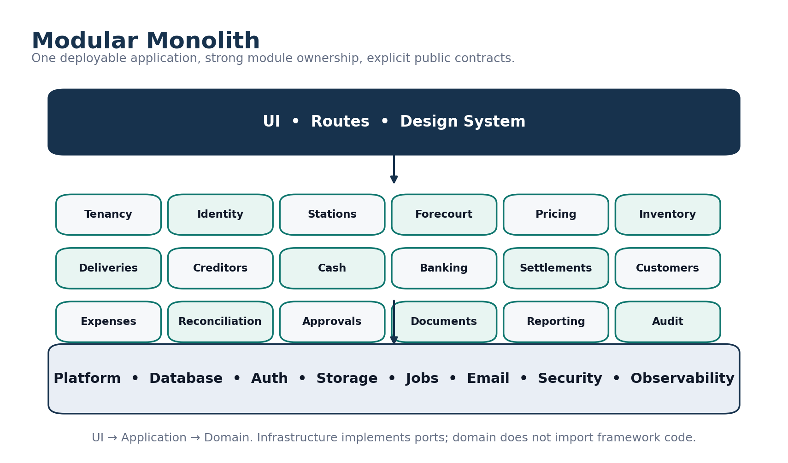
Figure 7. Modular-monolith ownership model and dependency direction.
src/
app/ # Next routes/adapters only
modules/
tenancy identity authorization stations configuration
forecourt pricing tanks inventory deliveries purchasing creditors
cash banking settlements customers expenses reconciliation
approvals exceptions documents reporting notifications audit onboarding
platform/
db auth storage email jobs security observability idempotency
design-system/
shared/ # deliberately tiny

Each module owns domain/application/infrastructure/ui/schema/tests and exposes a small public API. UI does not call the database directly; cross-module financial integrity uses real typed relationships, not a generic universal transactions table.

13.3 Command Pipeline
UI / Server Action / Route Handler
→ authenticate
→ authorize permission + scope
→ validate command DTO
→ check idempotency
→ BEGIN tenant DB transaction
→ lock roots deterministically
→ verify state/version/approval
→ domain command
→ ledger/business rows
→ projections
→ audit + outbox
→ COMMIT
→ authoritative response

13.4 Numeric & ID Conventions
Type | Database convention
Money | NUMERIC(20,4) + currency code
Litres/dips | NUMERIC(18,3)
Selling price | NUMERIC(20,6)
Weighted unit cost | NUMERIC(20,8)
Intermediate valuation | NUMERIC(24,8)
Ratios | NUMERIC(18,8)
Internal IDs | UUIDv7
Human references | Atomic document counters; never MAX()+1

13.5 Database Principles
- No universal transactions table; separate ledgers preserve semantics.
- No giant JSON settings blob for core business rules; important configuration is relational and effective-dated.
- JSONB is narrow-use metadata, not a substitute for financial relationships.
- No generic soft delete everywhere; domains use explicit lifecycle/archive rules.
- Current balance/state tables are projections and rebuildable.
- Named state-transition commands only; no arbitrary status mutation API.
- Deterministic lock ordering and optimistic version checks handle concurrency safely.

14. Offline, Background Work & Integrations

14.1 Offline/PWA Policy
Allowed offline/local | Online required
Limited meter draft, dip draft, expense draft, notes, selected upload queue | Approval, posting, reversal, price activation, bank changes, supplier payment, privilege changes
Tenant/user scoped IndexedDB with purge on logout/offboarding | Any action that creates authoritative money/stock/permission state

The UI may say “draft saved on this device” but never “submitted/approved/posted” until the server confirms.

14.2 Transactional Outbox & Jobs
Business transactions write outbox events in the same DB transaction. Workers claim leased jobs and perform idempotent effects. The system targets at-least-once execution with exactly-once business effects through idempotency rather than claiming impossible exactly-once execution infrastructure.
- Typical jobs: report generation, email/in-app notification, audit checkpointing, scheduled alerts and safe projection refresh/rebuild.
- Cron/webhook entry points are authenticated; future external webhooks add replay protection.
- Job attempts, errors and durations are persisted for operations/debugging.

14.3 ShandaHR Integration Boundary
ShandaHR and Shanda Fuel remain separate operational systems. Future integration uses explicit APIs/SSO contracts. ShandaHR remains authoritative for employee/payroll information; Fuel consumes only fields needed for access/station context or approved recurring payroll cost integration.

14.4 Future Integration Adapters
- Bank statement import and matching.
- Provider statement/API ingestion.
- DocumentProcessor/OCR suggestions that never silently post transactions.
- Native mobile clients if PWA limitations become measured constraints.

15. Onboarding, Forms & Cutover Data

15.1 Development vs Onboarding Boundary
IMPORTANT
Bank accounts, payment providers, tank capacities, calibration points, pump serials, supplier/customer lists, station floats and opening balances are tenant onboarding data. Their absence does not stop the software build.

15.2 Discovery / Setup Workbook
The companion “Shanda Fuel Discovery, Setup & Operational Forms Pack” is the working capture mechanism for real TEI setup values and our proposed replacement forms. It includes:
Workbook area | Purpose
Locations / Pilot / Shifts | Confirm site types, pilot station and station-specific shift clock times
Banks / Payment Channels | Capture bank accounts, POS/EcoCash/provider IDs and settlement behavior
Tanks / Calibration / Pumps-Nozzles | Capture physical station configuration and approved calibration sources
Suppliers / Customers | Master data and opening commercial terms/balances
Approvals / Cash / Variance Alerts | Pilot defaults and station/company policy tuning
Tax & Accounting | Accountant confirmation register; not a software-design blocker
Opening Inventory / Money / Accounts | Approved cutover positions
Recent History | Selective reference import only where useful/clean
Daily Reconciliation / Delivery / Cash Handover / Expense Forms | Authored operational reference forms that inform the application workflows

15.3 Opening Position Batch
The new authoritative history starts with one approved opening-position batch per cutover scope and all Shanda Fuel transactions thereafter. Outstanding items at cutover are opening positions even though they may refer to older invoices/transactions.
Opening position type | Examples
Inventory | Pool/product quantity and value plus physical dip evidence
Cash | Station safe/drawer, collector/transit, management custody
Bank / provider | Tracked bank starting amount if used; unsettled POS/EcoCash/provider receivables
Supplier | Open invoices, supplier credits/prepayments, unbilled exposure as needed
Customer | Open receivables, unapplied credits, prepaid value, prepaid litres
Obligations | Known unpaid operating expenses/recurring obligations

15.4 Selective Recent History
Recent closed history may be imported for comparison or user continuity only when useful and sufficiently clean. It does not become authoritative new-ledger movement unless it represents an outstanding cutover position.

16. Testing, Quality & Definition of Done

16.1 Test Layers
Layer | Examples
Domain unit tests | State transition rules, WAC arithmetic, settlement variance, allocation rules, authorization/reservation behavior
Property-based tests | Cash conservation, allocation caps, prepaid non-negative balances, inventory quantity/value conservation
PostgreSQL integration | Transactions, constraints, exclusion ranges, idempotency and projection updates
RLS/security | Tenant isolation for CRUD/search/export/jobs; missing tenant context fail-closed
E2E / Playwright | Critical user journeys from station operations through approval/posting/reporting
Accessibility | Keyboard/focus/labels/status semantics, axe checks, reduced-motion behavior
Migration/restore | Fresh schema, upgrade path, backup restore, tenant-scoped recovery procedure

16.2 Definition of Done for a Vertical Slice
- Schema migration and rollback/forward strategy considered.
- Tenant isolation and authorization covered by tests.
- Server-side validation and typed command DTO implemented.
- Duplicate/idempotency/concurrency behavior handled.
- Decimal/currency/litre calculations use canonical utilities.
- Audit/outbox behavior included in the same transaction.
- Loading, empty, error, conflict and weak-network states implemented.
- Mobile and desktop responsive behavior reviewed.
- Correction/reversal behavior specified before posting is enabled.
- Observability and user-safe error codes included.
- Module docs and acceptance scenarios updated.

16.3 Performance Targets
Target | Planning goal
Ordinary command | Usually < 1 second under reasonable regional mobile conditions, excluding network latency outside our control
Useful page | ~2 seconds or better for common screens under reasonable conditions; progressive loading allowed
Large reports | Background job, never block ordinary request execution
Low bandwidth | Compress images, avoid unnecessary data payloads, preserve drafts and provide truthful retry

17. Delivery Plan & Build Sequence

17.1 Development Strategy
Build vertical slices that create real operational value and exercise the full security/data architecture early. Avoid building every table before any complete workflow works.
Phase | Approx. planning duration | Primary output
0. Blueprint / repo / ERD / wireframes | ~1 week | This specification, schema plan, design system skeleton, environments
1. Foundation | ~2 weeks | Tenancy, auth, roles, stations/config, documents, audit, RLS, CI
2. Core station vertical slice | ~3 weeks | Business day → shift → meters → declarations → reconciliation → approval/post/report
3. Inventory / delivery / costing | ~3 weeks | Tanks/dips, delivery, inventory movements, WAC/revaluation
4. Money | ~3 weeks | Cash custody, collection/deposit, bank tracking, POS/EcoCash settlement
5. Suppliers / customers / expenses | ~3 weeks | Creditors, customer accounts/prepaid, payments, expenses/fixed costs
6. Profit / reporting | ~2 weeks | Profitability, operational position, curated PDF/XLSX reports
7. Hardening | ~2–3 weeks | Security, performance, accessibility, restore drills, failure/reversal scenarios
8. Pilot | ~1–2 weeks | One real station shadow operation, discrepancy resolution and sign-off

Planning estimate: roughly 18–22 weeks / 700–950 development hours for a strong full-time single developer; part-time/junior delivery will take longer. These are planning ranges, not contractual promises.

17.2 First Six-Week Objective
MILESTONE
One real station can complete a full shift, capture meters/declarations, reconcile the day, submit/approve/post it, and produce traceable operational reporting with tenant isolation and audit intact.

17.3 Build Order by Dependency
- Foundation tenancy/auth/RLS/roles/stations/configuration/documents/audit/idempotency/outbox.
- Station business day, shifts, meter installation/boundaries/segments, pricing and declarations.
- Reconciliation revision/approval/sale recognition and basic daily report.
- Cash custody, handovers, collections, deposits and bank confirmation.
- Tanks/dips, deliveries, inventory movement/WAC/revaluation.
- Supplier invoices/payments/credit exposure.
- Customer authorization/credit/prepaid/payments.
- Expenses/recurring costs and profitability.
- Full report catalogue, exports, alerts, hardening and pilot readiness.

18. Pilot, Rollout & Production Readiness

18.1 Pilot Preparation
- Select one representative TEI operating location; exact site can be chosen while development is underway.
- Populate real station master data: users, products, pumps/nozzles/meters, tanks/calibration, payment channels, prices, bank/cash policy.
- Prepare and approve opening positions.
- Train role-specific users in staging using realistic synthetic/pilot data.
- Run Shanda Fuel alongside the existing process for approximately 7–14 operating days.

18.2 Daily Pilot Discrepancy Classification
Class | Meaning
Software defect | Shanda calculated/behaved incorrectly
Old-process problem | Paper/Excel process itself produced inconsistent or unsupported result
Source-data issue | Wrong/late/missing master or operational data
Formula/policy clarification | Business rule needs explicit client/accountant decision
Training/usability | System is correct but user interaction is confusing/slow

18.3 Pilot Exit Gates
- Approximately seven clean operating days with no critical unresolved issue.
- Meter/reconciliation, cash, delivery/stock and profitability formulas signed off by appropriate business owners.
- Users can perform their normal role without developer intervention.
- Backup/restore drill completed; key security controls verified.
- Opening positions and major customer/supplier balances reconcile.

18.4 Rollout Sequence
Staging / UAT
→ 1 TEI pilot location
→ 2–3 TEI locations
→ all TEI locations
→ stabilization
→ second independent tenant
→ broader commercial rollout

Do not treat a single-company deployment as proof of commercial SaaS readiness. Customer #2 should be onboarded without manual database edits, and an independent penetration test should precede broad commercial rollout.

19. Hosting, Operations, Backup & Recovery

19.1 Environment Separation
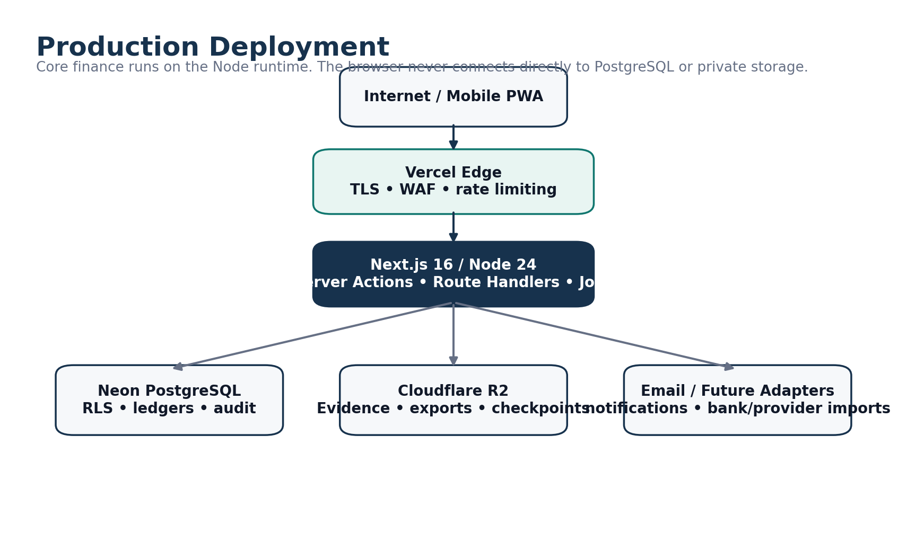
Figure 8. Production deployment and infrastructure boundary.
Environment | Rule
Local | Developer data only; no production credentials
Staging | Separate Neon/R2/auth secrets with synthetic/anonymized data
Production | Separate production Vercel/Neon/R2/secrets/keys; developer DB access by controlled break-glass only

19.2 Backup & Recovery
- Neon point-in-time recovery plus independent logical backups stored separately from normal runtime blast radius.
- Private documents, report artifacts, audit checkpoints and backups use appropriate distinct storage/lifecycle policy boundaries.
- Restore drills before launch/major DB changes and at least quarterly thereafter.
- Planning targets: RPO <= 15 minutes and RTO <= 4 hours for architecture/testing purposes; not presented as contractual SLA until operations are proven.
- Tenant-scoped logical corruption is repaired through isolated restore/extract/repair rather than rolling back all other tenants.

19.3 Observability & Incidents
- Structured logs with correlation/request IDs and sensitive-data redaction.
- Health checks include application/database, jobs, storage, audit checkpointing and backup status.
- P0–P3 incident classification with security, restore and data-repair runbooks.
- No false promise of 24/7 human support unless the commercial support model actually funds it.

19.4 Early Operating Cost
For planning, early production infrastructure should remain in the tens of USD per month rather than hundreds if usage is modest. Keep a rough planning reserve of USD 60–100/month for the core stack, but recheck current vendor pricing at launch rather than treating this as a quote.

20. Remaining Confirmation Register
These items do not stop normal development. They become onboarding, pilot or accountant/legal gates at the appropriate stage.
Item | When needed | Default / action if not yet supplied
Final active TEI location/station classification and pilot site | Before pilot setup | Use client-provided 11-location seed; do not block code
Actual shift clock times per station | Before station activation | Use configurable 8-hour starter templates
Banks and POS/EcoCash providers/merchant IDs | Before money workflow go-live | Provider/bank-neutral structures already built
Tank capacities, calibration charts, pumps/nozzles/meters | Before station operations go-live | Capture via setup workbook/onboarding
Supplier/customer masters and current terms | Before commercial module pilot | Capture via setup workbook/import
Cash floats / reorder levels / station-specific thresholds | Before station activation or tune during pilot | Use recommended provisional defaults where safe
Opening balances | Immediately before cutover | Finance prepares; authorized management approves opening-position batch
Tax/VAT/statutory invoice treatment | Before tax-specific automation or formal statutory outputs | Remain tax-ready; do not invent treatment
Retention periods | Before automated deletion/lifecycle policies | Retain conservatively until accountant/legal confirmation
Exact ShandaHR integration fields | Before integration phase | Keep explicit API boundary and manual recurring cost fallback

20.1 What Is Not a Client Question Anymore
- Database/hosting architecture, ORM, framework and module boundaries.
- How audit immutability works.
- How tenant isolation/RLS works.
- Whether cash collected equals banked (it does not).
- Whether supplier invoice rewrites delivery quantity (it does not).
- How corrections to posted facts work (reversal/compensation/adjustment).
- How customer credit/prepaid fuel reconciles to meters without duplicate litres.
- How weighted-average inventory cost is preserved across later purchases.

21. Implementation Readiness Statement
READY FOR BUILD
The logical product architecture is sufficiently specified for implementation to begin without recurring client interruption. Remaining unknowns are predominantly tenant setup/onboarding values and legal/accounting confirmations, not software architecture decisions.

21.1 Frozen Logical Layers
Layer | Status
Requirements coverage | Complete for the supplied V1 brief
Operating/domain model | Locked
ERD / aggregate boundaries / ledgers | Locked at logical level
State machines / named commands | Locked
Roles / permissions / approval philosophy | Locked; business thresholds configurable
UX architecture / core screen families | Locked
Security / tenant isolation / audit | Locked
Engineering architecture / stack | Locked for implementation planning
Onboarding forms / opening-position model | Defined
Pilot / rollout plan | Defined

21.2 Implementation Guardrails
- A developer may change a physical index name, component implementation or internal code organization detail when reasonable, but may not silently reinterpret the business model.
- Any proposed change that weakens tenant isolation, immutable posting, cash/fuel conservation, approval versioning or source-of-truth boundaries requires explicit architecture review.
- When a real-world onboarding fact is missing, add/configure the data later; do not hard-code guesses into the domain model.

21.3 Immediate Next Engineering Artifact
After this blueprint, perform the Developer Readiness Review and convert the locked design into exact repository/module conventions, permission-code catalogue, route map, command/query contracts, Drizzle schema/migration sequence, RLS test matrix, seed data, environment-variable register, CI gates and an implementation backlog/ticket dependency graph.

Appendix A. Core Aggregate Roots
Domain | Aggregate roots / major entities
Tenancy & access | Tenant, Legal Entity, Tenant Membership, Role Assignment
Station operations | Station, Station Business Day, Shift, Meter Installation, Meter Segment, Selling Price Change
Inventory | Inventory Pool, Tank, Delivery, Inventory Adjustment, Inventory Transfer, Cost Adjustment/Revaluation
Money | Cash Handover, Cash Collection, Bank Deposit, Bank Account, Payment Channel, Provider Batch/Settlement
Suppliers | Supplier, Supplier Invoice, Supplier Payment, Supplier Credit Note
Customers | Customer, Customer Account, Fuel Authorization/Transaction, Customer Payment, Customer Invoice/Credit Note
Expenses | Expense, Recurring Cost Template/Period
Cross-cutting | Approval Request, Document, Business Exception, Report Run, Opening Position Batch

Appendix B. Core Named Commands
Domain | Representative commands
Business day / shift | OpenBusinessDay, StartShift, CloseMeters, CompleteShift, MarkNotOperated, ExceptionalClose
Meter / price | ConfirmBoundary, SealSegment, RequestPriceChange, ActivatePriceChange, ReplaceMeter
Delivery / inventory | RecordArrival, BeginOffloading, ConfirmReceipt, PostDelivery, SubmitAdjustment, PostAdjustment, DispatchTransfer, ReceiveTransfer
Reconciliation | CalculateReconciliation, SubmitReconciliation, ReturnReconciliation, ApproveAndPostReconciliation, LockReconciliation
Cash / bank | CountCash, PrepareHandover, SenderConfirmHandover, ReceiverConfirmHandover, ResolveHandoverDispute, RecordDeposit, ConfirmBankReceipt
Provider | RecordProviderBatch, MatchProviderBatch, RecordProviderSettlement, ResolveSettlementDifference
Supplier | SubmitSupplierInvoice, PostSupplierInvoice, SubmitSupplierPayment, PostSupplierPayment, ReverseSupplierPayment
Customer | AuthorizeCustomerFuel, CompleteCustomerFuel, RecordCustomerPayment, PostCustomerPayment, GenerateCustomerInvoice
Expense | SubmitExpense, ApproveExpense, PostExpense, GenerateRecurringCostPeriod, RecognizeRecurringCost
Cross-cutting | CreateApprovalRequest, ApproveStep, ReturnForCorrection, ExecuteReversal, VerifyDocument, GenerateReport, PostOpeningPositionBatch

Appendix C. Core Route / Screen Families
Area | Representative screens/routes
Home / actions | /app/home, /app/actions
Operations | /operations/today, business-days, shifts, deliveries, dips
Money | /money/cash, collections, deposits, settlements, bank
Inventory | /inventory/position, tanks, movements, transfers
Suppliers | /suppliers, invoices, payments
Customers | /customers, accounts, payments
Expenses | /expenses
Reports / audit | /reports, /audit
Settings | organisation, stations, shifts, products, pumps/nozzles, tanks, prices, banks, payment channels, users/roles, alerts

Appendix D. Minimum Acceptance Scenarios
Scenario | Pass condition
Normal day | Shift meters → declarations → reconciliation → approval/post → stock/revenue/profit/cash classifications reconcile
Attendant handover | One shared boundary closes first responsibility and opens next with no duplicated/missing litres
Mid-shift price change | Old price remains until boundaries complete; segment values use correct prices
Delivery shortage | Delivery-note quantity differs from accepted quantity; stock uses accepted litres, supplier claim remains separate
Late transport cost | No original movement rewritten; remaining inventory and historical COGS revaluation split correctly
Cash dispute | Sender/receiver disagreement represented once across custody + dispute
Partial provider settlement | Outstanding provider balance and expected/actual settlement variance remain correct
Supplier payment reversal | Allocations reverse atomically and invoices reopen
Customer concurrent credit | Second authorization cannot exceed remaining available credit after first reservation
Prepaid litre draw | Only matching product balance is reduced; no silent product conversion
Tenant isolation | Tenant A cannot read/write/link/export Tenant B data through any application or job path
Report as-of | Later posted correction changes later as-of report without altering old artifact/checksum
Offline draft | Draft survives interruption; authoritative state stays unchanged until server submission
Opening cutover | Approved opening batch posts atomically across configured domains and becomes starting authoritative position

Appendix E. Companion Artifacts
This visual edition embeds the architecture/process diagrams and primary mobile/desktop wireframes directly in the DOCX so the blueprint can be reviewed without a separate diagram pack.
Artifact | Purpose
Shanda Fuel Discovery, Setup & Operational Forms Pack.xlsx | Capture real station master/setup data, opening positions, provisional policies and reference operational forms.
Master ERD / migration dependency map | Logical database ownership, cardinalities, RLS/security classes and migration ordering.
Master State-Machine Pack | Legal record transitions, commands, authority, conditions, effects and recovery routes.
Screen Architecture & Wireframe Pack | Role-specific information architecture and critical workflow layouts.
Master Architecture Diagram Pack | System/deployment/security/data-flow/recovery architecture.
Requirements Traceability Matrix | Requirement → design → module → workflow/data source → acceptance coverage.

Appendix F. V1 Mid-Fidelity Wireframe Pack
This appendix embeds the complete screen-flow boards used for V1 implementation. It replaces the earlier conceptual mockup gallery as the authoritative UX reference. For easier UX review, the same material is also delivered as a standalone Wireframe Pack v1.2.
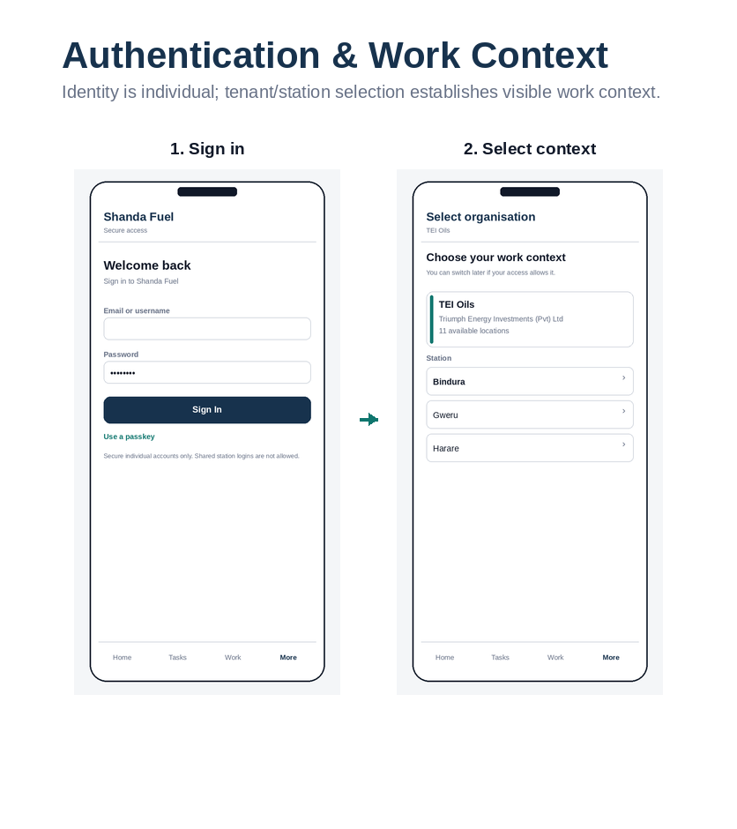
Wireframe board F.1: Authentication & work context. Role: Identity & tenancy.

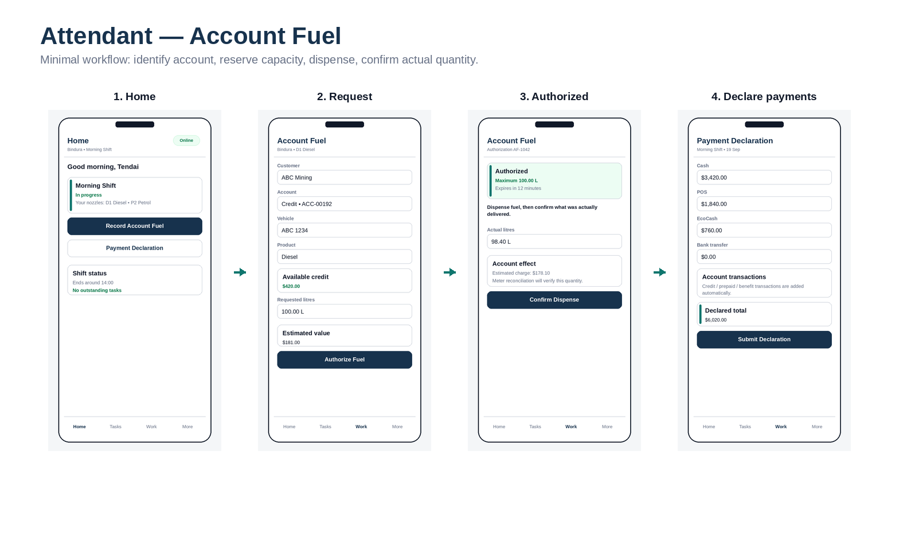
Wireframe board F.2: Attendant — account fuel. Role: Attendant.

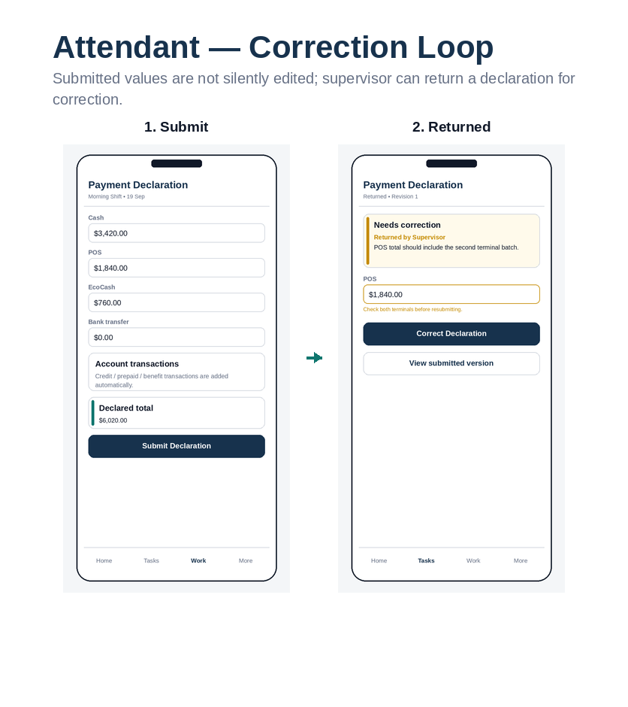
Wireframe board F.3: Attendant — correction loop. Role: Attendant / Supervisor.

Wireframe board F.4: Supervisor — start shift. Role: Supervisor.

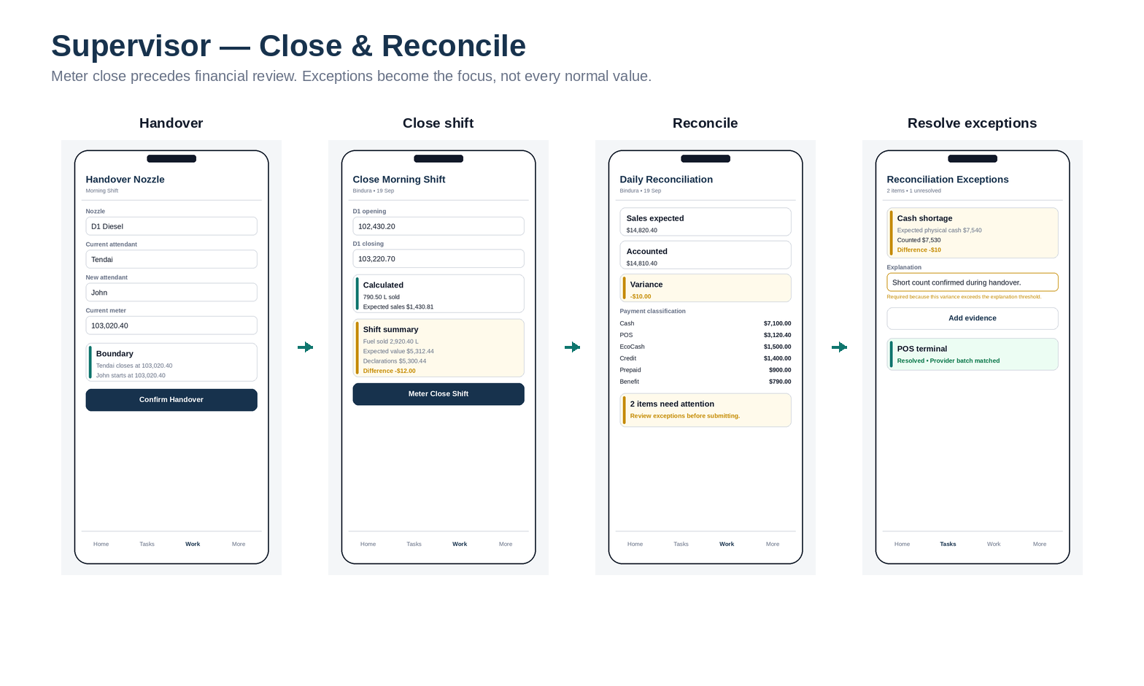
Wireframe board F.5: Supervisor — close & reconcile. Role: Supervisor.

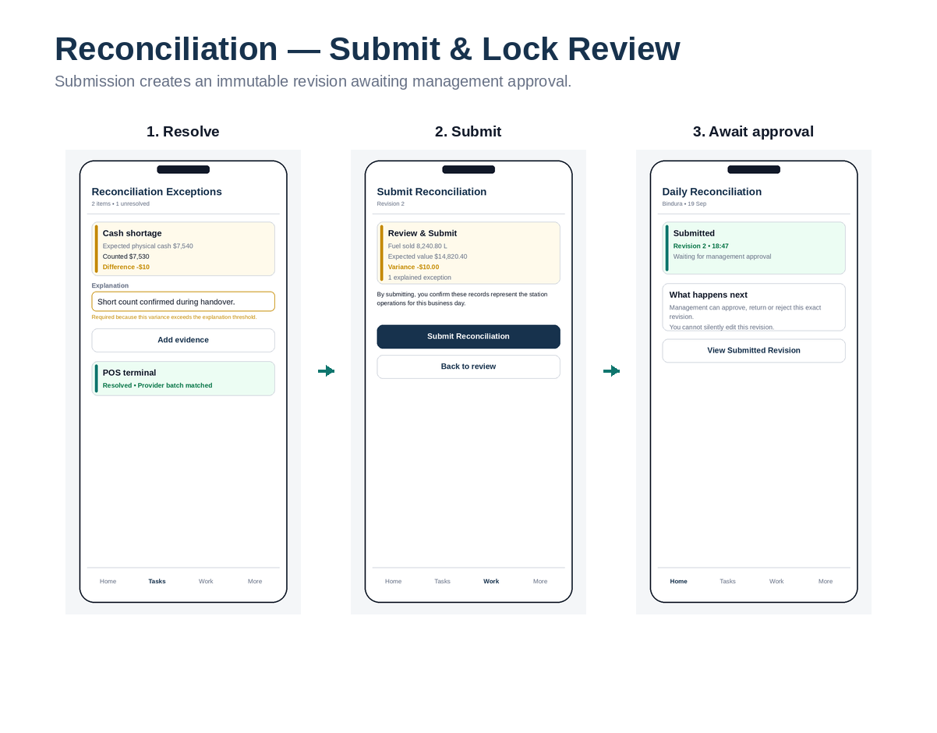
Wireframe board F.6: Reconciliation — submit & approval wait. Role: Supervisor / Management.

Wireframe board F.7: Delivery — guided physical receipt. Role: Supervisor / Delivery Receiver.

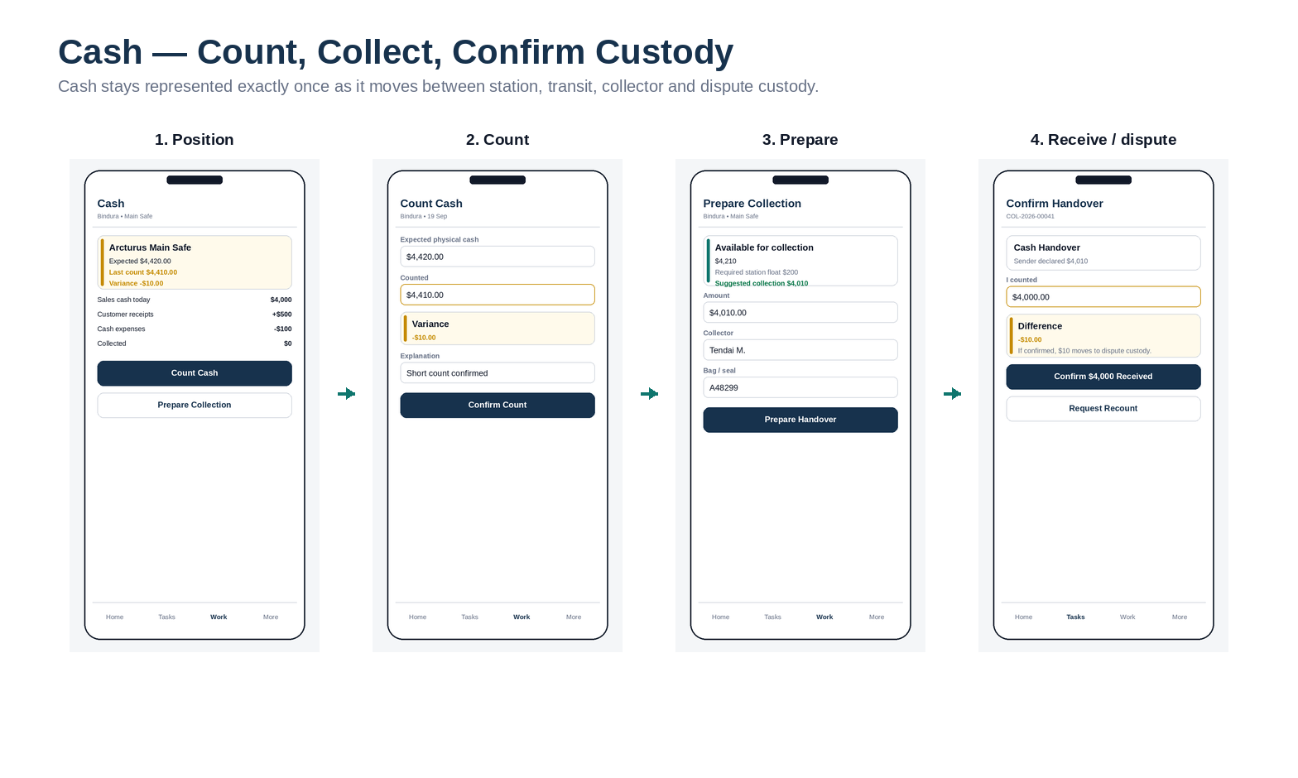
Wireframe board F.8: Cash — count, collect, confirm custody. Role: Supervisor / Collector.

Wireframe board F.9: Finance — queue-based work. Role: Finance.

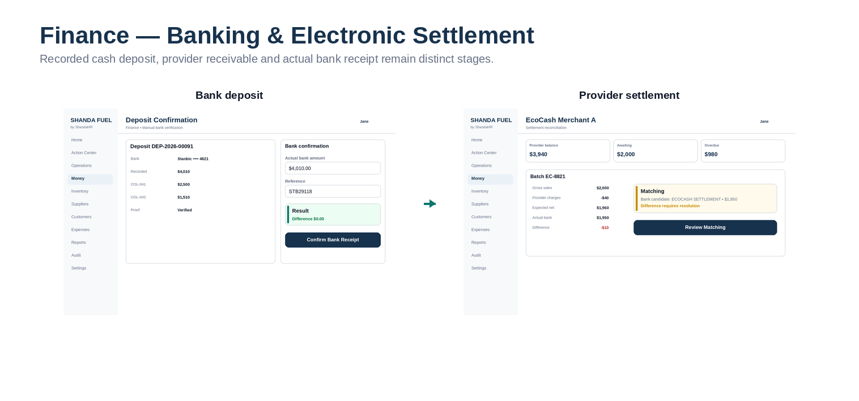
Wireframe board F.10: Banking & electronic settlement. Role: Finance.

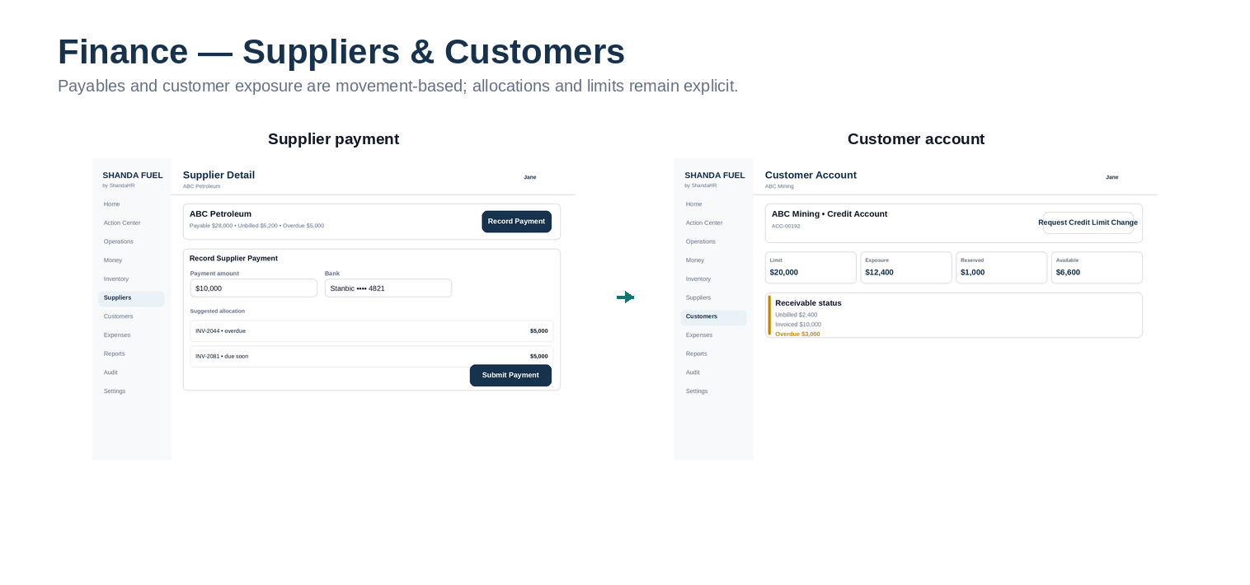
Wireframe board F.11: Suppliers & customers. Role: Finance.

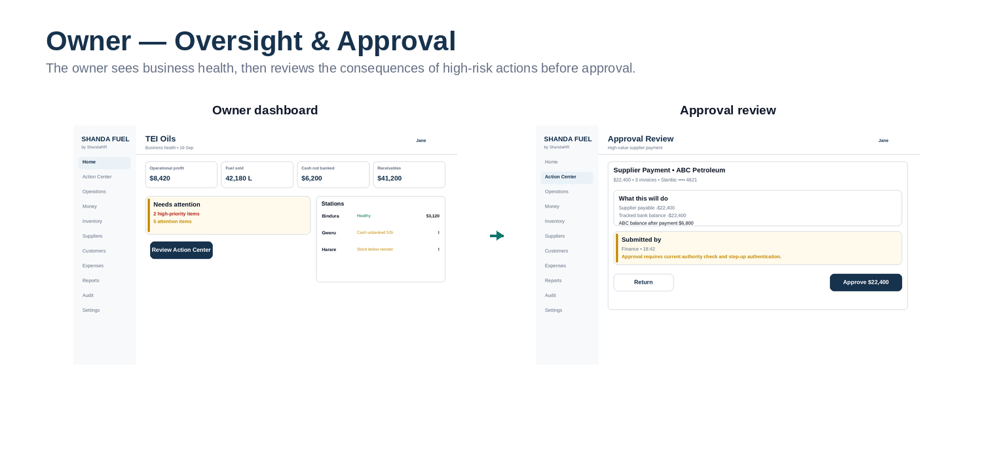
Wireframe board F.12: Owner — oversight & approval. Role: Owner / Admin.

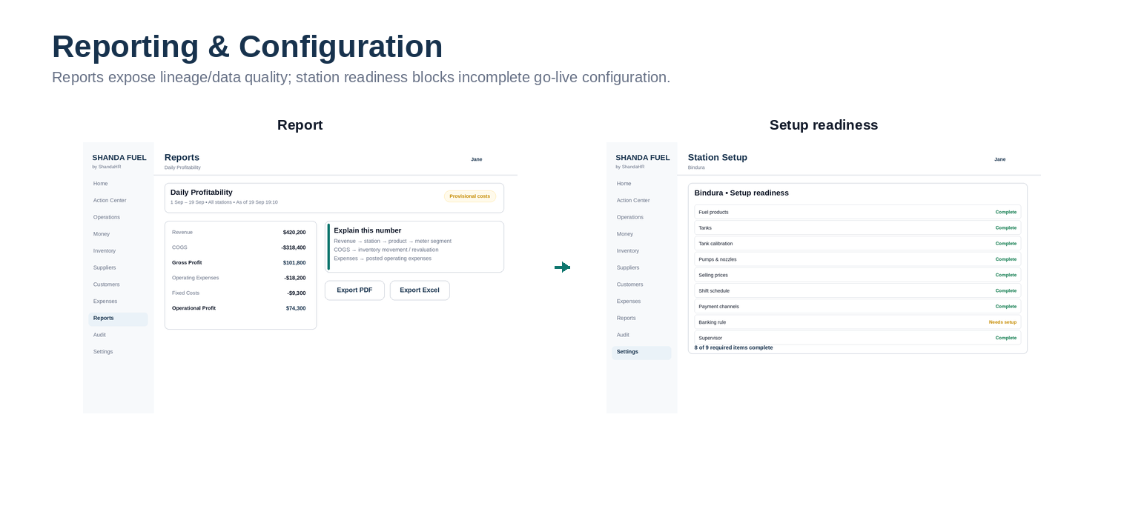
Wireframe board F.13: Reporting & station readiness. Role: Owner / Finance / Admin.

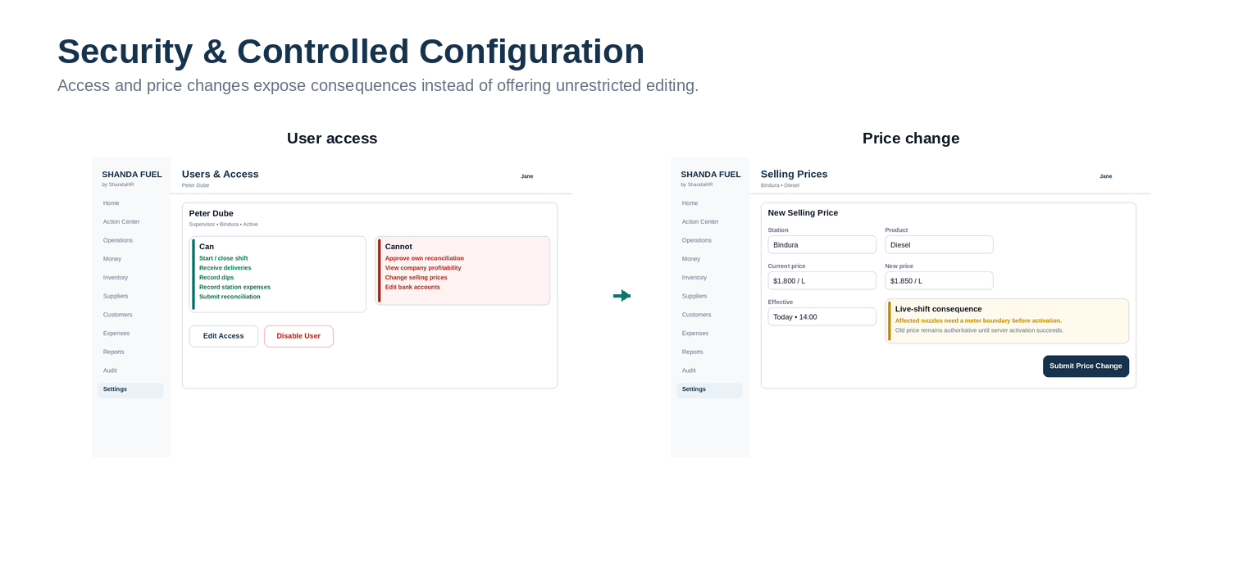
Wireframe board F.14: Security & controlled configuration. Role: Owner / Admin.

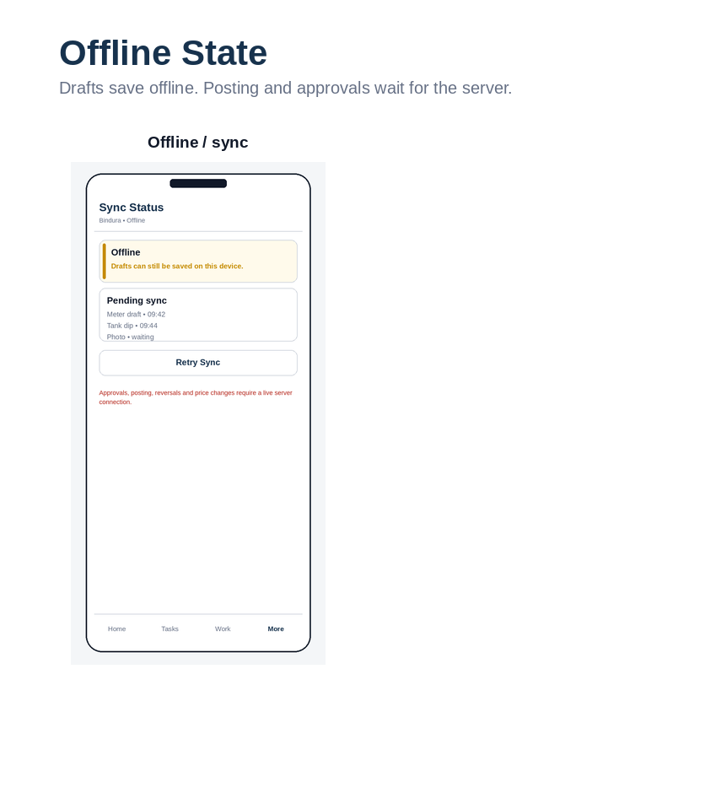
Wireframe board F.15: Weak-connection state. Role: All mobile roles.

F.16 Screen-to-Command Mapping
ID | Screen | Role | Device | Primary action | Command / state action
WF-01 | Sign in | All users | Mobile/Web | Sign in | Authenticate
WF-02 | Select organisation / station | Multi-scope users | Mobile/Web | Select context | SelectTenantContext
WF-03 | Attendant Home | Attendant | Mobile | Start role task | —
WF-04 | Account Fuel Request | Attendant | Mobile | Authorize Fuel | RequestCustomerFuelAuthorization
WF-05 | Account Fuel Authorized | Attendant | Mobile | Confirm Dispense | CompleteCustomerFuelTransaction
WF-06 | Payment Declaration | Attendant | Mobile | Submit Declaration | SubmitPaymentDeclaration
WF-07 | Returned Declaration | Attendant | Mobile | Correct Declaration | ResubmitPaymentDeclaration
WF-08 | Supervisor Today | Supervisor | Mobile | Continue Shift | —
WF-09 | Start Shift — Team | Supervisor | Mobile | Continue | AssignShiftTeam
WF-10 | Start Shift — Opening Readings | Supervisor | Mobile | Confirm readings | ConfirmMeterBoundary
WF-11 | Shift Workflow | Supervisor | Mobile | Open task | —
WF-12 | Nozzle Handover | Supervisor | Mobile | Confirm Handover | HandoverNozzle
WF-13 | Close Shift | Supervisor | Mobile | Meter Close Shift | CloseMeters
WF-14 | Reconciliation Summary | Supervisor | Mobile | Review exceptions | CalculateReconciliation
WF-15 | Reconciliation Exceptions | Supervisor | Mobile | Save explanation | ResolveReconciliationException
WF-16 | Submit Reconciliation | Supervisor | Mobile | Submit Reconciliation | SubmitReconciliation
WF-17 | Reconciliation Waiting | Supervisor | Mobile | View revision | —
WF-18 | Delivery Verification | Supervisor | Mobile/Tablet | Continue | StartDeliveryVerification
WF-19 | Before Offload | Supervisor | Mobile/Tablet | Capture Boundary & Begin | BeginOffloading
WF-20 | Delivery Interrupted | Supervisor | Mobile/Tablet | Resume / Finish Partial | ResumeOffloading / FinishPartialReceipt
WF-21 | Delivery Review | Supervisor | Mobile/Tablet | Confirm Receipt | ConfirmDelivery
WF-22 | Cash Position | Supervisor | Mobile | Count / Prepare Collection | —
WF-23 | Cash Count | Supervisor | Mobile | Confirm Count | ConfirmCashCount
WF-24 | Prepare Collection | Supervisor | Mobile | Prepare Handover | PrepareCashCollection
WF-25 | Confirm Handover | Collector | Mobile | Confirm received amount | ConfirmCashHandover
WF-26 | Offline / Sync | Mobile roles | Mobile | Retry Sync | SyncDraft
WF-27 | Finance Home | Finance | Desktop | Open Action Center | —
WF-28 | Action Center | Finance | Desktop | Resolve / Match | ResolveException
WF-29 | Deposit Confirmation | Finance | Desktop | Confirm Bank Receipt | ConfirmBankReceipt
WF-30 | Provider Settlement | Finance | Desktop | Review Matching | MatchProviderSettlement
WF-31 | Supplier Payment | Finance | Desktop | Submit Payment | SubmitSupplierPayment
WF-32 | Customer Account | Finance | Desktop | Request limit change | RequestCustomerLimitChange
WF-33 | Owner Dashboard | Owner | Desktop | Review Action Center | —
WF-34 | Approval Review | Owner | Desktop | Approve / Return | ApproveSupplierPayment / ReturnApproval
WF-35 | Report View | Owner / Finance | Desktop | Export / Explain | GenerateReport / GenerateExport
WF-36 | Setup Readiness | Admin | Desktop | Configure missing item | ValidateStationReadiness
WF-37 | User Access | Owner / Admin | Desktop | Edit Access / Disable | ChangeMembershipAccess / DisableMembership
WF-38 | Price Change | Pricing authority | Desktop | Submit Price Change | SubmitPriceChange

