Shanda Fuel
V1 Mid-Fidelity Wireframe Pack
Version 1.2 • Product/UX implementation reference
Purpose: define actual screen hierarchy, navigation, fields, primary actions, warnings and role behavior before implementation. These are wireframes, not pixel-perfect final visual design.
Locked UX principle: Simple by default. Powerful when needed. Explicit when risky.

1. Wireframe Rules
- Mobile operational workflows are first-class; desktop is not simply shrunk onto a phone.
- Every screen exposes the active organisation/station/date/shift context where relevant.
- One dominant primary action per screen where practical; secondary actions are visually subordinate.
- Normal values are quiet; exceptions and consequences receive visual priority.
- Meter-derived litres are canonical for ordinary forecourt sales.
- Posted/approved financial records do not expose normal Edit/Delete actions.
- Authoritative actions only show success after server confirmation.
- Offline mode supports drafts and capture, not approvals/posting/reversals/price activation.
Fidelity: mid-fidelity. Layout, wording, interaction hierarchy and domain meaning are implementation requirements; exact spacing, font metrics and final brand polish may evolve within the design system.

2. User-Flow Boards
Each board shows the main screen sequence a user experiences. The green arrows indicate the expected forward path; exception/return paths are shown inside the relevant screens.
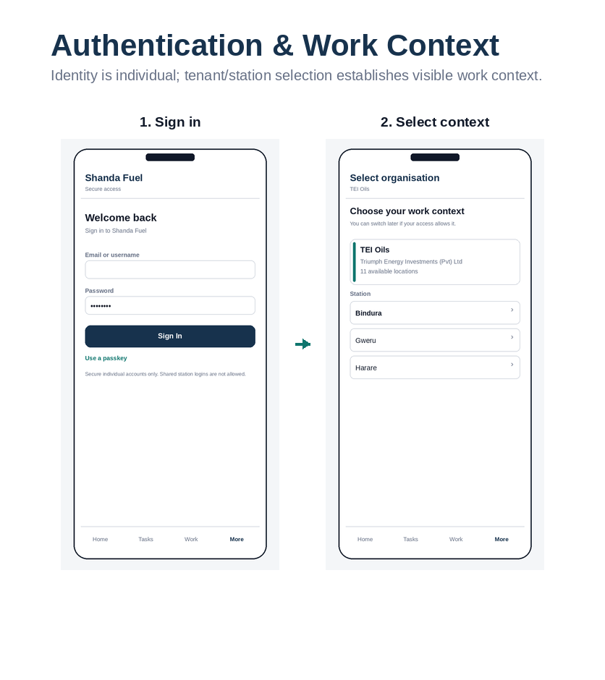
Wireframe board 1: Authentication & work context. Role: Identity & tenancy.

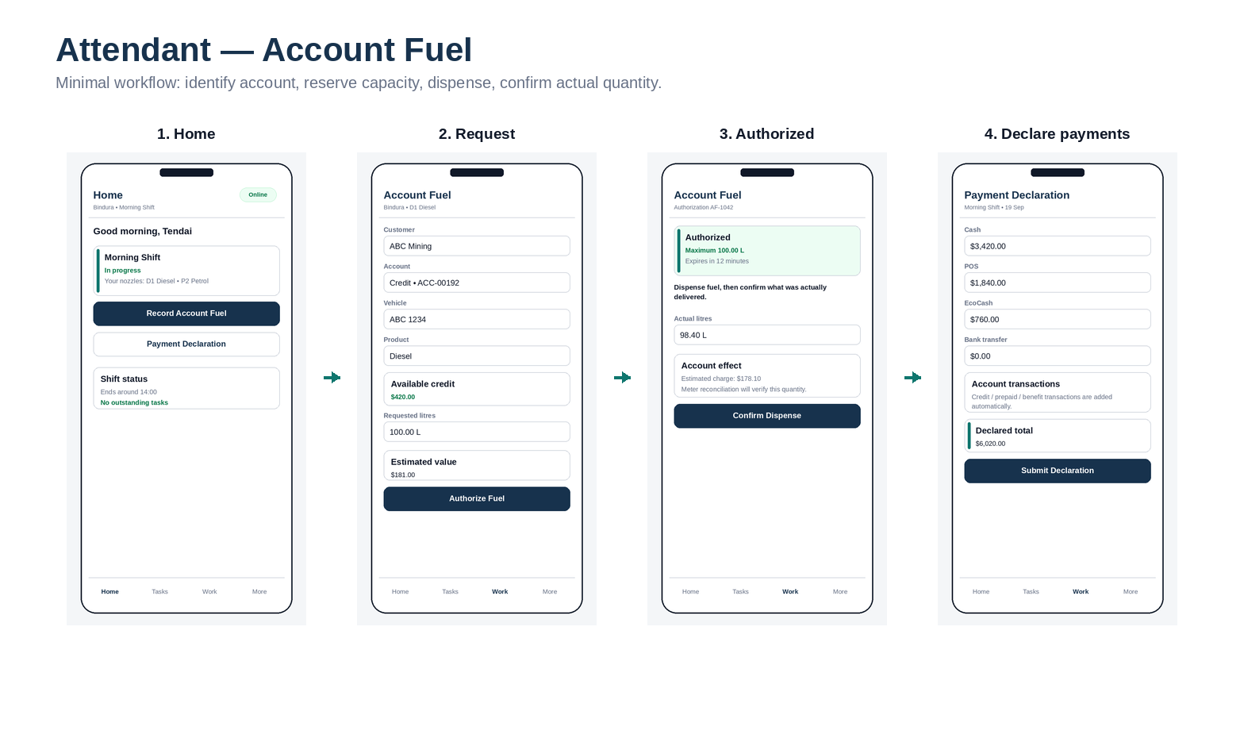
Wireframe board 2: Attendant — account fuel. Role: Attendant.

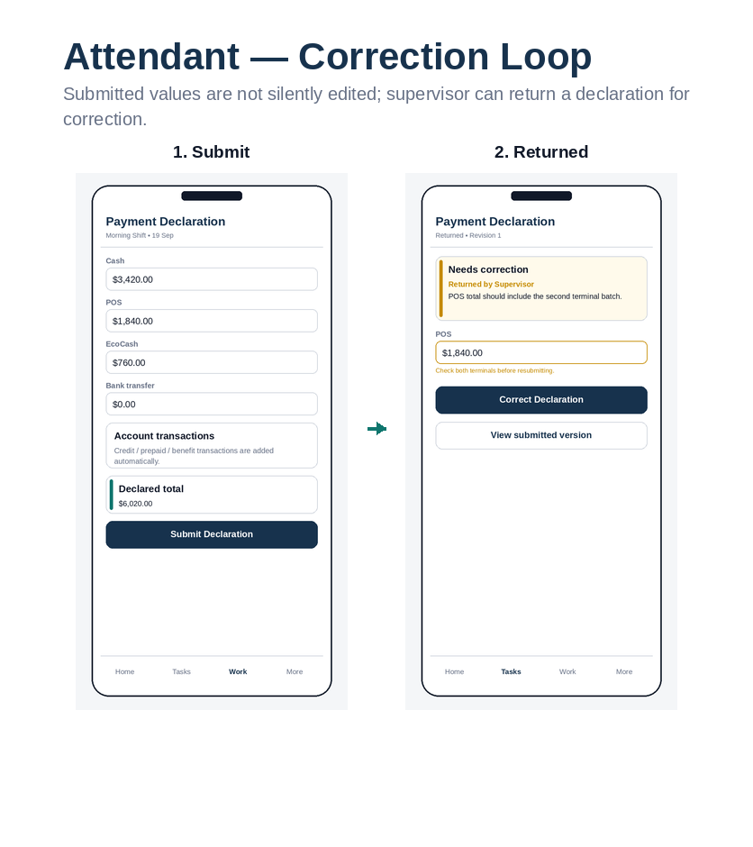
Wireframe board 3: Attendant — correction loop. Role: Attendant / Supervisor.

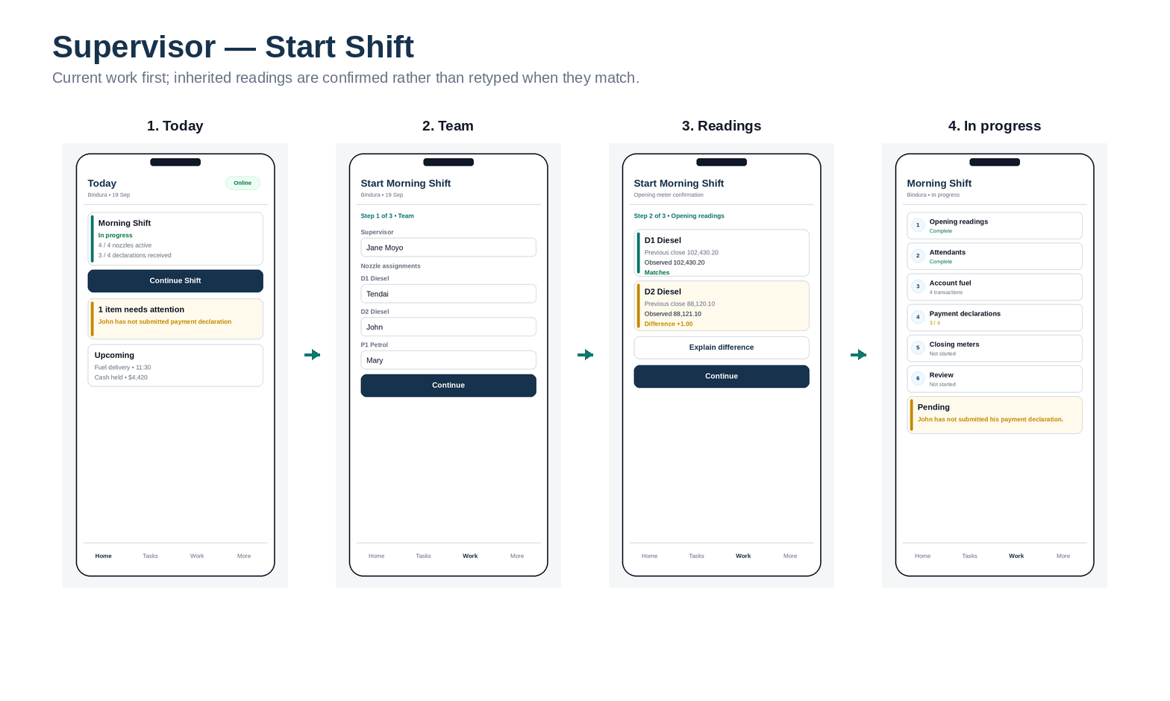
Wireframe board 4: Supervisor — start shift. Role: Supervisor.

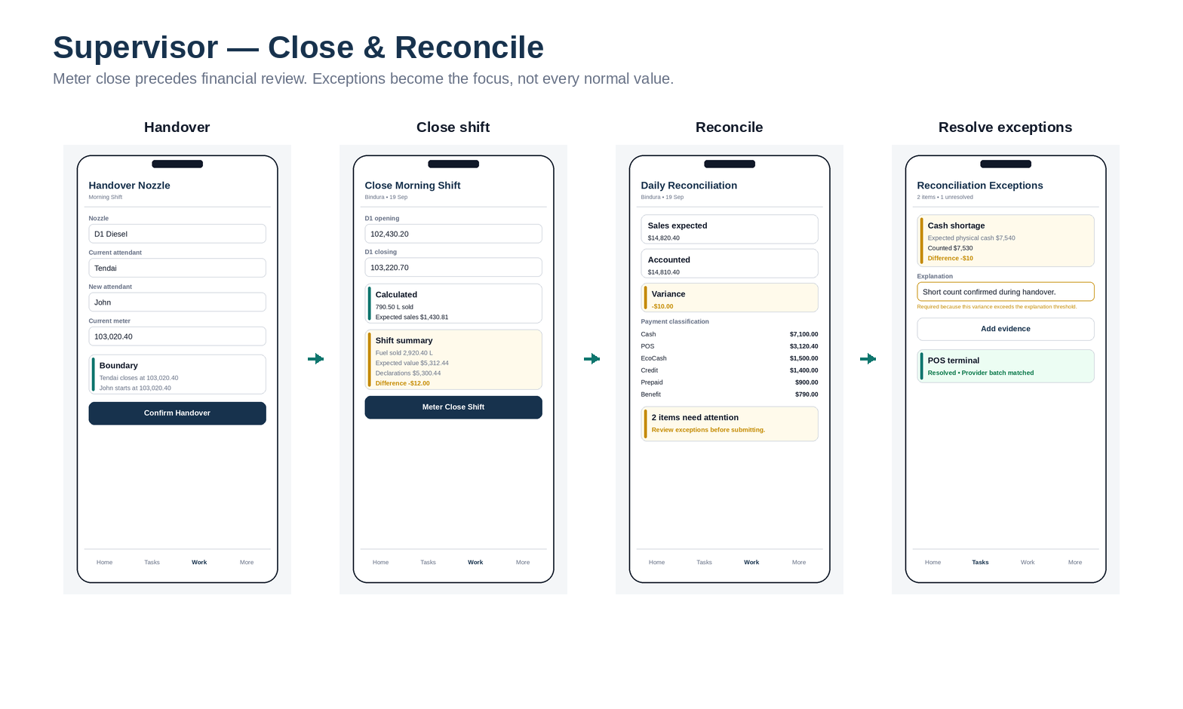
Wireframe board 5: Supervisor — close & reconcile. Role: Supervisor.

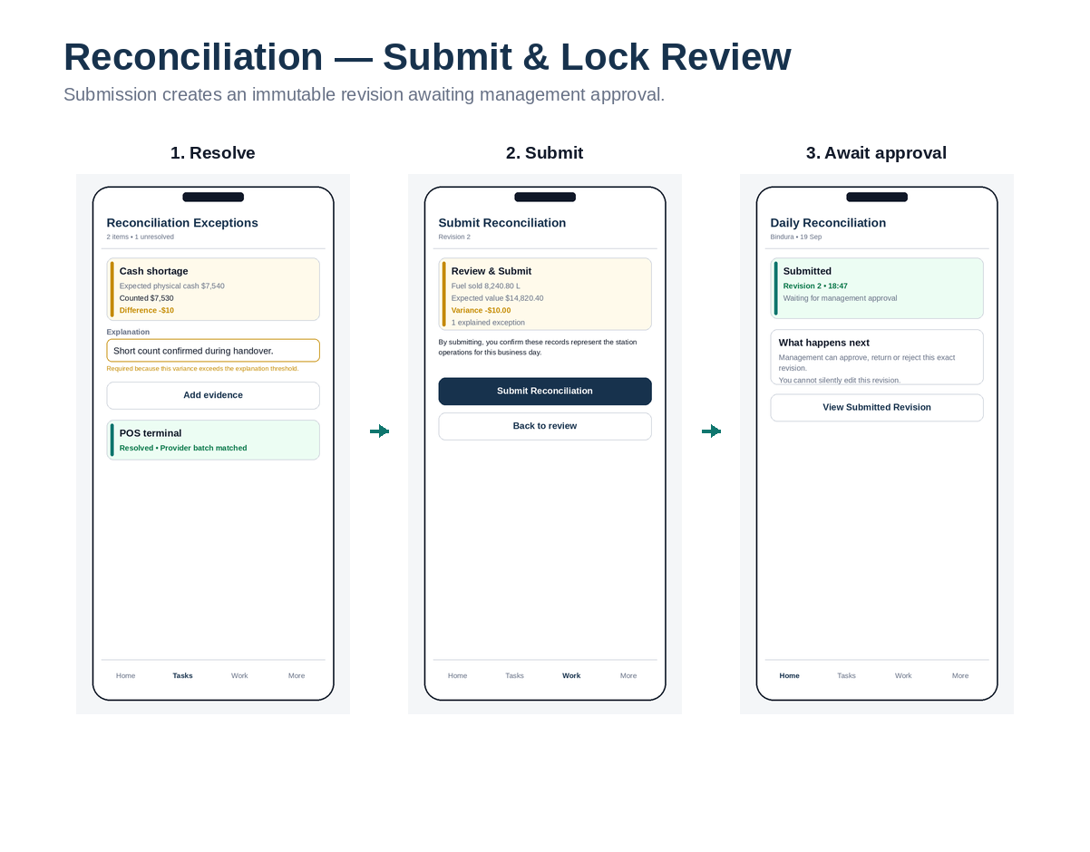
Wireframe board 6: Reconciliation — submit & approval wait. Role: Supervisor / Management.

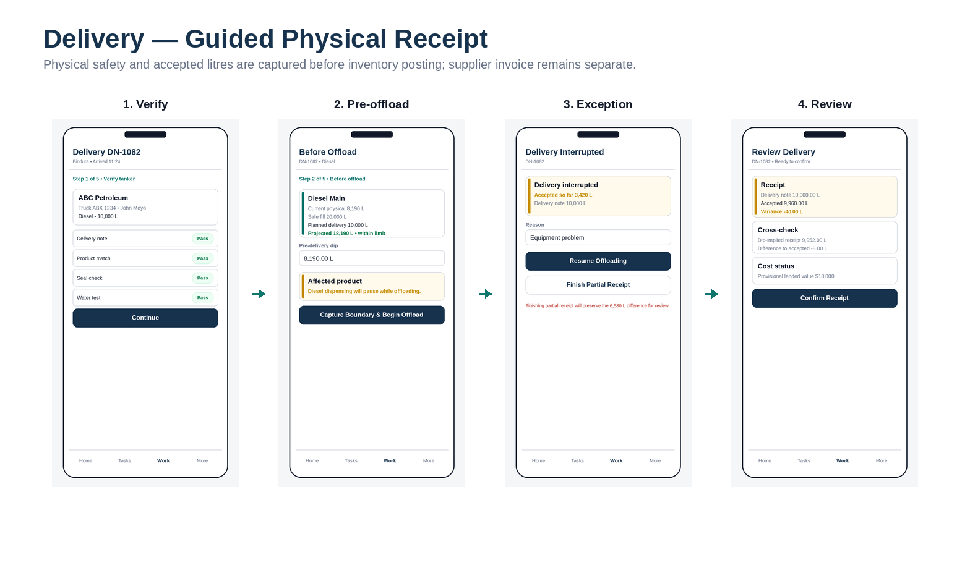
Wireframe board 7: Delivery — guided physical receipt. Role: Supervisor / Delivery Receiver.

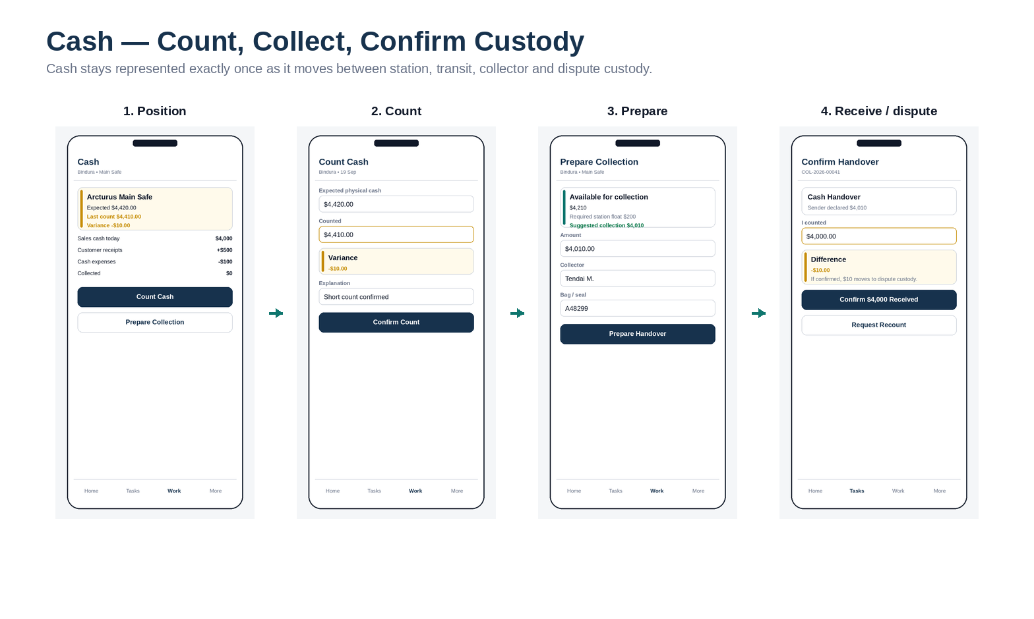
Wireframe board 8: Cash — count, collect, confirm custody. Role: Supervisor / Collector.

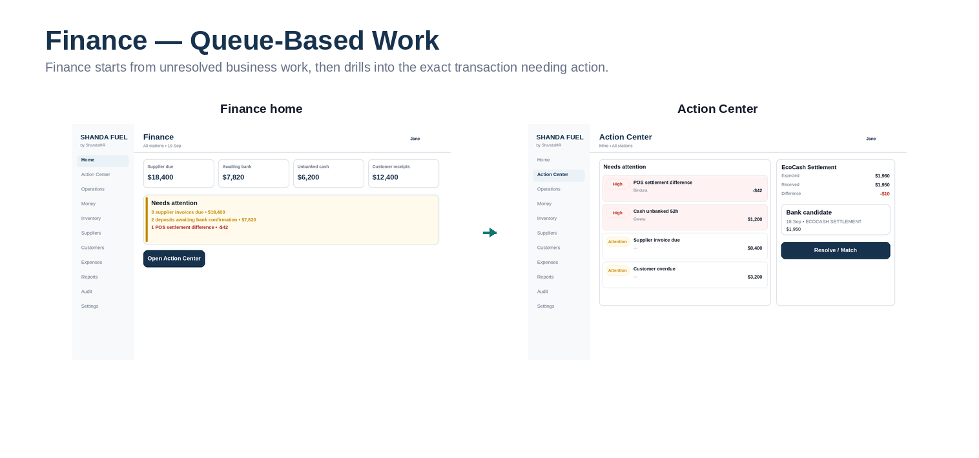
Wireframe board 9: Finance — queue-based work. Role: Finance.

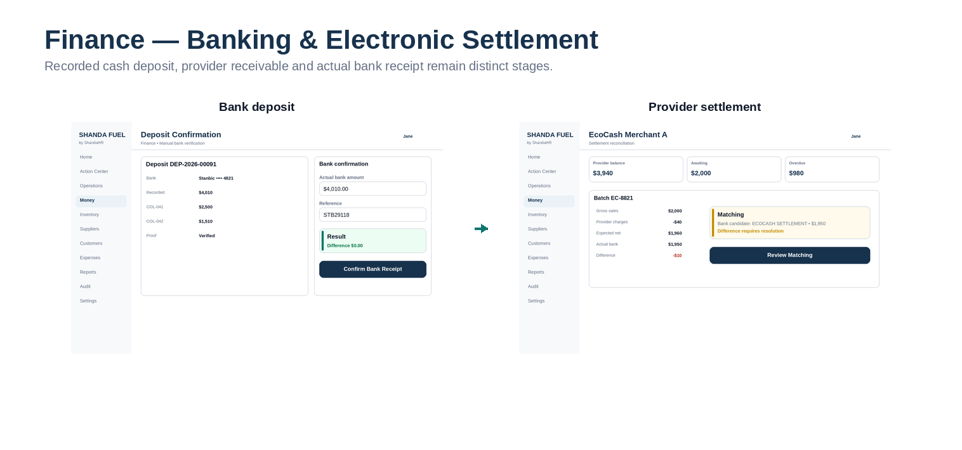
Wireframe board 10: Banking & electronic settlement. Role: Finance.

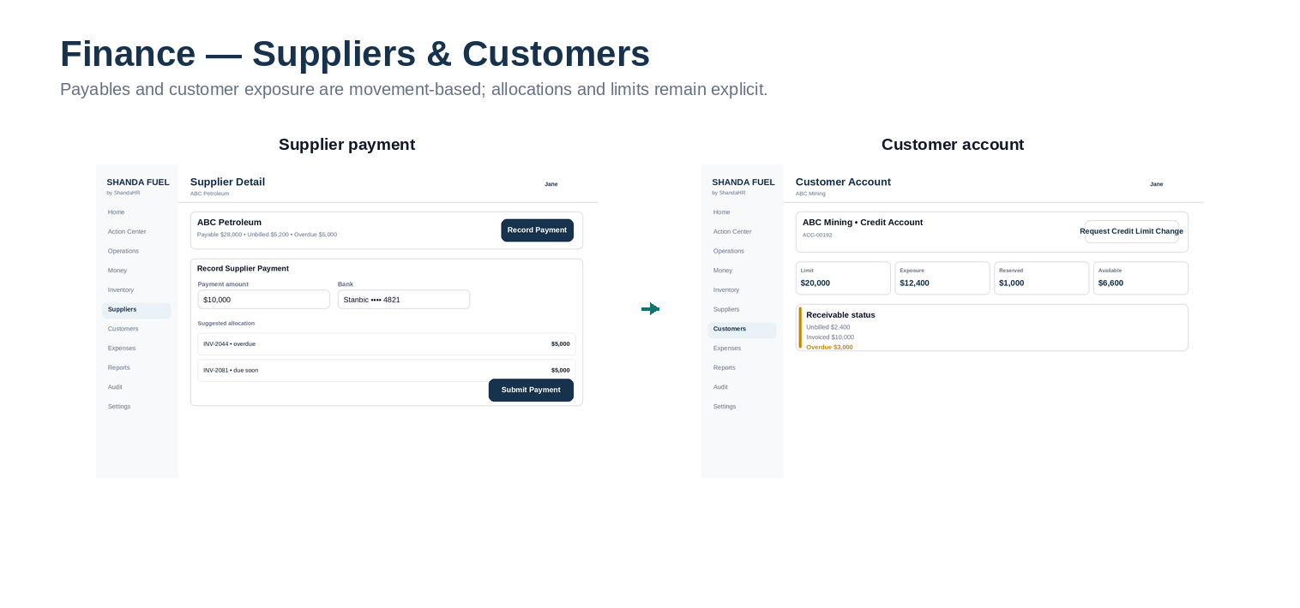
Wireframe board 11: Suppliers & customers. Role: Finance.

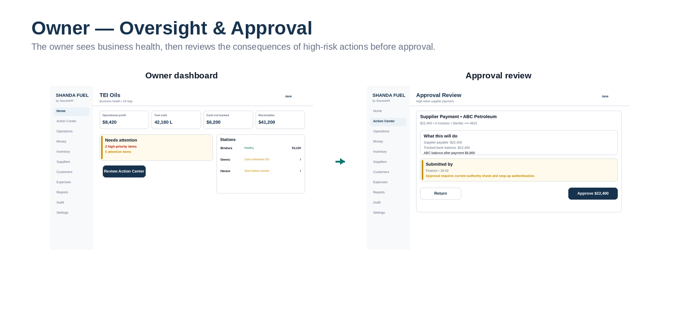
Wireframe board 12: Owner — oversight & approval. Role: Owner / Admin.

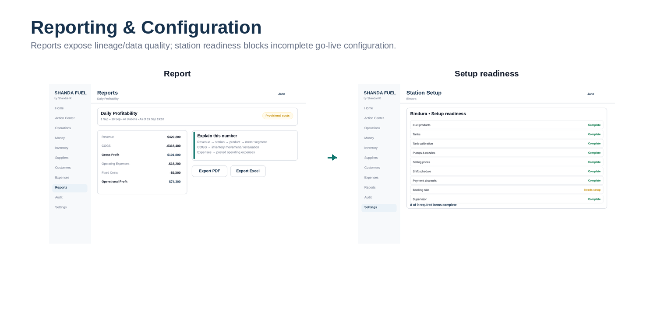
Wireframe board 13: Reporting & station readiness. Role: Owner / Finance / Admin.

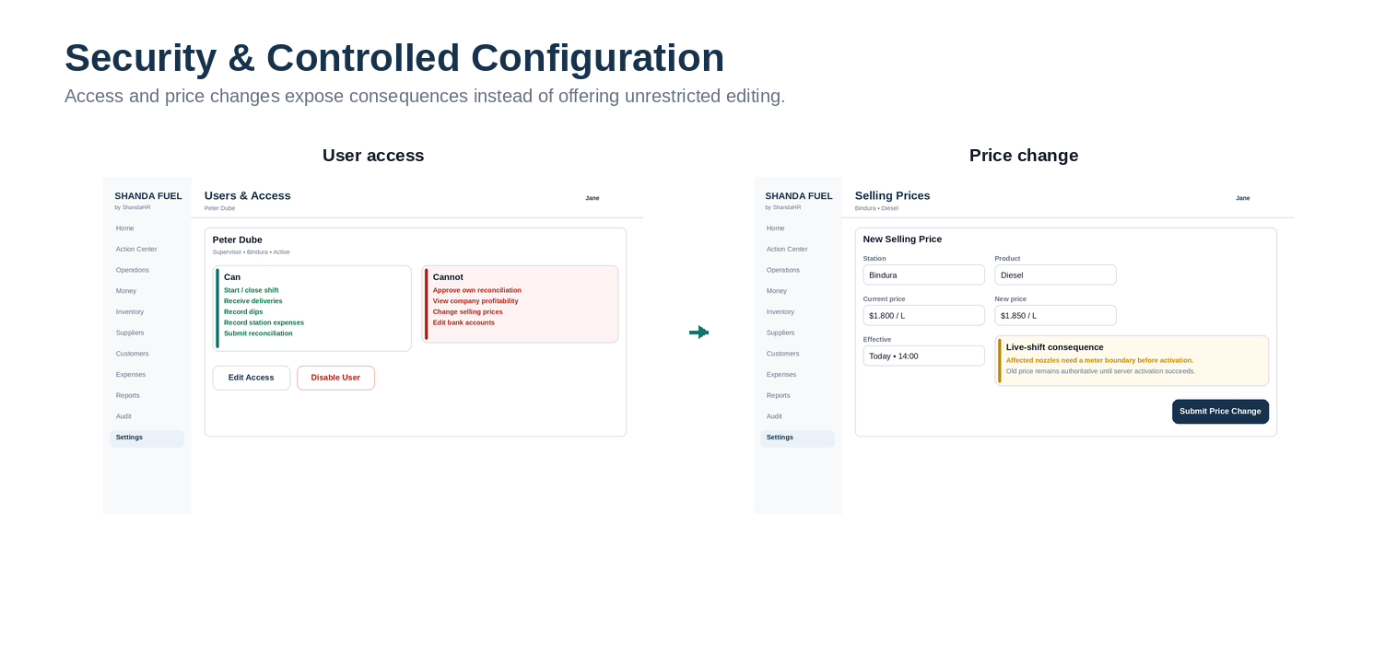
Wireframe board 14: Security & controlled configuration. Role: Owner / Admin.

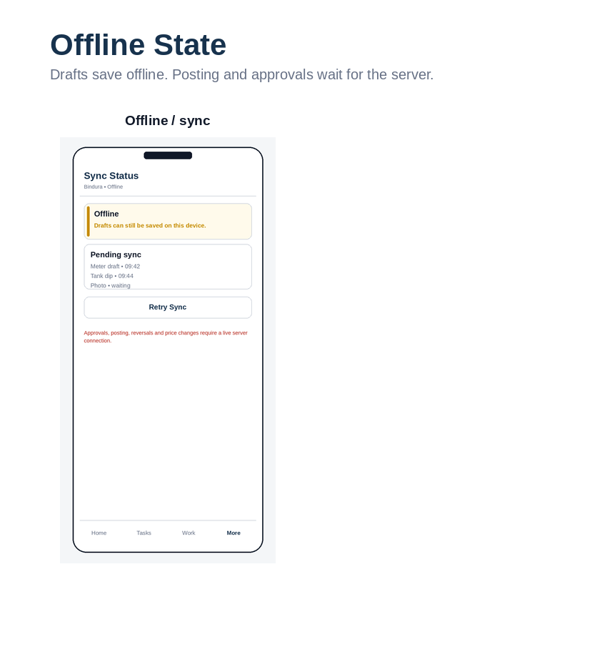
Wireframe board 15: Weak-connection state. Role: All mobile roles.

3. Screen Inventory & Command Mapping
This mapping prevents UI work from inventing new business behavior. A screen may gather draft input, but authoritative state changes must call the named application/domain command shown here.
ID | Screen | Role | Device | Route family | Primary action | Command / state action | Connectivity
WF-01 | Sign in | All users | Mobile/Web | /login | Sign in | Authenticate | Online
WF-02 | Select organisation / station | Multi-scope users | Mobile/Web | /select-organisation | Select context | SelectTenantContext | Online
WF-03 | Attendant Home | Attendant | Mobile | /app/home | Start role task | — | Cached view okay
WF-04 | Account Fuel Request | Attendant | Mobile | /app/work/account-fuel/new | Authorize Fuel | RequestCustomerFuelAuthorization | Online
WF-05 | Account Fuel Authorized | Attendant | Mobile | /app/work/account-fuel/{id} | Confirm Dispense | CompleteCustomerFuelTransaction | Online
WF-06 | Payment Declaration | Attendant | Mobile | /app/work/payment-declaration | Submit Declaration | SubmitPaymentDeclaration | Draft offline; submit online
WF-07 | Returned Declaration | Attendant | Mobile | /app/tasks/{id} | Correct Declaration | ResubmitPaymentDeclaration | Online submit
WF-08 | Supervisor Today | Supervisor | Mobile | /app/operations/today | Continue Shift | — | Cached view okay
WF-09 | Start Shift — Team | Supervisor | Mobile | /app/operations/shifts/{id}/start | Continue | AssignShiftTeam | Online
WF-10 | Start Shift — Opening Readings | Supervisor | Mobile | /app/operations/shifts/{id}/start | Confirm readings | ConfirmMeterBoundary | Online
WF-11 | Shift Workflow | Supervisor | Mobile | /app/operations/shifts/{id} | Open task | — | Mixed
WF-12 | Nozzle Handover | Supervisor | Mobile | /app/operations/nozzles/{id}/handover | Confirm Handover | HandoverNozzle | Online
WF-13 | Close Shift | Supervisor | Mobile | /app/operations/shifts/{id}/close | Meter Close Shift | CloseMeters | Online
WF-14 | Reconciliation Summary | Supervisor | Mobile | /app/operations/reconciliations/{id} | Review exceptions | CalculateReconciliation | Online calculation
WF-15 | Reconciliation Exceptions | Supervisor | Mobile | /app/tasks/{id} | Save explanation | ResolveReconciliationException | Online final
WF-16 | Submit Reconciliation | Supervisor | Mobile | /app/operations/reconciliations/{id}/submit | Submit Reconciliation | SubmitReconciliation | Online
WF-17 | Reconciliation Waiting | Supervisor | Mobile | /app/operations/reconciliations/{id} | View revision | — | Read online/cached
WF-18 | Delivery Verification | Supervisor | Mobile/Tablet | /app/operations/deliveries/{id} | Continue | StartDeliveryVerification | Online
WF-19 | Before Offload | Supervisor | Mobile/Tablet | /app/operations/deliveries/{id} | Capture Boundary & Begin | BeginOffloading | Online
WF-20 | Delivery Interrupted | Supervisor | Mobile/Tablet | /app/operations/deliveries/{id} | Resume / Finish Partial | ResumeOffloading / FinishPartialReceipt | Online
WF-21 | Delivery Review | Supervisor | Mobile/Tablet | /app/operations/deliveries/{id} | Confirm Receipt | ConfirmDelivery | Online
WF-22 | Cash Position | Supervisor | Mobile | /app/money/cash | Count / Prepare Collection | — | Cached view okay
WF-23 | Cash Count | Supervisor | Mobile | /app/money/cash/count | Confirm Count | ConfirmCashCount | Draft offline; confirm online
WF-24 | Prepare Collection | Supervisor | Mobile | /app/money/collections/new | Prepare Handover | PrepareCashCollection | Online
WF-25 | Confirm Handover | Collector | Mobile | /app/tasks/{id} | Confirm received amount | ConfirmCashHandover | Online
WF-26 | Offline / Sync | Mobile roles | Mobile | /app/sync | Retry Sync | SyncDraft | Connection dependent
WF-27 | Finance Home | Finance | Desktop | /app/home | Open Action Center | — | Online
WF-28 | Action Center | Finance | Desktop | /app/actions | Resolve / Match | ResolveException | Online
WF-29 | Deposit Confirmation | Finance | Desktop | /app/money/deposits/{id} | Confirm Bank Receipt | ConfirmBankReceipt | Online
WF-30 | Provider Settlement | Finance | Desktop | /app/money/settlements/{id} | Review Matching | MatchProviderSettlement | Online
WF-31 | Supplier Payment | Finance | Desktop | /app/suppliers/{id} | Submit Payment | SubmitSupplierPayment | Online
WF-32 | Customer Account | Finance | Desktop | /app/customers/accounts/{id} | Request limit change | RequestCustomerLimitChange | Online
WF-33 | Owner Dashboard | Owner | Desktop | /app/home | Review Action Center | — | Online
WF-34 | Approval Review | Owner | Desktop | /app/actions/approvals/{id} | Approve / Return | ApproveSupplierPayment / ReturnApproval | Online + step-up if required
WF-35 | Report View | Owner / Finance | Desktop | /app/reports/{code} | Export / Explain | GenerateReport / GenerateExport | Online
WF-36 | Setup Readiness | Admin | Desktop | /app/settings/stations/{id} | Configure missing item | ValidateStationReadiness | Online
WF-37 | User Access | Owner / Admin | Desktop | /app/settings/users/{id} | Edit Access / Disable | ChangeMembershipAccess / DisableMembership | Online + step-up
WF-38 | Price Change | Pricing authority | Desktop | /app/settings/pricing/new | Submit Price Change | SubmitPriceChange | Online + step-up

4. Developer Handoff Notes
- Wireframes define information architecture and behavior, not reusable component implementation details. Build them with the Shanda design system components.
- All money, litre, meter, price, date and status values shown are representative examples only; production values are server-derived or tenant-configured as defined in the Master Blueprint.
- When a wireframe conflicts with an authoritative state-machine/database invariant, the invariant wins and the wireframe must be corrected.
- Every primary action must have loading, success, business-rule error, permission error and concurrency/conflict states.
- Sensitive fields must not be sent to the browser merely to hide them visually.
- Responsive behavior: desktop tables become mobile cards; long workflows become pages/steps rather than modal stacks.

