* Q. 1 Write python code for to **Perform contrast stretching using Piecewise Linear transformation functions on the input image shown below according to the transfer function shown in the Figure.**

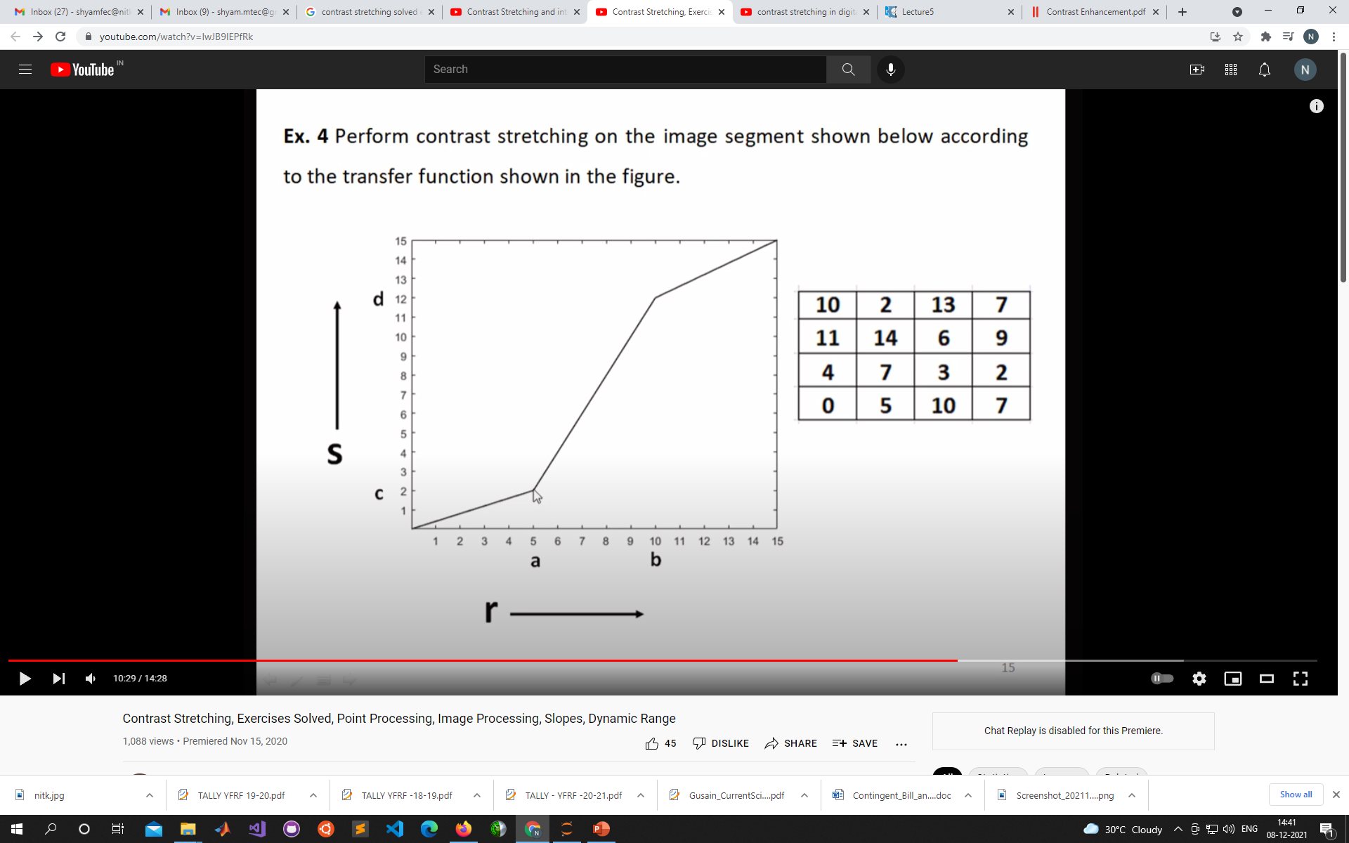

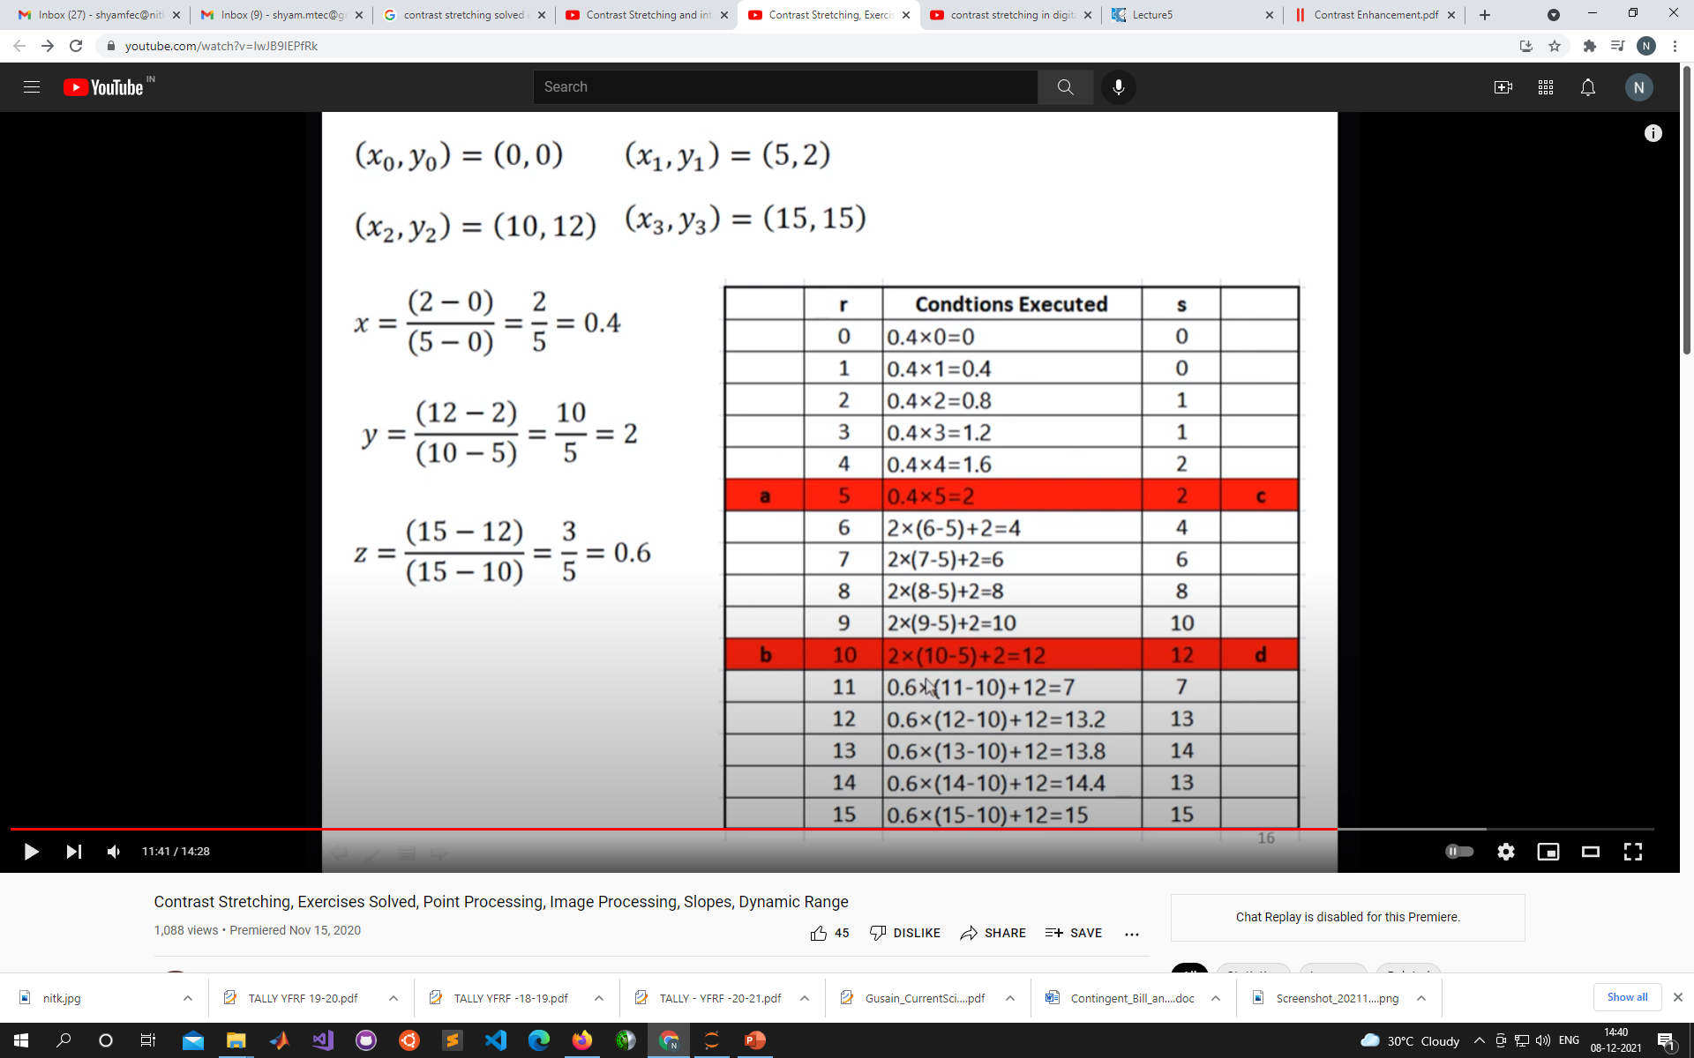

Q.2. Implement in python of the following Matlab implemented concepts  (https://github.com/b1sakher/Contrast-enhancement-in-digital-images)  and link of details are available at  https://www.slideshare.net/SakherBELOUADAH/contrast-enhancement-in-digital-images

1-Local color correction

2-Simplest color balance

3-Screened Poisson Equation for Image Contrast Enhancement

(Hints: First kindly following the following GitHub link to understand the python implementation of the paper:  "[A New Image Contrast Enhancement Algorithm Using Exposure Fusion Framework](https://baidut.github.io/OpenCE/caip2017.html)" <https://github.com/AndyHuang1995/Image-Contrast-Enhancement>)

Q. 3. Implement in python of research paper 1 which is attached

Q. 4. Implement in python of research paper 2 or 3 which are attached