In this project as extension I am adding Extreme Machine Learning Algorithm which is an advance neural network based algorithm and the advantage of this algorithm is filtration of dataset to remove irrelevant columns/attributes and used only important attributes to build machine learning model and due to this filtration an efficient and accurate model will be generated and which can increase prediction accuracy. To run project follow projects screen shots and to run extension concept just you need to run all button and then click on ‘Run Extension Extreme Learning Machine Algorithm’ button to apply ELM algorithm on dataset and to get below prediction accuracy.

Double click on ‘run.bat’ file to get below screen and then run all button and when u click on ‘Run Extension Extreme Learning Machine Algorithm’ button then you will get below extension results

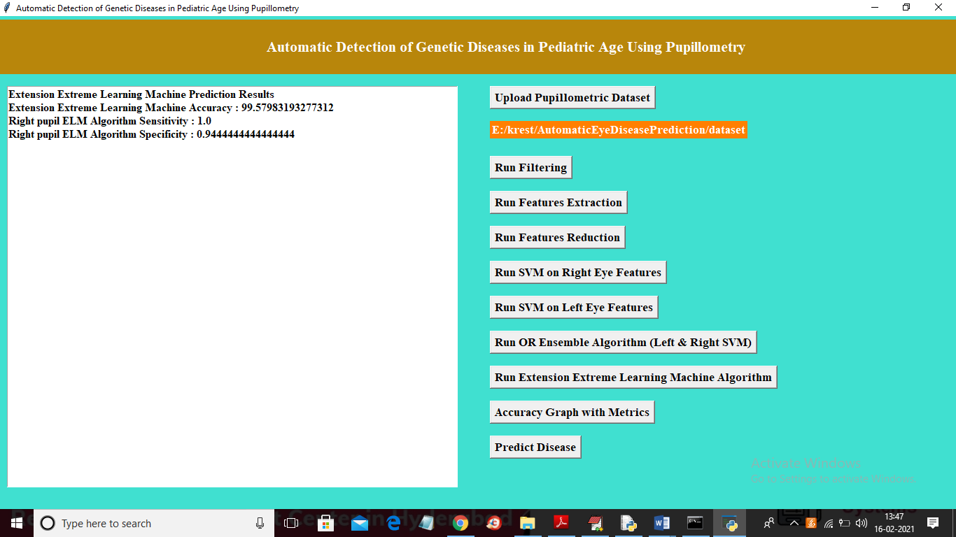

In above screen on same dataset we got 99.57% accuracy and other algorithms got accuracy less than extension accuracy and now click on ‘Accuracy Graph with Metrics’ button to get below screen

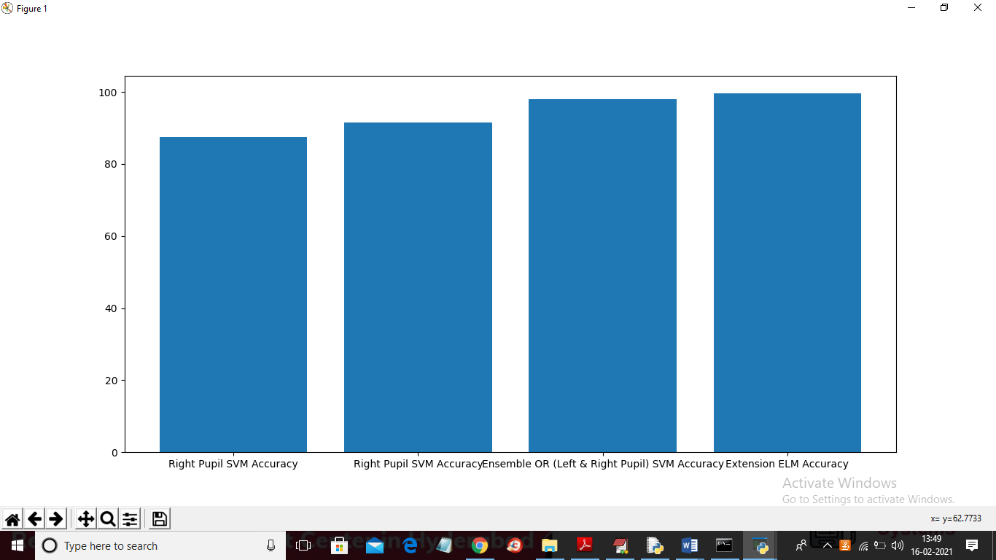

In above graph x-axis represents algorithm name and y-axis represents accuracy of those algorithms and from above graph we can conclude that Extension ELM accuracy is more than other algorithms