In this project as per your request we added LSTM and BI-LSTM algorithms and in below code you can see coding of LSTM and BI-LSTM and for your understanding purpose I wrote comments also with # symbol

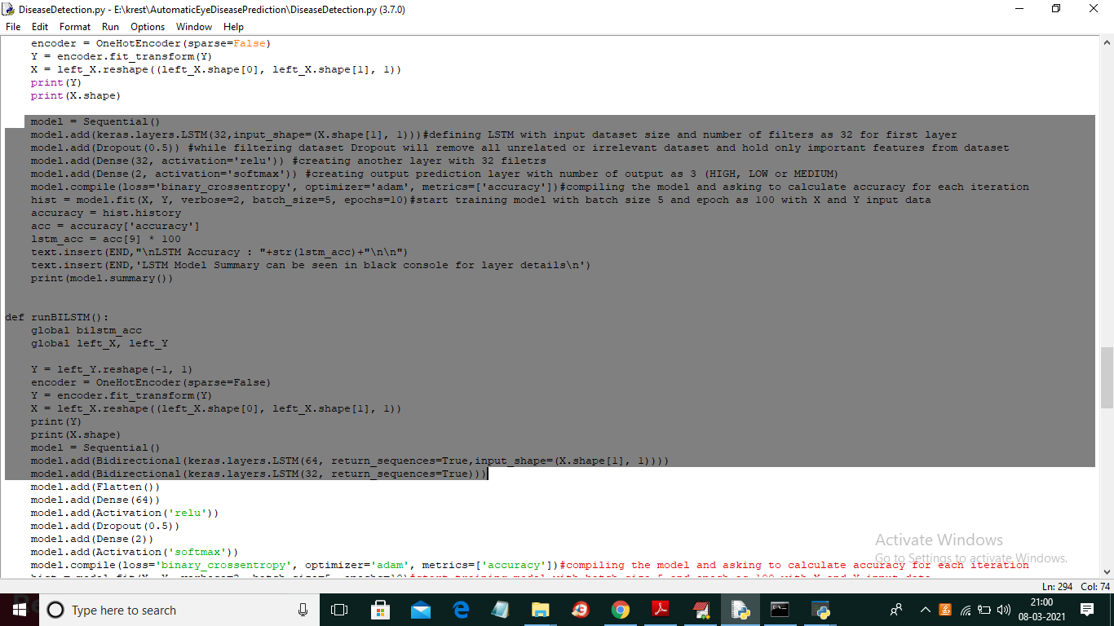

In above screen in selected text you can see implementation of LSTM and Bi-LSTM coding and to run code you just double click on ‘run.bat’ file to get below screen

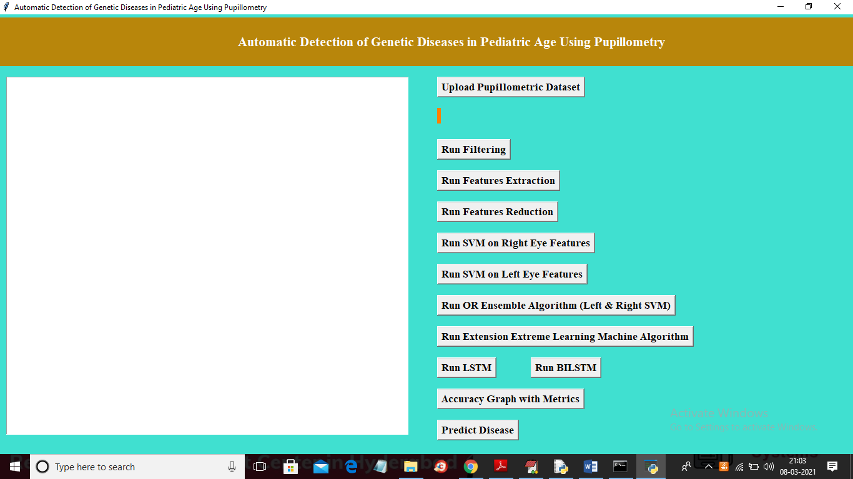

In above screen run all buttons one by one as per previous execution and in above screen you can find 2 extra buttons for LSTM and BI-LSTM algorithms. Now when you run LSTM button then you may get LSTM layer details in black console like below screen

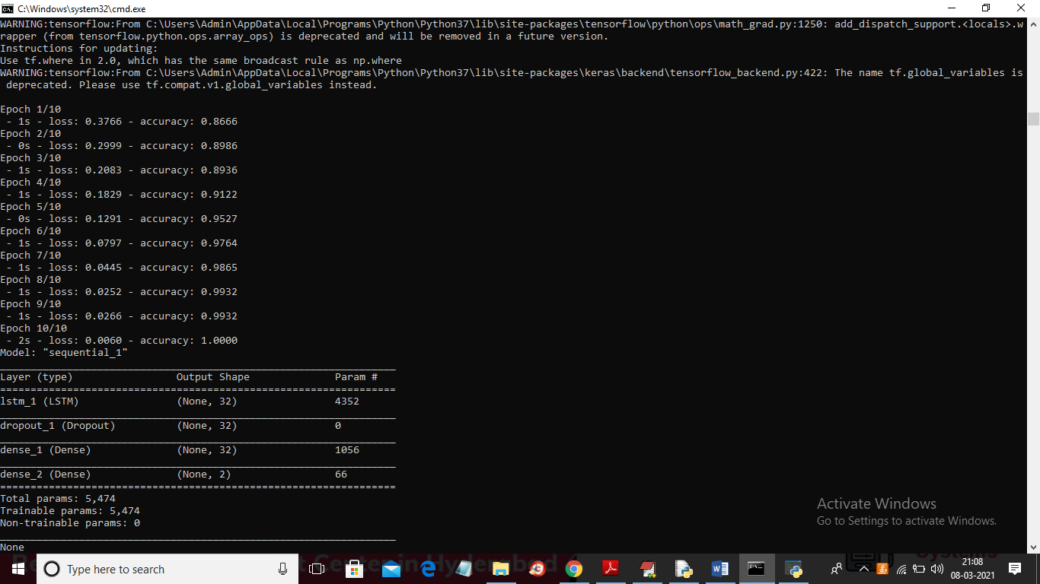

In above screen for LSTM I took 10 iterations or epochs and at each iteration LSTM accuracy get better and better and later we can see LSTM model details and in below screen we can see LSTM final accuracy

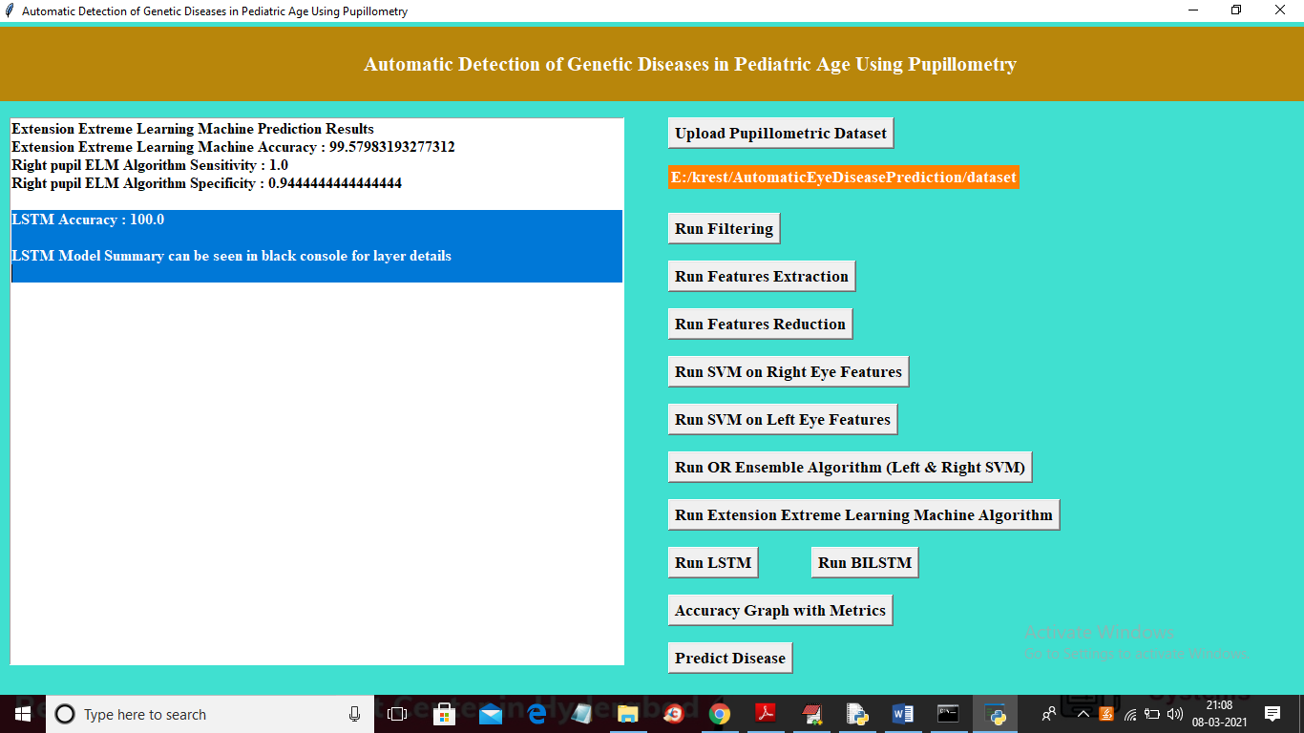

In above screen we got LSTM accuracy as 100% and now click on ‘Run BILSTM button to run BILSTM algorithm and to get below screen

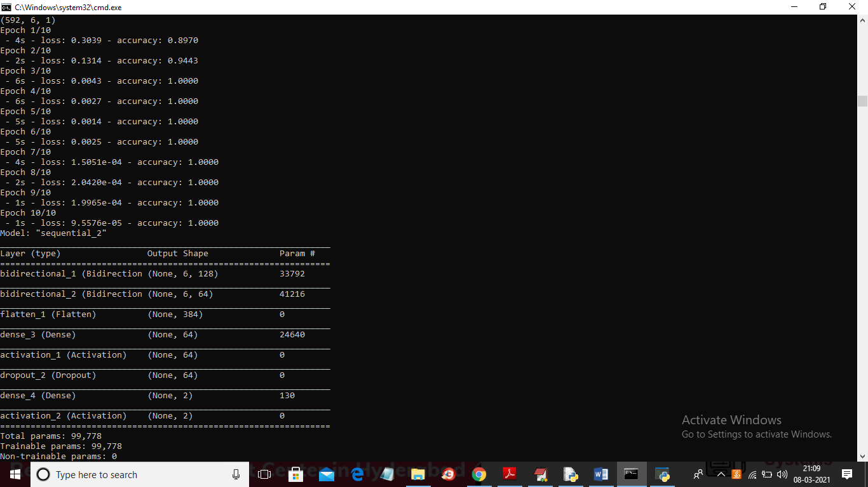

In above console for BILSTM also I took 10 epochs and at third epoch only BILSTM got 100% accuracy and we can say BILSTM better than LSTM and below accuracy we can see bidirectional layer details and now in below screen we can see final BILSTM accuracy

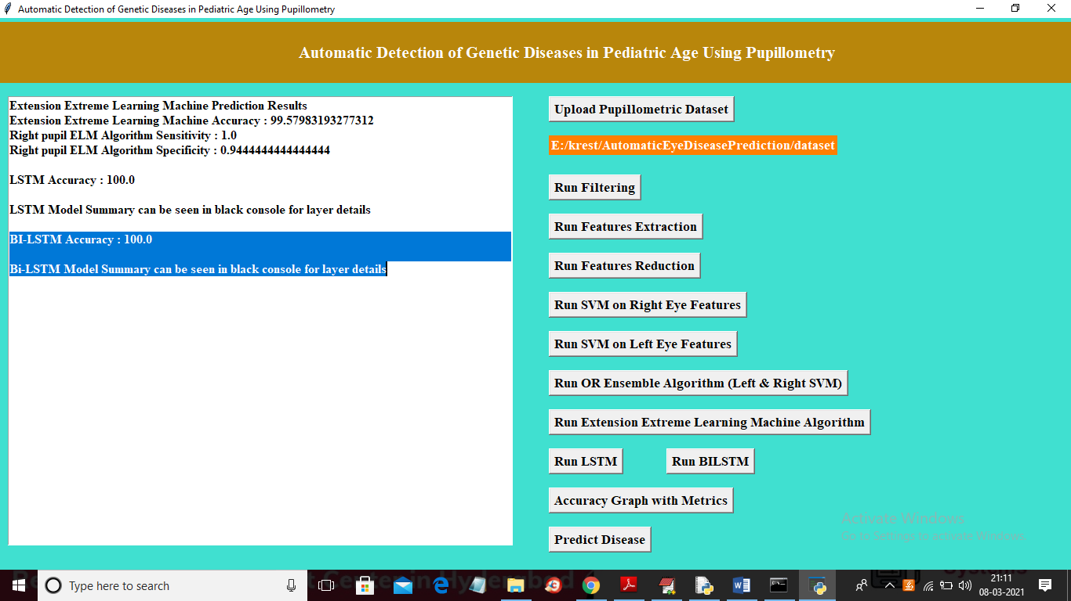

In above screen BI-LSTM accuracy also 100% and now click on ‘Accuracy Graph with Metrics’ button to get below screen

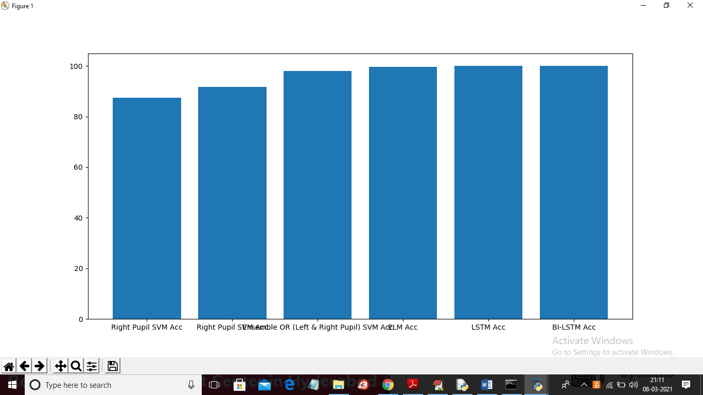

In above graph x-axis represents algorithm name and y-axis represents accuracy values and in all algorithms ELM, LSTM and BILSTM gave better result