TATA CONSUMER PRODUCTS LIMITED
Financial Analysis Report
Prepared by | Independent Financial Analyst
Company | Tata Consumer Products Limited
Period Covered | FY2023-24, FY2024-25, FY2025-26
Data Source | Tata Consumer Products Annual Reports 2024, 2025, 2026
FY2023-24 — FY2025-26

COMPANY PROFILE, HISTORY & EVOLUTION

Chapter Objective
For Tata Consumer, this is particularly important because the company of today is materially different from the business with which its identity was historically associated.
The central theme emerging from the FY2024–25 and FY2025–26 Annual Reports is a continuing transformation:
From a business historically rooted in packeted tea and beverages to an integrated, multi-category Food & Beverage company.

1.1 Tata Consumer Products: Understanding the Company
Tata Consumer Products Limited brings together the food and beverage interests of the Tata Group under one umbrella.
The FY2024–25 Annual Report described the company as having been formed five years earlier with a brand portfolio largely focused on tea, coffee and salt. Since then, Tata Consumer has expanded into multiple categories and consumption occasions while building its reach, platforms and capabilities.
The FY2025–26 Annual Report presents the company's current identity more broadly. Tata Consumer describes itself as an integrated Food & Beverage company with a growing portfolio, operating across brands, formats and channels and serving households in India and key international markets. Its portfolio spans beverages, packaged foods, staples and wellness.
This progression is important. The FY2024–25 report focused on the company's transformation into a broader FMCG platform, while the FY2025–26 report reflects a business whose portfolio now spans a wider set of consumer categories.
Therefore, Tata Consumer should not be understood simply through its traditional association with tea.
Its business identity is increasingly defined by the combination of:
- Established beverage businesses
- Salt and packaged food businesses
- Growth-oriented consumer categories
- Health and wellness offerings
- Ready-to-drink products
- International brands and operations
- New formats and channels
Tata Consumer's Transformation in One View
Packaged Tea Heritage
▼
Tea and Coffee Platform
▼
Tea + Coffee + Salt
▼
Integration of Food Businesses
▼
Expansion Across Multiple Consumption Categories
▼
Integrated Multi-Category Food & Beverage Company
This transformation is the foundation upon which the rest of Tata Consumer's analysis will be built.

1.2 Tata Consumer Products at a Glance
The two annual reports provide a useful picture of the company's scale and the progression of its business.
Particulars | FY2024–25 | FY2025–26
Consolidated Revenue | ₹17,618 crore | ₹20,290 crore*
Retail Reach | 4.4 million outlets | 4.5 million outlets*
Households Reached in India | 275+ million | 290 million*
Global Branded Tea Position | #2 | #2
Growth Portfolio Contribution | — | 31% of India portfolio
Revenue Mix | — | 36% India Beverages, 37% India Foods, 27% International branded revenue
As disclosed in the FY2025–26 Annual Report. The latest report also presents the company's workforce and market presence across India and international regions. The movement from ₹17,618 crore of consolidated revenue in FY2024–25 to more than ₹20,000 crore in FY2025–26 represents a significant increase in business scale.
However, the more important development is not revenue growth alone.
The composition of Tata Consumer's business is also changing. By FY2025–26, the company had a portfolio structure where branded revenue was spread across:
- India Beverages – 36%
- India Foods – 37%
- International Business – 27%
This provides a clearer picture of Tata Consumer as a broader consumer platform rather than a company dependent on a single category.
Investor Interpretation
The company's scale matters, but business composition matters more for understanding its future direction. A company growing within one established category faces a different set of opportunities and risks compared with a company expanding across multiple categories.
Tata Consumer's current investment story is increasingly linked to the following question:
Can the company successfully transform its wider portfolio into sustainable growth, profitability and long-term value creation?

1.3 Historical Roots: The Beginning of the Consumer Business
Tata Consumer's modern business has its roots in the Tata Group's long-standing association with tea. According to the MD & CEO's message in the FY2024–25 Annual Report, the company began its journey as a pioneer in packeted tea operations in the 1980s.
This historical origin is important because it explains the company's original business identity. For many years, Tata Consumer's heritage was closely connected with:
- Tea
- Branded beverages
- International tea operations
Over time, the business expanded its portfolio and developed a presence across coffee and other beverage categories. The company's current global tea position reflects the strength of this historical foundation. The FY2024–25 report identified Tata Consumer as the second-largest branded tea player globally, with strong positions in India, the UK and Canada.
Therefore, Tata Consumer's modern expansion has not replaced its historical businesses.
Instead, the company is attempting to build a broader consumer platform on top of its established category strengths.

1.4 The 2020 Transformation: A Defining Turning Point
The most significant development in Tata Consumer's recent corporate evolution occurred in 2020.
According to management, the company entered a period of rapid transformation with the integration of the salt and foods business of Tata Chemicals. This integration laid the foundation for expanding Tata Consumer's target addressable market and enhancing its portfolio.
This was a defining strategic turning point. Before this transformation, Tata Consumer's identity was substantially associated with beverages.
The integration provided a stronger foundation in food and consumer categories, particularly through the addition of established businesses such as Tata Salt and the wider food portfolio. The significance of this development can be understood as follows:
Before 2020
The company had a strong heritage in:
- Tea
- Coffee
- Beverages
The 2020 Integration
The company gained a stronger platform in:
- Salt
- Food products
- Consumer staples
After 2020
The strategic objective expanded toward:
- A larger addressable market
- More consumption occasions
- A broader FMCG portfolio
- New growth categories
The integration was therefore more than a portfolio addition. It changed the strategic direction of the company. Tata Consumer moved from managing primarily established categories toward building a broader Food & Beverage platform.

1.5 Five Years of Transformation
The FY2024–25 Annual Report provides one of the clearest summaries of Tata Consumer's transformation. Management stated that over the previous five years, the portfolio had grown to span:
- Tea
- Coffee
- Water
- Ready-to-Drink beverages
- Food staples
- Breakfast cereals
- Snacks
- Mini meals
- Cooking aids
- Condiments
- Herbal supplements
This list is important because it demonstrates the extent to which the company has expanded beyond its original business identity. The Transformation Was Not Limited to Product Expansion. Over the same period, management stated that Tata Consumer had also built capabilities across:
- Sales and distribution
- Innovation
- Digitalisation
- Supply chain
This distinction is critical. A company cannot successfully become a multi-category consumer business simply by adding brands and products. It must also develop the organisational capabilities required to manage:
- Multiple categories
- Different consumer segments
- Wider distribution requirements
- Product innovation
- New channels
- Complex supply chains
The transformation of Tata Consumer must therefore be viewed through two dimensions:
Portfolio Transformation
Expansion into new categories and consumption occasions.
Capability Transformation
Development of the systems and organisational capabilities required to operate as a larger FMCG business.

1.6 From Core Categories to Growth Platforms
Tata Consumer's transformation does not involve abandoning its traditional businesses. Instead, management's approach has been to strengthen the core while building additional growth engines. The FY2024–25 Annual Report identified the company's core around:
- Tea
- Coffee
- Salt
Alongside these businesses, Tata Consumer added multiple growth vectors, including:
- Tata Sampann – Pantry staples
- NourishCo Beverages – Ready-to-drink beverages
- Tata Soulfull – Millet-based snacks and mini meals
- Capital Foods – Food brands and cooking categories
- Organic India – Health and wellness platform
This structure gives Tata Consumer a two-part business story.
The Core
The established businesses provide:
- Scale
- Brand recognition
- Existing consumer relationships
- Distribution strength
- Category leadership
The Growth Engines
The newer businesses provide exposure to:
- New consumer needs
- Health and wellness
- Convenience
- New food categories
- Ready-to-drink consumption
- Premium and differentiated offerings
The Company's Strategic Challenge
The opportunity is to create a business where the core provides a stable foundation while the newer portfolio expands the company's growth potential. However, this also creates an important execution challenge:
The growth businesses must eventually demonstrate that expansion can be converted into sustainable profitability and returns.
A broader portfolio does not automatically create shareholder value.
The real test is whether the company can scale these businesses efficiently.

1.7 Acquisitions and Portfolio Expansion
Tata Consumer's transformation has also been supported by acquisitions. Two particularly important additions to the portfolio have been:
Capital Foods
Capital Foods added brands including:
- Ching's Secret
- Smith & Jones
The acquisition strengthened Tata Consumer's presence in food categories such as condiments and cooking-related products.
Organic India
Organic India added a health and wellness platform with products spanning tea and food-related categories. The FY2024–25 Annual Report identified both Capital Foods and Organic India as important additions to Tata Consumer's growth vectors. By FY2025–26, both businesses were reflected within Tata Consumer's group structure, demonstrating their continued integration into the broader portfolio.
Why These Acquisitions Matter
The acquisitions accelerated Tata Consumer's entry into categories that would have taken longer to build organically.
They provided:
- Established brands
- Existing product portfolios
- Consumer recognition
- Category participation
- New growth platforms
However, acquisitions also create a different set of questions for investors. The long-term success of an acquisition depends on:
- Integration
- Growth after acquisition
- Ability to realise strategic benefits
- Capital efficiency
- Profitability
Therefore, in later chapters, particularly Capital Allocation, Financial Analysis and Segment Performance, we will examine whether Tata Consumer's expansion strategy is translating into measurable value creation.

1.8 The Expansion of Consumer Consumption Occasions
One of the most important changes in Tata Consumer's business is its increasing participation across different parts of a consumer's daily routine. The company's portfolio can be understood through the consumption occasions it addresses.
Consumption Need | Relevant Tata Consumer Categories
Daily Beverages | Tea and Coffee
Cooking | Salt, Cooking Aids and Condiments
Pantry | Staples and Related Products
Breakfast | Cereals and Food Products
Snacking | Snacks and Mini Meals
Refreshment | Ready-to-Drink Beverages
Hydration | Water and Beverage Products
Health & Wellness | Herbal Supplements and Wellness Products
This broadening of consumption occasions represents a major change in the company's strategic opportunity. Earlier, the company's consumer relationship was concentrated more heavily around established categories. Today, Tata Consumer is attempting to participate in multiple points of consumer spending.
Investor Interpretation
This expansion creates potential advantages. A wider portfolio can provide:
- A larger addressable market
- Reduced dependence on a limited number of categories
- Greater distribution opportunities
- More opportunities for innovation
- Exposure to emerging consumption trends
At the same time, it also increases:
- Competitive exposure
- Operating complexity
- Brand management requirements
- Supply chain complexity
- Capital requirements for growth
Therefore, the transformation has increased both Tata Consumer's opportunity and its execution responsibility.

1.9 Tata Consumer's Current Portfolio Identity
The FY2024–25 Annual Report described Tata Consumer as an integrated Food & Beverage company aspiring for a larger share of the FMCG market. The FY2025–26 report further described the company's portfolio as spanning:
- Beverages
- Packaged foods
- Staples
- Wellness
across brands, formats and channels in India and key international markets. The latest report also provides a useful perspective on the company's geographic and business mix.
Branded Revenue Mix
Business Area | Share of Branded Revenue
India Beverages | 36%
India Foods | 37%
International Business | 27%
This mix is significant because it demonstrates that Tata Consumer's business has become more balanced across:
- India beverage operations
- India food operations
- International businesses
The company is therefore evolving along two dimensions simultaneously:
Category Diversification
Moving beyond traditional beverage categories.
Geographic Diversification
Maintaining a presence across India and international markets. The FY2024–25 Annual Report also stated that Tata Consumer's brands had a presence in over 40 countries.

1.10 Key Milestones in the Company's Evolution
Period | Development | Importance
1980s | Pioneer in packeted tea operations | Established the foundation of the consumer business
Subsequent Years | Expansion of tea and coffee operations | Built a broader beverages platform
2020 | Integration of Tata Chemicals' salt and foods business | Created the foundation for a broader Food & Beverage strategy
Post-2020 | Expansion into multiple food and beverage categories | Increased the company's participation across consumption occasions
Recent Years | Development of Tata Sampann, Tata Soulfull and RTD platforms | Created additional growth engines
FY2024 | Acquisition of Capital Foods and Organic India | Accelerated expansion into food and wellness categories
FY2024–25 | Revenue reached ₹17,618 crore | Demonstrated increasing business scale
FY2025–26 | Revenue crossed ₹20,000 crore | Marked the next stage of scale in the company's transformation
FY2025–26 | India Foods represented 37% of branded revenue | Demonstrated the increasing importance of the food portfolio
The journey can therefore be summarised as:

Category Heritage | → | Portfolio Integration | → | Diversification | → | New Growth Platforms
Multi-Category Food & Beverage Scale

1.11 Tata Consumer's Purpose and Business Philosophy
The FY2024–25 Annual Report presents the company's mission as: “Passionately growing and transforming every day.”
Its vision is:
“To build better lives and thriving communities.”
The company identifies its values as:
- Empathy
- Integrity
- Excellence
- Agility
- Ownership
While mission and vision statements alone do not determine investment quality, they provide context for the company's broader transformation. The emphasis on growing and transforming is particularly aligned with the strategic direction visible across both annual reports.

1.12 SWOT ANALYSIS
The following SWOT analysis is based on the business characteristics, transformation strategy and disclosures emerging from the FY2024–25 and FY2025–26 Annual Reports.

Strengths
1. Strong Tata Group Heritage
Tata Consumer benefits from being part of one of India's most established business groups.
The Tata heritage supports:
- Consumer trust
- Brand recognition
- Corporate reputation
- Long-term institutional backing
2. Strong Core Businesses and Category Positions
The company has established positions in important categories. The FY2024–25 report highlighted Tata Consumer's positions as:
- Largest salt brand in India
- Second-largest branded tea player in India
- Second-largest branded tea player in the UK
- Largest tea brand in Canada
- Fourth-largest Roast & Ground coffee brand in the USA
These positions provide Tata Consumer with an established base from which it can build new businesses.
3. Increasing Portfolio Diversification
The company has expanded from a portfolio largely focused on tea, coffee and salt into multiple categories and consumption occasions. This reduces dependence on a limited number of businesses and expands the company's addressable market.
4. Large Consumer and Distribution Reach
FY2024–25 disclosures highlighted:
- More than 275 million households reached in India

4.4 million retail outlets
The FY2025–26 report further reflected an expanded retail and household reach. A wide distribution network can become an important competitive advantage when scaling multiple brands and categories.
5. Balanced Business Mix
By FY2025–26, branded revenue was spread across:
- India Beverages
- India Foods
- International Business
This reflects a broader business structure than the company's historical identity would suggest.

Weaknesses
1. Increasing Business Complexity
The company's transformation has significantly expanded the number of categories, brands and consumer segments it must manage. A more diversified portfolio requires greater:
- Operational coordination
- Brand management
- Supply chain capabilities
- Distribution efficiency
2. Dependence on Execution in New Categories
The growth portfolio still requires successful execution. Expansion into new categories requires the company to continuously:
- Build brands
- Develop products
- Expand distribution
- Compete effectively
- Maintain profitability
3. Acquisition Integration Requirements
Capital Foods and Organic India expand Tata Consumer's opportunity but also increase integration and execution requirements. The long-term value of these additions will depend on how successfully they are integrated and scaled.

Opportunities
1. Expanding Indian Consumer Market
The FY2024–25 report highlighted opportunities arising from:
- Rising disposable incomes
- Urbanisation
- Digital adoption
- Growing consumption
- Premiumisation
These trends support the company's broader Food & Beverage ambitions.
2. Health and Wellness
Changing consumer preferences create opportunities in:
- Health-focused foods
- Wellness products
- Herbal products
- Nutrition-oriented offerings
Organic India and the company's broader portfolio provide exposure to this opportunity.
3. New-Age Distribution Channels
The FY2024–25 report identified the rapid adoption of e-commerce and quick commerce as an important change in the FMCG sector. This provides Tata Consumer with additional routes to reach consumers.
4. Portfolio Synergies
A broader consumer platform can potentially allow the company to leverage:
- Distribution infrastructure
- Consumer insights
- Brand-building capabilities
- Digital channels
across multiple categories.

Threats
1. Commodity and Input Cost Volatility
The company remains exposed to movements in key input and commodity costs, particularly across its traditional categories.
2. Intense Competition
The Food & Beverage market includes:
- Large FMCG companies
- Global brands
- Category specialists
- New consumer brands
As Tata Consumer expands into more categories, it also enters more competitive markets.
3. Execution Risk
The company's strategy involves managing transformation across:
- Core businesses
- Growth categories
- Acquisitions
- Distribution
- Innovation
- New channels
The larger the portfolio becomes, the more important execution discipline becomes.
4. Changing Consumer Preferences
Consumer categories can change rapidly. The company must continue to innovate and remain relevant across multiple segments.

INVESTOR TAKEAWAY
Tata Consumer's investment story is undergoing a transition.
An investor looking only at the company's traditional tea and beverage heritage would miss the larger structural change taking place.
The company has evolved through a clear sequence:
Tea Heritage
▼
Beverage Platform
▼
Integration of Salt and Foods
▼
Expansion into Multiple Consumption Categories
▼
Acquisitions and New Growth Platforms
▼
Integrated Multi-Category Food & Beverage Company
The FY2024–25 and FY2025–26 Annual Reports show that this transformation is continuing. The company has increased its scale, broadened its category participation and developed a more balanced business mix across India Beverages, India Foods and International Business.
The Positive Side
Tata Consumer has several characteristics that support its transformation:
- Strong Tata Group heritage
- Established category leadership
- Recognised brands
- Large consumer reach
- Broad distribution
- Increasing participation in food categories
- Exposure to wellness and new consumption trends
- International presence
The Challenge
The future of the investment story will increasingly depend on execution.
The company must prove that its broader portfolio can generate:
- Sustainable growth
- Profitable growth
- Strong cash generation
- Effective capital allocation
- Attractive long-term returns
Therefore, the central investor question is no longer:
How strong is Tata Consumer's tea business?
The more relevant question is:
Can Tata Consumer successfully convert its transformation into a diversified Food & Beverage platform into sustainable shareholder value?

CHAPTER 2: INDUSTRY LANDSCAPE & COMPETITIVE POSITION
Objective
After understanding Tata Consumer's history and transformation in the previous chapter, the next step is to understand the industry environment in which the company operates. Tata Consumer is no longer a business concentrated in a single category. Its portfolio now extends across multiple areas of the Food & Beverage market, including:
- Tea
- Coffee
- Salt
- Packaged foods
- Pantry staples
- Breakfast and snacking
- Cooking aids and condiments
- Ready-to-drink beverages
- Water
- Health and wellness
As a result, the company operates within a much broader and more competitive environment than its traditional tea business alone.
The key objective is to understand:
Is Tata Consumer operating in an attractive industry, and is the company strategically positioned to benefit from the opportunities within it?

2.1 Understanding Tata Consumer's Industry Position
Tata Consumer operates within the broader FMCG and Food & Beverage industry. However, the company's diversified portfolio means that it participates in several different consumer categories rather than operating within a single market. Its business today can broadly be understood across three major areas:
Business Area | Key Categories
India Beverages | Tea, Coffee, Ready-to-Drink Beverages and Related Products
India Foods | Salt, Staples, Breakfast, Snacks, Cooking Aids and Condiments
International Business | Tea, Coffee and Other Branded Food & Beverage Products
The company also has a growing presence in the health and wellness space through its portfolio of organic and herbal products. The importance of this diversified structure becomes clearer when looking at the company's branded revenue mix during FY2025–26.
Business Area | Share of Branded Revenue
India Beverages | 36%
India Foods | 37%
International Business | 27%
The composition of branded revenue demonstrates an important structural change in Tata Consumer's business. Historically, the company was strongly associated with beverages. Today, India Foods represents an equally significant part of the company's branded revenue base.
Analytical Perspective
This diversified structure creates a larger growth opportunity for Tata Consumer. However, it also means that the company competes across multiple categories, each with its own:
- Consumer preferences
- Competitive environment
- Pricing dynamics
- Distribution requirements
- Input costs
- Growth opportunities
Therefore, Tata Consumer's competitive position cannot be assessed through its position in tea or salt alone. It must be assessed as a broader Food & Beverage platform.

2.2 The Indian FMCG Environment
India remains one of the most important markets for Tata Consumer's growth. The domestic consumer environment continues to be supported by several structural factors, including:
- Rising disposable incomes
- Urbanisation
- A growing middle class
- Increasing consumer aspirations
- Digital adoption
- Growth in organised consumption
These developments are creating opportunities for FMCG companies across both essential and discretionary consumption categories. For Tata Consumer, the significance lies in the breadth of its portfolio.
A growing consumer market does not benefit all companies in the same way. Companies with a presence across multiple categories can potentially participate in different forms of consumption growth.
Key Drivers Supporting Consumer Growth
Rising Disposable Income
As incomes increase, consumers are able to spend more on:
- Branded products
- Premium products
- Convenience-oriented offerings
- Health and wellness products
This creates opportunities for Tata Consumer beyond its traditional mass-market categories.
Urbanisation
Urban lifestyles are changing the way consumers purchase and consume food and beverages. Increasingly, consumers are looking for:
- Convenience
- Ready-to-consume products
- Packaged foods
- Differentiated products
- Premium offerings
These trends support the expansion of categories such as ready-to-drink beverages, snacks, mini meals and packaged foods.
Growing Consumer Aspirations
Indian consumers are increasingly seeking products that provide:
- Better quality
- Convenience
- Health benefits
- Premium experiences
- Brand assurance
This provides an opportunity for companies that can successfully build differentiated brands.

2.3 Changing Consumer Trends
The Food & Beverage industry is being influenced by significant changes in consumer behaviour. Several trends are becoming increasingly important to Tata Consumer's long-term strategy. These include:
- Premiumisation
- Health and wellness
- Convenience
- Digital commerce
- Quick commerce
- Changing consumption occasions
Tata Consumer's portfolio transformation appears increasingly aligned with these trends.
Premiumisation
Premiumisation is becoming an important opportunity across Food & Beverage categories. Consumers are increasingly willing to explore products that offer:
- Higher quality
- Better experiences
- Differentiated products
- Health benefits
- Premium positioning
This creates opportunities across categories such as:
- Tea
- Coffee
- Packaged foods
- Wellness
- Beverages
For Tata Consumer, premiumisation is important because it can help the company move beyond growth driven purely by volumes. A stronger premium portfolio can potentially improve:
- Revenue per unit
- Product mix
- Brand value
- Profitability
However, premiumisation is not automatically beneficial. The company must successfully establish:
- Product differentiation
- Consumer acceptance
- Brand relevance
- Appropriate pricing
Therefore, premiumisation should be viewed as an opportunity that requires execution, rather than an automatic source of higher returns.

2.4 Health and Wellness
Health and wellness is becoming an increasingly important area of consumer spending. Consumers are showing greater interest in:
- Organic products
- Herbal products
- Health-oriented food
- Better-for-you products
- Nutritional offerings
Tata Consumer's portfolio expansion provides exposure to this trend. The acquisition of Organic India strengthened the company's presence in:
- Organic Food & Beverage
- Herbal health supplements
- Wellness-oriented products
The company also participates in other categories associated with changing consumer preferences, including millet-based products and health-oriented offerings.
Why This Matters
Health and wellness provides Tata Consumer with an opportunity to participate in a part of the consumer market that extends beyond traditional daily consumption.
However, the category also requires:
- Strong consumer trust
- Product credibility
- Innovation
- Brand differentiation
The long-term potential of the wellness portfolio will therefore depend on the company's ability to successfully scale these businesses.

2.5 Convenience and Changing Consumption Occasions
Consumer lifestyles are increasingly creating demand for products that offer convenience. This is particularly relevant to categories such as:
- Ready-to-drink beverages
- Ready-to-cook products
- Cooking aids
- Condiments
- Snacks
- Mini meals
Tata Consumer has expanded its portfolio into several of these areas. This is strategically important because the company is attempting to participate in a larger number of consumption occasions.
Earlier, a consumer's relationship with the company could have been concentrated around products such as tea or salt. Today, the company has the potential to participate across:
Morning Consumption
- Tea
- Coffee
- Breakfast products
Cooking and Meals
- Salt
- Staples
- Cooking aids
- Condiments
Snacking
- Snacks
- Mini meals
Refreshment
- Ready-to-drink beverages
- Water
Health and Wellness
- Organic products
- Herbal products
Analytical Perspective
The broader participation in consumption occasions creates a larger addressable market. However, it also means that Tata Consumer must compete with different companies across every category. The company's competitive advantage must therefore come not only from adding more products but from successfully using its:
- Brands
- Distribution
- Consumer understanding
- Innovation
- Scale
across the broader portfolio.

2.6 The Rise of E-Commerce and Quick Commerce
One of the most important changes in the FMCG industry is the rise of new-age distribution channels. Traditional FMCG distribution was largely dependent on physical retail networks.
Today, companies increasingly need to reach consumers through:
- General trade
- Modern trade
- E-commerce
- Quick commerce
Tata Consumer has been strengthening its omnichannel presence to participate in this changing environment. The company has highlighted its leadership in e-commerce for packaged beverages and the rapid growth of quick commerce as an important development in its distribution strategy.
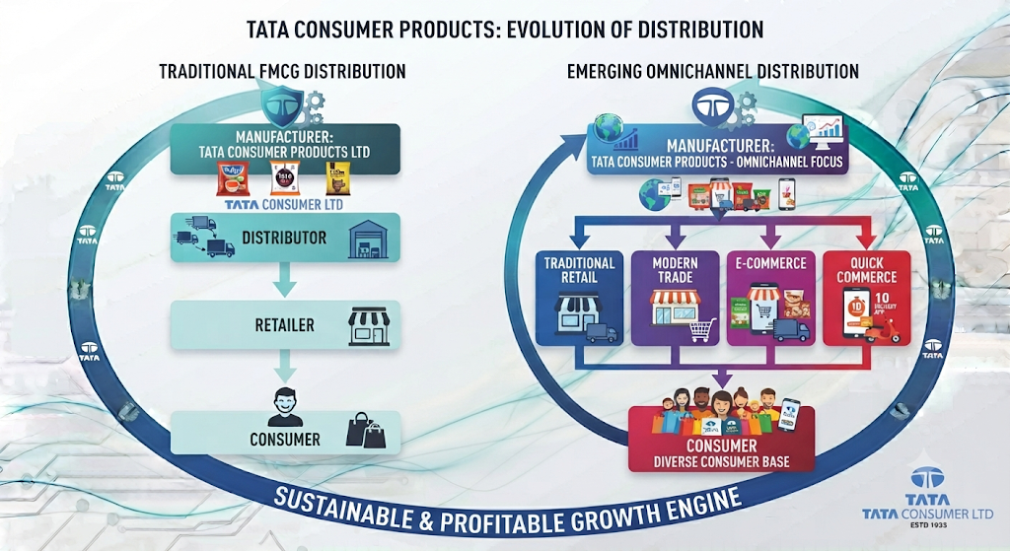This change is strategically significant. New-age channels allow consumer companies to:
- Reach consumers directly and faster
- Improve product availability
- Introduce new products
- Increase visibility
- Access consumer purchasing data
For Tata Consumer, omnichannel distribution can become increasingly important as its portfolio expands into newer categories.

2.7 Rural and Urban Consumption
India's consumption opportunity is not concentrated in one type of market. Both rural and urban markets remain important, but consumer behaviour differs significantly.
Urban Markets
Urban consumers increasingly drive:
- Premiumisation
- Convenience
- Digital commerce
- Quick commerce
- New product adoption
Rural Markets
Rural markets provide opportunities through:
- Expanding consumption
- Increasing access to branded products
- Improved connectivity
- Greater distribution reach
Tata Consumer's strategy therefore needs to address both markets.
Urban Opportunity | Rural Opportunity
Premiumisation | Increasing consumption
Convenience | Greater branded product penetration
Quick Commerce | Wider market access
E-Commerce | Improving connectivity
New Categories | Expansion of FMCG distribution
The company's broad portfolio provides flexibility to participate across different types of consumer demand.
However, effective execution requires strong distribution and category-specific strategies.

2.8 Category Landscape and Tata Consumer's Position
Tata Consumer's competitive position differs across its major categories.
Tea
Tea remains one of Tata Consumer's strongest and most established businesses. The company holds significant positions across several markets, including:
- Second-largest branded tea player globally
- Second-largest branded tea player in India
- Second-largest branded tea player in the UK
- Largest tea brand in Canada
Tea provides Tata Consumer with:
- Strong consumer recognition
- Established brands
- Category experience
- Distribution strength
- International presence
Industry Challenge
Despite its established position, the tea business faces challenges such as:
- Commodity price volatility
- Competitive intensity
- Changing consumer preferences
- The need for premiumisation and innovation
Therefore, Tata Consumer's strategy in tea must balance the strength of its traditional business with the need to maintain relevance in an evolving market.
Salt
Tata Salt remains one of the company's most important consumer brands. The company holds the position of the largest salt brand in India. Salt provides a strong foundation because it is:
- An essential household product
- A high-frequency consumption category
- A widely recognised brand
- Supported by large-scale distribution
The category provides stability to the portfolio. However, long-term value creation requires the company to continue strengthening its product mix and category position.
Coffee
Coffee provides Tata Consumer with exposure to both Indian and international markets. The company has a significant position in the international coffee market and is among the leading Roast & Ground coffee brands in the United States. Coffee also provides opportunities in:
- Premiumisation
- Distribution expansion
- Product innovation
However, coffee is particularly sensitive to commodity price volatility. Therefore, growth in the category must be assessed alongside the company's ability to manage input costs and margins.
India Foods
India Foods has become one of the most important parts of Tata Consumer's transformation.
The company's food portfolio includes brands and categories such as:
- Tata Sampann
- Tata Soulfull
- Ching's Secret
- Smith & Jones
During FY2025–26, India Foods contributed:

37% of branded revenue
This is slightly higher than the contribution from India Beverages.
Why This Is Important
This demonstrates that Tata Consumer's transformation into a broader Food & Beverage company is becoming visible in its revenue composition. Food is no longer simply an additional growth category.
It has become a major part of the company's branded business. The future performance of India Foods will therefore become increasingly important to Tata Consumer's overall growth story.
Health and Wellness
The health and wellness portfolio provides Tata Consumer with exposure to a different type of consumer opportunity.
Organic India operates across:
- Organic Food & Beverage
- Herbal health supplements
- Wellness products
The strategic importance of this business lies in its exposure to changing consumer preferences. Health and wellness can provide long-term growth opportunities, but the category also requires continued investment in:
- Brand trust
- Innovation
- Consumer awareness
- Distribution
Ready-to-Drink and Hydration
Tata Consumer has also expanded beyond traditional hot beverages. Its portfolio includes businesses across:
- Ready-to-drink products
- Packaged water
- Hydration
Himalayan holds a leading position in the natural mineral water market in India. The company's participation in these categories increases its exposure to evolving consumer preferences. However, demand in beverage categories can also be affected by:
- Seasonality
- Weather conditions
- Competitive intensity

2.9 Tata Consumer's Competitive Strengths
Tata Consumer's competitive position is based on multiple strengths rather than one individual advantage.
1. Strong Brand Portfolio
The company operates established brands across multiple categories. Its portfolio includes brands associated with:
- Tea
- Coffee
- Salt
- Staples
- Snacking
- Condiments
- Wellness
Strong brands can support:
- Consumer trust
- Product recognition
- Pricing power
- New product expansion
2. Wide Distribution Network
Tata Consumer's products reach millions of retail outlets and hundreds of millions of households in India. A strong distribution network is particularly important because it allows the company to scale newer products alongside established brands. The broader the portfolio becomes, the more valuable an efficient distribution network can be.
3. Category Leadership
The company holds strong positions across several major categories and international markets. Category leadership provides:
- Brand strength
- Scale
- Consumer recognition
- Competitive positioning
4. Portfolio Diversification
The company's business is now spread across:
- India Beverages
- India Foods
- International Business
This diversification provides Tata Consumer with multiple growth avenues. It also reduces dependence on a single category.
5. International Presence
Tata Consumer has operations and brands across international markets. Its international presence provides:
- Geographic diversification
- Access to developed markets
- Exposure to different consumer segments
- Opportunities for premiumisation
However, international operations also expose the company to:
- Currency movements
- Trade disruptions
- Geopolitical uncertainty
6. Omnichannel Presence
The company's ability to operate across traditional and digital channels is becoming increasingly important. Its presence across:
- General trade
- Modern trade
- E-commerce
- Quick commerce
provides flexibility in reaching consumers.

2.10 Industry Risks and Challenges
The Food & Beverage industry provides growth opportunities, but it also presents several risks.
Commodity Price Volatility
Tata Consumer remains exposed to volatility in agricultural commodities, particularly:
- Tea
- Coffee
Changes in commodity prices can affect:
- Input costs
- Gross margins
- Product pricing
- Profitability
Climate and Weather Risks
Weather conditions can influence:
- Agricultural production
- Commodity availability
- Consumer demand
Certain categories such as packaged water and ready-to-drink beverages can also be affected by seasonal and weather-related changes. Climate volatility therefore represents both a supply-side and demand-side risk.
Competitive Intensity
Tata Consumer competes with:
- Large FMCG companies
- Global companies
- Category specialists
- Emerging consumer brands
As the company enters new categories, its competitive environment becomes broader. The company must therefore continuously invest in:
- Brand building
- Innovation
- Distribution
- Product differentiation
International Risks
The company's international operations expose it to:
- Geopolitical developments
- Trade restrictions
- Tariffs
- Shipping disruptions
These factors can influence:
- Costs
- Supply chains
- International sales
International diversification is therefore both an opportunity and a source of additional risk.

2.11 Industry Opportunity Versus Industry Risk
Opportunity | Risk
Rising consumer incomes | Commodity inflation
Premiumisation | Competitive pricing
Health and wellness | Changing consumer preferences
E-Commerce growth | Channel competition
Quick Commerce | Execution requirements
Food category expansion | Portfolio complexity
International opportunities | Trade and geopolitical disruptions
Wider consumer reach | Higher operating complexity
This comparison is important for understanding Tata Consumer. The company operates in an industry with strong structural growth opportunities. However, growth alone does not guarantee profitability or shareholder returns. The company's success will depend on its ability to: Capture consumer opportunities while controlling costs, managing competition and maintaining strategic discipline.

2.12 CHAPTER ANALYSIS
The industry analysis shows that Tata Consumer's transformation is taking place at a time when the Food & Beverage market itself is changing significantly. The major structural trends include:
- Rising consumer spending
- Premiumisation
- Health and wellness
- Convenience
- Digital commerce
- Quick commerce
- Expansion of branded consumption
Tata Consumer's portfolio is increasingly aligned with these changes. The company is expanding:

From traditional beverages | → | into packaged foods

From essential consumption | → | into discretionary categories

From traditional retail | → | into omnichannel distribution

From established products | → | into health, wellness and convenience
The company's business composition also demonstrates that this transformation is becoming more significant. India Foods contributed 37% of branded revenue, while India Beverages contributed 36%. This indicates that the company's food business has become comparable in importance to its established beverage operations.
The Positive Side
Tata Consumer has several advantages:
- Strong brands
- Category leadership
- Wide distribution
- Tata Group heritage
- International presence
- Growing food portfolio
- Exposure to emerging consumer trends
The Challenge
The company must manage:
- Commodity volatility
- Competitive intensity
- Portfolio complexity
- Acquisition integration
- New-age channel development
- Changing consumer behaviour
Therefore, Tata Consumer's competitive position appears to be strengthening, but its future performance will depend heavily on execution. The company has created a broader platform. The next stage is to determine:
How effectively is this platform being managed, and how does Tata Consumer actually generate revenue and create value from its portfolio?

INVESTOR TAKEAWAY
Tata Consumer operates in an attractive long-term consumer environment.
The growth of India's consumer economy, combined with trends such as premiumisation, health and wellness, convenience and digital commerce, provides the company with multiple opportunities. The company's transformation appears strategically aligned with these trends.
Its portfolio now allows participation across:
- Daily beverages
- Household essentials
- Food
- Snacking
- Convenience
- Wellness
- Hydration
The strongest structural development is the increasing importance of the food business.
With India Foods contributing 37% of branded revenue, Tata Consumer is increasingly becoming a balanced Food & Beverage company rather than a business primarily associated with tea and beverages. However, the opportunity should be viewed alongside the risks.
A broader portfolio creates:
- Greater growth opportunities
- Greater execution complexity
The company must compete across more categories, manage more brands and respond to a wider range of consumer and industry risks. Therefore, the central investor conclusion from this chapter is:
Tata Consumer appears to be strategically positioned in several attractive consumer growth areas, but the investment case will ultimately depend on whether the company can convert this broad industry opportunity into sustainable profitable growth and long-term shareholder value.
CHAPTER 3: BUSINESS MODEL, PORTFOLIO STRUCTURE & HOW TATA CONSUMER MAKES MONEY

Chapter Objective
After understanding Tata Consumer's industry environment and competitive position, the next important question is: How does Tata Consumer actually make money?
For a consumer company, revenue generation is not simply about manufacturing and selling products. The business model involves a complete system:
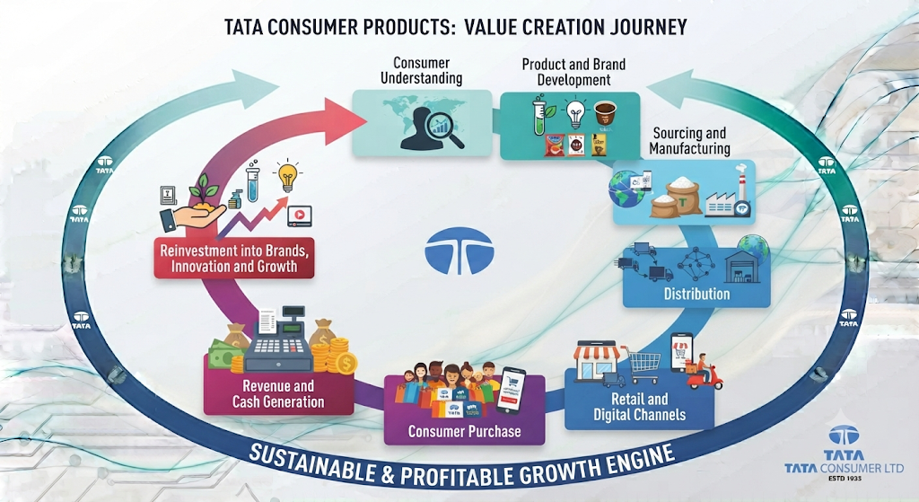
Tata Consumer's business model has become increasingly important to understand because the company has transformed from a portfolio primarily associated with beverages into a broader Food & Beverage platform.
The company now operates across:
- Established core categories
- Growth-oriented food businesses
- Ready-to-drink products
- Health and wellness
- International markets
- Multiple distribution channels

What Tata Consumer sells | → | Who it sells to | → | How its portfolio is structured | → | How products reach consumers
How the business generates revenue |  |  | → | What supports future growth.

3.1 Understanding Tata Consumer's Business Model
At its core, Tata Consumer operates as a branded Food & Beverage company. The company creates value by building consumer brands, developing products, sourcing or manufacturing those products and making them available through a large distribution network across India and international markets.
The fundamental business model can be understood as follows:
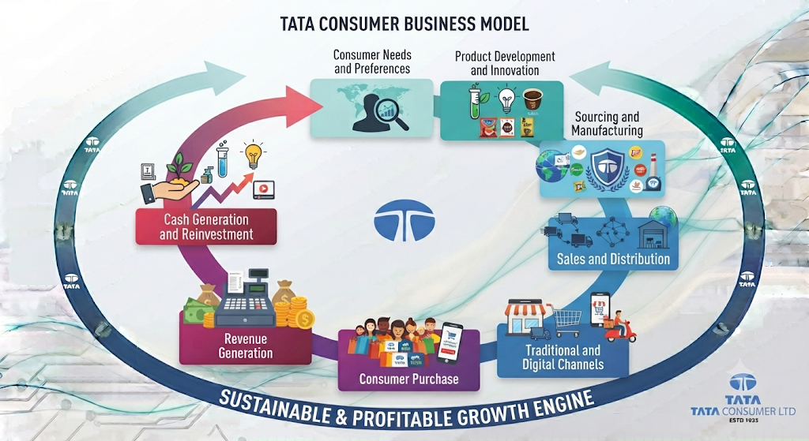
The strength of this model depends on the company's ability to continuously attract consumers to its brands. Unlike a business that relies primarily on one-time transactions, FMCG companies benefit from repeat consumption.
A consumer may regularly purchase:
- Tea
- Coffee
- Salt
- Pantry staples
- Snacks
- Beverages
This creates the potential for recurring demand. However, recurring demand must be supported by:
- Brand relevance
- Product availability
- Competitive pricing
- Product quality
- Consumer trust
Therefore, Tata Consumer's business model is fundamentally built around the combination of: Strong Brands + Consumer Consumption + Distribution Reach + Portfolio Expansion

3.2 What Does Tata Consumer Sell?
Tata Consumer's portfolio has expanded significantly. The company now operates across multiple consumption categories.
Beverages
The beverage portfolio includes:
- Tea
- Coffee
- Ready-to-drink beverages
- Packaged water
- Hydration products
Important brands include:
- Tata Tea
- Tetley
- Eight O'Clock Coffee
- Himalayan
- Tata Coffee
- Tata Gluco Plus
Foods
The food portfolio includes:
- Salt
- Staples
- Breakfast products
- Snacks
- Mini meals
- Cooking aids
- Condiments
- Other packaged food products
Important brands include:
- Tata Salt
- Tata Sampann
- Tata Soulfull
- Ching's Secret
- Smith & Jones
- Tata Simply Better
Health and Wellness
The company also participates in:
- Organic food products
- Organic beverages
- Herbal teas
- Herbal supplements
Organic India is an important platform within this part of the portfolio.
Out-of-Home Consumption
Tata Consumer also participates in the out-of-home consumption opportunity through businesses such as:
- Tata Starbucks
- Tata Consumer Specialist Solutions
- Tata MyBistro
This provides the company with exposure beyond traditional packaged consumer products. Tata Starbucks operates as a joint venture and represents Tata Consumer's participation in India's organised café market.

3.3 The Portfolio Structure
Tata Consumer's portfolio can broadly be divided into three major business areas.
Business Area | Share of Branded Revenue
India Beverages | 36%
India Foods | 37%
International Business | 27%
This structure provides an important insight into how the company has changed. The company's business is no longer dominated by a single category. Instead, revenue is distributed across: India Beverages + India Foods + International Business. This creates a more diversified business structure.

3.4 India Beverages
India Beverages represents one of Tata Consumer's major business platforms. This business includes:
- Packaged beverages
- Tea
- Coffee
- Ready-to-drink products
- Organic India revenues, including overseas revenues
The beverage portfolio combines the company's traditional strengths with newer consumption categories.
Core Beverage Brands
The portfolio includes established brands such as:
- Tata Tea
- Tetley
- Tata Coffee
Alongside these established brands, the company has expanded into:
- Ready-to-drink products
- Hydration
- Wellness beverages
Business Logic
The India Beverages business generates revenue by participating in different beverage consumption occasions.
For example:
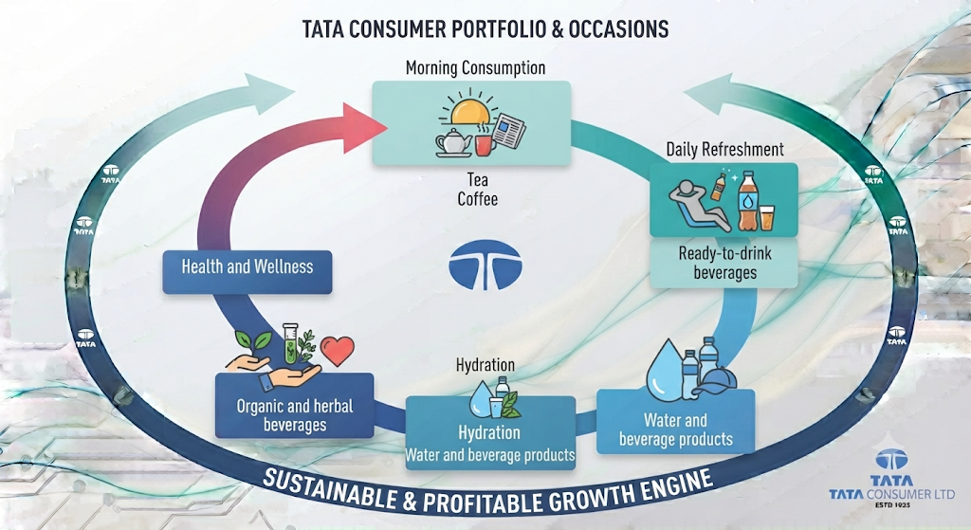
This allows Tata Consumer to expand beyond traditional hot beverages.

3.5 India Foods
India Foods has become one of the most important parts of Tata Consumer's transformation. The business contributed 37% of branded revenue. This makes India Foods slightly larger than India Beverages in terms of the latest branded revenue mix. The business includes:
- Salt
- Tata Sampann
- Tata Soulfull
- Capital Foods
including overseas revenues from these businesses.
Major Portfolio Components
Tata Salt
Tata Salt is one of the company's most established brands and operates in an essential household category. The brand provides:
- Everyday consumer relevance
- High household penetration
- Distribution scale
Tata Sampann
Tata Sampann provides Tata Consumer with a platform across pantry staples and food products.The business allows the company to participate in household consumption beyond beverages and salt.
Tata Soulfull
Tata Soulfull focuses on millet-based products, including:
- Snacks
- Mini meals
- Other food offerings
This business provides exposure to:
- Convenience
- Nutrition
- Changing consumer preferences
Capital Foods
Capital Foods added brands including:
- Ching's Secret
- Smith & Jones
The business expanded Tata Consumer's presence in food categories such as:
- Condiments
- Cooking products
- Food products
Analytical Perspective
India Foods represents one of the clearest examples of Tata Consumer's strategic transformation. The company has moved from: A strong presence in a few established consumer categories toward: A broader portfolio covering multiple food consumption occasions. The challenge will be to ensure that this expansion generates sustainable growth and profitability.

3.6 International Business
The international business contributed 27% of branded revenue. Tata Consumer has a presence across major international markets, including:
- Canada
- United Kingdom
- Europe
- Middle East
- India
- Australia
- South Africa
- United States
Its brands are available across a wide range of global markets. The international business includes:
- Tea
- Coffee
- Food products
Major International Brands and Businesses
The international portfolio includes brands such as:
- Tetley
- Teapigs
- Good Earth
- Eight O'Clock Coffee
- Organic India
The business model varies across markets but broadly involves:
- Manufacturing
- Marketing
- Distribution
- Brand development
of Food & Beverage products.
Why International Business Matters
The international business provides Tata Consumer with:
- Geographic diversification
- Access to developed consumer markets
- Established brand positions
- Opportunities for premiumisation
However, international operations also create exposure to:
- Currency movements
- Commodity costs
- Trade restrictions
- Logistics disruptions
- Different consumer preferences
Therefore, geographic diversification creates both opportunity and additional complexity.

3.7 Core Businesses Versus Growth Businesses
One of the most useful ways to understand Tata Consumer's portfolio is to separate its businesses into:
Core Businesses
The company's traditional strengths include:
- Tea
- Coffee
- Salt
These businesses provide:
- Established consumer relationships
- Brand recognition
- Scale
- Distribution strength
Growth Businesses
The company's newer growth platforms include:
- Tata Sampann
- Ready-to-drink beverages
- Tata Soulfull
- Capital Foods
- Organic India
These businesses provide Tata Consumer with exposure to:
- New consumer needs
- New consumption occasions
- Health and wellness
- Convenience
- Packaged foods
The growth businesses accounted for a significant portion of the India-focused portfolio.
This is important because it demonstrates that Tata Consumer's growth strategy is increasingly being supported by businesses beyond its traditional core.
The Portfolio Structure Can Be Visualised As:
CORE BUSINESSES
Tea + Coffee + Salt
(down) Provide Scale and Stability (down)
GROWTH BUSINESSES
Sampann + RTD + Soulfull + Capital Foods + Organic India
(down) Provide Future Growth Opportunities (down)

3.8 How Tata Consumer Reaches Consumers
A strong product portfolio alone is not enough in the FMCG industry.
Products must be available when and where consumers want them.
Tata Consumer's business model therefore depends heavily on its sales and distribution capabilities.
The company reaches consumers through multiple channels.
Traditional Channels
- General trade
- Traditional retail
- Distributors
Organised Retail
- Modern trade
- Large-format retail stores
Digital Channels
- E-commerce
- Quick commerce
Out-of-Home Channels
- Cafés
- Foodservice
- Specialist consumption channels
The company's distribution structure can be understood as:
Consumer
This omnichannel structure is becoming increasingly important.
Consumers are no longer purchasing FMCG products through one channel alone.
A consumer may purchase:
- Tea through traditional retail
- Pantry products through a supermarket
- Snacks through quick commerce
- Wellness products through e-commerce
The ability to reach consumers across multiple channels therefore strengthens Tata Consumer's business model.

3.9 Scale of Consumer Reach
Tata Consumer has developed significant market reach in India. The company reaches approximately 290 million households and has products available across approximately 4.5 million retail outlets. This scale is strategically important.A wide distribution network can provide several advantages.
1. Product Availability
Consumers are more likely to repeatedly purchase products that are easily available.
2. Portfolio Expansion
An established distribution network can help the company introduce newer products.
For example, distribution relationships developed for established brands can potentially support:
- Food products
- Snacks
- Wellness products
3. Scale Advantages
A larger distribution network can improve the company's ability to operate efficiently across a broad portfolio.
Investor Perspective
Distribution is not simply an operational function. For an FMCG company, it can become an important competitive advantage. The value of Tata Consumer's distribution infrastructure increases as the company expands into more categories.

3.10 The Role of Brands in the Business Model
Brands are at the centre of Tata Consumer's business model.The company operates a portfolio ranging from long-established brands to newer growth platforms. A strong consumer brand can help a company:
- Build trust
- Encourage repeat purchases
- Differentiate products
- Launch adjacent products
- Maintain consumer relationships
The importance of brands becomes particularly visible in the FMCG industry.
Products such as:
- Tea
- Salt
- Coffee
- Packaged foods
may be purchased repeatedly.Therefore, the long-term value of a brand depends on its ability to remain relevant to consumers over time.
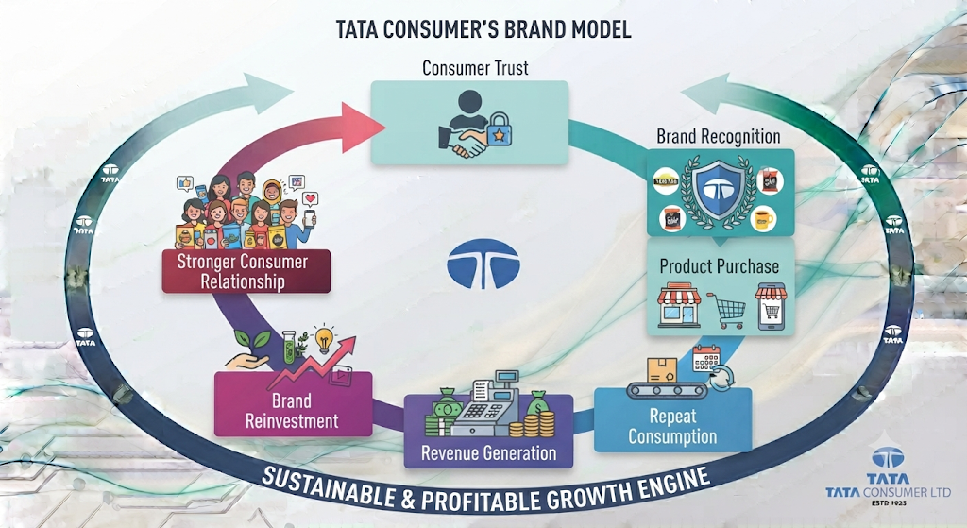
This creates a cycle in which strong brands can potentially support recurring revenue.
However, the company must continuously invest in:
- Advertising
- Innovation
- Product quality
- Consumer engagement
to maintain that relationship.

3.11 Innovation as a Growth Engine
Tata Consumer's portfolio expansion depends heavily on innovation. The company is not relying only on selling existing products. It is also developing products that address emerging consumer needs. The portfolio has expanded into categories such as:
- Health and wellness
- Convenience
- Premium products
- Nutrition-focused products
Examples of portfolio innovation include products such as:
- Vitamin-enriched tea
- Wellness-oriented beverages
- Fortified salt
- Millet-based food products
- Organic products
- Herbal supplements
Why Innovation Matters
Innovation allows Tata Consumer to:
- Enter new categories
- Respond to changing consumer preferences
- Build premium offerings
- Increase consumption occasions
However, innovation also carries risk.Not every product launch becomes successful. The real value of innovation depends on whether products can achieve:
- Consumer adoption
- Sustainable demand
- Distribution scale
- Profitability
Therefore, innovation should ultimately be measured through its contribution to long-term business performance.

3.12 Sourcing, Manufacturing and Supply Chain
Tata Consumer's business model also depends on the ability to source, manufacture and distribute products efficiently.Its operations include entities involved in:
- Manufacturing
- Marketing
- Distribution
- Purchasing and sale of products
across India and international markets.The company operates across multiple Food & Beverage supply chains.This includes businesses associated with:
- Tea
- Coffee
- Food products
The importance of supply chain capabilities increases as the portfolio expands. A broader portfolio requires the company to manage:
- More product categories
- Different sourcing requirements
- Multiple manufacturing systems
- Domestic and international operations
- Different distribution channels
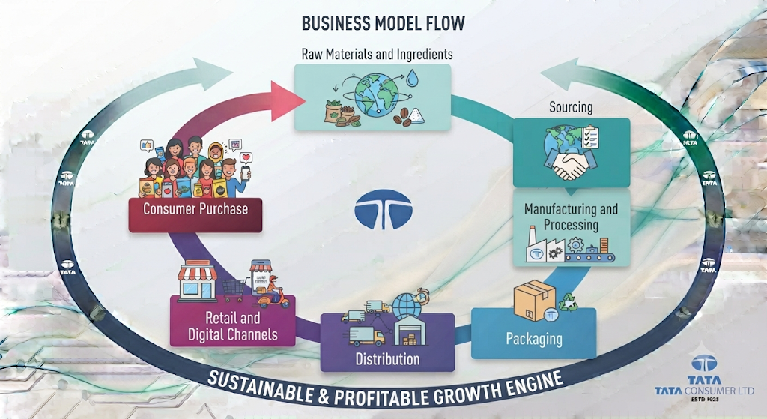
The efficiency of this system directly influences:
- Product availability
- Operating costs
- Margins
- Cash flow
This will become particularly important in later chapters when analysing profitability and working capital.

3.13 The Role of Acquisitions in the Business Model
Tata Consumer has used acquisitions to accelerate its portfolio transformation. Capital Foods and Organic India represent important additions to the company. These acquisitions provided Tata Consumer with:
- New brands
- New product categories
- Established consumer relationships
- Additional growth platforms
Capital Foods
Strengthened the company's food portfolio through brands such as:
- Ching's Secret
- Smith & Jones
Organic India
Strengthened the company's presence in:
- Organic products
- Herbal products
- Health and wellness
Why Acquisitions Matter
Acquisitions can allow Tata Consumer to enter categories more quickly than building brands organically. However, acquisitions must eventually create value. The key questions for investors are:
- Are the acquired businesses growing?
- Are they being integrated successfully?
- Are they improving the company's portfolio?
- Are they generating adequate returns?
These questions will become important in later chapters examining:
- Strategy
- Capital allocation
- Financial performance
- Return ratios

3.14 How Tata Consumer Generates Revenue
The company's revenue generation model can be simplified as follows.

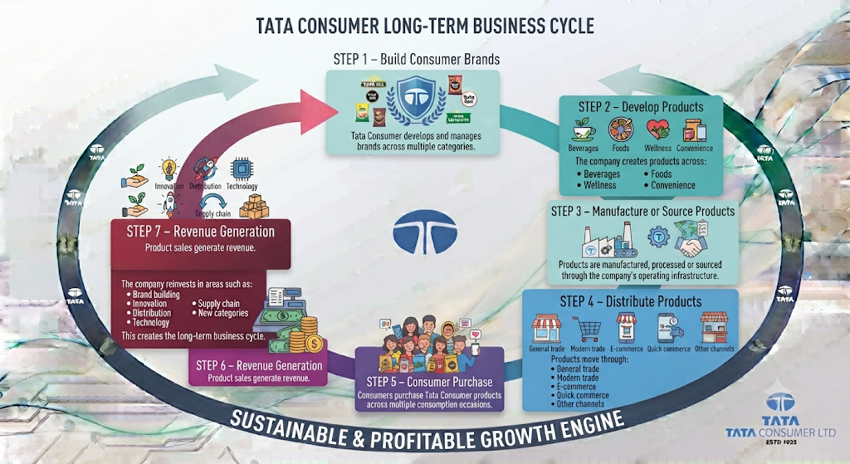3.15 Tata Consumer's Business Model in One Framework

INPUTS
- Raw materials
- Ingredients
- Manufacturing capabilities
- Brands
- Distribution infrastructure
- Employees
- Technology

BUSINESS ACTIVITIES
- Product development
- Innovation
- Manufacturing
- Sourcing
- Brand building
- Sales

SALES CHANNELS
- General trade
- Modern trade
- E-commerce
- Quick commerce

CONSUMERS
- Households
- Individual consumers
- Digital consumers

OUTCOME
- Revenue
- Cash generation
- Brand development

REINVESTMENT
- Innovation
- Distribution
- Technology
- New categories
- Brand building

3.16 CHAPTER ANALYSIS
Tata Consumer's business model demonstrates the extent of its transformation.
The company is no longer dependent primarily on a limited number of established categories. Its current structure combines Core Brands with New Growth Platforms and International Operations. The latest branded revenue mix demonstrates this diversification:
Business | Branded Revenue Contribution
India Beverages | 36%
India Foods | 37%
International Business | 27%
The most significant observation is the increasing importance of India Foods. At 37% of branded revenue, the food business has become a major pillar of Tata Consumer's overall business structure.
The Business Model Has Three Important Strengths
1. Recurring Consumer Demand
The company operates in categories with regular consumption. This can support recurring revenue.
2. Portfolio Diversification
The company participates across multiple consumption occasions. This reduces dependence on one category.
3. Distribution and Brand Strength
The company has significant consumer reach and a wide distribution network. This can support both established and newer products.
The Main Challenge
The business model has also become more complex. Tata Consumer must now manage:
- Multiple categories
- Multiple brands
- International operations
- Acquisitions
- New distribution channels
- Different consumer preferences
Therefore, future success depends on the company's ability to convert portfolio expansion into:
- Sustainable growth
- Strong margins
- Cash generation
- Attractive returns on capital
A larger portfolio does not automatically create greater shareholder value. The quality of execution will determine whether Tata Consumer's broader business model becomes a long-term competitive advantage.

INVESTOR TAKEAWAY
Tata Consumer makes money by building and selling branded Food & Beverage products across a large and increasingly diversified portfolio. The company's business model is built around:
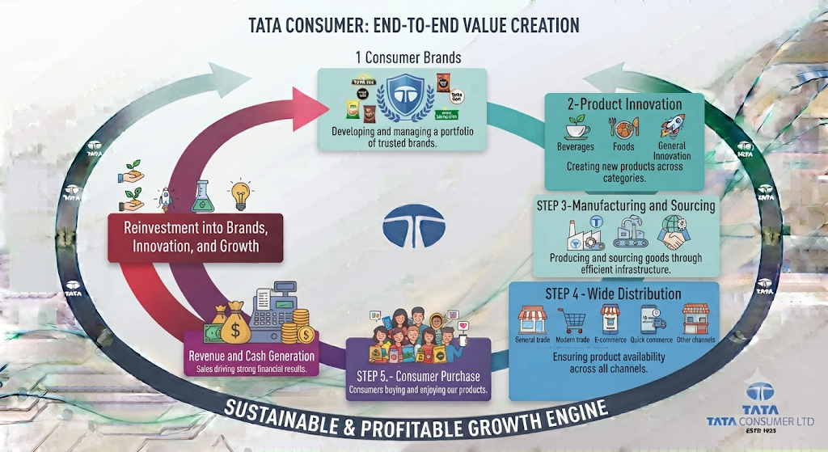The company has transformed this model significantly over recent years. Its traditional businesses in:
- Tea
- Coffee
- Salt
continue to provide the foundation.However, future growth is increasingly being supported by businesses such as:
- Tata Sampann
- Tata Soulfull
- Ready-to-drink beverages
- Capital Foods
- Organic India
The latest revenue structure shows that India Foods has become as important as India Beverages within the branded portfolio.
The Positive
Tata Consumer has created a business model supported by:
- Recurring consumer demand
- Established brands
- Large distribution reach
- Multiple consumption occasions
- Geographic diversification
- Growth-oriented categories
The Risk
The company has also become significantly more complex.
The broader portfolio requires successful:
- Brand management
- Innovation
- Supply chain execution
- Distribution
- Acquisition integration
- Capital allocation
For investors, the most important question is therefore: Can Tata Consumer use its strong brands and distribution infrastructure to scale its broader portfolio while maintaining profitability and generating attractive returns?
This question will become increasingly important as we move from understanding the business model to analysing the company's strategy, leadership and financial performance.

CHAPTER 4: MANAGEMENT STRATEGY, GROWTH PRIORITIES & FUTURE ROADMAP

Chapter Objective
After understanding Tata Consumer's industry environment and business model, the next step is to understand:
Where does the company want to go, and how does management plan to get there?
Tata Consumer is in the middle of a major business transformation. The company has expanded from its traditional categories into a broader Food & Beverage platform, but future growth will depend on how effectively management executes its strategy.
- The company's strategic direction
- Management's growth priorities
- Core versus growth businesses
- Portfolio expansion
- Distribution strategy
- Innovation
- Premiumisation
- Digital and new-age channels
- Acquisitions and integration
- The future roadmap
The objective is to move beyond what Tata Consumer currently is and understand what management is trying to build.

4.1 The Strategic Direction
The central strategic direction of Tata Consumer can be understood through one major objective: To build a larger, diversified and integrated Food & Beverage platform.The company has spent the last several years expanding beyond its historical identity as a tea and beverage business. Its strategy is not based on abandoning established categories. Instead, Tata Consumer is pursuing a model of Strengthening the Core + Building New Growth Engines
This is the foundation of the company's transformation.
The Strategic Framework
Strong Core Businesses
Expansion into Growth Categories
Larger Food & Beverage Platform
The company's strategy therefore combines stability with expansion.
The core businesses provide the existing foundation, while the newer categories are expected to expand Tata Consumer's future growth opportunity.

4.2 Strengthening the Core While Building for the Future
One of the most important elements of Tata Consumer's strategy is the balance between its traditional businesses and newer growth platforms.
The Core Businesses
The company's established businesses include:
- Tea
- Coffee
- Salt
These categories provide:
- Scale
- Brand recognition
- Consumer relationships
- Distribution strength
- Established market positions
These businesses remain important because they provide the foundation upon which the company is building its broader portfolio.
The Growth Platforms
The company has simultaneously expanded into newer categories through businesses such as:
- Tata Sampann
- Tata Soulfull
- Ready-to-drink beverages
- Capital Foods
- Organic India
These businesses provide exposure to:
- New consumption occasions
- Convenience
- Health and wellness
- Packaged food
- Premiumisation
The Strategic Balance
INTEGRATED FOOD & BEVERAGE PLATFORM: The success of this strategy depends on management's ability to ensure that the newer businesses grow without weakening the performance of the core portfolio.

4.3 Expanding the Addressable Market
A major reason behind Tata Consumer's portfolio transformation is the expansion of its addressable market. Historically, the company was concentrated around a relatively limited number of categories.
Its transformation has expanded its presence into areas such as:
- Packaged foods
- Staples
- Snacks
- Breakfast products
- Cooking aids
- Condiments
- Ready-to-drink beverages
- Water
- Health and wellness
This increases the number of consumer needs that Tata Consumer can address.
Earlier Consumer Opportunity
Limited Consumption Occasions
Current Consumer Opportunity
Multiple Consumption Occasions
The strategic objective is clear.
The more consumption occasions Tata Consumer participates in, the larger its potential consumer opportunity becomes.
However, expanding the addressable market does not automatically translate into revenue or profitability.
The company must successfully:
- Build products
- Create demand
- Expand distribution
- Compete effectively
- Maintain margins
Therefore, portfolio expansion creates opportunity, but execution determines value creation.

4.4 Portfolio Expansion as a Growth Strategy
Tata Consumer's strategy has involved both:
Organic Growth
Organic growth involves expanding existing brands and developing new products. The company has expanded its portfolio through:
- Product innovation
- New categories
- New formats
- New consumer segments
- Distribution expansion
Brands such as Tata Sampann and Tata Soulfull represent important growth platforms developed as part of the company's broader portfolio strategy.
Inorganic Growth
Tata Consumer has also used acquisitions to accelerate expansion. The additions of:
- Capital Foods
- Organic India
strengthened the company's presence in:
- Food
- Condiments
- Cooking products
- Organic products
- Herbal products
- Health and wellness
Why Acquisitions Are Strategically Important
Building a new consumer brand can take years. Acquisitions can provide immediate access to:
- Established brands
- Existing products
- Consumer awareness
- Distribution networks
- Category expertise
This can accelerate Tata Consumer's portfolio transformation. However, acquisitions also create an important investor question: Can management successfully integrate these businesses and generate attractive returns from the capital invested? This question will become particularly important in the later chapters on capital allocation and financial performance.

4.5 Building the Food Business
The growing importance of India Foods represents one of Tata Consumer's biggest strategic developments. India Foods contributed 37% of branded revenue. This demonstrates that the company's food strategy has moved beyond being a secondary expansion area. Food has become one of the major pillars of Tata Consumer's business. The company is building its food presence across:
- Essential household products
- Staples
- Convenience
- Snacking
- Breakfast
- Cooking products
- Condiments
Why the Food Strategy Matters
The food portfolio allows Tata Consumer to:
- Address more consumption occasions
- Expand its consumer base
- Increase opportunities for cross-category distribution
- Participate in faster-growing categories
- Reduce dependence on beverages
The future success of Tata Consumer's overall strategy will therefore depend significantly on the performance of its food businesses.

4.6 Distribution Expansion and Reach
A broader portfolio requires a strong route-to-market strategy.Tata Consumer has continued to expand its distribution reach across India.The company's products reach approximately 290 million households and are available across around 4.5 million retail outlets. Distribution is an important part of the company's growth strategy.
A new product cannot generate meaningful scale unless consumers can access it.
Therefore, Tata Consumer's strategic model involves using its distribution infrastructure to support both:
- Established brands
- New growth businesses
Strategic Distribution Model
Higher Revenue Opportunity
This is one of the potential advantages of operating a diversified FMCG platform. An established distribution network can support the introduction and scaling of new brands.

4.7 The Omnichannel Strategy
The FMCG market is changing because consumers are no longer dependent on traditional retail channels. Tata Consumer's strategy increasingly includes multiple routes to consumers.
Key Channels
- General trade
- Modern trade
- E-commerce
- Quick commerce
The company's presence across these channels is strategically important.
Traditional Retail
Provides:
- Scale
- Geographic reach
- Access to mass-market consumers
Modern Trade
Provides:
- Product visibility
- Organised retail presence
- Opportunities for premium products
E-Commerce
Provides:
- Digital consumer access
- Wider product availability
- Opportunities for niche categories
Quick Commerce
Provides:
- Convenience
- Fast delivery
- Higher-frequency purchasing opportunities
Tata Consumer has highlighted its growing strength in e-commerce and quick commerce. This is particularly important for newer and emerging categories. Some products may achieve faster adoption through digital channels before reaching large-scale traditional distribution.

4.8 Premiumisation Strategy
Premiumisation represents another important part of Tata Consumer's growth strategy. Consumers are increasingly seeking:
- Higher-quality products
- Differentiated experiences
- Premium brands
- Health-oriented products
Tata Consumer has opportunities to participate in this trend across:
- Tea
- Coffee
- International brands
- Wellness
- Packaged foods
- Beverages
Why Premiumisation Matters
Premium products can potentially support:
- Better product mix
- Higher revenue per unit
- Improved margins
- Stronger brand positioning
However, the success of premiumisation depends on consumer willingness to pay.
The company must create genuine product differentiation. Therefore, premiumisation should not be viewed simply as increasing prices. It requires Better Product + Better Consumer Experience + Strong Brand Positioning

4.9 Innovation as a Strategic Priority
Innovation is essential to Tata Consumer's transformation. The company is competing in categories where consumer preferences continue to change. To remain relevant, it must continuously introduce:
- New products
- New formats
- New flavours
- Health-oriented offerings
- Convenient consumption solutions
Innovation also allows the company to enter new consumption occasions.
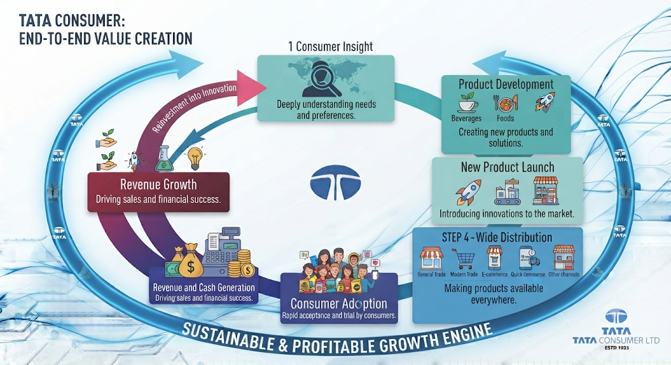
The company's strategic focus is therefore not limited to growing existing products. It also involves creating products that address emerging consumer preferences. However, innovation requires investment and carries risk.
Not every new product will succeed.The long-term value of innovation depends on whether successful products can:
- Scale
- Generate repeat demand
- Become profitable

4.10 Health and Wellness as a Growth Opportunity
Health and wellness is becoming increasingly relevant to Tata Consumer's future strategy.
The company has strengthened its position through:
- Organic India
- Herbal products
- Organic Food & Beverage
- Nutrition-oriented offerings
- Millet-based products
This provides Tata Consumer with exposure to consumers seeking:
- Better-for-you products
- Natural products
- Organic products
- Wellness-focused offerings
Strategic Importance
Health and wellness provides access to consumer segments beyond traditional FMCG categories. It also provides opportunities for:
- Premiumisation
- Product differentiation
- Higher-value categories
However, these categories require:
- Consumer trust
- Product quality
- Brand credibility
- Continued innovation
The long-term success of the wellness strategy will depend on Tata Consumer's ability to build these businesses into scalable and profitable growth platforms.

4.11 Digitalisation and Technology
Technology is becoming increasingly important across the consumer business. Tata Consumer's transformation includes investments in capabilities such as:
- Digitalisation
- Consumer engagement
- Data-driven decision-making
- Supply chain improvement
- Digital channels
Technology can potentially improve:
- Consumer understanding
- Demand forecasting
- Distribution
- Supply chain efficiency
- Marketing effectiveness
The strategic importance of technology becomes greater as Tata Consumer manages a larger and more complex portfolio.
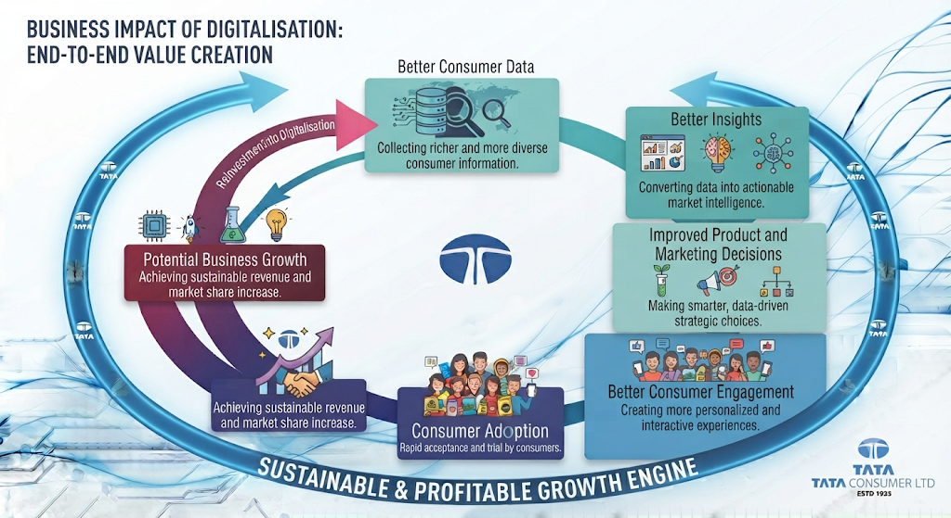Digitalisation can therefore support the company's growth strategy across multiple functions.

4.12 International Growth and Portfolio Strategy
International operations remain an important part of Tata Consumer's overall business.
International Business contributes 27% of branded revenue. The company has established positions across international markets through its beverage and food brands. The strategic opportunity internationally includes:
- Premiumisation
- Brand expansion
- Distribution growth
- Product innovation
The international business also provides geographic diversification. However, the company must manage:
- Currency movements
- Commodity costs
- Trade disruptions
- Tariffs
- Supply chain risks
Therefore, international growth requires a balance between Opportunity and Risk Management.

4.13 The Role of Acquisitions in the Future Roadmap
Capital Foods and Organic India are important additions to Tata Consumer's broader strategy. These acquisitions accelerated the company's entry into new consumer categories.
Capital Foods Strengthened:
- Cooking products
- Condiments
- Packaged foods
Organic India Strengthened:
- Organic Food & Beverage
- Herbal supplements
- Health and wellness
The strategic importance of these businesses is not simply their current revenue contribution. They also provide Tata Consumer with:
- New categories
- New brands
- New consumer segments
- New growth opportunities
However, acquisitions require successful integration. The future roadmap will need to focus on:
- Scaling these brands
- Improving distribution
- Expanding markets
- Creating synergies
- Maintaining profitability
For investors, acquisition success should ultimately be measured by Growth + Profitability + Cash Generation + Return on Capital

4.14 Management's Growth Framework
Tata Consumer's overall growth strategy can be summarised through six major pillars.
1. Strengthen Core Categories
Continue to build:
- Tea
- Coffee
- Salt
These businesses provide the foundation.
2. Scale Growth Businesses
Expand:
- Packaged foods
- Wellness
- Convenience
- Ready-to-drink products
These categories increase future growth opportunities.
3. Expand Distribution
Increase product availability across:
- Traditional trade
- Modern trade
- E-commerce
- Quick commerce
4. Drive Innovation
Develop products that address:
- Health
- Convenience
- Premiumisation
- Changing consumer preferences
5. Build Stronger Brands
Continue investing in:
- Consumer engagement
- Brand awareness
- Product differentiation
6. Use Capital for Strategic Growth
Deploy capital toward:
- Acquisitions
- Growth categories
- Innovation
- Distribution
- Capabilities
This framework can be visualised as:
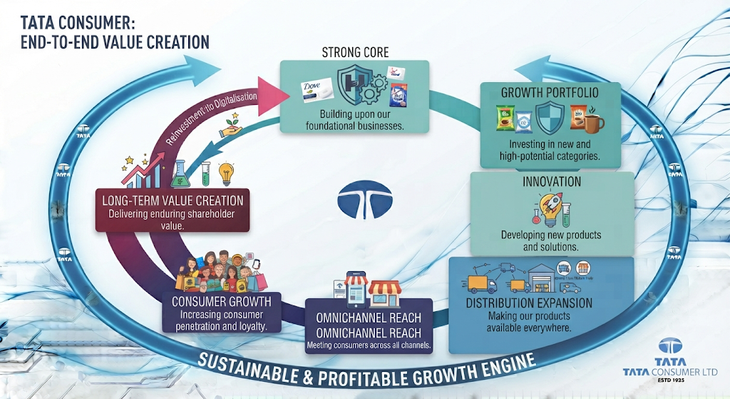

4.15 Strategic Opportunities
Tata Consumer has several major strategic opportunities.
1. Larger Food Market
The company's expansion into foods increases its addressable market.
2. Health and Wellness
Changing consumer preferences support long-term opportunities in wellness.
3. Premiumisation
Premium products can potentially improve product mix and profitability.
4. Digital Commerce
E-commerce and quick commerce provide new routes to consumers.
5. Portfolio Synergies
The company can potentially use its:
- Distribution
- Brands
- Consumer knowledge
- Infrastructure
across multiple categories.
6. International Expansion
The international portfolio provides opportunities for brand growth and premiumisation.

4.16 Strategic Risks
The strategy also involves several risks.
Portfolio Complexity
Managing a large number of categories and brands increases operational complexity.
Acquisition Integration
The acquired businesses must be successfully integrated and scaled.
Competitive Pressure
Tata Consumer faces strong competition across every major category.
Capital Allocation
Management must ensure that investments and acquisitions generate adequate returns.
Commodity Volatility
Input cost volatility can affect profitability.
Execution Risk
The company's transformation depends heavily on management's ability to execute across multiple areas simultaneously.

INVESTOR TAKEAWAY
Tata Consumer's future strategy is based on becoming a larger and more diversified Food & Beverage company.
The company's growth model combines:
Strong Core Categories with New Growth Businesses
supported by Innovation + Distribution + Premiumisation + Digital Channels + Strategic Acquisitions
The strategy creates significant opportunity. ata Consumer can participate in a larger number of consumer categories and consumption occasions than in the past. The increasing importance of the food portfolio demonstrates that this transformation is already changing the structure of the company.
The Positive Investor View
The company has:
- Strong established brands
- Large distribution reach
- A diversified portfolio
- Exposure to growing consumer trends
- Opportunities in food and wellness
- A growing omnichannel presence
The Key Investor Risk
The transformation must now produce financial results.
Investors should closely monitor whether the company's strategic expansion leads to:
- Sustainable revenue growth
- Improving profitability
- Strong cash generation
- Effective capital allocation
- Attractive returns on capital
The most important investor question is:
Can Tata Consumer successfully convert its ambitious portfolio expansion into profitable and sustainable long-term growth?

CHAPTER 5: MANAGEMENT, LEADERSHIP & CORPORATE GOVERNANCE

Chapter Objective
A company's strategy may look attractive on paper, but ultimately, strategy has to be executed by people.
For Tata Consumer, this is particularly important because the company is undergoing a significant transformation. It is expanding beyond its traditional businesses, integrating acquisitions, entering new categories and building a larger Food & Beverage platform.
Therefore, the next important question for an investor is:
Does Tata Consumer have the leadership and governance structure required to manage this transformation effectively?
- Board leadership
- Executive management
- Management experience
- Board composition
- Independent oversight
- Corporate governance
- Board committees
- Management remuneration
- The broader Tata governance framework
The objective is not simply to identify the people leading the company. It is to understand Who is responsible for strategic direction, who is responsible for execution, and what governance mechanisms are in place to protect stakeholder interests?

5.1 Why Management and Governance Matter
When analysing a consumer company, investors often focus heavily on:
- Revenue growth
- Profit margins
- Brands
- Market share
- Financial ratios
However, all of these outcomes are influenced by management decisions. Management decides:
- Where the company invests
- Which categories to enter
- Which brands to build
- Which businesses to acquire
- How capital is allocated
- How risks are managed
Corporate governance, meanwhile, determines how these decisions are supervised.A strong governance structure can help ensure that management remains accountable to:
- Shareholders
- Employees
- Consumers
- Other stakeholders
For Tata Consumer, governance becomes especially important because the company is managing a growing and increasingly complex portfolio. The company now operates across multiple:
- Categories
- Brands
- Geographies
- Subsidiaries
- Distribution channels
Therefore, as business complexity increases, the importance of effective leadership and oversight also increases.

5.2 The Leadership Structure
Tata Consumer's leadership structure can broadly be understood through three levels.

LEVEL 1 – BOARD LEADERSHIP
Responsible for:
- Strategic oversight
- Corporate governance
- Major decisions

LEVEL 2 – EXECUTIVE MANAGEMENT
Responsible for:
- Business execution
- Strategy implementation
- Operational performance

LEVEL 3 – MANAGEMENT ORGANISATION
Responsible for:
- Brand management
- Finance
- Operations
- Supply chain
- Sales and distribution
- People and capabilities
This separation is important.
The Board provides oversight and strategic direction, while the executive management team is responsible for executing the company's strategy.

5.3 The Chairman – N. Chandrasekaran
The Board is chaired by N. Chandrasekaran. His role at Tata Consumer is important because he also holds a central leadership position within the wider Tata Group. His broader experience brings exposure to:
- Large-scale business transformation
- Technology
- Consumer businesses
- Global operations
- Capital allocation
- Group-level strategy
He has also been associated with the Tata Group's broader focus on:
Simplification + Scale + Synergy
These principles are relevant when analysing Tata Consumer's transformation. The company itself has been attempting to:
- Build scale
- Simplify and strengthen its portfolio
- Create synergies across brands and categories
- Develop a larger consumer platform
Investor Perspective
The Chairman provides Tata Consumer with the benefit of strong strategic and group-level experience. However, it is equally important that operational execution remains focused on the consumer business itself. This is where the role of the Managing Director and Chief Executive Officer becomes particularly important.
The Chairman's role is primarily associated with:
Strategic Oversight and Governance
while executive management is responsible for:
Business Execution and Performance
During FY2024–25, N. Chandrasekaran attended all six Board meetings held during the year.

5.4 The Managing Director & CEO – Sunil D'Souza
The most important executive leadership position at Tata Consumer is held by:
Sunil D'Souza – Managing Director & Chief Executive Officer
The CEO's role is particularly significant because Tata Consumer is currently in a phase of transformation.
The company is simultaneously working on:
- Strengthening core businesses
- Scaling food businesses
- Expanding distribution
- Developing new categories
- Integrating acquisitions
- Building digital capabilities
- Improving profitability
The CEO therefore plays a central role in converting the company's strategic direction into operational performance.
The Strategic Transformation Under Executive Leadership
Tata Consumer's transformation can broadly be understood as:
Traditional Consumer Categories
Portfolio Expansion
New Capabilities
Integrated Food & Beverage Company
The success of this transformation will ultimately be reflected in future financial performance.
Therefore, investors should not evaluate management only based on the scale of expansion.
They should evaluate management based on whether the strategy produces:
- Sustainable growth
- Profitability
- Cash generation
- Attractive returns on capital

5.5 Executive Management and Operational Execution
The executive leadership structure includes:
- Sunil D'Souza – Managing Director & CEO
- Ajit Krishnakumar – Executive Director & COO
- Sivakumar Sivasankaran – Chief Financial Officer
- Delnaz D. Harda – Company Secretary and Compliance Officer
This structure brings together responsibilities across: Strategy + Operations + Finance + Compliance
The presence of a Chief Operating Officer is particularly relevant for a company of Tata Consumer's scale.
The company operates across:
- Multiple product categories
- Domestic markets
- International markets
- Manufacturing and sourcing systems
- Traditional distribution
- Digital commerce
As the company expands, operational execution becomes increasingly important. The COO's role therefore supports the translation of strategic priorities into:
- Business operations
- Supply chain execution
- Distribution
- Organisational coordination

5.6 Management Experience and Strategic Capability
Tata Consumer's leadership team is managing a company that is significantly different from the business that existed several years ago. The company has expanded through:
- Organic growth
- New categories
- Acquisitions
- International operations
- Digital channels
This requires management capabilities across multiple areas.
Consumer Understanding
Management must understand:
- Consumer preferences
- Category trends
- Premiumisation
- Health and wellness
- Changing consumption patterns
Brand Building
The company operates multiple brands across categories. Management must ensure:
- Brand relevance
- Consumer engagement
- Product differentiation
- Effective marketing
Operational Management
The company's broad portfolio requires effective management of:
- Sourcing
- Manufacturing
- Distribution
- Supply chains
Financial Discipline
The company's growth strategy has involved acquisitions and investments. Management must ensure that growth ultimately creates:
- Profitability
- Cash flow
- Returns on capital
Integration Capability
The addition of businesses such as Capital Foods and Organic India creates an additional responsibility for management. Acquired businesses need to be:
- Integrated
- Scaled
- Supported through distribution
- Managed profitably
Therefore, management capability will be tested not only through revenue growth but through the ability to manage a more complex organisation.

5.7 The Board of Directors
A strong Board provides oversight over management and major strategic decisions. During FY2024–25, the Board included a combination of:
- Non-Executive leadership
- Independent Directors
- Executive Directors
- Tata Group representation
The Board included:
Director | Position
N. Chandrasekaran | Chairman
P. B. Balaji | Non-Executive, Non-Independent Director
Bharat Puri | Independent Director
Shikha Sharma | Independent Director
Dr. K. P. Krishnan | Independent Director
David Crean | Independent Director
Sunil D'Souza | Managing Director & CEO
Ajit Krishnakumar | Executive Director & COO
Siraj Chaudhry served as an Independent Director until his resignation effective September 30, 2024.
Why Board Composition Matters ?
A Board should ideally bring together different forms of expertise. Tata Consumer's Board includes experience across areas such as:
- Consumer businesses
- Financial services
- Public policy
- Business leadership
- Food and product development
- Tata Group operations
This diversity of experience is important because Tata Consumer itself operates across multiple categories and markets.

5.8 The Role of Independent Directors
Independent Directors are an important part of corporate governance. Their role is to provide objective oversight and independent judgement on matters affecting the company and shareholders. The Independent Directors on the Board during FY2024–25 included:
- Bharat Puri
- Shikha Sharma
- Dr. K. P. Krishnan
- David Crean
Independent oversight is particularly important when a company is making major strategic decisions. For Tata Consumer, these areas include:
- Acquisitions
- Capital allocation
- Financial performance
- Risk management
- Executive remuneration
- Corporate governance
Investor Perspective
The presence of Independent Directors is important because management should not operate without effective oversight. A strong governance framework creates a system of:
Shareholder Accountability
This becomes increasingly important as the company's scale and complexity increase.

5.9 The Value of Diverse Board Experience
Tata Consumer's Board brings together experience from different industries and professional backgrounds.This is valuable because the company faces challenges across:
- Consumer behaviour
- Business strategy
- Regulation
- Finance
- International operations
- Product innovation
Consumer and Business Experience
Bharat Puri brings extensive experience in consumer businesses, sales, marketing and general management.This is particularly relevant for Tata Consumer because its growth depends heavily on:
- Brand building
- Consumer understanding
- Market expansion
Financial and Strategic Experience
Shikha Sharma brings extensive experience from financial services and large-scale organisational leadership.This type of experience can contribute to Board discussions relating to:
- Strategy
- Financial performance
- Risk
- Organisational transformation
Policy and Governance Experience
Dr. K. P. Krishnan brings experience related to public policy and governance. This can be particularly relevant in areas involving:
- Regulation
- Governance
- Economic policy
Food and Product Development Experience
David Crean brings experience connected with food research and development. This expertise is relevant for a company expanding across:
- Packaged foods
- Innovation
- Product development
- Consumer categories
Analytical Perspective
The diversity of Board expertise reflects the complexity of Tata Consumer's business. The company is not operating as a single-category business. Therefore, its governance requirements extend beyond traditional FMCG experience.

5.10 Corporate Governance Framework
Tata Consumer operates within a governance and reporting framework guided by several regulatory and reporting requirements. These include:
- The Companies Act, 2013
- Indian Accounting Standards
- SEBI Listing Obligations and Disclosure Requirements
- Business Responsibility and Sustainability Reporting
- Integrated reporting principles
The company also reports across multiple forms of capital, including:
- Financial capital
- Intellectual capital
- Manufactured capital
- Human capital
- Natural capital
- Social and relationship capital
This broader approach reflects the company's focus on stakeholder value rather than financial performance alone.

5.11 Board Committees
The Board operates through specialised committees. These committees allow specific areas to receive more detailed attention. The important areas of governance oversight include:
- Audit
- Nomination and remuneration
- Risk management
- Corporate social responsibility and sustainability
The purpose of these committees is to ensure that important decisions are not concentrated within one individual or one management function. Instead, different areas receive structured oversight.
Audit Committee
The Audit Committee plays an important role in overseeing areas such as:
- Financial reporting
- Internal controls
- Audit processes
- Financial integrity
For investors, this committee is important because financial statements form the foundation of investment analysis. A strong audit framework helps improve confidence in:
- Reported earnings
- Financial disclosures
- Internal financial controls
Nomination and Remuneration Committee
This committee is responsible for matters relating to:
- Board appointments
- Senior management evaluation
- Remuneration
Its role is particularly important in ensuring that executive incentives remain appropriately linked to company performance and long-term objectives.
Risk Management Committee
The Risk Management Committee is particularly relevant because Tata Consumer operates across:
- Multiple countries
- Agricultural commodities
- Complex supply chains
- Changing consumer markets
The company faces risks associated with:
- Commodity prices
- Foreign exchange
- Supply chains
- Competition
- Regulation
- Climate-related factors
Structured risk oversight helps management identify and monitor these challenges.
CSR and Sustainability Oversight
As a major consumer company, Tata Consumer also has responsibilities extending beyond financial performance. Governance therefore also includes oversight of:
- Corporate social responsibility
- Sustainability
- Stakeholder interests
These areas will be examined in greater depth in the sustainability chapter.

5.12 Governance and the Tata Group
One of Tata Consumer's important characteristics is its association with the Tata Group. The Tata brand carries significant importance in the Indian corporate environment. For Tata Consumer, this association can provide:
- Brand credibility
- Governance heritage
- Strategic support
- Access to wider group capabilities
However, from an investor's perspective, association with a large business group should not replace independent analysis. The company must still be evaluated based on:
- Financial performance
- Capital allocation
- Governance quality
- Management execution
The Tata Group connection is a strength, but shareholder value ultimately depends on Tata Consumer's own performance.

5.13 Management Remuneration and Alignment
Executive remuneration is an important part of corporate governance because it can influence management behaviour. Ideally, management incentives should encourage:
- Long-term growth
- Sustainable profitability
- Value creation
During FY2024–25, the company's remuneration disclosures included executive and leadership compensation details. The company also disclosed that long-term incentives were linked to performance share units, with the relevant incentives accounted for over the vesting period based on performance measures achieved.
Why This Matters
Short-term incentives alone can sometimes encourage management to focus excessively on immediate performance. Long-term incentives can potentially encourage management to focus on:
- Sustainable growth
- Long-term shareholder value
- Business performance over multiple years
However, investors should always evaluate whether management compensation remains aligned with actual business performance. The most important question is:
Is management being rewarded for genuine value creation?

5.14 Leadership and the Company's Transformation
Tata Consumer's leadership is currently managing a significant strategic transition.
The company has moved from: A portfolio primarily focused on Tea, Coffee and Salt
toward: A broader Food & Beverage platform
This transition requires management to simultaneously focus on:
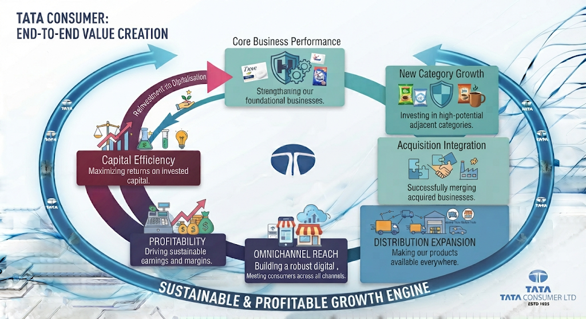This makes the quality of management execution especially important. The transformation cannot be judged only by the number of new brands or acquisitions. It must eventually be reflected in:
- Revenue growth
- Margin improvement
- Cash generation
- Return ratios
These financial outcomes will be examined in the upcoming chapters.

5.15 Key Management Challenges Ahead
While Tata Consumer has a strong leadership and governance structure, management faces several significant challenges.
1. Managing Portfolio Complexity
The company now operates across a much wider range of categories. Management must ensure that complexity does not reduce efficiency.
2. Scaling Acquired Businesses
Capital Foods and Organic India must continue to be integrated and scaled successfully. The focus must be on:
- Growth
- Synergies
- Profitability
3. Maintaining Core Business Strength
While building newer categories, Tata Consumer must continue protecting the strength of:
- Tea
- Coffee
- Salt
4. Delivering Profitable Growth
Revenue growth alone will not be sufficient. Management must demonstrate:
- Margin discipline
- Cost management
- Strong cash generation
5. Capital Allocation
As the company grows, management decisions regarding:
- Acquisitions
- Investments
- Expansion
will become increasingly important. Investors should closely monitor whether these decisions generate attractive returns.

5.16 CHAPTER ANALYSIS
Tata Consumer's leadership structure combines Tata Group-level strategic oversight with Executive management focused on business execution. The Board includes a mix of:
- Executive Directors
- Non-Executive Directors
- Independent Directors
This structure provides different layers of oversight and expertise. The company's governance framework also extends across:
- Financial reporting
- Risk management
- Remuneration
- Sustainability
- Regulatory compliance
The Strength
Tata Consumer benefits from:
- Experienced Board leadership
- Strong Tata Group governance heritage
- Independent Directors
- Diverse professional expertise
- Defined executive leadership
- Structured governance mechanisms
The Challenge
The quality of leadership will now be tested through execution.Tata Consumer has already expanded significantly. The next phase requires management to prove that it can: Manage a larger portfolio efficiently while delivering Profitable and sustainable growth. This distinction is extremely important. Growth through expansion is one thing.
Creating shareholder value from that expansion is another.

INVESTOR TAKEAWAY
Tata Consumer appears to have a strong leadership and governance structure supported by:
- Experienced Board leadership
- A defined executive management team
- Independent Directors
- Structured Board oversight
- Tata Group governance heritage
The Board brings together experience across:
- Consumer businesses
- Finance
- Policy
- Food and innovation
- Corporate strategy
This diversity is valuable for a company operating across multiple categories and geographies. However, the most important factor for investors is not simply the quality of leadership backgrounds. It is management execution. Tata Consumer's leadership is currently responsible for managing a major transformation.
The company must successfully convert:
Portfolio Expansion into Revenue Growth and ultimately into
Profitability + Cash Generation + Strong Returns on Capital
Therefore, the key investor question is: Can the management team convert Tata Consumer's strategic transformation into sustainable long-term shareholder value?
The next chapters will move from the people managing the business to the actual financial results produced by the business.
CHAPTER 6 FINANCIAL PERFORMANCE OVERVIEW: REVENUE, GROWTH & BUSINESS PERFORMANCE

Chapter Objective
The previous chapters focused on understanding Tata Consumer's:
- Business transformation
- Industry environment
- Portfolio structure
- Growth strategy
- Leadership and governance
The next step is to examine whether these strategic developments are translating into actual financial performance.
A company can have:
- Strong brands
- Attractive growth opportunities
- An expanding portfolio
- A capable management team
But ultimately, an investor needs to examine the financial outcome. The first question is therefore: Is Tata Consumer actually growing, and what is driving that growth?
- Revenue growth
- Five-year revenue trend
- EBITDA
- Profit before tax
- Group net profit
- Segment performance
- India business
- International business
- Growth businesses
- The quality and direction of growth
The objective is not simply to identify whether the numbers increased.It is to understand Where is the growth coming from, and is Tata Consumer's business transformation becoming visible in its financial performance?

6.1 Financial Performance at a Glance
Tata Consumer reported continued growth during FY2024–25.The company's key financial indicators showed the following performance:
Financial Metric | FY2024–25 | YoY Change
Revenue from Operations | ₹17,618 crore | 16%
EBITDA | ₹2,502 crore | 8%
Group Net Profit before Exceptional Items | ₹1,782 crore | -12%
Profit Before Tax and Exceptional Items | ₹1,252 crore | -17%
Return on Capital Employed | 34.7% | Declined from FY2023–24
Dividend | 845% | Increased from 775%
The first major observation is clear Tata Consumer continued to deliver strong revenue growth during FY2024–25. However, revenue growth was stronger than the growth in profitability. This distinction is important and will become a major theme as we move deeper into the financial analysis.

6.2 Revenue Performance
Revenue is one of the most important indicators of business scale. For Tata Consumer, revenue from operations increased to ₹17,618 crore in FY2024–25 compared with ₹15,206 crore in FY2023–24. This represents 16% year-on-year growth. The company's five-year revenue trend is shown below.
Financial Year | Revenue from Operations
FY2020–21 | ₹11,602 crore
FY2021–22 | ₹12,425 crore
FY2022–23 | ₹13,783 crore
FY2023–24 | ₹15,206 crore
FY2024–25 | ₹17,618 crore
Revenue Trend
₹17,618 crore
The company's revenue has increased significantly over the five-year period. From FY2020–21 to FY2024–25, Tata Consumer added more than ₹6,000 crore of annual revenue to its business.
Analytical Perspective
This demonstrates that Tata Consumer's transformation is visible in its business scale. The company has grown through a combination of:
- Core business expansion
- Growth businesses
- New product categories
- Portfolio expansion
- Acquisitions
However, revenue growth alone does not tell the complete story.The next important question is Which businesses are contributing to this growth?

6.3 Five-Year Revenue Growth Journey
The company's revenue growth over the last five years demonstrates a relatively consistent upward trajectory.
Year | Revenue from Operations | Growth Direction
FY2020–21 | ₹11,602 crore | Base Year
FY2021–22 | ₹12,425 crore | Growth
FY2022–23 | ₹13,783 crore | Growth
FY2023–24 | ₹15,206 crore | Growth
FY2024–25 | ₹17,618 crore | 16% YoY Growth
The company has therefore demonstrated Five consecutive years of increasing revenue from operations. This is important because Tata Consumer's growth has not been driven by a single year of exceptional performance. The revenue base has expanded consistently over time.
What Is Driving the Larger Revenue Base?
The growth reflects Tata Consumer's broader transformation from: Traditional Beverages and Essential Categories towards A Larger and More Diversified Food & Beverage Portfolio.
The increasing contribution of:
- Food businesses
- Growth businesses
- Acquired brands
- New categories
has supported the expansion of the overall revenue base.

6.4 India Business Performance
The India business is the largest contributor to Tata Consumer's business. During FY2024–25, India business revenue reached ₹11,241 crore compared with ₹9,736 crore in FY2023–24. This represents 15% year-on-year growth
The five-year trend is shown below.
Financial Year | India Business Revenue
FY2020–21 | ₹7,003 crore
FY2021–22 | ₹7,914 crore
FY2022–23 | ₹8,717 crore
FY2023–24 | ₹9,736 crore
FY2024–25 | ₹11,241 crore
Analytical Perspective
The India business added more than ₹1,500 crore of revenue during FY2024–25. This is significant because the Indian market remains central to Tata Consumer's future growth strategy. The company's expansion in India is supported by:
- Strong core brands
- Food business growth
- Distribution expansion
- New-age channels
- New categories
The India business is therefore not only the largest part of the company. It is also one of the most important drivers of Tata Consumer's transformation.

6.5 International Business Performance
The International business generated revenue of ₹4,549 crore in FY2024–25 compared with: ₹3,925 crore in FY2023–24.
This represents 16% year-on-year growth
The five-year revenue trend was:
Financial Year | International Business Revenue
FY2020–21 | ₹3,508 crore
FY2021–22 | ₹3,336 crore
FY2022–23 | ₹3,589 crore
FY2023–24 | ₹3,925 crore
FY2024–25 | ₹4,549 crore
Analytical Perspective
The International business demonstrated strong growth during FY2024–25. This is important because international operations provide Tata Consumer with:
- Geographic diversification
- Established global brands
- Exposure to developed markets
However, international revenue can also be influenced by:
- Currency movements
- Commodity prices
- Trade conditions
- Consumer demand in overseas markets
Therefore, international growth must be evaluated alongside profitability and segment performance.

6.6 Non-Branded Business Performance
The company's non-branded business generated revenue of ₹1,910 crore in FY2024–25
compared with ₹1,577 crore in FY2023–24
This represents 21% year-on-year growth.
The five-year trend was:
Financial Year | Non-Branded Business Revenue
FY2020–21 | ₹1,122 crore
FY2021–22 | ₹1,214 crore
FY2022–23 | ₹1,500 crore
FY2023–24 | ₹1,577 crore
FY2024–25 | ₹1,910 crore
Analytical Perspective
The non-branded business recorded the fastest percentage growth among the three reported business categories during FY2024–25. However, it is important to distinguish between Revenue growth and Strategic value.
The branded business remains central to Tata Consumer's long-term strategy because consumer brands generally provide the company with:
- Brand equity
- Consumer relationships
- Product differentiation
- Pricing opportunities
Therefore, the non-branded business should be assessed alongside its contribution to profitability and the overall portfolio.

6.7 Revenue Mix: India Versus International
Tata Consumer's reported segmental revenue mix during FY2024–25 showed:
Business | Share of Segment Revenue
India Business | 71%
International Business | 29%
This highlights the importance of the Indian market.
Revenue Structure

INDIA BUSINESS
Largest Revenue Contributor

INTERNATIONAL BUSINESS
Geographic Diversification
The Indian business remains the company's primary growth engine.
The international business provides an important secondary platform and geographic diversification.

6.8 Segment Results: Where Does Profitability Come From?
Revenue tells us how large a business is. Segment results help us understand where profitability is being generated. During FY2024–25, Tata Consumer's segment results showed:
Business | Share of Segment Results
India Business | 60%
International Business | 40%
This creates an important observation.
Revenue Mix
India: 71%
International: 29%
Segment Result Mix
India: 60%
International: 40%
This suggests that the International business contributes a larger proportion of segment results relative to its revenue contribution.
Analytical Perspective
This difference may indicate a different profitability profile between the India and International businesses. However, this chapter should not make a final conclusion regarding margins without examining detailed profitability information. That analysis will be covered in the upcoming profitability chapters. At this stage, the key takeaway is The India business drives the majority of revenue, while the International business has a relatively stronger contribution to segment results

6.9 EBITDA Performance
EBITDA is an important indicator of operating performance.
During FY2024–25, Tata Consumer reported EBITDA of ₹2,502 crore compared with ₹2,323 crore in FY2023–24 This represents 8% year-on-year growth.
The five-year trend was:
Financial Year | EBITDA
FY2020–21 | ₹1,569 crore
FY2021–22 | ₹1,749 crore
FY2022–23 | ₹1,874 crore
FY2023–24 | ₹2,323 crore
FY2024–25 | ₹2,502 crore
Analytical Perspective
EBITDA increased during FY2024–25.
However, there is an important difference between revenue growth and EBITDA growth.
Revenue Growth: 16%
EBITDA Growth: 8%
This means Revenue grew faster than EBITDA. This is an important signal. It suggests that the company achieved strong top-line growth, but operating profitability did not increase at the same pace.
Possible reasons can include:
- Input cost pressures
- Investments in growth
- Marketing expenditure
- Integration costs
- Changes in product mix
The detailed reasons for the difference between revenue and profit growth will be examined in the profitability analysis. For now, the important observation is The company is growing, but operating earnings are growing at a slower pace than revenue.

6.10 Group Net Profit Before Exceptional Items
Tata Consumer's Group Net Profit before exceptional items was ₹1,782 crore in FY2024–25 compared with ₹2,023 crore in FY2023–24.
This represents a decline of 12% The five-year trend was:
Financial Year | Group Net Profit Before Exceptional Items
FY2020–21 | ₹945 crore
FY2021–22 | ₹1,056 crore
FY2022–23 | ₹1,174 crore
FY2023–24 | ₹2,023 crore
FY2024–25 | ₹1,782 crore
Analytical Perspective
This is one of the most important observations in the company's FY2024–25 financial performance. While revenue increased by 16% Group Net Profit before exceptional items declined by 12%. This creates a divergence between Top-Line Growth and Bottom-Line Performance.
Why Does This Matter?
Revenue growth creates business scale.However, shareholders ultimately benefit from:
- Earnings
- Cash flow
- Returns on capital
Therefore, investors need to understand whether the company's strong growth is eventually translating into higher profits. The decline in Group Net Profit before exceptional items does not necessarily mean that the growth strategy is failing.
However, it does mean that The quality of profitability must be examined carefully.

6.11 Profit Before Tax and Exceptional Items
Profit Before Tax and Exceptional Items declined to ₹1,252 crore during FY2024–25.
This compares with ₹1,516 crore in FY2023–24 representing a decline of 17%
The five-year trend was:
Financial Year | Profit Before Tax and Exceptional Items
FY2020–21 | ₹1,174 crore
FY2021–22 | ₹1,342 crore
FY2022–23 | ₹1,508 crore
FY2023–24 | ₹1,516 crore
FY2024–25 | ₹1,252 crore
Analytical Perspective
The decline in Profit Before Tax and Exceptional Items was sharper than the decline in Group Net Profit before exceptional items. This indicates that the company's profitability performance requires deeper examination. The financial picture during FY2024–25 can therefore be summarised as:
Revenue (up
EBITDA (up)
but
Profit Before Tax (down)
and
Group Net Profit before Exceptional Items (down)
This demonstrates why investors should never analyse revenue growth in isolation.

6.12 Revenue Growth Versus Profit Growth
The most important financial relationship during FY2024–25 is the difference between the company's growth in revenue and growth in profits.
Metric | YoY Performance
Revenue from Operations | +16%
EBITDA | +8%
Group Net Profit before Exceptional Items | -12%
Profit Before Tax and Exceptional Items | -17%
What Does This Tell Us?
Tata Consumer delivered Strong Business Growth but faced Pressure on Earnings Growth. This is one of the key issues that needs to be analysed throughout the rest of the report. The company's strategic expansion appears to be increasing business scale.
However, investors need to examine whether:
- Costs are increasing
- Margins are under pressure
- Growth investments are affecting profitability
- Acquisitions are influencing financial performance
These questions will be addressed in the upcoming chapters.

6.13 Return on Capital Employed
Return on Capital Employed provides insight into how effectively the company generates operating returns from the capital invested in the business.
Tata Consumer reported a RoCE of:
34.7% in FY2024–25
compared with:
43.3% in FY2023–24
The five-year trend was:
Financial Year | RoCE
FY2020–21 | 32.8%
FY2021–22 | 34.3%
FY2022–23 | 34.7%
FY2023–24 | 43.3%
FY2024–25 | 34.7%
Analytical Perspective
The decline from:

43.3% | → | 34.7%
is significant.
RoCE can decline when:
- Profitability weakens
- The capital base increases faster than earnings
- The company invests in new businesses that have not yet generated proportional returns
Given Tata Consumer's recent portfolio expansion and acquisitions, capital efficiency will be an important area to examine later in the report.
At this stage, the key observation is:
The company continues to generate a relatively strong return on capital, but FY2024–25 saw a significant decline compared with the previous year.

6.14 Five-Year Financial Performance Summary
The company's financial performance over the five-year period can be summarised as follows:
Metric | FY2020–21 | FY2021–22 | FY2022–23 | FY2023–24 | FY2024–25
Revenue from Operations | ₹11,602 Cr | ₹12,425 Cr | ₹13,783 Cr | ₹15,206 Cr | ₹17,618 Cr
EBITDA | ₹1,569 Cr | ₹1,749 Cr | ₹1,874 Cr | ₹2,323 Cr | ₹2,502 Cr
Group Net Profit before Exceptional Items | ₹945 Cr | ₹1,056 Cr | ₹1,174 Cr | ₹2,023 Cr | ₹1,782 Cr
Profit Before Tax & Exceptional Items | ₹1,174 Cr | ₹1,342 Cr | ₹1,508 Cr | ₹1,516 Cr | ₹1,252 Cr
RoCE | 32.8% | 34.3% | 34.7% | 43.3% | 34.7%

6.15 The Financial Story So Far
The five-year financial data tells an important story about Tata Consumer.
Revenue
The company has consistently expanded its revenue base.

₹11,602 crore | → | ₹17,618 crore
This represents a significant increase in business scale.
EBITDA
Operating earnings have also increased.

₹1,569 crore | → | ₹2,502 crore
However, the pace of growth slowed during FY2024–25 relative to revenue growth.
Profitability
The most recent year showed pressure on profit growth.
Despite higher revenue:
Profit Before Tax and Group Net Profit before Exceptional Items declined.
Capital Efficiency
RoCE remained strong but declined significantly from the previous year's level.

43.3% | → | 34.7%
Overall Picture
The company is becoming:
Larger
but FY2024–25 indicates that becoming larger did not automatically translate into proportionately higher profits.
This makes the analysis of margins, costs and cash generation particularly important.

6.16 What Drove Business Growth?
Tata Consumer's revenue growth during FY2024–25 was supported by multiple businesses rather than a single category. The company's financial structure demonstrates growth across:
- India Business
- International Business
- Non-Branded Business
India Business
Revenue grew by:
15% to: ₹11,241 crore
International Business
Revenue grew by:
16% to: ₹4,549 crore
Non-Branded Business
Revenue grew by:
21% to: ₹1,910 crore
This indicates that growth was broad-based across the reported business categories.
Investor Perspective
Broad-based growth is generally more encouraging than growth dependent on one isolated business. However, the next stage of analysis must focus on whether all growth areas are contributing positively to:
- Profitability
- Cash generation
- Return on capital

6.17 Growth Businesses and Strategic Expansion
The financial performance of Tata Consumer also needs to be understood in the context of its broader transformation. The company has continued expanding into:
- Food
- Wellness
- Convenience
- Ready-to-drink products
This expansion has increased the company's revenue opportunities. However, newer businesses often require investment in:
- Brand building
- Marketing
- Distribution
- Product development
Therefore, a company can experience a period where: Revenue grows faster than profits because management is investing in future growth. This does not automatically represent a negative development. However, investors must determine whether those investments eventually generate:
- Higher margins
- Strong cash flow
- Attractive returns
This will be an important area of focus in the following chapters.

6.18 CHAPTER ANALYSIS
Tata Consumer delivered strong revenue growth during FY2024–25. Revenue from operations increased by 16% to ₹17,618 crore. The India, International and Non-Branded businesses all recorded double-digit growth. This demonstrates that Tata Consumer's broader business platform is continuing to expand.
However, the financial picture becomes more complex when profitability is considered.
Revenue
(increased) 16%
EBITDA
(increased) 8%
Group Net Profit before Exceptional Items
(declined) 12%
Profit Before Tax and Exceptional Items
(declined) 17%
RoCE
(down) from 43.3% to 34.7%
The most important conclusion from this chapter is therefore Tata Consumer is growing strongly in terms of business scale, but FY2024–25 demonstrated pressure on earnings and capital efficiency. This creates the central question for the next stage of analysis Why did profits not grow at the same pace as revenue? To answer that question, we need to move deeper into:
- Profitability
- Margins
- Operating costs
- Expense structure
- Segment performance

INVESTOR TAKEAWAY
Tata Consumer's FY2024–25 financial performance presents a mixed but important picture.
The Positive
The company demonstrated strong business growth. Revenue increased to ₹17,618 crore with 16% year-on-year growth. All three reported business categories recorded double-digit growth. The company is clearly becoming larger.
The Concern
Profitability did not keep pace with revenue growth.
While revenue increased by 16%. EBITDA increased by only 8% and both
- Group Net Profit before Exceptional Items
- Profit Before Tax and Exceptional Items
declined. RoCE also fell from 43.3% to 34.7%
Investor Conclusion
The financial story is therefore not simply: Strong Growth = Strong Performance
Instead, it is: Strong Revenue Growth + Pressure on Profitability
For investors, the next chapters become crucial.
The key issue is whether the pressure on earnings represents:
- Temporary investment for future growth
or
- A structural weakness in the company's profitability
The answer will depend on a deeper analysis of margins, costs and cash flows.

CHAPTER 7: PROFITABILITY & MARGIN ANALYSIS: UNDERSTANDING THE QUALITY OF TATA CONSUMER'S GROWTH

Chapter Objective
The previous chapter established an important pattern in Tata Consumer's FY2024–25 financial performance. The company delivered strong revenue growth, but profitability did not increase at the same pace. Revenue from operations grew by 16%, while:
- EBITDA grew by 8%
- EBIT declined by 2%
- Profit before exceptional items and tax declined by 12%
- Profit margins declined across major profitability levels
This creates the central question for this chapter Why did Tata Consumer's profitability weaken despite strong revenue growth? Revenue tells us how much the business is growing. Profitability tells us how efficiently that growth is being converted into earnings.For an investor, this distinction is extremely important.
A company can become larger every year, but if:
- Costs rise faster than revenue,
- Margins decline,
- Growth requires excessive investment, or
- Returns weaken,
then revenue growth alone may not translate into proportional shareholder value.
- Operating profitability
- EBITDA performance and margin trends
- EBIT performance
- Profit before exceptional items and tax
- Net profit performance
- Margin compression
- Commodity cost pressures
- Growth investments
- The quality of Tata Consumer's earnings
The objective is to understand: Is Tata Consumer simply growing larger, or is it growing more profitably?

7.1 PROFITABILITY AT A GLANCE
The FY2024–25 profitability picture shows a clear difference between revenue growth and earnings growth.
Metric | FY2023–24 | FY2024–25 | Change
Revenue from Operations | ₹15,206 Cr | ₹17,618 Cr | +16%
EBITDA | ₹2,323 Cr | ₹2,502 Cr | +8%
EBITDA Margin | 15.3% | 14.2% | -110 bps
EBIT | ₹1,946 Cr | ₹1,902 Cr | -2%
EBIT Margin | 12.8% | 10.8% | -200 bps
Profit before Exceptional Items & Tax | ₹2,023 Cr | ₹1,782 Cr | -12%
Margin before Exceptional Items & Tax | 13.3% | 10.1% | -320 bps
Group Net Profit | ₹1,215 Cr | ₹1,287 Cr | +6%
Net Profit Margin | 8.0% | 7.3% | -70 bps
The pattern is clear. Revenue increased faster than operating earnings, while several profitability margins declined. This is the central financial theme of Tata Consumer's FY2024–25 performance. The company generated significantly higher sales. However, it retained a lower proportion of those sales as profit.

7.2 EBITDA PERFORMANCE
EBITDA is one of the key indicators of a company's operating profitability. Tata Consumer reported EBITDA of ₹2,502 crore in FY2024–25 compared with ₹2,323 crore in FY2023–24. This represents growth of 8%
The five-year EBITDA trend shows continued growth in absolute operating earnings.
Financial Year | EBITDA
FY2020–21 | ₹1,569 Cr
FY2021–22 | ₹1,749 Cr
FY2022–23 | ₹1,874 Cr
FY2023–24 | ₹2,323 Cr
FY2024–25 | ₹2,502 Cr
Over the five-year period, EBITDA increased from ₹1,569 crore to ₹2,502 crore. This demonstrates that Tata Consumer has successfully increased the absolute scale of its operating earnings.
However, the most important observation emerges when EBITDA growth is compared with revenue growth.
Revenue Growth
16%
EBITDA Growth
8%
Therefore, Revenue grew twice as fast as EBITDA during FY2024–25.
This indicates that the additional revenue generated by the company did not translate proportionately into operating earnings.

7.3 EBITDA MARGIN: THE FIRST MAJOR SIGN OF PRESSURE
Tata Consumer's EBITDA margin declined from 15.3% in FY2023–24 to 14.2% in FY2024–25
This represents a decline of 110 basis points
The company therefore generated more EBITDA in absolute terms but less EBITDA relative to every rupee of revenue.
Simplified View
For every ₹100 of revenue FY2023–24
Tata Consumer generated approximately ₹15.30 of EBITDA
FY2024–25
Tata Consumer generated approximately ₹14.20 of EBITDA
The company grew larger. However, its operating profitability became relatively weaker.
This is known as Margin Compression
For investors, this is important because margin trends often provide more insight into the quality of growth than revenue growth alone.

7.4 THE PRIMARY REASON: TEA COST INFLATION
One of the major reasons behind the decline in operating margins during FY2024–25 was significant tea cost inflation in the India business. This is particularly important for Tata Consumer because tea remains one of the company's major product categories. The company's profitability can therefore be affected when the cost of tea increases significantly. The financial impact can be understood through the following chain:
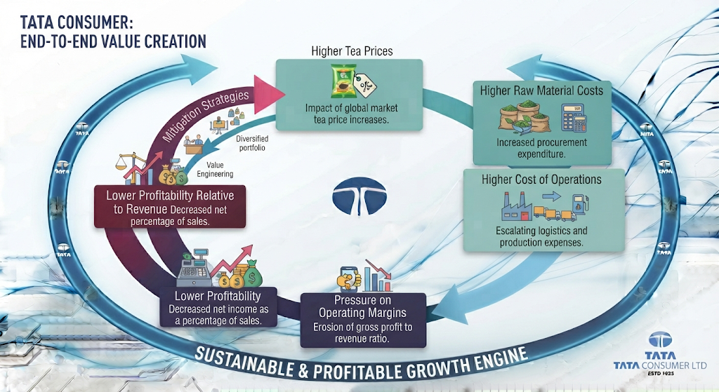A consumer company facing higher input costs generally has several options.
1. Increase Product Prices
This may protect profitability. However, higher prices can affect:
- Consumer demand
- Sales volumes
- Market share
2. Absorb the Cost Increase
This may help protect consumer demand.However, profitability margins can decline.
3. Improve Cost Efficiency
The company may attempt to offset higher input costs through:
- Operational efficiencies
- Better sourcing
- Supply chain improvements
- Product mix
However, significant commodity inflation may not always be fully offset.The strength of Tata Consumer's brands will therefore play an important role in determining how effectively the company can manage input cost inflation.

7.5 REVENUE GROWTH VERSUS PROFIT GROWTH
FY2024–25 demonstrates an important difference between Business Growth and Profit Growth. The company achieved:
Revenue Growth
+16%
However:
EBITDA Growth
+8%
EBIT Growth
-2%
Profit before Exceptional Items & Tax Growth
-12%
This creates a clear progression.
Revenue
Underlying Profitability
(down) Further Decline
The further we move down the income statement, the greater the pressure on profitability becomes.
This means investors should not evaluate Tata Consumer's performance based only on the headline revenue growth.
The company's financial performance needs to be assessed through the complete profitability structure.

7.6 EBIT PERFORMANCE
After accounting for depreciation and amortisation, Tata Consumer reported EBIT of:
₹1,902 crore in FY2024–25
compared with:
₹1,946 crore in FY2023–24
This represents a decline of:
2%
This is an important development because the company achieved strong revenue growth while EBIT declined.
The Difference
Revenue:
+16%

EBITDA:
+8%

EBIT:
-2%
The pattern shows that the pressure on profitability became stronger after accounting for depreciation and amortisation.
This may reflect the impact of a growing business and a larger asset base.
As companies expand through:
- New facilities
- Manufacturing investments
- Technology
- Acquisitions
- Business infrastructure
the associated depreciation and amortisation can increase.
The result is that:
EBIT can grow more slowly than EBITDA or even decline despite EBITDA growth.
For Tata Consumer, this makes the analysis of future capital investment and return on capital particularly important.

7.7 EBIT MARGIN
Tata Consumer's EBIT margin declined from:
12.8%
in FY2023–24
to:
10.8%
in FY2024–25.
This represents a decline of:

200 basis points
The decline in EBIT margin was larger than the decline in EBITDA margin.
EBITDA Margin

15.3% | → | 14.2%
Decline:

110 bps
EBIT Margin

12.8% | → | 10.8%
Decline:

200 bps
This indicates that profitability pressure was not limited to operating costs alone.
The company also experienced greater pressure further down the income statement.
Investor Perspective
A growing company can sometimes maintain EBITDA growth while facing pressure at the EBIT level.
Therefore, investors should analyse multiple profitability indicators rather than relying only on EBITDA.
Tata Consumer's FY2024–25 results demonstrate this clearly.

7.8 PROFIT BEFORE EXCEPTIONAL ITEMS AND TAX
Profit before exceptional items and tax declined from:
₹2,023 crore in FY2023–24
to
₹1,782 crore in FY2024–25
This represents a decline of:
12%
The margin also declined significantly.
FY2023–24
13.3%
FY2024–25
10.1%
The decline was:

320 basis points
This was one of the most significant profitability movements during FY2024–25.
Why Is This Important?
Profit before exceptional items provides investors with a clearer view of underlying profitability because it excludes unusual or exceptional events.
The decline therefore indicates that:
The underlying profitability of Tata Consumer's business experienced pressure during FY2024–25.
This is different from simply looking at the final reported profit.
The final profit number can be influenced by:
- Exceptional items
- Tax movements
- One-time events
Therefore, analysing underlying profitability provides a more complete understanding of the company's financial performance.

7.9 EXCEPTIONAL ITEMS AND THE FINAL PROFIT PICTURE
An important feature of Tata Consumer's FY2024–25 financial performance was the significant difference between:
Underlying Profitability and Reported Profitability
Exceptional items were significantly lower during FY2024–25 compared with FY2023–24.
FY2023–24 Exceptional Items
₹327 crore
FY2024–25 Exceptional Items
₹5 crore
As a result, the final reported profitability picture improved despite pressure on underlying earnings.
Group Net Profit
FY2023–24:
₹1,215 crore
FY2024–25:
₹1,287 crore
Growth:
6%
This creates an important investor distinction.
Headline View
Group Net Profit Increased
Underlying View
Profit before Exceptional Items & Tax Declined
Both observations are correct. However, they tell different stories. This is why investors should always examine:
- Reported profit
- Underlying profit
- Exceptional items
- Margin trends

7.10 NET PROFIT MARGIN
Tata Consumer's Group Net Profit Margin declined from: 8.0% in FY2023–24
To 7.3% in FY2024–25. This represents a decline of: 70 basis points
Despite the increase in absolute Group Net Profit, the company retained a lower percentage of revenue as final profit.
Simplified View
For every ₹100 of revenue:
FY2023–24
Group Net Profit:
₹8.00
FY2024–25
Group Net Profit:
₹7.30
Therefore:
Absolute profit increased, but profit efficiency declined.
This is another example of why absolute financial numbers should always be analysed together with financial ratios and margins.

7.11 THE COMPLETE PROFITABILITY JOURNEY
Tata Consumer's FY2024–25 financial performance can be understood through the following progression.

REVENUE
Growth:

EBITDA
Growth:
+8%
Margin:

EBIT
Growth:
-2%
Margin:

PROFIT BEFORE EXCEPTIONAL ITEMS & TAX
Growth:
-12%
Margin:

GROUP NET PROFIT
Growth:
+6%
Margin:

8.0% | → | 7.3%
The pattern shows that:
Revenue growth remained strong, but underlying profitability weakened.
The improvement in final Group Net Profit was influenced by significantly lower exceptional items compared with the previous year.

7.12 GROWTH BUSINESSES AND PROFITABILITY
Tata Consumer's growth businesses are becoming an increasingly important part of the company's portfolio. During FY2024–25, growth businesses increased significantly and their contribution to the India business also increased. The company's growth businesses expanded by: 76% including acquisitions while like-to-like growth was 18%
Their contribution to the India business increased from 18% to 28%.This demonstrates the progress of Tata Consumer's portfolio transformation.
However, rapid expansion also creates an important profitability question.
Growing businesses often require investment in:
- Marketing
- Brand development
- Distribution
- Innovation
- Supply chain
- Organisational capabilities
Therefore, the journey of a growth business can be understood as:
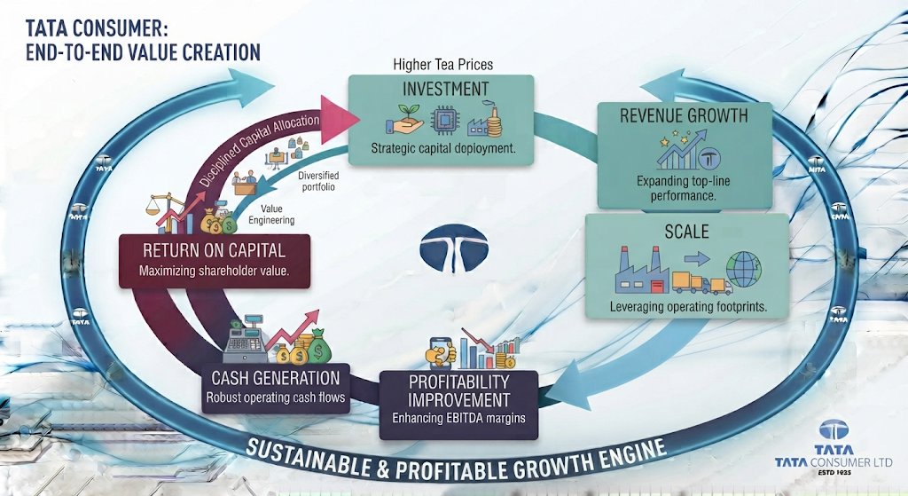
The most important question is not simply whether Tata Consumer's growth businesses can increase revenue. The more important question is: Can these businesses eventually become strong contributors to profitability and return on capital?

7.13 ACQUISITIONS AND THE QUALITY OF GROWTH
The company's growth during FY2024–25 was also supported by acquisitions, including the contribution from Capital Foods and Organic India. This is why it is important to distinguish between:
Reported Growth
This includes:
- Organic business growth
- Growth from acquired businesses
and:
Like-to-Like Growth
This provides a better indication of:
- Underlying organic growth
The growth businesses reported: 76% growth including acquisitions but: 18% like-to-like growth. Both numbers are important. The first demonstrates the increased scale of the portfolio. The second provides a clearer indication of underlying growth.
Investor Perspective
Acquisitions can accelerate revenue growth.
However, the long-term success of an acquisition depends on whether it eventually delivers:
- Sustainable revenue growth
- Profitability
- Synergies
- Cash generation
- Strong returns on invested capital
Therefore, investors should monitor Tata Consumer's acquisitions over multiple years rather than judging them based only on their immediate contribution to revenue growth.

7.14 THE ROLE OF COMMODITY INFLATION
Commodity cost inflation remains one of the major profitability risks for consumer companies. Tata Consumer's exposure to tea makes this particularly important.
The company experienced significant tea cost inflation during FY2024–25, which contributed to pressure on the India business margin.
Consumer companies operate within a complex cost structure that can include:
- Agricultural commodities
- Raw materials
- Packaging
- Transportation
- Energy
- Labour
When input costs rise, management must balance two competing priorities.
Protecting Profitability through:
- Pricing
- Cost control
- Efficiency
while also Protecting Consumer Demand by avoiding excessive price increases. This creates an important test of management and brand strength. Companies with strong brands may have greater ability to manage inflation through:
- Selective price increases
- Premiumisation
- Product mix improvement
Tata Consumer's ability to manage future input inflation will therefore be an important factor influencing its profitability.

7.15 MARGIN COMPRESSION: TEMPORARY OR STRUCTURAL?
One of the most important investor questions following FY2024–25 is: Is Tata Consumer's margin pressure temporary or structural?
At this stage, the company faced a significant increase in tea costs, which contributed to the decline in margins. If commodity costs stabilise or decline, Tata Consumer may benefit from:
- Lower input cost pressure
- Improved margins
- Better operating leverage
The company may also improve profitability through:
- Pricing actions
- Product mix
- Scale efficiencies
- Growth business maturity
- Integration benefits from acquisitions
However, investors should also monitor whether continued expansion requires increasing:
- Marketing expenditure
- Distribution investment
- Brand investment
- Operating costs
If revenue continues to grow while margins continue to decline, the company could face a more structural profitability challenge. Therefore, future margin performance will be one of the most important indicators to monitor.

7.16 STRENGTHS IN TATA CONSUMER'S PROFITABILITY
Despite the margin pressure, Tata Consumer continues to have several important strengths.
1. EBITDA Continued to Grow
EBITDA increased by 8% to ₹2,502 crore. This indicates that the company continues to generate increasing absolute operating earnings.
2. Strong Revenue Growth
Revenue increased by 16% to ₹17,618 crore. Higher scale can potentially create future operating leverage.
3. Growth Businesses Are Expanding
The contribution of growth businesses to the India business increased to 28%.
This provides Tata Consumer with additional long-term growth opportunities.
4. Diversified Portfolio
The company operates across:
- Beverages
- Foods
- Wellness
- Convenience
- International markets
This reduces dependence on a single product category.
5. Strong Brand Portfolio
Tata Consumer's established brands provide a foundation for:
- Consumer trust
- Distribution strength
- Product expansion
- Potential pricing power

7.17 PROFITABILITY RISKS
FY2024–25 also highlighted several important risks.
1. Commodity Inflation
Significant tea cost inflation created pressure on operating margins.
2. Margin Compression
The company experienced declines across multiple profitability margins.
3. Underlying Profit Pressure
Profit before exceptional items and tax declined by 12% despite strong revenue growth.
4. Investment Requirements
New categories and growth businesses may require continued investment before reaching mature profitability.
5. Acquisition Integration
Acquired businesses need to deliver:
- Synergies
- Scale
- Profitability
- Returns on capital

7.18 CHAPTER ANALYSIS
Tata Consumer's FY2024–25 profitability performance was significantly weaker than its revenue growth performance. The company achieved:
Strong Top-Line Growth
with revenue increasing by 16%
However, profitability did not keep pace.

EBITDA
(increased) 8%
but the margin declined from:

15.3% | → | 14.2%

EBIT
(declined) 2%
with the margin declining from:

12.8% | → | 10.8%
Profit Before Exceptional Items & Tax
(declined) 12%
with the margin declining from:

13.3% | → | 10.1%
Group Net Profit
(increased) 6%
but the margin declined from:

8.0% | → | 7.3%
The improvement in reported Group Net Profit should therefore be viewed alongside the significant reduction in exceptional items compared with the previous year.
The overall profitability story is Strong Revenue Growth + Commodity Cost Pressure + Margin Compression + Weak Underlying Profit Growth. The company is clearly expanding its business. However, the next phase of the investment story depends on whether this expansion can eventually produce Higher Margins + Stronger Cash Generation + Better Returns

INVESTOR TAKEAWAY
The most important conclusion from Tata Consumer's profitability analysis is: Revenue growth alone does not represent the complete quality of growth. Tata Consumer grew revenue by 16% during FY2024–25.
However:
- EBITDA grew by only 8%
- EBIT declined by 2%
- Profit before exceptional items and tax declined by 12%
- EBITDA margin declined
- EBIT margin declined
- Net profit margin declined
The company faced significant tea cost inflation, which contributed to pressure on margins in the India business. At the same time, Tata Consumer continued to invest in its growth businesses and expand its broader Food & Beverage portfolio.
The Positive
The company is:
- Growing rapidly
- Increasing its business scale
- Expanding its growth businesses
- Building a broader portfolio
The Concern
The company must demonstrate that Revenue Growth can eventually convert into Sustainable Profit Growth. For investors, the key indicators to monitor going forward will be:
- Commodity costs
- Pricing actions
- EBITDA margin
- India business profitability
- Growth business margins
- Acquisition integration
- Cash generation
- Return on capital
The central investor question is: Can Tata Consumer convert its expanding revenue base into stronger and more sustainable profitability?

CHAPTER 8: CASH FLOW ANALYSIS: UNDERSTANDING HOW TATA CONSUMER GENERATES AND USES CASH

Chapter Objective
The previous chapter examined Tata Consumer's profitability and identified an important pattern. The company delivered strong revenue growth during FY2024–25, but profit growth did not move at the same pace. This raises another important question for investors:
How much of Tata Consumer's business performance is actually converting into cash?
Profit and cash are closely connected, but they are not the same.A company can report accounting profits while:
- Cash remains tied up in working capital
- Large investments consume cash
- Acquisitions require significant funding
- Debt repayments or financing activities affect liquidity
Therefore, cash flow analysis helps us understand the financial reality behind the income statement. This chapter examines:
- Cash flow from operating activities
- Cash flow from investing activities
- Cash flow from financing activities
- Capital expenditure
- Acquisition-related cash flows
- Working capital movements
- Cash and cash equivalents
- The overall movement of cash during FY2024–25
The central objective is to understand Where did Tata Consumer's cash come from, and where did it go?

8.1 CASH FLOW AT A GLANCE
Tata Consumer's consolidated cash flow movement during FY2024–25 is summarised below.
Cash Flow Category | FY2023–24 | FY2024–25
Net Cash from Operating Activities | ₹2,057 Cr | ₹2,422 Cr
Net Cash Used in Investing Activities | ₹2,354 Cr | ₹1,398 Cr
Net Cash from Financing Activities | ₹453 Cr | ₹1,075 Cr Used
Net Increase / (Decrease) in Cash and Cash Equivalents | ₹156 Cr | ₹52 Cr Decrease
Cash and Cash Equivalents at Year End | ₹1,378 Cr | ₹1,413 Cr
The first important observation is that Tata Consumer generated ₹2,422 crore from operating activities during FY2024–25. However, the company also deployed significant amounts of cash towards:
- Investments
- Capital expenditure
- Deposits and investments
- Loans and advances
- Financing obligations
Therefore, while the operating business generated strong cash, the overall increase in cash and cash equivalents remained limited. This reflects the company's current stage of transformation Strong Operating Cash Generation + Significant Cash Deployment for Growth and Capital Allocation

8.2 CASH FLOW FROM OPERATING ACTIVITIES
Cash flow from operating activities represents the cash generated from the company's core business operations. For Tata Consumer, this is particularly important because the company is expanding rapidly across:
- Beverages
- Foods
- Wellness
- Convenience
- Premium categories
- International markets
During FY2024–25, Tata Consumer generated ₹2,422 crore of net cash from operating activities compared with ₹2,057 crore in FY2023–24. This represents an increase of approximately 18%
Operating Cash Flow Trend
Financial Year | Net Cash from Operating Activities
FY2023–24 | ₹2,057 Cr
FY2024–25 | ₹2,422 Cr
The improvement in operating cash flow is an important positive development. The company generated approximately ₹365 crore more operating cash than in the previous year.

8.3 WHAT DOES THE IMPROVEMENT IN OPERATING CASH FLOW SHOW?
The increase in operating cash flow indicates that Tata Consumer's business continued to generate strong cash from its underlying operations. This is particularly important when viewed alongside the profitability analysis.
During FY2024–25:
- Revenue increased strongly
- EBITDA increased
- Operating margins faced pressure
- Underlying profitability weakened
Despite the pressure on profitability margins, the company still generated stronger operating cash. This suggests that The business remained a meaningful generator of operating cash even during a year of margin pressure. For investors, this is important because cash generation provides a stronger foundation for:
- Capital expenditure
- Acquisitions
- Debt repayment
- Dividend payments
- Future business investments

8.4 OPERATING PROFIT AND CASH GENERATION
Tata Consumer's operating cash flow during FY2024–25 was supported by its core business operations. However, the cash generated by a business is also affected by changes in working capital. Working capital movements can influence how much of the company's accounting profit is actually converted into cash during a particular year.
The operating cash flow structure broadly follows this journey:
Net Operating Cash Flow
Therefore, operating cash flow should not be evaluated only by comparing it with net profit.
Investors should also understand:
- Changes in receivables
- Inventory movements
- Changes in trade payables
- Other operating assets and liabilities
- Taxes paid
These factors can significantly affect cash generation.

8.5 WORKING CAPITAL MOVEMENTS
Working capital is an important component of cash flow for an FMCG company. Tata Consumer operates across a large distribution network and multiple product categories. Therefore, the company needs to manage:
- Inventory
- Trade receivables
- Trade payables
- Other operating assets
- Other operating liabilities
During FY2024–25, working capital movements influenced the conversion of operating profit into cash. This is particularly important for Tata Consumer because the company is simultaneously:
- Expanding its portfolio
- Growing its distribution network
- Integrating acquired businesses
- Increasing its presence across categories
Rapid business expansion can increase working capital requirements.
For example: Higher Inventory, Higher Receivables and Higher Payables
can support short-term cash availability. The ability to manage these components efficiently will therefore remain important as Tata Consumer continues to scale.

8.6 CASH FLOW FROM OPERATIONS: AN INVESTOR PERSPECTIVE
The most important positive feature of Tata Consumer's cash flow statement is the strong operating cash generation. The company generated ₹2,422 crore from operations during FY2024–25. This is important because Tata Consumer's future growth strategy requires significant capital.
The company is expanding through:
- New products
- New categories
- Manufacturing capabilities
- Distribution expansion
- Technology
- Brand investments
- Acquisitions
A company that generates strong internal cash has greater flexibility to fund these activities. Therefore, the central positive takeaway is Tata Consumer's core business continued to generate substantial cash internally. However, generating cash is only one part of the analysis. The next question is How did the company use that cash?

8.7 CASH FLOW FROM INVESTING ACTIVITIES
Tata Consumer used ₹1,398 crore in investing activities during FY2024–25. This was lower than the ₹2,354 crore used during FY2023–24. The reduction in investing cash outflow was significant. However, Tata Consumer continued to deploy substantial capital. The company's investing activities included cash deployment towards areas such as:
- Property, plant and equipment
- Intangible assets
- Investments
- Deposits
- Loans and advances
- Other strategic investment activities
The company is therefore not simply accumulating operating cash. Instead, it is actively redeploying cash to support its future growth strategy.

8.8 CAPITAL EXPENDITURE
Capital expenditure represents one of the most important uses of cash for a growing company. During FY2024–25, Tata Consumer invested approximately ₹460 crore in capital expenditure. The company's cash flow statement also reflects substantial spending towards property, plant and equipment and intangible assets. Capital expenditure is important because Tata Consumer is expanding its business capabilities across multiple categories.
Investment in physical and business infrastructure can support:
- Manufacturing capacity
- Product expansion
- Technology
- Operational efficiency
- Supply chain capabilities
- Future growth
The key investor question is therefore not whether the company is spending money.
The more important question is: Will these investments generate attractive returns in the future?

RETURN ON CAPITAL
Tata Consumer is currently operating within an important expansion phase. Therefore, capital expenditure needs to be assessed together with future:
- Revenue growth
- Margin improvement
- Cash generation
- Return on capital

8.9 INVESTING CASH FLOW: WHY IT MATTERS
Cash used in investing activities is not automatically negative.In fact, a growing company is expected to invest in its future. The important distinction is between:
Productive Investment
Investment that can eventually generate:
- Revenue growth
- Higher profits
- Stronger cash flows
- Better returns
and:
Unproductive Investment
Investment that:
- Consumes large amounts of capital
- Generates weak returns
- Requires continuous funding
- Does not improve long-term shareholder value
Therefore, Tata Consumer's significant investment activity should be viewed in the context of its broader transformation strategy.
The company is building itself beyond its traditional portfolio of:
- Tea
- Coffee
- Salt
and is expanding into a broader Food & Beverage platform.
This transformation requires capital.
The long-term success of the strategy will depend on whether:
Today's cash investments become tomorrow's profitable businesses.

8.10 ACQUISITIONS AND CASH DEPLOYMENT
Acquisitions have become an important part of Tata Consumer's transformation strategy. The company has expanded its portfolio through acquisitions and has added new growth platforms to its business. This makes acquisition-related capital allocation an important part of cash flow analysis. During the previous period, significant cash was deployed towards the acquisition of businesses. FY2024–25 continued to reflect the broader financial impact of Tata Consumer's transformation and portfolio expansion.
The company is increasingly moving towards categories that can provide exposure to:
- Packaged foods
- Wellness
- Premium products
- Convenience
- New consumer segments
However, acquisitions create an important responsibility for management.
The acquired business must eventually generate:
Returns greater than the cost of acquiring and developing it.
For investors, the acquisition journey should therefore be monitored through:
Return on Invested Capital
The immediate contribution to revenue is not sufficient.
The ultimate question is Will the acquisition create long-term shareholder value?

8.11 CASH FLOW FROM FINANCING ACTIVITIES
Tata Consumer's financing cash flow changed significantly during FY2024–25. During FY2024–25, the company reported Net cash used in financing activities of approximately ₹1,075 crore. In comparison, FY2023–24 reflected Net cash inflow from financing activities of approximately ₹453 crore
This represents a major shift.
FY2023–24
Cash Inflow from Financing Activities
FY2024–25
Cash Outflow from Financing Activities
The change reflects the company's evolving capital structure and financing requirements.
Financing activities can include movements related to:
- Equity capital
- Borrowings
- Repayment of borrowings
- Commercial paper
- Lease liabilities
- Dividends
- Finance costs
For investors, the shift from financing inflow to financing outflow indicates that Tata Consumer used a significant amount of cash for financing-related commitments during FY2024–25.

8.12 DEBT AND FINANCING MOVEMENTS
Tata Consumer's financing cash flow during FY2024–25 included important movements related to its borrowing and financing structure. The company had previously undertaken financing activities associated with its growth and acquisition strategy. During FY2024–25, the cash flow position reflected movements such as:
- Repayment of acquisition-related funding
- Repayment of borrowings
- Dividend payments
- Lease obligations
- Finance cost payments
This is important because financing cash flow provides insight into:
How the company funds its growth and how it manages the resulting financial obligations.
A growing company can finance expansion through:
Operating Cash Flow
Borrowings
Shareholder Capital
The best long-term position depends on the company's ability to maintain an appropriate balance between growth and financial strength.
Tata Consumer's strong operating cash generation therefore becomes particularly important because internally generated cash reduces dependence on external financing over time.

8.13 DIVIDENDS AND CASH RETURN TO SHAREHOLDERS
Dividend payments also represent an important use of cash. During FY2024–25, Tata Consumer continued to return cash to shareholders through dividend payments.
The company paid approximately:
₹741 crore in dividends
Dividend payments are important because they demonstrate the company's ability to share a portion of its cash generation with shareholders.
However, Tata Consumer also remains in an expansion phase.
Therefore, management faces an important capital allocation decision:
How much cash should be returned to shareholders, and how much should be reinvested for future growth?
The balance can be represented as:
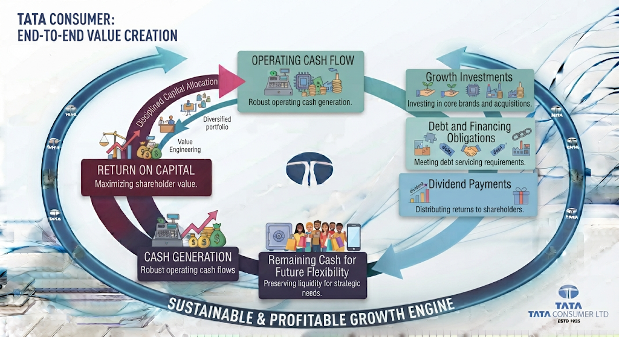
The quality of management's capital allocation will become increasingly important as Tata Consumer continues to expand.

8.14 FINANCE COST PAYMENTS
Cash payments related to finance costs also form an important part of financing cash flows. During FY2024–25, Tata Consumer made significant finance cost payments. This is particularly relevant because the company's recent growth strategy has involved:
- Business expansion
- Acquisitions
- Capital deployment
Whenever a company uses borrowings to support growth, investors must monitor:
- Interest costs
- Debt repayment
- Operating cash generation
- Financial flexibility
The most important long-term question is: Can the company's operating cash flow comfortably support its financing obligations? This will be examined further when we analyse Tata Consumer's:
- Capital structure
- Debt levels
- Solvency
- Interest coverage
- Financial ratios

8.15 NET MOVEMENT IN CASH
After considering operating, investing and financing activities, Tata Consumer's net movement in cash and cash equivalents during FY2024–25 was
A decrease of approximately ₹52 crore
This followed an increase of ₹156 crore during FY2023–24. At first glance, a decline in cash may appear negative. However, the reason behind the movement is important.
Tata Consumer generated ₹2,422 crore from operations but deployed substantial amounts towards:
- Investing activities
- Financing obligations
- Capital deployment
- Dividends
- Other financial commitments
Therefore, the decline in cash should not be interpreted simply as weak financial performance.
Instead, it reflects: Strong cash generation combined with significant cash deployment. This is why investors should never analyse the ending cash balance alone. They should analyse Where the cash came from and where it was used.

8.16 CASH AND CASH EQUIVALENTS
Tata Consumer ended FY2024–25 with cash and cash equivalents of approximately ₹1,413 crore compared with ₹1,378 crore in the previous year. The company's cash and liquidity position also needs to be understood alongside bank overdrafts and its broader cash management arrangements. The overall year-end cash position demonstrates that Tata Consumer maintained substantial liquidity despite significant investment and financing activity.
Liquidity is particularly important for a company operating across:
- Multiple countries
- Multiple currencies
- Large supply chains
- Consumer categories
- Manufacturing operations
A strong liquidity position provides flexibility to:
- Manage working capital
- Fund operations
- Invest in growth
- Meet financial obligations
- Respond to unexpected market conditions

8.17 CASH FLOW AND TATA CONSUMER'S GROWTH STRATEGY
The cash flow statement provides an important insight into Tata Consumer's current stage of development. The company is generating substantial operating cash.
At the same time, it is deploying capital to build a larger and more diversified business.
The complete cycle can be understood as:
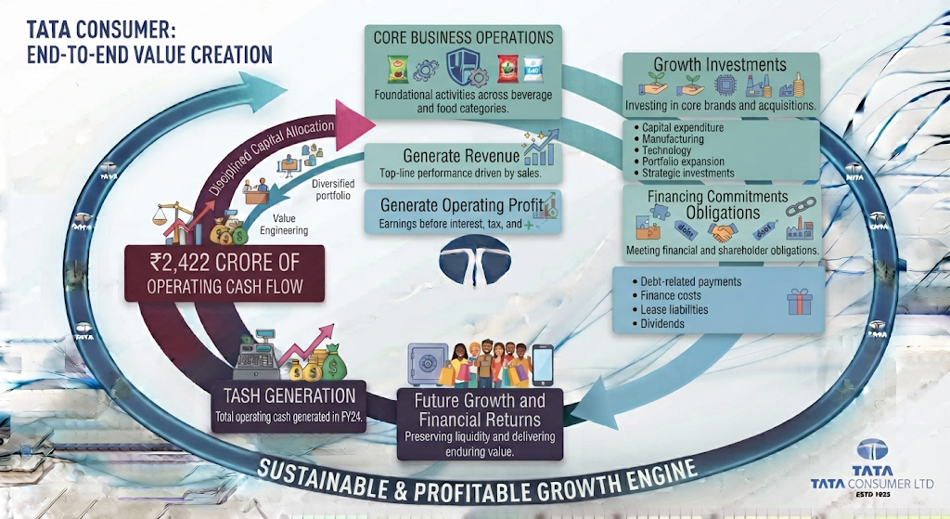This demonstrates that Tata Consumer's cash flow story is closely connected to its transformation strategy. The company is not operating as a mature business that simply generates cash and distributes most of it.
Instead, it is: Generating cash while simultaneously reinvesting to build future growth platforms.

8.18 FREE CASH FLOW: THE INVESTOR PERSPECTIVE
One of the most important questions for investors is: How much cash remains after the company invests in maintaining and expanding its business?
Tata Consumer generated strong operating cash during FY2024–25. However, the company also incurred significant capital expenditure and investment outflows.
Therefore, the amount of cash available after investments becomes an important indicator of financial flexibility.
The company's FY2024–25 performance shows that Tata Consumer's operating cash generation was strong enough to support a significant portion of its investment requirements.
However, the company is also pursuing an active growth strategy. Therefore, investors should continue monitoring:
- Operating cash flow growth
- Capital expenditure
- Acquisition spending
- Financing requirements
- Dividend payments
The objective is to determine whether: Operating cash flow can increasingly fund Tata Consumer's future growth requirements.

8.19 CASH FLOW QUALITY
The quality of a company's earnings can be assessed partly by examining whether profits are supported by operating cash generation. For Tata Consumer, FY2024–25 presents a relatively positive operating cash flow picture. The company generated ₹2,422 crore in net operating cash flow
This demonstrates that the business was not dependent only on accounting profits.
It continued to generate significant actual cash from operations.
However, the complete cash flow picture also highlights the company's capital intensity during its current transformation phase.
The company must use cash for:
- Business expansion
- Capital expenditure
- Investments
- Acquisitions
- Financial obligations
- Shareholder distributions
Therefore, Tata Consumer's long-term cash flow quality will depend on whether its growth investments eventually produce:
Higher Revenue + Higher Margins + Higher Operating Cash Flow

8.20 CASH FLOW STRENGTHS
Tata Consumer's FY2024–25 cash flow performance highlights several strengths.
1. Strong Operating Cash Generation
Operating cash flow increased to ₹2,422 crore. This provides the company with an important internal source of funding.
2. Improved Operating Cash Flow
Operating cash flow increased by approximately 18% compared with FY2023–24.
This demonstrates improved cash generation from the underlying business.
3. Ability to Fund Growth
The company generated sufficient operating cash to support significant investment activity. This reduces the need to rely entirely on external capital for growth.
4. Continued Investment in Future Growth
The company continued to deploy capital towards:
- Business infrastructure
- Capital expenditure
- Strategic investments
This supports Tata Consumer's broader transformation strategy.
5. Continued Shareholder Returns
The company continued to return cash to shareholders through dividend payments while also investing for future growth.

8.21 CASH FLOW RISKS
The cash flow statement also highlights several areas investors should continue monitoring.
1. Significant Cash Deployment
The company continues to use substantial cash for investing and financing activities.
Future investments must generate appropriate returns.
2. Capital Allocation
As Tata Consumer expands, management's ability to allocate capital efficiently becomes increasingly important. Poor capital allocation can reduce shareholder value even if revenue continues to grow.
3. Acquisition Funding
Acquisitions require substantial capital. Investors must monitor whether acquired businesses eventually generate:
- Positive cash flow
- Strong margins
- Attractive returns
4. Working Capital Requirements
A larger business and broader portfolio can increase working capital needs.Efficient management of:
- Inventory
- Receivables
- Payables
will remain important.
5. Financing Obligations
Debt-related and financing cash outflows need to remain comfortably supported by operating cash generation.

8.22 CHAPTER ANALYSIS
Tata Consumer's FY2024–25 cash flow performance presents a positive but investment-heavy picture. The company generated ₹2,422 crore of operating cash flow compared with ₹2,057 crore in the previous year.
This demonstrates that the underlying business remained a strong generator of cash.
However, the company also deployed substantial amounts towards:
- Investing activities
- Capital expenditure
- Strategic growth
- Financing commitments
- Dividend payments
The overall pattern can be summarised as:
Limited Net Change in Cash
This is consistent with Tata Consumer's broader transformation strategy. The company is expanding from a more traditional portfolio towards a broader Food & Beverage platform.
That transformation requires capital. Therefore, the key question for investors is not whether Tata Consumer is spending cash.
The important question is:
Will today's investments generate stronger cash flows and returns in the future?

INVESTOR TAKEAWAY
The most important conclusion from Tata Consumer's cash flow analysis is:
The company continues to generate strong cash from its core operations, but a significant portion of that cash is being redeployed for growth and financial commitments.
The Positive
Tata Consumer generated ₹2,422 crore in operating cash flow representing an improvement from the previous year. This demonstrates that the company's core operations remain capable of generating substantial cash.
The Investment Story
The company continues to deploy capital towards:
- Capital expenditure
- Business expansion
- Strategic investments
- Portfolio transformation
This is necessary for Tata Consumer's long-term growth ambitions.
The Investor Question
The most important issue is whether: Cash invested today will produce higher returns tomorrow.
Investors should therefore monitor:
- Operating cash flow growth
- Capital expenditure
- Acquisition-related cash deployment
- Working capital efficiency
- Debt and financing obligations
- Dividend payments
- Return on capital
The ultimate objective is to determine whether Tata Consumer can create a virtuous financial cycle:

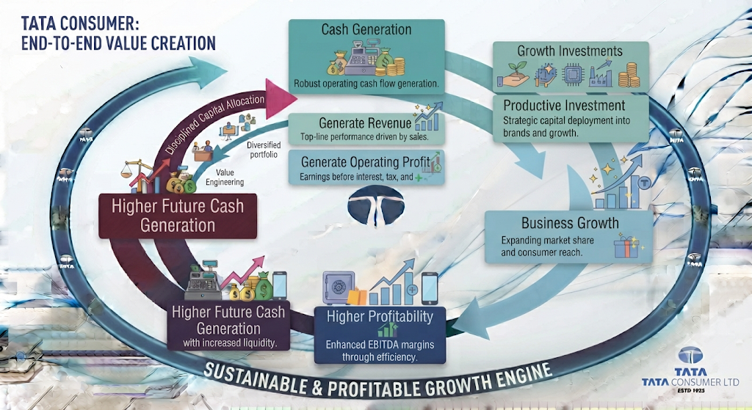CHAPTER 9: BALANCE SHEET ANALYSIS: UNDERSTANDING THE COMPANY'S FINANCIAL POSITION

Chapter Objective
The previous chapter examined how Tata Consumer generated and deployed cash during FY2024–25. The company generated strong operating cash flow while continuing to deploy capital towards:
- Business expansion
- Capital expenditure
- Strategic investments
- Portfolio transformation
- Financing commitments
- Shareholder returns
However, cash flow alone does not provide the complete picture of a company's financial strength. To understand the financial position of Tata Consumer, we must now examine its balance sheet. The balance sheet answers several important investor questions:
What does the company own?
What does the company owe?
How much of the business is financed by shareholders?
How much financial flexibility does the company have?
- Total assets
- Asset composition
- Current and non-current assets
- Equity
- Current and non-current liabilities
- Borrowings
- Financial obligations
- Liquidity
- Balance sheet strength
The objective is to understand: How financially strong is Tata Consumer while it continues its transformation and expansion strategy?

9.1 UNDERSTANDING TATA CONSUMER'S FINANCIAL POSITION
Tata Consumer has been going through a significant transformation. The company is expanding beyond its traditional businesses into a broader Food & Beverage platform. This expansion has involved:
- Organic growth
- Capital expenditure
- New product categories
- Distribution expansion
- Acquisitions
- Investment in brands and capabilities
As a result, the balance sheet has become increasingly important. A growing company can increase revenue quickly. However, investors also need to understand:
- Whether assets are increasing efficiently
- How acquisitions are affecting the balance sheet
- Whether debt is increasing
- Whether equity remains strong
- Whether current liabilities can be comfortably managed
The balance sheet therefore provides the financial foundation behind Tata Consumer's growth strategy.

9.2 THE BALANCE SHEET AT A GLANCE
Tata Consumer's consolidated balance sheet represents a significantly diversified and expanded business. The financial position includes:

ASSETS
- Property, plant and equipment
- Right-of-use assets
- Goodwill
- Other intangible assets
- Investments
- Inventory
- Trade receivables
- Cash and bank balances
- Other financial assets

EQUITY
- Share capital
- Other equity
- Non-controlling interests

LIABILITIES
- Borrowings
- Lease liabilities
- Trade payables
- Provisions
- Employee benefit obligations
- Other financial liabilities
- Other current and non-current liabilities
The structure reflects the nature of Tata Consumer as a Large, diversified and internationally operating consumer products business.

9.3 ASSETS: WHAT DOES TATA CONSUMER OWN?
Assets represent the economic resources controlled by the company. For Tata Consumer, the asset base supports its operations across:
- India
- International markets
- Manufacturing
- Distribution
- Food and beverage businesses
- Brands
- Acquired businesses
The company's assets can broadly be divided into:

NON-CURRENT ASSETS
These are assets generally held for long-term use. They include:
- Property, plant and equipment
- Right-of-use assets
- Goodwill
- Other intangible assets
- Investments
- Other long-term financial assets

CURRENT ASSETS
These are assets expected to be realised or used within the normal operating cycle or relatively shorter periods. They include:
- Inventories
- Trade receivables
- Cash and cash equivalents
- Bank balances
- Other current financial assets
- Other current assets
The balance between current and non-current assets provides insight into the nature of Tata Consumer's business model.

9.4 NON-CURRENT ASSETS: THE LONG-TERM BUSINESS FOUNDATION
Tata Consumer's non-current asset base is important because the company operates across multiple businesses and geographies. Its long-term assets support:
- Manufacturing
- Processing
- Distribution
- Brand development
- International operations
- Acquired businesses
The major categories include:
Property, Plant and Equipment
These assets support the company's operational infrastructure. They can include:
- Manufacturing facilities
- Machinery
- Buildings
- Equipment
- Other operational assets
Right-of-Use Assets
These arise from assets used by the company under lease arrangements. Leased assets can support:
- Offices
- Warehouses
- Manufacturing operations
- Other business infrastructure
Goodwill
Goodwill becomes particularly important for Tata Consumer because the company has expanded through acquisitions. Acquisitions can create a significant difference between: The purchase price of a business and The identifiable net assets acquired.
This difference can appear on the balance sheet as goodwill. For Tata Consumer, goodwill is therefore closely connected with the company's strategy of expanding through acquisitions and portfolio transformation.
Intangible Assets
Intangible assets can include assets associated with:
- Brands
- Technology
- Customer relationships
- Intellectual property
- Other identifiable non-physical assets
For a consumer products company, brands are particularly important. A strong consumer brand can create long-term economic value through:
- Consumer trust
- Repeat purchases
- Pricing power
- Market presence
However, investors should always distinguish between The economic strength of a brand and The accounting value of intangible assets recorded on the balance sheet.

9.5 THE IMPACT OF ACQUISITIONS ON THE ASSET BASE
Tata Consumer's recent transformation has involved the acquisition and integration of new businesses. The company has expanded its portfolio through businesses such as:
- Capital Foods
- Organic India
These additions provide Tata Consumer with exposure to new categories and consumer segments. However, acquisitions also affect the balance sheet. The acquisition process can increase:
- Goodwill
- Intangible assets
- Property and other business assets
- Working capital assets
The financial story therefore becomes:
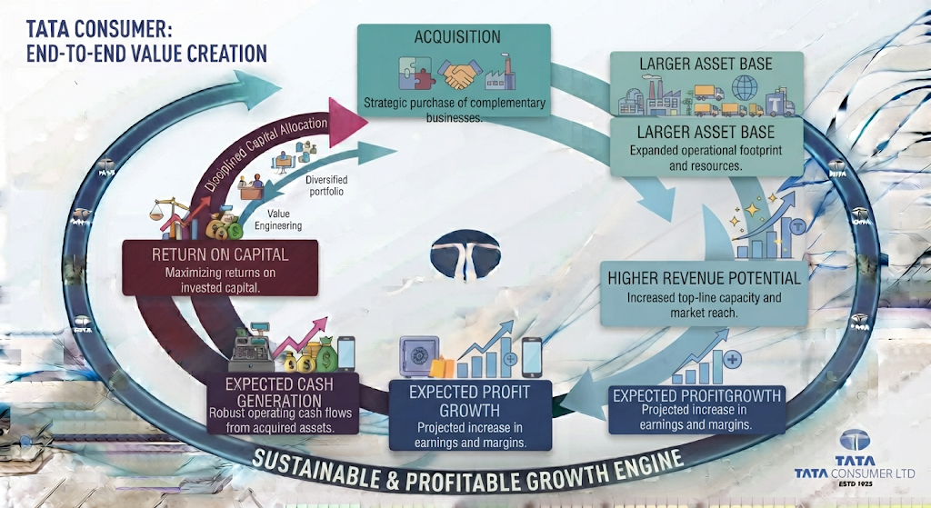This is where investors need to remain disciplined. A larger balance sheet does not automatically create shareholder value. The acquired assets must eventually generate:
- Profits
- Cash flow
- Attractive returns

9.6 CURRENT ASSETS: THE SHORT-TERM FINANCIAL BASE
Current assets are important because they support Tata Consumer's day-to-day operations. The major components include:
- Inventory
- Trade receivables
- Cash and cash equivalents
- Bank balances
- Other financial assets
For an FMCG and consumer products company, inventory management is particularly important. The company operates across multiple:
- Product categories
- Manufacturing facilities
- Distribution channels
- Geographies
Therefore, Tata Consumer must maintain sufficient inventory to support sales. At the same time Excess inventory can tie up cash.
This creates a balance between PRODUCT AVAILABILITY and WORKING CAPITAL EFFICIENCY. As the company continues to expand into new categories, effective management of current assets will become increasingly important.

9.7 INVENTORY: AN IMPORTANT WORKING CAPITAL COMPONENT
Inventory represents products and materials held by the company for its operations.For Tata Consumer, this can involve:
- Tea
- Coffee
- Food products
- Raw materials
- Packaging materials
- Finished goods
The company's inventory requirements are influenced by:
- Consumer demand
- Commodity prices
- Seasonal patterns
- Manufacturing cycles
- Supply chain requirements
The profitability analysis in the previous chapter showed that Tata Consumer experienced significant tea cost inflation. This also makes inventory management important. When commodity prices increase, the value of inventory and the cost of future production can be affected. Therefore, investors should monitor whether Tata Consumer can effectively manage:
- Inventory levels
- Commodity procurement
- Input costs
- Working capital
The objective should be to maintain sufficient product availability without unnecessarily locking large amounts of cash into inventory.

9.8 TRADE RECEIVABLES AND CASH CONVERSION
Trade receivables represent money owed to Tata Consumer by customers. For a consumer products company with a large distribution network, receivable management is an important part of financial discipline.
The ideal operating cycle is:

CASH COLLECTED
The longer the company takes to collect cash, the more capital can remain tied up in the business.
As Tata Consumer continues expanding:
- Distribution channels
- Product categories
- International markets
- Digital and emerging channels
the efficient management of receivables will remain important. Investors should monitor whether revenue growth is accompanied by Healthy Cash Collection rather than an excessive increase in money owed by customers.

9.9 CASH AND LIQUIDITY
Tata Consumer maintained a meaningful cash and liquidity position during FY2024–25.
The company's cash position is important because it provides flexibility to:
- Meet operational requirements
- Manage working capital
- Fund investments
- Meet financing obligations
- Respond to unexpected market conditions
The cash flow analysis showed that Tata Consumer generated strong operating cash during the year. However, the company also deployed substantial cash towards:
- Investments
- Financing commitments
- Capital expenditure
- Dividend payments
This makes liquidity management important. A strong liquidity position allows the company to continue its growth strategy without becoming excessively dependent on short-term financing.

9.10 EQUITY: THE FINANCIAL FOUNDATION OF THE BUSINESS
Equity represents the shareholders' financial interest in the company. Tata Consumer's equity base includes:
- Share capital
- Reserves and surplus
- Retained earnings
- Other components of equity
- Non-controlling interests at the consolidated level
A strong equity base is particularly important for a company pursuing significant expansion. Equity provides financial support for:
- Business growth
- Investments
- Acquisitions
- Unexpected losses
- Long-term capital requirements
The company has also benefited from the ability to generate and retain earnings over time. The relationship between assets and equity provides an important insight into the company's financial structure. A company with a stronger equity base can potentially:
- Maintain greater financial stability
- Reduce dependence on borrowings
- Support future investment
- Absorb periods of business volatility

9.11 RETAINED EARNINGS AND BUSINESS GROWTH
One of the most important components of equity is retained earnings. A company can use its profits in two broad ways: DISTRIBUTE PROFITS through dividends or RETAIN PROFITS
for:
- Business expansion
- Capital expenditure
- Acquisitions
- Financial strengthening
Tata Consumer is currently balancing both objectives. The company continues to:
- Invest for future growth
- Expand its portfolio
- Return cash to shareholders
This makes capital allocation an increasingly important area for investors. Management must decide: How much of the company's financial resources should be retained for future growth, and how much should be returned to shareholders?
The quality of this decision will influence long-term shareholder returns.

9.12 LIABILITIES: WHAT DOES THE COMPANY OWE?
Liabilities represent Tata Consumer's financial obligations. These can broadly be divided into:

NON-CURRENT LIABILITIES
Longer-term obligations such as:
- Long-term borrowings
- Lease liabilities
- Deferred tax liabilities
- Employee benefit obligations
- Other long-term provisions and liabilities

CURRENT LIABILITIES
Short-term obligations such as:
- Trade payables
- Short-term borrowings
- Current maturities of long-term obligations
- Lease obligations
- Other financial liabilities
- Provisions
- Other current liabilities
The liability structure provides investors with insight into How Tata Consumer finances its operations and expansion.

9.13 BORROWINGS AND FINANCIAL STRUCTURE
Borrowings are an important part of the balance sheet because Tata Consumer has been actively expanding its business. Growth through acquisitions and investments can require significant capital. Companies generally have three major sources of funding:
Internally generated funds
Shareholder capital and retained earnings
Borrowings and other financing
The ideal balance depends on:
- Business stability
- Cash generation
- Cost of debt
- Growth opportunities
- Return on investment
Tata Consumer's financial structure should therefore be evaluated not simply by looking at the amount of debt. The more important question is: Can the company comfortably support its financial obligations through its operating cash flow and financial resources?
The strong operating cash generation observed in the previous chapter provides an important foundation.

9.14 LEASE LIABILITIES
Modern companies increasingly use leased assets to support their operations. Lease arrangements can include:
- Offices
- Warehouses
- Manufacturing infrastructure
- Other operational facilities
While the company receives the economic benefit of using these assets, the associated lease obligations also become an important financial commitment. Therefore, when analysing Tata Consumer's liabilities, investors should consider:
- Traditional borrowings
- Lease liabilities
- Other financing obligations
This provides a more complete understanding of the company's financial commitments.

9.15 CURRENT LIABILITIES AND SHORT-TERM FINANCIAL MANAGEMENT
Current liabilities are particularly important because they represent obligations that need to be settled within the relatively short term. For Tata Consumer, these can include:
- Trade payables
- Short-term financial obligations
- Employee-related liabilities
- Tax obligations
- Other operating liabilities
A growing FMCG business needs to carefully manage the relationship between CURRENT ASSETS and CURRENT LIABILITIES. This determines the company's ability to meet its short-term obligations. The company's liquidity position will be examined more deeply through financial ratios in the following stage of the analysis.
However, the balance sheet structure provides the underlying data required to understand:
- Current ratio
- Quick ratio
- Working capital
- Short-term financial flexibility

9.16 THE RELATIONSHIP BETWEEN ASSETS AND LIABILITIES
The balance sheet can be understood through a simple financial relationship:

ASSETS = LIABILITIES + EQUITY
Tata Consumer's growth strategy increases the importance of this relationship.
As the company expands:
Assets Increase
through:
- Acquisitions
- Capital expenditure
- Working capital
- New capabilities
At the same time, these assets must be financed through: Equity and/or Liabilities
The important investor question: Is Tata Consumer expanding its asset base in a financially sustainable manner?
The answer depends on whether the company's assets generate sufficient:
- Revenue
- Profit
- Cash flow
- Returns

9.17 GOODWILL AND INTANGIBLE ASSETS: AN IMPORTANT INVESTOR CONSIDERATION
Tata Consumer's acquisition-led expansion makes goodwill and intangible assets particularly important. These assets can represent significant expectations regarding future business performance. For example, an acquisition may be justified based on expectations of:
- Revenue growth
- Brand strength
- Market access
- Distribution synergies
- Margin improvement
These expectations become part of the economic rationale for the acquisition. However, investors should monitor whether acquired businesses actually deliver those expected benefits. If an acquired business performs significantly below expectations, the company may eventually need to reassess the carrying value of goodwill or other intangible assets. Therefore, the key investor question is:
Are Tata Consumer's acquisition-related assets generating the returns originally expected from them?
This will become increasingly important as the company's portfolio transformation continues.

9.18 BALANCE SHEET STRENGTHS
Tata Consumer's balance sheet has several important strengths.
1. Diversified Asset Base
The company has assets supporting:
- Beverages
- Foods
- Wellness
- International operations
- Manufacturing
- Distribution
This diversification reduces dependence on a single category.
2. Strong Operating Cash Generation
The business generated substantial operating cash during FY2024–25. This provides an important source of internal financial support.
3. Established Equity Foundation
The company's equity base provides financial support for:
- Business expansion
- Investments
- Long-term growth
4. International Presence
The company's international operations provide a geographically diversified business structure.
5. Growing Portfolio
The expansion into new consumer categories provides additional long-term growth opportunities.

9.19 BALANCE SHEET RISKS
The balance sheet also highlights areas that investors should monitor carefully.
1. Acquisition-Related Assets
Goodwill and intangible assets created through acquisitions must eventually generate economic returns.
2. Capital Allocation
As Tata Consumer deploys more capital, management's investment decisions become increasingly important.
3. Working Capital Requirements
A larger and more diversified business may require increasing investments in:
- Inventory
- Receivables
- Supply chain operations
4. Financial Obligations
Borrowings, lease liabilities and other obligations need to remain manageable relative to:
- Cash flow
- Earnings
- Financial resources
5. Return on Assets
The most important long-term question is whether the company's growing asset base can generate attractive:
- Profitability
- Cash flow
- Returns on capital

9.20 CHAPTER ANALYSIS
Tata Consumer's balance sheet reflects a company undergoing a major transformation. The business is no longer limited to its traditional categories. The company is expanding across:
- Food
- Beverages
- Wellness
- Convenience
- International markets
This expansion is visible in the broader structure of its assets and financial commitments. The company is building a larger asset base through:
- Organic investment
- Capital expenditure
- Acquisitions
- Business expansion
At the same time, Tata Consumer needs to ensure that this expansion remains financially disciplined. The central balance sheet question is not simply: How large are Tata Consumer's assets? The more important question is: How productively are those assets being used?
The next stage of analysis will therefore focus on financial ratios.
These ratios will help us evaluate:
- Liquidity
- Solvency
- Capital structure
- Operational efficiency
- Financial strength

INVESTOR TAKEAWAY
The most important conclusion from Tata Consumer's balance sheet analysis is: The company's financial position reflects an expanding business that is actively building assets and capabilities for future growth.
Tata Consumer is:
- Expanding its portfolio
- Investing in new categories
- Integrating acquired businesses
- Building a broader Food & Beverage platform
This strategy naturally increases the importance of:
- Asset quality
- Capital allocation
- Liquidity
- Financial obligations
- Return on capital
The Positive
The company has:
- A diversified business structure
- Strong operating cash generation
- An established equity base
- Multiple growth platforms
The Investor Question
The most important question going forward is Can Tata Consumer generate sufficient returns from its growing asset base? Investors should therefore closely monitor:
- Asset growth
- Working capital
- Borrowings
- Goodwill and intangible assets
- Liquidity
- Return on assets
- Return on capital
The balance sheet provides the foundation. The next chapter will now convert this financial information into measurable indicators of financial strength.

CHAPTER 10: FINANCIAL RATIO ANALYSIS: LIQUIDITY, SOLVENCY, EFFICIENCY & RETURNS

Chapter Objective
The previous chapters examined Tata Consumer's:
- Revenue growth
- Profitability
- Cash flow generation
- Balance sheet structure
However, analysing individual financial statement numbers alone does not always provide a complete picture. Financial ratios help connect these numbers and answer important questions such as: Can the company comfortably meet its short-term obligations? How dependent is the company on debt? How efficiently does it manage inventory and receivables? How effectively is capital being used to generate returns? Are the company's financial strengths improving or weakening?
1. Liquidity
The company's ability to meet short-term obligations.
2. Solvency
The company's financial leverage and ability to manage debt obligations.
3. Operating Efficiency
How effectively the company manages working capital and business resources.
4. Returns
How effectively Tata Consumer generates returns from shareholder capital and capital employed. The objective is to move beyond absolute financial numbers and understand:
How financially efficient and financially resilient is Tata Consumer?

10.1 FINANCIAL RATIOS AT A GLANCE
The following table provides an overview of Tata Consumer's key financial ratios.
Ratio | FY2023–24 | FY2024–25 | Movement
Current Ratio | 1.51 | 1.54 | Improved
Debt-Equity Ratio | 0.18 | 0.11 | Improved
Debt Service Coverage Ratio | 8.05 | 5.79 | Declined
Return on Equity / Net Worth | 6.53% | 6.63% | Improved
Inventory Turnover | 5.69 | 5.53 | Declined
Trade Receivables Turnover | 19.60 | 19.95 | Improved
Trade Payables Turnover | 4.59 | 4.66 | Improved
Net Capital Turnover | 5.87 | 5.44 | Declined
Net Profit Margin | 7.99% | 7.31% | Declined
Return on Capital Employed | 41.01% | 37.54% | Declined
Return on Investment | 6.72% | 6.40% | Declined
The overall picture is mixed.
Financial Strength Improved
- Current ratio improved
- Debt-equity ratio improved
- Return on net worth improved slightly
- Receivables turnover improved
- Payables turnover improved
Operating and Return Indicators Faced Pressure
- Inventory turnover declined
- Net capital turnover declined
- Net profit margin declined
- Return on capital employed declined
- Return on investment declined
- Debt service coverage declined
This creates an important conclusion: Tata Consumer strengthened some aspects of its financial structure, but the profitability and efficiency of capital deployment came under pressure.

PART I – LIQUIDITY ANALYSIS

10.2 CURRENT RATIO
The current ratio measures Tata Consumer's ability to meet its short-term obligations using its current assets.
The company's current ratio was:
FY2023–24: 1.51
FY2024–25: 1.54
The ratio improved slightly during the year. This indicates that Tata Consumer maintained a reasonable level of current assets relative to its current liabilities.
What Does a Current Ratio of 1.54 Mean? Broadly, for every ₹1 of current liabilities
Tata Consumer had approximately ₹1.54 of current assets
This indicates that the company had a current asset base exceeding its short-term obligations.

10.3 LIQUIDITY POSITION: INVESTOR INTERPRETATION
The improvement in the current ratio is a positive development. TtThis is particularly important because Tata Consumer is currently in an active expansion phase. The company needs sufficient liquidity to manage:
- Inventory requirements
- Supplier payments
- Distribution operations
- Business expansion
- Financing obligations
- Unexpected market conditions
The company's current ratio improved from:

1.51 | → | 1.54
This suggests that the company's short-term financial position remained stable. However, investors should not evaluate liquidity using the current ratio alone. The composition of current assets is equally important.
Current assets may include:
- Cash
- Bank balances
- Investments
- Receivables
- Inventory
Some assets are more immediately available than others. For example:
Cash is more liquid than inventory. Therefore, Tata Consumer's liquidity should also be assessed alongside:
- Operating cash flow
- Working capital
- Borrowings
- Cash balances
- Debt obligations
The strong operating cash flow generated during FY2024–25 provides additional support to the company's liquidity position.

10.4 WORKING CAPITAL AND LIQUIDITY
Working capital represents the financial resources available to support Tata Consumer's day-to-day operations. For a consumer products company, working capital management involves balancing:
Enough products and materials to support sales
Efficient collection from customers
Managing payments to suppliers
Maintaining sufficient liquidity for operations As Tata Consumer continues to expand into:
- New product categories
- New distribution channels
- New businesses
- International markets
working capital management will become increasingly important. The company's liquidity position remains supported by:
A current ratio above 1 and strong operating cash generation.
However, investors should continue monitoring whether growth requires an increasingly large amount of working capital.

PART II – SOLVENCY AND DEBT ANALYSIS

10.5 DEBT-EQUITY RATIO
The debt-equity ratio provides insight into the relationship between:
Debt and Shareholder Capital
Tata Consumer's debt-equity ratio improved significantly during FY2024–25.
FY2023–24
0.18
FY2024–25
0.11
The decline indicates a lower level of debt relative to the company's equity base.
This is a positive development.

10.6 WHAT DOES A DEBT-EQUITY RATIO OF 0.11 INDICATE?
A debt-equity ratio of 0.11 suggests that Tata Consumer has relatively low debt compared with its total equity base. This provides several financial advantages.
Lower Financial Risk
Lower debt reduces dependence on external financing.
Lower Interest Burden
A lower debt burden can reduce pressure from interest obligations.
Greater Financial Flexibility
The company may have greater capacity to fund future opportunities.
Better Resilience
A lower debt-equity ratio can provide greater protection during periods of:
- Commodity inflation
- Economic slowdown
- Higher interest rates
- Business volatility
The improvement from:
0.18 | → | 0.11
therefore represents a strengthening of Tata Consumer's capital structure.

10.7 WHY DID THE DEBT-EQUITY RATIO IMPROVE?
Tata Consumer's improvement in debt-equity reflects a stronger balance between financial obligations and shareholder capital. This is particularly important because the company has been pursuing growth through:
- Acquisitions
- Business expansion
- Capital investment
Growth funded entirely through borrowings can increase financial risk. However, Tata Consumer's FY2024–25 ratio indicates that its debt remained relatively low compared with its equity base.
For investors, this means The company's expansion strategy has not resulted in an excessively leveraged balance sheet. This provides an important financial strength.

10.8 DEBT SERVICE COVERAGE RATIO
The debt service coverage ratio indicates the company's ability to meet its debt-related obligations through the earnings available for debt service. Tata Consumer's ratio was:
FY2023–24
8.05
FY2024–25
5.79
The ratio declined during the year. Although the company continued to maintain a strong level of coverage, the decline should be understood in the context of its financial commitments and profitability pressure.
A ratio of:
5.79
still indicates that the company generated earnings substantially higher than its debt service requirements.
However, compared with the previous year, Debt servicing capacity became relatively weaker.

10.9 INVESTOR VIEW: DEBT SERVICE CAPACITY
The decline in debt service coverage should not automatically be interpreted as financial distress. Tata Consumer continues to maintain a relatively low debt-equity ratio. However, the movement highlights an important principle. Financial strength depends not only on the amount of debt but also on the ability to service that debt.
The ratio should therefore be monitored alongside:
- Operating cash flow
- EBITDA
- Finance costs
- Debt repayments
- Future borrowing requirements
Tata Consumer's strong operating cash flow provides support to its ability to manage financial obligations.
Nevertheless, the decline from:
8.05 | → | 5.79
shows that investors should continue monitoring the company's debt servicing capacity.

10.10 INTEREST COVERAGE
Interest coverage measures the company's ability to meet interest obligations from its operating earnings. During FY2024–25, Tata Consumer's interest coverage ratio stood at: 8.71 times
This indicates that operating earnings were approximately 8.71 times the company's interest obligations. This represents a comfortable level of interest coverage.
However, investors should recognise that interest coverage can be affected by:
- Changes in operating profitability
- Borrowing levels
- Interest rates
- Acquisition financing
The company's future interest coverage will therefore depend on its ability to maintain:
Strong operating earnings while keeping financing costs under control.

PART III – OPERATING EFFICIENCY ANALYSIS

10.11 INVENTORY TURNOVER
Inventory turnover measures how efficiently the company manages and sells its inventory.
Tata Consumer's inventory turnover ratio was:
FY2023–24

5.69 times
FY2024–25

5.53 times
The ratio declined slightly. This means inventory moved through the business marginally more slowly during FY2024–25.

10.12 WHAT DOES THE DECLINE IN INVENTORY TURNOVER MEAN?
A decline in inventory turnover can occur for several reasons.
For Tata Consumer, the movement needs to be viewed in the context of:
- Business expansion
- Portfolio diversification
- Growth in food categories
- New acquisitions
- Commodity cost movements
- Distribution expansion
A broader portfolio may naturally require the company to manage a larger and more diverse inventory base.
The decline from:
5.69 | → | 5.53
was relatively modest.
Therefore, this does not necessarily indicate a major operational concern. However, investors should monitor inventory turnover because: Inventory ties up cash.
If inventory grows significantly faster than sales, it can:
- Increase working capital requirements
- Reduce cash conversion
- Increase storage requirements
- Create the risk of slow-moving inventory
The key objective is to ensure that inventory growth remains aligned with: Revenue growth and consumer demand.

10.13 INVENTORY MANAGEMENT AND COMMODITY COSTS
Inventory management becomes particularly important for Tata Consumer because the company operates in commodity-linked categories.
The company faced significant tea cost inflation during FY2024–25.
Commodity price movements can affect:
- Inventory values
- Procurement costs
- Working capital
- Operating margins
A consumer products company must therefore balance:
Sufficient Inventory
to ensure product availability
with:
Efficient Inventory Management
to avoid unnecessary cash being tied up.
The slight decline in inventory turnover will be an important ratio to monitor as Tata Consumer continues to:
- Expand its portfolio
- Add new products
- Scale its distribution network

10.14 TRADE RECEIVABLES TURNOVER
Trade receivables turnover measures how efficiently Tata Consumer collects money from customers. The company's receivables turnover ratio improved slightly.
FY2023–24

19.60 times
FY2024–25

19.95 times
This represents a positive movement.
The higher ratio indicates slightly faster conversion of credit sales into cash.

10.15 RECEIVABLES MANAGEMENT
Efficient receivables management is important because:
Revenue is not the same as cash.
A company may report higher sales.
However, if customers take longer to make payments, cash remains tied up in receivables.
Tata Consumer's improvement in receivables turnover indicates that the company maintained effective collection efficiency despite growing its business.
This is a positive sign because the company delivered:

16% revenue growth
during FY2024–25.
The improvement in receivables turnover suggests that higher sales were not accompanied by a significant deterioration in collection efficiency.
For investors, this supports the broader observation from the cash flow chapter:
The company continued to maintain meaningful operating cash generation.

10.16 TRADE PAYABLES TURNOVER
Trade payables turnover provides insight into how Tata Consumer manages payments to suppliers and other vendors. The company's trade payables turnover ratio was:
FY2023–24

4.59 times
FY2024–25

4.66 times
This represents a slight improvement. The movement suggests relatively efficient management of supplier-related obligations. Payables are an important component of working capital management. A company needs to balance:
Paying Suppliers on Time
while also:
Managing Cash Efficiently
The modest improvement in Tata Consumer's payables turnover indicates that the company's supplier payment cycle remained relatively stable during the year.

10.17 THE WORKING CAPITAL CYCLE
The relationship between:
- Inventory
- Receivables
- Payables
determines the efficiency of the company's working capital cycle.
For Tata Consumer:
Inventory Turnover
Receivables Turnover
Payables Turnover
Improved.
The overall picture suggests that:
Working capital efficiency remained broadly stable, although inventory management showed some pressure. This is important because Tata Consumer is simultaneously:
- Expanding its product portfolio
- Integrating acquired businesses
- Increasing distribution
- Growing revenue
A rapidly expanding company can often experience pressure on working capital.
The ability to maintain reasonable efficiency during this phase is therefore important.

10.18 NET CAPITAL TURNOVER
Net capital turnover measures how efficiently the company generates revenue from the capital invested in its operations. Tata Consumer's net capital turnover declined from:
FY2023–24

5.87 times
to:
FY2024–25

5.44 times
This represents a decline in capital efficiency.

10.19 WHAT DOES THE DECLINE IN NET CAPITAL TURNOVER SHOW?
The decline indicates that Tata Consumer generated slightly less revenue for each unit of capital employed in its operations. This is important because the company has been increasing its investment in:
- Business expansion
- New categories
- Acquisitions
- Operational capabilities
The financial cycle should ideally be:

STRONGER RETURNS
However, when capital increases faster than revenue efficiency improves, capital turnover can decline.
The movement from:

5.87 | → | 5.44
therefore suggests that Tata Consumer's growing capital base has not yet translated into proportionately higher revenue efficiency. This is not unusual during an expansion phase.
However, investors should monitor whether capital efficiency improves as:
- Acquired businesses scale
- New categories mature
- Investments begin generating returns

10.20 NET PROFIT MARGIN
Tata Consumer's net profit margin declined from:
FY2023–24
7.99%
to:
FY2024–25
7.31%
This represents a decline of approximately:

68 basis points
The movement is consistent with the profitability pressure identified in Chapter 7.
Revenue increased strongly.
However, the company retained a lower percentage of revenue as final profit.
The decline in net profit margin reflects:
- Commodity cost pressure
- Lower operating margins
- Pressure on underlying profitability
Therefore, the ratio confirms an important conclusion from the profitability analysis:
Tata Consumer grew, but its profit efficiency weakened during FY2024–25.

10.21 RETURN ON EQUITY / NET WORTH
Return on net worth measures the return generated from the shareholders' capital invested in the business.
Tata Consumer's return on net worth improved slightly.
FY2023–24
6.53%
FY2024–25
6.63%
The improvement was modest but positive.
This means Tata Consumer generated a slightly higher return relative to its average equity base.

10.22 WHAT DOES THE IMPROVEMENT IN RETURN ON NET WORTH SHOW?
The slight improvement in return on net worth is positive.
However, investors should view the ratio alongside Tata Consumer's broader profitability performance.
The company experienced:
- Margin compression
- Decline in EBIT
- Decline in underlying profit before exceptional items and tax
Despite these pressures, return on net worth improved marginally.
This demonstrates that shareholder capital continued to generate a reasonable return.
However, for a company undertaking significant expansion, the long-term objective should be:
To improve returns as new investments and acquisitions mature.
The key question is whether Tata Consumer can increase its return on equity over time while continuing to grow.

10.23 RETURN ON CAPITAL EMPLOYED
Return on Capital Employed, or ROCE, is one of the most important ratios for analysing a company's capital efficiency.
It indicates how effectively the company generates operating returns from the capital employed in the business.
Tata Consumer's ROCE declined from:
FY2023–24
41.01%
to:
FY2024–25
37.54%
This represents a decline of approximately:

347 basis points

10.24 WHY DID ROCE DECLINE?
The decline in ROCE is an important development.
Tata Consumer is investing significant capital into:
- Business expansion
- New growth categories
- Acquisitions
- Operational capabilities
The company's capital employed increased following its growth and acquisition activities.
However, profitability did not increase at the same pace.
This created pressure on capital efficiency.
The situation can be represented as:
This is one of the most important financial indicators for investors.
A company can grow its:
- Revenue
- Assets
- Business portfolio
while still creating lower returns on the capital invested.
Therefore:
Growth must eventually translate into higher returns, not just a larger business.

10.25 ROCE: AN IMPORTANT INVESTOR QUESTION
Despite the decline, Tata Consumer's ROCE of:
37.54%
remained relatively strong.
However, the direction of the ratio is important.
The company is currently investing heavily in transformation.
Therefore, investors need to monitor whether the current decline is:
Temporary
because capital has been invested ahead of future growth
or:
Structural
because new investments are generating lower returns.
This is one of the most important long-term questions for Tata Consumer.
The ideal future journey would be:
ROCE IMPROVEMENT
If ROCE begins to recover as growth businesses mature, it would strengthen the investment case.

10.26 RETURN ON INVESTMENT
Tata Consumer's return on investment declined from:
FY2023–24
6.72%
to:
FY2024–25
6.40%
The decline indicates a slightly lower return generated from invested funds. This ratio should be viewed alongside the company's broader capital allocation strategy. Tata Consumer maintains investments and financial assets as part of its overall financial management.
The return generated from these funds declined during FY2024–25.
While the decline was relatively modest, investors should monitor the company's ability to optimise returns from surplus and invested funds.

10.27 THE COMPLETE RETURN PROFILE
Tata Consumer's return ratios present a mixed picture.
Return on Net Worth
Improved slightly

6.53% | → | 6.63%
Return on Capital Employed
Declined

41.01% | → | 37.54%
Return on Investment
Declined

6.72% | → | 6.40%
The most important movement is the decline in ROCE.
This reflects the broader financial pattern identified throughout the analysis.
Tata Consumer is:
Increasing its business scale and investing for growth.
However:
Returns on the capital employed declined during FY2024–25.
This reinforces an important investor principle:
Growth is valuable only when the returns generated from that growth remain attractive.

10.28 FINANCIAL RATIO STRENGTHS
Tata Consumer's ratio analysis highlights several important strengths.
1. Healthy Liquidity
The current ratio improved to 1.54. This indicates that current assets remained higher than current liabilities.
2. Lower Financial Leverage
The debt-equity ratio improved from:

0.18 | → | 0.11
This reflects a stronger and less leveraged capital structure.
3. Comfortable Interest Coverage
Interest coverage remained at 8.71 times
This indicates a reasonable ability to meet interest obligations.
4. Strong Receivables Efficiency
Receivables turnover improved to 19.95 times
This suggests efficient cash collection.
5. Slight Improvement in Return on Net Worth
The ratio improved from:

6.53% | → | 6.63%
This indicates a modest improvement in returns generated from shareholder capital.

10.29 FINANCIAL RATIO RISKS
The analysis also highlights several areas requiring continued investor attention.
1. Declining Net Profit Margin
Net profit margin declined from:
7.99% | → | 7.31%
This reflects weaker profit efficiency.
2. Lower ROCE
ROCE declined from:
41.01% | → | 37.54%
This indicates pressure on capital efficiency.
3. Lower Debt Service Coverage
The ratio declined from:
8.05 | → | 5.79
The company remains capable of servicing its obligations, but the downward movement should be monitored.
4. Lower Inventory Turnover
Inventory turnover declined slightly.
This could indicate increased working capital requirements as the business expands.
5. Lower Net Capital Turnover
The decline from:
5.87 | → | 5.44
indicates lower efficiency in generating revenue from working capital and operational capital.
6. Lower Return on Investment
Return on investment declined from:
6.72% | → | 6.40%
This indicates slightly lower returns from invested funds.

10.31 CHAPTER ANALYSIS
Tata Consumer's financial ratios present a balanced picture of financial strength and return pressure. The company improved several important indicators.
Financial Structure
Improved through lower debt relative to equity.
Liquidity
Remained stable and improved slightly.
Receivables Management
Remained efficient.
Operating Cash Generation
Continued to provide financial support.
However, the company's expansion strategy also created pressure on capital efficiency.
The decline in:
- ROCE
- Net capital turnover
- Net profit margin
indicates that: The company's capital and revenue base expanded faster than its profitability efficiency. This does not necessarily mean the strategy is unsuccessful. Tata Consumer is investing in businesses that may generate returns over the longer term.
However, investors need evidence that these investments will eventually result in:
Higher Returns on Capital and Sustainable Profit Growth.

INVESTOR TAKEAWAY
The most important conclusion from Tata Consumer's ratio analysis is:
The company's balance sheet and financial structure remain relatively strong, but profitability and capital efficiency require close monitoring.
The Positive
Tata Consumer demonstrated:
- Healthy liquidity
- Low debt relative to equity
- Comfortable interest coverage
- Strong operating cash generation
- Efficient receivables management
These factors provide the company with financial flexibility.
The Concern
The company also experienced declines in:
- Net profit margin
- ROCE
- Net capital turnover
- Return on investment
This suggests that Tata Consumer's rapidly expanding business has not yet translated proportionately into stronger financial returns.
The Central Investor Question
The key question going forward is:
Can Tata Consumer improve profitability and returns as its new businesses, acquisitions and growth investments mature?
Investors should monitor:
- EBITDA margins
- Net profit margins
- ROCE
- Return on net worth
- Inventory turnover
- Working capital
- Debt levels
- Operating cash flow
The most important indicator will be whether Tata Consumer can achieve:
Growth + Margin Recovery + Improving Return on Capital

CHAPTER 11: SHAREHOLDER RETURNS, DIVIDEND ANALYSIS & EARNINGS PER SHARE

Chapter Objective
The previous chapters examined Tata Consumer's:
- Revenue growth
- Profitability
- Cash flow generation
- Balance sheet position
- Financial ratios
- Return on capital
The analysis now moves towards a different perspective:
What did Tata Consumer's financial performance mean for its shareholders?
Shareholders participate in the company's performance primarily through two broad channels:
1. Earnings and Growth in Business Value
The company's ability to generate higher profits over time can increase its long-term economic value.
2. Direct Cash Returns
The company can return a portion of its profits to shareholders through dividends.
Therefore, this chapter examines:
- Earnings per share
- Dividend per share
- Dividend payout
- Dividend policy
- Retained earnings
- Rights issue and shareholder capital
- The balance between shareholder returns and future growth
The central objective is to understand:
How is Tata Consumer balancing the distribution of current profits with reinvestment for future growth?

11.1 SHAREHOLDER RETURNS AT A GLANCE
Tata Consumer's FY2024–25 shareholder-related performance reflects a company that is simultaneously:
Returning cash to shareholders while also by raising and retaining capital for future growth.
The key developments during the year included:
Shareholder Measure | FY2024–25
Recommended Dividend per Share | ₹8.25
Face Value per Share | ₹1
Dividend Rate | 825%
Estimated Dividend Cash Outflow | ₹816.34 Cr
Dividend Payout Ratio | 65.06%
Basic EPS – Consolidated | ₹13.06
Return on Net Worth | 6.63%
Rights Issue | ₹2,997.77 Cr
These numbers reveal an important aspect of Tata Consumer's capital allocation strategy. The company is not following a strategy of distributing all available profits to shareholders.
Instead, it is attempting to balance Dividend
with
Retained Earnings + Capital Raising + Growth Investment
This balance is particularly important because Tata Consumer is currently undergoing significant portfolio expansion and transformation. The company recommended a dividend of ₹8.25 per equity share for FY2024–25, with an estimated cash outflow of ₹816.34 crore and a payout of 65.06% of standalone net profit.

11.2 WHAT DOES EARNINGS PER SHARE TELL US?
Earnings per share, or EPS, represents the amount of profit attributable to each equity share on a weighted-average basis.
For shareholders, EPS is important because it helps answer:
How much profit is being generated for each share of the company?
However, EPS should not be analysed in isolation.
It must be understood alongside:
- Total profit growth
- Number of shares outstanding
- Equity dilution
- Rights issues
- Business acquisitions
- Future earnings potential
This is particularly relevant for Tata Consumer because the company completed a significant rights issue during FY2024–25.

11.3 BASIC EPS
Tata Consumer's consolidated basic EPS for FY2024–25 stood at:
₹13.06 per share
The figure represents the consolidated earnings attributable to shareholders on a per-share basis.
This is an important indicator because Tata Consumer's consolidated business includes:
- India Beverages
- India Foods
- International operations
- Acquired businesses
- Subsidiaries
- Joint ventures and associates
Therefore, consolidated EPS provides a shareholder-level view of the earnings generated by the broader Tata Consumer group.
The company's later comparative financial disclosures identify FY2025 consolidated basic EPS at ₹13.06 per share.

11.4 UNDERSTANDING EPS IN TATA CONSUMER'S CONTEXT
EPS is influenced by two major factors: PROFIT ATTRIBUTABLE TO SHAREHOLDERS
and NUMBER OF EQUITY SHARES. The relationship can be understood as:
Higher Earnings + Stable Share Count = Potentially Higher EPS
However: Higher Earnings + Significant Increase in Shares = EPS Growth May Be Lower
This becomes important for Tata Consumer because the company raised fresh equity capital during FY2024–25. Therefore, while evaluating future EPS growth, investors must consider not only whether:
Total Profit Is Increasing
but also whether:
Profit Per Share Is Increasing.
This distinction becomes particularly important after a company raises new equity capital.

11.5 THE RIGHTS ISSUE: AN IMPORTANT SHAREHOLDER DEVELOPMENT
During FY2024–25, Tata Consumer undertook a significant rights issue.
The company issued 3,66,47,492 equity shares at a price of ₹818 per share.
The total size of the issue was approximately ₹2,997.77 crore.
The rights issue offered eligible shareholders 1 equity share for every 26 fully paid-up equity shares held as of the relevant record date.
The rights issue represents an important development in Tata Consumer's financial and shareholder structure.

11.6 WHY DOES THE RIGHTS ISSUE MATTER TO SHAREHOLDERS?
A rights issue allows existing shareholders to participate in the company's capital raising. This is important because Tata Consumer required additional financial resources to support its broader growth and transformation strategy.
The capital raised can support areas such as:
- Business expansion
- Acquisitions
- Financial strengthening
- Growth investments
- General corporate purposes
However, raising new equity also increases the number of shares in the company.
Therefore, shareholders must eventually assess whether the capital raised generates sufficient additional earnings.
The ideal cycle is: LONG-TERM SHAREHOLDER VALUE CREATION
If the additional capital generates attractive returns, shareholders can benefit from stronger future earnings.
However, if capital deployment produces weak returns, the increase in the number of shares can dilute earnings per share.
Therefore, the long-term success of the rights issue depends on:
The return generated from the capital raised.

11.7 EPS AND CAPITAL ALLOCATION
The rights issue makes EPS growth an especially important metric for Tata Consumer going forward. The company has raised substantial shareholder capital.
It has also continued to invest in:
- New businesses
- Acquisitions
- Growth categories
- Manufacturing and operational capabilities
Therefore, investors should ask:
Can Tata Consumer convert its expanded capital base into higher per-share earnings? The future relationship should ideally look like:

HIGHER EPS
If revenue grows but EPS does not improve over time, it could indicate that:
The company is growing in size without generating proportionately higher shareholder earnings.
This makes EPS growth a key metric to monitor in future years.

11.8 FY2024–25 DIVIDEND
The Board recommended a dividend of:
₹8.25 per equity share
for FY2024–25.
The equity shares have a face value of:
₹1 per share
Therefore, the dividend represented:

825% of the face value
The dividend recommendation was subject to shareholder approval at the Annual General Meeting.
The estimated total cash outflow associated with the dividend was:
₹816.34 crore
This demonstrates Tata Consumer's continued commitment to returning a portion of its profits directly to shareholders.

11.9 DIVIDEND: THE SHAREHOLDER'S DIRECT CASH RETURN
A dividend represents one of the most direct forms of shareholder return.
When a company pays a dividend:
Cash moves from the company's retained financial resources to shareholders.
For Tata Consumer, the dividend payment provides shareholders with a direct cash return while they continue to participate in the company's long-term growth.
However, dividends also create an important capital allocation trade-off.
Every rupee paid as a dividend is a rupee that cannot be directly reinvested into:
- New businesses
- Acquisitions
- Manufacturing capacity
- Technology
- Brand development
- Distribution expansion
Therefore, the dividend decision is especially important for a company such as Tata Consumer that is in an active expansion phase.

11.10 DIVIDEND PAYOUT RATIO
The company's total dividend payout for FY2024–25 worked out to 65.06% of the standalone net profit. The previous year's payout was reported at 75.31% of pre-amalgamation standalone net profit. The decline in the payout percentage indicates that Tata Consumer retained a relatively larger proportion of its standalone profits during FY2024–25.
The company's stated payout figures are based on its standalone net profit.

11.11 WHAT DOES A 65.06% PAYOUT RATIO SHOW?
A payout ratio of: 65.06% indicates that Tata Consumer distributed a significant portion of its standalone profits as dividends. At the same time, approximately the remaining portion of profits was available to be retained within the business. This creates the following capital allocation structure 65.06% Dividend to Shareholders.
Potentially available to support:
- Growth
- Expansion
- Financial flexibility
- Future investments
For Tata Consumer, this balance is particularly important because the company is pursuing a transformation strategy that requires significant capital.

11.12 DIVIDEND VS REINVESTMENT
One of the most important decisions for any management team is Should profits be distributed to shareholders or reinvested into the business? For Tata Consumer, the decision is particularly relevant because the company is pursuing growth across multiple categories.
The company needs capital for:
- Organic growth
- Acquisitions
- Manufacturing capacity
- Brand building
- Technology
- Distribution
- New categories
At the same time, shareholders expect returns from their investment.
Therefore, Tata Consumer needs to balance:

OPTION 1 – HIGHER DIVIDEND
Benefits
- Direct cash return to shareholders
- Immediate shareholder income
Limitation
- Less internally retained capital for future investment

OPTION 2 – HIGHER RETAINED EARNINGS
Benefits
- More capital available for business expansion
- Greater internal funding for growth
Limitation
- Lower immediate cash return to shareholders
The ideal decision depends on:
The returns the company can generate by reinvesting retained profits.
If Tata Consumer can reinvest money at attractive returns, retaining a larger share of earnings can create long-term shareholder value.
If reinvested capital produces weak returns, shareholders may have been better served by receiving more cash directly.
This makes the company's future ROCE and EPS growth extremely important.

11.13 DIVIDEND POLICY AND CAPITAL ALLOCATION
Tata Consumer has a Dividend Distribution Policy that guides its dividend decisions.
For FY2024–25, the company stated that the dividend recommendation was based on the parameters contained in this policy.
The Board also decided:
Not to transfer any amount to the general reserve
and to retain the profit for FY2024–25 in retained earnings, subject to the dividend distribution decision.
This reflects the company's approach to preserving financial flexibility while continuing to provide direct shareholder returns.
The broader message is that Tata Consumer's shareholder return strategy cannot be assessed through dividends alone.
It must also be evaluated through:
- Retained earnings
- Capital allocation
- Business growth
- EPS growth
- Return on capital

11.14 RETURN ON NET WORTH
The financial ratio analysis showed that Tata Consumer's Return on Net Worth improved slightly during FY2024–25.
FY2023–24
6.53%
FY2024–25
6.63%
The improvement was modest but positive. Return on Net Worth provides an indication of the return generated from the company's equity base. The slight improvement suggests that Tata Consumer generated a marginally better return from shareholder capital during FY2024–25. However, the ratio also highlights an important long-term issue. Tata Consumer's equity base has expanded significantly because of:
- Retained earnings
- Business growth
- Capital raising
Therefore, future profitability must grow sufficiently to generate stronger returns from this larger equity base.

11.15 SHAREHOLDER CAPITAL IS INCREASING
Tata Consumer's financial strategy during FY2024–25 resulted in a significant increase in shareholder capital through the rights issue. This creates a higher responsibility for management. More shareholder capital means that the company must demonstrate:
Higher Future Earnings and Attractive Returns on That Capital
The investment cycle becomes SHAREHOLDER VALUE CREATION
The rights issue therefore creates an important benchmark for future analysis.
Investors should monitor:
How effectively Tata Consumer uses the capital raised.

11.16 TATA CONSUMER'S CAPITAL ALLOCATION STORY
Tata Consumer is currently balancing three major uses of capital.
1. DIVIDENDS
Returning cash directly to shareholders.
FY2024–25 Recommendation
₹8.25 per share
2. RETAINED EARNINGS
Keeping profits within the business to support future financial requirements.
3. NEW EQUITY CAPITAL
The company also raised approximately:
₹2,997.77 crore
through the rights issue.
This creates a large capital base that management must deploy productively.
The company's capital allocation strategy can therefore be represented as:
The success of this strategy will depend on the final stage:
Whether the capital deployed today generates stronger per-share value tomorrow.

11.17 THE DIVIDEND AND GROWTH BALANCE
Tata Consumer's FY2024–25 dividend policy reflects a company that is not purely focused on immediate shareholder income.
Instead, it is attempting to provide CURRENT CASH RETURNS through dividends
while preserving: LONG-TERM GROWTH POTENTIAL through capital retention and investment. This is appropriate for a company undergoing transformation. However, the strategy creates an important expectation. If shareholders accept a lower proportion of profits being distributed because the company wants to reinvest, they should eventually see the benefits through:
- Higher EPS
- Higher profitability
- Higher ROCE
- Higher business value
Therefore, the long-term shareholder return story cannot be evaluated only through the ₹8.25 dividend. The bigger question is: What returns will Tata Consumer generate from the capital it retains and raises?

11.18 CASH DIVIDEND AND CASH FLOW
The dividend represents a direct use of cash. Tata Consumer's FY2024–25 recommended dividend would result in an estimated cash outflow of ₹816.34 crore.
This should be viewed alongside the company's operating cash generation.
The company generated significant cash from operations, providing an internal financial foundation for:
- Dividend payments
- Growth investments
- Financing commitments
However, Tata Consumer also has substantial investment requirements.
Therefore, the sustainability of future dividend growth will depend on:
The company's ability to continue generating strong operating cash flow.
A sustainable shareholder return cycle would be : SUSTAINABLE SHAREHOLDER RETURNS

11.19 DIVIDEND SUSTAINABILITY
The sustainability of Tata Consumer's dividend depends on several factors.
1. Profitability
The company must continue generating sufficient profits.
2. Operating Cash Flow
Dividends ultimately require cash.
Strong operating cash generation supports sustainable distributions.
3. Capital Expenditure
Higher investment requirements can reduce the amount of cash available for distribution.
4. Acquisitions
Future acquisitions may require significant capital.
5. Debt Obligations
Financial commitments can affect capital allocation flexibility.
6. Growth Strategy
A company in an active expansion phase may choose to retain more profits.
For Tata Consumer, all of these factors are relevant.
Therefore, future dividend decisions should be analysed alongside the company's:
- Cash flow
- Profitability
- Investment requirements
- Acquisition strategy
- Capital allocation priorities

11.20 SHAREHOLDER RETURN STRENGTHS
Tata Consumer's shareholder return profile highlights several positive features.
1. Direct Cash Return
The company recommended a dividend of:
₹8.25 per share
for FY2024–25.
2. Significant Dividend Distribution
The payout represented:
65.06% of standalone net profit.
This demonstrates a meaningful direct return of profits to shareholders.
3. Positive Return on Net Worth
Return on Net Worth improved slightly to:
6.63%
during FY2024–25.
4. Participation in Growth
Shareholders have exposure to Tata Consumer's transformation into a broader Food & Beverage platform.
5. Rights Issue for Growth and Capital Strength
The company raised substantial equity capital through a rights issue, providing additional financial resources for its growth strategy.

11.21 SHAREHOLDER RETURN RISKS
There are also important issues investors should monitor.
1. Capital Deployment
The rights issue increased the company's equity base.
Management must now demonstrate attractive returns from this additional capital.
2. EPS Growth
Future profit growth must translate into:
Higher Per-Share Earnings
and not simply higher total profits.
3. Return on Equity
Return on Net Worth remains an important measure of how efficiently shareholder capital is being used.
4. Dividend Sustainability
Future dividends must remain supported by:
- Profitability
- Operating cash flow
- Financial flexibility
5. Growth vs Distribution
Tata Consumer must maintain the correct balance between:
Paying Shareholders Today and Creating Greater Value for Shareholders Tomorrow

11.22 THE MOST IMPORTANT SHAREHOLDER QUESTION
Tata Consumer's FY2024–25 shareholder story can be summarised through one central question:
Can the company convert its expanding capital base into stronger per-share earnings and long-term shareholder value?
The company has:
- Raised new equity
- Retained a portion of profits
- Invested in growth
- Expanded through acquisitions
- Continued to pay dividends
This creates an important future expectation.
Shareholders should eventually see the benefits of this capital deployment through:
Greater Long-Term Shareholder Value

11.23 CHAPTER ANALYSIS
Tata Consumer's FY2024–25 shareholder return profile reflects a company in transition.
The company continues to provide a meaningful direct return to shareholders through its dividend.
At the same time, it is retaining and raising capital to support future growth.
The major shareholder developments were:
Dividend
₹8.25 per share
Dividend Payout
65.06% of standalone net profit
Estimated Dividend Cash Outflow
₹816.34 crore
Consolidated Basic EPS
₹13.06 per share
Rights Issue
₹2,997.77 crore
The combination of a substantial dividend and a significant rights issue reflects Tata Consumer's dual objective:
Reward shareholders today while building financial capacity for future growth.
The long-term success of this strategy will depend on capital efficiency.
The company must prove that:
The money raised and retained can generate stronger earnings in the future.

INVESTOR TAKEAWAY
The most important conclusion from Tata Consumer's shareholder return analysis is:
The company is providing shareholders with meaningful current cash returns, but the larger long-term investment story depends on how effectively it deploys its expanding capital base.
The Positive
Tata Consumer recommended ₹8.25 per share as a dividend with ₹816.34 crore of estimated cash outflow and a 65.06% payout of standalone net profit.This demonstrates a continued commitment to direct shareholder returns.
The Bigger Story
The company also raised approximately:₹2,997.77 crore through a rights issue.
This capital now needs to create future value.
The Key Investor Question
Investors should not evaluate Tata Consumer only on:
Dividend Per Share
The more important long-term question is:
Can Tata Consumer generate stronger EPS and returns from the capital being deployed today?
Future investors should monitor:
- EPS growth
- Return on Net Worth
- ROCE
- Dividend growth
- Dividend payout ratio
- Operating cash flow
- Capital allocation
- Returns from acquisitions and growth investments

CHAPTER 12: VALUATION & INVESTMENT ANALYSIS: UNDERSTANDING WHAT THE MARKET IS PRICING IN

Chapter Objective
The previous chapters examined Tata Consumer from the perspective of:
- Business model
- Growth strategy
- Revenue performance
- Profitability
- Cash flow
- Balance sheet strength
- Financial ratios
- Shareholder returns
However, a strong business does not automatically mean that its shares are an attractive investment at every price. This brings us to one of the most important questions in investing:
How much is the market currently willing to pay for Tata Consumer's business and future growth potential?
Valuation analysis attempts to connect: BUSINESS PERFORMANCE
With MARKET VALUE.
The objective is not simply to determine whether Tata Consumer is a good company.
Instead, the more important investor question is: Is the market price already reflecting Tata Consumer's expected future growth?
- Market capitalisation
- Earnings
- Revenue
- Earnings per share
- Dividend
- Growth expectations
- Capital efficiency
- Market valuation premium
- Investment risks and opportunities
The chapter follows the central investment principle that: A good business can still be an expensive investment if the market price already assumes very strong future performance.

12.1 TATA CONSUMER'S MARKET VALUE AT A GLANCE
During FY2024–25, Tata Consumer reported Consolidated Revenue of ₹17,618 crore
and highlighted a market capitalisation of More than ₹99,000 crore.
The difference between the scale of the company's annual revenue and its market value is immediately important from a valuation perspective.
Valuation Indicator | FY2024–25
Consolidated Revenue | ₹17,618 Cr
Market Capitalisation | ₹99,000 Cr+
Consolidated Basic EPS | ₹13.06
Recommended Dividend per Share | ₹8.25
Return on Net Worth | 6.63%
Return on Capital Employed | 37.54%
These figures reveal an important characteristic of Tata Consumer's market position:
The market value assigned to the company is significantly larger than the annual revenue generated during FY2024–25. This suggests that investors are not valuing Tata Consumer only on its current financial performance. The market is also placing value on expectations related to:
- Future growth
- Brand strength
- Portfolio expansion
- Growth categories
- Distribution scale
- Premiumisation
- Acquisitions
- Long-term FMCG potential

12.2 THE MARKET CAPITALISATION QUESTION
Market capitalisation represents the total market value assigned by investors to the company's equity. Tata Consumer's market capitalisation of ₹99,000 crore+ is significant when compared with its FY2024–25 revenue of ₹17,618 crore.
This immediately raises an important valuation question:
Why is the market assigning such a high value to the company relative to its current revenue base?
The answer lies partly in expectations.
Investors are likely not looking at Tata Consumer as only:
- A tea company
- A coffee company
- A salt company
Instead, the market appears to be valuing the company based on its potential to become:
A larger and more diversified Food & Beverage platform.
This distinction is important.
The company's valuation reflects not only WHAT TATA CONSUMER IS TODAY
but also WHAT INVESTORS EXPECT IT TO BECOME.

12.3 MARKET CAPITALISATION TO REVENUE
Using the FY2024–25 figures highlighted by the company:
Market Capitalisation
₹99,000 crore+
Consolidated Revenue
₹17,618 crore
This results in an approximate market capitalisation-to-revenue multiple of:
More than 5.6 times
The calculation indicates that the equity market was valuing Tata Consumer at more than:
₹5.6 of market value for every ₹1 of annual revenue generated.
This is a useful indicator because it shows the scale of investor expectations embedded in the company's market valuation.
However, this should not be interpreted as an exact price-to-sales ratio at a specific market close, because the annual report presents the market capitalisation as:
₹99,000 crore+
rather than providing an exact valuation figure and corresponding closing share price.
Therefore, the figure should be treated as:
An approximate annual-report-based valuation indicator.

12.4 WHAT DOES A HIGH MARKET VALUE RELATIVE TO REVENUE SUGGEST?
A high market value relative to revenue can indicate that investors expect:
- Strong future growth
- Margin expansion
- Higher profitability
- Stronger cash flows
- Greater market share
- Successful portfolio transformation
For Tata Consumer, the market valuation appears to reflect expectations surrounding the company's expansion into a broader set of consumer categories.
The company's portfolio now extends across areas including:
- Tea
- Coffee
- Salt
- Pantry staples
- Cooking aids and condiments
- Breakfast cereals and snacking
- Ready-to-drink beverages
- Natural mineral water
- Organic food and wellness products
The company's transformation from a more concentrated portfolio towards a broader Food & Beverage platform is therefore central to its valuation story.
The market is effectively asking:
Can Tata Consumer successfully convert this larger portfolio into significantly higher earnings in the future?

12.5 EARNINGS PER SHARE
Tata Consumer reported consolidated basic earnings per share of:
₹13.06 per share
for FY2024–25.
EPS is particularly important in valuation because market prices are ultimately linked to the earnings that shareholders expect to receive from the business over time.
However, Tata Consumer's EPS must be viewed carefully.
The company has recently:
- Expanded its portfolio
- Made acquisitions
- Raised new capital
- Increased its business scale
Therefore, future EPS growth will depend heavily on whether these investments generate stronger profits. The FY2025 consolidated basic EPS figure of ₹13.06 is reflected in the company's subsequent comparative disclosures.

12.6 WHY CURRENT EARNINGS ALONE DO NOT EXPLAIN THE VALUATION
One of the most important observations from Tata Consumer's valuation analysis is that:
The company's market value appears to reflect future earnings expectations, not just current earnings.
This is common for companies that investors expect to grow significantly.
The market may be willing to assign a higher valuation if it believes that future growth will come from:
- New categories
- Brand expansion
- Premiumisation
- Higher distribution reach
- Digital and e-commerce channels
- Acquisitions
- International expansion
However, this creates an important investment risk.
When a company is valued based on future expectations:
Future performance must justify those expectations.
If the company performs better than expected, the valuation may be supported.
If growth or profitability disappoints, the market can reduce the valuation premium.

12.7 THE EARNINGS EXPECTATION GAP
Tata Consumer's FY2024–25 performance revealed an important pattern.
The company achieved strong revenue growth.
However:
- Net profit margin declined
- ROCE declined
- Return on investment declined
- Underlying profitability faced pressure
This creates a gap between:

BUSINESS GROWTH
and

PROFITABILITY GROWTH
The valuation question therefore becomes: Can Tata Consumer eventually convert its strong revenue growth into stronger earnings growth?
The market value can remain attractive only if future earnings eventually justify the expectations placed on the business.
The ideal financial journey is:

SUPPORT FOR MARKET VALUATION

12.8 TATA CONSUMER'S REVENUE SCALE
Tata Consumer generated: ₹17,618 crore in consolidated revenue during FY2024–25. This represented the company's growing scale as an integrated Food & Beverage business.
The company is also continuing to expand its growth portfolio.
The long-term revenue opportunity is supported by:
- India's packaged foods opportunity
- Consumer premiumisation
- Urbanisation
- Digital commerce
- Wider distribution
- Health and wellness trends
- Convenience-led consumption
The annual report itself highlights the significant structural opportunity available in categories such as packaged foods, including the growth potential created by evolving consumer lifestyles and increasing urbanisation.
Therefore, the market valuation is partly connected to the belief that:
Tata Consumer's future revenue base can become significantly larger than its current revenue base.

12.9 THE REVENUE VALUATION PREMIUM
Using the annual-report-based market capitalisation and revenue figures, Tata Consumer's market value was more than:

5.6 times annual revenue.
This indicates that the market was assigning substantial value to:
Future Revenue Growth
and
Future Profitability Potential
However, investors must remember:
Revenue alone does not create shareholder value.
Revenue must eventually generate:
- Operating profit
- Net profit
- Cash flow
- Return on capital
A company can grow revenue rapidly while still creating limited shareholder value if:
- Margins remain weak
- Capital requirements become excessive
- Acquisitions produce low returns
- Cash conversion deteriorates
Therefore, Tata Consumer's revenue valuation needs to be evaluated alongside the company's:
Profitability and capital efficiency.

12.10 THE MARGIN QUESTION
The previous financial analysis showed that Tata Consumer experienced pressure on profitability during FY2024–25.
The company's:
Net Profit Margin
declined from:
7.99% to 7.31%
At the same time, the company continued to grow its revenue base.
This creates an important valuation challenge.
A high market valuation can be supported more easily when:
Revenue Growth + Margin Expansion
occur together.
However, when:
Revenue Growth + Margin Compression
occur simultaneously, investors need to evaluate whether the margin pressure is temporary or structural.
For Tata Consumer, the key question is:
Can margins improve as commodity pressures moderate and growth businesses scale?

12.11 WHY MARGIN RECOVERY IS IMPORTANT FOR VALUATION
The market may assign a premium valuation based on future expectations.
However, future expectations must eventually appear in financial performance.
For Tata Consumer, margin improvement could potentially support:
Stronger Fundamental Support for the Market Valuation
This makes profitability improvement one of the most important factors for investors.
Revenue growth alone may not be enough to justify a premium valuation over the long term.

12.12 RETURN ON CAPITAL EMPLOYED
Tata Consumer's ROCE declined from:41.01% in FY2023–24 to: 37.54% in FY2024–25
Despite remaining at a relatively strong level, the direction of the ratio is important. The decline indicates that the company's expanding capital base generated relatively lower returns during FY2024–25. This is particularly relevant to valuation because:
The market is valuing the company's future investments today.
If those investments produce strong returns, the valuation premium can be justified.
However, if capital continues to increase while returns decline, the investment case becomes more challenging.

12.13 THE CAPITAL ALLOCATION TEST
Tata Consumer is investing in:
- New categories
- Brands
- Acquisitions
- Manufacturing
- Distribution
- Business capabilities
These investments increase the company's future potential. However, they also create an important test. The company must demonstrate:
That every major investment can eventually generate attractive returns.
The valuation cycle can be understood as VALUATION PREMIUM BECOMES JUSTIFIED.
The final stage is critical. Without strong future returns, a high valuation can become difficult to sustain.

12.14 OPERATING CASH FLOW AS A VALUATION SUPPORT
Tata Consumer generated: ₹2,422 crore of operating cash flow during FY2024–25.
This is an important positive factor. Valuation is ultimately connected to the future cash that a business can generate for its shareholders and investors. Strong operating cash flow provides support for:
- Capital expenditure
- Acquisitions
- Debt obligations
- Dividends
- Future investments
For Tata Consumer, strong operating cash generation provides a fundamental financial base beneath the company's growth strategy. However, the company is also actively deploying cash. Therefore, investors need to evaluate not only: How much cash the company generates
but also:
How effectively the company reinvests that cash.

12.15 THE FREE CASH FLOW QUESTION
Tata Consumer is currently operating in an active investment phase.
The company is deploying cash towards:
- Capital expenditure
- Business expansion
- Portfolio development
- Strategic investments
Therefore, investors should not expect the company to behave like a mature business that simply accumulates excess cash. Instead, the current strategy can be understood as:

FUTURE CASH FLOW
The valuation case therefore depends on whether:
Current cash investments produce larger future cash flows.

12.16 DIVIDEND PER SHARE
Tata Consumer recommended a dividend of:
₹8.25 per equity share
for FY2024–25.
The estimated cash outflow associated with the dividend was approximately:
₹816.34 crore.
The dividend payout represented:
65.06% of standalone net profit.
The dividend provides a direct return to shareholders.
However, from a valuation perspective, the dividend alone does not explain Tata Consumer's market value.
The company appears to be valued primarily as a:
Long-term growth business
rather than only as a high-income dividend stock.
Therefore, investors buying Tata Consumer at a premium valuation are likely expecting a combination of:
- Earnings growth
- Business expansion
- Potential capital appreciation
- Long-term dividend growth

12.17 DIVIDEND AND VALUATION
A company's dividend can provide a partial valuation anchor.
However, when a company is in an expansion phase, investors may accept a lower immediate cash yield if they believe the retained capital can generate higher future returns.
For Tata Consumer, the important question is:
Can retained and newly raised capital generate future earnings growth that supports higher shareholder returns?
The ideal long-term cycle is: BUSINESS REINVESTMENT

12.18 WHAT IS THE MARKET PAYING FOR?
Tata Consumer's valuation appears to reflect a significant growth premium.
The market is not only valuing the company's current:
- Revenue
- Earnings
- Dividend
It is also valuing its potential future position in the FMCG industry.
The company has several characteristics that can support a growth premium.
1. STRONG BRAND PORTFOLIO
Tata Consumer owns and operates brands across multiple categories.
These include businesses across:
- Tea
- Coffee
- Salt
- Staples
- Ready-to-drink beverages
- Wellness
- Organic products
- Snacking
Strong brands can support:
- Consumer trust
- Distribution
- Repeat purchases
- Pricing power
2. PORTFOLIO TRANSFORMATION
The company has evolved beyond its traditional categories. It is expanding towards a broader:
Food & Beverage platform.
The market may assign value to the potential scale of this transformation.
3. GROWTH CATEGORIES
The company is expanding into categories with structural growth opportunities. These include:
- Packaged foods
- Wellness
- Convenience
- Premium products
- Digital-first consumption
4. DISTRIBUTION SCALE
Tata Consumer highlighted its presence across:

4.4 million retail outlets and reach across 275+ million households in India
Distribution scale can become a competitive advantage because it allows the company to:
- Launch new products faster
- Reach more consumers
- Expand categories
- Improve portfolio cross-selling opportunities
5. TATA GROUP ASSOCIATION
The Tata brand and group ecosystem can provide:
- Consumer trust
- Corporate credibility
- Long-term orientation
While brand association alone cannot justify valuation, it can contribute to investor confidence in the company's long-term strategy.

12.19 THE RISK OF A GROWTH PREMIUM
A premium valuation creates a higher level of expectation. When investors pay for future growth:
The company must deliver that growth. The market may become sensitive to:
- Slower revenue growth
- Margin pressure
- Weak earnings growth
- Acquisition integration challenges
- Lower returns on capital
- Commodity inflation
This creates an important investment principle: The higher the expectations embedded in the valuation, the greater the risk of disappointment if those expectations are not achieved.
For Tata Consumer, this is particularly relevant because the company is still in the process of:
- Integrating acquisitions
- Scaling new businesses
- Expanding categories
- Building profitability in growth platforms

12.20 THE BULL CASE
The positive investment case for Tata Consumer depends on the successful execution of its transformation strategy. The major opportunities include:
1. Continued Revenue Growth
The company continues expanding across consumer categories.
2. Growth Portfolio Scaling
Businesses in newer categories can become increasingly important contributors to revenue and profit.
3. Margin Recovery
If commodity cost pressures reduce and pricing actions become effective, profitability could improve.
4. Acquisition Synergies
Successful integration of acquired businesses could generate:
- Revenue growth
- Distribution benefits
- Cost efficiencies
- Higher profitability
5. Strong Cash Generation
Operating cash flow provides the company with financial capacity to continue investing.
6. Brand and Distribution Strength
The company's portfolio and distribution network can support future product expansion.
The bullish investment case can therefore be represented as:

12.21 THE BEAR CASE
The risks to the investment case should also be considered carefully.
1. High Growth Expectations
A significant market valuation relative to current revenue means expectations are already high.
2. Margin Pressure
Commodity inflation and operating costs can reduce profitability.
3. Declining Capital Efficiency
ROCE declined during FY2024–25.
Future investments must demonstrate stronger returns.
4. Acquisition Risk
Acquisitions require successful:
- Integration
- Execution
- Scaling
- Profitability improvement
5. Equity Capital Expansion
The rights issue increased the company's capital base.
Future earnings must increase sufficiently to create value on a per-share basis.
6. Valuation Risk
A strong business can still deliver weak investment returns if an investor purchases it at an excessively high valuation.
This is one of the most important risks for long-term investors.

12.22 THE CENTRAL VALUATION QUESTION
Tata Consumer's valuation ultimately depends on the answer to one question:
How much future growth is already priced into the company's market value?
The annual report provides evidence of:
- Strong business expansion
- Large revenue scale
- Strong brands
- Growth opportunities
- Significant operating cash flow
However, it also shows:
- Margin pressure
- Declining ROCE
- Significant capital deployment
- An expanding equity base
Therefore, the market valuation appears to require Tata Consumer to deliver:
Continued Revenue Growth
and eventually:
Improved Profitability and Capital Efficiency

12.23 VALUATION AND THE INTELLIGENT INVESTOR PERSPECTIVE
The most important lesson from a long-term investment perspective is that: The quality of a business and the attractiveness of its share price are two different questions. Tata Consumer has several qualities that can make the business attractive:
- Strong brands
- Diversified portfolio
- Large distribution network
- Growth opportunities
- Strong operating cash generation
- Expansion into attractive consumer categories
However, the investor must also consider:
What is already reflected in the market valuation?
A company can perform well operationally while its stock delivers limited returns if investors previously paid too much for expected growth. Therefore, a disciplined investor should evaluate Tata Consumer through both lenses BUSINESS QUALITY and PURCHASE PRICE.
The investment decision should ideally be made only when the investor believes that:
The price paid provides a reasonable relationship between current performance, future growth and investment risk.

12.25 WHAT NEEDS TO HAPPEN FOR THE VALUATION TO BE JUSTIFIED?
Tata Consumer's future performance needs to demonstrate several improvements.
1. Sustained Revenue Growth
The growth portfolio must continue expanding.
2. Margin Improvement
The company needs to demonstrate that revenue growth can translate into stronger profitability.
3. Higher EPS
Future investments must eventually generate stronger per-share earnings.
4. Better Capital Efficiency
ROCE should stabilise and ideally improve as growth investments mature.
5. Strong Cash Conversion
Revenue and profits should continue translating into operating cash flow.
6. Successful Acquisition Integration
Acquired businesses should generate:
- Growth
- Profitability
- Cash flow
- Returns
The complete value creation cycle should become:

INVESTOR TAKEAWAY
The most important conclusion from Tata Consumer's valuation analysis is:
The market appears to be valuing Tata Consumer not only for what the company currently earns, but also for what investors expect it to become.
The company generated:
₹17,618 crore of consolidated revenue
while carrying a market capitalisation of:
More than ₹99,000 crore.
This implies an approximate market value of more than:

5.6 times annual revenue.
This suggests that the valuation includes significant expectations regarding:
- Future growth
- Portfolio transformation
- Brand expansion
- Growth categories
- Profitability improvement
The Positive
Tata Consumer has several strong foundations:
- Strong brands
- Large distribution scale
- Expanding portfolio
- Meaningful operating cash flow
- Attractive long-term FMCG opportunities
The Concern
The company also needs to demonstrate:
- Margin recovery
- Higher EPS growth
- Better capital efficiency
- Successful acquisition integration
The Core Investment Question
Can Tata Consumer grow fast enough and profitably enough to justify the expectations already reflected in its market value?
That question is more important than simply asking whether Tata Consumer is a good company.

CHAPTER 13: FINAL INVESTMENT THESIS: BULL CASE, BEAR CASE, KEY RISKS, FUTURE TRIGGERS & OVERALL INVESTOR CONCLUSION

Chapter Objective
The previous chapters analysed Tata Consumer Products Limited from multiple perspectives:
- Business model and transformation
- Brand portfolio
- Industry and competitive position
- Revenue performance
- Segment and category growth
- Profitability
- Balance sheet strength
- Cash flow generation
- Financial ratios
- Capital efficiency
- Shareholder returns
- Dividend policy
- Valuation
The final chapter brings these findings together.
The purpose is not to repeat every financial number or business development.
Instead, the objective is to answer the most important question for an investor:
After understanding the business, financial performance, risks, growth strategy and valuation, what is the overall investment thesis for Tata Consumer?
This chapter therefore examines Tata Consumer through five final lenses:
- The Bull Case
- The Bear Case
- Key Investment Risks
- Future Triggers to Monitor
- Overall Investor Conclusion
The final objective is to understand whether Tata Consumer represents:
A strong business, a strong long-term investment opportunity, or a business whose investment attractiveness depends heavily on future execution and valuation.

13.1 TATA CONSUMER'S TRANSFORMATION STORY
The most important finding from the overall analysis is that Tata Consumer is undergoing a significant transformation.
Historically, the company was primarily associated with categories such as:
- Tea
- Coffee
- Salt
However, the current business strategy is much broader.
Tata Consumer is building a larger:
Food & Beverage platform
with exposure to categories including:
- Tea
- Coffee
- Salt
- Staples
- Pantry products
- Cooking aids
- Condiments
- Breakfast categories
- Snacking
- Ready-to-drink beverages
- Wellness products
- Natural mineral water
- Organic and health-focused products
Therefore, Tata Consumer should not be evaluated only on the basis of its traditional beverage and salt businesses.
The more important investment question is:
Can the company successfully transform its broader portfolio into a larger and more profitable consumer business?
This transformation is at the centre of the long-term investment thesis.

13.2 THE TWO SIDES OF THE TATA CONSUMER STORY
The complete analysis reveals two important sides of Tata Consumer.

SIDE ONE: STRONG LONG-TERM BUSINESS POTENTIAL
The company has:
- Strong brands
- A diversified portfolio
- Large distribution reach
- Exposure to India's consumer growth story
- Growing presence in new categories
- International operations
- Strong operating cash generation
- A financially comfortable capital structure
These factors support the long-term growth opportunity.

SIDE TWO: EXECUTION AND VALUATION EXPECTATIONS
At the same time, the company faces:
- Margin pressure
- Declining profitability ratios in certain areas
- Lower ROCE compared with the previous year
- Capital deployment requirements
- Acquisition integration risk
- A larger equity base following capital raising
- High market expectations
This means Tata Consumer's future investment returns will depend heavily on:
Execution.
The company has already built the platform.
The next stage is to demonstrate that:
Scale can translate into stronger profitability, higher EPS and attractive returns on capital.

13.3 WHAT IS THE BULL CASE FOR TATA CONSUMER?
The bullish investment case is based on the belief that Tata Consumer can successfully transform itself into a larger, more diversified and more profitable Food & Beverage company.
The positive case is supported by several important factors.

13.4 BULL CASE DRIVER 1 – STRONG AND RECOGNISED BRANDS
Brands are among the most important assets of a consumer company.
Tata Consumer operates across several established consumer brands and categories.
Strong brands can provide advantages such as:
- Consumer trust
- Repeat purchases
- Distribution strength
- Category expansion opportunities
- Better product visibility
- Potential pricing power
For a consumer company, brands can become long-term economic assets.
The bullish case assumes that Tata Consumer will continue to use its established brands and consumer relationships to expand into:
Higher-growth and adjacent categories.
The company's broader strategy creates an opportunity to move from INDIVIDUAL PRODUCT CATEGORIES towards A LARGER CONSUMER ECOSYSTEM
This can potentially create long-term growth opportunities.

13.5 BULL CASE DRIVER 2 – EXPANSION BEYOND THE TRADITIONAL PORTFOLIO
Tata Consumer's transformation is one of the strongest parts of the long-term investment thesis. The company is expanding beyond its traditional businesses into categories associated with:
- Convenience
- Premiumisation
- Health and wellness
- Packaged foods
- Modern consumption patterns
This is important because consumer behaviour is changing. Consumers are increasingly looking for:
- Convenience
- Branded packaged products
- Health-focused products
- Premium products
- Ready-to-consume products
Tata Consumer's broader portfolio strategy provides exposure to these changing consumption trends. The long-term opportunity can be represented as POTENTIAL PROFIT GROWTH. The bullish case assumes that Tata Consumer can capture a meaningful share of these opportunities.

13.6 BULL CASE DRIVER 3 – LARGE DISTRIBUTION NETWORK
One of Tata Consumer's important competitive strengths is its distribution reach. The company has access to millions of retail outlets and a large number of Indian households. Distribution is particularly important in FMCG because:
A strong product has limited value if consumers cannot easily access it. A large distribution network can help Tata Consumer:
- Launch new products
- Expand into new markets
- Increase product availability
- Improve brand visibility
- Enter adjacent categories
The potential advantage is not limited to existing products. A strong distribution system can also create. A platform for future product launches.
For example: POTENTIAL REVENUE GROWTH
This gives Tata Consumer an important strategic advantage as it expands its portfolio.

13.7 BULL CASE DRIVER 4 – INDIA'S LONG-TERM CONSUMER STORY
Tata Consumer operates in a market supported by several long-term structural opportunities. These include:
- Urbanisation
- Rising consumer spending
- Premiumisation
- Growth in organised retail
- E-commerce
- Convenience-led consumption
- Greater interest in health and wellness
India's consumer market continues to create opportunities for branded FMCG businesses.
Tata Consumer is attempting to position itself across multiple categories within this opportunity. The bullish case assumes that Long-term growth in consumer spending will support continued expansion of Tata Consumer's addressable market.
However, the opportunity alone is not enough. The company must successfully convert:
Consumer Trends into Revenue Growth and eventually Profitable Growth.

13.8 BULL CASE DRIVER 5 – REVENUE GROWTH AND BUSINESS SCALE
Tata Consumer generated consolidated revenue of approximately ₹17,618 crore in FY2024–25. This demonstrates that the company has already built substantial business scale. The next opportunity is to continue expanding this revenue base through:
- New products
- New categories
- Premiumisation
- Distribution expansion
- Acquisitions
- Digital channels
- International opportunities
Revenue growth is important because greater scale can potentially provide:
- Better operating leverage
- Higher manufacturing efficiency
- Stronger distribution economics
- Greater brand investment capacity
The ideal growth cycle would be: EPS GROWTH
This final progression is critical. The bull case depends not only on Tata Consumer becoming larger. It depends on the company becoming: Larger and more profitable.

13.9 BULL CASE DRIVER 6 – STRONG OPERATING CASH FLOW
Tata Consumer generated meaningful operating cash flow during FY2024–25. Strong operating cash generation is important because it provides financial capacity for:
- Business expansion
- Capital expenditure
- Acquisitions
- Dividend payments
- Debt servicing
- Future investments
For a company undergoing transformation, cash flow provides an important financial foundation. The positive investment case is strengthened when a company can Generate cash internally while continuing to invest for growth.
The long-term objective should be: A SELF-REINFORCING VALUE CREATION CYCLE

13.10 BULL CASE DRIVER 7 – FINANCIAL FLEXIBILITY
The financial analysis showed that Tata Consumer maintained a relatively comfortable financial position. The company demonstrated:
- Low debt-equity levels
- Strong interest coverage
- Healthy liquidity
- Positive operating cash generation
This provides the company with financial flexibility. Financial flexibility is particularly valuable when a company is:
- Expanding
- Investing
- Acquiring businesses
- Entering new categories
The company is therefore better positioned to pursue growth opportunities compared with a business facing significant financial stress. The bullish case assumes that Tata Consumer can use this financial strength to Invest in growth without creating excessive financial risk.

HE COMPLETE BULL CASE
The bullish investment thesis can therefore be represented as:
- STRONG BRANDS
- LARGE DISTRIBUTION NETWORK
- INDIA'S CONSUMER GROWTH
- PORTFOLIO EXPANSION
- NEW CATEGORIES
- OPERATING CASH FLOW
- HIGHER SHAREHOLDER VALUE
The success of this thesis depends on one major factor:
Execution.

13.12 WHAT IS THE BEAR CASE FOR TATA CONSUMER?
The bearish investment case does not necessarily argue that Tata Consumer is a weak business.
Instead, it highlights the possibility that: The company's future growth may not translate into sufficient profitability and shareholder returns to justify the expectations embedded in its valuation. This distinction is important.
A company can:
- Grow revenue
- Expand its portfolio
- Increase its market presence
and still generate disappointing shareholder returns if:
- Margins remain under pressure
- Capital efficiency declines
- EPS growth remains weak
- Acquisitions fail to generate adequate returns
- The market valuation is already too high
The bear case therefore focuses heavily on: The gap between growth expectations and actual financial outcomes.

13.13 BEAR CASE DRIVER 1 – REVENUE GROWTH WITHOUT PROFIT GROWTH
One of the most important risks identified in the analysis is the possibility of:
Top-line growth without proportionate bottom-line growth. Tata Consumer achieved strong revenue growth. However, profitability measures experienced pressure.
The net profit margin declined from 7.99% to: 7.31%.
This indicates that higher sales did not automatically translate into proportionately higher profitability.
This creates a potential risk.
The company could continue to grow its revenue base while investors wait for:
- Margin expansion
- Higher net profit
- Stronger EPS growth
The bear case is VALUATION COMES UNDER PRESSURE
This makes margin recovery an important requirement for the long-term investment case.

13.14 BEAR CASE DRIVER 2 – DECLINING CAPITAL EFFICIENCY
Return on Capital Employed declined from: 41.01% in FY2023–24 to: 37.54% in FY2024–25.
Although the absolute level remains significant, the direction of the ratio is important. The company is investing more capital into:
- Growth
- Acquisitions
- New categories
- Business expansion
These investments need to generate attractive future returns. The bear case is that: Capital continues to increase faster than the returns generated from that capital. This could result in PRESSURE ON SHAREHOLDER VALUE The company therefore needs to demonstrate that its current investments can eventually generate stronger returns.

13.15 BEAR CASE DRIVER 3 – ACQUISITION AND INTEGRATION RISK
Acquisitions can accelerate growth. However, they also introduce risks. The company must successfully manage:
- Integration
- Brand positioning
- Distribution
- Cost structures
- Operational execution
- Profitability
An acquisition creates shareholder value only when: The future economic benefit exceeds the capital invested. The risks include WEAKER RETURNS
The bear case is therefore not that acquisitions are inherently negative.
Instead, the concern is:
Whether acquired and growth businesses can deliver sufficient returns over time.

13.16 BEAR CASE DRIVER 4 – COMMODITY AND INPUT COST PRESSURE
Tata Consumer operates in categories exposed to commodity and input cost movements.
Changes in:
- Agricultural commodity prices
- Raw material costs
- Packaging costs
- Transportation costs
can affect profitability.
If the company faces higher costs, it has two broad choices:

OPTION 1 – INCREASE PRODUCT PRICES
This can protect margins.
However, it can potentially affect:
- Consumer demand
- Volumes
- Competitiveness

OPTION 2 – ABSORB THE COST INCREASE
This can protect consumer demand.
However, it can reduce:
Profit margins.
The company's ability to manage this balance will remain important.
Persistent commodity inflation could continue to create pressure on profitability.

13.17 BEAR CASE DRIVER 5 – HIGH MARKET EXPECTATIONS
The valuation analysis showed that Tata Consumer's market capitalisation was significantly higher than its annual revenue base.
This suggests that investors are valuing the company partly on:
Future expectations.
This creates valuation risk.
When expectations are high, even a good company can experience weaker market returns if:
- Growth slows
- Margins disappoint
- EPS growth remains weak
- Returns on capital decline
The investment risk can be represented as HIGH EXPECTATIONS

POTENTIAL VALUATION PRESSURE
This is one of the most important risks for a long-term investor.

13.18 BEAR CASE DRIVER 6 – EQUITY BASE EXPANSION
Tata Consumer raised substantial capital through its rights issue.
This increased the company's financial resources.
However, it also increased the equity base.
This creates an important challenge.
The company must now generate sufficient additional earnings to ensure that:
Future profit growth is reflected in per-share value.
The key risk is:

EPS AND RETURNS MAY REMAIN UNDER PRESSURE
Therefore, investors should closely monitor whether the capital raised generates attractive returns.

13.19 THE MOST IMPORTANT RISKS FOR AN INVESTOR
Based on the complete analysis, the key risks can be grouped into the following categories.
1. PROFITABILITY RISK
Revenue growth may not translate into stronger margins and profits.
2. COMMODITY COST RISK
Input cost volatility can affect gross and operating profitability.
3. CAPITAL ALLOCATION RISK
Growth investments and acquisitions may not generate adequate returns.
4. ACQUISITION RISK
Integration and execution challenges could affect expected synergies.
5. CAPITAL EFFICIENCY RISK
ROCE could remain under pressure if capital deployment grows faster than profits.
6. EPS GROWTH RISK
An expanded equity base increases the need for stronger per-share earnings growth.
7. VALUATION RISK
High market expectations can create downside risk if future performance disappoints.
8. COMPETITION RISK
The FMCG and Food & Beverage industries remain highly competitive.
Tata Consumer competes with:
- Large FMCG companies
- Regional brands
- International brands
- New-age consumer businesses
Maintaining growth and market share requires continued investment.

13.20 WHAT COULD IMPROVE THE INVESTMENT CASE?
The long-term investment thesis could strengthen if Tata Consumer demonstrates progress in several important areas.

TRIGGER 1 – SUSTAINED REVENUE GROWTH
The company should continue demonstrating growth across:
- Core businesses
- Growth businesses
- New categories
- Food platforms
Revenue growth is the foundation of the transformation strategy.
However, the quality of this growth is equally important.

TRIGGER 2 – MARGIN RECOVERY
One of the most important positive triggers would be:
Improvement in profitability margins.
Investors should monitor whether:
- Input costs stabilise
- Pricing actions become effective
- Operating leverage improves
- Scale benefits emerge
Margin recovery could lead to:

HIGHER EPS
This would strengthen the fundamental support for the investment thesis.

TRIGGER 3 – ROCE IMPROVEMENT
Tata Consumer's future investments need to demonstrate attractive returns.
Investors should monitor whether:
ROCE stabilises and eventually improves.
An improving ROCE would indicate that:
- Growth investments are becoming productive
- Capital is being deployed effectively
- Business expansion is generating economic value
This is particularly important following the company's expansion and capital deployment initiatives

TRIGGER 4 – EPS GROWTH
For shareholders, one of the most important long-term measures will be:
Growth in earnings per share.
Future EPS growth would indicate that:
- Profits are increasing
- Capital deployment is productive
- The larger equity base is being supported by stronger earnings
The key relationship investors should monitor is:

PROFIT GROWTH
versus

SHARE CAPITAL / EQUITY BASE GROWTH
The objective should be:
Strong and sustainable growth in earnings per share.

TRIGGER 5 – SUCCESSFUL GROWTH BUSINESS SCALING
The newer and expanding categories need to become increasingly meaningful contributors to:
- Revenue
- Profitability
- Cash flow
The long-term success of Tata Consumer's transformation depends heavily on whether growth businesses can move from: Expansion Phase to Scale and Profitability Phase.

TRIGGER 6 – ACQUISITION SYNERGIES
Investors should monitor whether acquisitions and portfolio additions produce:
- Higher revenue
- Better distribution
- Cost efficiencies
- Margin improvement
- Stronger returns
Successful integration would strengthen the long-term growth thesis.

TRIGGER 7 – DIVIDEND GROWTH
Tata Consumer continues to provide direct returns to shareholders through dividends.
Future dividend growth would be supported by:
- Higher profits
- Stronger operating cash flow
- Financial flexibility
However, dividend growth should be evaluated alongside the company's investment requirements.
A higher dividend is positive only when it does not weaken:
Long-term value creation.

13.21 WHAT SHOULD AN INVESTOR TRACK EVERY YEAR?
A long-term investor should not evaluate Tata Consumer based only on the share price.
Instead, the following indicators should be monitored annually.

A. BUSINESS GROWTH
- Revenue growth
- Volume growth
- Growth in new categories
- Market expansion
- Distribution expansion

B. PROFITABILITY
- Gross margins
- Operating margins
- Net profit margin
- Profit growth

C. CAPITAL EFFICIENCY

ROCE
- Return on Net Worth
- Return on Investment

D. CASH FLOW
- Operating cash flow
- Investing cash flow
- Free cash generation
- Cash conversion

E. SHAREHOLDER RETURNS
- EPS growth
- Dividend per share
- Dividend payout ratio
- Return on Net Worth

F. FINANCIAL STRENGTH
- Debt-equity ratio
- Interest coverage
- Current ratio
- Liquidity

G. VALUATION
The investor should continuously compare:
Business Growth
with
Market Expectations
This is critical because investment returns depend not only on how well the company performs, but also on:
The price paid for that performance.

13.22 TATA CONSUMER: BUSINESS QUALITY VS INVESTMENT ATTRACTIVENESS
One of the most important conclusions from the complete analysis is that two questions must be separated.

QUESTION 1
Is Tata Consumer a strong long-term business?
The analysis suggests that the company has several important strengths:
- Strong brands
- Diversified portfolio
- Large distribution network
- Exposure to consumer growth
- Strong operating cash generation
- Financial flexibility
- Significant long-term growth opportunities
Therefore, from a business perspective:
Tata Consumer has a strong strategic platform.

QUESTION 2
Is Tata Consumer always an attractive investment regardless of its market price?
The answer is more complicated.
The valuation analysis showed that the market already places significant expectations on Tata Consumer's future.
Therefore:
Business quality alone is not enough to determine investment attractiveness.
The investor must also consider:
- Valuation
- Future growth expectations
- Margin performance
- EPS growth
- Capital efficiency
This distinction is central to the final investment thesis.

13.23 THE LONG-TERM POSITIVE CASE
The positive long-term investment case can be summarised as:
Tata Consumer successfully transforms from a strong traditional consumer business into a larger, diversified and profitable Food & Beverage platform.
The transformation would ideally result in:

LONG-TERM SHAREHOLDER VALUE CREATION
If this cycle develops successfully, Tata Consumer's current strategic investments could produce meaningful long-term value.

13.24 THE LONG-TERM NEGATIVE CASE
The negative case would occur if:
- Revenue growth continues without sufficient profit growth
- Margin pressure remains persistent
- Acquisitions underperform
- Capital efficiency declines further
- EPS growth remains weak
- Growth investments fail to generate attractive returns
The negative cycle would look like:

POTENTIAL PRESSURE ON SHAREHOLDER RETURNS
This is the major risk investors should understand.

13.25 THE MOST IMPORTANT QUESTION GOING FORWARD
After analysing the complete business and financial performance, the most important question is:
Can Tata Consumer convert its growth investments into higher per-share earnings and stronger returns on capital?
This single question connects almost every major part of the analysis.

SHAREHOLDER VALUE
The company's future investment success will depend on the strength of this chain.

INVESTOR TAKEAWAY
The final investor takeaway from the Tata Consumer analysis is:
Tata Consumer appears to have a strong long-term business foundation, but the future investment case depends heavily on execution and the ability to convert business expansion into stronger profitability and per-share returns.

THE STRENGTHS
The company benefits from:
- Strong brands
- Broad consumer reach
- Large distribution capabilities
- A growing Food & Beverage portfolio
- Exposure to India's consumer growth opportunity
- Strong operating cash generation
- Financial flexibility

THE OPPORTUNITY
The long-term opportunity lies in Tata Consumer successfully becoming:
A larger and more diversified Food & Beverage company with stronger growth businesses.

THE RISK
The company must prove that its investments and portfolio expansion can generate:
- Better margins
- Higher profits
- Stronger EPS growth
- Improving ROCE
- Sustainable shareholder value

