**Industrial Internship Report on**

**”Crop and Weed Detection”**

**Prepared by**

**[Harshit Mehta**

**Ekta Singh**

**Ashivraj Solanki**

**Swar Parikh]**

|  |
| --- |
| *Executive Summary* |
| This report provides details of the Industrial Internship provided by upskill Campus and The IoT Academy in collaboration with Industrial Partner UniConverge Technologies Pvt Ltd (UCT).  This internship was focused on a project/problem statement provided by UCT. We had to finish the project including the report in 6 weeks’ time.  My project was about Crop and Weed Detection Since ,India has a wide range of climate and soil types. The highly diverse agriculture system are best with different types of weed problems. Weeds can cause 10-80% crop yield losses besides impairing product quality and causing environmental hazards. This weeds tend to take all nutrients from the crops and thus efficiency of crop production simply degrades. Thus , to deal with this problem crop and weed detection model is used where by using various deep learning algorithms will help in detecting whether the crop is a weed or not. The automation used for implementing identification of weeds is deep learning (DL) and image processing (IP). Firstly, the convolutional neural network (CNN) algorithm is used to recognize the weeds by drawing the bounding boxes around the green plants, and the leftover parts are identified as crops. Later on, support vector machine (SVM) is used on same data set, and confusion matrix and accuracy are generated. The data set provided consist of 1300 images of sesame crops and different types of weeds with each image labels. And with that dataset,model was built and weed and crop are detected .  This internship gave me a very good opportunity to get exposure to Industrial problems and design/implement solution for that. It was an overall great experience to have this internship. |

**TABLE OF CONTENTS**

1 Preface 3

2 Introduction 4

2.1 About UniConverge Technologies Pvt Ltd 4

2.2 About upskill Campus 8

2.3 Objective 9

2.4 Reference 9

2.5 Glossary 10

3 Problem Statement 11

4 Existing and Proposed solution 12

5 Proposed Design/ Model 13

5.1 High Level Diagram (if applicable) 13

5.2 Low Level Diagram (if applicable) 13

5.3 Interfaces (if applicable) 13

6 Performance Test 14

6.1 Test Plan/ Test Cases 14

6.2 Test Procedure 14

6.3 Performance Outcome 14

7 My learnings 15

8 Future work scope 16

# Preface

The Crop and Weed Detection project aims to develop a machine learning solution for identifying and distinguishing between crops and weeds in agricultural fields. During this 6 weeks internship program ,I tried to build and optimize a model which can take image as an input and provide the output whether it’s a crop or weed. Firstly the project scope was defined then dataset was gathered and pre-processed images containing crops and weeds. There were many data augmentation techniques that were explored to enhance model generalization. After preprocessing the data, various experiments were studied with different deep learning architectures (e.g., CNNs, ResNet, Inception) for feature extraction. Trained initial models and evaluated their performance using metrics such as accuracy, precision, and recall . Tuned hyperparameters to improve model accuracy. Implemented real-time object detection algorithms to speed up inference, also conducted additional data collection to improve model robustness . After six weeks of work, the Crop and Weed Detection project has made substantial progress in developing a machine learning solution for crop and weed identification. The model's accuracy, real-time capabilities, and user-friendly interface are promising, but further work is required to address challenges and improve performance under real-world conditions. The project is on track to meet its goals with more than 90% of accuracy.

**About need of relevant Internship in career development.**

Internships are a valuable opportunity for students and recent graduates to gain hands-on experience in their chosen field and develop skills that will be critical to their future careers. They provide a unique opportunity to bridge the gap between academic learning and real-world application, allowing students to gain practical knowledge and insight that can't be learned in a classroom. Some major goals of a relevant internship is to gain real-world Experience, develop professional skills ,make better industrial connections, developing professionalism. Thus, internships are vital for anyone who wants to get ahead in their career. Internships provide an opportunity to apply what you've learned in the classroom and gain valuable experience while making new connections with people in the industry.

**Brief about Your project/problem statement.**

Weed is an unwanted thing in agriculture. Weed use the nutrients, water, land and many more things that might have gone to crops. Which results in less production of the required crop. The farmer often uses pesticides to remove weed which is also effective but some pesticides may stick with crop and may causes problems for humans. Thus , to deal with this problem crop and weed detection model is used where by using various deep learning algorithms will help in detecting whether the crop is a weed or not .The automation used for implementing identification of weeds is deep learning (DL) and image processing (IP).

**Opportunity given by USC/UCT.**

It was a great learning opportunity provided by USC/UCT , as during this 6 weeks of internship they provided us with a lot of learning material related to data science and machine learning . The learnings provided by them would help us to get a good job.

**How Program was planned**

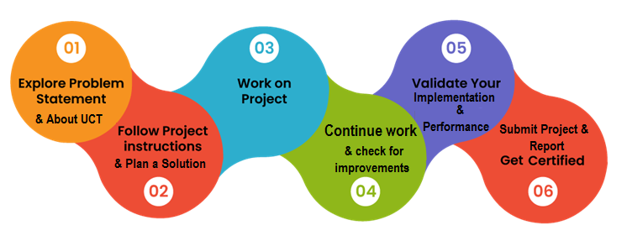

**Your Learnings and overall experience.**

During my 6 week data science internship at Uniconverge technologies, I had the opportunity to delve into the exciting world of data science and machine learning. It was a transformative experience that allowed me to apply my classroom knowledge to real-world scenarios and gain invaluable insights into the data science field.Overall, my data science internship at Uniconverge technologies provided me with a comprehensive learning experience that not only expanded my technical skills but also gave me valuable insights into the practical applications of data science in a business setting. This internship has solidified my passion for data science and machine learning and provided a strong foundation for my future career in this field. I am grateful for the opportunity to have been a part of this amazing internship.

# Introduction

## About UniConverge Technologies Pvt Ltd

A company established in 2013 and working in Digital Transformation domain and providing Industrial solutions with prime focus on sustainability and RoI.

For developing its products and solutions it is leveraging various**Cutting Edge Technologies e.g. Internet of Things (IoT), Cyber Security, Cloud computing (AWS, Azure), Machine Learning, Communication Technologies (4G/5G/LoRaWAN), Java Full Stack, Python, Front end**etc.



1. UCT IoT Platform **(****)**

**UCT Insight** is an IOT platform designed for quick deployment of IOT applications on the same time providing valuable “insight” for your process/business. It has been built in Java for backend and ReactJS for Front end. It has support for MySQL and various NoSql Databases.

* It enables device connectivity via industry standard IoT protocols - MQTT, CoAP, HTTP, Modbus TCP, OPC UA
* It supports both cloud and on-premises deployments.

It has features to  
• Build Your own dashboard  
• Analytics and Reporting  
• Alert and Notification  
• Integration with third party application(Power BI, SAP, ERP)  
• Rule Engine

 

1. **Smart Factory Platform (****)**

Factory watch is a platform for smart factory needs.

It provides Users/ Factory

* with a scalable solution for their Production and asset monitoring
* OEE and predictive maintenance solution scaling up to digital twin for your assets.
* to unleased the true potential of the data that their machines are generating and helps to identify the KPIs and also improve them.
* A modular architecture that allows users to choose the service that they what to start and then can scale to more complex solutions as per their demands.

Its unique SaaS model helps users to save time, cost and money.

 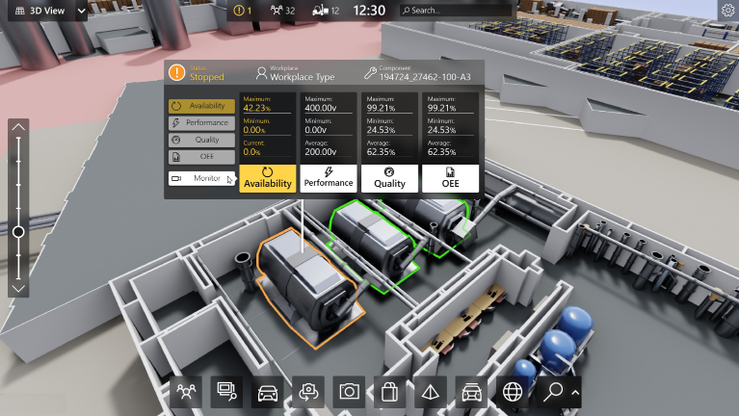

1. 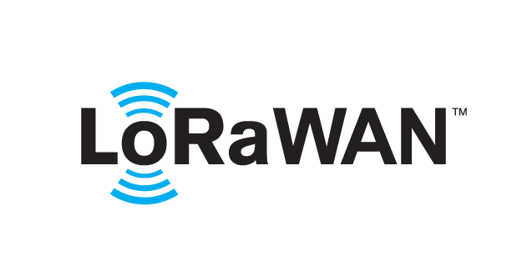 based Solution

UCT is one of the early adopters of LoRAWAN teschnology and providing solution in Agritech, Smart cities, Industrial Monitoring, Smart Street Light, Smart Water/ Gas/ Electricity metering solutions etc.

1. Predictive Maintenance

UCT is providing Industrial Machine health monitoring and Predictive maintenance solution leveraging Embedded system, Industrial IoT and Machine Learning Technologies by finding Remaining useful life time of various Machines used in production process.



## About upskill Campus (USC)

upskill Campus along with The IoT Academy and in association with Uniconverge technologies has facilitated the smooth execution of the complete internship process.

USC is a career development platform that delivers **personalized executive coaching** in a more affordable, scalable and measurable way.



Seeing need of upskilling in self paced manner along-with additional support services e.g. Internship, projects, interaction with Industry experts, Career growth Services

<https://www.upskillcampus.com/>

upSkill Campus aiming to upskill 1 million learners in next 5 year

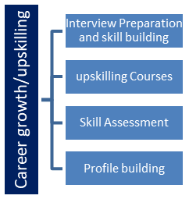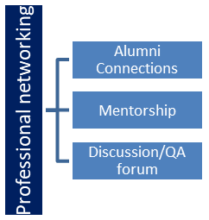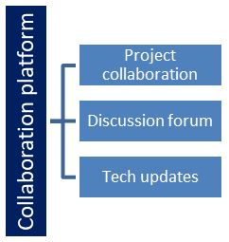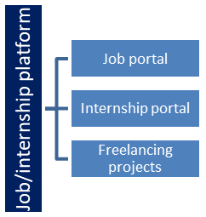

## The IoT Academy

The IoT academy is EdTech Division of UCT that is running long executive certification programs in collaboration with EICT Academy, IITK, IITR and IITG in multiple domains.

## Objectives of this Internship program

The objective for this internship program was to

 ☛ get practical experience of working in the industry.

 ☛ to solve real world problems.

 ☛ to have improved job prospects.

 ☛ to have Improved understanding of our field and its applications.

 ☛ to have Personal growth like better communication and problem solving.

## Reference

[1] Github

[2] Youtube

[3]

## Glossary

|  |  |
| --- | --- |
| Terms | Acronym |
|  |  |
|  |  |
|  |  |
|  |  |
|  |  |

# Problem Statement

India has a wide range of climate and soil types. The highly diverse agriculture system are best with different types of weed problems. Weeds can cause 10-80% crop yield losses besides impairing product quality and causing environmental hazards. This weeds tend to take all nutrients from the crops and thus efficiency of crop production simply degrades. Thus , to deal with this problem crop and weed detection model is used where by using various deep learning algorithms will help in detecting whether the crop is a weed or not. The automation used for implementing identification of weeds is deep learning (DL) and image processing (IP). Firstly, the convolutional neural network (CNN) algorithm is used to recognize the weeds by drawing the bounding boxes around the green plants, and the leftover parts are identified as crops. Later on, support vector machine (SVM) is used on same data set, and confusion matrix and accuracy are generated. The data set provided consist of 1300 images of sesame crops and different types of weeds with each image labels. With that , model is optimized which can detect weed with an accuracy more than 90%.

# Existing and Proposed solution

**Provide summary of existing solutions provided by others, what are their limitations?**

Crop and weed detection projects aim to develop automated systems that can distinguish between crops and weeds in agricultural fields. These systems can help farmers optimize their farming practices, reduce the use of herbicides, and increase crop yields. For that various models are constructed that are based on Sensor-basedApproaches,Robotics and Autonomous Vehicles ,Data Fusion and Multi-sensor Integration but these models has some limitations such as cost inefficient, limited maintenance, field accessibility ,limited expertise of farmers in exploiting them , data impurity etc. Thus with that these models are unable to provide the accuracy.

**What is your proposed solution?**

Crop and weed detection using weighted models, which typically involve assigning different importance or weights to various features or classes, can offer several advantages in agricultural applications. These solutions provides various benefits such as enhanced accuracy ,robustness to noise , better data handling, cost efficient, improved model interpretability .Thus this model suits better than using heavy sensors which provide less cost effective solutions.

**What value addition are you planning?**

The value addition for farmers through crop and weed detection technology goes beyond immediate financial gains. It encompasses sustainability, efficiency, risk management, and empowerment, ultimately contributing to the long-term success and viability of agricultural practices .This technology will ultimately increase crop yield , become time efficient for the farmers.

## Code submission (Github link):

https://github.com/hrshtmhta/weed_detection.git

## Report submission (Github link) : first make placeholder, copy the link.

# Proposed Design/ Model

The workflow for a crop and weed detection project using weighted models involves several designs .Here is the step by step process proposed in order to build the crop and weed detection model.

1. **Problem Definition and Data Collection:**
   * Define the specific objectives of your project, including the types of crops and weeds you want to detect.
   * Collect a diverse dataset of images representing different crop and weed varieties, growth stages, and environmental conditions. Ensure that the dataset is properly labeled.
2. **Data Preprocessing:**
   * Preprocess the image data, which may include resizing, normalization, and augmentation techniques to enhance the model's ability to generalize across different conditions.
3. **Feature Extraction or Representation:**
   * Extract relevant features from the images or use pre-trained convolutional neural networks (CNNs) for feature extraction. This step helps in capturing discriminative information from the images.
4. **Data Splitting:**
   * Split your dataset into training, validation, and test sets. The training set is used to train the model, the validation set is used for hyperparameter tuning, and the test set is used for final evaluation.

**5. Model Selection:**

* Choose an appropriate machine learning or deep learning model architecture for your task. Common choices include CNNs, deep neural networks (DNNs), or more advanced architectures like U-Net for semantic segmentation.

6**.Weight Assignment:**

* Determine which classes (crop and weed) are more important for your project's objectives. Assign weights to the classes based on their significance. Typically, you would assign a higher weight to the class you want to prioritize (e.g., weed detection).

7.**Model Training:**

* Train your chosen model on the training dataset using the weighted loss function. The weighted loss gives more importance to the minority class (weeds) during training.

8.**Model Evaluation**:

* Evaluate the model's performance on the validation dataset. Common evaluation metrics include accuracy, precision, recall, F1-score, and the confusion matrix. Adjust hyperparameters and the weight assignment as needed to improve performance.

9.**Testing and Deployment:**

* Once satisfied with the model's performance, evaluate it on the separate test dataset to assess its generalization capability.

10**.Monitoring and Maintenance:**

* Continuously monitor the model's performance in the field and retrain it periodically with new data to adapt to changing conditions.

## Interfaces (if applicable)

Update with Block Diagrams, Data flow, protocols, FLOW Charts, State Machines, Memory Buffer Management.

# Performance Test

**This is very important part and defines why this work is meant of Real industries, instead of being just academic project**.

Crop and weed detection projects hold significant relevance and value for real industries, especially in agriculture and related sectors, as opposed to being solely academic exercises. Here are several key reasons why these projects are essential in real-world industries .As it impact the Economic growth ,resource efficiency, environmental sustainability, job creation, long term viability, technological Advancement etc.

In summary, crop and weed detection projects are not merely academic exercises; they have far-reaching implications for industries, including agriculture, environmental conservation, food security, and economic prosperity. The practical benefits of these projects are substantial, making them a vital part of real-world industry initiatives.

**Here we need to first find the constraints.**

Crop and weed detection projects often face various constraints and challenges that must be addressed to develop effective and practical solutions. Here are some common constraints encountered in crop and weed detection that is Data Quality and Availability, Imbalanced Datasets,Scaling to Large Fields,Real-Time Processing,Data Annotation and Labeling,Cost Constraints, yield efficiency etc.

**How those constraints were taken care in your design?**

Addressing the constraints in crop and weed detection projects requires careful planning, innovative approaches to solve such constraint. Here's how these constraints were taken care in our project.

1.Using data augmentation techniques to artificially increase the diversity of the dataset.

2.Applying techniques like oversampling the minority class, undersampling the majority class, or using more advanced methods like Synthetic Minority Over-sampling Technique (SMOTE) to balance the dataset.

3.Developing cost-effective hardware and software solutions that can be affordable for small-scale and resource-constrained farmers.

**What were test results around those constraints?I**

With the test results, we were getting an accuracy of more than 90% and RMSE value less than 1 .

## Test Plan/ Test Cases

Creating test cases for a crop and weed detection project is essential to ensure the accuracy and reliability of the detection system. Test cases help verify that the model performs as expected under different conditions and scenarios. Here are some sample test cases for a crop and weed detection project.

With this test cases, our model accuracy was scored more than 93% thus our model accuracy was good .

## Test Procedure

Data Splitting: Divide your dataset into three parts: training data, validation data, and test data. The training data is used to train the model, the validation data helps optimize hyperparameters, and the test data is used for final evaluation.

Model Training: Train your convolutional neural network (CNN) using the training data. You can use techniques like transfer learning (using pre-trained models like VGG16, ResNet, or Inception) to improve performance with a limited dataset.

Hyperparameter Tuning: Use the validation data to fine-tune hyperparameters such as learning rate, batch size, and the number of layers or units in the network. This step helps optimize your model's performance.

Model Evaluation: Once your model is trained and optimized, evaluate it on the test dataset using the previously mentioned metrics (accuracy, precision, recall, F1-score, and confusion matrix).

## Performance Outcome

The primary performance outcome for your project is the accurate detection and classification of crops and weeds in agricultural images. This can be measured using the following key metrics:

Accuracy: Accuracy is a fundamental metric that measures the percentage of correctly classified instances (both crops and weeds). It can be calculated as the ratio of correctly predicted instances to the total instances in the test dataset.

Accuracy = (Number of Correct Predictions) / (Total Number of Predictions)

Precision and Recall: Precision measures the ratio of true positives (correctly identified weeds) to all predicted positives (weeds), while recall measures the ratio of true positives to all actual positives (true weeds).

Precision = (True Positives) / (True Positives + False Positives)

Recall = (True Positives) / (True Positives + False Negatives)

F1-Score: The F1-score is the harmonic mean of precision and recall and provides a balance between these two metrics. It's especially useful when there is an imbalance between crop and weed instances.F1-Score = 2 * (Precision * Recall) / (Precision + Recall)

F1 score is around 1.5

# My learnings

From this project on Crop and Weed Detection, me and my team have likely learned several important lessons and gained valuable insights, both in terms of technical knowledge and broader implications.

**Deep Learning and Image Processing**: Your project has provided hands-on experience in implementing deep learning algorithms, particularly Convolutional Neural Networks (CNNs), for image classification and object detection. You've learned how to preprocess images, create models, and use bounding boxes for object localization.

**Data Handling:** Working with a dataset of 1300 images of sesame crops and various weed types with labeled images, you've gained expertise in data preprocessing, augmentation, and handling, which is fundamental in machine learning projects.

**Model Evaluation**: You've applied machine learning evaluation techniques, such as confusion matrices and accuracy calculations, to assess the performance of your models. This demonstrates your ability to measure the effectiveness of your solutions.

**Real-World Problem Solving**: You've successfully addressed a real-world problem in agriculture using automation and technology. This showcases your problem-solving skills and creativity in applying machine learning to practical challenges.

**Interdisciplinary Collaboration**: Your project required collaboration between agriculture and computer science domains. You've learned how to bridge the gap between these two fields, translating agricultural problems into technical solutions.

# Future work scope

The future scope of this project is promising and could involve several directions for further development and applications:

**Precision Agriculture**: Your model can be integrated with farming machinery such as drones and autonomous tractors to enable real-time weed detection and targeted weed control. This would reduce the need for herbicides and improve crop yields.

**Crop Health Monitoring**: Extend your project to not only detect weeds but also assess the overall health of crops. Detecting diseases, nutrient deficiencies, or stress in plants can help farmers take timely corrective actions.

**Crop Yield Prediction**: Use historical data and machine learning techniques to predict crop yields based on the detected weed and crop distribution. This information can help farmers plan their harvest and resources more efficiently.

**Crop Management Recommendations:** Develop a system that provides farmers with recommendations for weed control methods, fertilization, irrigation, and pest management based on real-time field data.

**Integration with IoT**: Integrate your weed detection system with IoT sensors to gather environmental data such as temperature, humidity, and soil moisture. This data can further enhance the accuracy of your recommendations.

**Mobile Applications**: Create user-friendly mobile applications for farmers to easily access and use your weed detection and crop management system.