Nama : Haris Pendina

Kelas : SHIFT

NIM : 19020017

Tugas Install composer dan CodeIgniter

1. 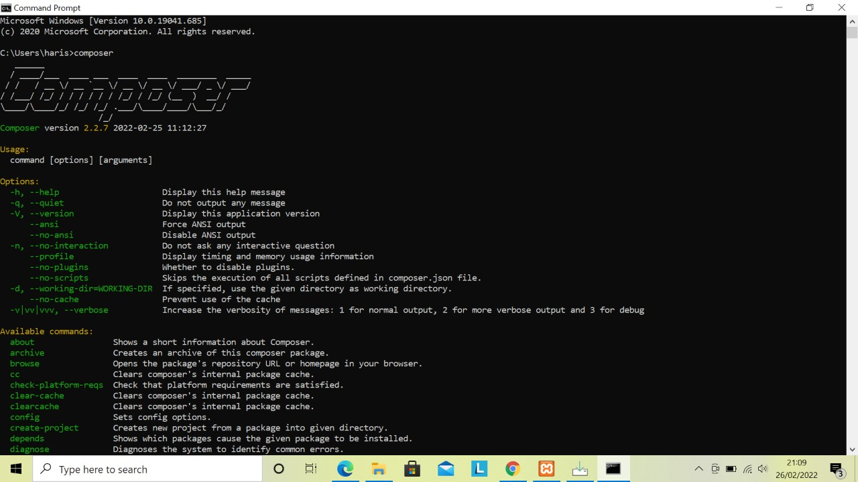Install Composer

`

1. 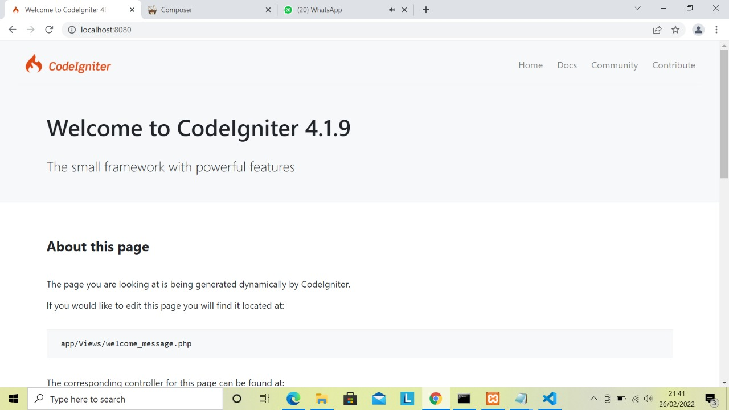Install CodeIgniter 4