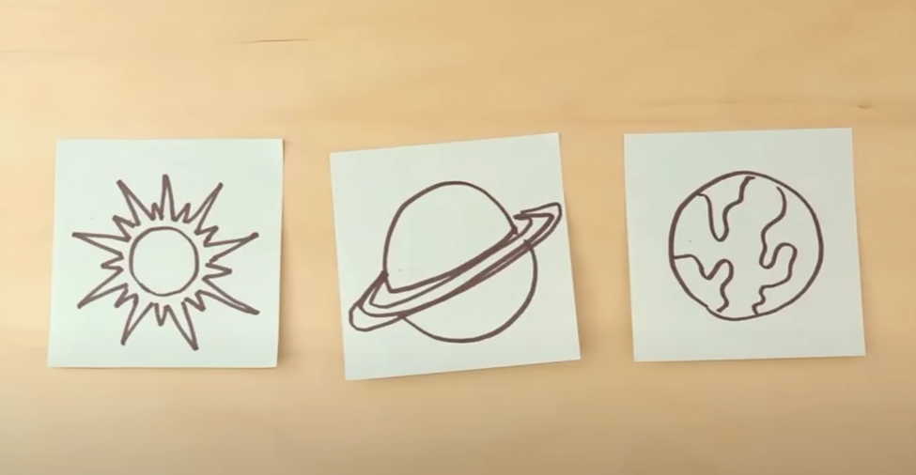

Is this the right order? Consider the distance from the sun and explain your reasoning.

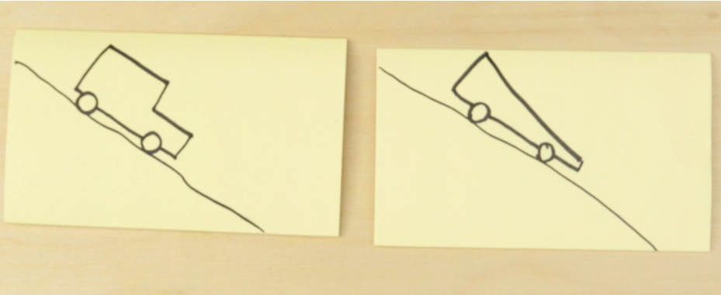

Which of these cars is more aerodynamic? The one on the left or the right? Explain why, using specific visual details.

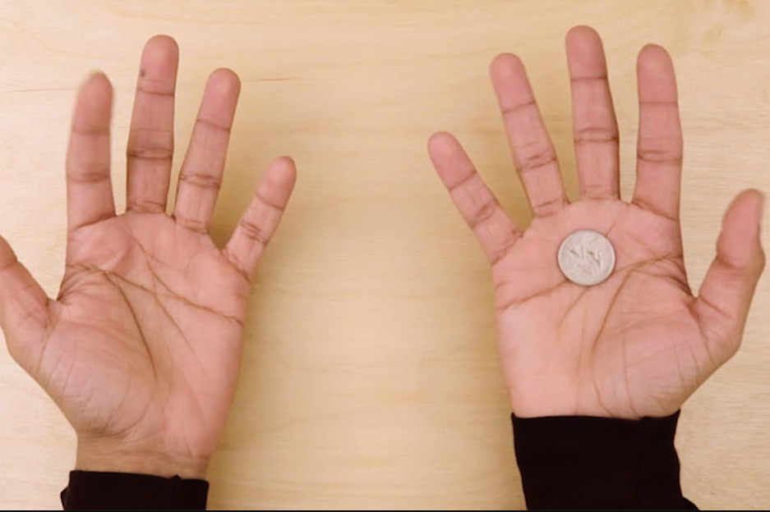

Explain what I'm doing.

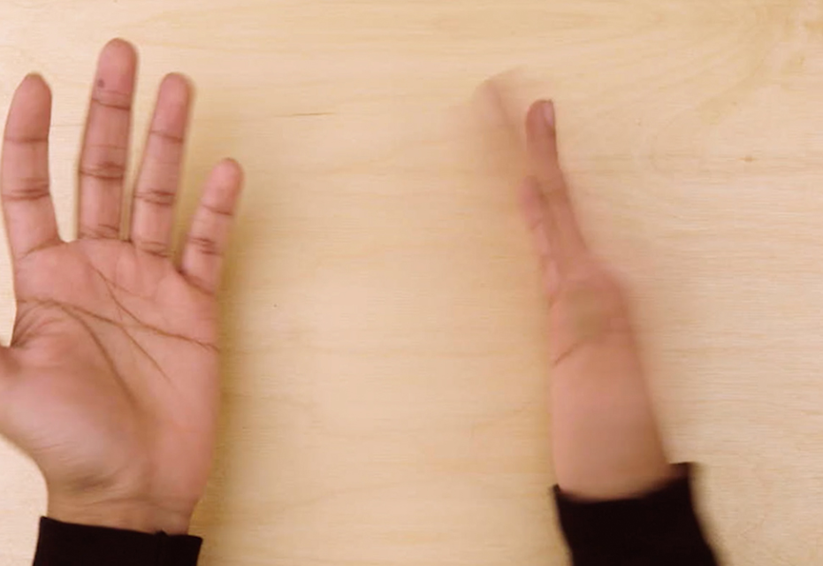

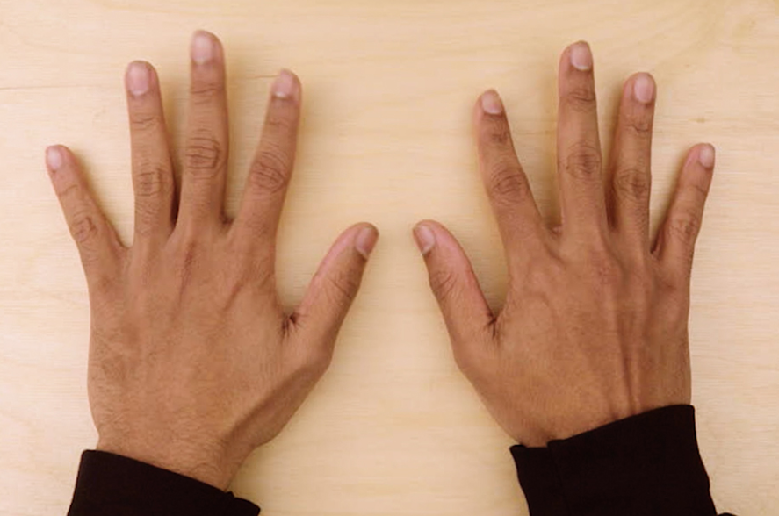

Where do you think the coin is?