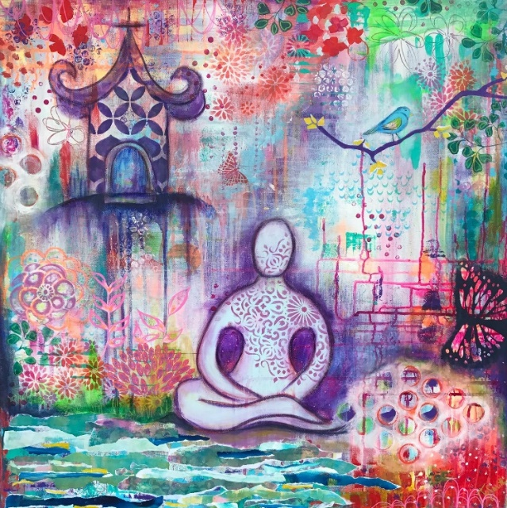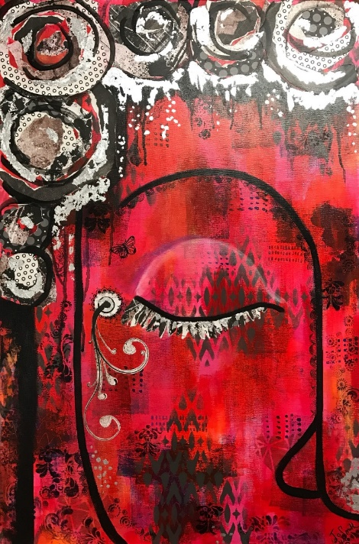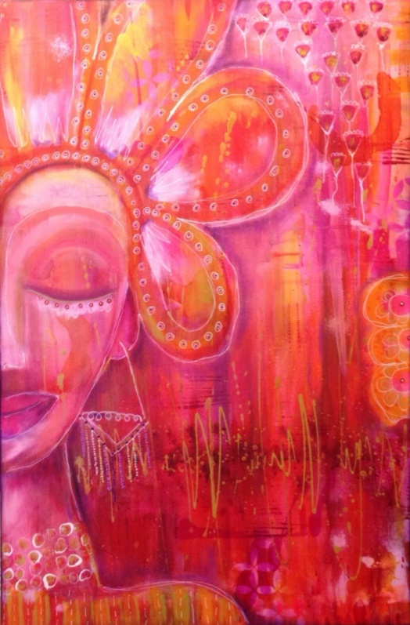

“Clarity”

760x760mm Mixed Media

$200AUD + postage/deliver

“Red Buddha”

510x760mm Mixed Media

$175AUD + postage/delivery

“Warrior Woman”

610x915mm Mixed Media

$150AUD + postage/delivery

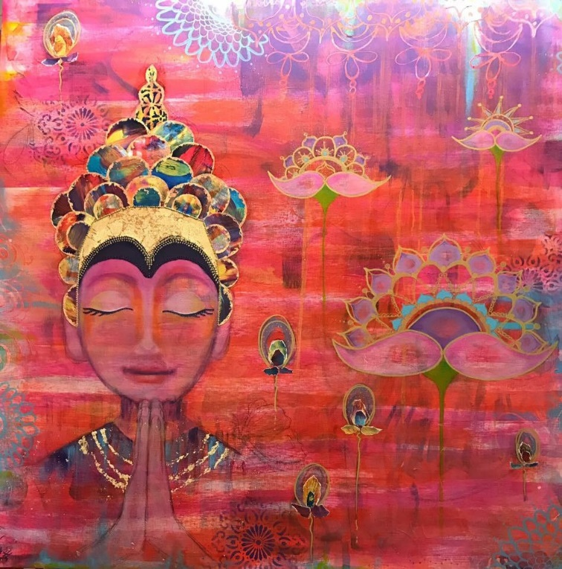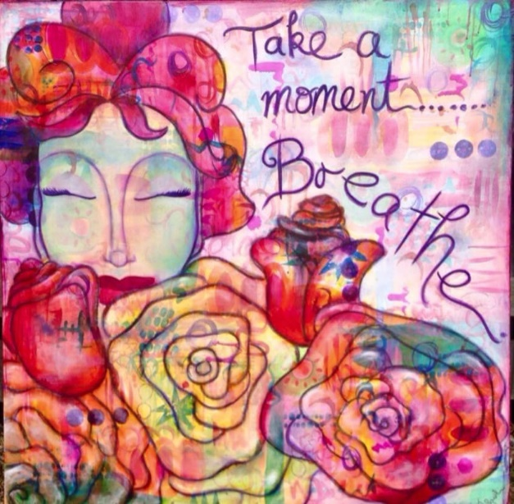

“Take a Moment”

915x915mm Mixed Media

$225AUD + postage/deliver

“The Prayer”

915x915mm Mixed Media

$275AUD + postage/deliver