Natural Language Processing
Exam Project Report
News Topic Classification: A Comparative Study of a Classical Baseline and a Fine-Tuned Transformer
Hrutuja Girish Kargirwar — Matricola 925351
Università degli Studi di Milano-Bicocca — M.Sc. Data Science

1. Selected Domain
The domain addressed in this project is automated news topic classification: the task of assigning a short news article to one of a predefined set of topical categories based solely on its textual content. Topic classification is a foundational problem in natural language processing with direct downstream applications in news aggregation, personalized content recommendation, and large-scale information retrieval. It also constitutes a well-controlled setting for comparing text representation methods, since topical categories in news text are typically signalled by a mixture of surface-level lexical cues (named entities, domain-specific terminology) and higher-level semantic and contextual information — making it a suitable testbed for contrasting a classical bag-of-words approach with a contextualized transformer model.

2. Dataset
The AG News corpus (Zhang et al., 2015) was selected as the dataset for this project. It is a widely used benchmark for topic classification, constructed from a collection of more than one million news articles gathered from over 2,000 news sources, subsampled and labelled into four balanced topical categories: World, Sports, Business, and Sci/Tech.
- Training set: 120,000 examples (30,000 per class)
- Test set: 7,600 examples (1,900 per class)
- Input fields: article headline concatenated with a short description; single categorical label per example
Because the class distribution is perfectly balanced in both splits, accuracy and macro-averaged F1 are expected to be closely aligned for any reasonable classifier; a large divergence between the two would itself indicate a systematic bias toward specific classes. This property makes AG News a convenient dataset for isolating the effect of the modelling approach rather than having to correct for class imbalance.

3. NLP Task Addressed
The task addressed is multi-class text classification over four topical categories. Two methods introduced in the course are implemented and compared under the same evaluation protocol:
- A classical baseline, consisting of TF-IDF vectorization (unigrams and bigrams) followed by a multinomial Logistic Regression classifier.
- A contextualized language model, DistilBERT (Sanh et al., 2019), fine-tuned end-to-end with a classification head for the four-way task.
The guiding research question is twofold: first, whether a contextualized transformer representation yields a measurable improvement over a classical sparse bag-of-words baseline on a task where topical vocabulary already carries strong discriminative signal; and second, on which specific categories and examples the two modelling paradigms diverge, and why.

4. Experiments

4.1 Baseline: TF-IDF + Logistic Regression
- Vectorization: TF-IDF with unigram and bigram features, vocabulary capped at 20,000 terms, English stop words removed.
- Classifier: multinomial Logistic Regression, trained with a maximum of 1,000 iterations.
- Training data: the full 120,000-example training set.

4.2 Fine-Tuned Transformer: DistilBERT
- Base model: distilbert-base-uncased, with a randomly initialized linear classification head for 4 output classes.
- Training data: an 8,000-example subset of the training set (approximately 6.7% of the full 120,000 examples), selected to keep fine-tuning time tractable on local (non-cloud) hardware.
- Tokenization: WordPiece subword tokenization, maximum sequence length of 128 tokens, with truncation and padding applied uniformly.
- Optimization: 3 training epochs, batch size 16, evaluated at the end of each epoch on the held-out test set; the checkpoint with the highest macro-F1 was retained. Final training loss after 3 epochs (1,500 optimization steps) was 0.228.
- Hardware: Apple Silicon, using PyTorch's Metal Performance Shaders (MPS) backend.
The disparity in training set size between the two models (120,000 vs. 8,000 examples) is a deliberate resource trade-off rather than an oversight, and is treated explicitly as an experimental variable in the analysis that follows, rather than being glossed over.

4.3 Evaluation Protocol
Both models are evaluated on the identical held-out test set of 7,600 examples, using accuracy, macro-averaged F1, weighted F1, per-class F1, and a confusion matrix. This protocol follows the evaluation guidance provided in the course material for classification tasks, and ensures that any performance difference between the two models reflects the modelling approach and training data rather than differences in the evaluation procedure itself.

5. Analysis of the Results

5.1 Overall Results
Model | Accuracy | Macro-F1 | Weighted-F1
TF-IDF + Logistic Regression (baseline) | 0.9200 | 0.9198 | 0.9198
DistilBERT (fine-tuned, 8k-example subset) | 0.9114 | 0.9116 | 0.9120

Contrary to the common expectation that a fine-tuned transformer will outperform a classical baseline, the TF-IDF + Logistic Regression model (92.00% accuracy, 0.9198 macro-F1) slightly outperformed the fine-tuned DistilBERT model (91.14% accuracy, 0.9116 macro-F1) under this experimental setup. The most plausible explanation is the substantial difference in training data available to each model: the baseline was trained on the complete 120,000-example training set, whereas DistilBERT was fine-tuned on only 8,000 examples. AG News is also a task in which topical categories are strongly signalled by surface vocabulary — team and player names for Sports, market and corporate terminology for Business — which is precisely the regime in which a well-tuned sparse linear model is known to remain competitive with, and can occasionally exceed, a transformer trained on comparatively little data. The observed gap (0.86 percentage points in accuracy) is modest, and would plausibly close or reverse if DistilBERT were fine-tuned on the full training set.

5.2 Per-Class Performance
Class | Baseline F1 | DistilBERT F1 | Support (test)
World | 0.9227 | 0.9237 | 1900
Sports | 0.9676 | 0.9730 | 1900
Business | 0.8906 | 0.8657 | 1900
Sci/Tech | 0.8983 | 0.8838 | 1900

Both models identify Business as the most difficult category (F1 = 0.891 for the baseline, 0.866 for DistilBERT) and Sports as the easiest (F1 = 0.968 and 0.973, respectively). DistilBERT achieves a higher F1 than the baseline on three of the four classes (World, Sports, Sci/Tech), but is noticeably weaker specifically on Business — the one class where the effect of its reduced training data appears most concentrated, plausibly because Business articles share substantial lexical overlap with Sci/Tech (e.g., corporate earnings reports involving technology firms).

5.3 Confusion Matrix Comparison
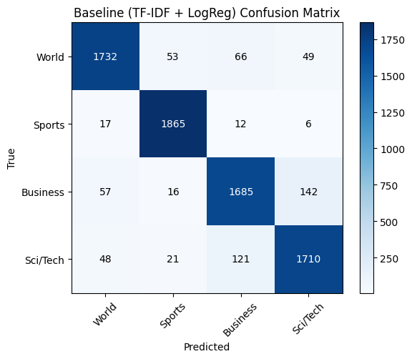
Figure 1. Confusion matrix — TF-IDF + Logistic Regression baseline.
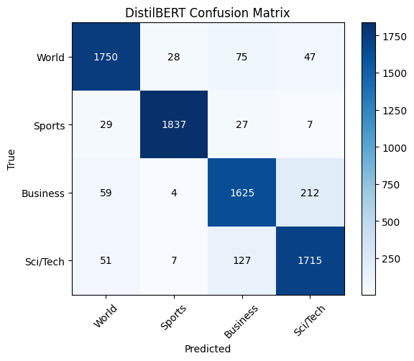
Figure 2. Confusion matrix — fine-tuned DistilBERT.
In both models, the dominant source of error is confusion between Business and Sci/Tech: the baseline misclassifies 142 Business articles as Sci/Tech, while DistilBERT misclassifies 212 — a proportionally larger share. This is consistent with the per-class F1 degradation observed for Business under DistilBERT, and suggests that with less training data the model relies more heavily on topic-adjacent vocabulary (e.g., company names, financial terminology applied to technology firms) that is genuinely ambiguous between the two categories. World and Sports remain the most cleanly separated classes for both models, with very few examples confused between them in either direction.

5.4 Qualitative Error Analysis
To complement the quantitative metrics, Table 3 reports representative test examples on which the two models disagree, drawn directly from the model outputs.
True Label | Text (excerpt) | Baseline Pred. | DistilBERT Pred.
Sci/Tech | “IBM to hire even more new workers.” By the end of the year, the computing giant plans to have its biggest headcount since 1991. | Business | Sci/Tech (correct)
World | “India's Tata expands regional footprint via NatSteel buyout.” Tata Iron and Steel took a strategic step to expand its Asian footprint... | Business | World (correct)
Sci/Tech | “Promoting a Shared Vision.” As Michael Kaleko kept running into people who were getting older and having more vision problems, he realized he could do something about it. | Sci/Tech (correct) | Business
Sports | “Afghan women make brief Olympic debut.” Afghan women made a short-lived debut as 18-year-old judo wildcard Friba Razayee was defeated... | Sports (correct) | World

The cases in which DistilBERT corrects the baseline's error (e.g., the IBM hiring article, the Tata Steel acquisition article) share a common pattern: their surface vocabulary — company names, financial verbs — superficially resembles Business text, but their actual subject matter (workforce expansion, cross-border industrial expansion) is more accurately categorized elsewhere. This is exactly the type of contextual disambiguation that contextualized representations are expected to capture more reliably than a bag-of-words model. Conversely, DistilBERT's errors (misclassifying a vision-research article and a biotech-sector commentary piece as Business, and an Olympics report as World) tend to occur on examples that are genuinely ambiguous on a brief reading, or on topics likely underrepresented within its smaller 8,000-example training slice.

6. Conclusions
This project compared a classical TF-IDF + Logistic Regression baseline against a fine-tuned DistilBERT model on the task of AG News topic classification. The central empirical finding is that the baseline slightly outperformed the fine-tuned transformer overall (92.00% vs. 91.14% accuracy), a result attributable primarily to the substantial difference in training data available to each model (120,000 vs. 8,000 examples) rather than to any inherent limitation of contextualized representations for this task. This outcome reinforces a point emphasized throughout the course: model capacity alone does not guarantee superior performance, and a fair, controlled comparison must account for the amount of supervision each method receives.
At a finer grain, both models converge on the same principal source of error — confusion between the Business and Sci/Tech categories, reflecting genuine lexical overlap in the underlying data rather than a flaw specific to either modelling approach — while both separate World and Sports cleanly. DistilBERT's qualitative advantage is most visible on examples that require resolving surface-level lexical ambiguity through context, consistent with the architectural motivation for contextualized language models.
The principal limitation of this study is the asymmetry in training data between the two models, which precludes a fully controlled head-to-head comparison; in addition, no hyperparameter tuning or multiple-seed averaging was performed for either model, so the reported margins should be interpreted as indicative rather than statistically robust. A natural direction for future work is to fine-tune DistilBERT on the complete 120,000-example training set to determine whether it surpasses the baseline once given comparable supervision, and to investigate whether targeted data augmentation for the Business and Sci/Tech categories reduces the confusion pattern identified in Section 5.3.

References
- Zhang, X., Zhao, J., & LeCun, Y. (2015). Character-level Convolutional Networks for Text Classification. Advances in Neural Information Processing Systems (NeurIPS).
- Sanh, V., Debut, L., Chaumond, J., & Wolf, T. (2019). DistilBERT, a distilled version of BERT: smaller, faster, cheaper and lighter. arXiv:1910.01108.
- Manning, C. D., & Schütze, H. Foundations of Statistical Natural Language Processing. MIT Press.
- Jurafsky, D., & Martin, J. H. Speech and Language Processing. Prentice Hall.

