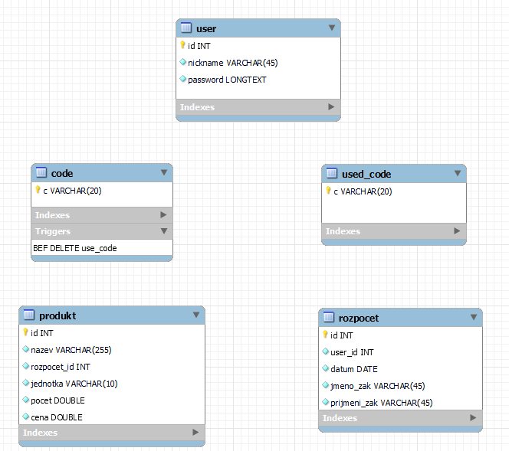
Trigger is on table code before delete insert code into used_code

