WEEK 1 PROJECT REPORT

Demand Planning and Forecasting
in SAP SCM
Case Study: BreezeMax 1.5 Ton 5-Star Inverter Room Air Conditioner
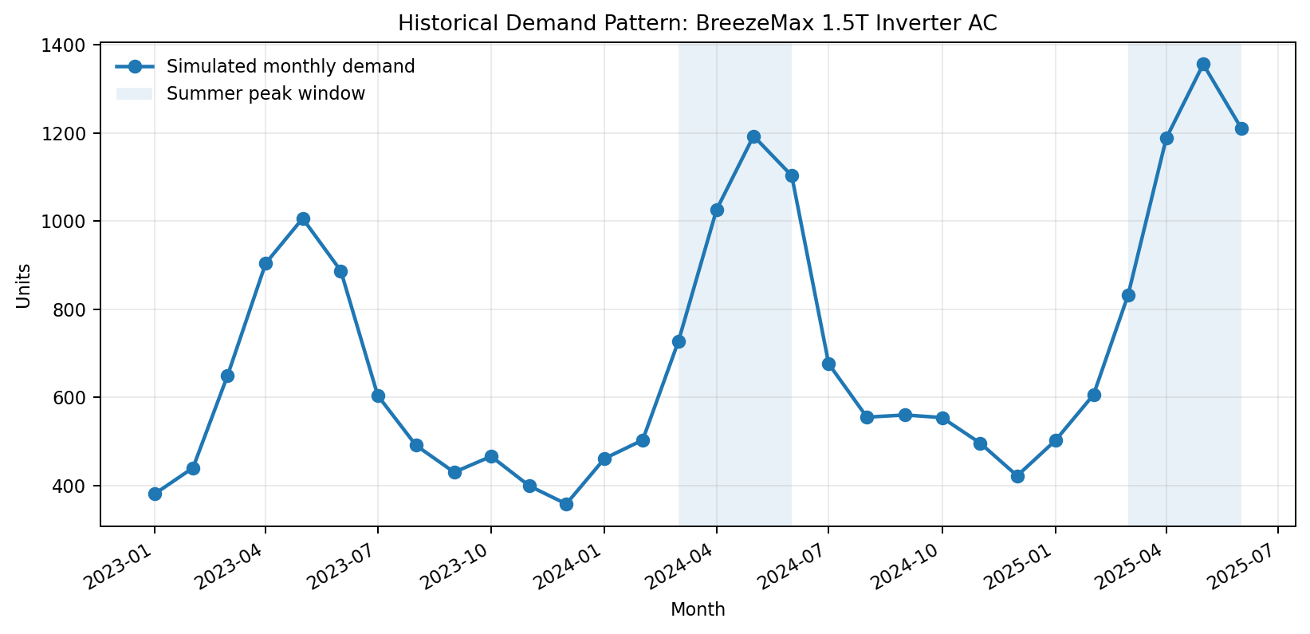
Project visual: simulated monthly demand used for the forecasting exercise.
Prepared by: Hrudhai Prem Kumar Patwari
Submission period: September 2026
Scope: SAP SCM / SAP APO Demand Planning simulation and configuration documentation

Table of Contents
1. Executive Summary
2. Introduction and Task Objectives
3. Research Phase: Demand Planning Concepts and Forecasting Models
4. Simulation Setup and Market Context
5. Forecasting Simulation and Comparative Analysis
6. Practical SAP SCM/APO Demand Planning Configuration
7. Operational Interpretation and Business Decisions
8. Risks, Controls and Forecast Governance
9. Conclusion
Appendix A. Simulated Demand Dataset
Appendix B. Submission Description (200+ words)
References

1. Executive Summary
Demand planning converts historical demand signals, market knowledge and statistical methods into a forward-looking view of what customers are likely to buy. In an integrated supply chain, the forecast is not merely a sales estimate: it drives purchasing, production, inventory positioning, transportation capacity and service-level decisions. This project demonstrates a complete demand-planning cycle using SAP Supply Chain Management (SAP SCM), specifically the classic SAP Advanced Planning and Optimization (SAP APO) Demand Planning concepts that are commonly taught as part of SAP SCM. The business case is a simulated 1.5 ton inverter room air-conditioner product sold through a Hyderabad distribution channel. The product was selected because air-conditioner demand has a strong and intuitive seasonal pattern, with demand rising sharply in the hotter months and declining during cooler periods.
The market assumptions are anchored in publicly available industry information. In 2024, the Consumer Electronics and Appliances Manufacturers Association (CEAMA) expected Indian air-conditioner sales to reach roughly 14 million units and highlighted a 30-40 percent summer volume surge. ICRA separately expected Indian room air-conditioner industry volumes to rise strongly in FY2025 and continue growing in FY2026. These sources are not used as company-level sales history; instead, they justify the scenario design: positive market growth, pronounced summer seasonality and sensitivity to temperature and consumer demand. A 30-month simulated history from January 2023 to June 2025 was created around these assumptions.
Three forecasting approaches were evaluated: a three-month moving average, simple exponential smoothing with alpha 0.30, and a multiplicative Holt-Winters seasonal model. The first 24 months were used as the training period and January-June 2025 was used as a six-month holdout test. The moving-average model achieved a MAPE of 42.73 percent, while simple exponential smoothing achieved 36.61 percent. The seasonal model performed best with a MAPE of 2.59 percent because it captured the repeating summer demand pattern. The result demonstrates an important demand-planning principle: model choice must match the demand behavior rather than being based only on computational simplicity.
The second half of the report translates the analytical exercise into a practical SAP SCM/APO workflow. It documents how to define planning characteristics, create a Master Planning Object Structure (MPOS), create and initialize a planning area, maintain characteristic value combinations (CVCs), load historical data, create a planning book and data view, configure forecast profiles, run statistical forecasts in interactive planning, compare forecast errors, apply business overrides, and release a final demand plan. The report closes with risk controls and governance recommendations so that the forecast remains a managed business process rather than a one-time statistical output.

2. Introduction and Task Objectives
A demand forecast is an estimate of future customer requirements over a defined time horizon. Forecasting is necessary because procurement and manufacturing decisions must usually be made before final customer orders are known. If demand is underestimated, the organization may face stock-outs, missed sales, emergency freight, overtime and poor customer service. If demand is overestimated, the result may be excess inventory, working-capital pressure, storage cost and obsolescence. Demand planning therefore aims to balance service, cost and risk by producing the most useful forecast possible and continuously improving it as new information becomes available.
Within SAP SCM/APO, Demand Planning provides a structured planning environment in which historical data can be stored or transferred from BW/InfoCubes into a planning area, forecasts can be generated against defined characteristic combinations, and planners can review forecasts through planning books and data views. SAP documentation describes the planning area as the central data structure for Demand Planning and identifies characteristic value combinations as the master-data combinations against which planning occurs. Interactive Demand Planning can be used to create forecasts, validate different univariate or causal models, review background results and process exceptions.
The objectives of this project are to:
- Explain the demand drivers and statistical forecasting concepts relevant to a seasonal consumer durable.
- Evaluate at least three forecasting models using the same historical dataset and common accuracy measures.
- Build a transparent simulated scenario whose assumptions are supported by public market information.
- Map the forecasting exercise to a practical SAP SCM/APO Demand Planning configuration and execution flow.
- Demonstrate critical thinking by explaining why the preferred model performs better, where it can still fail, and how planners should govern manual adjustments.

3. Research Phase: Demand Planning Concepts and Forecasting Models

3.1 Key Demand Drivers
Demand is rarely generated by a single factor. For the selected air-conditioner product line, the most important driver is seasonality. Temperature increases typically raise the urgency of cooling purchases, so March-June demand can be substantially higher than demand in December or January. A second driver is long-term market growth caused by rising household ownership, urbanization, disposable income, consumer financing and replacement demand. A third driver is price and promotion: discounts, exchange offers, e-commerce sale events and dealer incentives can move purchases between months. Channel availability, product ratings, energy-efficiency preferences, competitor launches and regional electricity conditions can also change the realized demand.
In an SAP planning design, some of these drivers appear as characteristics or causal variables. Product, location, sales organization, region and channel are natural planning characteristics. Promotions, temperature indices, price, holidays or distribution availability can be treated as additional causal information if the organization has reliable data and an appropriate forecasting design. The important principle is to keep the planning level detailed enough to support supply decisions but not so fragmented that every combination becomes statistically sparse.

3.2 Forecasting Model 1 - Moving Average
A moving average estimates future demand from the arithmetic average of a fixed number of recent periods. For a three-month moving average, the next forecast is calculated as the average of the latest three observations. The method is easy to understand, inexpensive to calculate and useful for stable demand with limited trend or seasonality. SAP provides moving-average forecasting strategies as part of its forecasting model family. The weakness is that an ordinary moving average reacts only after demand has changed. For a product with sharp seasonal peaks, the model can be dangerously late: low winter demand depresses the average just before summer demand accelerates.
Formula used in this simulation: Forecast(t+1) = [Demand(t) + Demand(t-1) + Demand(t-2)] / 3.

3.3 Forecasting Model 2 - Simple Exponential Smoothing
Simple exponential smoothing (SES) updates the forecast by combining the latest actual demand with the previous forecast. The alpha parameter controls responsiveness. A higher alpha gives more weight to the newest observation, while a lower alpha produces a smoother, less reactive series. SAP documentation lists first-order exponential smoothing under constant-model forecasting strategies and shows alpha as a configurable parameter. For this exercise alpha is fixed at 0.30, which is also a commonly shown SAP default setting. SES works well when demand fluctuates around a fairly stable level, but by itself it does not explicitly represent recurring seasonal factors.
Formula: Forecast(t+1) = alpha x Actual(t) + (1 - alpha) x Forecast(t), where alpha = 0.30.

3.4 Forecasting Model 3 - Seasonal Holt-Winters
Holt-Winters forecasting extends exponential smoothing to model recurring seasonal behavior. A multiplicative seasonal form is appropriate when the size of the seasonal peak grows as the overall demand level grows. In this project, the summer peak in 2024 is larger than the summer peak in 2023, making a multiplicative seasonal structure reasonable. SAP APO provides seasonal and seasonal-trend forecasting strategies and can also perform automatic model selection depending on the configured profile. The external calculation in this project uses a Holt-Winters seasonal model as an analytical demonstration; in a real SAP system the planner would configure and validate the corresponding seasonal strategy available in the forecast profile rather than assuming the external formula is byte-for-byte identical to SAP implementation details.
Seasonal models require more history than simple level models. SAP documentation on automatic model selection notes that at least two seasonal cycles are preferable for seasonal identification. This is one reason the training sample in this project contains 24 monthly periods, representing two complete years before the six-month test horizon.

4. Simulation Setup and Market Context

4.1 Business Scenario
The simulated company, BreezeMax Appliances Pvt. Ltd., distributes residential cooling products in South India. The forecasting object for Week 1 is product BM-15INV, a 1.5 ton 5-star inverter split air conditioner supplied from a Hyderabad distribution center. The demand plan is maintained monthly because procurement of finished units and critical components is planned several weeks ahead, while daily demand is too noisy for a strategic forecast. The planning horizon is six months and the historical horizon used for model fitting is 24 months.
Proposed SAP planning characteristics for the scenario are:
- Product = BM-15INV
- Product Family = Room Air Conditioner
- Location = HYD-DC
- Region = South
- Sales Channel = Retail / E-commerce
- Planning Version = 000 (active planning version for simulation)

4.2 Public Market Parameters Used to Design the Simulation
The demand quantities in this report are simulated and do not represent actual sales of a specific manufacturer. Public information is used only to define realistic direction and seasonality. IBEF summarized CEAMA commentary that 2024 air-conditioner sales could approach 14 million units and that summer volumes could rise by roughly 30-40 percent. ICRA expected the Indian room air-conditioner industry to record strong volume expansion in FY2025 and forecast roughly 10-12 percent growth in FY2026. The India Cooling Action Plan and later policy discussions also indicate substantial long-term cooling demand. Based on that background, the simulation applies a strong March-June seasonal multiplier, higher 2024 demand than 2023, and a more moderate 2025 growth rate.
The model intentionally avoids copying national market totals into a fictional company forecast. Instead, the national information is translated into relative assumptions: (1) the business is in a growing category, (2) summer is materially stronger than winter, and (3) the demand peak can scale upward as the market expands. Random noise of approximately +/-3.5 percent is introduced so that the series does not look mechanically generated.
Figure 1. Simulated monthly demand, January 2023-June 2025. The March-June summer peak is clearly visible.

5. Forecasting Simulation and Comparative Analysis

5.1 Training and Test Design
The first 24 observations, January 2023 through December 2024, are used as training history. The following six months, January through June 2025, are held back as if they were unknown future periods. Each model produces a six-month forecast from the same December 2024 cutoff. This approach is more meaningful than fitting and judging the model on the same observations because the holdout period approximates how the forecast would behave in actual planning.
Accuracy is evaluated with Mean Absolute Error (MAE), Root Mean Squared Error (RMSE), Mean Absolute Percentage Error (MAPE), and forecast bias. MAE shows the typical magnitude of the unit error. RMSE penalizes large misses more heavily. MAPE expresses the error as a percentage of actual demand and makes model comparison easier for business users. Bias indicates whether forecasts tend to be systematically high or low. A model should not be selected on one metric alone; stability, explainability, business impact and suitability for the demand pattern also matter.

5.2 Holdout Forecast Results
Month | Actual | 3-Month MA | SES (alpha=0.30) | Seasonal Model
Jan 2025 | 502 | 491 | 552 | 522
Feb 2025 | 606 | 470 | 552 | 574
Mar 2025 | 832 | 461 | 552 | 831
Apr 2025 | 1188 | 474 | 552 | 1162
May 2025 | 1356 | 468 | 552 | 1322
Jun 2025 | 1210 | 467 | 552 | 1194

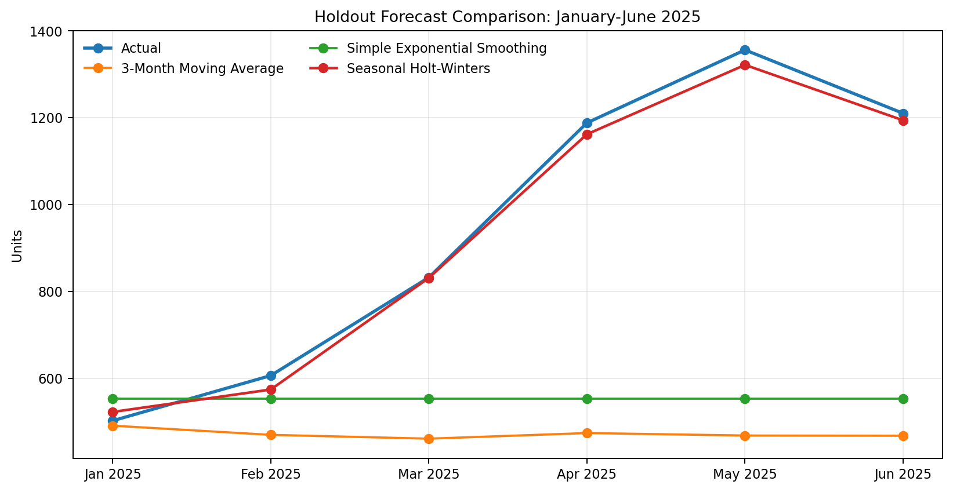
Figure 2. Comparison of actual demand and the three forecasts for the six-month holdout period.

5.3 Error Comparison
Model | MAE | RMSE | MAPE | Bias
3-Month Moving Average | 477.32 | 578.33 | 42.73% | -477.32
Simple Exponential Smoothing | 413.49 | 510.96 | 36.61% | -396.74
Seasonal Holt-Winters | 21.71 | 24.43 | 2.59% | -14.95

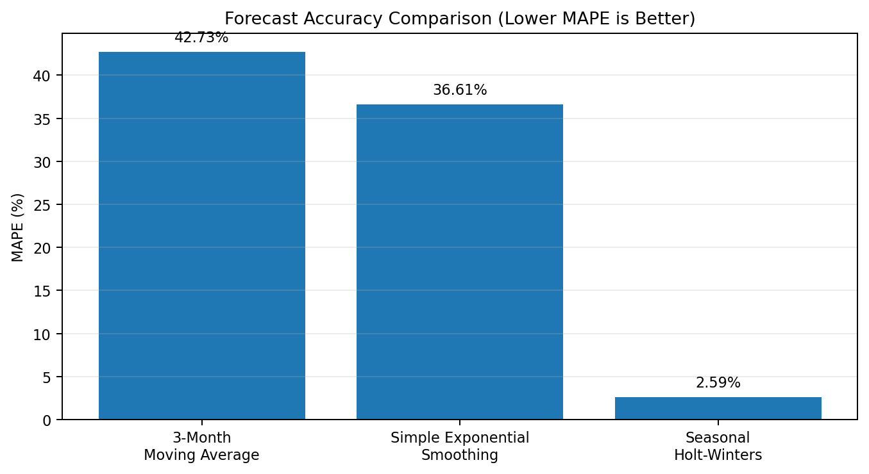
Figure 3. MAPE comparison. The seasonal model is clearly superior for this seasonal scenario.

5.4 Interpretation of Model Differences
The three-month moving average has a MAPE of 42.73 percent and a strongly negative bias. It enters January 2025 with a forecast based mainly on the relatively low October-December 2024 demand. When the forecast horizon extends into March, April, May and June, the recursive moving average cannot anticipate the summer peak. The model therefore under-forecasts exactly when inventory requirements are highest. This is a practical example of why a simple moving average should not be used blindly for seasonal products.
Simple exponential smoothing performs somewhat better but still produces a MAPE of 36.61 percent. Because SES models a level rather than a seasonal cycle, its six future forecasts remain close to the estimated end-of-history level. It also underestimates the large April-May peak. The model would be more suitable for a product whose demand fluctuates around a stable average without a recurring annual pattern.
The seasonal Holt-Winters model records a MAPE of only 2.59 percent, an MAE of 21.71 units and an RMSE of 24.43 units. It succeeds because it has learned the monthly seasonal indices from two full annual cycles. January and February remain moderate, March increases sharply, April and May reach the peak, and June begins to soften. This pattern matches the design of the simulated data and the market behavior that motivated the case study.
The strong result should still be interpreted critically. Because the dataset was deliberately constructed with recurring seasonality, a seasonal model has a structural advantage. Real demand can be disrupted by a heatwave, an unusually early monsoon, a stock-out, a competitor discount, a product recall or a channel shift. In production forecasting, the selected model should be re-evaluated every cycle using rolling back-tests, outlier correction, causal information and planner knowledge. Statistical accuracy is a starting point for demand consensus, not a guarantee of future demand.

6. Practical SAP SCM/APO Demand Planning Configuration
The following configuration describes how the same scenario can be represented in a classic SAP SCM/APO Demand Planning environment. Exact field names and authorizations can differ by SAP SCM enhancement package and customer configuration, but the sequence reflects the standard APO DP design documented by SAP. The project uses conceptual screen maps rather than pretending to provide screenshots from a live corporate SAP client.
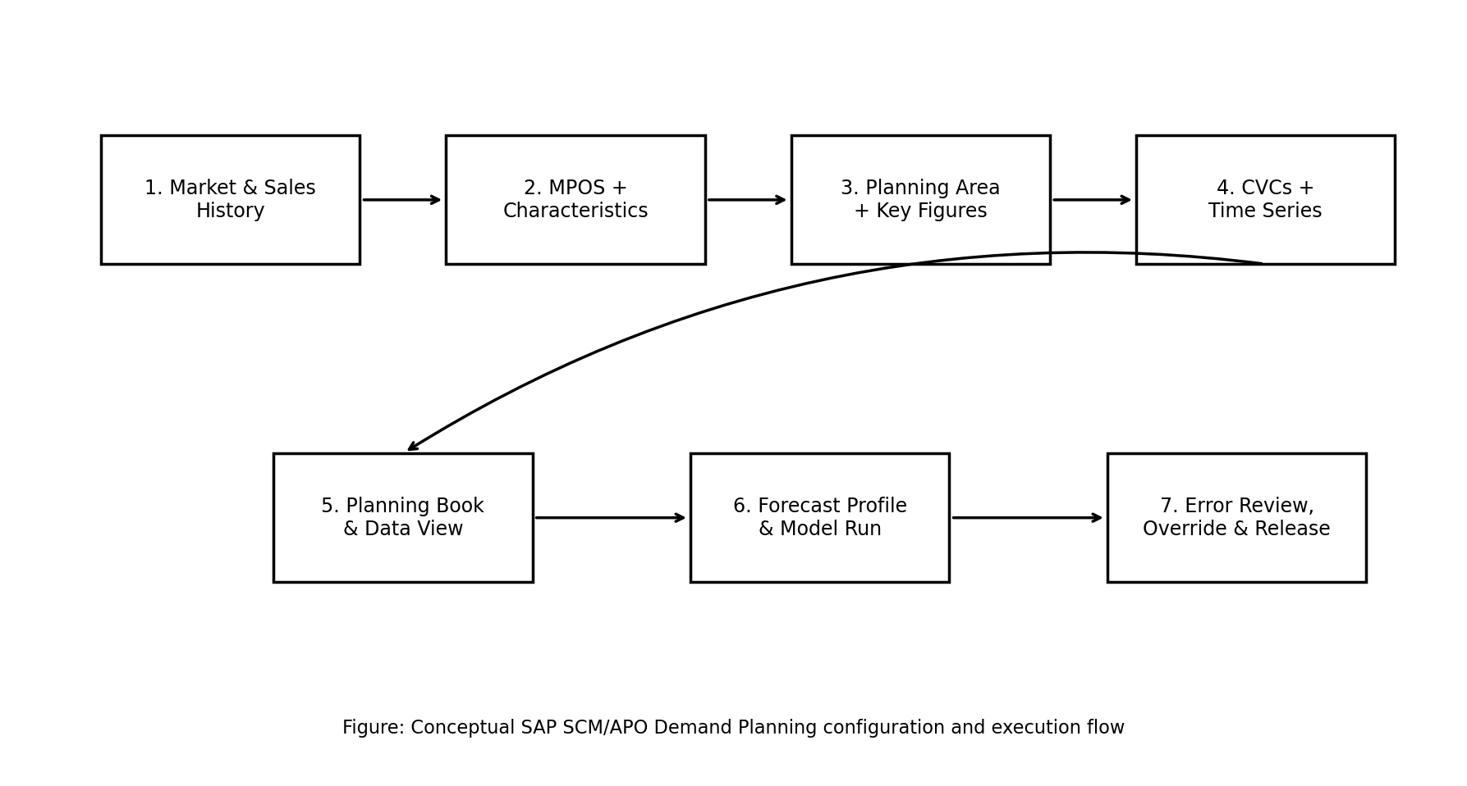
Figure 4. Conceptual SAP SCM/APO Demand Planning process used in this project.

6.1 Step 1 - Define Planning Characteristics
Demand Planning characteristics determine the levels at which data can be stored, selected, aggregated and disaggregated. Standard BW/APO characteristics can be used where available; customer-specific characteristics can be created when necessary. For this scenario, the essential characteristics are Product, Location, Product Family, Region and Sales Channel. The combination must support the business decision: the company needs a product-location forecast for supply planning, while region and channel provide useful aggregation and review levels.

6.2 Step 2 - Create the Master Planning Object Structure (MPOS)
Use transaction /SAPAPO/MSDP_ADMIN and switch to the Master Planning Object Structure view. Create a structure such as ZDP_AC_MPOS and assign the selected characteristics. SAP documentation identifies the MPOS as the structure that contains the plannable characteristics and as a prerequisite for creating the planning area. Activate the MPOS after checking consistency. In the simulation, the MPOS defines which product-location-channel combinations can later become CVCs.

6.3 Step 3 - Create Storage/Planning Buckets and the Planning Area
Create or select a storage buckets profile that includes monthly periods because the analysis is monthly. Then, in /SAPAPO/MSDP_ADMIN, create a planning area such as ZDP_AC_PA and assign it to ZDP_AC_MPOS. Configure the base unit of measure as EA (each) and add the required key figures. SAP describes the planning area as the central structure that controls unit of measure, storage buckets, key figures, aggregation/disaggregation and data storage.
Suggested key figures for the case study are:
- HIST_SALES - historical actual sales quantity.
- BASE_FCST - statistical baseline forecast.
- PROMO_UPLIFT - planned promotional increment.
- MANUAL_ADJ - planner override based on market intelligence.
- FINAL_FCST - approved demand plan after adjustments.
- FCST_ERROR / MAPE - diagnostic key figures used for review.

6.4 Step 4 - Initialize the Planning Area and Create CVCs
Initialize the planning area for the relevant planning version so that time-series objects can be used. Then maintain characteristic value combinations using /SAPAPO/MC62 or the CVC maintenance functions accessible from Demand Planning administration. A CVC is the unique combination of characteristic values against which planning occurs. For example: Product BM-15INV + Location HYD-DC + Region South + Channel Retail. Without the CVC, the planner cannot store or forecast the time series for that combination.

6.5 Step 5 - Load Historical Demand
Historical actuals can originate from SAP ERP/S/4HANA sales or billing history, external files, or SAP BW/InfoCubes. SAP documentation explains that permanent historical actual data is commonly kept in InfoCubes while current planning data is held in planning areas/liveCache, and that data can be transferred from an InfoCube into a planning area. For this project, the 30-month simulated dataset would first be staged as monthly historical sales and loaded into the HIST_SALES key figure. The load should be checked for missing periods, duplicate records, incorrect units, negative quantities and stock-out periods that may not represent true unconstrained demand.

6.6 Step 6 - Create Planning Book and Data View
Use /SAPAPO/SDP8B to create or maintain a planning book and data view, for example ZDP_AC_BOOK with monthly view ZDP_MONTHLY. The planning book should display Historical Sales, Baseline Forecast, Promotional Uplift, Manual Adjustment, Final Forecast and forecast-error diagnostics. Give planners only the key figures that are necessary for decisions so the screen remains readable. The planning buckets profile should expose the 24-month history and at least the next six months of forecast horizon.
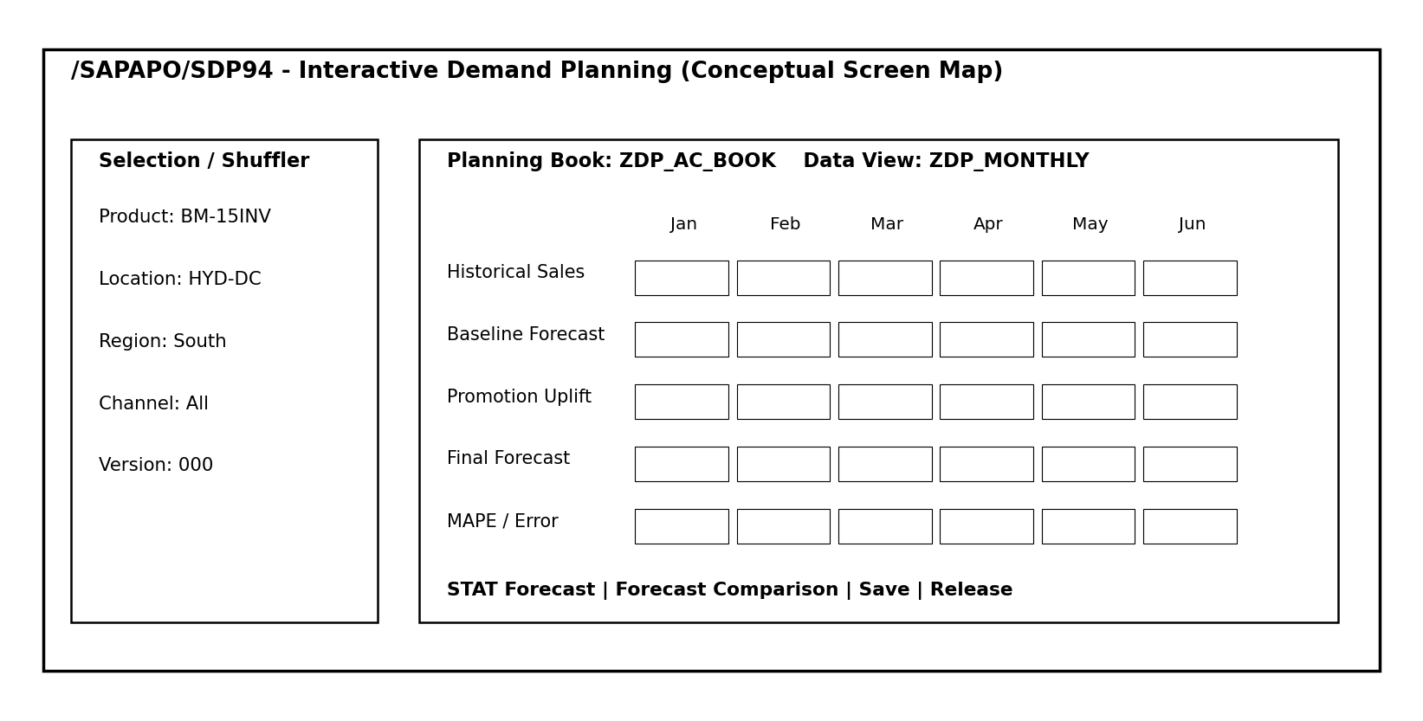
Figure 5. Conceptual screen map for /SAPAPO/SDP94. This is not a screenshot from a live SAP client.

6.7 Step 7 - Configure Forecast Profile
Create a forecast profile using the Demand Planning forecast-profile functions (SAP support documentation references transaction /SAPAPO/MC96B for forecast-profile creation). Define the historical horizon, forecast horizon, periodicity, forecast key figure and model selection. For the three analytical approaches, separate profiles or forecast versions can be created: moving average, first-order exponential smoothing with alpha 0.30, and a seasonal or seasonal-trend strategy. SAP forecast settings provide configurable parameters such as alpha, beta and seasonal settings depending on strategy.
For the production recommendation in this scenario, use the seasonal profile because the back-test shows clear annual seasonality. If the organization manages many SKUs with different patterns, automatic model selection can be tested, but the resulting model should still be monitored by demand class and exception threshold.

6.8 Step 8 - Run Forecast in Interactive Demand Planning
Open /SAPAPO/SDP94 and select the planning book, data view, planning version and the required CVC. Confirm that the historical series is visible. Run the statistical forecast (for example through the STAT forecasting function in the forecasting view) and save the baseline forecast. Interactive Demand Planning is useful because the planner can validate model behavior, compare alternatives and examine the result visually before the forecast is committed or scheduled for mass processing.

6.9 Step 9 - Review Accuracy and Apply Business Overrides
Compare the ex-post or back-test errors and inspect whether the forecast systematically under- or over-predicts specific months. In this case, the seasonal model is retained as the baseline. The planner may then apply a controlled manual adjustment if there is information that is not present in the historical series, such as a confirmed promotional campaign, dealer expansion, supply constraint, major heatwave alert or model replacement. Manual overrides should be recorded with reason codes and should be measured later to determine whether they improved or reduced forecast accuracy.

6.10 Step 10 - Finalize, Save and Release the Demand Plan
After consensus review, calculate FINAL_FCST = BASE_FCST + PROMO_UPLIFT + MANUAL_ADJ, subject to any business rules. Save the approved demand plan. In an integrated SAP landscape, the final forecast can then be released to downstream supply planning such as Supply Network Planning (SNP) or used to drive procurement and inventory decisions. For larger volumes, Demand Planning activities and forecasts can be included in mass-processing jobs rather than run manually one CVC at a time.

6.11 Configuration Checklist
Step | SAP Object / Transaction | Activity | Expected Result
1 | Characteristics | Product, Location, Region, Channel | Planning levels defined
2 | /SAPAPO/MSDP_ADMIN | Create/activate ZDP_AC_MPOS | MPOS ready
3 | /SAPAPO/MSDP_ADMIN | Create ZDP_AC_PA and key figures | Planning area ready
4 | /SAPAPO/MC62 | Create CVC for BM-15INV / HYD-DC | Planning master data ready
5 | BW / InfoCube / load function | Load monthly historical sales | History visible in key figure
6 | /SAPAPO/SDP8B | Create planning book/data view | Planner workspace ready
7 | Forecast Profile | Set horizon, strategy and parameters | Forecast logic configured
8 | /SAPAPO/SDP94 | Run statistical forecast | Baseline generated
9 | Forecast comparison | Check MAPE/MAE/bias and exceptions | Preferred model validated
10 | Save / Release | Approve final forecast for supply planning | Demand plan published

7. Operational Interpretation and Business Decisions
Forecast quality has direct operational consequences. For the air-conditioner scenario, using the moving-average forecast would produce severe under-planning before the April-May peak. Procurement teams could place insufficient orders for compressors, coils or finished units; warehouses could run out of inventory; and the business could require expensive emergency replenishment. Conversely, blindly extending a summer peak into the monsoon and winter periods could create excess stock. The seasonal forecast supports a better pre-build strategy: inventory can be increased gradually before the expected peak and allowed to normalize after June.
The forecast should also be translated into capacity and service decisions. Warehouse slotting can reserve fast-moving positions for the peak season. Transport contracts can secure additional capacity for March-June. Sales teams can compare distributor orders with the baseline to detect unusually high channel loading. Finance can use the demand plan to estimate working capital and revenue scenarios. These cross-functional uses show why demand planning is part of an integrated supply-chain process rather than an isolated statistics exercise.
A practical monthly cycle would close actual sales at month end, load the latest history, review data-quality exceptions, regenerate the statistical forecast, compare changes versus the previous cycle, review sales and marketing inputs, approve justified overrides, and then release the final forecast. The previous forecast should be retained so that Forecast Value Added (FVA) can be measured: if repeated manual adjustments make accuracy worse than the statistical baseline, the organization should change the override process.

8. Risks, Controls and Forecast Governance
Risk | Impact | Control / Contingency
Demand history contains stock-outs | Observed sales may be lower than true demand. | Flag lost-sales periods and use corrected/unconstrained history where evidence exists.
Heatwave or monsoon timing changes | Seasonal index may be shifted or amplified. | Use weather alerts as a causal override and shorten the reforecast cycle during peak season.
Promotion not captured in history | Baseline can understate campaign demand. | Maintain promotion uplift separately so the statistical baseline remains auditable.
New product / limited history | Seasonal model lacks two full cycles. | Use lifecycle/reference-product history, market input or a simpler model until sufficient history exists.
Manual bias from sales teams | Forecast may be inflated to protect availability. | Use reason codes, approval limits and FVA measurement for overrides.
Master-data/CVC errors | Demand can be stored against wrong combinations or not stored at all. | Run MPOS/CVC consistency checks and govern product/location/channel master data.
Unit-of-measure mismatch | Forecast quantities can be overstated or understated. | Standardize EA/case conversions and validate load totals before forecasting.

Forecast governance should define ownership, calendars, thresholds and escalation rules. A demand planner can own the statistical baseline, sales can contribute market intelligence, marketing can own promotions, supply planning can challenge feasibility, and finance can verify major commercial assumptions. The final number should have one accountable owner and a documented approval date. This governance is especially important when a forecast affects high-value inventory or imported components with long lead times.

9. Conclusion
This project demonstrates the complete logic of demand planning from market context through statistical forecasting and SAP implementation. The selected room air-conditioner scenario contains both growth and a strong annual demand cycle, making it a useful test of model suitability. The model comparison shows that simple techniques can be misleading when their assumptions do not match the demand pattern. The three-month moving average and simple exponential smoothing both under-forecast the summer peak, while the seasonal Holt-Winters approach captures the recurring cycle and produces the lowest holdout error.
The analytical conclusion translates directly into SAP SCM/APO design. Demand Planning depends on well-defined characteristics, an MPOS, a planning area, CVCs, time-series history, planning books/data views and an appropriate forecast profile. The process is iterative: load actuals, forecast, diagnose error, incorporate justified business knowledge, approve the result and release it for supply decisions. The value of SAP is not only the statistical algorithm; it is the integrated structure that allows master data, forecasts, planner actions and downstream supply planning to operate within one controlled process. For the simulated BreezeMax product, the seasonal model is therefore recommended as the baseline, supported by monthly accuracy monitoring and exception-based overrides.

Appendix A. Simulated Demand Dataset
The following data is generated specifically for this educational project. It is not proprietary company data. Public market sources were used only to determine reasonable seasonality and growth assumptions.
Month | Demand Units | Scenario Note
Jan 2023 | 381 | Off-season
Feb 2023 | 440 | Off-season
Mar 2023 | 649 | Peak summer
Apr 2023 | 904 | Peak summer
May 2023 | 1006 | Peak summer
Jun 2023 | 887 | Peak summer
Jul 2023 | 604 | Post-peak/monsoon
Aug 2023 | 491 | Post-peak/monsoon
Sep 2023 | 430 | Post-peak/monsoon
Oct 2023 | 466 | Off-season
Nov 2023 | 399 | Off-season
Dec 2023 | 358 | Off-season
Jan 2024 | 461 | Off-season
Feb 2024 | 503 | Off-season
Mar 2024 | 727 | Peak summer
Apr 2024 | 1026 | Peak summer
May 2024 | 1193 | Peak summer
Jun 2024 | 1103 | Peak summer
Jul 2024 | 676 | Post-peak/monsoon
Aug 2024 | 555 | Post-peak/monsoon
Sep 2024 | 560 | Post-peak/monsoon
Oct 2024 | 554 | Off-season
Nov 2024 | 496 | Off-season
Dec 2024 | 422 | Off-season
Jan 2025 | 502 | Off-season
Feb 2025 | 606 | Off-season
Mar 2025 | 832 | Peak summer
Apr 2025 | 1188 | Peak summer
May 2025 | 1356 | Peak summer
Jun 2025 | 1210 | Peak summer

Appendix B. Submission Description (Copy/Paste - 200+ Words)
This report presents my Week 1 project on Demand Planning and Forecasting using SAP Supply Chain Management (SAP SCM) and SAP APO Demand Planning concepts. The project uses a simulated business case for a 1.5 ton inverter room air-conditioner product distributed through Hyderabad. I selected this product because cooling demand has a clear seasonal pattern and is influenced by temperature, market growth, promotions, channel availability and consumer purchasing behavior. Publicly available Indian air-conditioner market information was used to establish realistic assumptions for growth and summer seasonality, while all company-level sales quantities in the project were generated specifically for this simulation. The analytical section compares three forecasting methods: a three-month moving average, simple exponential smoothing with an alpha value of 0.30, and a seasonal Holt-Winters model. I used 24 months of data as the training period and kept the following six months as a holdout period to test forecast accuracy. The models were compared using MAE, RMSE, MAPE and forecast bias. The seasonal model produced the best result because it captured the recurring summer peak that the simpler models missed. The practical implementation section explains how the scenario would be configured in SAP SCM/APO, including planning characteristics, Master Planning Object Structure, planning area, key figures, characteristic value combinations, historical-data loading, planning books and data views, forecast profiles, interactive forecasting, error review, manual adjustments and final forecast release. The report also includes charts, a conceptual SAP process diagram, a configuration checklist, risk analysis and forecast-governance controls. The main learning from this project is that forecasting accuracy depends on matching the model to the actual demand behavior and combining statistical results with controlled business knowledge.

References
[1] SAP Help Portal. Forecast Strategies - SAP Advanced Planning and Optimization (SAP APO). https://help.sap.com/docs/sap_advanced_planning_and_optimization,_on_sap_erp/881e9c98c2e64900bc5ec58ce4b97939/4ef9029644ee1b01e10000000a421bc1.html
[2] SAP Help Portal. Forecast Settings - SAP APO Demand Planning. https://help.sap.com/docs/SAP_SUPPLY_CHAIN_MANAGEMENT/49dd58c18be2493b80f84359d659f4a4/903cc95360267614e10000000a174cb4.html
[3] SAP Help Portal. Master Planning Object Structure. https://help.sap.com/docs/sap_supply_chain_management/cd9e0c364e1e41e19ea633db7862222e/483bc95360267614e10000000a174cb4.html
[4] SAP Help Portal. Planning Area. https://help.sap.com/docs/PRODUCT_ID/15f45255438149fa996da194295b132b/3816ab18-aba8-4dbb-9fbd-3fee71c92c84.html
[5] SAP Help Portal. Characteristic Value Combination. https://help.sap.com/docs/PRODUCT_ID/c95f1f0dcd9549628efa8d7d653da63e/423bc95360267614e10000000a174cb4.html
[6] SAP Help Portal. Interactive Demand Planning. https://help.sap.com/docs/SAP_SUPPLY_CHAIN_MANAGEMENT/5632d7cbffa04b21be22106e9a212038/fc3bc95360267614e10000000a174cb4.html
[7] SAP Help Portal. Exchange of Data Between InfoCubes and Planning Areas. https://help.sap.com/docs/PRODUCT_ID/15f45255438149fa996da194295b132b/8d3dc95360267614e10000000a174cb4.html
[8] SAP Support Content. List of DP related transactions. https://help.sap.com/docs/SUPPORT_CONTENT/sapo/3354622446.html
[9] India Brand Equity Foundation (IBEF), 7 June 2024. AC sales may touch a new record of 14 million units by the end of 2024: CEAMA. https://www.ibef.org/news/ac-sales-may-touch-a-new-record-of-14-million-units-by-the-end-of-2024-ceama
[10] ICRA, 15 October 2024. Climate and consumer trends propel room air-conditioner sales volumes to record high levels in FY2025. https://www.icra.in/CommonService/OpenMediaS3?Key=5f125ea6-253b-4ae6-ae41-b4901892e024
[11] Press Information Bureau, Government of India, 8 March 2019. India Cooling Action Plan Launched. https://www.pib.gov.in/pressreleaseiframepage.aspx?lang=2&prid=1568328&reg=48
Approximate document word count (including appendices/references): 4,288 words

