Post-Implementation Review and End-User Training Plan
Project ERP Implementation Consultant | Week 4 | 30 October 2026
A 90-day simulated review and role-based learning programme
SIMULATED REVIEW ONLY — All KPIs, counts, user adoption and training results below are fabricated for a training case. No go-live, production telemetry or real learner assessment is claimed.

1. Review scope and method
This hypothetical review assumes that the Week 1–3 design was implemented in a fictional Horizon Foods environment and considers the first 90 days after an imagined launch. The figures are controlled sample values made for this portfolio; they are not system extracts and should not be described as actual benefits. The review compares a legacy/early-use baseline with a simulated day-90 sample and uses denominators so that rates can be recalculated. Where a measure is a sample rather than a full population, the report says so.

2. Simulated KPI scorecard
Measure | Baseline | Day 90 | Calculation and reading
Inventory record accuracy | 43/50 = 86.0% | 48/50 = 96.0% | Correct sampled records ÷ sampled records; +10.0 percentage points. Validate with physical counts and consistent sampling.
Production schedule adherence | 39/50 = 78.0% | 44/50 = 88.0% | Orders completed on planned date ÷ orders due; +10.0 pp. Review material availability and schedule changes.
PO approval cycle time | 260/50 = 5.2 days | 190/50 = 3.8 days | Total elapsed calendar days ÷ sampled POs; 1.4 days lower (26.9% reduction). Do not compare mixed calendar/business-day rules.
Order-entry error rate | 12/200 = 6.0% | 5/200 = 2.5% | Orders needing correction ÷ orders sampled; −3.5 pp. Categorize errors to target job aids.
Active user adoption | 20/30 = 66.7% at day 30 | 27/30 = 90.0% at day 90 | Users completing at least one assigned task ÷ in-scope users; +23.3 pp. Logins alone are insufficient.
Training task pass rate | Not applicable before training | 24/27 = 88.9% | Learners passing observed task check ÷ learners assessed; three attended but need coaching.

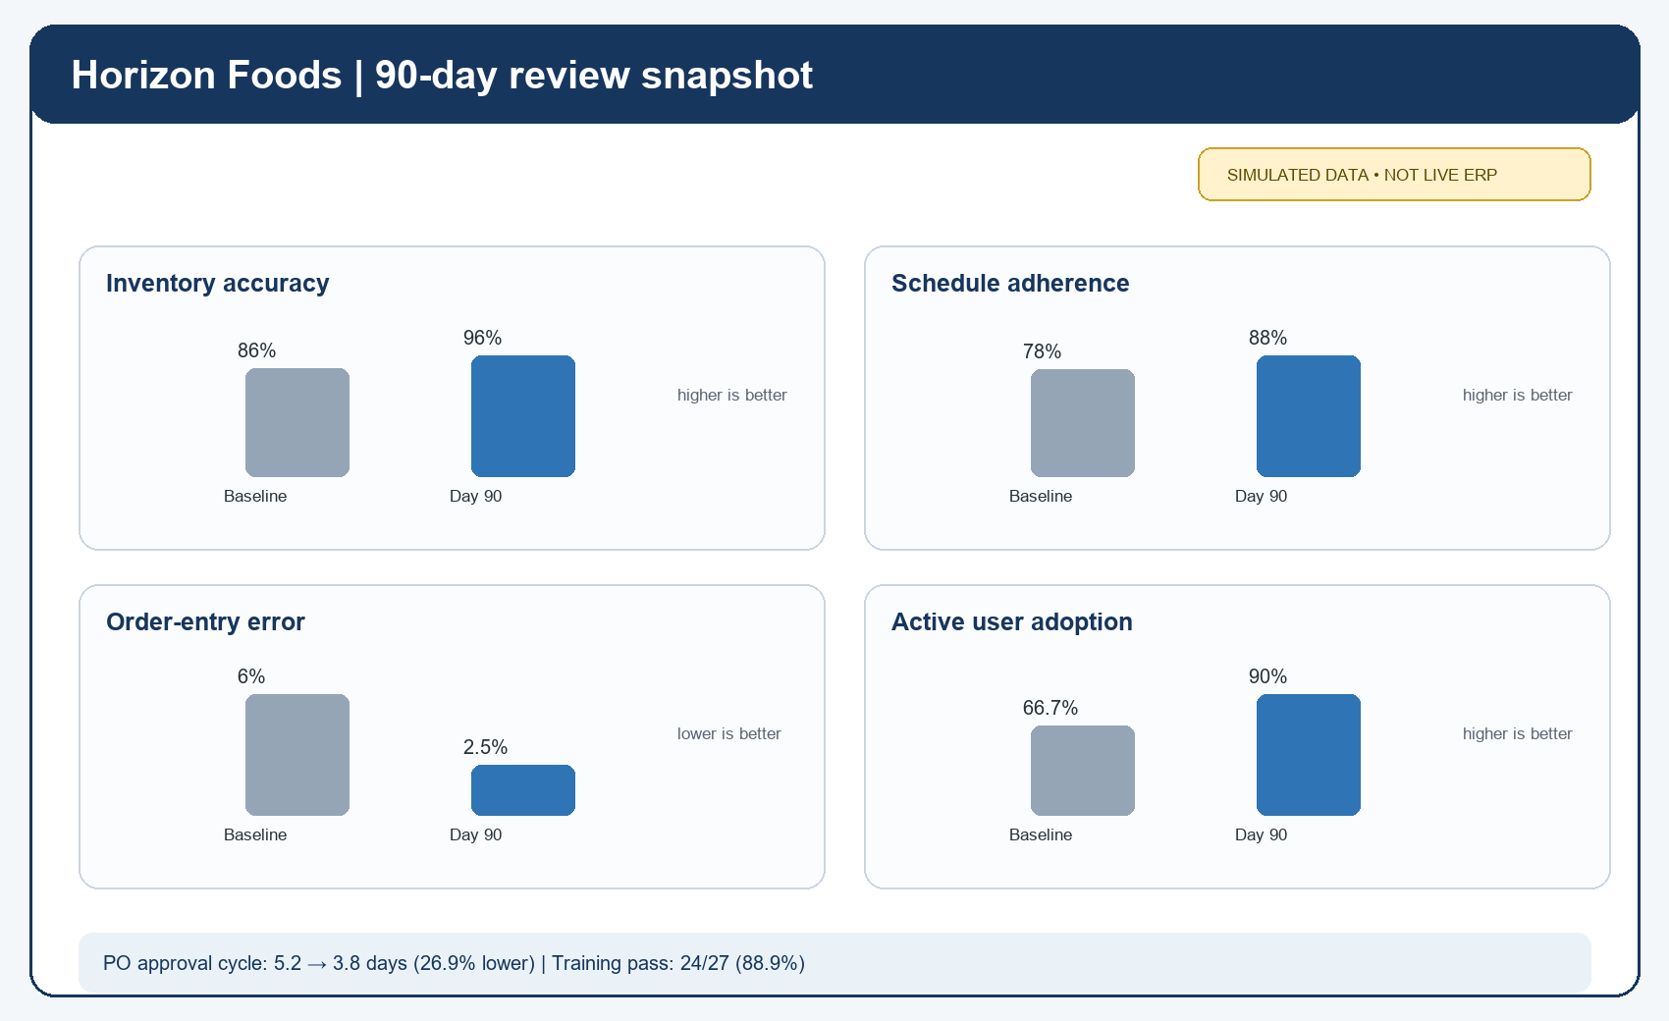
The workbook-ready KPI file contains the numerators, denominators and formulas. Percentage-point movement is the after rate minus the baseline rate. Relative reduction in approval time is (5.2−3.8)÷5.2 = 26.9%. The simulated 90-day patterns suggest improvement, but they do not establish causation: staffing, demand mix, data cleanup and policy changes could also affect results. Before using real figures, agree definitions, compare equivalent periods and validate source records.

3. Performance interpretation and action plan
Finding in the simulated case | Action for next review cycle | Owner / trigger
Inventory accuracy improves to 96% but 2 of 50 counts still mismatch. | Classify mismatch cause by unit, location, receipt/issue timing and training; cycle count high-impact items weekly until stable. | Inventory lead; trigger: accuracy below 98% target (illustrative).
Schedule adherence reaches 88%; 6 of 50 orders miss date. | Review late material, capacity, master data and schedule changes at weekly planning meeting; track recovery owner/date. | Planner + production lead; trigger: two consecutive weeks below approved target.
Average PO cycle time falls to 3.8 days in sample. | Break elapsed time into requester, buyer and approver waits; monitor high-value route separately. | Procurement manager; investigate any approval exceeding policy SLA.
Five errors remain among 200 sampled orders. | Use error categories to update bilingual quick reference and add targeted practice. | Change lead; trigger: recurring error category appears twice.
27/30 active users and 24/27 task checks pass. | Schedule make-up and coaching for three non-attendees and three assessed learners who did not pass; reassess before role authorization. | Training coordinator + line managers.

4. Training plan and syllabus
The training file contains five sessions with audiences, duration, learning objectives, practice and completion evidence. Six role groups cover all 30 in-scope users: 6 buyers, 4 approvers, 8 warehouse/receiving users, 4 planners, 2 supervisors and 6 finance users. Session assignments may overlap super-users; attendance is counted once per person. In the illustrative outcome, 27 of 30 attend (90%); 24 of 27 assessed learners pass (88.9%). Three miss training and three need coaching; those gaps remain open until make-up attendance and reassessment are documented.
Session | Audience / hours | Core practice | Completion evidence
Buyer and approver | 6 buyers + 4 approvers / 3h | Create PO, route low/high value approval, handle a blocked item. | Observed checklist; independent approval verified.
Receiving and inventory | 10 users / 3h | Receive against PO, record quantity/inspection, investigate mismatch. | Correct document reference, unit and stock status.
Planning and production | 4 planners + 4 supervisors / 4h | Review plan, investigate shortage, confirm one FG-CHUTNEY batch flow. | Planning and order-review scenario checklist.
Finance and support | 6 finance + 2 super-users / 3h | Trace sample receipt to financial review; route a support issue. | Scenario quiz and correct support route.
Refresher / make-up | Users with gaps / 2h | Repeat failed steps selected from gap log. | Reassessment; target and actual counts recorded.

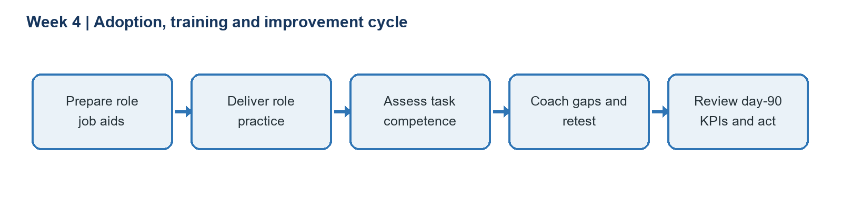

5. Language access and effectiveness checklist
Use simple bilingual job aids with English ERP field identifiers kept visible. Practice vocabulary in context: 计划 (jìhuà, plan), 任务 (rènwu, task), 确认 (quèrèn, confirm), 数量 (shùliàng, quantity), 质量 (zhìliàng, quality), 标准 (biāozhǔn, standard). For example: “Check the quantity (数量) against the purchase order before confirming (确认).” A bilingual reviewer should validate high-impact instructions and explain technical terms in plain language. Do not assume HSK vocabulary alone is sufficient for finance, quality or safety instructions.
Effectiveness check | Evidence / pass rule
Attendance | 27/30 attend at least one required role session in the simulated target; absent learners scheduled for make-up.
Task competence | 24/27 assessed meet all critical safety, quantity, reference and role checks; failed steps are coached and retested.
Access / comprehension | Bilingual reviewer signs off critical job aids; learner can explain the task and identify when to stop/escalate.
Adoption | At day 90, 27/30 complete at least one assigned task; role-appropriate use checked, not merely login count.
Sustainment | Line manager reviews recurring errors, open issues, training gaps and KPIs monthly for the first quarter.

6. Lessons learned, limitations and references
A review is useful when each metric has a definition, sample frame, owner and decision threshold. Better rates should trigger investigation and targeted action, not an unsupported claim that ERP alone caused the change. Training should use job tasks and observed competence rather than attendance alone; unresolved gaps must block unsupervised task authorization where business risk requires it. The next cycle should validate actual source evidence, explain adverse results, and refine the training from real help-desk and error categories only after an authorized implementation exists.
SAP Activate methodology: https://www.sap.com/products/erp/activate-methodology.html
SAP Learning, Processing Production Orders: https://learning.sap.com/courses/exploring-end-to-end-business-processes-in-sap/production-order-processing_b61dc067-bab8-461e-aa8a-2331d7d04bf4
SAP Learning, Posting Goods Receipt with Reference: https://learning.sap.com/courses/inventory-management-in-sap-cloud-erp/posting-goods-receipt-with-reference-1

