ERP Module Configuration and Customization Blueprint
Project ERP Implementation Consultant | Week 2 | 30 October 2026
Procurement and production planning design for a hypothetical packaged-food manufacturer
SIMULATED DESIGN ONLY — This document describes proposed settings and tests. No SAP or other ERP tenant was configured, and no screenshot is presented as a live-system capture.

1. Objective and business context
Horizon Foods Ltd. is the same hypothetical business used in Week 1: two plants, three distribution centres, and separate spreadsheet records across procurement, inventory, production, sales and finance. This week translates the discovery assumptions into a fit-to-standard configuration blueprint for two connected functional areas: purchasing/inventory (often represented by SAP Sourcing and Procurement / MM concepts) and production planning (PP concepts). The design is platform-neutral where release-specific settings differ. The aim is to make decisions reviewable before any configuration work, with named owners, controls and acceptance evidence.
The case uses four illustrative materials carried into the migration exercise: RM-CHILI (120 KG opening balance), RM-OIL (80 L), PKG-POUCH (2,500 EA), and FG-CHUTNEY (400 CASE). These quantities are training assumptions, not company facts or system extracts.

2. Fit-to-standard design decisions
Area | Proposed rule | Reason and control
Purchasing approval | Routine low-value PO uses buyer approval; above illustrative INR 100,000, require a second approver. Buyer cannot approve own high-value PO. | Keeps most work simple while adding a review for higher exposure; threshold is a scenario assumption subject to finance policy.
Master data | Named owners maintain supplier, material, UOM, plant and purchasing data; duplicate and required-field checks precede activation. | Prevents invalid codes and duplicate records from entering purchasing and planning.
Goods receipt | Receipt references the purchase order. A quantity difference beyond illustrative ±2% is held for review; inspection status controls availability. | Supports traceability and prevents unchecked receipts from becoming unrestricted stock.
Planning data | For each material/plant, approve procurement type, planned delivery or production lead time, lot size, planner, and safety stock where justified. | MRP proposals depend on valid material, BOM, stock, demand and timing parameters; parameters need business-owner validation.
Production orders | Use an approved BOM and routing/version; planner reviews shortages and capacity before release. | Makes component requirements and execution sequence traceable; avoids releasing infeasible orders by default.
Language and access | Retain stable English technical identifiers and add reviewed Chinese helper labels; grant buyer, approver, receiver, planner and supervisor roles separately. | Supports bilingual use without obscuring exact field names or weakening segregation of duties.

3. Proposed configuration and test sequence
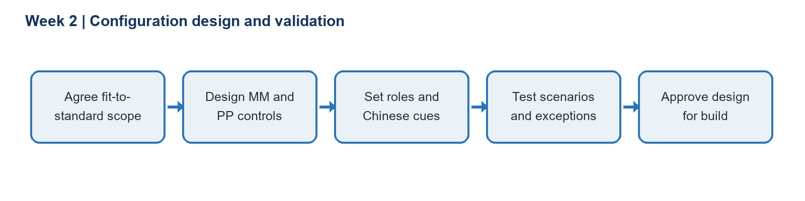
The detailed spreadsheet-ready decision register is in data/week2_configuration_blueprint.csv. Each row is a proposed design position, not a recorded configuration change. A functional lead should confirm local tax, valuation, quality, approval and planning requirements before converting these positions into product-specific settings.

4. Example bilingual interface labels and instructions
English system label | Simplified Chinese cue | Pinyin / use
Purchase order | 采购订单 | cǎigòu dìngdān — use for a purchasing document, not a supplier request.
Quantity | 数量 | shùliàng — enter the value with the displayed unit.
Plan | 计划 | jìhuà — review the plan before confirming the production task.
Confirm | 确认 | quèrèn — confirm only after checking quantity and reference.
Standard / quality | 标准 / 质量 | biāozhǔn / zhìliàng — use the approved standard; report an exception instead of guessing.

Example job aid: “Check the purchase order (采购订单) and quantity (数量) before confirming (确认) the receipt. If the unit or amount is unclear, stop and contact the buyer.” A bilingual reviewer must verify the Chinese wording and local usage. These are learning cues, not a substitute for validated product translation or language instruction.

5. Acceptance criteria and risks
Control | Pass condition | Owner
Approval routing | Low-value sample routes to buyer; high-value sample requires independent approver; role cannot approve own high-value order. | Finance + procurement lead
Receipt handling | PO reference, unit, tolerance and hold status behave as designed in normal and exception samples. | Warehouse + quality lead
Planning proposal | Approved BOM and stock produce an explainable net requirement; missing/invalid master data is surfaced. | Production planner
Bilingual/access review | Critical labels reviewed by bilingual user; access tests prove role boundaries. | Change lead + security lead

Key risks are over-customization, unsafe unit conversions, incomplete roles, incorrect lead times, and labels that introduce ambiguity. Mitigations are fit-to-standard review, data-owner approval, a traceable decision log, test evidence, and explicit sign-off. Any numeric threshold in this blueprint is illustrative and must be replaced with approved policy.

6. Reflection
A configuration choice is only useful when it connects to a process need, owner and test. The main learning from this exercise is to document decisions before attempting system settings: a buyer approval threshold, tolerance, unit mapping or planning lead time can change financial control and production feasibility. Bilingual labels improve access only when identifiers remain precise and a fluent reviewer checks instructions. A future hands-on exercise should use a permitted training tenant, record the software release and configuration evidence, and distinguish observed results from this blueprint.

References
SAP Learning, Purchasing in SAP S/4HANA: https://learning.sap.com/courses/purchasing-in-sap-s-4hana
SAP Learning, Running Materials Requirements Planning: https://learning.sap.com/courses/business-processes-in-sap-s-4hana-sourcing-procurement/running-materials-requirements-planning
SAP Learning, Understanding MRP in SAP S/4HANA: https://learning.sap.com/courses/exploring-production-planning-in-sap-s-4hana/understanding-mrp-in-sap-s-4hana

