Data Migration and Integration Testing Strategy
Project ERP Implementation Consultant | Week 3 | 30 October 2026
Controlled migration and end-to-end validation for the Horizon Foods training case
SIMULATED DATA AND MOCK TESTS — Sample records, balances, errors, results and reconciliations are fabricated for this portfolio. They were not extracted from or loaded into a live ERP system.

1. Purpose and migration scope
This plan moves a small illustrative opening dataset from separate legacy spreadsheets into a proposed ERP target for Horizon Foods. Scope is limited to four active material records, four opening inventory balances, and the procurement-to-production integration path. It excludes historical closed transactions, production execution, tax/legal balances and any real customer or supplier personal data. The migration principle is profile → cleanse → map → stage → simulate → correct → mock-load → reconcile → obtain owner sign-off. A production migration would additionally require approved tools, release-specific object rules, security, cutover timing, backups and formal change control.

2. Sample dataset and mapping rules
Object | Sample scope | Rule / validation
Material master | 5 legacy rows: 4 unique valid materials plus 1 repeated CHL-01 row. | Map CHL-01→RM-CHILI, OIL-02→RM-OIL, PKG-03→PKG-POUCH, FG-04→FG-CHUTNEY. Quarantine repeated SRC-M005; do not silently overwrite.
Units | Legacy KGS and LITRE plus EA and CASE. | Approved crosswalk maps KGS→KG and LITRE→L; unapproved codes stay blocked until owner sign-off.
Opening inventory | 120 KG RM-CHILI; 80 L RM-OIL; 2,500 EA PKG-POUCH; 400 CASE FG-CHUTNEY. | Reconcile by material and UOM separately; do not add quantities across unlike units.
Target location | PLANT-A/RM01 for raw materials, PLANT-A/PK01 for packaging, DC-01/FG01 for finished goods. | Location and material must exist before the opening balance is accepted.

The source-to-target mapping file records the sample source fields, transformation logic, Chinese field cues, validation and disposition. Its rows include illustrative corrected unit mappings and the quarantined duplicate. Four unique material records are accepted from five extracted rows (80% accepted by row count); one duplicate is quarantined (20%). The four opening-balance rows reconcile to zero variance by item and unit in the mock target. The CSV values are training data, not actual inventory.

3. Migration control flow
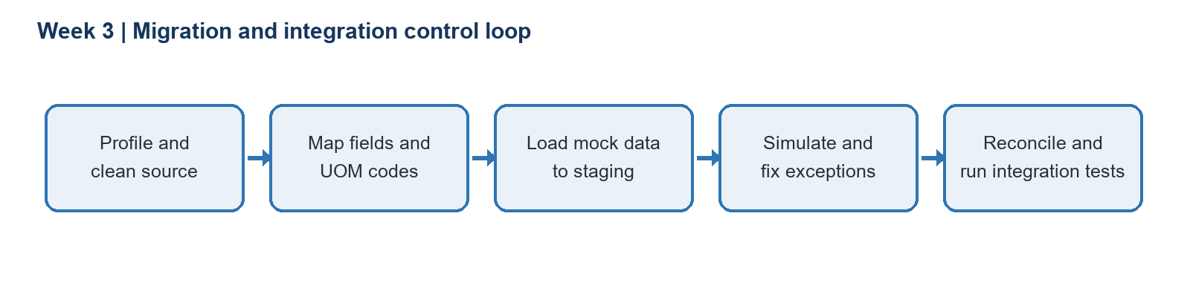
A repeatable simulation cycle is essential: resolve mapping tasks and data errors, then simulate again before a final load. In this exercise, two initial test exceptions were intentionally introduced: an unapproved LITRE code and a missing target unit on a balance. After data-owner approval/crosswalk correction and reload, both retests pass. The duplicate record remains quarantined; approval to merge or retire it belongs to the material owner and is outside the mock-load success count.

4. Integration test plan and results
Test group | Coverage | Initial mock | Final mock / evidence
Procurement | Create PO for approved supplier/material; route approval; post receipt against PO. | 3 tests pass. | Receipt retains PO reference, material and UOM; role separation is verified.
Migration validation | Duplicate ID, unknown unit, required fields, location, quantity reconciliation. | One unit mapping and one blank target unit fail; duplicate is held. | Corrected unit and balance pass; 4/4 accepted balance rows have zero variance by UOM.
Planning and production | BOM explosion, shortage review, order release, component issue, finished receipt. | 3 tests pass. | Expected component requirements and stock movements are traceable through the scenario.
Control and audit | High-value independent approval and user/time trace. | 2 tests pass. | Approver cannot approve own high-value PO; audit evidence is present in test scenario.

The accompanying test register contains 10 integration scenarios. Eight pass in the first mock cycle; two fail with explicit causes. After corrections, all 10 pass on retest (100% final pass rate for this small scripted sample), and both seeded defects close (2/2). This is a designed simulation result and not evidence of a real system test. Testers should save input version, expected result, observed result, defect ID, retest evidence and sign-off in an approved project repository.

5. Reconciliation formulas and quality gates
Record count control: extracted rows = accepted rows + quarantined rows (5 = 4 + 1). Balance control: for each material/UOM, variance = source quantity − mock target quantity; acceptance requires variance = 0 at the defined precision, with no cross-UOM aggregation. Final test pass rate = passed retests ÷ total test cases = 10 ÷ 10 = 100%. Seeded defect closure = corrected and retested defects ÷ seeded defects = 2 ÷ 2 = 100%. Neither metric demonstrates production readiness by itself: scope coverage, severity, security, performance, role, financial and cutover tests also need approval.

6. Challenges, mitigations and contingency
Challenge | Mitigation / recovery
Duplicate or conflicting keys | Quarantine, assign a data owner, decide merge/retire policy, preserve source-to-target cross-reference.
Unknown UOM or inaccurate conversion | Stop record; validate dimension and conversion with operations; rerun simulation and reconcile. Never infer a conversion.
Missing material/location prerequisites | Load prerequisite master objects first; report rejects; use controlled correction file and retain error log.
Cutover extract changes after freeze | Timestamp and checksum extracts, agree freeze window, capture approved delta, rehearse rollback and restore.
Totals reconcile but individual records are wrong | Combine aggregate checks with key-level duplicate, required-field, unit, location, and sampled physical checks.

7. Mandarin HSK 4 field cues
Use stable technical identifiers plus bilingual helper text: 物料编号 (wùliào biānhào, material ID), 单位 (dānwèi, unit), 库存数量 (kùcún shùliàng, stock quantity), 描述 (miáoshù, description), and 确认 (quèrèn, confirm). Example: “Check the material ID and unit before confirming the stock quantity.” A bilingual reviewer should validate the field label and instruction before use, and the learner should verify which HSK syllabus version their course follows.

8. Reflection and sources
The mock illustrates why migration readiness depends on ownership and controlled exception handling, not simply copying files. Row-count agreement can hide unit or key errors, so reconciliation must combine counts, record-level validation and balances grouped by the correct unit. Integration tests then verify that accepted data supports purchasing, inventory and planning behavior. In future authorized practice, I would preserve every extraction and mapping version and retain evidence for each correction and retest.
SAP Help Portal, Simulating the Migration (SAP S/4HANA on-premise, 2025 FPS01): https://help.sap.com/docs/SAP_S4HANA_ON-PREMISE/29193bf0ebdd4583930b2176cb993268/0ee46d72aa734da6ba5d9285da4d7148.html
SAP Help Portal, What Data Can Be Migrated?: https://help.sap.com/docs/SAP_S4HANA_CLOUD/d5699934e7004d048c4801b552f3b013/886e1b9bf25245d093a98e0c635818e5.html
SAP Learning, Posting Goods Receipt with Reference: https://learning.sap.com/courses/inventory-management-in-sap-cloud-erp/posting-goods-receipt-with-reference-1

