SAP SCM INTERNSHIP PROJECT
WEEK 3 REPORT
Logistics and Distribution Network Design in SAP SCM
Deccan Harvest Foods Pvt. Ltd. — Simulated Case Study

Prepared by: Hrudhai Prem Kumar Patwari
Project focus: SAP SCM / APO SNP / Transportation Planning
Scenario geography: Hyderabad, Telangana; Vijayawada, Andhra Pradesh; Bengaluru, Karnataka; Nizamabad, Telangana
Submission type: Academic / Internship Simulation
Prepared: October 2026

Important note: All company data, route distances, demand quantities, costs, capacities and financial impacts in this report are illustrative unless explicitly identified as public-source facts. The report demonstrates how SAP SCM concepts would be configured and analyzed; it does not claim execution in a live production SAP system.

Contents
- 1. Executive Summary
- 2. Assignment Alignment and Objectives
- 3. Public-Data Background and Scenario Definition
- 4. Distribution Network Design
- 5. Demand, Capacity and Inventory Assumptions
- 6. SAP SCM Architecture and Configuration Blueprint
- 7. Step-by-Step Configuration and Simulation Guide
- 8. Distribution Process Flow and Route Planning
- 9. Transaction and Inventory-Transfer Simulation
- 10. Route Optimization Analysis
- 11. Disruption Scenario and Recovery Plan
- 12. KPI Framework and Performance Evaluation
- 13. Risks, Controls and Governance
- 14. Validation and Testing Plan
- 15. Optimization Recommendations and Future-State Design
- 16. Estimated Project Effort
- 17. Learning Outcomes and Conclusion
- 18. References
- 19. Portal Submission Description

1. Executive Summary
This Week 3 project designs and evaluates a logistics and distribution network for the fictional Deccan Harvest Foods Pvt. Ltd., a Hyderabad-based manufacturer of packaged millet ready-to-cook foods. The objective is to convert a weekly demand pattern into a practical distribution structure with defined distribution centers, transportation lanes, delivery schedules, inventory policies, SAP SCM master data and route-planning controls. The analysis deliberately combines public market context with clearly identified simulation assumptions so that the report demonstrates practical SAP thinking without presenting fictional execution as live system activity.
The public context is relevant because the Government of India reported total millet production of 180.15 lakh tonnes in 2024–25 and identified Karnataka as the third-largest millet-producing state. The same Government backgrounder describes a millet value chain spanning production, storage and transport, processing, packaging, distribution and consumption. Separately, the Department for Promotion of Industry and Internal Trade (DPIIT), with NCAER, estimated India’s logistics cost at 7.97% of GDP for 2023–24 and highlighted the importance of first- and last-mile efficiency for journeys around 600 km. These facts support a scenario in which a millet-based processor must design a cost-conscious regional network across Telangana, Andhra Pradesh and Karnataka. [1][2]
The simulated network uses one Hyderabad plant and four destination nodes: Hyderabad DC, Vijayawada DC, Bengaluru DC and Nizamabad DC. Weekly demand totals 150 tonnes against an illustrative plant capacity of 170 tonnes, giving 88.2% plant utilization. A baseline all-16-tonne truck plan requires 12 trips and provides 78.1% fleet utilization. The optimized plan uses 16-tonne vehicles for local/medium lanes and 20-tonne vehicles for longer Bengaluru and Nizamabad movements, reducing the plan to 10 trips and raising modeled fleet utilization to 87.2%. Under the stated illustrative trip-cost assumptions, weekly transport cost falls from ₹1.78 lakh to ₹1.41 lakh, a reduction of ₹37,000 or about 20.8%.
SAP Supply Network Planning is used conceptually to model locations, products, resources and transportation lanes and to synchronize supply, demand, inventory and transportation decisions. SAP documentation describes transportation lanes as links between locations and explains that the SNP model contains locations and lanes that support planning. SAP Transportation Management adds transportation planning and execution functions such as freight units, freight orders, carrier selection and route planning. The report therefore bridges APO/SNP network design with TM-style transportation execution and ERP/EWM integration concepts. [3][4][5]

2. Assignment Alignment and Objectives
The assignment requires a minimum 2,000-word case study covering distribution network design, diagrams and configuration, transaction simulation, analytical evaluation, optimization strategies and risk mitigation. This report addresses each requirement through a single end-to-end case study. The scenario is intentionally structured so that every major decision can be traced from demand to network design, from network design to SAP master data, and from SAP planning to transportation execution.
- Design a regional distribution network with a Hyderabad manufacturing plant and multiple distribution nodes.
- Translate public market context into realistic planning assumptions without treating assumptions as public facts.
- Define transportation lanes, vehicle capacities, delivery schedules, route costs and inventory targets.
- Explain SAP SCM/APO SNP configuration for locations, location-products, transportation lanes, resources and planning versions.
- Show how SAP TM concepts support freight-unit creation, carrier selection, route planning and freight-order execution.
- Simulate inventory transfers and an emergency route response during a delivery disruption.
- Compare a baseline distribution plan with an optimized plan using measurable KPIs.
- Identify risks, controls, validation tests and governance responsibilities.
- Propose a future-state design that balances cost, service, inventory and resilience.

3. Public-Data Background and Scenario Definition
Public-data background. The Government of India’s 2025 millet backgrounder reports that India produced 180.15 lakh tonnes of millets in 2024–25, up by 4.43 lakh tonnes from the previous year. It also states that Karnataka ranked third among states in millet production. The same source identifies ICAR–Indian Institute of Millets Research in Hyderabad as the nodal agency for millet research and notes government support for millet-based processing and ready-to-cook/ready-to-eat products. This provides a defensible external context for locating a simulated millet processor in Hyderabad and serving markets in neighboring southern states. [1]
Public logistics background. A November 2025 Government of India logistics backgrounder reports an estimated logistics cost of 7.97% of GDP for 2023–24 and states that the underlying assessment was built from primary data from more than 3,500 industry stakeholders plus secondary data from MOSPI, RBI and GSTN. The source also highlights first- and last-mile improvements for journeys around 600 km. This supports the report’s decision to treat vehicle utilization, route choice, delivery reliability and local distribution design as strategic levers rather than merely dispatch activities. [2]
Multimodal context. In January 2026, the Government reported 306 approved Gati Shakti Cargo Terminals, of which 118 were commissioned, with a combined handling capacity of 192 million tonnes per year. The Government also highlighted the role of integrated rail-road hubs in reducing bottlenecks and improving freight efficiency. The report therefore keeps a rail-linked option as a future-state contingency for the Bengaluru corridor rather than assuming road transport is the only possible mode. [6]
Scenario definition. Deccan Harvest Foods Pvt. Ltd. is a fictional manufacturer of millet ready-to-cook mixes, breakfast products and packaged grain blends. The plant is modeled in Hyderabad because the scenario benefits from proximity to Hyderabad’s food-processing ecosystem and ICAR-IIMR. The company has a single production site but sells across Telangana, Andhra Pradesh and Karnataka. Management wants to improve service while avoiding unnecessary regional warehouse stock and low-utilization truck movements.
The main distribution challenge is that weekly demand is uneven across destinations. Bengaluru has a long transport distance and requires careful vehicle selection; Vijayawada has medium-distance demand with multiple weekly delivery windows; Nizamabad has smaller demand that is poorly matched to a 16-tonne full-truckload; and Hyderabad is a high-frequency local market. A network that simply assigns one vehicle type to every lane creates avoidable capacity waste. The proposed network therefore uses differentiated transportation lanes, replenishment frequencies and vehicle capacities.

4. Distribution Network Design
The proposed network has one manufacturing plant, four destination nodes and a controlled set of direct transportation lanes. Direct shipping is preferred where demand is large enough to justify efficient linehaul. A cross-dock or rail-linked option is retained as a future-state alternative for long-haul or disruption conditions. The network is not intentionally over-connected because every additional lane creates master-data, planning and operational complexity.
Node | Role | Weekly demand / flow | Illustrative distance | Primary mode | Target frequency
Hyderabad Plant | Manufacturing / central dispatch | 170 t capacity | Origin | Road | Daily / as required
Hyderabad DC | High-frequency regional DC | 55 t demand | 20 km | 16 t road | 4 trips/week
Nizamabad DC | North Telangana DC | 20 t demand | 175 km | 20 t road | 1 trip/week
Vijayawada DC | Coastal AP DC | 40 t demand | 275 km | 16 t road | 3 trips/week
Bengaluru DC | Karnataka DC | 35 t demand | 570 km | 20 t road | 2 trips/week

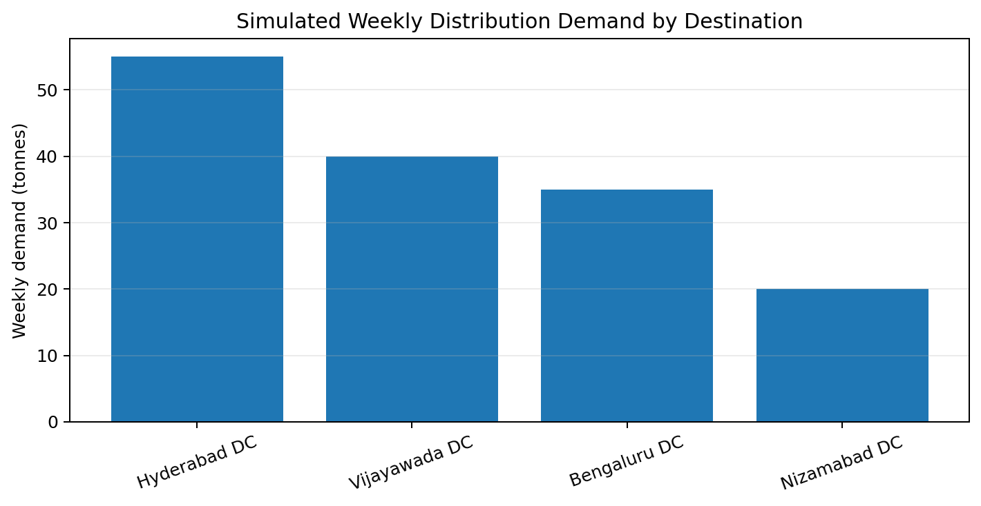
Figure 1. Simulated weekly demand by distribution destination. All quantities are scenario assumptions.
The design principle is to align transportation capacity with demand rather than force every lane into a common 16-tonne vehicle. Hyderabad demand of 55 tonnes is served by four 16-tonne trips, giving 85.9% utilization. Vijayawada demand of 40 tonnes is served by three 16-tonne trips, giving 83.3% utilization. Nizamabad demand of 20 tonnes is assigned to one 20-tonne trip at 100% utilization. Bengaluru demand of 35 tonnes is served by two 20-tonne trips at 87.5% utilization. This produces a more balanced fleet plan than using three 16-tonne trucks for Bengaluru and two for Nizamabad.

5. Demand, Capacity and Inventory Assumptions
The following figures are simulation inputs, not company facts. They are intentionally explicit so that an evaluator can reproduce the calculations and challenge individual assumptions. The plant is assumed to have 170 tonnes of practical weekly dispatch capacity against 150 tonnes of weekly destination demand. The resulting 88.2% utilization leaves 20 tonnes of theoretical weekly capacity headroom, but this headroom should not automatically be treated as unrestricted emergency capacity because production variability, maintenance and quality holds may reduce usable output.
Parameter | Value | Purpose
Weekly network demand | 150 t | Baseline finished-goods distribution requirement
Plant dispatch capacity | 170 t/week | Capacity constraint for planning
Plant utilization | 88.2% | 150 ÷ 170 × 100
Hyderabad demand | 55 t/week | High-frequency local market
Vijayawada demand | 40 t/week | Medium-distance AP market
Bengaluru demand | 35 t/week | Long-haul Karnataka market
Nizamabad demand | 20 t/week | Smaller northern Telangana market
DC target operating stock | Approx. 2.5 days of demand | Illustrative replenishment policy
Plant contingency reserve | 20 t | Illustrative resilience buffer
Planning horizon | 1 week tactical + 1 day execution | Simulation horizon
Destination stock targets are modeled at approximately 2.5 days of average demand. For example, Bengaluru consumes 35 ÷ 7 = 5 tonnes per day, so a 2.5-day target is approximately 12.5 tonnes. A rounded 13-tonne target is used in the disruption simulation. This is not a formal safety-stock calculation; it is a practical simulation assumption. In a live SAP system, safety stock would be derived from service level, demand variability, replenishment lead time and the selected planning method.

6. SAP SCM Architecture and Configuration Blueprint
SAP APO Supply Network Planning provides the conceptual network-planning layer. SAP Help describes SNP as a process that models the supply network, including constraints, and uses master data such as locations, products, resources, PPMs/PDS and transportation lanes. The supply chain model connects nodes through transportation lanes and can use planning versions for simulation. These concepts are directly relevant to this assignment because the network design must be represented as structured master data before planning algorithms can evaluate it. [3][7]
SAP Transportation Management provides the transportation-execution layer. Current SAP TM documentation describes support for transportation requirements, freight units, freight orders, carrier selection, dispatch and monitoring, and transportation charges. The route-planning logic can consider network structure, resources, capacity, time windows and costs. The report therefore uses APO/SNP for network and replenishment planning and TM for the detailed transportation execution blueprint. Exact functions depend on SAP release and deployment. [4][5]
Configuration object | Example setup | Why it matters
Location | HYD_PLANT, HYD_DC, VJA_DC, BLR_DC, NZB_DC | Defines network nodes
Location-product | RTC_MILLET at each DC | Controls planning at node level
Transportation lane | HYD_PLANT → each DC | Defines feasible movement paths
Means of transport | 16 t road, 20 t road; future rail-linked option | Matches lane capacity to demand
Resource | Truck-16T / Truck-20T | Represents transport capacity
Planning version | SIM_W3_BASE / SIM_W3_OPT | Allows scenario comparison
Demand key figure | Weekly DC demand | Drives replenishment requirement
Safety/target stock | 2.5 days illustrative target | Protects service against variability
Carrier master / agreement | Approved carriers per lane | Supports carrier selection
Route/schedule | Departure windows and transit assumptions | Supports delivery feasibility
Cost profile | Illustrative lane/trip cost | Allows cost comparison
Exception threshold | Late delivery > 4 h | Triggers corrective action
The key configuration principle is separation of master data from planning parameters. A transportation lane should identify the source, destination, permitted product and transportation mode; planning parameters should then define capacity, lead time, cost and scheduling constraints. This separation makes it possible to test an alternative route without rebuilding the entire model. SAP documentation specifically states that transportation lanes represent paths between locations and can have means of transport assigned. [8]

7. Step-by-Step Configuration and Simulation Guide
Step 1 — Define organizational scope: Create or identify the Hyderabad manufacturing plant and destination distribution centers. In a real system, verify plant, storage location, shipping point and transportation-relevant organizational assignments before creating planning master data.
Step 2 — Create products and location-products: Create the finished product or product family and extend it to the plant and each DC. Maintain units of measure, planning parameters, lead times and target-stock assumptions.
Step 3 — Build the APO/SNP model: Create the supply-chain model and planning version. Add the relevant locations, resources and product-location combinations. SAP documentation describes locations, resources, products and transportation lanes as core model elements. [3]
Step 4 — Create transportation lanes: Create HYD_PLANT to HYD_DC, NZB_DC, VJA_DC and BLR_DC lanes. Assign permitted transportation modes, transit times, calendars and capacity assumptions.
Step 5 — Maintain demand and supply data: Enter or simulate weekly demand at each DC. Verify that the total 150-tonne demand is consistent with the 170-tonne plant dispatch capacity.
Step 6 — Configure planning constraints: Define minimum/maximum transport quantities, available truck capacity, lead times, delivery windows and inventory targets. Use planning versions to compare the baseline and optimized scenarios.
Step 7 — Configure TM planning inputs: Map transportation-relevant orders or deliveries into TM, create freight units where applicable, define planning profiles and make carrier/route information available.
Step 8 — Execute baseline planning: Run the baseline scenario using 16-tonne vehicles. Record trip count, capacity utilization, cost and delivery feasibility.
Step 9 — Execute optimization scenario: Allow differentiated 16-tonne and 20-tonne resources. Recalculate trips, utilization and cost. Retain the baseline version for comparison.
Step 10 — Validate inventory: Check that each DC receives enough replenishment to meet demand and target stock. Confirm that no negative projected inventory remains under normal conditions.
Step 11 — Simulate disruption: Delay the Bengaluru linehaul by one day. Recalculate projected stock and create an emergency 8-tonne shipment from the plant if the stockout threshold is reached.
Step 12 — Close and document: Compare KPIs, record the decision rationale, document exceptions and preserve the final planning version and assumptions as evidence.

8. Distribution Process Flow and Route Planning
The distribution process begins with demand at the DC level and ends with a confirmed delivery and inventory update. The key control is that planning must not create transportation merely because inventory exists; it must reconcile demand, inventory position, route feasibility, vehicle capacity, delivery windows and transportation cost. In a live environment, the exact document flow depends on the SAP deployment, but the conceptual sequence below is stable.
Demand signal | SNP replenishment plan | Delivery / freight demand | Freight unit | Route + carrier | Freight order | Dispatch + receipt
SAP TM documentation explains that freight units represent transportation requirements and that freight orders can result from transportation planning. The planning process can use routes, resources, capacity, time windows and costs. The same documentation describes carrier selection and transportation execution functions. [4][5]
Route decision logic used in the simulation: (1) select a feasible lane; (2) check product and vehicle compatibility; (3) check capacity utilization; (4) check required delivery date/time; (5) compare route and carrier cost; (6) prefer consolidation only when it does not violate service; and (7) create an exception when no feasible plan exists. This logic avoids the common mistake of optimizing transport cost while ignoring customer service.

9. Transaction and Inventory-Transfer Simulation
The following transaction sequence is simulated rather than executed in a live SAP system. The purpose is to show how a planner would translate the network design into operational steps. The exact transaction codes and Fiori apps vary by SAP release, so the report emphasizes business objects and control points rather than claiming one universal screen path.
Step | Simulated business action | Key data | Control
1 | Review DC demand | 55 / 40 / 35 / 20 t | Demand totals 150 t
2 | Check plant availability | 170 t capacity | 20 t headroom
3 | Create replenishment requirement | Destination-specific quantities | No duplicate requirement
4 | Create/plan transportation demand | Freight unit or equivalent | Correct origin/destination
5 | Select vehicle | 16 t or 20 t | Capacity and route fit
6 | Assign carrier | Approved carrier per lane | Service and cost check
7 | Create freight order / delivery | Departure and arrival window | Feasible schedule
8 | Dispatch | Vehicle leaves plant | Event timestamp
9 | Receive at DC | Goods receipt / stock update | Quantity reconciliation
10 | Update KPI | OTIF, utilization, cost, stock | Evidence retained
Inventory-transfer simulation. Assume Bengaluru DC starts with 13 tonnes. Its average daily demand is 5 tonnes. A scheduled linehaul is delayed, so the DC receives no planned replenishment on Day 1 or Day 2. Without corrective action, stock falls from 13 to 8 tonnes on Day 1, to 3 tonnes on Day 2 and below zero on Day 3. The proposed response is an emergency 8-tonne plant shipment that arrives at the end of Day 2. Inventory then becomes 11 tonnes instead of 3 tonnes, preventing the Day 3 stockout. This example demonstrates why distribution planning must combine route status with inventory projection rather than waiting for a customer-service failure.

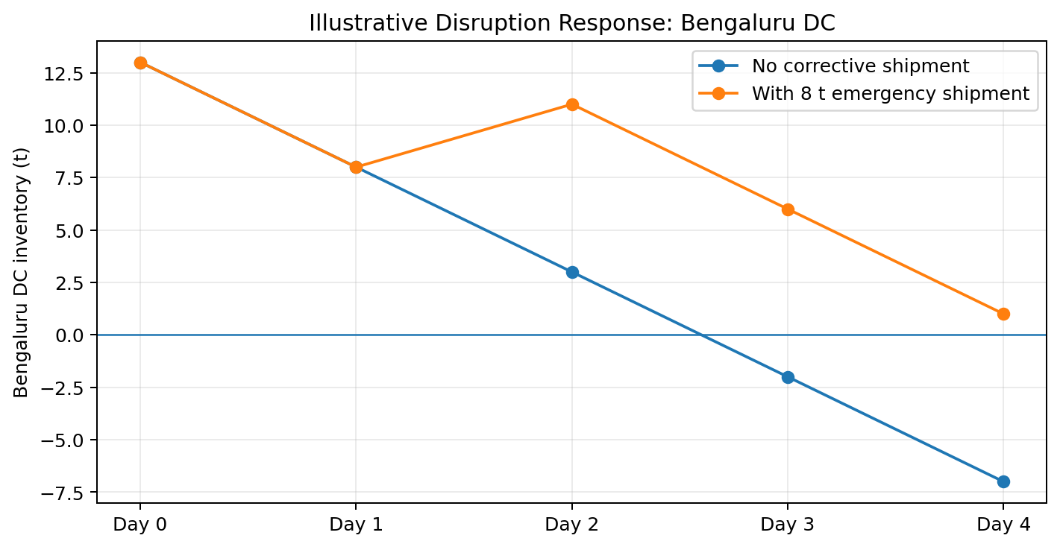
Figure 2. Simulated Bengaluru DC disruption and emergency replenishment response.

10. Route Optimization Analysis
Baseline. The baseline assumes all destinations are served with 16-tonne trucks. Hyderabad requires four trips (55/16 rounded up), Vijayawada requires three trips, Bengaluru requires three trips and Nizamabad requires two trips. Total trips are therefore 12. Total nominal capacity is 12 × 16 = 192 tonnes. Fleet utilization is 150/192 × 100 = 78.1%.
Optimized plan. The optimized design uses four 16-tonne trips for Hyderabad, three 16-tonne trips for Vijayawada, one 20-tonne trip for Nizamabad and two 20-tonne trips for Bengaluru. Total trips fall to 10. Nominal capacity becomes (4×16)+(3×16)+(1×20)+(2×20)=172 tonnes. Utilization is 150/172 × 100 = 87.2%. The result is an 18.8% reduction in truck trips and a 9.1 percentage-point increase in utilization.

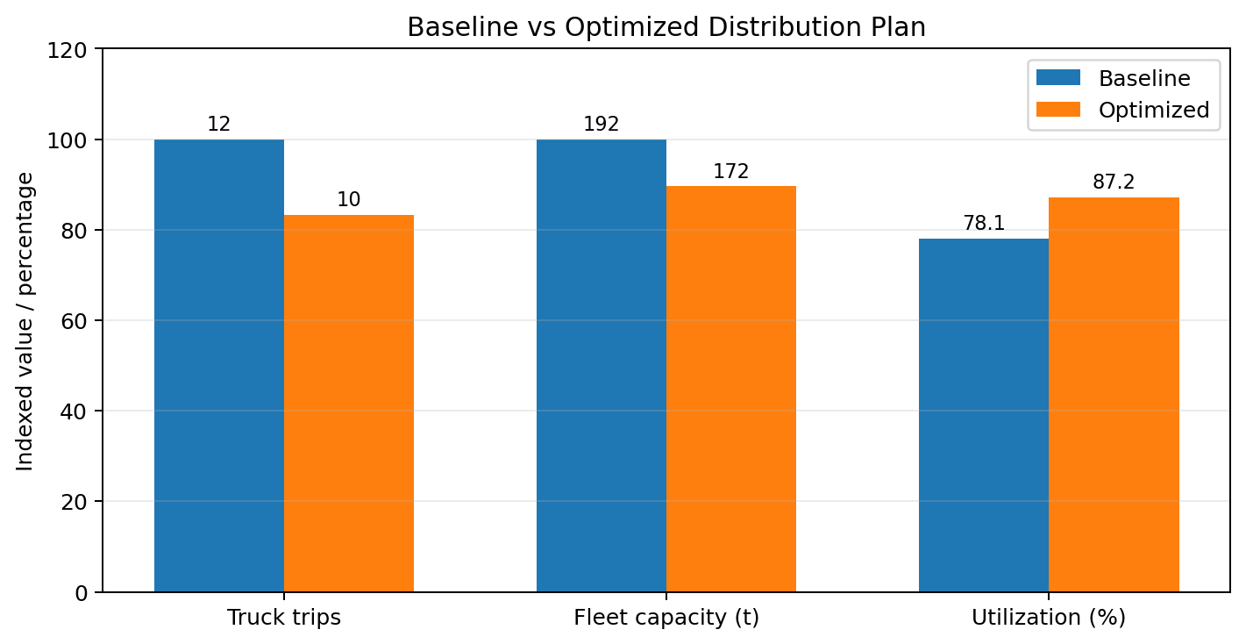
Figure 3. Baseline versus optimized distribution plan. Bar labels show the underlying values; the chart uses indexed display for mixed units.
Destination | Demand | Baseline vehicles | Optimized vehicles | Baseline utilization | Optimized utilization
Hyderabad | 55 t | 4 × 16 t | 4 × 16 t | 85.9% | 85.9%
Vijayawada | 40 t | 3 × 16 t | 3 × 16 t | 83.3% | 83.3%
Bengaluru | 35 t | 3 × 16 t | 2 × 20 t | 72.9% | 87.5%
Nizamabad | 20 t | 2 × 16 t | 1 × 20 t | 62.5% | 100.0%
Total | 150 t | 12 trips | 10 trips | 78.1% | 87.2%
Cost model. To keep the simulation reproducible, the report uses fixed illustrative trip costs: ₹8,000 per Hyderabad local trip, ₹7,000 per Nizamabad trip, ₹14,000 per Vijayawada trip and ₹30,000 per Bengaluru trip. The baseline weekly cost is 4×8,000 + 2×7,000 + 3×14,000 + 3×30,000 = ₹1,78,000. The optimized weekly cost is 4×8,000 + 1×7,000 + 3×14,000 + 2×30,000 = ₹1,41,000. The modeled saving is ₹37,000 per week, or approximately ₹19.24 lakh per year if the same pattern were sustained for 52 weeks. This annual figure is illustrative and should not be interpreted as a guaranteed financial benefit.

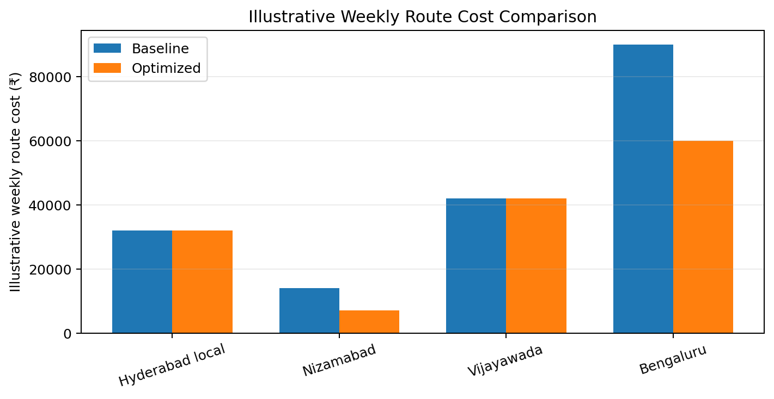
Figure 4. Illustrative weekly route cost comparison.

11. Disruption Scenario and Recovery Plan
Scenario: Bengaluru linehaul disruption. A scheduled 20-tonne vehicle is delayed by 24 hours due to a route or carrier event. Bengaluru DC has 13 tonnes of opening stock and consumes 5 tonnes per day. The planning system therefore projects 3 tonnes after two days and a stockout on Day 3 if no replenishment arrives. The emergency response is to create an 8-tonne direct plant-to-Bengaluru movement, subject to carrier availability and approval.
Decision point | Normal plan | Disruption signal | Recovery action
Inventory | 13 t opening | Projected < 1 day cover | Raise exception
Transportation | 20 t linehaul | ETA slips by 24 h | Search alternate capacity
Quantity | Scheduled replenishment | Insufficient cover | Emergency 8 t
Route | Primary road lane | Risk remains | Alternate feasible route/carrier
Approval | Normal dispatch | Premium cost possible | Exception approval
After receipt | Normal stock update | Emergency receipt posted | Recalculate coverage
Closure | KPI recorded | OTIF risk avoided | Root-cause review
The emergency shipment should not become the default planning method. Repeated emergency movements would increase cost and could conceal poor master data or inadequate safety-stock settings. Therefore, every emergency shipment receives a reason code, approval, cost capture and root-cause classification. If the same route records three or more comparable disruptions in a rolling month, the network design should be reviewed rather than repeatedly expediting.

12. KPI Framework and Performance Evaluation
KPI | Formula | Target / threshold | Purpose
OTIF | On-time and in-full deliveries ÷ total deliveries ×100 | ≥95% | Service reliability
Truck utilization | Loaded tonnes ÷ usable capacity ×100 | ≥85% modeled | Asset efficiency
Trips per week | Count of completed linehaul/local trips | ≤10 for this demand profile | Network efficiency
Freight cost / tonne | Total transport cost ÷ tonnes delivered | ≤₹950/t modeled | Cost control
DC stock cover | Available stock ÷ average daily demand | 2.0–3.0 days | Resilience without excess
Stock-out days | Days projected inventory <0 | 0 normal case | Customer-service protection
Emergency shipment rate | Emergency shipments ÷ total shipments ×100 | <5% | Planning stability
Route adherence | Trips following planned lane/slot ÷ total trips ×100 | ≥95% | Execution discipline
The optimized transport cost per tonne is ₹1,41,000 ÷ 150 = ₹940/t, which is just below the illustrative target of ₹950/t. The baseline is ₹1,78,000 ÷ 150 = ₹1,186.67/t. This gives a modeled reduction of approximately ₹246.67/t. The calculation should be reviewed against actual contracted carrier rates, fuel surcharges, tolls, detention and accessorial charges before being used for real procurement decisions.
The KPI design intentionally combines cost, service, utilization and inventory. A plan that lowers freight cost but creates stockouts is not considered successful. Similarly, maximizing truck utilization beyond feasible loading limits is not acceptable. The preferred decision is the one that meets service constraints first and then minimizes avoidable cost and capacity waste.

13. Risks, Controls and Governance
Risk | Potential effect | Preventive control | Owner
Incorrect lane master data | Wrong route / infeasible plan | Lane validation and periodic review | SAP master-data analyst
Stale transit time | Late deliveries | Monthly lane performance review | Transport planner
Overloaded vehicle | Safety/compliance risk | Capacity hard stop | Transport execution
Low vehicle utilization | High cost per tonne | Vehicle-type optimization | Transport planner
DC stock too low | Stockout | Target-stock review | Inventory controller
Excess DC stock | Working capital increase | Coverage limits | Supply planner
Carrier failure | Missed delivery | Approved alternate carriers | Logistics manager
Duplicate transfer | Excess inventory | Open-order reconciliation | Planner
Late event posting | Poor visibility | Same-day event discipline | Carrier / operations
Poor master-data governance | Repeated planning errors | Change approval and audit trail | SAP support
Governance is divided by decision ownership. The supply planner owns demand and replenishment assumptions; the transport planner owns lane, carrier and route decisions; the warehouse/DC supervisor owns receiving and inventory accuracy; the inventory controller owns stock coverage and exception thresholds; SAP support owns master-data integrity and configuration evidence; and the business manager approves major network-policy changes. This division reduces the risk that one role changes demand, transportation and inventory parameters without independent review.

14. Validation and Testing Plan
Before accepting the simulated future-state network, the following tests should be performed. The tests are written so that a future live SAP exercise could produce evidence such as screenshots, planning logs, order numbers, route plans or reconciled spreadsheets.
Test | Scenario | Expected result | Evidence
V1 | Demand total | 55+40+35+20 = 150 t | Demand extract / planning table
V2 | Plant capacity | 150 ≤ 170 t | Capacity check
V3 | Baseline trip count | 12 trips | Baseline planning version
V4 | Optimized trip count | 10 trips | Optimized planning version
V5 | Vehicle capacity | No load exceeds vehicle limit | Freight-order check
V6 | Utilization | 87.2% optimized | KPI calculation
V7 | Cost | ₹1.41 lakh optimized | Cost worksheet / report
V8 | Normal inventory | No projected stockout | Inventory projection
V9 | Disruption response | 8 t emergency move prevents Day 3 stockout | Exception simulation
V10 | Route master | All four lanes exist and are directional | Lane master evidence
V11 | Delivery window | Planned arrivals meet slot assumptions | Schedule check
V12 | Data reconciliation | Demand, shipments and receipts reconcile | Reconciliation log
Acceptance criteria are: zero unexplained negative inventory in the normal scenario; zero capacity violations; optimized trips no greater than 10 for the modeled demand; transport cost at or below the illustrative ₹1.41 lakh scenario result; and no unapproved emergency movement. If a test fails, the planner should identify whether the cause is demand, master data, capacity, route, carrier or transaction timing before changing the network design.

15. Optimization Recommendations and Future-State Design
1. Maintain differentiated fleet capacity: Keep 16-tonne resources for Hyderabad and Vijayawada and use 20-tonne resources where the modeled demand profile supports them. Review utilization monthly.
2. Use route-specific delivery calendars: Set different departure frequencies for local, medium and long-haul lanes rather than using a single weekly schedule.
3. Introduce controlled emergency capacity: Maintain a small pool of approved alternate carriers for Bengaluru and other critical lanes, with approval thresholds for premium freight.
4. Use planning versions for what-if analysis: Maintain a baseline and optimized version so cost/service changes can be compared before changing operational parameters.
5. Add a rail-linked option for long-haul resilience: Monitor suitable Gati Shakti or rail-linked facilities and evaluate a road-rail-road alternative if volume and service windows justify it. This is a future-state study, not a claim that the modeled company currently has such a connection.
6. Review DC inventory by service level: Avoid using the same stock-cover target for every DC. Long lead-time or high-risk destinations may require higher protection than local markets.
7. Establish lane scorecards: Track OTIF, cost per tonne, utilization, delay hours and emergency shipments by route and carrier.
8. Automate exception escalation: Set alerts for projected stock below one day, carrier ETA slippage above four hours, and utilization below a defined threshold.
9. Govern master-data changes: Require approval for new lanes, transit times, vehicle capacities, carrier assignments and target-stock parameters.
10. Rebalance the network when demand changes: If Bengaluru demand rises materially, test whether a regional satellite or rail-linked consolidation point becomes economically justified instead of simply adding more direct trucks.
The future-state principle is therefore not “minimum transport cost at any price.” It is “minimum total logistics cost subject to service, capacity, inventory and resilience constraints.” This is consistent with the purpose of integrated supply network planning: synchronizing supply, demand, inventory and transportation rather than optimizing one function in isolation. [3]

16. Estimated Project Effort
Work package | Estimated hours | Evidence / output
Research and public-data review | 3.0 | Government and SAP references
Scenario and demand design | 3.0 | Network assumptions and demand table
Network topology and lane design | 4.0 | Node/lane model
SAP SCM/TM configuration blueprint | 5.0 | Configuration tables and steps
Route and inventory simulation | 5.0 | Baseline/optimized calculations
Disruption and recovery analysis | 3.0 | Inventory response simulation
KPI and cost analysis | 3.0 | KPI table and charts
Risk, validation and governance | 2.5 | Controls and test plan
Documentation, formatting and QA | 4.5 | Final DOCX and visual review
Total | 33.0 | Estimated internship project effort
The 33-hour figure is an estimated project-effort plan for the internship assignment. It is not a claim that the work was performed in a live SAP system for 33 hours. The distinction is important because this report is a simulation and configuration blueprint.

17. Learning Outcomes and Conclusion
This project demonstrates how logistics and distribution network design can be translated into an SAP SCM-oriented planning model. The most important learning is that network design begins with a clear representation of demand, locations, transportation lanes, capacity and inventory policies. SAP APO/SNP concepts provide the structure for this model, while SAP TM concepts support detailed transportation planning and execution. The same model can then be tested against baseline, optimized and disrupted conditions.
The simulation shows a concrete business decision: the baseline 12-trip plan produces only 78.1% fleet utilization, while the optimized 10-trip plan reaches 87.2%. Under the illustrative cost model, weekly transport cost falls from ₹1.78 lakh to ₹1.41 lakh. The Bengaluru disruption simulation also demonstrates why route planning and inventory management must be linked: an 8-tonne emergency movement prevents a projected Day 3 stockout. These results are not presented as guaranteed real-world savings; they demonstrate how a planner can quantify trade-offs before changing the live network.
The final network is deliberately simple enough to govern but rich enough to support scenario analysis. It uses differentiated vehicle capacity, route-specific schedules, target inventory, exception controls and future multimodal evaluation. The project therefore bridges theoretical SAP SCM concepts with a practical distribution challenge and creates a foundation for later internship work on production planning, supply-chain integration and performance evaluation.

18. References
[1] Government of India, Press Information Bureau, “Shree Anna for Shreshta Bharat — Empowering India through Millets,” 8 August 2025. https://www.pib.gov.in/PressNoteDetails.aspx?ModuleId=3&NoteId=154991&id=154991&lang=2&reg=48
[2] Government of India, Press Information Bureau, “From Growth Engine to Global Edge: Supercharging India’s Logistics,” 27 November 2025. https://www.pib.gov.in/PressReleasePage.aspx?PRID=2195125&lang=2&reg=3
[3] SAP Help Portal, “Supply Network Planning Process,” SAP Supply Chain Management. https://help.sap.com/docs/SAP_SUPPLY_CHAIN_MANAGEMENT/49dd58c18be2493b80f84359d659f4a4/793fc95360267614e10000000a174cb4.html
[4] SAP Help Portal, “Transportation Management (TM),” SAP S/4HANA On-Premise, 2025 FPS01. https://help.sap.com/docs/SAP_S4HANA_ON-PREMISE/e3dc5400c1cc41d1bc0ae0e7fd9aa5a2/9c27c9535f267414e10000000a174cb4.html?locale=en-US
[5] SAP Help Portal, “TM: Planning Freight and Selecting Carriers,” SAP Transportation Management documentation. https://help.sap.com/http.svc/rc/73a19bec18c4434c9e36101e7e874a8f/9.0/en-US/PD_90_Planning_Freight_and_Selecting_Carriers.pdf
[6] Government of India, Press Information Bureau, “Gati Shakti Multi-Modal Cargo Terminals: Driving India’s Logistics Transformation,” 13 January 2026. https://www.pib.gov.in/PressNoteDetails.aspx?ModuleId=3&NoteId=156923&lang=1&reg=3
[7] SAP Help Portal, “Supply Chain Model Setup,” SAP Advanced Planning and Optimization. https://help.sap.com/docs/SAP_ADVANCED_PLANNING_AND_OPTIMIZATION%2C_ON_SAP_ERP/c95f1f0dcd9549628efa8d7d653da63e/fd78c95360267514e10000000a174cb4.html
[8] SAP Help Portal, “Create Transportation Lanes,” SAP Advanced Planning and Optimization. https://help.sap.com/docs/SAP_ADVANCED_PLANNING_AND_OPTIMIZATION%2C_ON_SAP_ERP/c95f1f0dcd9549628efa8d7d653da63e/7627c9535f267414e10000000a174cb4.html
[9] SAP Help Portal, “Path Finder,” SAP Transportation Management, 2025 FPS01. https://help.sap.com/docs/SAP_S4HANA_ON-PREMISE/e3dc5400c1cc41d1bc0ae0e7fd9aa5a2/af430ceebbb6448dba3087ddb4b01ee2.html?locale=en-US
Access note: Public sources were reviewed in October 2026. SAP functionality and navigation vary by release, deployment model and activated components; the report therefore uses business-process and configuration concepts rather than claiming a universal transaction path.

19. Portal Submission Description
This Week 3 report presents a Logistics and Distribution Network Design simulation using SAP SCM, SAP APO Supply Network Planning and SAP Transportation Management concepts. The project continues the fictional Deccan Harvest Foods Pvt. Ltd. scenario and uses public Government of India logistics and millet-sector information to establish a realistic business background. The proposed network contains a Hyderabad manufacturing plant and distribution nodes serving Hyderabad, Nizamabad, Vijayawada and Bengaluru, with 150 tonnes of simulated weekly demand. The report documents distribution-center roles, transportation lanes, vehicle capacities, delivery schedules, inventory targets and SAP-oriented master-data requirements. It provides step-by-step guidance for configuring locations, location-products, transportation lanes, resources, planning versions, transportation modes, route parameters and exception thresholds. A baseline 16-tonne vehicle plan is compared with an optimized mixed-capacity plan. The analysis reduces modeled trips from 12 to 10, improves fleet utilization from 78.1% to 87.2%, and reduces illustrative weekly transport cost from ₹1.78 lakh to ₹1.41 lakh. The report also simulates a Bengaluru delivery disruption and an 8-tonne emergency replenishment response to prevent a projected stockout. It includes process-flow diagrams, network and demand charts, route-cost analysis, KPI definitions, risk controls, governance responsibilities, validation tests, future-state multimodal considerations and a 33-hour estimated project plan. All company data, route distances, costs, capacities and financial results are clearly identified as illustrative simulation values rather than live SAP execution.
End of Report

