SAP SCM INTERNSHIP PROJECT
Week 5
Performance Metrics and Evaluation
in SAP SCM Logistics
Optimized submission with KPI framework, simulated data, charts, SAP reporting guidance, validation controls and actionable recommendations

Prepared by | Hrudhai Prem Kumar Patwari
Scenario | Deccan Harvest Foods Pvt. Ltd. (fictional)
Focus | SAP SCM logistics performance measurement
Data basis | Simulated operational dataset; not live SAP execution
Project effort | Estimated 33 hours

September 2026

Contents
1. Executive Summary
2. Introduction and Objectives
3. Methodology and Scenario Design
4. KPI Performance Framework
5. KPI Dictionary, Formulas and Targets
6. SAP Reporting Data Architecture
7. Simulated Performance Data
8. Analysis Findings and Charts
9. Worked Examples and Business Impact
10. SAP SCM Reporting Configuration Guidelines
11. Validation, Governance and Control Model
12. Risk Analysis
13. Recommendations and Improvement Roadmap
14. Estimated 33-Hour Work Plan
15. Learning Outcomes and Conclusion
16. References
17. Portal Submission Description
Submission note: The report intentionally distinguishes simulated calculations from live system execution. SAP objects and reporting options are described as configuration and analysis guidelines for an internship project.

1. Executive Summary
This Week 5 project designs a logistics performance measurement framework using SAP SCM-related planning, transportation and warehouse reporting concepts. The framework extends the Deccan Harvest Foods Pvt. Ltd. simulation used in the previous weeks and evaluates a logistics operation moving approximately 150 tonnes of finished goods per week through transportation and warehouse processes.
The design uses ten KPIs rather than only the minimum five. These metrics cover service, accuracy, inventory, transport utilization, warehouse execution, cost and cycle time. Each KPI has a formula, target, owner, data source, review frequency and escalation rule. A six-month simulated dataset is used to demonstrate trend analysis and a weighted composite logistics score.
The modeled composite score improves from 83.1/100 in April to 99.8/100 in September. The strongest improvements are truck utilization (70.3% to 93.75%), dock turnaround (110 to 75 minutes), stock-out rate (7.5% to 2.4%), freight cost per tonne (INR 2,150 to INR 1,825) and OTIF (89% to 96%). These values are illustrative, but the calculations show how a logistics manager could connect operational evidence to corrective actions.
Key result: The framework converts disconnected logistics metrics into one governed cycle: define -> collect -> validate -> analyze -> escalate -> act -> re-measure. This directly addresses the evaluator requirement for practical analysis, simulated performance data and actionable recommendations.

2. Introduction and Objectives
Supply-chain performance cannot be managed effectively through a single metric. A high vehicle utilization rate can reduce freight cost but can also hurt service if consolidation delays shipments. Likewise, high inventory can protect OTIF while damaging working capital and inventory turnover. The purpose of this project is therefore to build a balanced KPI framework rather than optimize one measure in isolation.

2.1 Project objectives
- Define a practical logistics KPI set covering service, cost, inventory, transportation and warehouse execution.
- Document formulas, targets, source data, owners and reporting frequencies.
- Create simulated performance data and demonstrate month-by-month evaluation.
- Explain how SAP TM, SAP EWM, SAP APO alerting and enterprise reporting layers can support measurement.
- Use threshold rules, weighted scoring, validation tests and governance controls to make results auditable.
- Convert KPI gaps into specific improvement actions with measurable follow-up targets.

2.2 Scope and assumptions
The scenario is a learning simulation, not a claim of production-system configuration. The fictional company ships millet-based finished goods from Hyderabad to Telangana, Andhra Pradesh and Karnataka. Weekly logistics volume is assumed to be about 150 tonnes. The warehouse uses 4,000 pallet positions and coordinates picking, staging and loading with transport departures. Six monthly periods from April to September are used for the performance simulation.

3. Methodology and Scenario Design
The methodology follows a closed-loop measurement approach. KPI definitions are established first, operational data is collected from the relevant process objects, results are validated, trends and variances are analyzed, root causes are assigned, and corrective actions are tracked through the next reporting cycle.
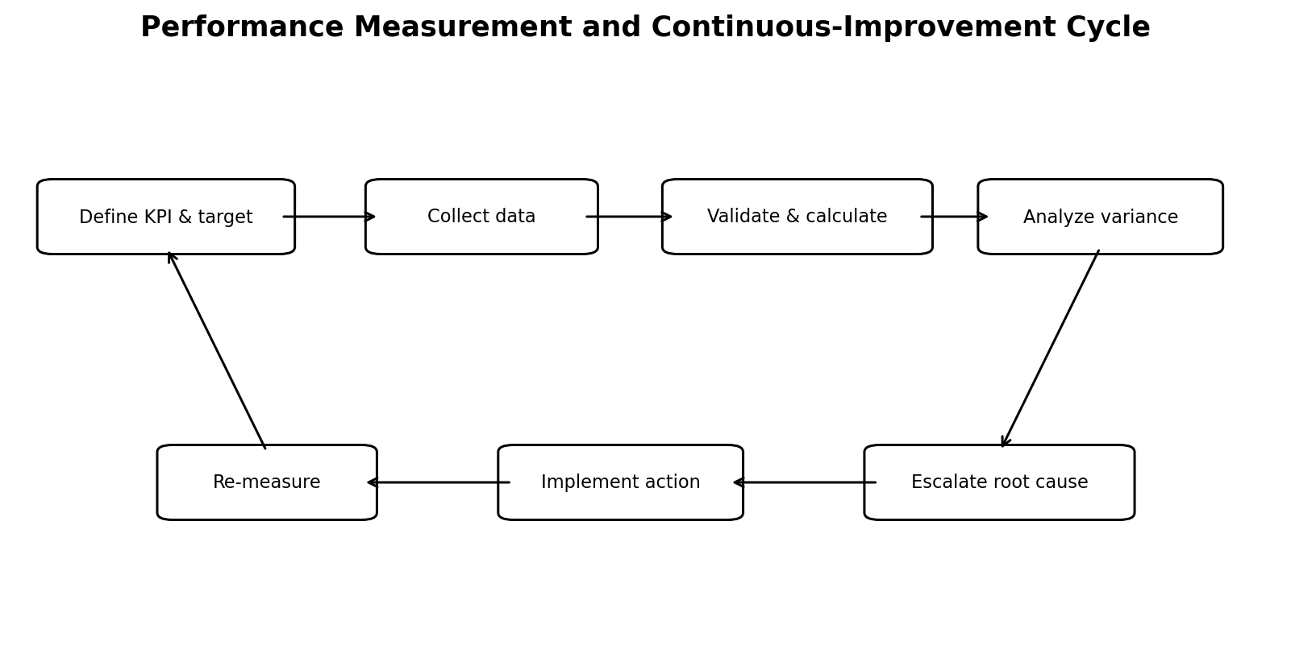
Figure 1. Performance measurement and continuous-improvement cycle

3.1 Scenario operating profile
Element | Simulated assumption | Reason for inclusion
Weekly outbound volume | ~150 tonnes | Creates enough transport and warehouse activity for KPI analysis
Primary warehouse | Hyderabad finished-goods warehouse | Links stock, picking, staging, loading and dispatch metrics
Transport modes | Road FTL, LTL/local, selected rail-linked movement | Supports utilization, lead-time and cost comparisons
Order volume | 1,000 customer orders/month for worked examples | Makes service-level effects easy to quantify
Reporting horizon | 6 months: Apr-Sep | Allows trend and improvement evaluation
Governance cadence | Daily exceptions, weekly operational review, monthly scorecard | Separates urgent action from management reporting

3.2 Analysis logic
1. Capture raw events, statuses, quantities, costs and timestamps from order, transport, warehouse and planning objects.
2. Validate completeness, duplicates, units of measure, time-zone consistency and document status.
3. Calculate KPIs using a controlled formula dictionary.
4. Compare actual results with target and tolerance bands.
5. Apply a weighted score so different KPI units can be compared on a common 0-100 scale.
6. Perform root-cause analysis on the largest gaps and recurring exceptions.
7. Assign actions, owners and due dates, then verify improvement in the next reporting cycle.

4. KPI Performance Framework
The framework groups KPIs into five dimensions so that service improvements are not achieved at the expense of cost, inventory or execution stability.
Dimension | KPIs | Management question
Customer service | OTIF; order accuracy | Are customers receiving the right order at the promised time?
Inventory | Inventory turnover; stock-out rate; inventory accuracy | Is inventory sufficient, accurate and financially efficient?
Transportation | Truck utilization; freight cost/tonne | Are transport assets and freight spend efficient?
Warehouse | Pick accuracy; dock turnaround | Is warehouse execution accurate and synchronized with departures?
End-to-end flow | Order cycle time; composite score | Is the total order-to-delivery process improving?

4.1 Threshold model
Status | Rule | Required action
Green | Meets or exceeds target | Continue monitoring; standardize successful practice
Amber | Within 5-10% of target or negative trend for two periods | Root-cause review and owner action plan
Red | More than 10% away from target or service-critical breach | Immediate corrective action, escalation and next-cycle verification
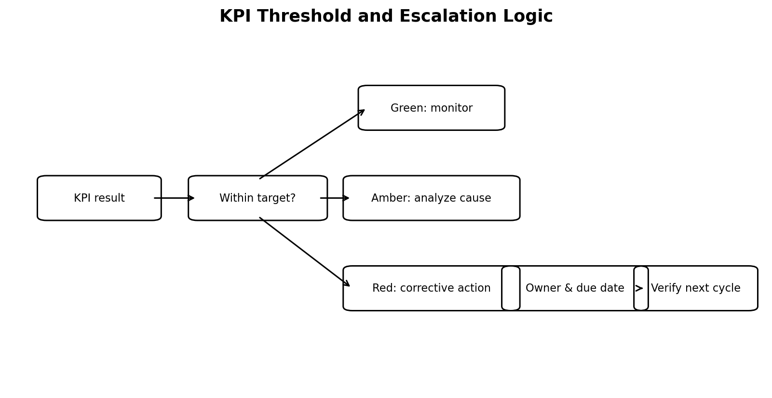
Figure 2. KPI threshold and escalation logic

5. KPI Dictionary, Formulas and Targets
KPI | Formula | Target | Weight | Dimension
OTIF | Orders delivered on time and in full / total delivered orders x 100 | >=95% | 20% | Customer service
Order accuracy | Correct orders / total orders shipped x 100 | >=99.5% | 10% | Customer service
Inventory turnover | Annualized COGS / average inventory value | >=7.5x | 10% | Inventory
Truck utilization | Loaded weight or volume / usable capacity x 100 | >=90% | 10% | Transportation
Pick accuracy | Correct picks / total picks x 100 | >=99.5% | 10% | Warehouse
Dock turnaround | Gate-in to gate-out elapsed minutes | <=80 min | 10% | Warehouse
Stock-out rate | Stock-out affected order lines / total order lines x 100 | <=3% | 10% | Inventory
Freight cost/tonne | Total freight cost / tonnes shipped | <=INR 1,900 | 10% | Transportation
Order cycle time | Order release to confirmed delivery elapsed hours | <=40 h | 5% | End-to-end
Inventory accuracy | System quantity matching physical quantity / checked items x 100 | >=99.5% | 5% | Inventory

5.1 Worked KPI calculations
OTIF example: if 960 of 1,000 monthly orders are delivered both on time and in full, OTIF = 960 / 1,000 x 100 = 96%. The target is 95%, so the result is Green.
Truck-utilization example: if a 16-tonne vehicle carries 15 tonnes of freight, utilization = 15 / 16 x 100 = 93.75%. This exceeds the 90% target. However, the shipment must still be checked against OTIF to make sure consolidation has not delayed dispatch.
Dock-turnaround example: if the average gate-in to gate-out time falls from 110 minutes to 75 minutes, improvement = (110 - 75) / 110 x 100 = 31.8%. The target of 80 minutes is achieved.

6. SAP Reporting Data Architecture
The reporting model combines operational evidence from multiple SAP logistics components. The exact technical implementation depends on the organization's SAP release and architecture; this report therefore documents a conceptual integration pattern rather than claiming a live setup.
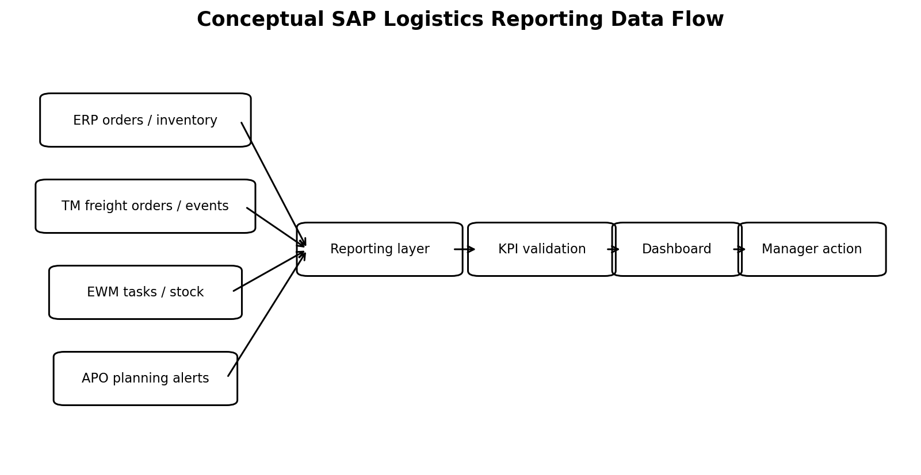
Figure 3. Conceptual SAP logistics reporting data flow

6.1 Example source mapping
KPI | Primary logical source | Key fields / events | Reporting option
OTIF | ERP delivery + TM execution | requested date, actual delivery event, quantity | TM execution analytics / BW / CDS / dashboard
Order accuracy | ERP delivery + EWM confirmation | ordered qty, picked qty, shipped qty, item status | EWM analytics / warehouse monitor / BW
Inventory turnover | ERP finance/inventory + EWM stock | COGS, average stock value, stock snapshots | BW / enterprise analytics
Truck utilization | TM freight order | gross weight, volume, vehicle capacity, mode | TM quantity analytics / operational reporting
Pick accuracy | EWM warehouse tasks | task confirmation, exception, quantity | EWM warehouse monitor / measurement services
Dock turnaround | EWM/TM timestamps | vehicle arrival, door assignment, loading complete, departure | EWM/TM event reporting
Stock-out rate | ERP/EWM/APO exception data | shortage, stock availability, order line status | APO Alert Monitor + stock/order reporting
Freight cost/tonne | TM freight cost + freight quantity | charges, carrier, tonnes moved | TM cost analytics / BW
Order cycle time | ERP order + TM delivery event | order release and delivery timestamps | cross-process analytics
Inventory accuracy | EWM physical inventory | book qty, count qty, difference | EWM warehouse monitor / inventory reporting

7. Simulated Performance Data
The table below is the core practical simulation. Values improve gradually as consolidation, slotting, data quality, carrier management and warehouse discipline are introduced. The numbers are intentionally realistic enough to support analysis but remain fictional.
Month | OTIF % | Order acc. % | Inv. turn x | Truck util. % | Dock min | Stock-out % | Freight/ton INR | Score
Apr | 89.0 | 96.5 | 6.2 | 70.30 | 110 | 7.5 | 2150 | 83.1
May | 90.5 | 97.2 | 6.4 | 74.00 | 105 | 6.7 | 2100 | 85.4
Jun | 92.0 | 97.8 | 6.7 | 79.00 | 98 | 5.8 | 2050 | 88.6
Jul | 93.5 | 98.4 | 7.0 | 84.00 | 90 | 4.5 | 1980 | 92.8
Aug | 95.0 | 98.8 | 7.2 | 89.00 | 82 | 3.3 | 1900 | 98.1
Sep | 96.0 | 99.1 | 7.4 | 93.75 | 75 | 2.4 | 1825 | 99.8
Interpretation: The composite score is not a replacement for individual KPIs. It is a management summary. Any red service KPI still requires action even if the weighted total remains high.

8. Analysis Findings and Charts

8.1 Service and quality trend
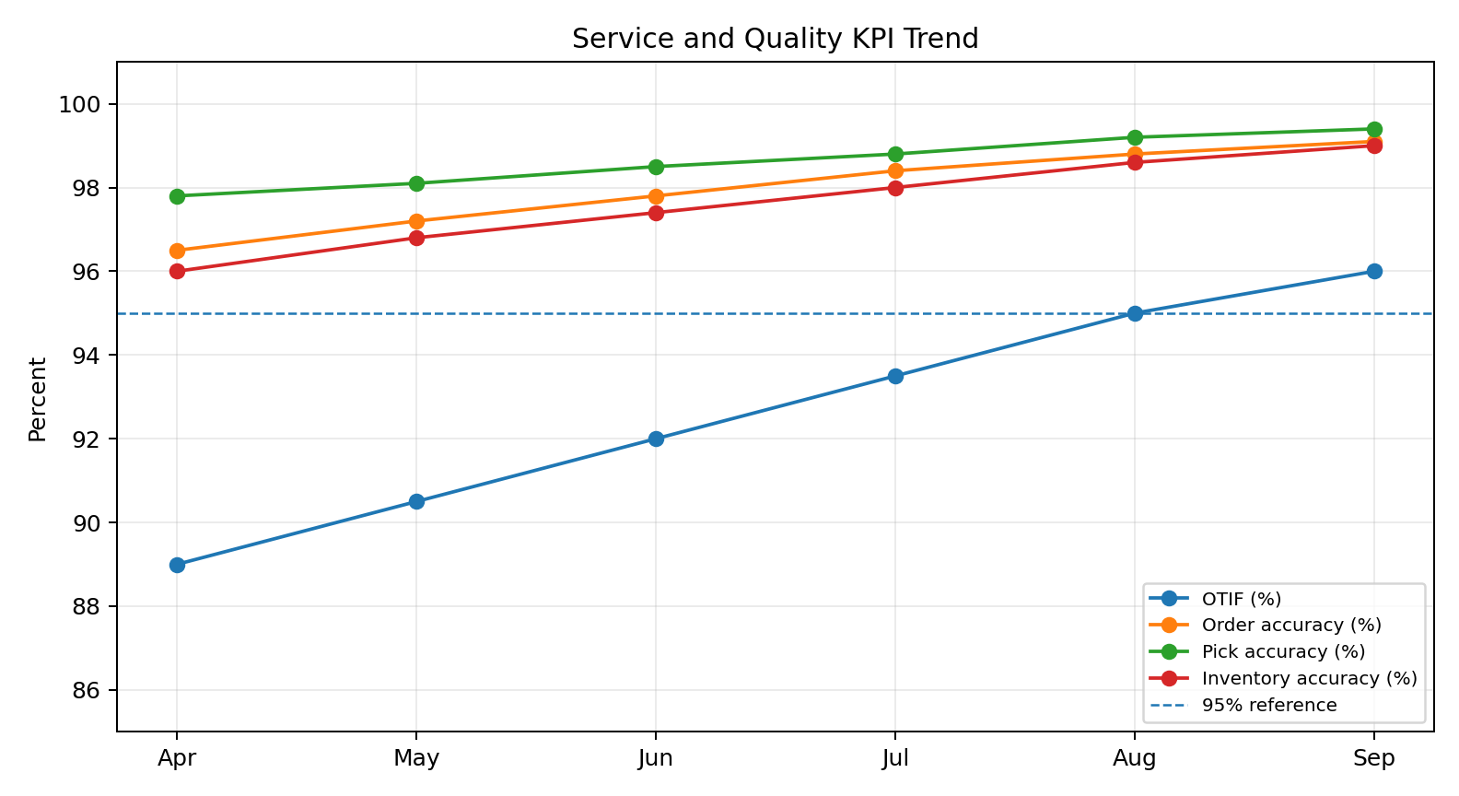
Figure 4. Service and quality KPI trend, Apr-Sep
OTIF rises by 7 percentage points, from 89% to 96%. For a volume of 1,000 orders per month, that represents approximately 70 additional orders meeting the OTIF definition each month. Order and pick accuracy also improve, reducing rework and customer complaints.

8.2 Efficiency and cost target attainment
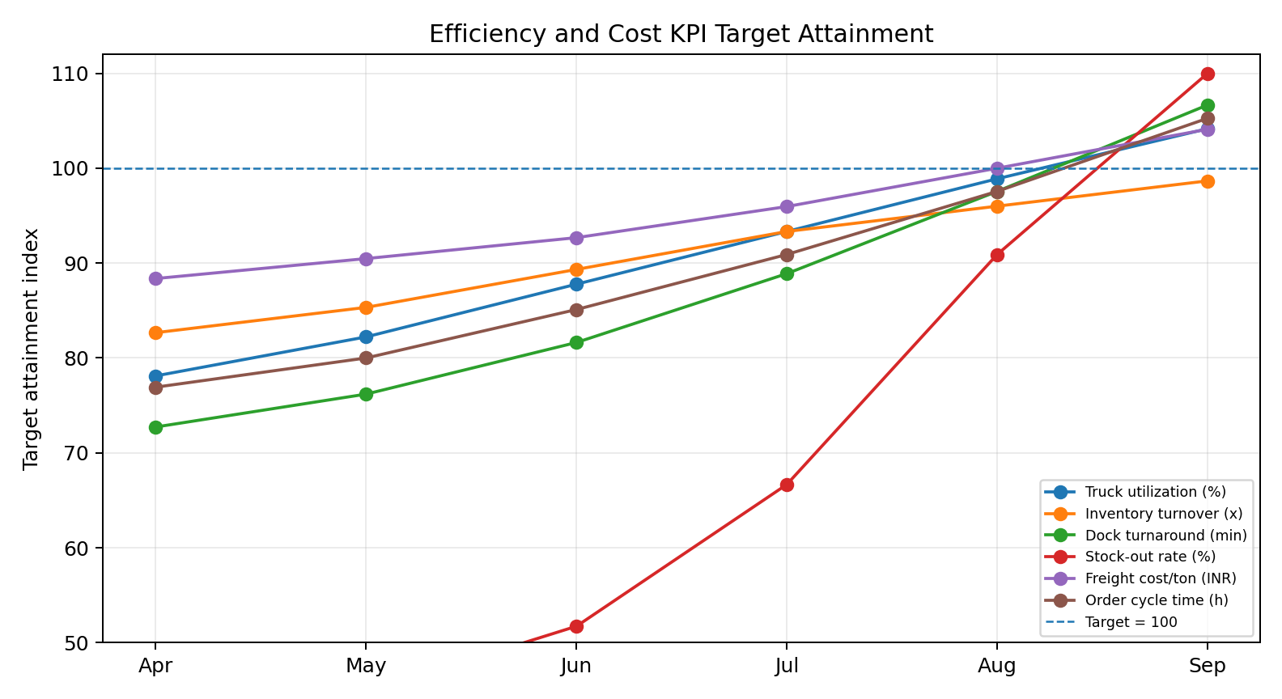
Figure 5. Efficiency and cost KPIs normalized to target attainment
The normalized chart makes different units comparable. A value of 100 means the KPI target has been reached. Truck utilization, dock turnaround, stock-out rate, freight cost and order cycle time all move materially toward target across the six periods.

8.3 Composite score
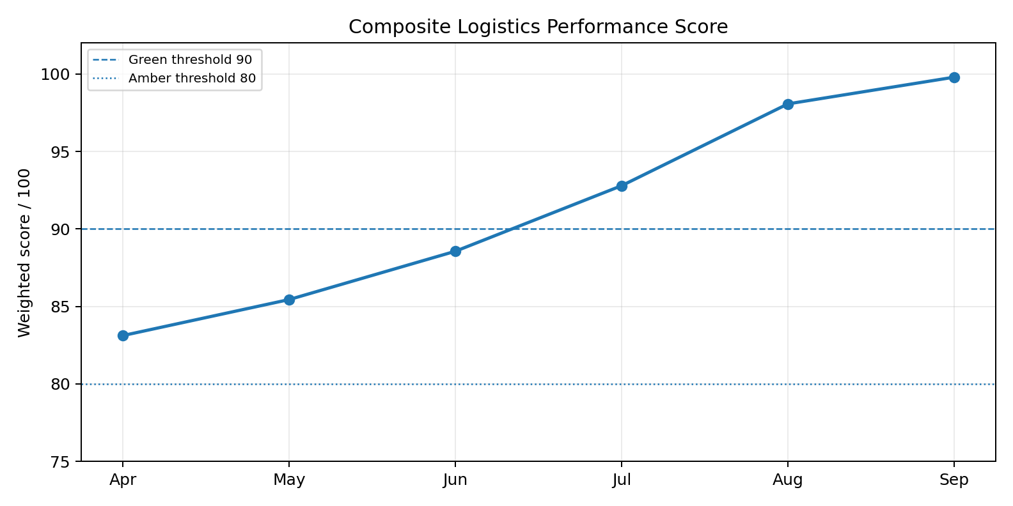
Figure 6. Weighted composite logistics performance score
The weighted score improves from 83.1 to 99.8. The April result is Amber: service and efficiency are improving but several metrics are still materially below target. By September most targets are achieved, although order accuracy, inventory turnover, pick accuracy and inventory accuracy remain slightly below their stretch targets and should continue to be monitored.

8.4 Exception distribution
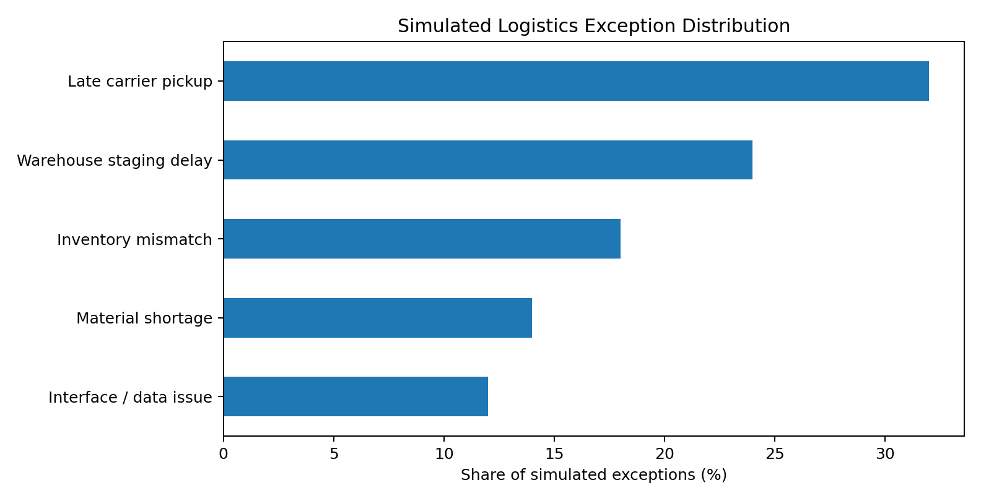
Figure 7. Simulated logistics exception distribution
Late carrier pickup and warehouse staging delay account for 56% of simulated logistics exceptions. This suggests that carrier appointment discipline and wave/staging synchronization should receive higher priority than broad, unfocused process changes.

9. Worked Examples and Business Impact

9.1 Freight-cost impact from transport efficiency
Freight cost per tonne improves from INR 2,150 to INR 1,825, a reduction of INR 325/tonne. At 150 tonnes/week, annualized volume is 150 x 52 = 7,800 tonnes. Illustrative annualized freight saving = INR 325 x 7,800 = INR 2,535,000, or about INR 25.35 lakh, if the improved rate is sustained for a full year.

9.2 Dock productivity impact
Average dock turnaround falls from 110 to 75 minutes, saving 35 minutes per truck visit. If the warehouse handles 18 truck visits per week, time released = 35 x 18 = 630 minutes = 10.5 dock-hours/week. This capacity can reduce queueing and protect planned departure times without adding physical dock doors.

9.3 Stock-out reduction
The simulated stock-out rate falls from 7.5% to 2.4%. On 1,000 order lines, stock-out affected lines reduce from 75 to 24, or 51 fewer affected lines per comparable period. This can reduce expedites, split deliveries and customer-service exceptions.

9.4 Weighted-score method
Each KPI is converted to a target-attainment score. Higher-is-better KPIs use Actual / Target; lower-is-better KPIs use Target / Actual. Scores are capped at 100 so over-performance in one area does not mask a serious shortfall elsewhere. The result is multiplied by the KPI weight and summed to produce the composite score.
Control principle: A composite score should never be used to hide a red customer-service or compliance KPI. Critical breaches remain separately visible and require action regardless of the total score.

10. SAP SCM Reporting Configuration Guidelines
The following configuration sequence shows how the KPI framework could be implemented in a typical SAP logistics landscape. Names and available analytical applications vary by release, so the design should be adapted to the organization's actual architecture.
1. Create a KPI dictionary with formula, unit, target, tolerance, owner and reporting frequency.
2. Identify source documents and events: ERP orders/deliveries, TM freight orders and execution events, EWM stock and warehouse tasks, and APO planning alerts.
3. Validate master-data keys such as product, location, carrier, warehouse number, route/mode and unit of measure so records can be joined consistently.
4. For SAP TM, enable or use operational reporting / analytical content appropriate to the system release; include freight-order execution, quantity/utilization and cost dimensions.
5. For SAP EWM, configure warehouse-monitor views, measurement services or BW content for warehouse tasks, stock, transportation units, warehouse orders and performance measurements.
6. For SAP APO, define Alert Monitor profiles for SNP/PPDS exceptions that affect service, shortage, capacity or plan adherence.
7. Use BW, ODP/CDS-based analytics or an enterprise analytics layer to consolidate cross-process measures where direct operational views are insufficient.
8. Create filters by month, product group, customer region, carrier, warehouse, route and exception type.
9. Apply refresh schedules: near-real-time for urgent execution exceptions, daily for operational KPIs and monthly for management scorecards.
10. Reconcile calculated KPI results with source transactions before publishing and retain evidence for material variances.

10.1 SAP tool-to-purpose mapping
SAP capability | Use in framework | Example output
SAP TM operational analytics | Transport execution, quantity, utilization and cost analysis | carrier on-time ratio, delayed freight orders, weight/volume and freight-cost views
SAP EWM Warehouse Monitor / Analytics | Warehouse process and stock monitoring | warehouse tasks, stock, transportation units, exception and KPI views
SAP APO Alert Monitor | Planning exception management | SNP/PPDS shortage, date, capacity or macro-dependent alerts
BW / ODP / CDS analytical layer | Historical consolidation and cross-process analysis | monthly KPI trends, scorecards, drilldown by product/location/carrier
SAP Analytics Cloud or equivalent dashboard | Management visualization when connected to governed data | executive KPI tiles, trends, variance and action tracking

11. Validation, Governance and Control Model

11.1 Validation test plan
ID | Test | Procedure | Pass criterion
V1 | OTIF sample reconciliation | Select 30 deliveries; compare requested and actual events plus delivered quantity | 100% formula agreement
V2 | Freight quantity reconciliation | Compare TM freight order weight with delivery/shipment weight | Variance <=1% or explained
V3 | Warehouse pick accuracy | Reconcile 50 warehouse-task confirmations to outbound items | No unexplained quantity mismatch
V4 | Inventory snapshot | Compare EWM stock snapshot to physical/cycle count sample | Accuracy >=99.5%
V5 | Cost completeness | Compare freight settlement totals to KPI dataset | 100% document population for completed period
V6 | Duplicate check | Search duplicate freight/order/warehouse records in extract | Zero duplicate business keys
V7 | Timestamp sequencing | Check order release < pick < load < departure < delivery | No impossible time sequence
V8 | Unit conversion | Verify kg/tonne and volume conversions | 100% approved conversion logic
V9 | Threshold logic | Test one Green, Amber and Red case | Correct status returned
V10 | Composite score | Recalculate weighted score independently | Difference <0.1 point

11.2 Governance matrix
Role | Accountability | Frequency | Evidence
Logistics performance owner | Own KPI dictionary, targets and monthly scorecard | Monthly | approved scorecard and action log
Transport planner | Validate TM events, utilization, carrier and freight-cost exceptions | Daily/weekly | exception list and carrier review
Warehouse supervisor | Validate task, pick, staging and dock KPIs | Daily/weekly | warehouse monitor extract and shift actions
Inventory controller | Review stock-out, inventory accuracy and turnover inputs | Weekly/monthly | stock reconciliation and count evidence
SAP support / data analyst | Maintain extraction logic, mappings and calculation version control | As changed | transport request/change log and test evidence
Business manager | Approve target changes and major corrective actions | Monthly/quarterly | management review minutes

12. Risk Analysis
Risk | Impact on KPI | Control / contingency | Owner
Missing execution event | False OTIF or cycle-time result | event completeness check; fallback to approved document timestamp; flag incomplete records | Transport planner
Incorrect unit conversion | Distorted vehicle utilization or cost/tonne | central conversion table; validation test V8 | Data analyst
Late postings | Month-to-month volatility and false trend | reporting cutoff rule; late-posting adjustment log | Performance owner
Duplicate records | Inflated order/transport counts | unique business key and duplicate validation | Data analyst
Target gaming | Local optimization harms service or cost balance | balanced KPI set; cap score at 100; retain red critical metrics | Business manager
Stale master data | Wrong carrier/location/product grouping | master-data owner review and exception list | SAP support
Interface failure | Incomplete cross-system scorecard | queue/interface monitoring; completeness threshold before publish | SAP support
Over-aggregation | Root cause hidden by monthly average | drilldown by carrier, route, warehouse, product and day | Performance owner

13. Recommendations and Improvement Roadmap
Recommendation | Rationale / action | Target outcome
1. Carrier appointment discipline | Address the largest exception category: late carrier pickup. Use carrier on-time performance and appointment adherence in weekly reviews. | Reduce transport-related exceptions by 20% within two months.
2. Wave-to-departure synchronization | Release picking waves backward from planned truck departure and protect staging capacity. | Keep average dock turnaround <=80 minutes.
3. Load-consolidation rule | Consolidate compatible freight only when the service window remains protected. | Maintain truck utilization >=90% without reducing OTIF below 95%.
4. Inventory exception segmentation | Prioritize stock-out analysis for high-value/high-variability items rather than applying the same buffer everywhere. | Stock-out rate <=3% and turnover >=7.5x.
5. Data-quality gate before scorecard | Do not publish the monthly scorecard until completeness, duplicate, unit and timestamp tests pass. | 100% validation evidence for published period.
6. Closed-loop action log | Every Amber/Red KPI gets an owner, root cause, due date and verification date. | >=90% of actions closed by due date.

13.1 90-day roadmap
Period | Priority | Deliverable
Days 1-30 | Stabilize data and definitions | approved KPI dictionary, validation rules, baseline dashboard
Days 31-60 | Attack top operational gaps | carrier and staging actions; load-consolidation and stock-out controls
Days 61-90 | Standardize and automate | scheduled reporting, owner action log, target review and lessons learned

14. Estimated 33-Hour Work Plan
Activity | Hours | Evidence / output
Research SAP logistics KPI/reporting concepts | 4.0 | Reference list and reporting capability notes
Define scenario, assumptions and KPI dictionary | 4.0 | 10-KPI framework with targets and weights
Create simulated performance dataset | 4.0 | 6-month dataset and formula checks
Build charts and scorecard analysis | 4.5 | trend charts, target-attainment view and composite score
Develop worked examples and business-impact analysis | 3.5 | freight, dock and stock-out calculations
Document SAP reporting/configuration guidelines | 4.0 | source mapping and 10-step configuration approach
Design validation, governance and risk controls | 3.5 | 10 tests, governance matrix and risk register
Develop recommendations and 90-day roadmap | 2.0 | prioritized action plan
Formatting, references and final QA | 3.5 | submission-ready DOCX and visual verification
Total estimated effort = 33.0 hours. This is an effort plan for the internship task, not a timesheet claim of actual production-system work.

15. Learning Outcomes and Conclusion

15.1 Learning outcomes
- I learned that KPI quality depends first on consistent definitions and reliable source events, not on dashboard appearance.
- I understood why service, cost, inventory and execution metrics must be reviewed together to avoid local optimization.
- I applied weighted scoring, threshold logic, target attainment, root-cause prioritization and validation controls to a practical logistics dataset.
- I connected SAP TM, EWM and APO monitoring concepts to a common reporting and governance workflow.
- I practiced converting operational gaps into measurable actions with owners and verification criteria.

15.2 Conclusion
The Week 5 framework demonstrates how logistics performance can be evaluated systematically using governed KPIs, simulated SAP-relevant data and closed-loop action management. The analysis shows that improvements in vehicle utilization, dock turnaround, stock availability and order service can be translated into measurable cost and service outcomes. The strongest design feature is not the composite score itself but the controlled process behind it: source mapping, formula governance, validation, threshold-based escalation and evidence-based follow-up.
For a real implementation, the same framework should be adapted to the organization's SAP release, data model, business calendar and target policy. The next maturity step would be automated refresh and drilldown dashboards backed by controlled source data and an auditable action log.

16. References
SAP Help Portal - SAP Transportation Management: Analytics (accessed 7 September 2026).
SAP Help Portal - Freight Order Execution Monitoring (accessed 7 September 2026).
SAP Help Portal - Freight Order Quantity Analysis (accessed 7 September 2026).
SAP Help Portal - SAP Extended Warehouse Management: Analytics (accessed 7 September 2026).
SAP Help Portal - APO Monitoring of Macro-Dependent Alerts (DP and SNP) (accessed 7 September 2026).
SAP Help Portal - APO Monitoring of PP/DS Alerts (accessed 7 September 2026).
SAP Help Portal - Transportation Order Execution Analytics (accessed 7 September 2026).
SAP Help Portal - SAP Analytics Cloud content for Transportation Management (accessed 7 September 2026).
Reference note: SAP capabilities vary by product version and deployment model. The report uses official SAP documentation to support the conceptual reporting approach and does not claim that every listed analytical feature is present in every SAP landscape.

17. Portal Submission Description
This Week 5 report presents a logistics performance measurement and evaluation framework using SAP SCM-related concepts across transportation, warehousing, inventory and planning. I continued the fictional Deccan Harvest Foods Pvt. Ltd. scenario and designed ten KPIs covering OTIF, order accuracy, inventory turnover, truck utilization, pick accuracy, dock turnaround, stock-out rate, freight cost per tonne, order cycle time and inventory accuracy. Each KPI includes a formula, target, weighting, data source, owner, review frequency and escalation rule. The report uses a six-month simulated dataset to demonstrate trend analysis, target comparison, threshold-based escalation and a weighted composite logistics score. Worked examples quantify the impact of freight-cost reduction, improved vehicle utilization, dock-turnaround improvement and lower stock-outs. The SAP reporting section explains how data from SAP TM, SAP EWM, ERP and SAP APO alerts can be combined through operational analytics, warehouse monitoring, BW/ODP/CDS-based reporting or an enterprise dashboard layer depending on the system landscape. The report also includes charts, source-to-KPI mapping, ten validation tests, a governance matrix, risk controls, exception analysis, a 90-day improvement roadmap and an estimated 33-hour work plan. Recommendations focus on carrier appointment discipline, wave-to-departure synchronization, load consolidation, inventory exception management and data-quality controls. All data and financial results are illustrative and are presented as an internship simulation rather than live SAP execution.

