WEEK 2 TASK
Master Data Management and
Inventory Optimization in SAP SCM
Project Plan • Data Mapping • SAP APO Master Data • Inventory Optimization • Risk & Monitoring

Prepared by | Hrudhai Prem Kumar Patwari
Project context | SAP SCM / SAP APO learning and internship project
Scenario | Deccan Harvest Foods Pvt. Ltd. (fictional)
Focus | Master data quality and inventory optimization
Date | 06 September 2026

Submission note: This report is a planning simulation and configuration blueprint. It demonstrates how I would structure master data, data quality controls, and inventory optimization in SAP SCM/APO; it does not claim execution in a live production SAP landscape.

Contents
1. Executive Summary and Scope | 3
2. Business Scenario and Assumptions | 4
3. Master Data Analysis | 5
4. Inventory Performance Parameters | 6
5. Project Plan and Governance | 7
6. Data Mapping Strategy | 8
7. Data Cleansing, Integration and Migration | 9
8. SAP SCM Master Data Configuration Guidelines | 10
9. Inventory Optimization Techniques | 11
10. Practical Simulation: Stock-out | 12
11. Practical Simulation: Excess Inventory | 13
12. Monitoring and Post-Implementation Evaluation | 14
13. Governance, Risks and Controls | 15
14. Validation Plan and Estimated Effort | 16
15. Conclusion and References | 17
Appendix A. Field Dictionary and Calculation Examples | 18
The report continues the Week 1 network scenario so that the master-data and inventory decisions remain connected to the same suppliers, plant, regional distribution centers, and markets. All quantities and results are illustrative for learning purposes.

1. Executive Summary and Scope
For Week 2, I continued the Deccan Harvest Foods supply-chain scenario from Week 1 and shifted the focus from network design to the quality of planning master data and the way inventory parameters influence replenishment decisions. My objective is to show how product, location, resource, sourcing, lead-time, stock and safety-stock data can be reviewed, mapped, cleansed and governed before they are used for SAP SCM/APO planning.
The project covers a controlled master-data lifecycle: source review, profiling, cleansing, mapping, integration/migration, SAP APO validation, inventory parameter setting, exception simulation and KPI monitoring. I use SAP APO/SNP concepts because master data such as locations, products, location-products, resources, production sources and transportation lanes directly shape supply-network planning results.

1.1 Deliverables covered
- Project plan for data-quality improvement and inventory optimization.
- Data mapping strategy from execution/source data to SAP APO planning objects.
- Master data configuration guidelines for products, locations, resources, sourcing and transportation.
- Inventory optimization methods covering safety stock, days of supply, lot size, EOQ and ABC-XYZ segmentation.
- Two practical simulations: a stock-out risk and an excess-inventory condition.
- Post-implementation monitoring framework with KPIs, governance roles and review cadence.
Key principle: Inventory optimization should not begin with formulas alone. If lead time, unit of measure, location assignment, product status or sourcing data is wrong, even a mathematically correct planning method can produce an unusable plan.

2. Business Scenario and Assumptions
Deccan Harvest Foods Pvt. Ltd. is a fictional packaged millet-based ready-to-cook food manufacturer. The Week 2 exercise uses the same single manufacturing plant and three regional distribution centers so that I can analyze inventory behavior at location-product level rather than redesign the network.
Planning object | Illustrative setup | Why it matters for Week 2
Finished product | DH-MIL-01 – Millet Upma Mix, 1 kg | Used as the main location-product for inventory simulation.
Plant | Hyderabad manufacturing plant | Creates finished-goods supply and is constrained by production capacity.
Distribution centers | Hyderabad, Vijayawada, Bengaluru | Hold regional stock and show different demand/lead-time profiles.
Primary raw-material supplier | Nizamabad supplier | Shorter lead time and main share of procurement.
Secondary supplier | Nagpur supplier | Backup source for resilience and quota-based sourcing.
Planning horizon | 12 weeks, weekly buckets | Long enough to observe demand variation and replenishment effects.
Baseline finished-goods demand | 145 tonnes/week across the three DCs | Maintains continuity with the Week 1 network capacity example.

2.1 Assumptions used
- Demand values, costs, stock levels and service levels are sample values created for the internship exercise.
- The report assumes SAP ECC or a comparable execution source supplies core master data to SAP APO through controlled integration.
- CIF is treated as the SAP APO integration mechanism for master and transaction data; the report documents the sequence conceptually rather than claiming a live interface run.
- Inventory targets are differentiated by location instead of using one blanket safety-stock value for all DCs.

3. Master Data Analysis
SAP APO planning depends on a connected set of master-data objects. I reviewed the objects that have the greatest effect on inventory and grouped them by the planning decision they influence.
Master-data object | Key attributes reviewed | Inventory impact
Product | Product ID, description, base UoM, product hierarchy, status, lot-size settings | Incorrect UoM or lot size can create over-ordering, under-ordering or impossible quantities.
Location | Location type, address, calendar, time zone, handling/receiving constraints | Defines where stock is held and whether receipts can be planned on valid dates.
Location-product | Safety stock method, service level, lot size, procurement settings, horizons | Main object for differentiated inventory policy by product and location.
Resource | Capacity, calendar, utilization and availability | Limits how quickly inventory can be replenished from production.
Production source / PDS or PPM | Input/output quantities, duration, resource usage | Determines feasible production receipts and lead time.
Transportation lane | Source, destination, product assignment, transit time, means of transport | Directly affects replenishment lead time and pipeline stock.
Source of supply / quota | Eligible suppliers, priorities, quota shares | Balances cost, resilience and supplier dependency.
Calendars | Working days, holidays, shipping/receiving days | Prevents false availability and unrealistic lead-time calculations.

3.1 Data-quality dimensions
Dimension | Example check | Target
Completeness | Required location-product planning fields populated | ≥ 98%
Validity | Lead times > 0; service level within allowed range; valid UoM | 100% critical fields valid
Uniqueness | No duplicate product-location or source records | 0 duplicates
Consistency | Same base UoM and location code across source and target | 100% mapped objects
Timeliness | Recent lead-time and demand-history refresh | Per weekly/monthly governance calendar
Referential integrity | Every lane points to valid source/destination and product | 100%

4. Inventory Performance Parameters
I separated the parameters into demand, supply, policy and cost drivers. This makes it easier to understand why inventory rises or falls instead of treating stock as one isolated number.
Parameter | How it affects inventory | Illustrative control
Average demand | Higher demand increases cycle stock and replenishment frequency. | Use rolling demand and forecast-error review.
Demand variability | More uncertainty normally requires a larger buffer for the same service level. | Track MAD / standard deviation by location-product.
Replenishment lead time | Longer lead time increases exposure before the next receipt arrives. | Maintain realistic procurement and transport lead times.
Lead-time variability | Unreliable suppliers/transport increase stock-out risk. | Measure actual vs planned lead time.
Safety stock / safety days | Protects against uncertainty but adds carrying cost. | Differentiate by service criticality and variability.
Lot size / EOQ | Large lots reduce ordering frequency but can create excess stock. | Balance ordering/setup cost and holding cost.
Minimum / maximum stock | Provides practical inventory boundaries for exceptions. | Set alert thresholds and planner review.
Service level | Higher service target usually requires more buffer inventory. | Use higher target for A-items than low-priority C-items.
Shelf life | Limits how much stock can be safely held. | Avoid bulk replenishment beyond realistic consumption.
Supplier reliability | Low reliability increases contingency requirement. | Use secondary source and supplier scorecard.

4.1 Segmentation approach
I would combine ABC classification (value/importance) with XYZ classification (demand variability). An AX item receives tight monitoring and a high service target because it is important and predictable; a CZ item receives a more conservative policy because its low importance and erratic demand can make high buffers expensive.

5. Project Plan and Governance
The project plan is designed as a repeatable data-quality cycle rather than a one-time cleanup. Each phase has an output that can be checked before the next phase begins.
Phase | Main activities | Output / acceptance point
1. Scope & baseline | Confirm products, locations, owners, current inventory KPIs and data sources. | Approved scope and baseline inventory snapshot.
2. Data extract & profile | Extract product/location/source data; identify blanks, duplicates, invalid values and outliers. | Data-quality issue log.
3. Cleanse & standardize | Correct codes, UoM, dates, descriptions, lead times and ownership with business sign-off. | Cleansed staging dataset.
4. Map & transform | Define source-to-target field mappings, value conversions and default rules. | Approved mapping workbook.
5. Integrate / migrate | Use controlled CIF/integration-model or staging sequence; separate master and transaction data. | Transferred objects and integration log.
6. Validate in APO | Check products, locations, location-products, resources, lanes and sources. | Reconciliation sign-off.
7. Optimize inventory | Set classification, safety stock, days of supply, lot-size and exception parameters. | Proposed inventory policy by segment.
8. Simulate exceptions | Run stock-out and excess-stock scenarios and document response. | Scenario results and corrective actions.
9. Monitor & govern | Track service, stock, lead-time and data-quality KPIs; review parameter changes. | Ongoing KPI dashboard and governance cadence.

5.1 Roles
Role | Responsibility
Master Data Owner | Approves product/location standards and field ownership.
Supply Planner | Owns safety stock, lot size, exception review and replenishment parameters.
Procurement | Confirms supplier lead time, source validity, MOQ and quota assumptions.
Warehouse / Logistics | Confirms receiving calendar, stock accuracy and transport lead time.
IT / SAP Support | Controls integration, master-data transfer, logs and access.
Business Approver | Signs off material changes that affect cost or service.

6. Data Mapping Strategy
The mapping strategy connects source-system records to SAP APO planning objects. I would keep the source system as the system of record for core execution master data and use APO-specific planning attributes only where they are needed for planning.
Source/business field | Target SAP APO object | Transformation / validation rule
Material number | Product master (/SAPAPO/MAT1) | Preserve unique ID; reject duplicates and obsolete records.
Material description | Product description | Standard naming; remove uncontrolled abbreviations.
Base unit of measure | Product base UoM | Validate conversion factors before transfer.
Plant / DC / Vendor / Customer | Location master (/SAPAPO/LOC3) | Map to correct location type and confirm address/calendar.
Plant-material combination | Location-product | Create only for valid planning combinations.
Work center / capacity | Resource (/SAPAPO/RES01) | Validate calendar, capacity and unit of capacity.
Purchasing source / supplier relationship | External source of supply | Check validity period, source location and procurement lead time.
BOM + routing / recipe | PDS or PPM planning source | Confirm component quantity, production duration and resource assignment.
Source-destination route | Transportation lane (/SAPAPO/SCC_TL1) | Validate transit time, product assignment and means of transport.
Stock / open orders / requirements | Transaction data for planning | Transfer only after required master data is valid and active.

6.1 Mapping controls
- Maintain a source-to-target field dictionary with owner, datatype, mandatory flag and transformation rule.
- Do not silently default critical fields such as base UoM, lead time or location type; route them to an exception queue.
- Reconcile object counts before and after transfer and sample-check high-value A-items.
- Version-control mapping changes so inventory shifts can be traced back to parameter changes.

7. Data Cleansing, Integration and Migration
The cleansing sequence is designed to prevent bad data from entering the planning model. I would profile first, correct in staging or the source system with owner approval, and only then activate the transfer.

7.1 Example cleansing rules
Issue | Rule | Action
Duplicate product-location | Same product + location appears more than once | Retain approved active record; merge dependent attributes.
UoM mismatch | Source says KG while planning record uses EA without conversion | Block transfer until conversion is approved.
Zero/negative lead time | Procurement or transport lead time ≤ 0 | Flag as critical; confirm with procurement/logistics.
Obsolete product still active | Discontinued material included in planning scope | Exclude or set valid end date based on business sign-off.
Missing location calendar | No valid receiving/shipping calendar | Assign approved calendar before planning.
Extreme safety stock | Buffer far above historical demand without rationale | Review service level, variability and policy owner.

7.2 Integration sequence
SAP documentation describes CIF as the interface that supplies APO with relevant master and transaction data from ERP. For a controlled migration, I would generate an integration model in ECC (for example using CFM1), validate the object selection, activate it (CFM2), monitor transfer queues/logs and reconcile the resulting APO objects. Master-data and transaction-data integration models should be separated for manageability and performance.
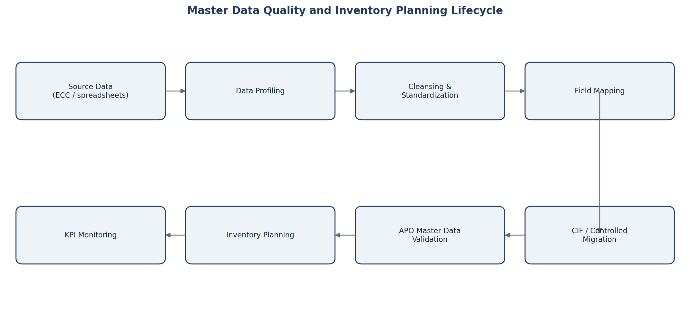
Figure 1. Master data quality and inventory planning lifecycle

8. SAP SCM Master Data Configuration Guidelines
The steps below are written as configuration/validation guidelines for the internship scenario. The actual path and fields used in a live system depend on the SAP SCM release, business design and system authorization.
Step | Guideline | Inventory relevance
1 | Validate product master in /SAPAPO/MAT1: base UoM, planning status, lot-size and location-dependent settings. | Wrong UoM or lot size distorts planned receipts and stock.
2 | Validate locations in /SAPAPO/LOC3: type, address, time zone and calendars. | Determines where stock exists and valid receiving/shipping dates.
3 | Review location-product parameters: safety-stock method/value, safety days, service target and procurement settings. | Defines the buffer and replenishment behavior at each DC.
4 | Validate resources in /SAPAPO/RES01: capacity and calendars. | Capacity constraints can delay replenishment and increase shortage risk.
5 | Confirm production sources (PDS/PPM) and procurement relationships. | Ensures APO has a valid way to create supply.
6 | Maintain transportation lanes in /SAPAPO/SCC_TL1 with source, destination, product and transit time. | Transit time is a key inventory and pipeline-stock driver.
7 | Review quota arrangement/source priority where dual sourcing is used. | Reduces dependency and supports contingency sourcing.
8 | Assign objects to the correct model/planning version and check selection scope. | Prevents planning with incomplete or wrong network objects.
9 | Load/release demand and confirm stock/open orders are visible only after master data reconciliation. | Avoids transaction data being planned against invalid master data.
10 | Run planning and review alerts/exceptions for shortages, excess, overload and missing sources. | Provides feedback for parameter tuning.
Control point: I would require a reconciliation sign-off before changing safety stock. If the stock on hand, lead time or demand history is wrong, changing the buffer merely hides the data problem.

9. Inventory Optimization Techniques
Inventory optimization in this project uses a combination of SAP APO safety-stock concepts and general inventory-management calculations. The purpose is not to force one method on every product, but to select a policy that matches demand variability, importance, lead time and cost.
Technique | Use in the project | Decision rule / note
Safety stock | Protect against demand and replenishment uncertainty. | Higher variability or service target requires more buffer.
Safety days of supply | Express buffer in time rather than fixed quantity. | Useful when demand level changes by season.
Dynamic safety stock | Allow the buffer to change over time. | Prefer for seasonal demand rather than one static value.
EOQ | Balance order/setup frequency with average cycle stock. | EOQ = √(2DS/H) as an illustrative analytical check.
Reorder point | Trigger review when stock position approaches expected lead-time demand plus buffer. | ROP ≈ demand during lead time + safety stock.
Lot-size review | Avoid MOQ/lot values that force excess stock. | Compare lot quantity with weeks of demand and shelf life.
ABC-XYZ segmentation | Differentiate service targets and planner attention. | AX gets tighter service/monitoring than CZ.
Redeployment | Move available stock between DCs before buying/producing more. | Use when one DC is excess and another is at shortage risk.
Dual sourcing | Reduce disruption exposure. | Primary source for cost/lead time, backup source for resilience.
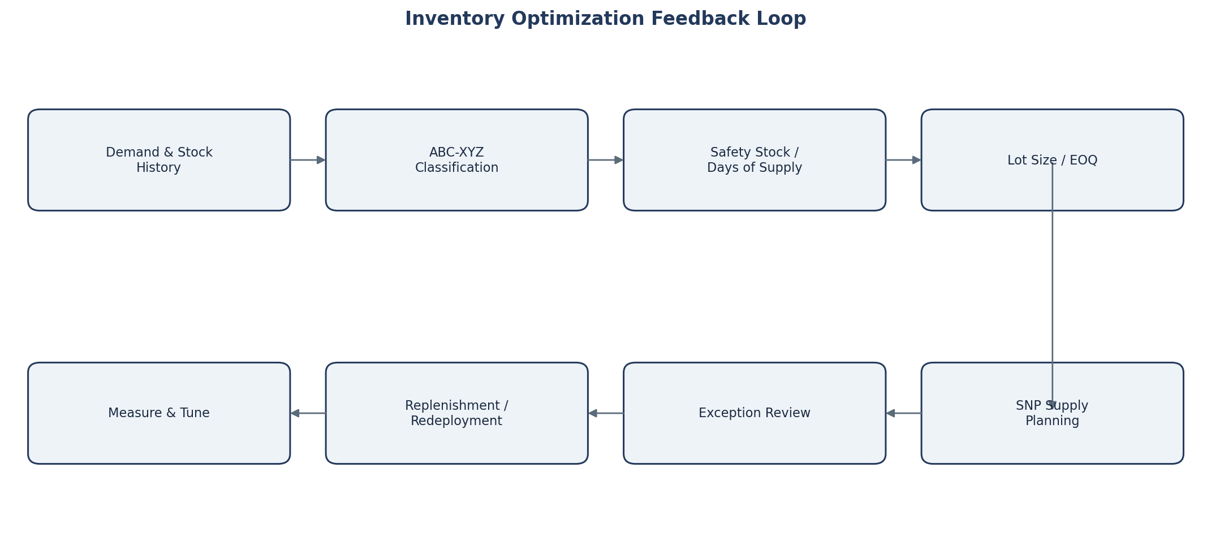
Figure 2. Inventory optimization feedback loop

10. Practical Simulation: Stock-out Risk
I simulated a short-term stock-out risk at the Hyderabad DC for DH-MIL-01. The intention is to show how master-data accuracy and inventory parameters affect the response, not to claim an executed live planning run.
Input | Illustrative value
Opening available stock | 12 tonnes
Expected 7-day demand | 18 tonnes
Confirmed inbound receipt | 10 tonnes, planned on Day 5
Unexpected transport delay | 3 additional days
Current safety stock | 3 tonnes
Target service objective | High service for an A-class finished product

10.1 Problem diagnosis
- Lead-time master data is understated if the lane repeatedly takes longer than the planned value.
- A 3-tonne buffer is not enough to absorb the combined demand and transport delay in this example.
- If another DC holds excess stock, a network-level response is better than simply increasing every location’s safety stock.

10.2 Proposed response
Priority | Action | Reason
Immediate | Check ATP/stock position and confirm the revised inbound date. | Avoid planning against an outdated receipt.
Immediate | Evaluate redeployment from Bengaluru/Vijayawada if their projected cover remains above target. | Uses existing network stock before creating new supply.
Short term | Use secondary source or expedited transport for the constrained quantity if commercially justified. | Protects service for a critical item.
Master data | Correct transportation lead time if actual performance consistently differs from master data. | Stops the same shortage from recurring in every plan.
Policy | Recalculate safety stock/safety days using demand and lead-time variability. | Aligns the buffer with the observed uncertainty.
Governance | Track supplier/carrier on-time performance and require owner sign-off for lead-time changes. | Maintains the parameter over time.
Illustrative outcome: If 5 tonnes can be redeployed and the delayed 10-tonne receipt is confirmed, the immediate shortage can be reduced without permanently raising stock at every location. The long-term fix is to correct the lead-time assumption and then retune the safety buffer.

11. Practical Simulation: Excess Inventory
The second simulation creates the opposite problem: excessive stock at the Vijayawada DC after a forecast slowdown. The location has enough inventory to cover several weeks, while another DC is closer to its target buffer.
Input | Illustrative value
Opening stock at Vijayawada | 32 tonnes
Expected weekly demand | 7 tonnes/week
Current coverage | ≈ 4.6 weeks
Desired normal coverage | ≈ 2.0 weeks before safety-stock review
Next planned replenishment | 10 tonnes in Week 2
Shelf-life consideration | Finished food product; avoid unnecessary aging stock

11.1 Root causes to test
- Forecast may have decreased after a replenishment lot was already created.
- Lot size or minimum order quantity may be too large for the current demand rate.
- Safety stock may be based on an old service/variability assumption.
- A duplicate or incorrect location-product record could cause double planning.
- Planned receipts may not have been re-evaluated after demand changed.

11.2 Proposed correction
Action | Inventory effect
Freeze or reduce non-firm future replenishment where business rules allow. | Stops additional excess from arriving.
Redeploy 8–10 tonnes to a DC with higher projected demand/shortage risk. | Improves network balance without new production.
Review lot size / MOQ with procurement and production. | Reduces future cycle-stock peaks.
Recalculate safety days based on current demand variability. | Avoids holding a stale buffer.
Add excess-coverage alert (for example > target + tolerance). | Creates earlier planner visibility.
Monitor aging / shelf-life risk separately from quantity coverage. | Protects against write-off and waste.
Illustrative outcome: Redeploying 9 tonnes reduces Vijayawada stock from 32 to 23 tonnes, lowering coverage from about 4.6 to 3.3 weeks before the next planning cycle. Further reduction should come from cancelling or resizing future receipts, not from forcing an immediate transfer that creates unnecessary transport cost.

12. Monitoring and Post-Implementation Evaluation
Post-implementation monitoring checks whether better master data actually improves business outcomes. I would monitor both inventory KPIs and data-quality KPIs because a good service result can temporarily hide poor data, and clean data can still be paired with a poor inventory policy.
KPI | Purpose | Illustrative target / trigger | Review cadence
Fill rate / service level | Measures ability to satisfy demand. | ≥ 96% for A-items; segment-specific target | Weekly
Stock-out frequency | Counts shortage events. | Downward trend; investigate every A-item event | Weekly
Inventory coverage | Shows weeks/days of stock. | Within target band by segment | Weekly
Excess inventory value | Identifies working capital tied up above policy. | Reduce month-on-month | Monthly
Forecast error | Explains demand-driven buffer needs. | Track by ABC-XYZ class | Monthly
Supplier/transport lead-time variance | Tests master-data accuracy. | Actual vs planned within tolerance | Monthly
Master-data completeness | Checks mandatory fields. | ≥ 98% overall; 100% critical fields | Weekly during rollout
Duplicate rate | Detects repeated planning objects. | 0 critical duplicates | Weekly
CIF/integration exceptions | Detects transfer failures. | No unresolved critical queue errors | Daily during migration

12.1 Review method
- Compare baseline vs post-change values using the same product/location scope.
- Investigate sudden inventory reduction to ensure service has not been damaged.
- Require documented reason and approver for major lead-time, service-level or safety-stock changes.
- Review the top 10 excess and top 10 shortage-risk items first; then expand to the full portfolio.
- Keep a parameter-change log so planners can connect a KPI movement to the configuration change that caused it.

13. Governance, Risks and Controls
Risk | Impact | Control / contingency
Incorrect UoM conversion | Severe over/under planning | Block transfer; dual validation for conversion factors.
Outdated lead time | Repeated stock-outs or excess buffer | Monthly actual-vs-master lead-time review.
Duplicate location-product | Double requirements / distorted plan | Uniqueness check before migration.
Unauthorized parameter change | Inventory policy drift | Role-based access and change log.
CIF queue/integration failure | Missing or stale planning data | Queue monitoring, reconciliation and restart procedure.
Forecast shock | Shortage despite clean master data | Exception alerts, backup source, redeployment.
MOQ too large | Excess inventory / aging | Supplier negotiation and lot-size review.
Over-aggressive stock reduction | Service deterioration | Pilot by segment and monitor fill rate.
No data owner | Issues remain unresolved | Assign owner for each data domain and SLA for fixes.

13.1 Change-control rule
For critical planning fields, I would use a simple four-step control: request → impact review → business approval → implementation and reconciliation. This is especially important for lead time, base UoM, safety stock, service level, lot size and source priority because these fields can change inventory immediately.
Governance principle: A master-data project is complete only when ownership and monitoring are defined. Cleaning the data once without a control process simply postpones the next inventory problem.

14. Validation Plan and Estimated Effort

14.1 Proposed validation tests
Test | Procedure | Expected result
Product-location completeness | Compare scope list with APO location-product records. | Every in-scope product/DC combination exists once.
UoM consistency | Sample source base UoM and APO product UoM. | No unexplained conversion mismatch.
Lead-time reasonableness | Compare planned lane lead time with recent actuals. | Within agreed tolerance or exception documented.
Safety-stock behavior | Increase/decrease variability in simulation. | Buffer changes in the expected direction.
Stock-out scenario | Delay an inbound receipt in the scenario dataset. | Planner detects shortage and evaluates redeployment/expedite.
Excess scenario | Reduce forecast after large receipt. | Planner suppresses/reduces future receipts and flags excess.
Integration reconciliation | Compare source object counts and target APO objects. | No unexplained missing/duplicate objects.
Planning-source validity | Check every planned product has a valid supply source. | No source-missing exception for approved scope.

14.2 Estimated 30–35 hour work plan
Activity | Hours
Research SAP APO master data, CIF and inventory concepts | 4
Scenario baseline and data-field inventory | 3
Data profiling and cleansing-rule design | 5
Mapping strategy and migration plan | 4
SAP SCM configuration guideline documentation | 5
Inventory optimization calculations and segmentation | 4
Stock-out and excess-stock simulations | 3
KPI, risk, governance and validation sections | 3
Report formatting, diagrams and final review | 2
Total estimated effort | 33
This is an estimated effort plan for the assignment. It is included to show how I would allocate the 30–35 hours indicated in the task brief, not as a claim of system execution time.

15. Conclusion and References
This Week 2 exercise showed me that inventory optimization is strongly dependent on master-data quality. A planner can choose a sophisticated safety-stock or replenishment method, but the result will still be poor if product/location relationships, units of measure, lead times, calendars, sources or stock data are inconsistent.
For the Deccan Harvest Foods scenario, I would first establish data ownership and reconciliation, then validate the SAP APO master-data objects, and only after that tune safety stock, safety days, lot sizes and sourcing parameters. The two simulations also show why a network response is important: a shortage at one DC and excess at another should be assessed together before increasing total inventory.
My main learning from the task is that master data management and inventory optimization should operate as one feedback loop. Data quality determines whether the plan is trustworthy, while KPI results reveal which master data or planning parameters need to be corrected next.

References used
SAP Help Portal – Supply Network Planning Process – SAP Help (accessed 06 September 2026)
SAP Help Portal – Integration via Core Interface (CIF) – SAP Help (accessed 06 September 2026)
SAP Help Portal – Integration of Master Data – SAP Help (accessed 06 September 2026)
SAP Help Portal – Safety Stock Planning – SAP Help (accessed 06 September 2026)
SAP Help Portal – Core Interface Integration Model – SAP Help (accessed 06 September 2026)
SAP Help Portal – List of Master Data Related Transactions – SAP Help (accessed 06 September 2026)

Appendix A. Field Dictionary and Calculation Examples

A.1 Example field dictionary
Field | Owner | Mandatory | Validation example
Product ID | Master Data | Yes | Unique and active in planning scope.
Base UoM | Master Data / Finance | Yes | Valid unit and approved conversion.
Location ID / type | Logistics | Yes | Correct plant/DC/vendor/customer type.
Procurement lead time | Procurement | Yes | > 0 and within historical tolerance.
Transport lead time | Logistics | Yes | Matches carrier performance baseline.
Safety stock method | Supply Planning | Yes for stocked items | Approved method by product segment.
Safety stock / days | Supply Planning | Conditional | Within policy band; exception reason captured.
Lot size / MOQ | Procurement / Production | Conditional | Does not create unacceptable excess coverage.
Service level | Business / Supply Planning | Yes for segmented policy | Mapped to ABC-XYZ class.
Planner code | Supply Planning | Yes | Active owner assigned.

A.2 Illustrative calculations
EOQ analytical check: EOQ = √(2DS/H), where D is annual demand, S is ordering/setup cost per order and H is annual holding cost per unit. In this internship report I use EOQ only as a reasonableness check for lot-size decisions; the actual SAP planning design can use system-specific lot-sizing and safety-stock methods.
Reorder point analytical check: ROP ≈ average demand during replenishment lead time + safety stock. This is useful for explaining the relationship between lead time and shortage risk even when the operational planning process is executed through SAP APO.
Coverage: inventory coverage = available stock ÷ average demand per period. In the excess-stock example, 32 tonnes ÷ 7 tonnes/week ≈ 4.6 weeks of coverage. This makes the excess visible in a way that is easy to compare across locations.
Final note: All field names, formulas, values and scenario results in this appendix are used for learning and documentation. A production implementation would validate each rule against the organization’s SAP release, customizing, data model and business policy.

