WEEK 3 INTERNSHIP PROJECT
Production Planning and Scheduling
Integration with SAP SCM
SAP SCM / SAP APO PP/DS Planning Framework
Prepared by | Hrudhai Prem Kumar Patwari
Task | Week 3 - Production Planning and Scheduling Integration
Scenario | Deccan Harvest Foods Pvt. Ltd. (fictional)
Project type | Internship planning simulation / configuration blueprint
Date | September 2026

This report explains how production demand, master data, capacity, sequencing, detailed scheduling, and ERP integration can be combined into a practical SAP SCM planning approach. All quantities and results are illustrative and do not represent live production-system execution.

Contents
1. Executive Summary
2. Introduction and Objective
3. Scenario Creation and Business Assumptions
4. SAP SCM Production Planning Functionalities
5. Master Data and Configuration Guidelines
6. Methodology: Demand to Production Schedule
7. Scheduling Protocols and Sample Production Plan
8. ERP - SAP SCM Integration Framework
9. Scenario-Based Bottleneck Analysis
10. KPI Framework and Monitoring
11. Validation and Testing Approach
12. Risks, Controls and Contingency Actions
13. Estimated 30-35 Hour Work Plan
14. Key Learning Outcomes
15. Conclusion
16. References
17. Portal Submission Description
The document is intentionally structured as a planning and configuration blueprint. Where transaction codes are mentioned, they are illustrative examples commonly used in SAP ERP/APO environments and may vary by system release or organization configuration.

1. Executive Summary
This Week 3 project develops a production planning and scheduling framework for Deccan Harvest Foods Pvt. Ltd., the fictional food-manufacturing scenario used in the earlier weeks. I focused on converting demand into a realistic production schedule while considering finite machine capacity, raw-material availability, changeovers, packaging constraints, inventory buffers, and delivery requirements.
The proposed design uses SAP SCM / SAP APO concepts, especially Supply Network Planning (SNP) for medium-term supply balancing and Production Planning and Detailed Scheduling (PP/DS) for short-term finite-capacity planning. ERP production master data such as material masters, BOMs, routings, work centers, and production versions are conceptually synchronized with SAP SCM through the Core Interface (CIF).
A key learning from the exercise is that production scheduling is not only about creating planned orders. The quality of runtime, lot-size, calendar, resource, routing, and lead-time data directly affects the feasibility of the plan. The scenario therefore includes a peak-demand week, packaging-line capacity pressure, changeover sequencing, and a short equipment breakdown to demonstrate how planners can identify bottlenecks and reschedule production.

Project deliverables included
- Realistic production planning scenario linked to demand and supply-chain constraints.
- SAP SCM/APO functionality map for demand, supply, PP/DS, and execution integration.
- Master-data and configuration guidelines for products, locations, resources, PDS, routing, and scheduling parameters.
- Step-by-step methodology from forecast release to finite-capacity schedule.
- Conceptual ERP-SCM integration flow using CIF.
- Sample weekly production schedule and capacity-utilization calculations.
- Bottleneck, risk, KPI, validation, and contingency analysis.

2. Introduction and Objective
Production planning connects market demand with actual manufacturing capability. A supply plan can look acceptable at aggregate level but still fail during execution if a packaging machine is overloaded, a raw material is late, a changeover is ignored, or a routing duration is incorrect. For this reason, Week 3 moves from network and inventory planning into detailed production planning and scheduling.

2.1 Objective
The objective of this project is to build a practical framework that aligns production with supply-chain demand using SAP SCM concepts. I use demand inputs, finite capacity, master data, scheduling rules, ERP integration, and exception management to create a schedule that can be explained and evaluated.

2.2 Scope
- Forecast / demand input and release to supply planning.
- Medium-term planning with SNP concepts and short-term detailed scheduling with PP/DS concepts.
- Product, location, resource, BOM/routing/PDS, calendar, and lot-size master data.
- Finite capacity, sequence-dependent changeovers, pegging, and production priorities.
- ERP and SCM synchronization through CIF integration concepts.
- Bottleneck evaluation, KPI monitoring, and rescheduling actions.

2.3 Out of Scope
The exercise does not claim configuration in a live SAP production system, creation of real purchase/production orders, or use of actual company data. It is a structured internship simulation based on standard SAP SCM/APO planning concepts.

3. Scenario Creation and Business Assumptions
I continued with Deccan Harvest Foods Pvt. Ltd. so the Week 3 production plan remains connected to the Week 1 network and Week 2 master-data exercise. The Hyderabad plant produces three packaged millet-based products for distribution through Hyderabad, Vijayawada, and Bengaluru regional DCs.

3.1 Products and Demand
SKU | Description | Normal weekly demand | Peak-week demand | Assumption
MUM500 | Millet Upma Mix 500 g | 48 t | 55.2 t | 15% uplift
RDM500 | Ragi Dosa Mix 500 g | 42 t | 48.3 t | 15% uplift
JIM500 | Jowar Idli Mix 500 g | 35 t | 35.0 t | Normal
Total |  | 125 t | 138.5 t | Peak week

The peak-week demand of 138.5 tonnes is intentionally close to the packaging resource limit so that the scheduling exercise has a real capacity trade-off. I assumed demand is firm enough to be used for planning but still requires sequencing and capacity review before release to execution.

3.2 Resource and Supply Constraints
Constraint | Nominal availability | Planning assumption | Risk
Mixing line | 160 t/week | Shared across all SKUs | Moderate
Packaging line | 145 t/week | Single main constraint; product changeovers | High
Quality hold / cleaning | 6 h/week | Reduces available runtime | Medium
Planned maintenance | 4 h/week | Weekend preventive maintenance | Medium
Raw millet supply | 150 t/week | Adequate but limited buffer | Medium
Packaging material | 5-day replenishment lead time | Supplier delay can stop output | High

At 138.5 t of demand against 145 t of packaging capacity, theoretical utilization is approximately 95.5%. This leaves only about 6.5 t of nominal headroom before considering downtime, changeovers, or quality losses, making packaging the main bottleneck for the scenario.

4. SAP SCM Production Planning Functionalities
The framework uses multiple SAP SCM/APO planning capabilities rather than treating production scheduling as a single function. The following roles show how the components fit together conceptually.
Functionality | Role in this Week 3 design
Demand Planning / demand input | Creates or receives forecast requirements and demand signals.
SNP | Balances medium-term demand, supply, production, procurement, and distribution at an aggregate level.
PP/DS | Performs short-term product planning and detailed finite-capacity scheduling.
Global ATP / pegging concepts | Supports requirement-to-receipt relationships and availability visibility where configured.
CIF | Synchronizes relevant master and transaction data between ERP and SAP SCM/APO.
Alert / exception monitoring | Highlights shortages, overloads, delays, and planning inconsistencies.

4.1 Why PP/DS is Important
SNP can produce a valid supply plan at weekly level, but a plant still needs an executable sequence. PP/DS adds detailed order timing, resource capacity, scheduling relationships, and order sequencing. This is especially useful when the same packaging line is shared across products and frequent changeovers reduce effective output.

4.2 Planning Horizons
Planning level | Illustrative horizon | Primary decision
Strategic / network | Beyond 12 weeks | Network and capacity assumptions
Tactical / SNP | 3-12 weeks | Supply-demand balance, production quantities
Operational / PP/DS | 0-14 days | Finite schedule, sequence, start/finish times
Execution / ERP | Current shift / day | Release, confirmation, goods movement

5. Master Data and Configuration Guidelines
I treated master data as the foundation of the schedule. If a routing time is too short, PP/DS may show a plan as feasible even though the shop floor cannot execute it. The following objects therefore require validation before planning.
Master-data object | System representation | Week 3 fields to validate
Material / Product | ERP material master; APO product | Base UoM, MRP parameters, lot size, planning procedure, shelf-life where relevant
Plant / Location | ERP plant; APO location | Factory calendar, time zone, planning relevance
BOM | ERP BOM | Component quantities, scrap assumptions, validity dates
Routing | ERP routing | Operations, standard values, sequence, setup/runtime
Work Center / Resource | ERP work center; APO resource | Capacity, operating time, utilization, calendar
Production Version | ERP production version | Valid BOM-routing combination for manufacturing
PDS / PPM | Transferred/generated planning structure | Operations, activities, component consumption, resource usage
Transportation / source relationships | ERP/APO sourcing data | Source, lead time, priority, quota or lane logic

5.1 Illustrative Configuration Sequence
- Validate ERP material master planning views for the three SKUs and main components.
- Validate BOM quantities and alternative BOM validity where applicable.
- Check work centers, shift calendars, available capacity, and standard values.
- Check routing operation sequence, setup time, processing time, and queue/wait assumptions.
- Confirm valid production version linking the correct BOM and routing.
- Create / activate CIF integration models for relevant master data.
- Confirm APO product, location, resource, and PDS objects after transfer.
- Maintain PP/DS planning procedure, lot-size and scheduling parameters at product/location level.
- Define scheduling horizon and resource finiteness for the bottleneck packaging line.
- Review alerts and planning-board results before transferring executable planning results to ERP.
Example transactions commonly associated with these activities include ERP material master maintenance, BOM, routing, work center, production version, CIF integration-model maintenance, APO product/location/resource maintenance, the product view, and the detailed scheduling planning board. Exact transaction codes and screen names can differ by SAP release and implementation.

6. Methodology: Demand to Production Schedule
The methodology starts with a demand signal and ends with a finite production sequence that can be handed to execution. I would use the following cycle for the Week 3 scenario.
Step | Method
1. Capture demand | Load forecast and confirmed demand by SKU and delivery week.
2. Validate planning data | Check product, BOM/PDS, resources, calendars, lead times, and existing stocks.
3. Run supply plan | Use SNP concepts to determine required production quantities and material coverage.
4. Convert to PP/DS planning | Bring near-term requirements into detailed product planning.
5. Create planned receipts | Generate or review planned orders based on net requirements.
6. Finite schedule | Schedule planned orders against actual resource availability.
7. Sequence orders | Group products to reduce changeovers while still protecting due dates.
8. Review exceptions | Check late orders, overloads, missing components, and pegging issues.
9. Reschedule | Adjust order dates, split lots, use overtime, or change source/resource if allowed.
10. Transfer / execute | Send approved planning results to ERP according to the integration setup.
11. Monitor feedback | Use confirmations, receipts, stock, and order status to update the next planning cycle.

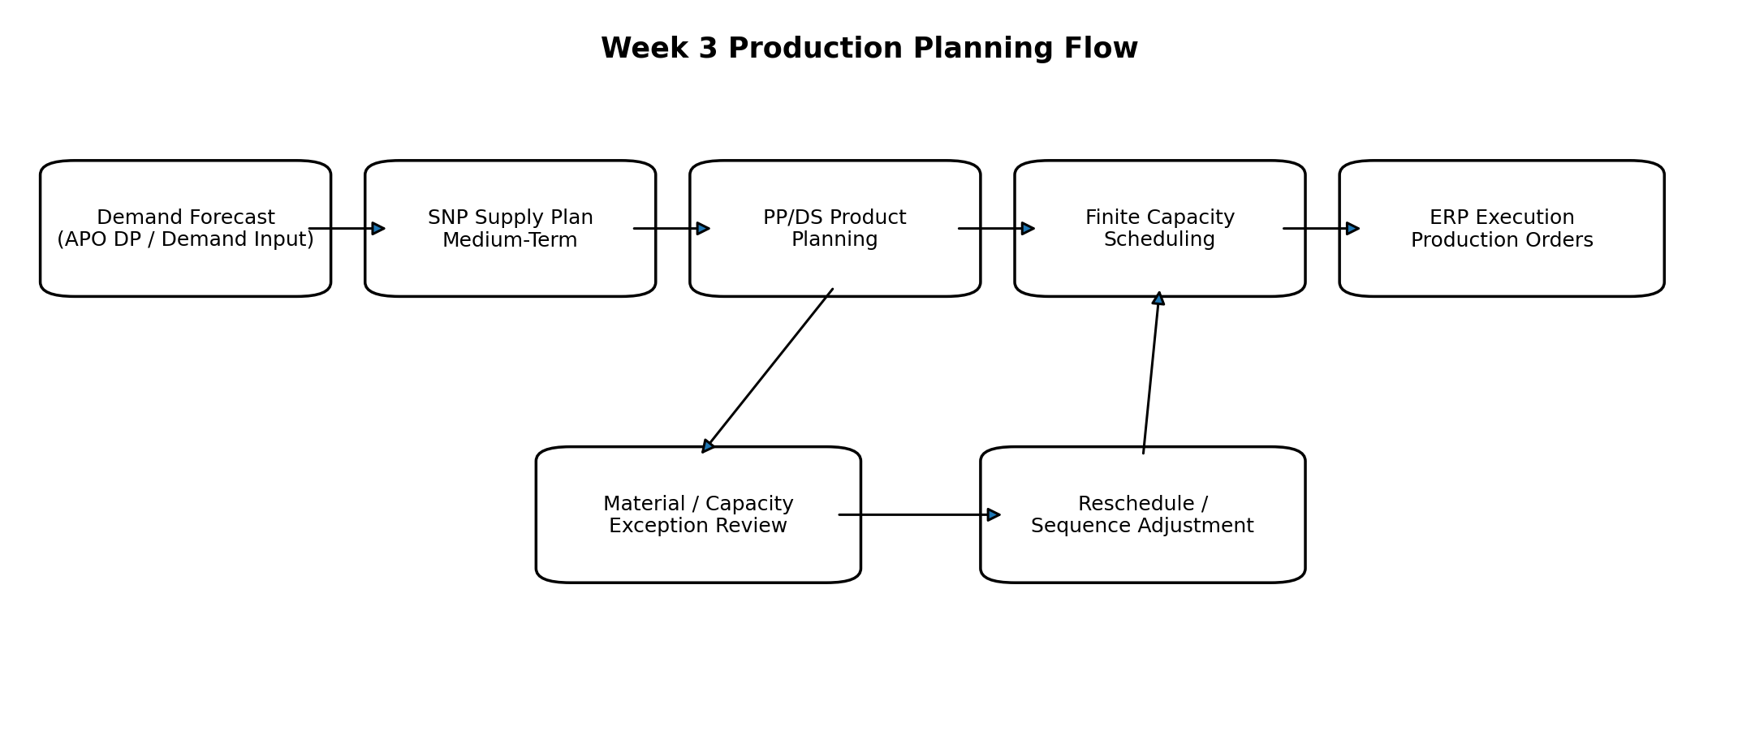
Figure 1. Demand-to-schedule planning flow (conceptual).

6.1 Planning Decision Logic
For the peak week, the objective is not simply to maximize utilization. I would first protect customer due dates and key SKUs, then minimize unnecessary changeovers, and finally use the remaining capacity for lower-priority demand. This creates a more stable schedule than continuously changing the sequence based only on the newest requirement.

7. Scheduling Protocols and Sample Production Plan

7.1 Scheduling Rules
- Use finite capacity on the packaging resource because it is the identified bottleneck.
- Use a 14-day detailed scheduling horizon and a 12-week broader supply-planning horizon.
- Use a minimum practical batch of 5 t and preferred campaign lots of 15-30 t where demand allows.
- Sequence similar products together to reduce cleaning and changeover time.
- Protect customer due dates and priority orders before optimizing utilization.
- Reserve planned maintenance and cleaning windows as unavailable capacity.
- Reschedule only after checking component availability and downstream delivery requirements.

7.2 Illustrative Peak-Week Schedule
Day | SKU | Planned qty | Main resources | Rationale
Mon | MUM500 | 25 t | Packaging + mixing | Start high-demand SKU
Tue | MUM500 | 30 t | Packaging + mixing | Complete main MUM campaign
Wed | RDM500 | 30 t | Packaging + mixing | Single planned changeover
Thu | RDM500 | 20 t | Packaging + mixing | Complete RDM campaign
Fri | JIM500 | 20 t | Packaging + mixing | Start JIM campaign
Sat | JIM500 | 15 t | Packaging + mixing | Finish demand + maintenance window
Total |  | 140 t |  | Approx. 1.5 t planning buffer vs 138.5 t demand

The schedule rounds production into practical 5-tonne lots and plans 140 t, slightly above the 138.5 t forecast. The small difference can be absorbed as planned buffer stock only if shelf-life, demand confidence, and warehouse capacity are acceptable. In a live environment the quantity would be fine-tuned using actual stock, open orders, yield, and lot-size rules.

7.3 Capacity Check
Measure | Value | Interpretation
Peak demand | 138.5 t | Demand requirement
Packaging nominal capacity | 145 t | Main bottleneck
Nominal utilization | 95.5% | 138.5 / 145
Nominal headroom | 6.5 t | Before breakdowns/changeovers
Mixing capacity | 160 t | Approx. 86.6% utilization

Because packaging utilization is above 95%, even a short breakdown or longer-than-planned changeover can make the schedule infeasible. This is why the next section focuses on ERP-SCM synchronization and exception response rather than treating the schedule as fixed.

8. ERP - SAP SCM Integration Framework
The production plan depends on synchronized master and transaction data. In the conceptual design, SAP ERP is the execution and core master-data source, while SAP SCM/APO performs advanced planning. CIF is used to control which objects are transferred and to keep relevant changes synchronized.
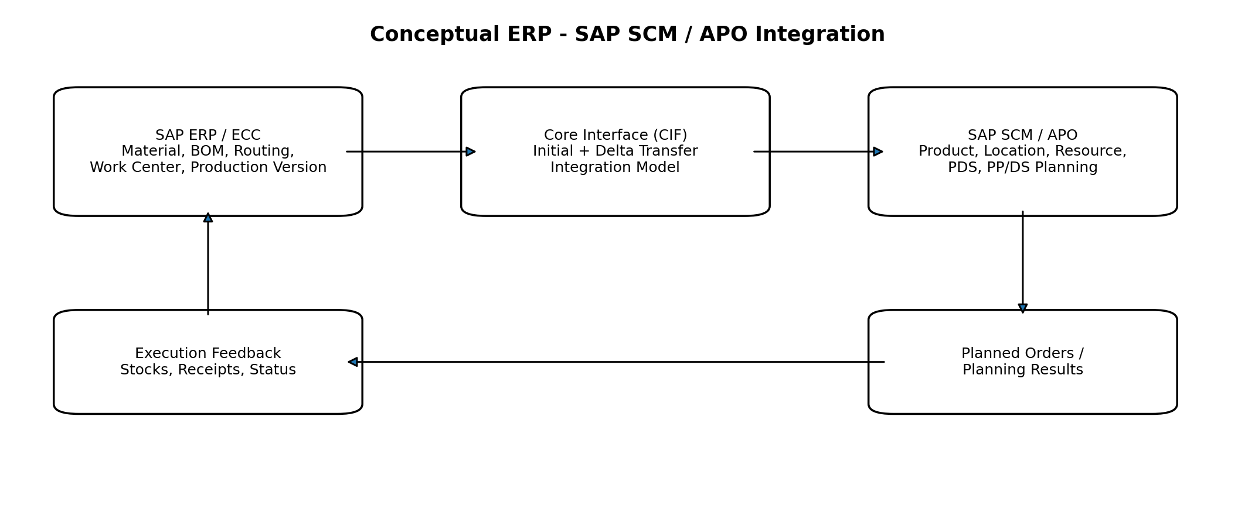
Figure 2. Conceptual ERP-SCM integration using CIF.

8.1 Information Flow
Direction | Typical information | Purpose
ERP -> SCM | Material/product, plant/location, work center/resource, BOM/routing-derived planning structure, production version, stocks and selected transactional data | Creates consistent planning model
SCM internal | Forecast, supply plan, PP/DS planned orders, scheduling, pegging and alerts | Creates feasible planning result
SCM -> ERP | Transferable planned orders / procurement proposals according to integration configuration | Allows execution conversion and release
ERP -> SCM feedback | Order status, receipts, stock changes, confirmations and relevant master-data updates | Keeps next planning cycle current

8.2 Integration Controls
- Use controlled CIF integration models rather than transferring unnecessary objects.
- Validate queue / integration errors before assuming the planning picture is current.
- Use consistent units of measure, calendars, time zones, and object validity dates.
- Reconcile critical master data after major routing, capacity, or production-version changes.
- Avoid rescheduling based on stale stock or order status.

9. Scenario-Based Bottleneck Analysis
The scenario was intentionally designed with limited headroom so that bottlenecks become visible. I evaluated three practical disruptions and the planning response I would propose.
Disruption | Illustrative event | Likely impact | Planning response
Packaging line breakdown | 8-hour unplanned stop during peak week | Late completion; resource overload | Move low-priority lots, use approved overtime, split lots, resequence after maintenance
Packaging-material delay | Supplier delivery slips by 2 days | Orders cannot start even if machine is free | Check alternate supplier / emergency transfer, protect critical SKUs, adjust schedule
Demand spike beyond forecast | Additional 8 t customer demand | Demand exceeds remaining capacity | Use available buffer stock, prioritize customer/service class, move lower-priority production to next period

9.1 Packaging Breakdown Evaluation
With only about 6.5 t of nominal headroom, an 8-hour packaging stop can consume most or all remaining flexibility depending on the actual hourly rate and changeover profile. The first response should therefore be to protect due dates, not simply to push every order later. I would identify which orders are pegged to the earliest customer requirements, reschedule lower-priority lots, and then test whether overtime or an alternate packaging option is allowed.
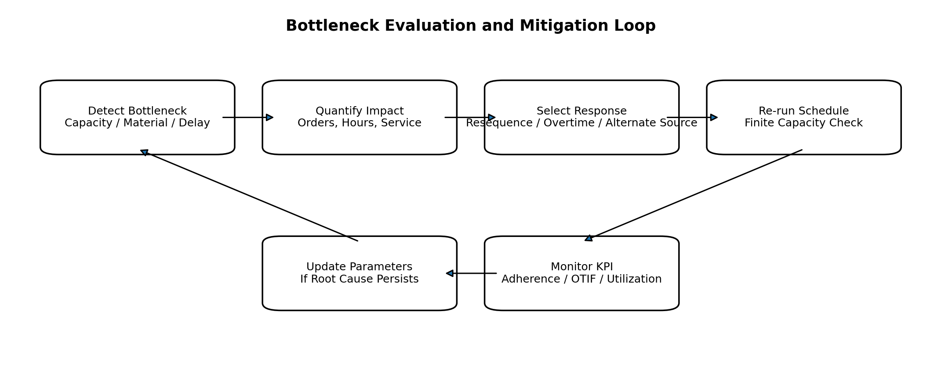
Figure 3. Bottleneck evaluation and mitigation loop.

9.2 Root-Cause Perspective
Repeated overloads should not be solved only by emergency overtime. If the same resource remains overloaded every week, the planner should review standard runtime, forecast bias, lot-size policy, maintenance windows, changeover assumptions, and whether additional capacity or an alternate resource is economically justified.

10. KPI Framework and Monitoring
KPI | Definition | Illustrative target
Schedule adherence | % of orders completed according to planned sequence/time | >= 95%
On-time in-full (OTIF) | Customer orders delivered complete and on time | >= 95%
Packaging utilization | Used capacity / available capacity | 85-95% sustainable range
Changeover hours | Setup / cleaning time per week | Trend downward without quality risk
Production plan stability | Orders not repeatedly rescheduled inside frozen horizon | High stability
Material shortage incidents | Orders delayed because required components are unavailable | Near zero
Forecast vs actual variance | Difference between demand plan and consumption | Monitor by SKU / week
CIF / integration errors | Open transfer or queue errors affecting planning | Zero critical unresolved

10.1 Monitoring Frequency
Frequency | Review focus
Shift / Daily | Machine downtime, urgent shortages, order delay, sequence deviation
Weekly | Schedule adherence, changeover time, capacity utilization, stock and service
Monthly | Forecast bias, repeated bottlenecks, master-data errors, capacity-investment needs

11. Validation and Testing Approach
Because this is a planning simulation rather than live-system execution, the validation section defines how I would test the framework in a training or sandbox environment.
Test | Procedure | Expected result
Master data consistency | Compare ERP and APO product/resource/PDS values for selected SKUs | No critical mismatch
Demand planning test | Load peak-week demand and verify planning requirements | 138.5 t reflected correctly
Finite scheduling test | Schedule all three SKUs on packaging resource | No hidden overlap
Changeover test | Change product sequence and verify setup impact | Capacity reflects setup logic
Breakdown scenario | Block 8 hours on bottleneck resource and re-run schedule | Late orders visible; mitigation possible
Material-delay test | Delay packaging component availability | Dependent production becomes constrained
Integration test | Confirm relevant planning/master-data transfer status | No critical queue errors

11.1 Acceptance Criteria
- No planned order overlaps on the same finite bottleneck resource.
- Peak demand is either scheduled, covered by valid stock, or clearly identified as shortage.
- Master-data differences that affect runtime or quantity are resolved before schedule approval.
- Critical alerts and integration errors are reviewed before releasing planning results.
- Rescheduling decisions preserve traceability to the reason for change.

12. Risks, Controls and Contingency Actions
Risk | Impact | Planning consequence | Control / contingency
Incorrect routing time | High | False capacity picture | Validate standard values against actual run history
CIF synchronization issue | High | Stale master/transaction data | Queue monitoring, controlled integration-model review
Frequent schedule changes | Medium | Shop-floor instability | Frozen horizon and change-control rule
Single packaging bottleneck | High | Late orders during breakdown | Preventive maintenance, overtime/alternate capacity plan
Supplier delay | Medium | Material shortage | Safety stock, alternate source, expediting process
Forecast error | Medium | Excess or shortage | Rolling forecast review and plan rebalancing
Excessive lot size | Medium | Inventory build-up, long cycle | Lot-size review and smaller campaign where economic

13. Estimated 30-35 Hour Work Plan
The task brief estimates 30-35 hours. The following allocation shows how I would structure approximately 33 hours of work for research, scenario design, documentation, analysis, and validation.
Activity | Estimated hours
Research SAP SCM / PP/DS production-planning concepts | 4.0
Review Week 1-2 scenario and define Week 3 assumptions | 2.5
Develop demand, capacity, resource and scheduling scenario | 4.0
Map ERP and APO master-data requirements | 4.0
Document configuration and integration methodology | 5.0
Create sample production schedule and capacity calculations | 3.0
Perform bottleneck and contingency analysis | 3.0
Define KPIs, testing and monitoring framework | 2.5
Prepare diagrams, tables, formatting and references | 3.0
Final review and corrections | 2.0
Total | 33.0

This is an estimated work plan for the assignment rather than a claim that each activity was timed to the minute. The purpose is to demonstrate a realistic effort breakdown consistent with the internship requirement.

14. Key Learning Outcomes
- I understood the difference between a medium-term supply plan and a short-term finite production schedule.
- I learned why packaging or another shared resource can become the true plant bottleneck even when overall plant capacity appears sufficient.
- I connected ERP production master data - material, BOM, routing, work center, and production version - with SAP SCM/APO planning objects and PDS concepts.
- I understood how CIF supports synchronization between ERP execution data and the advanced planning system.
- I learned to evaluate a schedule using due dates, capacity, material availability, changeovers, and plan stability instead of only production quantity.
- I learned that repeated overloads require root-cause correction in master data, forecast, lot size, or capacity rather than continuous emergency rescheduling.

15. Conclusion
This Week 3 project demonstrates a complete production-planning and scheduling framework using SAP SCM/APO concepts. Starting from forecast demand, the method moves through supply planning, PP/DS product planning, finite resource scheduling, sequence optimization, ERP integration, exception review, and execution feedback.
For the Deccan Harvest Foods scenario, the packaging line is the most important constraint because peak-week demand uses about 95.5% of nominal packaging capacity. This creates a practical reason to use finite scheduling, protect due dates, reduce unnecessary changeovers, and maintain contingency actions for breakdowns or supplier delays.
The main conclusion is that production planning quality depends on both planning logic and master-data accuracy. A schedule can only be trusted when resources, runtimes, calendars, lot sizes, BOM/PDS data, stock, and demand are synchronized. SAP SCM/APO concepts provide the framework to make these relationships visible and to convert supply-chain demand into a more executable production plan.

16. References
1. SAP Help Portal - SAP Supply Chain Management / SAP Advanced Planning and Optimization documentation.
2. SAP Help Portal - Production Planning and Detailed Scheduling (PP/DS) concepts and planning functions.
3. SAP Help Portal - Supply Network Planning (SNP) concepts.
4. SAP Help Portal - Core Interface (CIF) integration between SAP ERP and SAP APO.
5. SAP ERP Production Planning (PP) concepts: material master, BOM, routing, work center, production version, planned and production orders.
6. Course notes and training materials used for SAP MM / SAP SCM learning. Accessed September 2026.
Note: Transaction names and process steps can vary by SAP release and customer configuration. The report therefore focuses on standard planning concepts rather than claiming a specific productive-system setup.

17. Portal Submission Description
This Week 3 report presents a production planning and scheduling framework using SAP Supply Chain Management concepts, with emphasis on SAP APO Supply Network Planning and Production Planning and Detailed Scheduling (PP/DS). I continued the fictional Deccan Harvest Foods Pvt. Ltd. scenario from the previous weeks and created a peak-demand production case for three millet-based products manufactured at a shared plant. The report explains how demand requirements can be converted into a medium-term supply plan and then into a short-term finite-capacity production schedule.
The project covers planning-relevant master data such as products, locations, BOMs, routings, work centers/resources, production versions, PDS structures, calendars, lead times, lot sizes, and scheduling parameters. It documents a step-by-step methodology from demand forecasting and supply planning through planned-order creation, detailed scheduling, sequencing, exception review, rescheduling, and ERP execution. The report also explains the conceptual integration between SAP ERP and SAP SCM/APO using CIF for master-data and planning synchronization.
A realistic capacity constraint is included by setting peak-week demand close to packaging-line capacity. Scenario analysis evaluates an equipment breakdown, packaging-material delay, and unexpected demand increase. Proposed responses include resequencing, overtime, alternate sourcing, lot splitting, and priority-based scheduling. KPIs such as schedule adherence, OTIF, capacity utilization, changeover hours, material shortages, forecast variance, and integration errors are included along with validation tests, risk controls, and post-planning monitoring. All values and results are illustrative and are presented as an internship planning simulation rather than live SAP production-system execution.
Word count: approximately 238 words

