SAP SCM - WEEK 4
Transportation Management and
Warehouse Logistics
Integrated SAP SCM / TM / EWM Planning Simulation

Prepared by | Hrudhai Prem Kumar Patwari
Project | Week 4 Internship Assignment
Scenario | Deccan Harvest Foods Pvt. Ltd. (fictional)
Focus | Transportation, warehouse execution, integration & risk controls
Task duration | 30-35 hours (estimated plan: 33 hours)
Date | 7 September 2026
Academic / internship simulation. The company, quantities, costs, routes and performance results are illustrative and do not represent a live SAP production implementation.

Executive Summary
This Week 4 project develops a transportation-management and warehouse-logistics framework for a fictional packaged-food supply chain. I continued the Deccan Harvest Foods scenario used in the earlier weeks so that network, inventory, production, transportation and warehouse decisions remain connected. The design combines SAP Supply Chain Management planning concepts with SAP Transportation Management (TM), SAP Extended Warehouse Management (EWM), ERP logistics integration and SNP Transport Load Builder (TLB) concepts.
The scenario processes approximately 150 tonnes of finished goods per week from a Hyderabad manufacturing location to Hyderabad, Vijayawada and Bengaluru distribution channels. Primary movements use full-truckload road transport, a rail-linked option for stable Bengaluru volume, and LTL / milk-run delivery for local customers. The Hyderabad warehouse is modeled with 4,000 pallet positions, six dock doors and a peak occupancy risk of 92%.
To make the analysis concrete, the report includes worked examples rather than only definitions. A Vijayawada consolidation case improves vehicle fill from 70.3% to 93.75%, avoids one 16-ton truck trip per week and gives an illustrative annual freight saving of ₹13.52 lakh at ₹26,000 per trip. A warehouse slotting example reduces modeled picker travel from 29.76 km/day to 21.12 km/day, a 29.0% reduction. The report also contains configuration guidelines, process diagrams, integration controls, validation tests, governance ownership, KPI targets and contingency plans.
The objective is not to claim live SAP execution. It is to demonstrate how a planner can translate logistics requirements into SAP-relevant master data, planning parameters, warehouse processes and measurable operational controls.

Report Structure
Section | Coverage
1-3 | Scenario, baseline data, research findings and SAP landscape
4-5 | Transportation and warehouse configuration guidelines
6 | Integrated operational workflow and synchronization
7 | Worked examples and original analysis
8 | KPIs and expected improvements
9-10 | Validation, governance and controls
11 | Risk and contingency planning
12 | 33-hour estimated effort plan
13-15 | Learning outcomes, conclusion, references and submission description

1. Introduction, Objective and Scope

1.1 Objective
The objective is to design a practical logistics framework that coordinates transport planning with warehouse execution. The project focuses on how shipment creation, mode selection, load consolidation, dock planning, picking, staging, loading and status updates can be synchronized so that transportation decisions do not create warehouse congestion and warehouse delays do not cause missed carrier departures.

1.2 Scope
- Transport requirements, freight units / shipment demand, modes, routes, capacities and carrier planning.
- Warehouse structure, storage types, bins, activity areas, doors, staging areas and warehouse process types.
- Outbound wave, picking, packing, staging, loading and goods-issue workflow.
- Inbound unloading, receiving, putaway and availability controls.
- SNP transportation lanes and TLB concepts for consolidation.
- ERP - TM - EWM synchronization and exception handling.
- Operational KPIs, validation tests, governance and contingency planning.

1.3 Methodology
1. Define the weekly logistics scenario and baseline constraints.
2. Map business requirements to SAP-relevant master data and configuration objects.
3. Design transportation and warehouse workflows.
4. Calculate capacity, utilization, cost and service examples.
5. Simulate transport and warehouse exceptions.
6. Define measurable controls, KPIs and validation evidence.
7. Review risks and document contingency actions.

2. Scenario Design and Baseline Data

2.1 Business Scenario
Deccan Harvest Foods Pvt. Ltd. is modeled as a Hyderabad-based manufacturer of packaged millet products. Finished goods move from the plant / central warehouse to three regional demand zones. The company needs to coordinate weekly transport while controlling warehouse congestion, vehicle utilization, picking efficiency and delivery reliability.
Demand zone | Weekly demand | Primary mode | Planning logic
Hyderabad / Telangana | 65 t | Road FTL + local LTL | Frequent replenishment; short lead time
Vijayawada / Andhra Pradesh | 45 t | Road FTL | Consolidate order-led loads into 16 t trucks
Bengaluru / Karnataka | 40 t | Rail-linked container + road backup | Use stable base volume on rail; road for urgent / recovery

Total modeled weekly outbound demand = 65 + 45 + 40 = 150 tonnes.

2.2 Warehouse Baseline
Parameter | Illustrative baseline | Reason it matters
Pallet positions | 4,000 | Defines storage capacity and occupancy risk
Average stock | 3,150 pallets (78.75%) | Healthy but requires monitoring
Peak stock | 3,680 pallets (92.0%) | Above preferred operating buffer; congestion risk
Dock doors | 6 (2 inbound, 4 outbound) | Shared capacity for receiving and shipping
Outbound pallets | ~300 pallets/week | Approx. 50/day across six operating days
Staging capacity | 60 pallets | Wave size and door sequence must respect this limit
Baseline dock turnaround | 110 min/truck | Targeted for improvement
Baseline pick accuracy | 96.8% | Service and rework impact

2.3 Key Constraints
- Peak warehouse occupancy can exceed 90%, reducing flexibility for inbound putaway and outbound staging.
- Order-by-order dispatching can create under-filled trucks and unnecessary freight cost.
- If picking waves are released without reference to freight departure times, staging congestion can occur.
- Multiple modes require different cut-off times and contingency rules.
- TM planning changes and EWM execution status must remain synchronized to avoid loading the wrong vehicle or missing a departure.

3. SAP Logistics Landscape and Planning Principles
For this project, I separate the planning roles of the SAP components. SAP SCM/SNP concepts support supply and deployment planning, transportation lanes and Transport Load Builder logic. SAP TM supports transport requirements, freight-unit creation, planning, mode / resource selection and freight-order execution. SAP EWM supports warehouse requests, warehouse tasks, waves, putaway, picking, staging, doors, transportation units and loading. ERP provides commercial and execution documents such as sales orders, stock transport orders and deliveries.
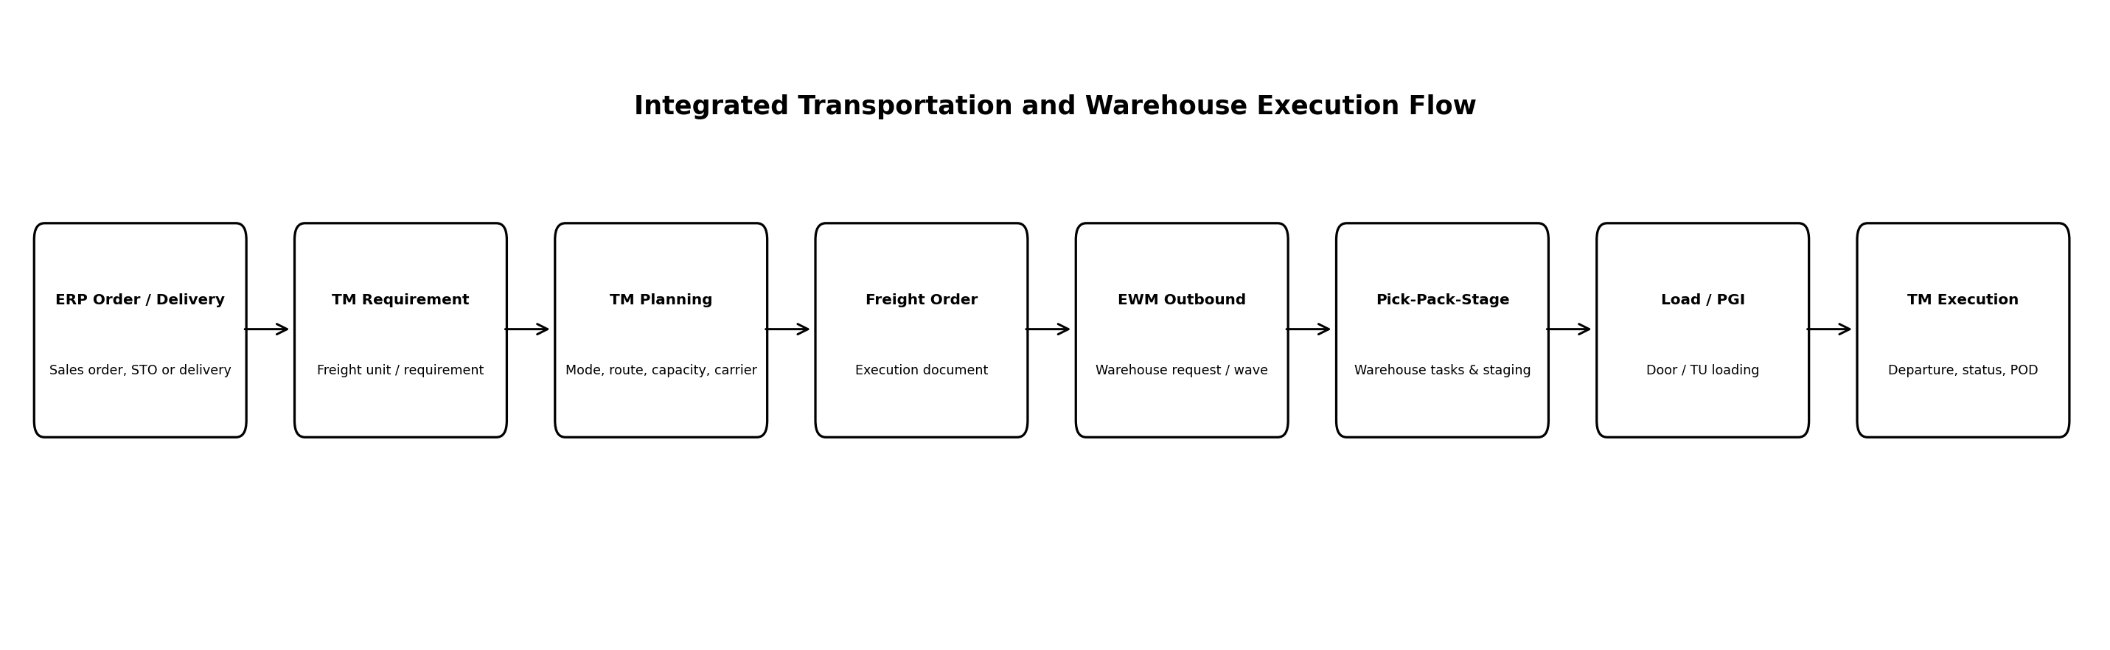
Figure 1. Conceptual ERP - TM - EWM logistics integration flow used in this project.

3.1 Planning Principles Applied
Principle | Application in this scenario
Consolidate before dispatch | Combine compatible orders within weight, volume, time-window and route constraints.
Plan warehouse to departure | Release picking waves backward from planned vehicle departure and dock slot.
Protect capacity buffer | Avoid sustained >90% warehouse occupancy and >95% transport / dock utilization without recovery options.
Segment service | Use rail-linked capacity for stable base volume; road backup for urgent or disrupted flows.
Event-driven exception control | Escalate late picking, delayed vehicles, quantity discrepancies and inventory mismatch before dispatch failure.
Master-data governance | Maintain consistent locations, resources, calendars, product dimensions, lanes, doors and staging assignments.

4. Transportation Management Configuration Guidelines

4.1 Transportation Master Data
Object / parameter | Project setup | Operational purpose
Locations | Hyderabad plant/DC, Vijayawada DC, Bengaluru DC, customer zones | Defines transportation origins and destinations.
Business partners | Carriers, suppliers, customers | Supports carrier and partner assignment.
Products | Finished goods with weight / volume / handling attributes | Required for capacity and compatibility checks.
Transportation resources | 16 t road truck; 20 t rail-linked container; 4 t local vehicle | Enables mode and capacity planning.
Transportation lanes / routes | HYD-VJA, HYD-BLR, HYD-local | Defines feasible movement paths and lead times.
Calendars / cut-offs | Carrier availability, warehouse shifts, rail cut-off | Prevents plans outside executable windows.
Zones | Telangana, Andhra Pradesh, Karnataka service zones | Simplifies geographic planning and rates.

4.2 Planning and Execution Sequence
1. Create or receive order / delivery-based transportation requirements from ERP.
2. Build freight units according to product, source, destination, delivery window and consolidation rules.
3. Assign feasible mode, route and transportation resource.
4. Run manual or optimizer-assisted transportation planning within capacity and time constraints.
5. Create freight orders for planned road / rail movements.
6. Perform carrier selection, tendering or direct carrier assignment according to the scenario.
7. Send transportation-relevant information to warehouse execution.
8. Update loading, departure and execution status from warehouse / transport events.
9. Capture proof-of-delivery and cost / service metrics for monitoring.

4.3 SNP Transport Load Builder (TLB) Use in the Simulation
Where the assignment is interpreted specifically through SAP SCM/SNP, I use TLB as the conceptual load-consolidation mechanism. The profile should define upper and lower limits for weight / volume and be linked to the relevant means of transport and transportation lane. In this project, the 16 t road-truck profile is used to demonstrate how multiple deployment or replenishment requirements can be grouped into fuller shipments.

5. Warehouse Logistics Configuration Guidelines

5.1 Warehouse Structure
EWM object | Illustrative design | Purpose
Warehouse number | HYD-CW | Logical warehouse organization.
Storage types | GR staging, reserve pallet storage, fast-pick area, packing, GI staging | Separates process and storage functions.
Storage sections / bins | Fast movers near outbound staging; reserve stock deeper in warehouse | Supports slotting and search strategies.
Activity areas | Inbound, replenishment, picking, packing, staging | Groups bins for warehouse work.
Doors | 2 inbound + 4 outbound | Controls vehicle loading / unloading points.
Staging areas | Assigned to inbound / outbound doors | Temporary storage before putaway or loading.
Warehouse process types | Putaway, replenishment, picking, internal move, staging | Controls the nature and route of warehouse tasks.
Resources | Forklifts, pallet movers, picking teams | Supports workload and execution planning.

5.2 Outbound Workflow Configuration
1. Receive / create outbound delivery order in EWM.
2. Determine stock-removal strategy and source bins.
3. Assign items to waves based on route, departure time, door and capacity.
4. Release the wave to create warehouse tasks for picking.
5. Group tasks into warehouse orders for execution teams.
6. Pick products and confirm quantities.
7. Pack into handling units where required.
8. Move goods to the GI staging area assigned to the departure door / TU.
9. Load the transportation unit in the planned sequence.
10. Confirm loading and post goods issue, then synchronize departure status to transportation execution.

5.3 Inbound Workflow Configuration
1. Receive inbound delivery / freight-order information.
2. Check vehicle / TU arrival and assign inbound door.
3. Unload into GR staging and verify quantity / quality.
4. Post goods receipt according to the process design.
5. Create putaway warehouse tasks using storage-type and bin-determination strategies.
6. Confirm putaway and make stock available for replenishment / picking.

6. Integrated Operational Workflow
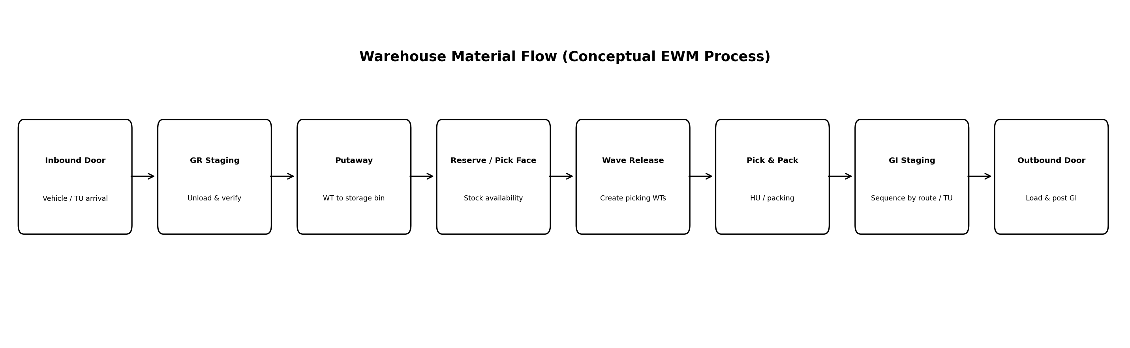
Figure 2. Warehouse material flow from vehicle arrival through putaway and outbound loading.

6.1 Departure-Driven Warehouse Planning
The key integration rule is that warehouse work should be scheduled against transportation departure, not independently. If a Vijayawada truck is planned to depart at 18:00, the picking wave must allow enough time for task creation, picking, packing, staging, loading and a buffer for exceptions. This avoids the common situation where the truck arrives but the order is not staged, or where goods are staged too early and occupy scarce GI space.
Time | Illustrative event | Control
12:00 | TM freight order / departure confirmed | Freeze major load changes unless approved.
13:00 | Wave created for Vijayawada load | Check staging capacity and stock availability.
14:00 | Wave released; WTs created | Monitor open / overdue tasks.
16:15 | Picking and packing target complete | Escalate shortages immediately.
16:30 | Stage by door / loading sequence | No mixing of route / TU staging.
17:00 | Truck docked; loading starts | Verify vehicle / freight order / handling units.
17:45 | Loading complete | Quantity discrepancy check.
18:00 | Departure / PGI | Update TM execution status.

7. Worked Examples and Original Analysis

7.1 Transportation Consolidation: Vijayawada
The baseline assumes four customer-order groups of 11 t, 10 t, 12 t and 12 t. If each order group is dispatched independently in a 16 t truck, the company uses four trucks for 45 t of demand.
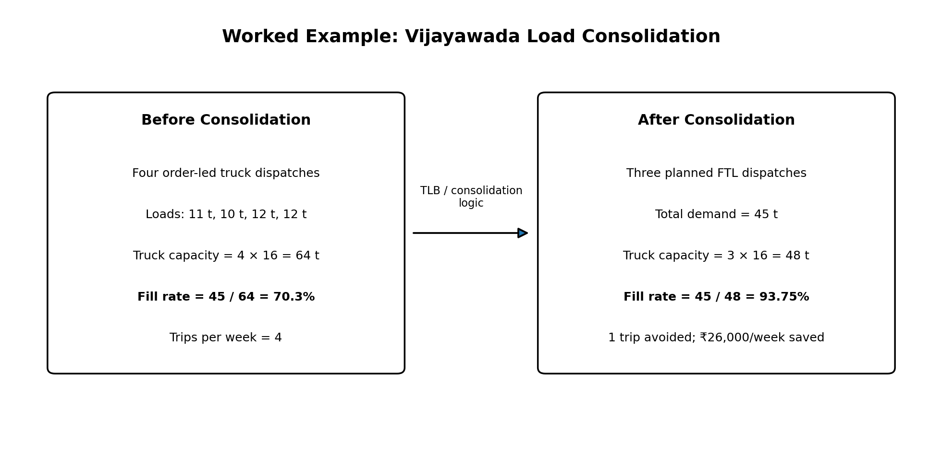
Figure 3. Consolidating four fragmented dispatches into three fuller 16 t truckloads.
Metric | Before | After | Improvement
Demand moved | 45 t | 45 t | No change in service volume
Truck trips | 4 | 3 | 1 trip avoided
Available truck capacity | 64 t | 48 t | Capacity better matched to demand
Vehicle fill | 45/64 = 70.3% | 45/48 = 93.75% | +23.45 percentage points
Illustrative cost | 4 × ₹26,000 = ₹104,000 | 3 × ₹26,000 = ₹78,000 | ₹26,000/week saving
Illustrative annual saving | - | ₹26,000 × 52 = ₹1,352,000 | ₹13.52 lakh/year

Planning decision: the fourth truck should only be used if delivery windows, product incompatibility, route constraints or late order changes prevent consolidation. This makes the analysis operational rather than simply maximizing fill at the expense of service.

7.2 Warehouse Occupancy Analysis
Average occupancy = 3,150 / 4,000 = 78.75%. Peak occupancy = 3,680 / 4,000 = 92.0%. At peak, only 320 pallet positions remain free. A single inbound promotion of 250 pallets would consume 78.1% of that residual capacity, leaving only 70 pallet positions. Therefore, the project uses 85% as an internal warning threshold and 90% as an escalation threshold, prompting faster outbound release, cross-dock / flow-through review, temporary overflow planning, or inbound appointment smoothing.

7.3 Slotting / Pick-Travel Example
The modeled warehouse processes 480 pick lines per day. Before ABC-based slotting, average travel is assumed at 62 m per pick line: 480 × 62 m = 29,760 m, or 29.76 km/day. After moving high-frequency A-items closer to outbound staging, average travel reduces to 44 m: 480 × 44 m = 21,120 m, or 21.12 km/day. The reduction is 8.64 km/day, equal to 29.0%. This does not directly prove a labor saving, but it provides a measurable reason to validate the slotting change in a pilot zone.

7.4 Dock Turnaround Improvement
The baseline dock turnaround is 110 minutes per truck. The target is 75 minutes. Improvement = (110 - 75) / 110 = 31.8%. The operational changes used to support this target are appointment discipline, pre-staging by freight order, door assignment before arrival, scan-based loading checks and exception escalation before the truck reaches the dock.

8. KPI Framework and Expected Results
KPI | Baseline | Target / simulated result | Why monitored
On-time dispatch | 88% | >=96% | Measures warehouse + transport synchronization.
Vehicle fill | 70.3% fragmented VJA case | >=90% on eligible FTL lanes | Controls freight efficiency.
Dock turnaround | 110 min | <=75 min | Protects door capacity and carrier time.
Pick accuracy | 96.8% | >=99.2% | Reduces rework and delivery discrepancy.
Peak occupancy | 92% | <=85% normal operating target | Protects working space and putaway flexibility.
Staging overflow | Occasional / unmeasured | 0 unplanned overflow events | Prevents route mixing and loading delay.
Freight departure miss | 6% of loads illustrative | <2% | Direct service indicator.
TM-EWM status mismatch | 2.5% illustrative | <0.5% | Measures integration / process-control quality.
Picker travel | 29.76 km/day modeled | 21.12 km/day pilot expectation | Tests slotting effectiveness.

These are simulation targets, not measured production-system results. In a real implementation, each KPI would require a defined data source, owner, measurement frequency and approved baseline period.

9. Validation and Test Plan
Test ID | Scenario / action | Expected result / pass criterion | Evidence to retain
T01 | Create 45 t Vijayawada requirements and consolidate | 3 × 16 t truck plan; fill 93.75%; no delivery-window violation | Planning screenshot / load list
T02 | Reduce one truck capacity from 16 t to 12 t | Planner identifies infeasible or additional-capacity requirement | Exception log / revised plan
T03 | Release outbound wave for 40 pallets | WTs created; staging capacity <=60 pallets | Wave + WT summary
T04 | Create wave for 80 pallets without split | System / planner detects staging overload; split into <=60-pallet waves | Wave plan / control note
T05 | Simulate stock shortage on 5 pallets | Shortage visible before loading; load not falsely completed | Shortage exception record
T06 | Change freight departure from 18:00 to 16:30 | Warehouse plan is re-prioritized; impacted wave is flagged | Re-planning record
T07 | Incorrect door assignment | Mismatch detected before loading; door / staging corrected | Door assignment check
T08 | Quantity discrepancy at loading | Loading status captures variance; TM / ERP follow-up triggered | Discrepancy log
T09 | Vehicle arrives 120 min late | Dock slot / staging plan adjusted without route mixing | Appointment change record
T10 | Peak occupancy reaches 90%+ | Escalation / inbound smoothing / outbound acceleration decision documented | Capacity dashboard / action log

9.1 Acceptance Approach
The project would not be accepted simply because a transaction can be saved. Validation must show that the plan remains operationally feasible: truck capacity is respected, warehouse staging is not overloaded, the correct goods are loaded to the correct TU / freight order, status updates are consistent, and exceptions are visible before they become service failures.

10. Governance, Ownership and Controls
Activity / data | Primary owner | Frequency | Control / approval
Transportation lanes, transit times, mode eligibility | Transport planner | Monthly / change event | Planner review + logistics manager approval
Carrier / resource capacity | Transport planner / carrier manager | Weekly | Capacity confirmation before planning horizon
Product weight / dimensions | Master-data owner | On change | Dual review against packaging specification
Door / staging assignment | Warehouse supervisor | Daily | Appointment and route board check
Wave template / release timing | Warehouse planning lead | Quarterly + peak review | Pilot before production use
Putaway / stock-removal strategy | EWM process owner | Quarterly | Exception-rate and travel analysis
Freight cost / rate assumptions | Logistics finance / procurement | Contract cycle | Rate-card approval
TM-EWM interface monitoring | IT integration support | Daily | Failed-message queue / status reconciliation
KPI review | SCM manager | Weekly / monthly | Root-cause action log and owner / due date

10.1 Change-Control Rules
- No master-data change to truck capacity, product weight, door, staging area or route should be made without an owner and effective date.
- Peak-season changes must be tested using a representative high-volume scenario before release.
- Critical integration failures must have a manual fallback process and reconciliation step.
- KPI deterioration for two consecutive review periods should trigger root-cause analysis rather than repeated parameter adjustment without evidence.

11. Risk and Contingency Analysis
Risk | Likelihood | Impact | Early indicator | Contingency / mitigation
Carrier no-show / vehicle breakdown | Medium | High | No GPS / appointment confirmation | Activate backup carrier; protect priority loads; re-tender / re-plan freight order.
Monsoon / road disruption | Medium | High | ETA deterioration / route alert | Use alternate route, advance dispatch, rail-linked option for stable volume, increase buffer selectively.
Rail cut-off missed | Low-Med | High | Warehouse wave late vs rail cut-off | Shift urgent volume to road backup; review departure-driven wave timing.
Warehouse >90% occupancy | Medium | High | Free bins <400 | Accelerate outbound, smooth inbound appointments, use overflow / cross-dock decision rules.
Staging overflow | Medium | Medium-High | Planned wave >60 pallets | Split wave, re-time release, allocate separate staging by route / TU.
Inventory mismatch | Medium | High | Pick shortage / negative difference | Cycle count, block affected stock, reallocate alternate stock, update plan.
Wrong load / route mix | Low | High | HU / TU scan mismatch | Stop loading, scan validation, segregated staging, supervisor release.
TM-EWM status mismatch | Low-Med | High | Loaded in EWM but open in TM | Interface monitoring, message reprocessing, manual reconciliation and documented handoff.
Dock congestion | Medium | Medium | Truck queue / turnaround >90 min | Appointment slots, door balancing, pre-staging, overflow waiting rule.
Demand spike + transport shortage | Medium | High | Open demand exceeds booked capacity | Prioritize confirmed orders, add spot capacity, split delivery, communicate service impact.

12. Estimated 33-Hour Work Plan
Activity | Hours | Concrete output / evidence
Research SAP TM / EWM / SNP logistics concepts | 4.0 | Reference notes; list of relevant objects and process boundaries
Scenario and data design | 3.0 | Demand, route, mode, warehouse and capacity baseline table
Transportation master-data mapping | 3.0 | Locations, lanes, modes, resources, calendars, partner mapping
Warehouse structure / process design | 4.0 | Storage types, bins, doors, staging, WPT and workflow map
TM configuration guideline | 3.0 | Requirement-to-freight-order planning sequence
EWM configuration guideline | 3.0 | Inbound / outbound and wave / WT sequence
Integration workflow design | 3.0 | ERP-TM-EWM synchronization diagram and controls
Worked examples / calculations | 3.0 | Consolidation, occupancy, slotting and dock-turnaround calculations
Risk and contingency analysis | 2.0 | Risk register with indicators and response actions
Validation / governance design | 2.0 | 10-test validation plan plus ownership matrix
KPI framework and evaluation | 1.5 | Baseline / target KPI table
Formatting, review and final documentation | 1.5 | Final report QA and submission-ready DOCX

Total estimated effort = 33.0 hours, within the requested 30-35 hour range. The table is an effort plan for the assignment, not a claim of system-logged working hours.

13. Learning Outcomes and Analytical Evaluation
The strongest learning from this project is that transportation and warehouse optimization cannot be treated as separate topics. A low-cost transport plan can fail if the warehouse cannot pick and stage the load before departure. Likewise, a highly efficient picking wave can still create poor logistics performance if it is released too early and blocks staging capacity or if it is not aligned to the correct carrier and route.
The quantitative examples also changed the planning decision. The Vijayawada case shows that vehicle-fill improvement is valuable only when delivery windows remain feasible. The 92% warehouse peak occupancy shows why inventory capacity must include working space, not only storage positions. The slotting example provides a measurable hypothesis that should be piloted and verified before a large rearrangement.
From an SAP perspective, the exercise connected transportation requirements, freight planning, freight orders, warehouse requests, waves, warehouse tasks, staging, transportation units and loading status into one end-to-end process. It also reinforced the need for clear ownership of master data and interfaces.

14. Conclusion
This Week 4 project designed an integrated transportation and warehouse logistics framework for a 150-tonne-per-week packaged-food network. The proposed process uses road, rail-linked and local-delivery modes, shipment consolidation, departure-driven wave planning, EWM-style warehouse execution and ERP / TM / EWM synchronization. The report moves beyond conceptual definitions by using worked load, capacity, occupancy, travel-distance and turnaround calculations, supported by validation tests and governance controls.
The recommended operating model is to consolidate compatible freight, keep peak warehouse occupancy below escalation thresholds, release waves according to transport departure, segregate staging by route / TU, monitor integration mismatches, and use contingency capacity for disruptions. The result is a logistics design that balances freight cost, service, warehouse flow and execution feasibility rather than optimizing any one metric in isolation.

15. References
SAP Help Portal - Outbound-Delivery-Based Transportation Planning (SAP TM) - Explains planning based on outbound deliveries and direct TM-EWM integration for warehouse loading. Accessed 7 September 2026.
SAP Help Portal - Integration with Extended Warehouse Management (TM) - Describes direct TM-EWM integration options, including freight-order and delivery / TU-based approaches. Accessed 7 September 2026.
SAP Help Portal - Freight Order Management (SAP TM) - Describes freight orders / bookings and their role in transportation planning and execution. Accessed 7 September 2026.
SAP Help Portal - ERP Logistics Integration (SAP TM) - Describes how ERP orders and deliveries are represented in TM and used for transportation planning. Accessed 7 September 2026.
SAP Help Portal - Transport Load Builder / TLB Planner (SAP SCM SNP) - Explains grouping of planned transport loads within weight / volume limits and transportation-lane / profile setup. Accessed 7 September 2026.
SAP Help Portal - Putaway and Stock Removal Strategies (SAP EWM) - Describes EWM bin determination for goods receipt, goods issue and internal movements. Accessed 7 September 2026.
SAP Help Portal - Creation of Warehouse Tasks for Stock Removal (SAP EWM) - Explains creation of outbound warehouse tasks and wave release. Accessed 7 September 2026.
SAP Help Portal - Staging Area and Door (SAP EWM) - Explains staging areas, doors and their role in goods receipt / issue and vehicle loading / unloading. Accessed 7 September 2026.
Reference note: SAP product architecture differs by system release (for example, standalone SAP SCM / APO, standalone TM / EWM, or embedded S/4HANA capabilities). This report therefore presents a conceptual integration blueprint and avoids claiming that every object is configured in a single identical system landscape.

Portal Submission Description (200+ words)
This Week 4 report presents a Transportation Management and Warehouse Logistics project using SAP supply-chain concepts, with emphasis on the integration of SAP Transportation Management, SAP Extended Warehouse Management, ERP logistics and SAP SCM/SNP Transport Load Builder principles. I continued the fictional Deccan Harvest Foods Pvt. Ltd. scenario and modeled approximately 150 tonnes of weekly finished-goods movement from Hyderabad to Telangana, Andhra Pradesh and Karnataka using road, rail-linked and local-delivery modes. The report explains transportation master data, freight-unit and freight-order planning, carrier and capacity considerations, transportation lanes, load consolidation and synchronization with warehouse execution.
The warehouse section covers storage types, bins, activity areas, warehouse process types, doors, staging areas, waves, warehouse tasks, picking, packing, loading and putaway. The operational workflow links planned departure times with wave release and staging so that transport and warehouse activities remain synchronized. I included specific worked examples to strengthen the analysis: a Vijayawada load-consolidation case improves modeled vehicle fill from 70.3% to 93.75% and avoids one truck trip per week; a warehouse slotting example reduces modeled picker travel by 29%; and peak warehouse occupancy is evaluated at 92%. The report also includes KPI targets, ten validation tests, governance ownership, integration controls, a risk register and an estimated 33-hour project plan. All quantities, costs and performance results are illustrative and are presented as an internship planning simulation rather than live SAP execution.

