WEEK 4 INTERNSHIP PROJECT
Production Planning and Scheduling Analysis in SAP SCM
SAP SCM / SAP APO PP/DS Planning Framework

Prepared by: Hrudhai Prem Kumar Patwari
Task: Week 4 - Production Planning and Scheduling Analysis in SAP SCM
Scenario: Deccan Harvest Foods Pvt. Ltd. (fictional)
Project type: Internship planning simulation / configuration blueprint
Date: October 2026

This report is a structured internship simulation. All quantities, capacities, costs and outcomes are illustrative and do not represent live production-system execution.

Contents
- 1. Executive Summary
- 2. Assignment Alignment and Objectives
- 3. Scenario Creation and Business Assumptions
- 4. SAP SCM Production Planning Functionalities
- 5. Production Master Data and Configuration Guidelines
- 6. Methodology: Demand to Production Schedule
- 7. Scheduling Simulation and Sample Production Plan
- 8. Bottleneck Analysis and Resource Constraints
- 9. ERP - SAP SCM Integration Framework
- 10. Scenario Analysis and Recovery Decisions
- 11. KPI Framework and Monitoring
- 12. Validation and Testing Approach
- 13. Risks, Controls and Contingency Actions
- 14. Estimated 33-Hour Work Plan
- 15. Key Learning Outcomes
- 16. Conclusion
- 17. References
- 18. Portal Submission Description
Note: Transaction names and process steps are illustrative examples. Exact screens, transaction codes and configuration paths can vary by SAP release and customer landscape.

1. Executive Summary
This Week 4 project develops a practical production planning and scheduling case study using SAP Supply Chain Management concepts. The fictional company, Deccan Harvest Foods Pvt. Ltd., manufactures millet-based ready-to-cook products on shared mixing and packaging resources. The objective is to convert demand into an executable production schedule while identifying capacity bottlenecks, managing changeovers, protecting material availability and responding to unexpected downtime.
The planning framework combines SAP Supply Network Planning (SNP) concepts for medium-term demand and supply balancing with SAP Production Planning and Detailed Scheduling (PP/DS) concepts for short-term, finite-capacity scheduling. ERP production master data such as material masters, bills of material, routings, work centers and production versions are treated as inputs to the planning model. The Core Interface (CIF) is used conceptually to explain synchronization between ERP and SAP SCM/APO.
The peak-week case contains 138.5 tonnes of demand against 145 tonnes of nominal packaging capacity. At first sight, nominal utilization is 95.5%. However, two 1.5-hour changeovers at an illustrative packaging rate of 1.25 tonnes/hour remove 3.75 tonnes of usable capacity. Effective capacity becomes 141.25 tonnes and utilization rises to approximately 98.1%, leaving only 2.75 tonnes of headroom.
An 8-hour packaging breakdown is then simulated. At 1.25 tonnes/hour, the disruption removes 10 tonnes, reducing available capacity to 131.25 tonnes and creating a 7.25-tonne shortfall against demand. A six-hour approved overtime recovery at the same rate produces 7.5 tonnes, bringing capacity to 138.75 tonnes and leaving a 0.25-tonne buffer. The example demonstrates why finite-capacity scheduling and exception management are essential when a resource is already highly utilized.
- Realistic production planning scenario with demand, resources and constraints.
- SAP SCM/APO functionality map covering SNP, PP/DS, master data, alerts and ERP integration.
- Step-by-step configuration blueprint for products, BOMs, routings, resources, PDS and calendars.
- Illustrative production schedule with product sequencing and capacity calculations.
- Bottleneck analysis covering changeovers, equipment breakdown, material shortage and demand increase.
- Recovery options including resequencing, overtime, alternate capacity, lot splitting and priority management.
- Quantified KPIs, validation tests, governance controls and a 33-hour work plan.
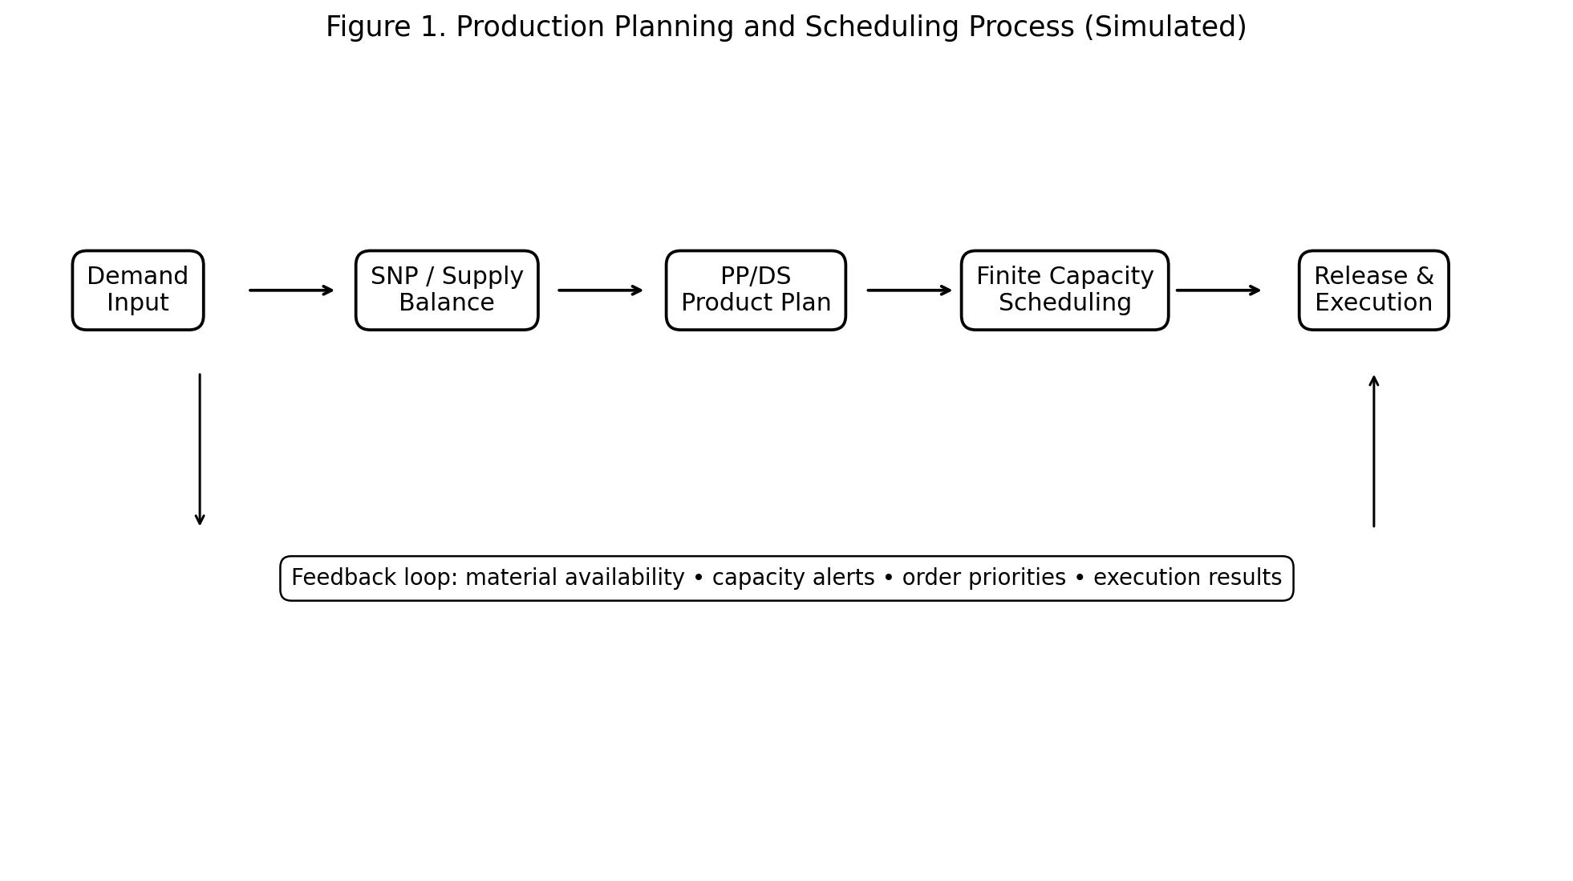
Figure 1. Production Planning and Scheduling Process (Simulated)

2. Assignment Alignment and Objectives
The internship brief requires a minimum 2,000-word case study, visual aids, simulated SAP configurations, scheduling analysis, bottleneck identification, recommended solutions and a consolidated DOC report. The following objectives directly address that brief.
Assignment requirement | How this report addresses it
Detailed case study | Deccan Harvest Foods peak-week production scenario with defined demand, capacity and constraints.
Constraints and objectives | Demand of 138.5 t, packaging capacity of 145 t, changeovers, downtime, materials and due-date priorities.
SAP SCM configuration | Products, locations, resources, PDS, calendars, BOM/routing, planning parameters and CIF concepts.
Scheduling simulation | Illustrative six-day production plan, finite-capacity reconciliation and recovery calculations.
Visual aids | Production flow, capacity chart, schedule diagram, bottleneck decision flow and simulated PP/DS planning board.
Analysis | Comparison of nominal vs effective capacity and quantified disruption/recovery impact.
Solutions | Resequencing, overtime, alternate capacity, material-readiness controls and priority-based scheduling.
Documentation quality | Structured sections, tables, figures, validation plan, risk register and portal description.

3. Scenario Creation and Business Assumptions

3.1 Business Context
Deccan Harvest Foods Pvt. Ltd. is a fictional packaged-food manufacturer used consistently as the learning scenario. The company produces millet-based ready-to-cook products for regional markets. Production is planned at a shared plant where mixing, packaging, quality checks and warehouse staging must be coordinated. Three representative SKUs are used in the simulation: MUM500, RDM500 and JIM500.
The scenario assumes that demand is firm enough for production planning but still requires a capacity and material review before release. The main planning challenge is that aggregate plant capacity looks sufficient while the packaging line is nearly fully loaded. This creates sensitivity to product changeovers, breakdowns, cleaning, maintenance and packaging-material availability.

3.2 Demand and Resource Constraints
Constraint / demand item | Planning value | Interpretation
MUM500 demand | 55.2 t | High-volume SKU; campaign production preferred.
RDM500 demand | 48.3 t | Second campaign; one planned changeover.
JIM500 demand | 35.0 t | Final campaign; sequence after RDM500.
Peak-week demand | 138.5 t | Total requirement.
Mixing capacity | 160 t/week | Shared upstream resource; moderate headroom.
Packaging capacity | 145 t/week | Primary finite bottleneck.
Raw millet supply | 150 t/week | Adequate but with limited buffer.
Packaging material lead time | 5 days | Delay can directly stop packaging.
Cleaning / quality hold | 6 h/week | Unavailable planning time.
Planned maintenance | 4 h/week | Reserved non-production time.

3.3 Worked Capacity Reconciliation
For a transparent simulation, the packaging rate is assumed to average 1.25 tonnes/hour and two product changeovers are assumed to consume 1.5 hours each. These are planning assumptions rather than live operating measurements.
Metric | Calculation | Result
Peak-week demand | 55.2 + 48.3 + 35.0 | 138.5 t
Nominal packaging capacity | Given scenario | 145.0 t
Nominal utilization | 138.5 / 145.0 x 100 | 95.5%
Changeover time | 2 x 1.5 h | 3.0 h
Capacity lost to changeovers | 3.0 h x 1.25 t/h | 3.75 t
Effective capacity | 145.0 - 3.75 | 141.25 t
Effective utilization | 138.5 / 141.25 x 100 | 98.1%
Effective headroom | 141.25 - 138.5 | 2.75 t

Interpretation: the schedule appears feasible when only nominal weekly capacity is considered, but the finite-capacity view shows that nearly all usable packaging capacity is consumed. This is the central bottleneck of the case.
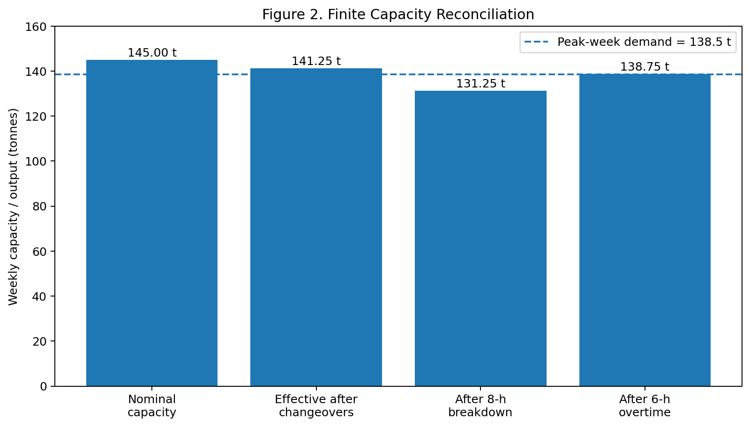
Figure 2. Finite Capacity Reconciliation

4. SAP SCM Production Planning Functionalities
The case uses several SAP SCM/APO planning concepts together rather than treating production scheduling as a single transaction. The purpose is to demonstrate the logical relationship between demand, aggregate supply balancing, detailed scheduling and execution feedback.
SAP capability | Role in this case
Demand Planning / demand input | Provides forecast or requirement signals that form the production-planning demand.
Supply Network Planning (SNP) | Balances demand, supply, production, procurement and distribution at an aggregate planning level.
Production Planning and Detailed Scheduling (PP/DS) | Creates and sequences short-term production plans while considering finite resource capacity.
Resource planning | Represents available machine or work-center capacity, calendars and capacity restrictions.
Product / location master data | Defines which materials are planned and where they are produced or consumed.
Production Data Structure (PDS) | Conceptually links product, BOM/routing and resource information for advanced planning.
Alert / exception monitoring | Highlights overloads, shortages, lateness and planning inconsistencies.
CIF | Conceptual integration mechanism for synchronizing relevant ERP and SAP SCM/APO data.

4.1 Why PP/DS Matters
SNP can create a feasible aggregate supply plan at weekly level, but the plant still needs a detailed sequence. PP/DS-style thinking adds resource timing, setup/changeover considerations, finite capacity and order priorities. In this scenario, that distinction is critical because the packaging line has only 2.75 tonnes of headroom after the two assumed changeovers.

4.2 Production Order Lifecycle
The simulated lifecycle is: demand requirement → supply planning → planned order → capacity check → detailed scheduling → material readiness check → production order / execution handoff → confirmation and goods receipt → planning feedback. A schedule is not released when a critical material shortage or unresolved bottleneck makes the plan infeasible.

5. Production Master Data and Configuration Guidelines
Before running a scheduling simulation, the planning model needs consistent master data. Incorrect runtimes, invalid calendars, wrong lot sizes or outdated BOMs can create misleading schedules. The following is a conceptual configuration blueprint rather than a claim of configuration in a live SAP system.

5.1 Product and Location Data
Object | Illustrative setup | Purpose
Finished products | MUM500, RDM500, JIM500 | Planning and production identifiers.
Plant | HYD-PL01 | Manufacturing location.
Production resources | MIX-01, PACK-01 | Mixing and packaging capacity.
Warehouse | HYD-FG01 | Finished-goods staging and receipt.
Planning horizon | 7-day detailed / longer aggregate horizon | Separates tactical and short-term planning.
Base UoM | tonnes | Consistent capacity and demand calculations.

5.2 BOM, Routing and Production Version
- Maintain a BOM for each finished product with raw millet and packaging components.
- Maintain routing/operation sequence for mixing, quality check and packaging.
- Assign realistic operation durations and resource requirements.
- Create or identify a production version linking the valid BOM and routing.
- Set validity dates and lot-size ranges so the planner does not select obsolete alternatives.
- Where applicable, model setup/changeover time between different products on the same packaging resource.

5.3 Resource and Calendar Settings
- Define PACK-01 as the primary constrained resource with 145 t/week nominal capacity.
- Define MIX-01 with 160 t/week nominal capacity.
- Maintain working-time calendars and explicitly block planned maintenance periods.
- Represent cleaning/quality-hold time as unavailable or restricted capacity.
- Maintain capacity consumption logic consistent with the routing and production rate.
- Use finite scheduling so the system does not place overlapping operations on PACK-01.

5.4 Planning Parameters
Parameter | Illustrative rule | Reason
Lot size | 5 t planning increments | Makes the schedule operationally practical.
Priority | Customer due date + service criticality | Protects urgent requirements.
Frozen horizon | First 24 h | Prevents unnecessary short-term replanning.
Planning horizon | 7 days detailed | Covers the simulated peak week.
Safety buffer | Small finished-goods buffer | Protects against minor disruption where shelf-life permits.
Rescheduling rule | Change only affected orders first | Reduces plan instability.

6. Methodology: Demand to Production Schedule
The scheduling methodology follows a controlled sequence so that each decision is supported by a capacity, material or service check.
Step | Method
Step 1 - Validate demand | Review 138.5 t peak demand by SKU and confirm due dates.
Step 2 - Check supply | Confirm raw millet and packaging-material availability.
Step 3 - Create aggregate plan | Balance demand and production capability at SNP level.
Step 4 - Convert to detailed supply | Create or review planned orders for the manufacturing plant.
Step 5 - Validate master data | Check BOM, routing, production version, resource and calendar validity.
Step 6 - Perform finite scheduling | Sequence production on MIX-01 and PACK-01 while respecting capacity.
Step 7 - Minimize changeovers | Group the same SKU into campaigns where customer dates permit.
Step 8 - Check material readiness | Do not release an order with a critical component shortage.
Step 9 - Review exceptions | Investigate overloads, late orders, material alerts and downtime.
Step 10 - Release controlled plan | Release only when capacity, materials and due dates meet agreed criteria.
Step 11 - Capture execution feedback | Use confirmations, receipts and exceptions to update the next planning cycle.

The methodology deliberately separates planning from execution. The report demonstrates what a planner should configure and validate, not a claim that these transactions were executed in a productive SAP client.

7. Scheduling Simulation and Sample Production Plan
The following schedule uses campaign logic to reduce unnecessary changeovers. Production is rounded into practical 5-tonne planning lots, resulting in 140 tonnes of scheduled output against 138.5 tonnes of demand. The 1.5-tonne difference is an illustrative buffer and would require an actual shelf-life, inventory and warehouse-capacity check before being produced in a live environment.
Day | SKU | Planned quantity | Main resources | Scheduling rationale
Mon | MUM500 | 25 t | MIX-01 + PACK-01 | Start high-demand campaign.
Tue | MUM500 | 30 t | MIX-01 + PACK-01 | Complete MUM500 campaign before changeover.
Wed | RDM500 | 30 t | MIX-01 + PACK-01 | First changeover; run RDM500 campaign.
Thu | RDM500 | 20 t | MIX-01 + PACK-01 | Complete RDM500 requirement.
Fri | JIM500 | 20 t | MIX-01 + PACK-01 | Second changeover; start JIM500.
Sat | JIM500 | 15 t | MIX-01 + PACK-01 | Finish requirement and reserve maintenance window.

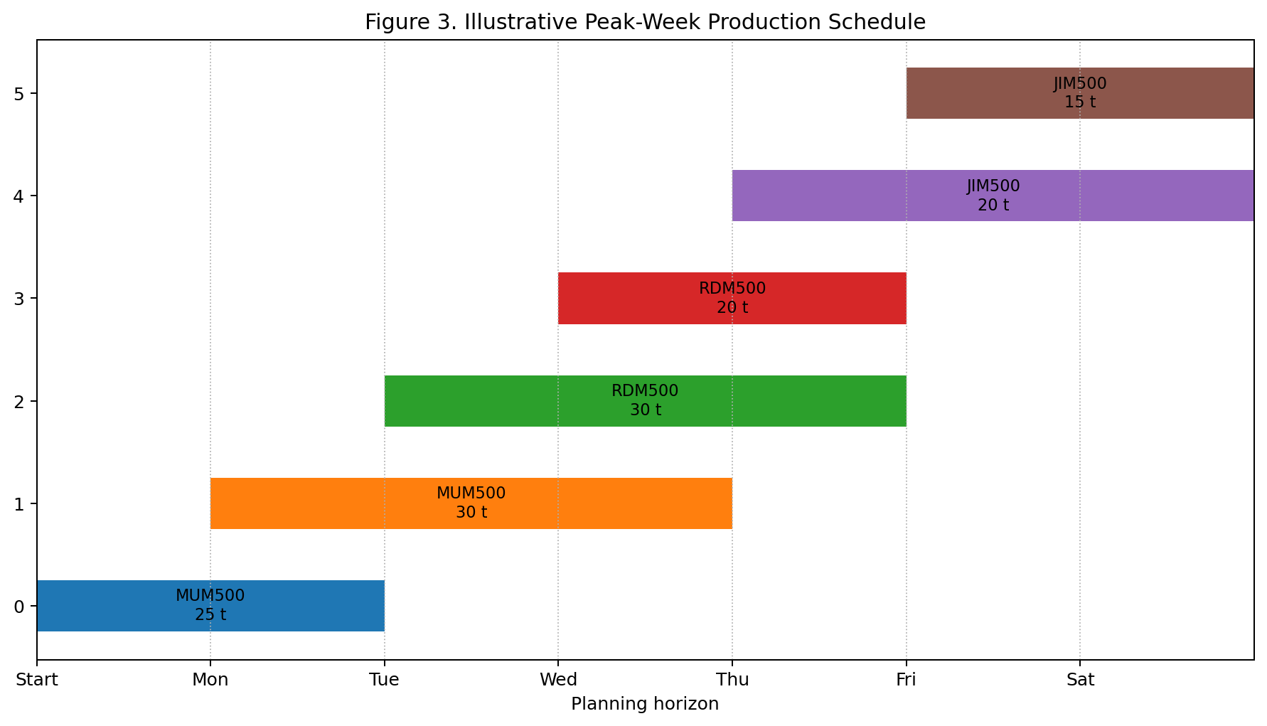
Figure 3. Illustrative Peak-Week Production Schedule

7.1 Simulated PP/DS Planning Board
Figure 5 is a training illustration of how a planner might view resource assignments, changeovers and material readiness in a PP/DS-style planning board. It is intentionally labelled as simulated because no live SAP system screenshot is being claimed.
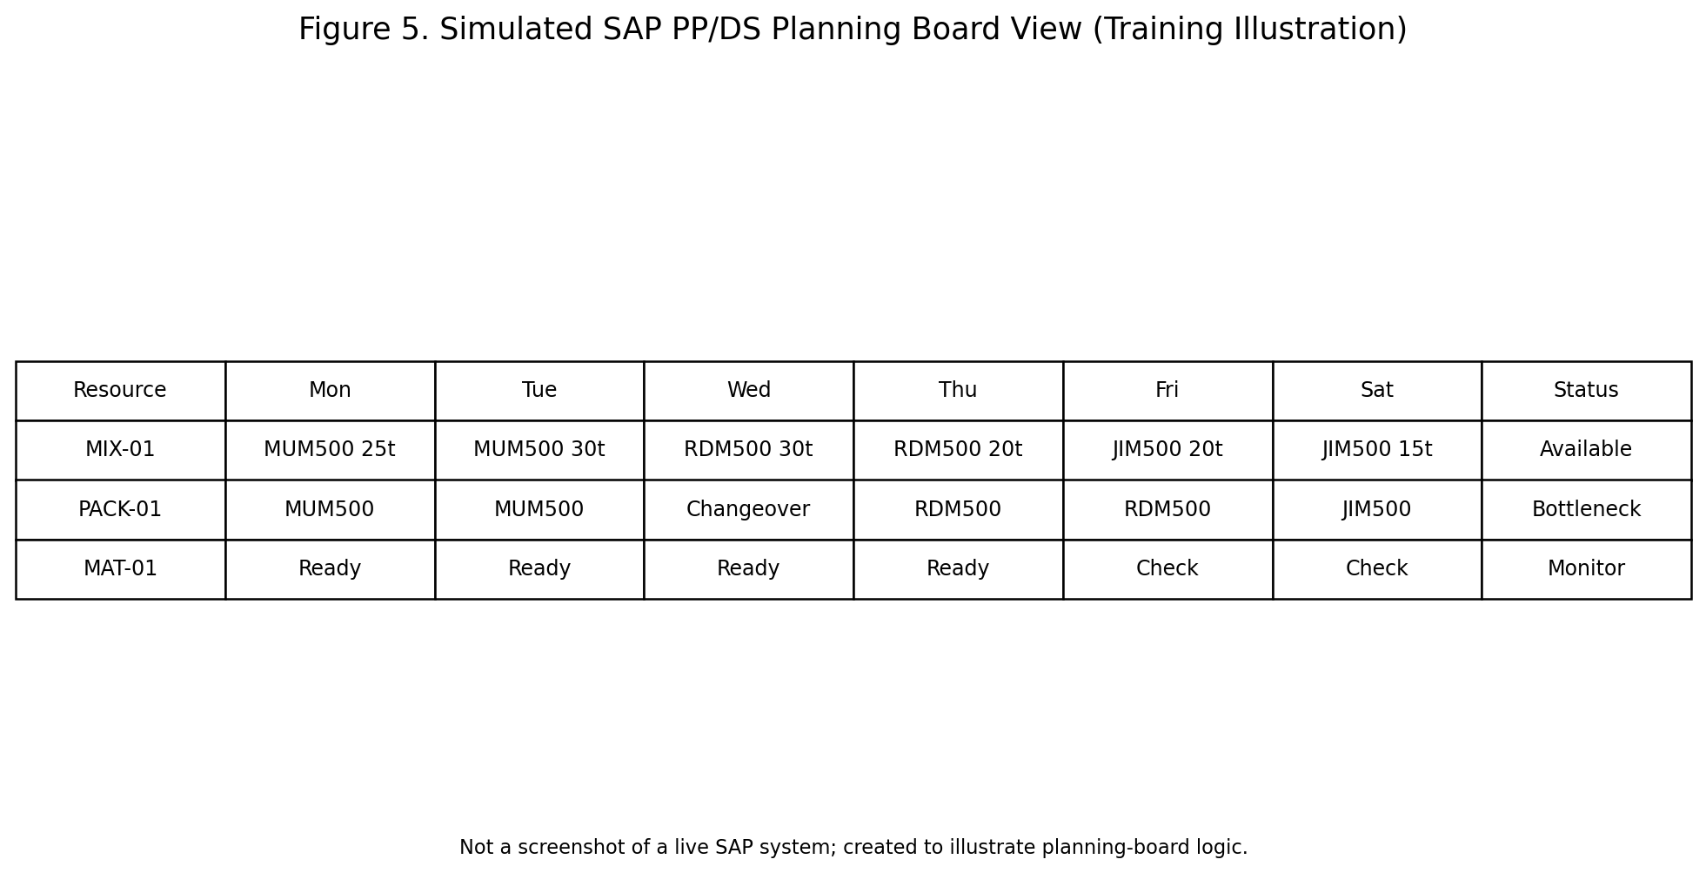
Figure 5. Simulated SAP PP/DS Planning Board View

7.2 Capacity Check
Measure | Value | Interpretation
Peak demand | 138.5 t | Requirement to be scheduled.
Packaging nominal capacity | 145 t | Primary bottleneck resource.
Nominal utilization | 95.5% | High utilization before sequence losses.
Effective capacity after changeovers | 141.25 t | Finite capacity after setup losses.
Effective utilization | 98.1% | Very small operational buffer.
Mixing capacity | 160 t | Approx. 86.6% utilization at peak demand.

The schedule therefore should not be treated as fixed. Any breakdown, longer changeover, material delay or demand increase requires exception review and potentially a controlled reschedule.

8. Bottleneck Analysis and Resource Constraints

8.1 Primary Bottleneck: Packaging
Packaging is the limiting resource because its 145-tonne nominal weekly capacity is closest to the 138.5-tonne demand requirement. Once 3.75 tonnes of capacity is consumed by changeovers, only 2.75 tonnes of effective headroom remains. This is less than the 10-tonne impact of the simulated eight-hour breakdown.

8.2 Secondary Constraints
- Raw millet: 150 t/week is only modestly above the 138.5 t production requirement, so a supplier delay can quickly become a production constraint.
- Packaging materials: a five-day replenishment assumption means a late delivery can affect the packaging line even when upstream mixing capacity is available.
- Cleaning and quality holds: six hours of weekly restricted time reduces available runtime.
- Maintenance: four hours are reserved, so the planner should not use that time as hidden production capacity.
- Changeovers: two 1.5-hour changes remove 3.75 tonnes at the assumed packaging rate.

8.3 Bottleneck Detection Logic
A practical planner decision sequence is: identify overloaded resource → quantify lost capacity → check affected orders and due dates → check material availability → determine whether resequencing can recover capacity → evaluate overtime or alternate capacity → document the exception and approval → release the revised schedule.
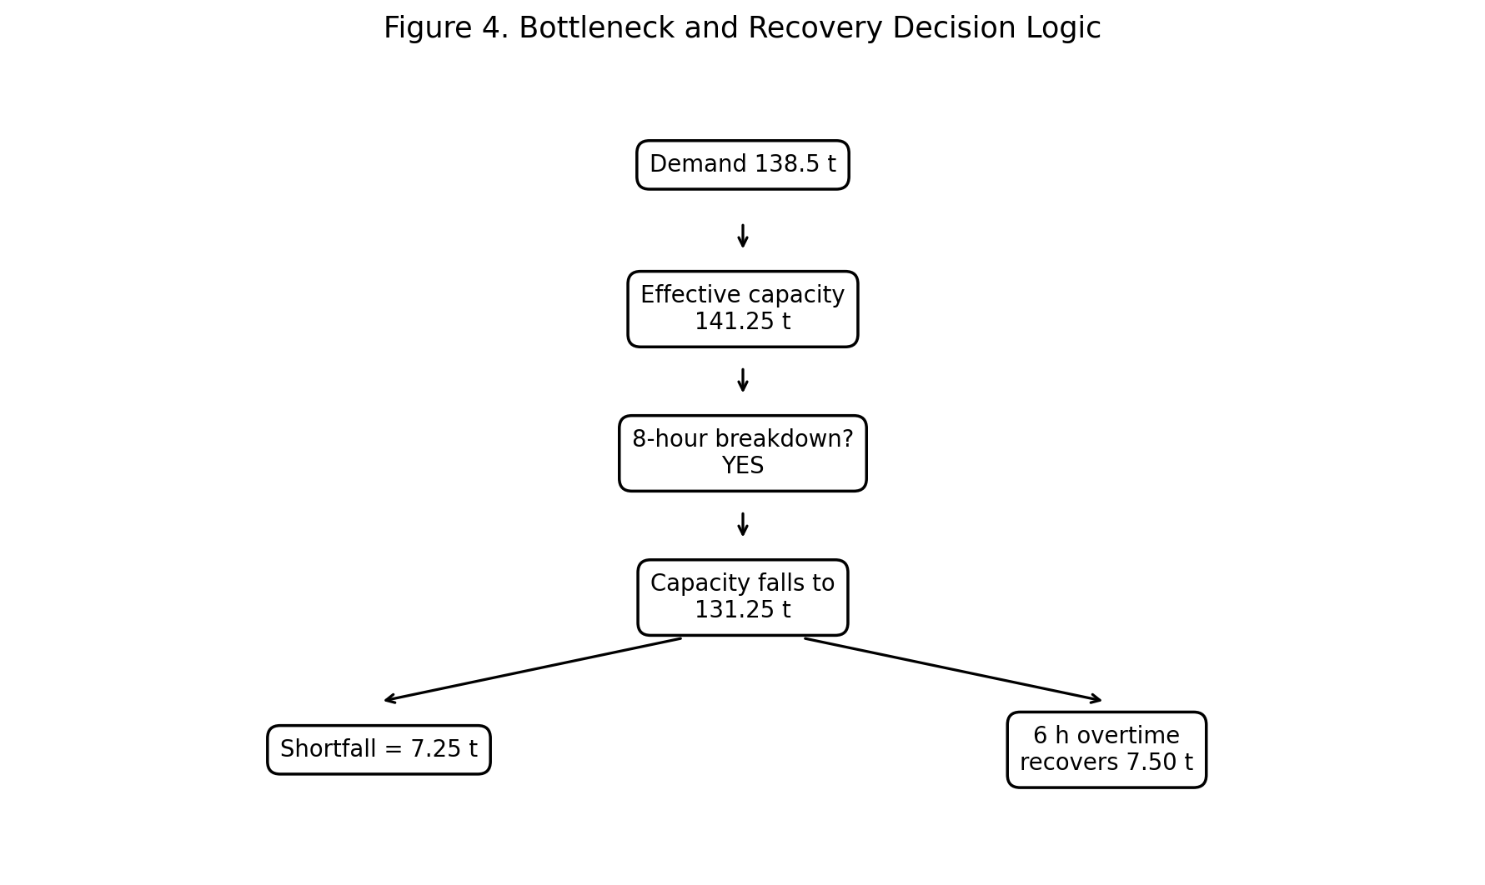
Figure 4. Bottleneck and Recovery Decision Logic

9. ERP - SAP SCM Integration Framework
The planning process depends on consistent data between ERP execution and SAP SCM/APO planning. In the simulation, CIF is used conceptually as the synchronization layer for relevant master data and planning information. The exact integration design depends on system release and landscape.
Data / object | ERP-side source | SCM planning use | Control
Material master | Material master | Product/location planning | Validity and UoM check
BOM | Production master data | Component requirements | Version validity check
Routing / work center | Production planning | Operation times and resource use | Runtime/capacity validation
Production version | Production planning | Valid BOM + routing combination | Date and lot-size check
Resource calendar | Capacity management | Finite scheduling | Working-time validation
Demand / requirements | Order or planning input | Supply and production planning | Quantity and date reconciliation
Execution confirmation | Production execution | Feedback to planning | Actual vs planned comparison

9.1 Integration Controls
- Reconcile product and location master data before planning.
- Check that BOM and routing validity dates overlap with the planning horizon.
- Review integration queues or error lists before schedule release where the landscape uses them.
- Prevent unresolved master-data errors from being hidden by manual schedule changes.
- Document emergency overrides with approver, reason, affected orders and recovery action.

10. Scenario Analysis and Recovery Decisions

10.1 Eight-Hour Packaging Breakdown
The disruption is deliberately quantified so that the recovery decision can be evaluated rather than described only in words.
Step | Calculation | Result
Effective capacity before disruption | 145.0 - 3.75 | 141.25 t
Breakdown loss | 8 h x 1.25 t/h | 10.00 t
Capacity after breakdown | 141.25 - 10.00 | 131.25 t
Peak-week shortfall | 138.50 - 131.25 | 7.25 t
Overtime recovery | 6 h x 1.25 t/h | 7.50 t
Capacity after overtime | 131.25 + 7.50 | 138.75 t
Residual buffer | 138.75 - 138.50 | 0.25 t

Decision: six hours of approved overtime is sufficient in this illustrative case, but it leaves almost no residual buffer. If overtime is unavailable, the planner must consider finished-goods stock, alternate approved capacity, customer-priority sequencing or a controlled due-date change.

10.2 Other Disruption Cases
Scenario | Impact | Recommended response
Packaging material delayed 2 days | Packaging cannot execute planned quantities | Expedite supplier; resequence mixing; protect material-ready orders.
Demand rises by 5% | 138.5 t becomes approx. 145.4 t | Add capacity/overtime or split production; review service priorities.
Raw millet receipt delayed | Mixing may stop | Use available stock, alternate approved source or resequence finished-goods production.
Quality hold extends by 4 h | Further capacity loss | Recalculate finite capacity and protect highest-priority orders.
Critical order due date pulled forward | Late risk increases | Prioritize order, reschedule lower-priority lots and check material readiness.

10.3 Strengths and Weaknesses of the Proposed Approach
Strengths | Weaknesses / limitations
Makes capacity and bottlenecks measurable. | Simulation uses assumed rates rather than live machine data.
Reduces unnecessary changeovers through campaign sequencing. | A live system may have more complex setup matrices.
Uses finite-capacity thinking rather than aggregate capacity only. | Actual SAP screen paths vary by release and configuration.
Defines controlled exception and recovery decisions. | Overtime and alternate capacity require real business approval.
Links master data quality to schedule feasibility. | No live integration queues or execution confirmations were available.

11. KPI Framework and Monitoring
The following KPIs help a production planner determine whether the schedule is both feasible and operationally useful.
KPI | Formula / definition | Illustrative target | Owner / review
Capacity utilization | Required output / available finite capacity | 90-97% normal; >97% alert | Production planner / daily
Schedule adherence | Orders completed as planned / planned orders | >=95% | Production supervisor / daily
OTIF | On-time, in-full orders / total orders | >=95% | Supply-chain lead / weekly
Changeover time | Actual setup hours by campaign | <= planned standard | Production / per changeover
Material readiness | Orders with all critical inputs available / planned orders | >=98% | Material planner / daily
Downtime | Unplanned downtime hours | Trend downward | Maintenance / daily
Shortage quantity | Demand affected by component/resource shortage | Minimize | Planner / daily
Plan stability | Changed orders / frozen-horizon orders | Low and controlled | Planning lead / daily

KPI interpretation should be exception-based. A high utilization number is not automatically good if it creates repeated lateness. In this case, 98.1% effective utilization demonstrates that the schedule has very little resilience, so the planner should treat it as an alert condition rather than a success by itself.

12. Validation and Testing Approach
Before releasing a production schedule, I would validate both master data and planning outcomes. The following tests convert the simulation into a practical acceptance checklist.
Test | Validation condition | Expected result
T01 Demand reconciliation | SKU demand totals equal 138.5 t | Pass; no unexplained quantity difference.
T02 Resource capacity | PACK-01 schedule does not exceed finite availability | No unresolved overload.
T03 Changeover calculation | Two 1.5-h changes are included | Effective capacity = 141.25 t.
T04 Material readiness | Critical raw and packaging inputs available | No critical shortage at release.
T05 Calendar validation | Maintenance and restricted time excluded | Schedule respects unavailable periods.
T06 Lot-size check | Production quantities follow 5-t planning increment | No unintended fractional lots.
T07 Breakdown simulation | 8-h downtime applied to PACK-01 | Shortfall = 7.25 t.
T08 Recovery test | 6-h overtime added | Recovered output = 7.50 t.
T09 Priority test | High-priority order moved ahead of lower priority | Due-date risk reduced.
T10 Integration/master-data test | BOM, routing, production version and resource data valid | No critical planning inconsistency.
T11 KPI test | Utilization and adherence formulas recalculated | Values trace to source quantities.
T12 Release-control test | Critical exception remains open | Schedule release blocked until approved.

13. Risks, Controls and Contingency Actions
Risk | Likelihood | Impact | Control / contingency | Owner
Packaging breakdown | Medium | High | Preventive maintenance; alternate capacity; overtime decision tree | Maintenance + planner
Packaging material delay | Medium | High | Supplier confirmation; expedite; safety buffer | Procurement
Wrong runtime master data | Medium | High | Validate routing/PDS times against approved standards | Master-data owner
Demand spike | Medium | High | Scenario planning; priority sequencing; capacity reservation | Planning lead
Raw-material shortage | Medium | High | Supplier confirmation; alternate source; inventory buffer | Material planner
Excess rescheduling | Medium | Medium | Frozen horizon and change-control rule | Planning lead
Integration/data error | Low/Medium | High | Pre-release reconciliation and error monitoring | Integration support
Overproduction | Low/Medium | Medium | Check demand, shelf-life and warehouse capacity before buffer production | Production + warehouse

13.1 Governance Matrix
Control | Responsible role | Frequency | Evidence
Master-data validation | Master-data owner | On change / monthly | Validation checklist
Capacity review | Production planner | Daily | Capacity report
Material readiness | Material planner | Daily | Shortage / confirmation list
Schedule release | Planning lead | Daily | Approved schedule
Downtime review | Maintenance + production | Per event | Downtime record
KPI review | SCM / planning lead | Weekly | KPI dashboard and actions
Exception closure | Assigned owner | Per exception | Action log

14. Estimated 33-Hour Work Plan
The following estimate demonstrates a realistic allocation of effort for research, scenario design, SAP concept mapping, analysis, documentation and validation. It is an estimated work plan, not a claim that every activity was timed to the minute.
Activity | Hours | Output / evidence
Research SAP SCM / PP/DS production planning concepts | 4.0 | Research notes and SAP references
Review previous supply-chain scenario and define Week 4 assumptions | 2.5 | Assumption log and continuity notes
Develop demand, capacity and resource scenario | 4.0 | Demand/capacity tables
Map ERP and APO master-data requirements | 4.0 | Master-data checklist
Document configuration and integration methodology | 5.0 | Configuration sequence and integration flow
Create schedule and capacity calculations | 3.0 | Schedule, utilization and breakdown calculations
Perform bottleneck and recovery analysis | 3.0 | Scenario analysis and decision logic
Define KPIs, tests and release controls | 2.5 | KPI/test matrix
Prepare diagrams, tables, formatting and references | 3.0 | Figures and report package
Final review and corrections | 2.0 | Calculation and visual QA
Total | 33.0 | Complete Week 4 submission package

15. Key Learning Outcomes
- I understood the difference between aggregate supply planning and short-term finite-capacity production scheduling.
- I learned why a shared packaging resource can become the true plant bottleneck even when overall plant capacity appears sufficient.
- I connected material masters, BOMs, routings, work centers/resources and production versions with SAP SCM/APO planning concepts.
- I learned how changeover time should be converted into measurable capacity loss rather than ignored.
- I learned to use a bottleneck scenario to compare shortage quantity with recovery options such as overtime and alternate capacity.
- I understood that material readiness and master-data quality are release controls, not administrative activities after scheduling.
- I learned to evaluate a production schedule using due dates, capacity, materials, changeovers, downtime and plan stability together.

16. Conclusion
This Week 4 project demonstrates a complete production planning and scheduling approach using SAP SCM/APO concepts. Starting with 138.5 tonnes of peak-week demand, the planning method moves through aggregate supply balancing, master-data validation, PP/DS-style finite scheduling, campaign sequencing, exception review and execution feedback.
The most important result is the capacity reconciliation. Nominal packaging utilization is 95.5%, but two 1.5-hour changeovers reduce usable capacity from 145 tonnes to 141.25 tonnes. Effective utilization therefore rises to approximately 98.1%, leaving only 2.75 tonnes of headroom. An 8-hour packaging breakdown then removes 10 tonnes of output and creates a 7.25-tonne shortfall. Six hours of approved overtime recovers 7.5 tonnes, leaving a 0.25-tonne residual buffer.
The exercise shows why a production planner should not rely only on aggregate capacity. A feasible plan must also account for sequencing, setup time, calendars, material readiness, downtime and order priorities. SAP SCM/APO planning concepts provide a structured way to make these relationships visible and to convert supply-chain demand into a more executable production plan.
All figures, company details and operational results in this report are illustrative. The document is presented as an internship planning simulation and configuration blueprint, not as evidence of live SAP production-system execution.

17. References
1. SAP Help Portal - SAP Supply Chain Management / SAP Advanced Planning and Optimization documentation.
2. SAP Help Portal - Production Planning and Detailed Scheduling (PP/DS) concepts and planning functions.
3. SAP Help Portal - Supply Network Planning (SNP) concepts and supply planning processes.
4. SAP Help Portal - Core Interface (CIF) integration concepts between SAP ERP and SAP APO.
5. SAP ERP Production Planning concepts: material master, BOM, routing, work center, production version, planned order and production order.
6. Course notes and training materials used for SAP MM / SAP SCM learning.
7. Internship Week 4 assignment brief: Production Planning and Scheduling Analysis in SAP SCM.

18. Portal Submission Description
This Week 4 report presents a Production Planning and Scheduling Analysis in SAP SCM using a practical internship simulation for the fictional Deccan Harvest Foods Pvt. Ltd. The case focuses on converting a peak-week demand requirement into an executable production schedule while considering finite capacity, product changeovers, material availability, resource calendars, downtime and order priorities.
The report uses SAP SCM/APO concepts including Supply Network Planning (SNP), Production Planning and Detailed Scheduling (PP/DS), production resources, Production Data Structures, master-data validation, exception monitoring and conceptual ERP-SCM integration through CIF. It documents the planning methodology from demand validation and aggregate supply balancing through planned-order review, finite-capacity scheduling, sequence optimization, material-readiness checks and controlled schedule release.
A worked capacity simulation uses 138.5 tonnes of peak-week demand and 145 tonnes of nominal packaging capacity. Two illustrative 1.5-hour changeovers at 1.25 tonnes per hour reduce effective capacity to 141.25 tonnes, increasing modeled utilization to approximately 98.1%. An 8-hour packaging breakdown then creates a 7.25-tonne shortfall. Six hours of approved overtime recovers 7.50 tonnes, leaving a small 0.25-tonne buffer.
The report includes production schedules, process-flow diagrams, a simulated PP/DS planning-board view, capacity analysis, bottleneck decision logic, KPI framework, 12 validation tests, governance controls, risks, contingency actions and a 33-hour work plan. All values and outcomes are illustrative and are presented as an internship planning simulation rather than live SAP production execution.
Word count of this portal description is above the internship minimum of 200 words.

