SUPPLY CHAIN MANAGEMENT / INTERNSHIP PROJECT
Supply Chain Integration
and Collaboration Analysis
SAP SCM • Week 5 Assessment
Prepared by
Hrudhai Prem Kumar
Case study: Deccan Harvest Foods Pvt. Ltd. (fictional company)
REPORT SCOPE
Cross-functional integration across procurement, production planning, inventory, quality, warehousing, transportation, sales, and partner collaboration.
Prepared 22 October 2026 • All company-specific quantities and workflow results are illustrative.

Contents
Executive Summary
1. Assignment Alignment and Objectives
2. Public Context and Scenario Design
3. Current-State Problem and Integration Objectives
4. Target SAP Integration Architecture
5. Master Data and Transactional Touchpoints
6. End-to-End Workflow Simulation
7. Worked Example: Packaging-Material Delay
8. Configuration and Implementation Blueprint
9. Collaboration and Operating Model
10. Integration Monitoring and Exception Management
11. KPI Framework and Target-State Measures
12. Validation and Testing Plan
13. Risks, Controls, and Failure Scenarios
14. Recommendations and 30/60/90-Day Roadmap
15. Estimated 33-Hour Work Plan
16. Learning Outcomes and Conclusion
Portal Submission Description
References
Reading note: The report separates public contextual evidence from the fictional operating scenario. Diagrams, monitoring records, timestamps, targets, and calculated outcomes are simulated design artifacts—not screenshots or results from a live SAP system.

Executive Summary
This Week 5 assessment examines how procurement, production planning, manufacturing execution, inventory, quality, warehousing, transportation, and customer-facing order management can work as one connected supply chain. The case study uses Deccan Harvest Foods Pvt. Ltd., a fictional manufacturer of 500-gram millet-based ready-to-cook food products. The objective is to design a practical information flow, specify where core business data originates, define how changes reach dependent teams, and show how exceptions should be detected and resolved.
Public context is taken from APEDA’s Annual Administrative Report 2024–25. It reports that the value of India’s cereal-preparation exports rose from USD 842 million in FY 2023–24 to USD 934 million in FY 2024–25, a reported increase of 10.92%. This provides a relevant context for considering packaged food supply chains; it is not treated as a demand forecast for the fictional company. [7]
The simulated weekly demand is 138.5 tonnes across three 500-gram SKUs. At 2,000 packs per finished tonne, the packaging requirement is 277,000 pouches. Current pouch stock is assumed to be 215,000 pieces, with a further 62,000-piece supplier delivery due at the start of the planning week. A 24-hour supplier delay creates a temporary coverage constraint equivalent to 31 tonnes. The integration response is to update the purchasing document, transfer the revised availability date into planning, re-sequence the packaging plan using customer due dates, alert warehouse and transport planners, and release the deferred balance only after receipt and quality status are confirmed.
The report compares a legacy SAP APO architecture, where ERP and APO exchange planning-relevant master and transactional data via CIF, with an SAP S/4HANA landscape in which PP/DS may be embedded. The architecture also maps procurement, production orders, sales deliveries, EWM/warehouse processes, TM freight planning, partner status updates, and monitoring ownership. The key recommendation is to treat integration as both a technical flow and an operating model: clean master data, explicit event ownership, acknowledgements, queue monitoring, documented correction steps, and shared service targets are required for dependable collaboration. [1][2][3][4][5]
A proposed test plan, RACI matrix, exception workflow, integration-monitor design, KPI definitions, risks, and a 30/60/90-day improvement roadmap are included. All case-specific numbers beyond the APEDA public facts are illustrative assumptions. The report describes how the process could be configured and tested; it does not claim live SAP execution.
Primary conclusion: Integration creates business value only when the right information reaches the right owner in time to change a decision. A technically successful message that is not acknowledged, understood, or acted upon is still an operational failure.

1. Assignment Alignment and Objectives
The assessment requires a detailed integration strategy covering procurement, production, and logistics; a map of SAP SCM integration touchpoints; simulated workflows and configuration steps; analysis of integration risks; and actions that strengthen cross-functional collaboration. This report answers those requirements through a single scenario rather than describing each SAP component in isolation.

1.1 Project objectives
- Create an end-to-end model showing how demand, purchase orders, supplier confirmations, stock, production orders, quality status, deliveries, freight planning, and proof of delivery relate to each other.
- Define the source of truth and business owner for each important data object, including material, location, supplier, unit of measure, BOM/production data, order, delivery, and transportation status.
- Demonstrate a simulated packaging-material delay and show the information and planning decisions needed to protect customer commitments.
- Document a version-aware SAP configuration blueprint, including where legacy APO/CIF steps may apply and where an embedded S/4HANA PP/DS landscape differs.
- Propose tests, monitors, KPIs, governance rules, and a staged improvement plan that can be adapted to a real implementation.

1.2 Scope and limitations
The scope covers integration design and collaboration across MM/procurement, PP/PP-DS planning, inventory management, QM/quality status, SD/order and delivery management, EWM/warehouse execution, TM/transportation planning, and external suppliers/carriers. Finance is considered only where goods receipts, invoice matching, freight charges, and document references need reconciliation. The report is not a technical design specification for a named customer SAP release. An actual build must confirm the installed products, activation status, integration approach, APIs/interfaces, authorizations, message types, and organizational settings.

2. Public Context and Scenario Design

2.1 Public context
APEDA’s Annual Administrative Report 2024–25 describes the role of processed and value-added foods in India’s export mix and lists cereal preparations as a significant category. The report records cereal-preparation export value of USD 934 million for FY 2024–25 compared with USD 842 million in FY 2023–24, and reports 10.92% growth year on year. It also identifies the USA, UAE, UK, Canada, and Nepal among the major markets for cereal preparations. [7] These public facts support a general scenario involving packaged grain-based products and distribution across multiple markets; they do not prove that millet ready-to-cook meals follow the same trend or share the same buyers.
The business implication is not simply “sell more.” A business serving multiple regions must coordinate supplier commitments, ingredients and packaging, production slots, quality release, warehouse capacity, transport cut-off times, and customer delivery windows. If the supplier changes the promised date but that change remains in an email inbox, the production plan can keep showing material as available and downstream orders may be promised on dates that cannot be met.

2.2 Fictional business profile
Deccan Harvest Foods Pvt. Ltd. is a fictional packaged-food manufacturer based in Nizamabad, Telangana, serving Hyderabad, Vijayawada, and Bengaluru. It produces three 500-gram millet-based ready-to-cook products, creating a manageable scenario with procurement, production, stock, quality, warehouse, transport, and customer-order dependencies.
Business element | Illustrative assumption
Manufacturing site | Nizamabad, Telangana
Distribution destinations | Hyderabad DC, Vijayawada DC, Bengaluru DC
Products | MUM500, RDM500, JIM500; each packaged as a 500 g unit
Weekly demand | 138.5 tonnes across the three products
Nominal weekly packaging capacity | 145 tonnes; effective planning allowance after sequence changeovers: 141.25 tonnes
Packaging material | Food-grade laminate pouch, one pouch per saleable 500 g unit for the simplified model
Supplier event | A scheduled 62,000-piece pouch receipt is delayed by 24 hours
System landscape | ERP execution with SAP planning capabilities; EWM/warehouse and TM/transport integration are design options based on actual product scope

2.3 Demand and material requirement
SKU | Weekly demand (t) | Pack size | Pouches needed
MUM500 | 55.2 | 0.5 kg | 110,400
RDM500 | 48.3 | 0.5 kg | 96,600
JIM500 | 35.0 | 0.5 kg | 70,000
Total | 138.5 | 0.5 kg | 277,000

Calculation: one tonne contains 1,000 kg; at 0.5 kg per saleable pack, one tonne equals 2,000 packs. Therefore, 138.5 tonnes × 2,000 packs/tonne = 277,000 pouch units. This simplified calculation assumes one usable pouch per saleable pack and ignores scrap, trial packs, damaged packaging, and yield loss. A live BOM and inventory design would plan each SKU’s actual packaging component, labels, batch rules, scrap factors, and unit conversions separately.
Data integrity note: The shared pouch quantity is an illustrative common-material constraint used to demonstrate cross-functional reaction. A real SKU-level integration must not substitute one product’s printed pack or label for another product’s component merely because the units are both counted as “pieces.”

3. Current-State Problem and Integration Objectives
The fictional current state relies on separate email, spreadsheet, ERP, and warehouse updates. Purchasing knows the supplier has moved the delivery date; production sees the original expected date; sales has already communicated delivery windows; and transport continues building loads from the old delivery plan. Each team may be acting reasonably with the data visible to it, yet the combined process is inconsistent.
Current-state weakness | Operational consequence | Integration objective
Supplier date change captured in email only | Planning continues to assume the original receipt date | Update the purchase order confirmation and make the new date visible to planning with a traceable event ID
Inconsistent product/UoM or material identifiers | Planning quantities and inventory balances cannot be reconciled confidently | Establish a governed master-data owner and validate base/sales/issue units
Production reschedule not shared with SD | Customer delivery promise remains unchanged despite a plan change | Recalculate dates and notify order management before customer communication
Warehouse readiness is separate from freight planning | Truck arrives before picking/staging is complete or misses the loading slot | Share delivery, handling unit, staging, loading, and departure statuses
Errors have no single owner or closure rule | Retries occur without fixing the cause; same issue returns | Use assigned queue ownership, correction evidence, and reconciliation before closure

3.1 What good integration looks like
- One current business truth for each event: a supplier date change is recorded in the purchasing document, not kept only in a private email.
- Planning can see the consequence: a changed receipt date affects material availability and is reflected in the production schedule.
- Downstream decisions follow the revised plan: order management, warehouse, and transport teams know which delivery dates and loads are at risk.
- Every critical exchange is observable: there is a document reference, status, timestamp, and an accountable resolver for failures.
- Collaboration closes the loop: a successful technical exchange is followed by business validation that the required stock, order, or delivery actually changed.

4. Target SAP Integration Architecture
The architecture has four conceptual layers: transactional execution, planning, warehouse/transport execution, and cross-functional monitoring. Suppliers, customers, and carriers participate through confirmed business documents and event/status messages. The diagram below is a conceptual map; the exact system boundaries depend on whether the organization operates older SAP APO with ERP, embedded PP/DS within S/4HANA, SAP IBP, decentralized EWM, or an external 3PL stack.
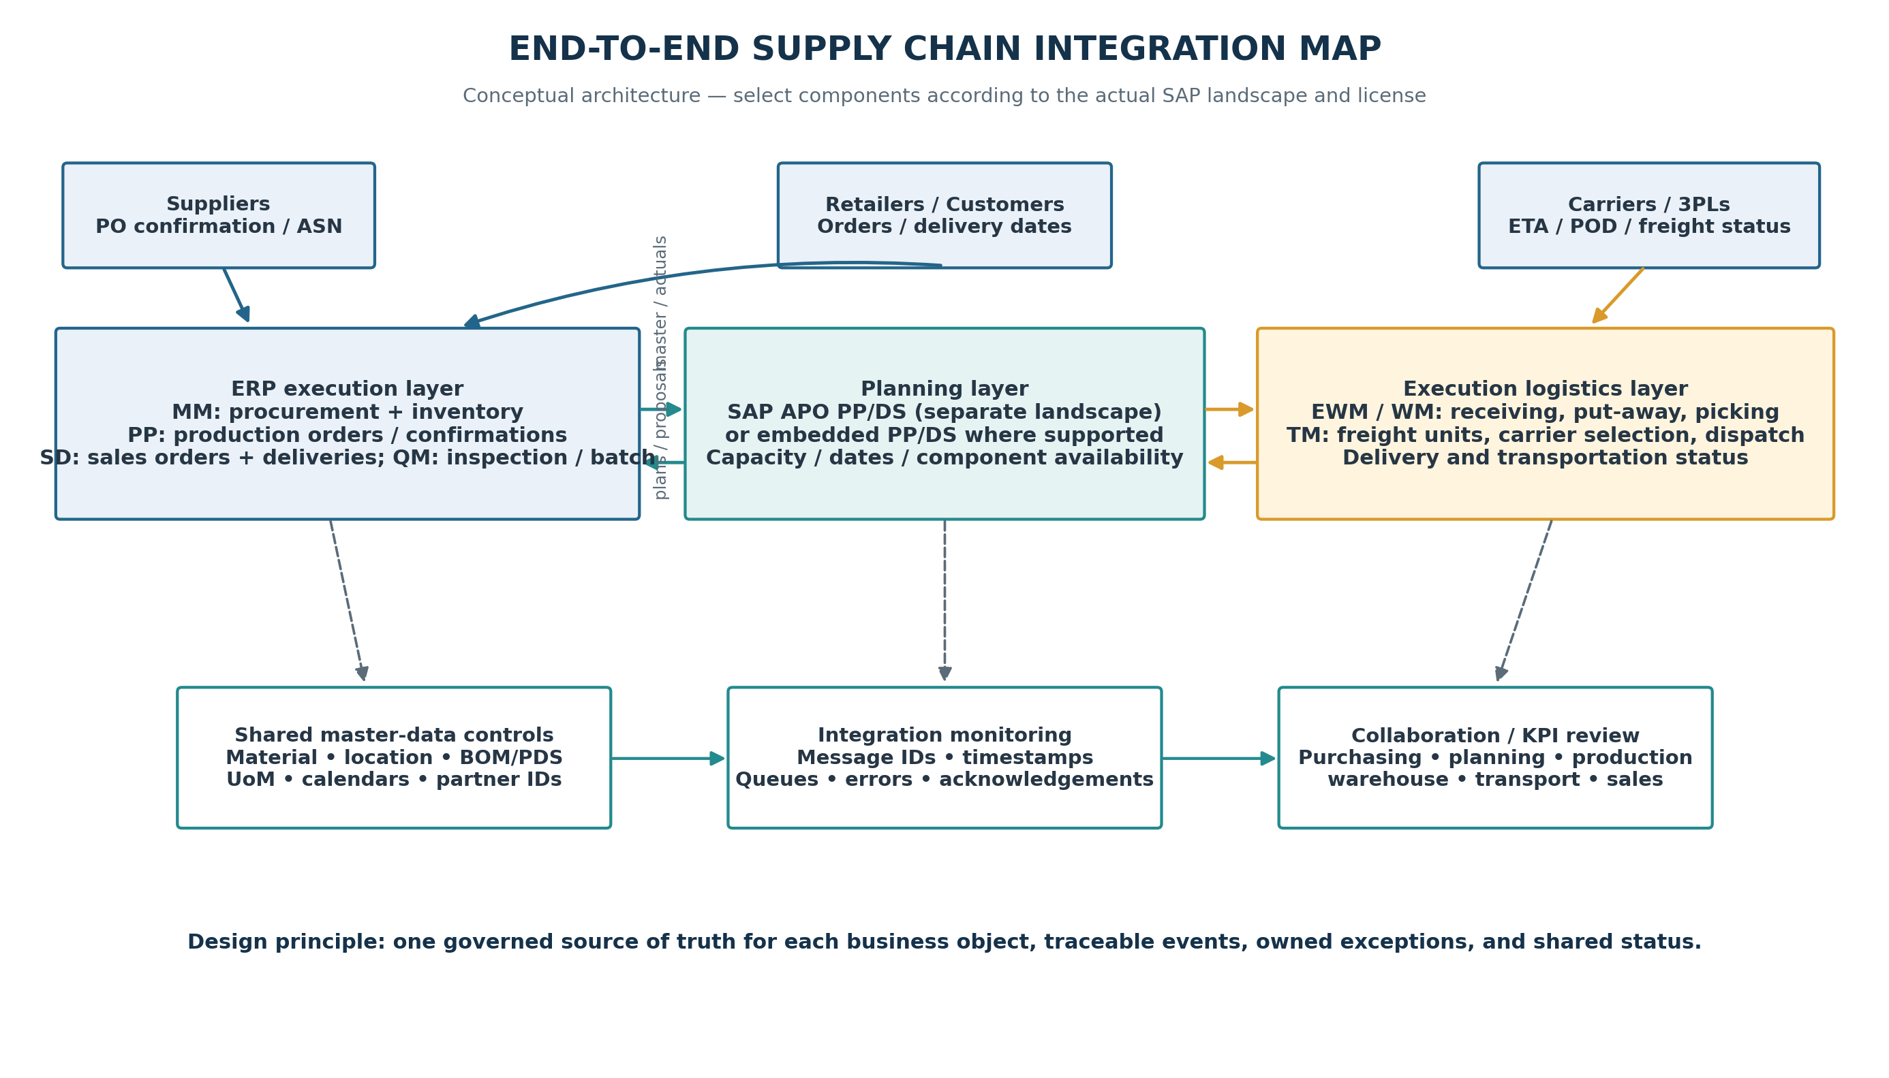
Figure 1. Conceptual end-to-end integration architecture; component deployment is landscape-dependent.

4.1 Planning landscape: version matters
In a legacy SAP APO landscape, the Core Interface (CIF) exchanges relevant master and transactional data between ERP and the connected SCM planning system. SAP documentation describes CIF functions such as initial master-data transfer, transfer of planning-relevant transaction data and changes, and return of planning results to ERP. [1] The integration model identifies which data objects are transferred, and master data is normally maintained in the execution system then transferred to planning. [2]
In an SAP S/4HANA landscape, PP/DS can be embedded where supported and configured. SAP describes PP/DS as creating procurement proposals, optimizing resource schedules and order dates, considering resource and component availability, and planning critical products. Planning-relevant master and transaction data, such as sales orders and stock, is transferred to PP/DS and planning results are returned to S/4HANA. [3] The report therefore uses “planning integration” as the business concept and treats specific CIF steps as conditional legacy-APO activities, not as mandatory steps for every deployment.

4.2 Functional responsibilities and integration roles
Function / component | Primary role in scenario | Key data or event passed to neighbours
MM / Procurement | Purchase requisitions, source, PO, supplier confirmation, goods receipt, invoice references | PO number/item, supplier, expected date, confirmed quantity, receipt posting, material stock
PP / Manufacturing execution | Production orders, release, components, confirmations, yield, goods movements | Order status, start/finish, component consumption, produced quantity, batch/lot
PP/DS / supply planning | Material-resource/date feasibility, order scheduling, exception analysis | Planning proposals, feasible dates, resource loads, shortage and rescheduling signal
Inventory / IM | Unrestricted, quality, blocked and reserved stock balances | Available stock by material, plant, batch, storage location and stock status
QM / batch controls | Inspection decisions, release/hold, lot traceability | Quality status and the earliest date stock can be used or shipped
SD / order and delivery | Sales order, confirmed schedule, outbound delivery, customer promise | Requirement dates, requested/confirmed quantities, delivery reference and shipping status
EWM / warehouse | Inbound receipt, put-away, picking, packing, staging, loading | Warehouse request, handling units, pick/pack status, loading confirmation
TM / transportation | Freight units/orders, carrier selection, tendering, dispatch, charges | Freight plan, vehicle/carrier, dates, ETA, departure, proof of delivery and charge
Supplier / carrier partner | Commitments and execution updates | Order acknowledgement, revised supply date, ASN where used, shipment event and delivery proof
Reporting / integration operations | Monitor freshness, errors, and cross-team exceptions | Message/queue status, lag, retries, owner, ageing, KPI and escalation

4.3 Main design principle
Avoid two-way ownership ambiguity. For example, purchasing owns the purchase order and supplier promise; inventory owns the posted stock state; planning owns the proposed schedule; production owns actual confirmation; warehouse operations own physical pick/load status; and transportation management owns the carrier/freight plan. Other components may consume these objects and send controlled status changes, but they should not silently create competing copies of the same business truth.

5. Master Data and Transactional Touchpoints
Integration quality is mostly determined before the first order is exchanged. Material identifiers, plant and storage-location definitions, supplier/business-partner identifiers, units of measure, BOMs, production versions, resource calendars, batch-management settings, and delivery partners need consistent definitions. In a legacy APO model, SAP documentation identifies master data such as plants/locations, materials/products, customers and vendors as integration objects, and explains that integration models define which objects are transferred. [2]
Data object | Likely owner / source | Validation before sharing | Why it matters
Material / product | ERP material master | Same material ID, status, description, base UoM and conversion | Avoids incorrect demand, stock, or production quantities
Supplier / business partner | ERP purchasing master | Valid partner number, purchasing organization, lead time, confirmations | PO updates must match the right supplier and source
Plant / DC / storage location | ERP / warehouse master | Location codes, time zone, calendar, permitted stock locations | Prevents inventory appearing at the wrong site
BOM / production version / PDS or PPM | Production master data | Correct component quantity, packaging component, alternative, validity dates | Ensures planning sees material dependency and appropriate production method
Resource and calendar | Manufacturing/planning master | Capacity, shift, downtime, setup and maintenance calendar | Prevents false schedule feasibility
Supplier purchase order | MM transactional document | Document/item, open quantity, promised date, receipt and cancellation statuses | Planning needs the latest open supply and confirmed receipt date
Sales order / delivery | SD transaction | Customer, SKU, confirmed date, quantity, shipping point and status | Connects demand, delivery commitments, and freight planning
Batch / quality status | QM / inventory | Lot, shelf life, inspection result, unrestricted/blocked status | Avoids shipping unavailable or unreleased inventory
Freight unit / freight order | TM | Delivery linkage, weight/volume, dates, carrier, vehicle and cost data | Supports feasible load planning and transport visibility

5.1 Rules for transactional event design
- Use a stable document reference, such as PO number/item, production order, delivery, batch, freight unit, or carrier event ID, so related records can be linked without guessing.
- Include event time and processing time. A message can be technically processed but still be too late to support a dispatch or production decision.
- Keep quantities and units explicit. Convert between tonnes and package pieces only through documented product/pack definitions; never compare the numbers without a valid conversion.
- Distinguish planned, confirmed, posted, inspected, released, picked, loaded, dispatched, and delivered statuses. These states are not interchangeable.
- Where the architecture uses asynchronous queues or interfaces, monitor failed messages and retries. Where synchronous APIs or other integration patterns are used, monitor their own response, authentication, and error behaviour.

6. End-to-End Workflow Simulation
The workflow begins with a weekly demand plan and confirmed customer orders. Requirement and stock data are considered by planning; the purchasing process secures material; PP/DS evaluates dates and resource availability; manufacturing executes released orders; inventory and quality records state what is actually usable; then delivery, warehouse, and transport processes execute. SAP procurement documentation describes a typical procurement cycle beginning with requirement determination and source determination before purchasing and receipt processes. [6] SAP PP/DS documentation similarly describes planning critical products and returning planning results to the execution system, with manufacturing orders subsequently processed through release, confirmation, goods movements, and completion. [3][8]
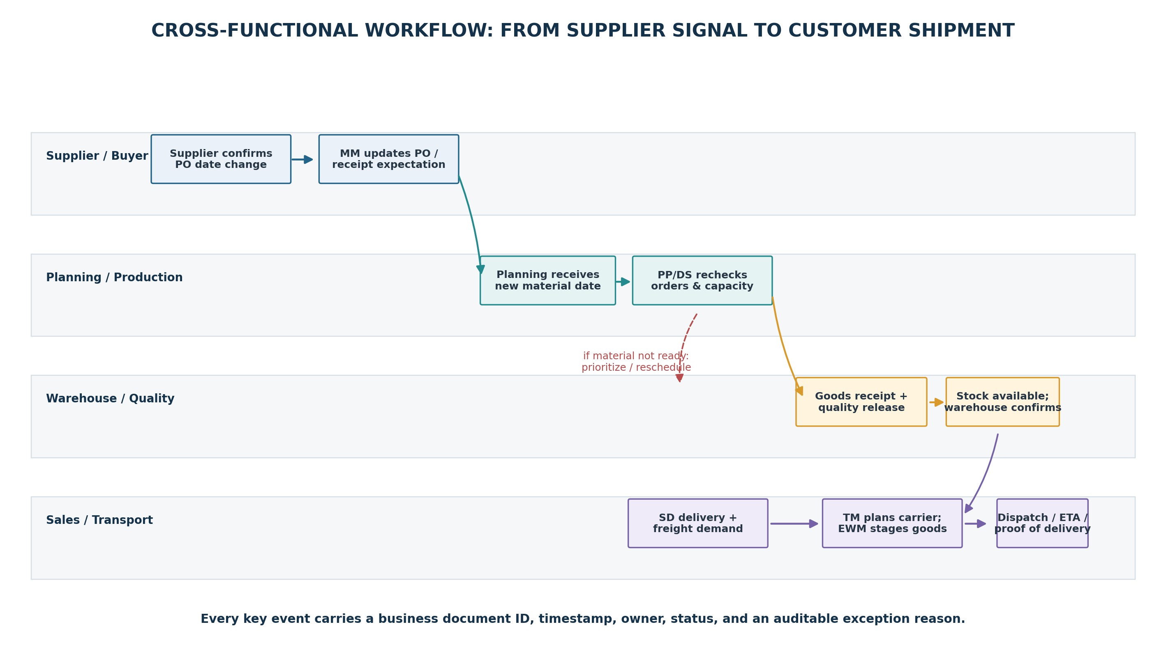
Figure 2. Workflow view showing supplier signal, plan revision, receipt, and delivery execution.

6.1 Step 1 — demand and order creation
Sales and distribution captures or receives the customer requirement with product, quantity, requested delivery date, ship-to, and delivery constraints. The demand total in this simulation is 138.5 tonnes. The requirement is not assumed to be firm until it reaches the agreed planning status. If forecasts, sales orders, and safety-stock demands overlap, the planning team must apply the agreed netting and priority rules to avoid double-counting.

6.2 Step 2 — procurement signal and supplier collaboration
The materials planner checks open supply and sees a planned receipt for 62,000 food-grade pouches. The supplier reports a 24-hour delay. Purchasing records the revised confirmation or delivery date against the relevant PO item. This is the authoritative business change: the date in the PO/confirmation should change through the approved procurement process, and the original promise, new promise, reason, and user or partner source should remain auditable.

6.3 Step 3 — planning integration and re-scheduling
The updated purchasing data becomes available to the planning function according to the selected integration design. PP/DS or the configured planning engine rechecks component availability, order dates, and packaging resource capacity. The planner compares the affected orders against customer delivery dates, sequence changeovers, and the inventory available before the supplier receipt. The planning result is reviewed by a human planner before it is treated as an approved production decision.

6.4 Step 4 — production execution and actuals
Released production orders are executed and actual confirmations, component consumption, and goods receipts are posted in the execution layer. A planning schedule is not proof that output has been produced. Integration should return relevant actuals and changes to the planning view so remaining demand is not planned against stale quantities. If quality inspection is required, the stock remains unavailable for unrestricted use until the inspection and release rules are satisfied.

6.5 Step 5 — warehouse and transportation planning
When finished goods are ready, outbound deliveries connect the sales order to the shipping process. EWM or warehouse management handles picking, packing, staging, and loading, while TM can build freight units and freight orders, select or tender a carrier, and monitor dispatch and freight events. SAP documentation explains that TM integrates transportation planning with orders and deliveries and, in Advanced Shipping and Receiving scenarios, can integrate with EWM handling units, warehouse requests, and freight units. [4][9] Delivery-based EWM communication is designed to distribute and update delivery-relevant data between S/4HANA and EWM; technical behavior depends on the selected embedded/decentralized arrangement. [5]

6.6 Step 6 — customer and partner feedback
Dispatch, ETA, proof of delivery, and any delay reason should update the relevant delivery/freight record or partner-status layer. Sales and customer service consume the revised status and decide whether a proactive customer notice is required. A complete process closes the loop by reconciling shipped quantity, warehouse stock, delivery status, freight charges, and any claims against the original order references.

7. Worked Example: Packaging-Material Delay

7.1 Initial balance
The example uses the demand and package conversion shown in Section 2. One tonne of finished goods represents 2,000 saleable 500-gram packs in this simplified case. Total demand of 138.5 tonnes therefore needs 277,000 pouches. The opening pouch inventory is assumed to be 215,000 pouches, with a scheduled purchase-order receipt of 62,000 pouches. If the receipt arrives on time, total available supply matches the modeled requirement exactly; this does not leave a safety buffer for damages, scrap, samples, or additional demand.
Measure | Calculation | Result
Total pack demand | 138.5 t × 2,000 packs/t | 277,000 pouches
Opening pouch stock | Scenario assumption | 215,000 pouches
Scheduled receipt | Scenario assumption | 62,000 pouches
Coverage before receipt | 215,000 ÷ 2,000 packs/t | 107.5 t
Temporarily deferred output | 62,000 ÷ 2,000 packs/t | 31.0 t
Pre-receipt coverage share | 215,000 ÷ 277,000 | 77.6%
Effective packaging capacity after changeover allowance | 145 t − (3 h × 1.25 t/h) | 141.25 t
Capacity headroom if all material is available | 141.25 t − 138.5 t | 2.75 t

7.2 Illustrative priority decision
For demonstration, the first 215,000 pouches are allocated in a priority sequence to MUM500 (110,400 pouches), RDM500 (96,600 pouches), and then 8,000 pouches for JIM500. This allows 55.2 tonnes of MUM500, 48.3 tonnes of RDM500, and 4.0 tonnes of JIM500 to be packed before the delayed receipt: total 107.5 tonnes. The remaining 62,000 JIM500 packs, equivalent to 31.0 tonnes, are scheduled after the material is received and accepted. This priority sequence is a scenario assumption only; in a real plan, firm customer dates, contractual service priorities, product-specific packaging, shelf life, and the current inventory situation must determine the order.

7.3 Event-by-event simulation
Time (illustrative) | Event / source | Integration action | Decision or control
Mon 26 Oct, 08:00 | Supplier notifies delay against PO item | Buyer validates revised date and updates PO confirmation | Do not leave original receipt date as the only active plan assumption
08:10 | Purchasing record saved | Latest open supply date becomes visible to planning | Confirm material ID, quantity, PO item, date, and message acknowledgement
08:20 | Planning receives material-date change | Recalculate available components and affected production orders | Identify 31.0 t temporary pouch-equivalent gap
08:35 | Planner reviews demand and due dates | Resequence the 107.5 t supported by opening stock | Communicate orders likely to move; do not overpromise
Tue 27 Oct, 08:00 | Supplier receipt arrives (assumption) | Post goods receipt and update inventory; initiate quality check if required | Pouches not treated as usable until required receipt/quality rules pass
After receipt/release | Stock status changes | Planning rechecks the remaining 31.0 t and downstream dates | Avoid duplicate receipt or duplicate replenishment proposals
Before shipping | Finished goods and delivery ready | EWM/warehouse and TM check pick, load, freight, and departure status | Release carrier/dispatch against approved quantity and valid delivery

7.4 What the simulation demonstrates
- Purchasing, planning, and operations must share a single revised material-availability date.
- The technically successful PO change is not enough: the planner must assess affected orders, and sales must know whether any confirmed customer promise is at risk.
- Warehouse and transport should consume approved delivery quantities and current ready-to-ship statuses, not the pre-exception schedule.
- After receipt, a second confirmation is needed: inventory is actually posted and released, the remaining orders are feasible, and no duplicate order or shipment was created.
- The initial total receipt only covers modelled demand exactly. A live plan needs a policy for damage, scrap, production loss, supplier quantity variance, and strategic safety stock.

8. Configuration and Implementation Blueprint
This section explains the logical configuration activities, rather than asserting that a live SAP system was accessed. Names of transactions and menu paths can vary by version, activation state, role, and deployment model. The correct sequence is to confirm the landscape first and then apply only the interface approach supported by that landscape.

8.1 Step 1 — confirm the architecture and ownership
1. Document the ERP/S/4HANA release, planning product (separate SAP APO, embedded PP/DS, SAP IBP, or other configured capability), warehouse solution (WM/EWM/3PL), transportation scope, and any middleware or external supplier/carrier channels.
2. Choose the planning system as the owner of planning proposals and schedule feasibility; retain procurement and actual stock ownership in the appropriate execution business objects.
3. Draw a system-context diagram including legal entities, clients, plants, DCs, purchasing organizations, shipping points, warehouse numbers, and business partners.
4. Agree service targets: acceptable propagation time for urgent PO or stock changes, maximum unresolved message age, priority for dispatch-impacting events, and escalation contacts.

8.2 Step 2 — clean and validate master data
1. Check material IDs, base and alternate units, product descriptions, shelf-life/batch flags, procurement type, planned delivery time, and purchasing group.
2. Validate BOM component usage, component quantities, scrap factors, production version/PDS or applicable planning structure, and valid-from dates.
3. Validate resource capacity, calendars, setup/changeover assumptions, shift patterns, maintenance periods, and plant time zones.
4. Confirm business-partner identifiers, supplier location, customer ship-to, route/shipping data, and the relationship between delivery, handling unit, freight unit, and freight order.
5. Keep a governed mapping table if an external supplier or 3PL uses different codes; one unambiguous cross-reference is preferable to repeated manual lookups.

8.3 Step 3 — configure planning integration
For a legacy SAP APO/ERP landscape, CIF setup typically includes choosing integration objects in an integration model, activating the relevant model, transferring the initial data, and monitoring subsequent changes. Older APO documentation describes CIF’s purpose as exchanging master and transaction data and returning planning results. [1][2] Common legacy APO activities may include integration-model maintenance (for example, CFM1/CFM2/CFM3 in applicable releases) and queue administration; the exact transactions and authorizations must be verified against the installed system. Do not apply legacy APO steps as if they were mandatory for an embedded PP/DS deployment.
For S/4HANA with PP/DS, verify that the required scope is activated and that relevant product, location, resource, production, stock, requirement, and order data is included in the planning flow. Confirm how planned orders, schedule changes, production orders, confirmations, and goods movements move between the planning and execution views. SAP’s PP/DS documentation describes planning critical products and transferring planning results back to S/4HANA. [3][8]

8.4 Step 4 — configure logistics integration
1. Confirm how outbound and inbound deliveries are created and distributed to the selected warehouse solution, and define handling-unit and status updates that planning and transport teams need.
2. If TM is in scope, document how relevant sales or purchasing orders become transportation demands/freight units, how freight orders are created, and which delivery or warehouse events return to TM.
3. Define carrier or 3PL communication method, message reference, expected acknowledgement, retry policy, and how external events map to internal statuses.
4. Ensure a late delivery status cannot accidentally reverse a posted goods movement or overwrite a later event. Define sequence checks and reconciliation.
SAP documentation describes TM order/delivery integration and freight unit creation from transportation-relevant SD/MM orders, as well as delivery and EWM interactions. The precise implementation should follow the configured process and version documentation. [4][5][9]

8.5 Step 5 — monitor and govern the integration
1. Log a correlation reference for source document, target object, message or queue, event timestamp, processing timestamp, status, and retry count.
2. Build exception categories that distinguish invalid master data, missing partner mapping, business validation error, transient connectivity error, and stale/late event.
3. Assign each category to an owner: master-data steward, buyer, planner, warehouse lead, transportation coordinator, or integration support.
4. Allow reprocessing only after the source cause is corrected; retain the original failure and correction history.
5. Reconcile business totals at key checkpoints: PO quantity against receipt, production component consumption against confirmation, delivery quantity against warehouse picking, and freight quantity against dispatch proof.

9. Collaboration and Operating Model
Integration becomes useful when functions agree not only on messages but also on responsibilities and decisions. In the simulated company, the buyer owns supplier promise updates; the planner owns feasibility and the proposed sequence; the production supervisor owns execution confirmations; quality owns release status; warehouse operations own physical preparation; transportation owns the carrier plan and dispatch status; and sales/customer service owns customer communication. Integration support owns technical diagnosis but should not make unapproved business decisions about promise dates or stock allocation.

9.1 RACI model
Activity | Buyer | Planner | Production | Quality / WH | Transport | Sales | Integration support
Maintain supplier PO date | A/R | C | I | I | I | I | C
Recheck material feasibility | C | A/R | C | C | I | C | I
Approve production sequence | C | A | R | C | I | C | I
Post receipt / release stock | C | I | I | A/R | I | I | C
Create/prepare outbound delivery | I | C | I | R | C | A | C
Plan freight and dispatch | I | C | I | C | A/R | C | C
Resolve interface / queue error | C | C | C | C | C | I | A/R
Communicate revised promise | C | C | I | I | C | A/R | I

R = Responsible for execution; A = Accountable decision owner; C = Consulted; I = Informed. In a small team, a person may carry more than one role, but the accountability should still be explicit. For example, integration support can replay a corrected message but should not independently change a supplier commitment or promise a new customer date.

9.2 Collaboration cadence
Cadence | Participants | Agenda / evidence
Daily exception huddle (15 min) | Buyer, planner, production, warehouse, transport, sales as needed | Late supply, shortages, changed dates, top at-risk deliveries, named owner and due time
Weekly integrated plan review | Planning, purchasing, production, warehouse, transport, sales | Demand/supply balance, supplier confirmation quality, capacity, dispatch windows, planned maintenance
Monthly data-governance review | Master-data owners, functional leads, integration support | Duplicate materials, UoM errors, stale lead times, mapping changes, recurring error categories
Post-incident review | Functions involved in material / delivery exception | Event timeline, first detection, lost time, root cause, control change, action owner and closure date

10. Integration Monitoring and Exception Management
Monitoring should answer four questions quickly: Did the message leave the source? Did the destination process it? Did the business object change as intended? If it failed, who owns the correction and how will downstream documents be reconciled? Queue status or HTTP response alone cannot prove that the business process is correct.
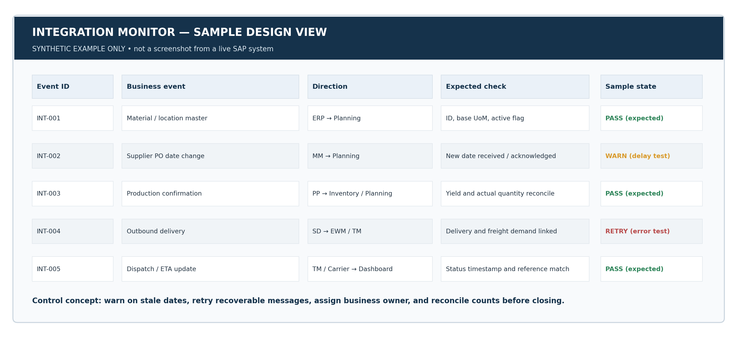
Figure 3. Conceptual monitoring view with synthetic records and expected test states; not a live SAP screen.

10.1 Exception-handling procedure
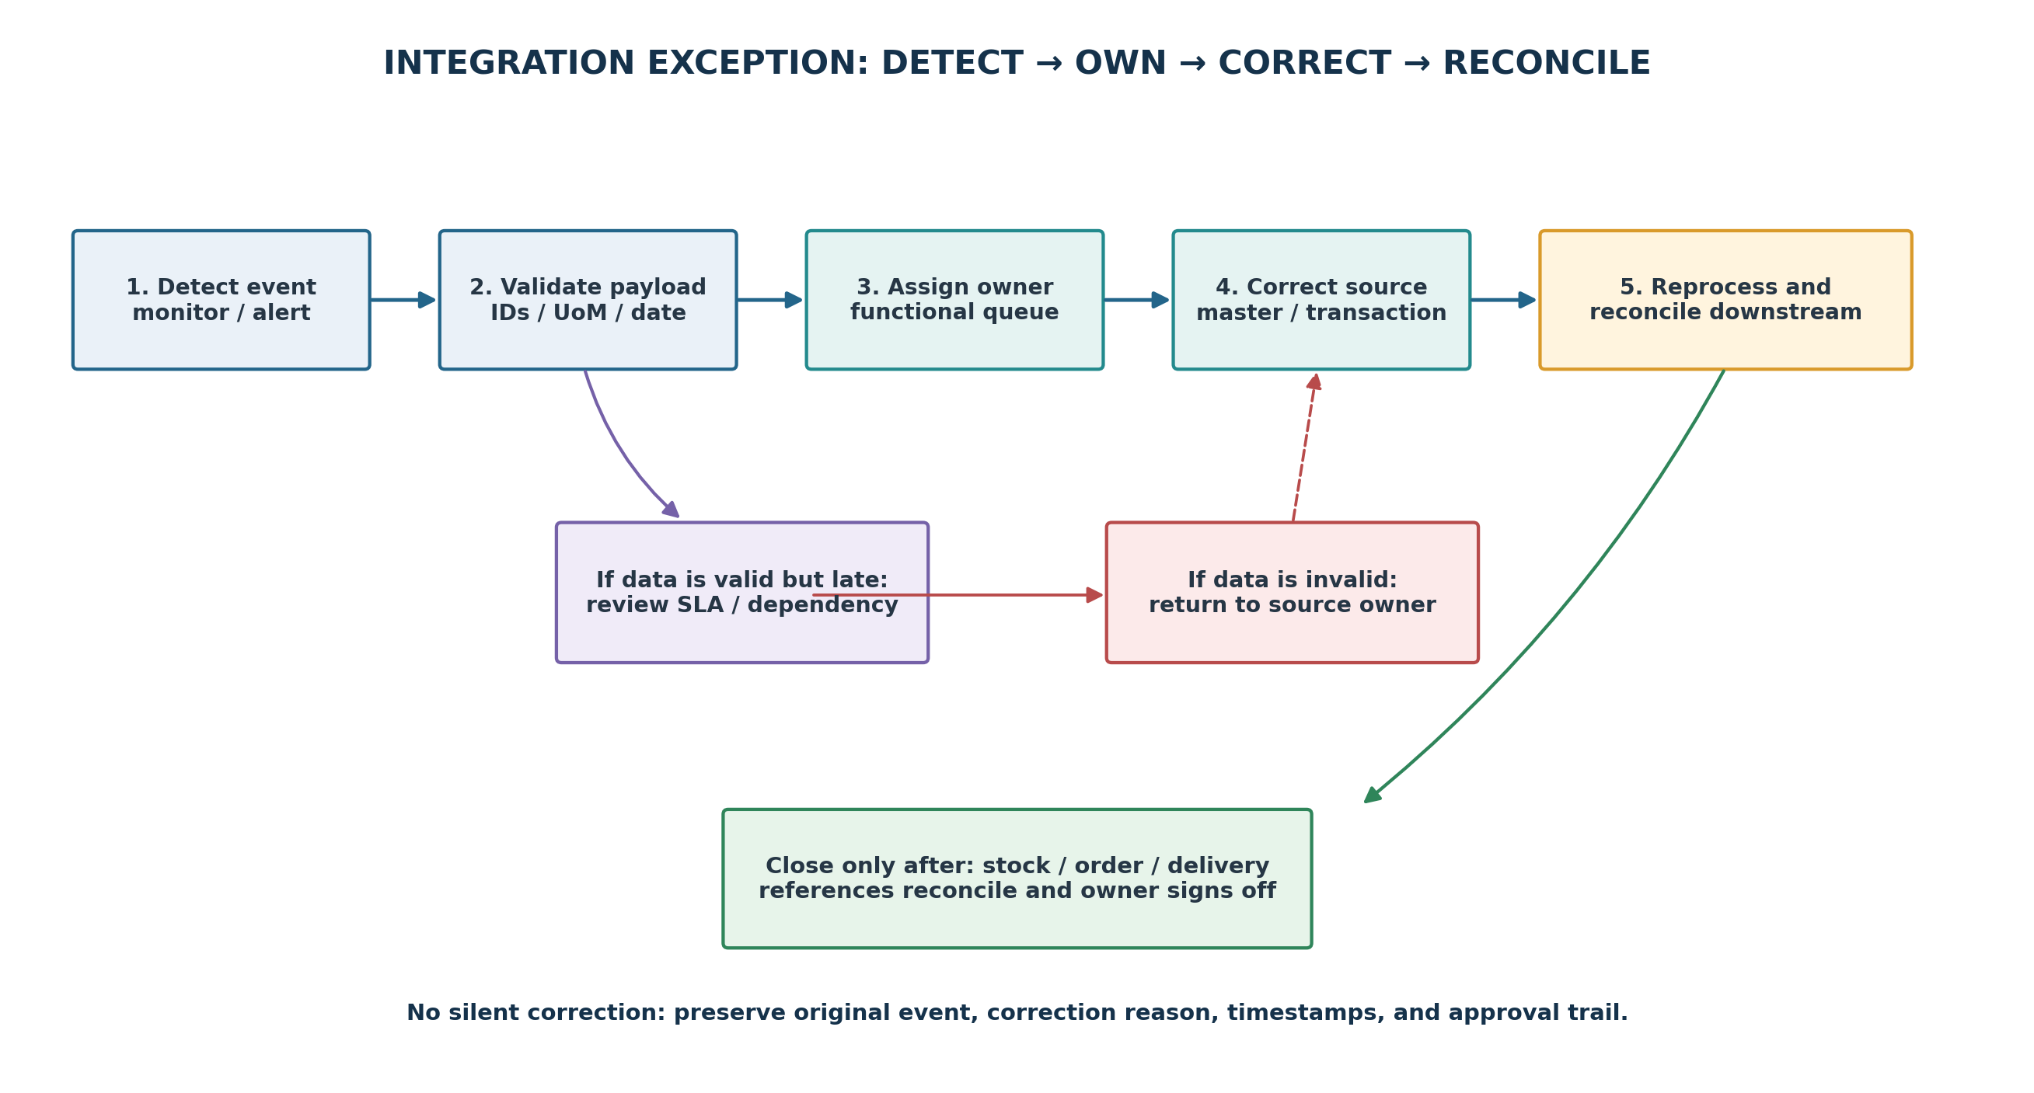
Figure 4. Proposed exception workflow with owner assignment and reconciliation.

10.2 Example control rules
- Critical purchasing date changes should reach the planning owner within the agreed threshold; if not, raise a stale-data alert and escalate to purchasing plus integration support.
- Master-data validation failures should be returned to the named data steward. Repeated retries without correction should be blocked or rate-limited.
- When an outbound delivery quantity changes, verify whether picking, handling units, and freight assignments need to be updated before dispatch.
- When goods receipt or quality release arrives after the planned order date, trigger a planner review rather than blindly preserving the original schedule.
- Close the incident only after the business reference has been checked in both relevant systems and the owner confirms the downstream effect is understood.

11. KPI Framework and Target-State Measures
The KPIs below measure the usefulness and reliability of integration. The proposed thresholds are scenario design targets for a future pilot, not actual performance results from Deccan Harvest Foods or a live SAP tenant. A baseline would need to be measured over a defined period before deciding whether each target is realistic.
KPI | Definition / formula | Illustrative target | Owner / response
Critical event propagation time | Destination acknowledgement timestamp − source update timestamp | PO/material date change: ≤15 minutes | Integration support + buyer; investigate stale data
Planning re-assessment time | Time from material/priority event to reviewed revised schedule | ≤30 minutes for dispatch-impacting event | Planner; compare before/after schedule and customer dates
Master-data first-pass validity | Valid objects accepted first time ÷ objects sent × 100 | ≥99% | Master-data steward; correct source attributes and mappings
Integration exception ageing | Open critical interface/business exceptions beyond agreed SLA | 0 critical items beyond shift handover without owner | Integration lead; escalate by category and age
Warehouse readiness visibility | Time from pick/load milestone to usable downstream status | ≤10 minutes | Warehouse lead; verify event posting and linkage
Carrier ETA acknowledgement | Time from dispatch/carrier event to usable transport status | ≤30 minutes | Transport coordinator; contact carrier/interface owner
Order OTIF | Orders delivered on time and in full ÷ orders due × 100 | ≥95% as a starting target | Supply-chain lead; review stock, capacity, and execution causes
Reconciliation accuracy | Matched document quantity / status pairs ÷ pairs checked × 100 | ≥99.5% | Functional owners; resolve unmatched references

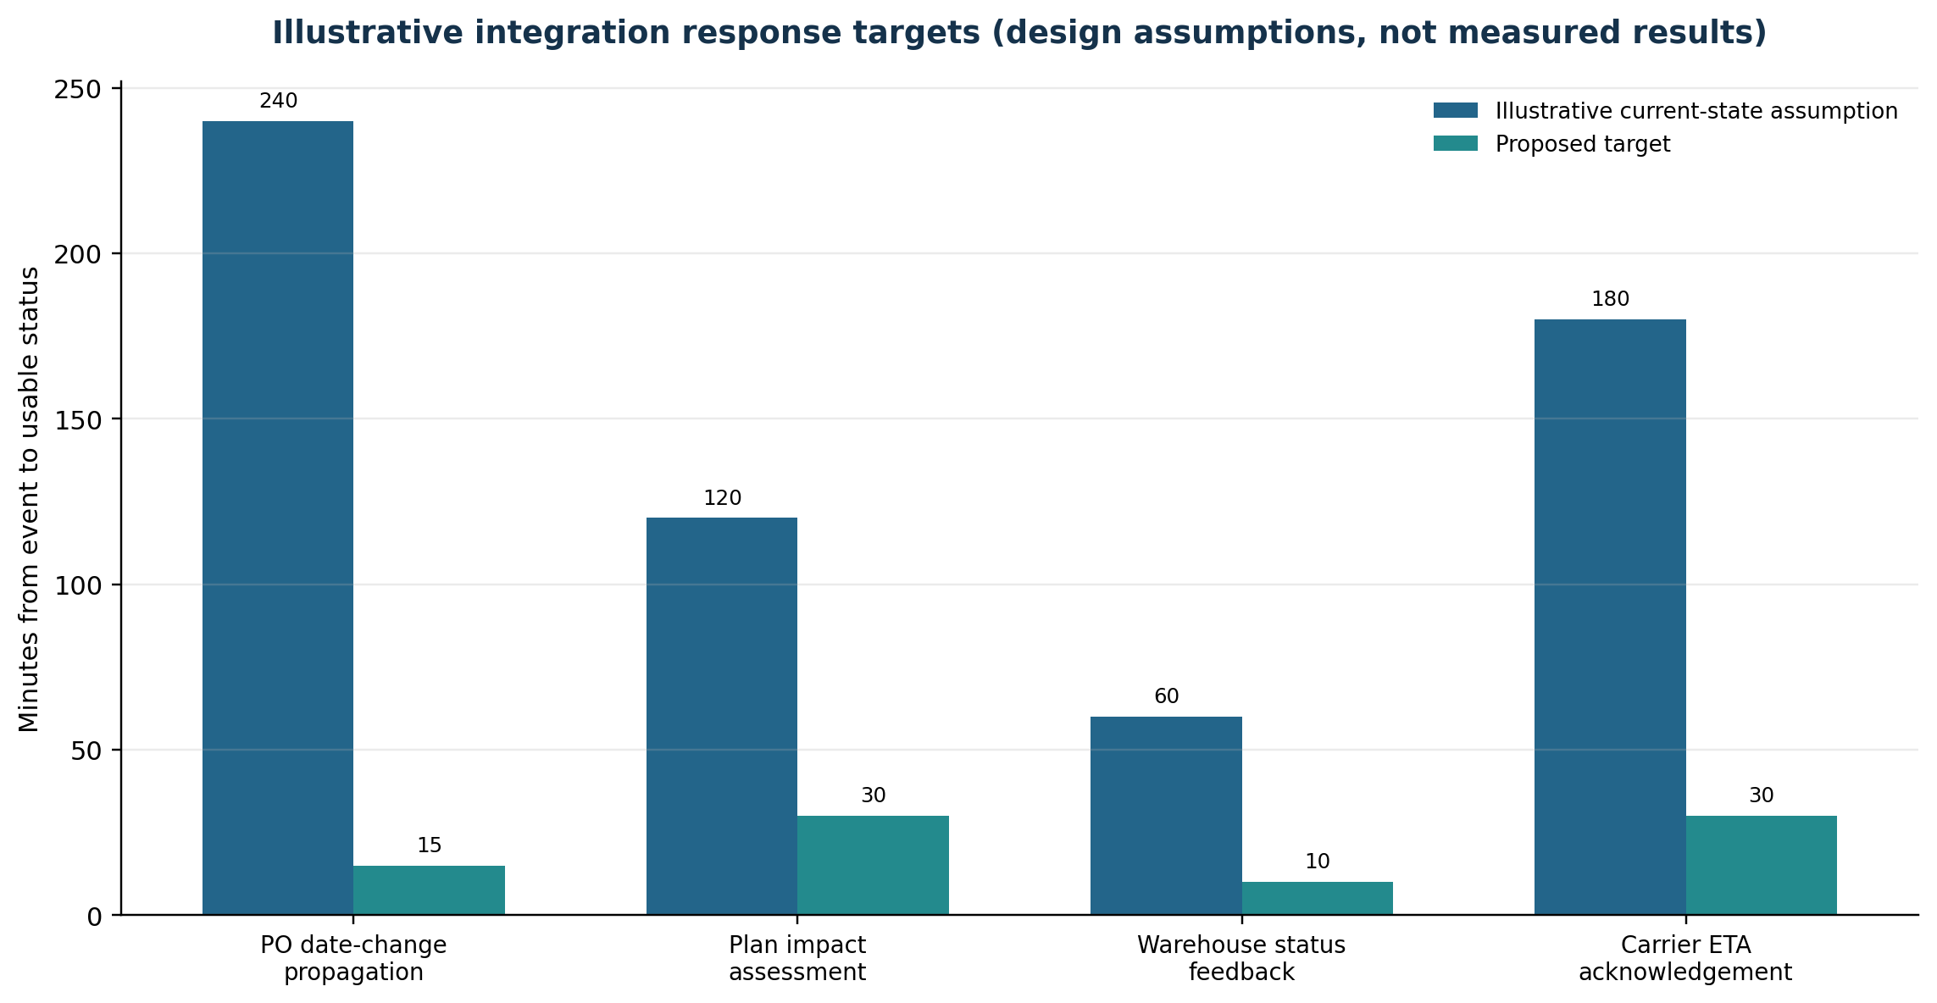
Figure 5. Illustrative current-state assumptions vs proposed integration targets; the values are design inputs, not observed measurements.
For the chart, the illustrative manual current-state assumptions are 240 minutes for PO date propagation, 120 minutes for planning impact assessment, 60 minutes for warehouse status feedback, and 180 minutes for carrier ETA acknowledgement. Proposed design targets are 15, 30, 10, and 30 minutes respectively. These assumptions show the kind of improvement to test, not a prediction that the system will achieve these times automatically. Interface design, workload, change management, partner responsiveness, and operational ownership determine the actual result.

11.1 Reporting design
A daily dashboard should show critical data changes still waiting for acknowledgement, top interface errors by age and source, planning changes not reviewed, production orders at risk, deliveries that lack warehouse readiness, and freight orders missing carrier status. Reports should support drill-down by plant, SKU, supplier, customer/DC, order, and message reference. A weekly review should trend issue count and age, not only display a single success percentage; otherwise repeated problems can remain hidden inside a high aggregate rate.

12. Validation and Testing Plan
The following cases are designed as acceptance tests for a training environment or future implementation. They are not presented as tests executed in a live SAP system. Each test should preserve input values, expected outcome, observed outcome, evidence reference, tester, and defect/approval status.
ID | Test case | Expected result / evidence
IT-01 | Initial master-data transfer | Selected material, plant/location, supplier, resource, and production structures arrive with correct IDs, validity, and units.
IT-02 | PO date change | Revised supplier date is stored once, traceable to the PO item, and available to planning within the agreed target.
IT-03 | Duplicate event / retry | Repeated event does not create a duplicate PO, receipt, production order, delivery, or freight document.
IT-04 | Unit-of-measure mismatch | Invalid or missing conversion is stopped and assigned to the data steward; quantity is not silently interpreted.
IT-05 | Material shortage rescheduling | The 62,000-pouch delay is visible; planner sees 31.0 t equivalent at risk and reviews affected orders.
IT-06 | Goods receipt and quality hold | Receipt updates stock; blocked/inspection stock is not treated as available until release criteria pass.
IT-07 | Production order actuals | Confirmed quantity, component consumption, and order status reconcile with execution records and planning.
IT-08 | Outbound delivery to warehouse | Delivery/warehouse reference links are correct and picking, packing, and staging updates are visible.
IT-09 | Freight-unit creation | A transportation demand is created from the relevant transportation order/delivery according to configuration.
IT-10 | Carrier ETA update | Carrier status is linked to the correct freight/delivery reference; timestamp and status mapping are validated.
IT-11 | Temporary interface outage | Recoverable message is retried safely; failed message remains visible and is reconciled after recovery.
IT-12 | End-to-end reconciliation | Demand, procurement, stock, production, delivery, and freight quantities/statuses agree or exceptions have owners.

12.1 Acceptance rule
A test passes only when the expected business outcome is verified at both source and destination and any dependent process is confirmed. For example, IT-02 should not pass merely because the source PO saved; the test also needs evidence that the revised date reached planning and that the planner can identify the affected order(s). For IT-08, a delivery record must link to the correct warehouse request and its status must not contradict the physical warehouse event.

13. Risks, Controls, and Failure Scenarios
Risk / failure scenario | Impact | Control / mitigation | Owner
Incorrect material, UoM or supplier mapping | Wrong plan quantities, wrong supplier, or unmatched receipts | Critical-field validation, cross-reference ownership, periodic duplicate checks | Master-data steward / buyer
Supplier date update does not reach planning | Production schedule uses stale supply assumption | Critical-event alert, acknowledgement check, interface queue monitoring | Buyer + integration support
Duplicate or out-of-order messages | Duplicate transactions or later event overwritten by older status | Idempotent document references, sequence/time validation, duplicate test cases | Integration support
Plan changes not shared with sales | Missed delivery promise and reactive customer communication | At-risk order alert, planner approval gate, agreed customer-notification trigger | Planner + sales
Warehouse status delayed or mislinked | Truck booked before pick/staging is ready | Delivery/handling-unit cross-check, readiness status, load confirmation rule | Warehouse lead
Carrier/3PL event missing | No reliable ETA or proof of delivery | External partner SLA, retry/escalation, manual fallback with audit record | Transport coordinator
Quality or batch status not respected | Unavailable or unreleased stock may be planned or shipped | Quality status integration and explicit ATP/availability treatment | Quality + inventory
No clear incident owner | Longer recovery, recurring errors, manual workarounds | RACI, exception categories, ageing escalation, closure evidence | Supply-chain process owner
Excessive automation without planner review | Unstable schedule and unintended customer-date changes | Approval thresholds, time fences, logged manual override and impact preview | Planning lead
Version-specific steps misapplied | Configuration rework or unsafe assumption about interfaces | Architecture review, release-specific SAP documentation, sandbox tests | Solution/integration architect

13.1 Business continuity
If the integration layer or a partner connection is unavailable, the process must not depend on silent spreadsheet overrides. The fallback should define which transactions may continue, who authorizes the decision, how the original and corrected status is recorded, how downstream updates are replayed, and how the system of record is reconciled after recovery. High-priority dispatches require a bounded manual verification procedure, not a blanket bypass of material, quality, or shipment controls.

14. Recommendations and 30/60/90-Day Roadmap
The roadmap below is a proposed implementation sequence for a small pilot. Timing assumes that required business owners and a test environment are available. It is not a commitment to complete a production deployment within 90 calendar days.
Phase | Focus | Deliverables / exit criteria
Days 1–30: Discover and define | Confirm landscape, map business objects, document current event timelines, assign data owners, agree SLA and escalation rules | Signed architecture/context map; integration inventory; critical material/order/delivery fields defined; baseline collection plan
Days 31–60: Configure and test | Clean master data; configure the chosen integration scope; build monitor/error categories; execute test cases IT-01 to IT-12 in a controlled environment | Test evidence with defects and owners; duplicate/retry safeguards reviewed; end-to-end quantity and status reconciliation demonstrated
Days 61–90: Pilot and improve | Pilot one plant and a limited product set; run daily exception huddles; track event age, schedule impact, warehouse readiness and OTIF | Business sign-off; measured baseline vs target; training completed; top three recurring causes assigned to improvement actions

14.1 Priority recommendations
- Start with one high-value business event: supplier date change for a packaging component. Prove source update, planning impact, acknowledgement, and downstream communication before integrating every event type.
- Create a shared exception list with one business owner and a due time for every critical exception. Technical monitoring and functional decision-making must be connected.
- Use a single controlled set of integration identifiers and unit conversions. Treat master-data correction as a source-data fix, not repeated destination-side patching.
- Build the test evidence around business outcomes and reconciliation, not only interface connectivity or a green technical status.
- After the pilot, add further high-value events such as goods receipt, production confirmation, quality release, warehouse loading, carrier ETA, and proof of delivery in a staged sequence.

15. Estimated 33-Hour Work Plan
Activity | Estimated effort | Output
Review assignment and public context | 3 h | Requirement checklist and source notes
Define scenario, network and data assumptions | 3 h | Scenario profile, demand and pouch calculations
Map architecture and system responsibilities | 4 h | Integration map and function-to-touchpoint matrix
Document master-data and transaction flow | 4 h | Data dictionary, ownership, source/target and validation rules
Build end-to-end workflow and delay simulation | 4 h | Timeline, material coverage calculation and planning decisions
Write configuration blueprint and version caveats | 4 h | APO/CIF versus embedded PP/DS distinction, warehouse/transport notes
Design collaboration RACI, monitor and KPI targets | 4 h | RACI, exception workflow, sample monitor and KPI table/chart
Develop test cases, risk register and roadmap | 4 h | 12 tests, control register and phased recommendations
Formatting, diagram review, references and final QA | 3 h | Reviewed Word report and portal description
Total | 33 h | Completed assessment package

The effort figures are an illustrative learning work plan used to structure the exercise. They should be updated to actual time spent if the internship requires a timesheet or formal time declaration.

16. Learning Outcomes and Conclusion

16.1 Learning outcomes
- Integration must be described as a chain of business events and responsibilities, not merely a list of SAP modules.
- Master data, units of measure, timestamps, document identifiers, and status semantics are foundational to reliable cross-functional execution.
- Procurement changes can affect planning, production sequence, customer delivery promises, warehouse readiness, and carrier decisions at the same time.
- The legacy APO CIF approach and embedded S/4HANA PP/DS approach must be distinguished; configuration steps depend on the landscape and product release.
- Exception handling requires source correction, controlled reprocessing, functional ownership, and end-to-end reconciliation.
- KPIs should measure business usefulness—freshness, correctness, planning response, warehouse readiness, OTIF and reconciliation—not just the number of messages sent.

16.2 Conclusion
This assessment designed an integrated supply-chain workflow for a fictional packaged-food manufacturer. The worked case showed that a 24-hour delay to a 62,000-piece packaging-material receipt temporarily places 31.0 tonnes of finished-pack demand at risk under the stated 500-gram-pack assumption. A useful response depends on coordinated actions: purchasing records the new supplier date, planning recalculates component feasibility, production sequences demand according to priority, inventory and quality confirm usable stock, warehouse confirms readiness, transportation updates the carrier plan, and sales manages customer commitments.
The proposed SAP architecture combines execution and planning systems with warehouse, transportation, and external partner collaboration. Public SAP documentation supports the key design patterns—master and transaction data exchange for APO/CIF, PP/DS planning against component/resource availability, and transportation/warehouse integration around orders and deliveries. [1][2][3][4][5][8][9] The strongest implementation priorities are clean governed master data, clear document ownership, prompt event acknowledgement, role-based exception resolution, and end-to-end testing. The result is not “integration for its own sake” but more reliable decisions and fewer avoidable surprises for the customer.
Overall finding: An integrated supply chain is only as dependable as its least visible hand-off. For this case, the critical hand-off is the supplier date change becoming a trusted planning signal and then a revised, executable customer-delivery plan.

Portal Submission Description
This Week 5 report presents a Supply Chain Integration and Collaboration Analysis in SAP SCM using an illustrative case study for the fictional Deccan Harvest Foods Pvt. Ltd., a manufacturer of millet-based ready-to-cook food products. The report examines how procurement, production planning, manufacturing execution, inventory management, quality, warehouse operations, transportation, sales, and external suppliers/carriers can share accurate information to support coordinated decisions. Public context is taken from APEDA’s 2024–25 annual report, which records growth in India’s cereal-preparation export category; this source provides industry context and is not treated as a forecast for the fictional company.
The report maps the roles of MM/procurement, PP/PP-DS planning, inventory, QM, SD, EWM/warehouse, TM/transportation, and integration monitoring. It distinguishes legacy SAP APO integration through CIF from an embedded SAP S/4HANA PP/DS landscape and explains why configuration steps must be selected according to the actual SAP version. A detailed workflow simulation follows a supplier’s 24-hour delay to a 62,000-piece packaging-material delivery. Using an illustrative demand of 138.5 tonnes and a one-pouch-per-500-gram-pack assumption, it calculates a total requirement of 277,000 pouches and a temporary coverage gap equivalent to 31 tonnes. The report shows how a purchasing update can trigger a planning review, revised production sequence, stock and quality confirmation, warehouse readiness check, transport rescheduling, and proactive customer communication.
Additional content includes an integration architecture diagram, cross-functional workflow, conceptual monitoring view, exception-resolution flow, KPI dictionary, proposed integration response targets, a RACI matrix, risk and control register, twelve validation tests, and a 30/60/90-day improvement roadmap. The focus is on practical governance: consistent master data, document references, timestamps, acknowledgement, error ownership, controlled retry, and end-to-end reconciliation. All company-specific figures, events, dashboard records, response-time targets, and workflow outcomes are illustrative. The report is a learning simulation and configuration blueprint; it does not claim live execution or results from a production SAP system.

References
The following public sources support the descriptions of SAP integration patterns and the industry context. SAP documentation is release-specific; use the version applicable to the actual implementation.
[1] SAP Help Portal. “Core Interface (CIF).” SAP Advanced Planning and Optimization, version 7.0 EHP1. Open source
[2] SAP Help Portal. “Integration of Master Data.” SAP Advanced Planning and Optimization. Open source
[3] SAP Help Portal. “Production Planning and Detailed Scheduling (PP/DS).” SAP S/4HANA on-premise, 2025 FPS01 documentation. Open source
[4] SAP Help Portal. “Internal TM Component Integration.” SAP S/4HANA on-premise, Transportation Management. Open source
[5] SAP Help Portal. “Communication from EWM to SAP S/4HANA.” SAP S/4HANA on-premise, Extended Warehouse Management. Open source
[6] SAP Help Portal. “Procurement in SAP S/4HANA.” Sourcing and Procurement, 2025 FPS02 documentation. Open source
[7] Agricultural and Processed Food Products Export Development Authority (APEDA), Government of India. “Annual Administrative Report 2024–25,” processed food and cereal preparations export data, pp. 29–31. Open source
[8] SAP Help Portal. “Production Process with SAP S/4HANA and PP/DS.” SAP S/4HANA on-premise, PP/DS. Open source
[9] SAP Help Portal. “Integration of Orders.” SAP S/4HANA on-premise, Transportation Management. Open source

Appendix A. Key Terms and Abbreviations
Term | Meaning in this report
APO | SAP Advanced Planning and Optimization; legacy planning suite referenced for a separate planning landscape.
CIF | Core Interface; a data-exchange approach documented for ERP-to-SAP APO integration.
PP/DS | Production Planning and Detailed Scheduling; plans product/resource feasibility and order timing.
MM / PP / SD / QM | Materials Management / Production Planning / Sales and Distribution / Quality Management.
IM | Inventory Management; stock quantity and stock status in the execution system.
EWM / TM | Extended Warehouse Management / Transportation Management.
BOM | Bill of Material; component structure required to make or package a product.
PDS / PPM | Production Data Structure / Production Process Model; planning-relevant production structure depending on the landscape.
ASN | Advance Shipping Notice; a partner communication about an expected shipment, where that process is used.
OTIF | On Time In Full; order service measure for deliveries that meet both timing and quantity criteria.
UoM | Unit of Measure; a base or alternate unit with a validated conversion.
RACI | Responsible, Accountable, Consulted, Informed; a way to assign execution and decision roles.
qRFC | Queued Remote Function Call; a queued integration technology described in relevant SAP integration documentation.

