FINAL WEEK • INTERNSHIP ASSESSMENT
Performance Evaluation and
Continuous Improvement
in SAP Supply Chain Management (SAP SCM)
A six-month KPI assessment, simulated dashboard, root-cause analysis and improvement roadmap
Project element | Details
Prepared by | Hrudhai Prem Kumar Patwari
Assessment | Week 6 - Performance Evaluation and Continuous Improvement in SAP SCM
Scenario | Deccan Harvest Foods Pvt. Ltd. (fictional)
Evaluation period | April–September 2026 (simulated)
Report type | Illustrative performance assessment and SAP monitoring blueprint
Evidence status | Simulated data and dashboard mock-up; no live SAP execution claimed
Report date | 22 October 2026

IMPORTANT SCOPE NOTE
This report uses fictional company details, generated monthly KPI values and illustrative dashboard graphics. It demonstrates an analytical and configuration approach; it is not a record of transactions executed in a live SAP system.

Report Contents
- 1. Executive Summary
- 2. Assignment Objectives, Scope and Method
- 3. Operational Scenario and Business Context
- 4. KPI Design Principles and Definitions
- 5. Six-Month Simulated Performance Dataset
- 6. Trend Analysis and Performance Interpretation
- 7. How SAP SCM Can Support Monitoring and Reporting
- 8. Dashboard Design and KPI Operating Rhythm
- 9. Root-Cause Analysis and Prioritized Findings
- 10. Continuous-Improvement Plan
- 11. Proposed 30/60/90-Day Roadmap
- 12. Validation and Testing Plan
- 13. Governance, Roles and Review Cadence
- 14. Risk Register and Control Measures
- 15. Illustrative Benefits and Business Case
- 16. Learning Outcomes and Conclusion
- 17. References
- Appendix A. Portal Submission Description
Reading guidance: Sections 5–6 provide the results; Sections 9–11 translate them into actions; Sections 12–14 describe how to validate and govern the proposed changes. The portal description in Appendix A is ready to copy into the internship submission form.

1. Executive Summary
This Week 6 report evaluates a six-month simulated supply chain for Deccan Harvest Foods Pvt. Ltd., a fictional manufacturer of millet-based ready-to-cook products. The assessment consolidates the earlier planning themes—demand, purchasing, inventory, production scheduling, distribution, integration monitoring—into a performance scorecard and continuous-improvement plan. The purpose is not to claim that a live SAP system was operated; it is to show how I would define performance measures, reconcile operational data, interpret trends, identify root causes and turn the findings into accountable actions.
Across the simulated period of April to September 2026, order on-time-in-full (OTIF) improves from 86.0% to 93.0%, forecast accuracy from 81.0% to 88.5%, production schedule adherence from 82.0% to 91.0%, and supplier OTIF from 78.0% to 89.0%. Inventory cover declines from 34 to 27 days, remaining within the proposed 25–30 day range in the final two months. Modeled logistics cost per tonne falls from ₹6,800 to ₹6,150, a reduction of ₹650 or 9.6%. Median critical-exception resolution time decreases from 16 to 6 hours, while packaging-material shortage incidents fall from nine to three per month.
The trend is positive but not yet at target across all measures. September OTIF remains two percentage points below a proposed 95% target, supplier OTIF is six points below target, exception resolution is two hours above its target, and scrap/expiry remains at 3.0% against a proposed maximum of 2.5%. Packaging capacity utilization reaches 92%, the top edge of the modeled control band, leaving little flexibility for a sudden demand or downtime event. These signals support a balanced improvement plan: strengthen supplier reliability, improve near-term demand sensing, protect finite capacity, reduce packaging shortages, and tighten end-to-end data reconciliation.
The recommended method uses a monthly performance review supported by weekly exception management and daily checks of critical events. SAP APO KPI reporting, planning books, key figures and the Plan Monitor are relevant in a legacy APO environment; source-system reporting and the appropriate analytics layer should be selected for the actual ERP/S/4HANA landscape. SAP Integrated Business Planning custom alerts are referenced only as an optional feature where that product is deployed. The report includes simulated KPI tables and charts, a dashboard mock-up, a root-cause analysis, proposed validation tests, a 30/60/90-day roadmap, governance roles and a PDCA cycle. All numbers and outcomes are illustrative learning assumptions.

2. Assignment Objectives, Scope and Method
The final-week assignment asks for a performance evaluation of a simulated SAP SCM supply chain, identification and justification of KPIs, analysis of a performance dashboard, and an actionable continuous-improvement strategy. This report addresses those requirements by using a realistic operating scenario, defining the measurement rules before interpreting the data, and connecting each proposed action to a named owner and follow-up measure.
The scope covers demand and customer service, production planning, supplier delivery, inventory coverage, logistics cost, exception response, material availability, capacity utilization, quality loss and data reconciliation. The report does not implement an SAP configuration, connect to a live system, or provide transaction-level evidence from an organization's system. Instead it describes a practical monitoring design and uses a six-month illustrative dataset to demonstrate how measurement could work.
Method: (1) set the scenario and period; (2) define each KPI, unit, formula, direction and target; (3) create a consistent six-month simulation; (4) compare trend and target status; (5) identify likely drivers rather than assuming the KPI alone proves a cause; (6) design countermeasures and assign ownership; (7) propose validation tests and a review cadence; and (8) recommend standardizing, adjusting or stopping actions based on evidence. A KPI trend is evidence of a pattern in this simulation, not proof that a specific intervention caused the change.

3. Operational Scenario and Business Context
Deccan Harvest Foods Pvt. Ltd. is fictional and represents a regional packaged-food business serving wholesale and retail customers from a central manufacturing site and regional distribution points. Products use millet-based recipes, retail packaging, labels and corrugated cartons. Procurement buys millet and packaging material; production batches and packs product; warehouse teams pick and stage finished goods; transportation plans dispatches; sales and customer service manage order promises. The chain is sensitive to seasonal demand, supplier confirmation quality, packaging-material availability, line changeovers, shelf-life limits and transport schedule adherence.
The six-month period April–September 2026 is deliberately simulated. It represents a scenario where the organization has already started corrective actions: formal supplier confirmations, a daily shortage review, a shared exception register, regular demand review, schedule freeze rules and standard KPI definitions. Improvement patterns are designed to be plausible but are not historical company facts. The report continues the fictional Deccan Harvest Foods scenario used in earlier assessments so that the KPI logic remains connected to procurement, network planning, production scheduling and integration collaboration.
A public SAP Help Portal description of SAP APO performance measurement explains that KPIs can translate supply-chain objectives into financial or physical measures, drawing information from planning and execution processes for comparison. SAP APO planning books and key figures organize planning views; the Plan Monitor can compare planning situations by object, version and period and display results in tables and graphics. These capabilities support the logic of the proposed scorecard, subject to the product release and implementation.

4. KPI Design Principles and Definitions
A useful scorecard balances service, cost, inventory, reliability and process quality. If it concentrates only on unit cost, the business may lower inventory but increase stock-outs. If it measures capacity utilization without schedule attainment or downtime, it may reward running a line too close to its limit. If it measures the number of successful messages but not data correctness, integration can appear healthy while the plan is still wrong.
Each KPI therefore requires a plain definition, a numerator and denominator where relevant, a source, a refresh cadence, a target owner and a reaction when thresholds are breached. The scorecard differentiates a customer-order OTIF rate from volume fill rate. OTIF counts orders delivered both on time and in full; fill rate compares shipped quantity with demand quantity. They can move differently because a partially fulfilled order may contribute shipped tonnes without qualifying as OTIF.
Targets in this report are proposed management thresholds for the simulation, not SAP standard values or universal industry benchmarks. They should be confirmed with the business using service commitments, SKU shelf life, supplier lead times, resource calendars, cost structures and risk appetite. A control band is used for inventory days and resource utilization where too low or too high can both be harmful.

KPI Dictionary and Management Targets
KPI | Definition / formula | Illustrative data source / cadence | Proposed target | Business use / owner
Customer OTIF | On-time-and-in-full deliveries ÷ total due orders × 100 | Order / delivery milestones; daily, monthly roll-up | ≥95% | Sales + logistics; service outcome
Forecast accuracy | (1 − WAPE) × 100, where WAPE = Σ|forecast − actual| ÷ Σ actual | Forecast and actual demand; weekly/monthly | ≥90% | Demand planning; reduces surprise supply changes
Production schedule adherence | Operations completed as planned ÷ scheduled operations due × 100 | Planned and confirmed operations; shift/week | ≥92% | Production planning; indicates schedule stability
Supplier OTIF | Supplier delivery lines complete and on time ÷ lines due × 100 | PO confirmation, receipt, accepted quantity; monthly | ≥95% | Procurement; supply reliability
Inventory days of supply | Usable on-hand stock ÷ average daily demand | Inventory by status and demand; daily/monthly | 25–30 days | Inventory; protects service while limiting excess
Logistics cost per tonne | In-scope logistics cost ÷ shipped tonnes | Freight invoices, deliveries, tonnes; monthly | ≤₹6,460/t* | Transport + finance; unit cost-to-serve
Critical-exception resolution | Median time from logged exception to verified business closure | Exception register / monitor; daily | ≤4 hours | Control tower / process owners; response speed
Packaging shortage incidents | Count of incidents with packaging unavailability blocking planned production | Shortage log / planner exceptions; monthly | ≤2 per month | Procurement + planning; loss of feasible production
Packaging resource utilization | Scheduled production load ÷ available resource capacity × 100 | Resource calendar and schedule; weekly | 85–92% band | Planning/production; capacity use and buffer
Scrap / expiry rate | Scrap and expired volume ÷ produced volume × 100 | Production and quality records; monthly | ≤2.5% | Quality + manufacturing; cost and waste
Data reconciliation accuracy | Matched source/target document-quantity-status samples ÷ samples checked × 100 | Interface/integration sample; weekly/monthly | ≥99.5% | Data/integration; trust in reported state
Volume fill rate | Shipped tonnes ÷ demand tonnes × 100 | Orders / goods issue / demand; monthly | ≥98% | Sales and supply; quantity fulfilment, not timing

*The ₹6,460/t target is a scenario threshold set at 5% below the April baseline of ₹6,800/t. Targets are illustrative internal operating targets and are not presented as SAP standard values or external benchmarks.

5. Six-Month Simulated Performance Dataset
Table 1 contains the core simulated dashboard. Values were constructed to demonstrate trend analysis, not retrieved from live ERP, SAP APO, SAP IBP, EWM, TM or a customer database. The monthly demand and shipped-tonnage rows provide context for volume fill rate. Remaining service and operations metrics are simulated monthly measures with separately defined denominators.
In the simulated dataset, shipped tonnes increase from 496 to 598 as demand increases from 520 to 610 tonnes. This is a volume fill rate improvement from 95.4% to 98.0%. The distinct OTIF measure rises from 86.0% to 93.0%, indicating that order completeness and punctuality improve, but customer orders still miss the proposed target.
Metric | Unit | Apr | May | Jun | Jul | Aug | Sep
Actual demand (t) | tonnes | 520 | 535 | 548 | 575 | 590 | 610
Shipped volume (t) | tonnes | 496 | 513 | 530 | 559 | 578 | 598
Volume fill rate | % | 95.4% | 95.9% | 96.7% | 97.2% | 98.0% | 98.0%
Customer OTIF | % | 86.0% | 87.5% | 88.0% | 90.0% | 91.2% | 93.0%
Forecast accuracy (1−WAPE) | % | 81.0% | 82.5% | 84.0% | 85.5% | 87.0% | 88.5%
Production schedule adherence | % | 82.0% | 83.5% | 85.0% | 87.0% | 89.0% | 91.0%
Supplier OTIF | % | 78.0% | 80.0% | 82.0% | 84.0% | 87.0% | 89.0%
Inventory days of supply | days | 34 | 33 | 32 | 31 | 29 | 27
Logistics cost / shipped tonne | ₹/t | 6,800 | 6,720 | 6,590 | 6,460 | 6,320 | 6,150
Median critical-exception resolution | hours | 16 | 14 | 13 | 10.5 | 8 | 6
Packaging shortage incidents | count | 9 | 8 | 7 | 6 | 4 | 3
Packaging capacity utilization | % | 88% | 89% | 90% | 91% | 91% | 92%
Scrap / expiry rate | % | 3.8% | 3.7% | 3.6% | 3.4% | 3.2% | 3.0%
Data reconciliation accuracy | % | 96.0% | 97.0% | 97.8% | 98.5% | 99.0% | 99.4%

Data note: all values in Table 1 are simulated. Volume fill rate is computed from shipped tonnes divided by demand tonnes. OTIF is a distinct order-level measure and should not be inferred from the tonne fill rate.

Performance snapshot for September 2026
Status grouping | September result
On / inside target | Inventory days of supply (27 days); logistics cost per tonne (₹6,150); volume fill rate (98.0%); utilization (92%, upper control boundary)
Near target / watch | Forecast accuracy 88.5%; schedule adherence 91.0%; reconciliation accuracy 99.4%
Priority gap | OTIF 93.0%; supplier OTIF 89.0%; exception resolution 6 hours; packaging shortages 3; scrap/expiry 3.0%

6. Trend Analysis and Performance Interpretation
6.1 Customer service and planning reliability. OTIF rises by 7.0 percentage points from 86.0% to 93.0%, while forecast accuracy rises by 7.5 points and schedule adherence by 9.0 points. These trends suggest that the simulated control package is associated with better planning stability and delivery performance. However, the measures do not establish causality, and each remains below its final target. The remaining OTIF gap can be caused by late supplier material, stock availability, late production completion, warehouse picking cut-offs, carrier capacity or promise-date changes. Root-cause coding by order is required before selecting a permanent countermeasure.
Forecast accuracy is treated as 100% minus weighted absolute percentage error (WAPE): 1 − sum of absolute forecast errors divided by sum of actual demand, multiplied by 100. The simulated accuracy values correspond to WAPE declining from 19.0% in April to 11.5% in September. The next analytical step should segment error by SKU, location, customer group and promotion/season, and also measure forecast bias. Overall accuracy can hide an over-forecast for one item and an under-forecast for another.
6.2 Supplier and component availability. Supplier OTIF improves from 78.0% to 89.0%, an 11-point increase, but remains six points below the proposed 95% target. Three packaging shortages remain in September. The pattern suggests progress from stronger confirmations and exception reviews, yet a single delayed critical component can still reduce feasible production. Supplier OTIF should be calculated using expected delivery lines as the denominator, with the agreed tolerance for time and quantity defined explicitly. Missing supplier confirmations should not be silently excluded, because that would bias performance upward.
6.3 Inventory and cost. Inventory days of supply falls from 34 to 27, a reduction of seven days or approximately 20.6%. The final two months land within the proposed 25–30 day band. This is a useful balance only if service does not deteriorate, inventory status is accurate, and slow-moving or expiry-prone items are not concealed by aggregate days. Logistics cost per shipped tonne reduces by ₹650, from ₹6,800 to ₹6,150, or about 9.56%. At a September volume of 610 tonnes, the difference between the April rate and the September rate equals about ₹3,96,500 for a simple rate comparison. This is an illustrative benchmark equivalent, not verified cash savings or proof that volume, product mix, fuel rates and service conditions stayed constant.
6.4 Exception responsiveness and process quality. Median critical-exception resolution declines from 16 to six hours, a reduction of 62.5%, while packaging shortage incidents fall by 66.7% from nine to three. Reconciliation accuracy improves from 96.0% to 99.4%. The next priority is not merely to improve average response; it is to identify long-tail ageing, measure time to detect separately from time to resolve, and verify that closure represents a correct business outcome. A green technical interface status is not enough if stock, production or delivery records remain inconsistent.
6.5 Capacity and quality. Packaging resource utilization rises from 88% to 92%. The proposed control band is 85–92%: low utilization may indicate idle capacity or weak scheduling, but high utilization leaves little buffer for unplanned downtime or product changeovers. At 92%, the team should check overtime dependence, maintenance exposure, setup loss and schedule volatility. Scrap/expiry rate improves from 3.8% to 3.0%, but remains above a proposed 2.5% ceiling. Pareto analysis should separate packaging damage, process loss, expiry, quality rejection and rework because each cause requires different action.

7. How SAP SCM Can Support Monitoring and Reporting
The toolset depends on the deployed SAP architecture. In a legacy SAP APO environment, SAP documentation describes KPI-based performance measurement for planning and execution processes, with KPI data stored in SAP Business Information Warehouse (SAP BW) for historical comparison and cockpit reporting. Planning books provide structured views of key figures for planning tasks; a planning book should therefore expose the measures that planners need, with consistent units, periods, product/location characteristics and aggregation rules. The Plan Monitor can evaluate key figures for a plan by object, version and period and present a table or graphic, which is useful for comparing planning versions or time buckets.
In a current SAP Integrated Business Planning landscape, custom alerts can identify threshold-based issues such as inventory shortage or supply-demand imbalance and route visibility to assigned users/cases where the relevant applications are deployed. This report references that capability as an optional pattern rather than assuming all organizations use IBP or the same apps. For S/4HANA-centric deployments, the actual analytics layer and operational data source must be selected for the installed release. The principle remains constant: source data, KPI logic, refresh timing, thresholds and exception ownership must be controlled.
Proposed collection chain: (1) source transactions capture demand, order confirmations, purchase orders, receipts, inventory, production confirmations, delivery milestones and freight costs; (2) data is mapped to consistent material, site, customer, supplier, calendar and unit identifiers; (3) extraction or integration logic applies quality checks and timestamp rules; (4) the analytics layer calculates validated monthly and daily KPIs; (5) threshold-based alerts create an exception with owner and due time; (6) planners and functional leads investigate and record actions; and (7) the monthly review compares results with targets and the prior period. Where APO/BW or IBP capability is not deployed, equivalent supported ERP reporting or a governed external analytics layer can be used, provided data lineage is documented.
The dashboard mock-up included in Figure 1 is intentionally illustrative, not a screenshot of an actual SAP screen. A real screenshot should be captured from the authorized training or project system after the relevant configuration and data refresh. The mock-up is evidence of proposed dashboard design only.

8. Dashboard Design and KPI Operating Rhythm
The dashboard should separate leading indicators from lagging outcomes. Supplier confirmation status, forecast bias, material shortages, capacity overloads, order ageing and queue latency provide early warnings. OTIF, logistics cost, scrap, inventory days and schedule adherence show resulting performance. A manager can see whether an increase in service is being achieved at the expense of overtime, cost, inventory or quality.
Every dashboard tile should show value, unit, target, trend and owner. A red/amber/green color cannot be the only signal: include a textual status and a definition link. A report should support drill-down from month to product, location, customer and order where authorized. Time zones and calendar boundaries must be consistent. A month that is only partially closed should be clearly marked as provisional rather than compared directly with complete months.
Suggested cadence: daily review of critical shortages and exceptions; weekly operations review of forecast changes, supply risk, finite capacity and dispatch issues; monthly KPI review of trends and causes; and quarterly target governance. Actions should be written with a problem statement, owner, due date, expected change, cost/effort, risk, and a validation method. Repeated exceptions should be grouped into causes so the team does not keep resolving the same incident manually.
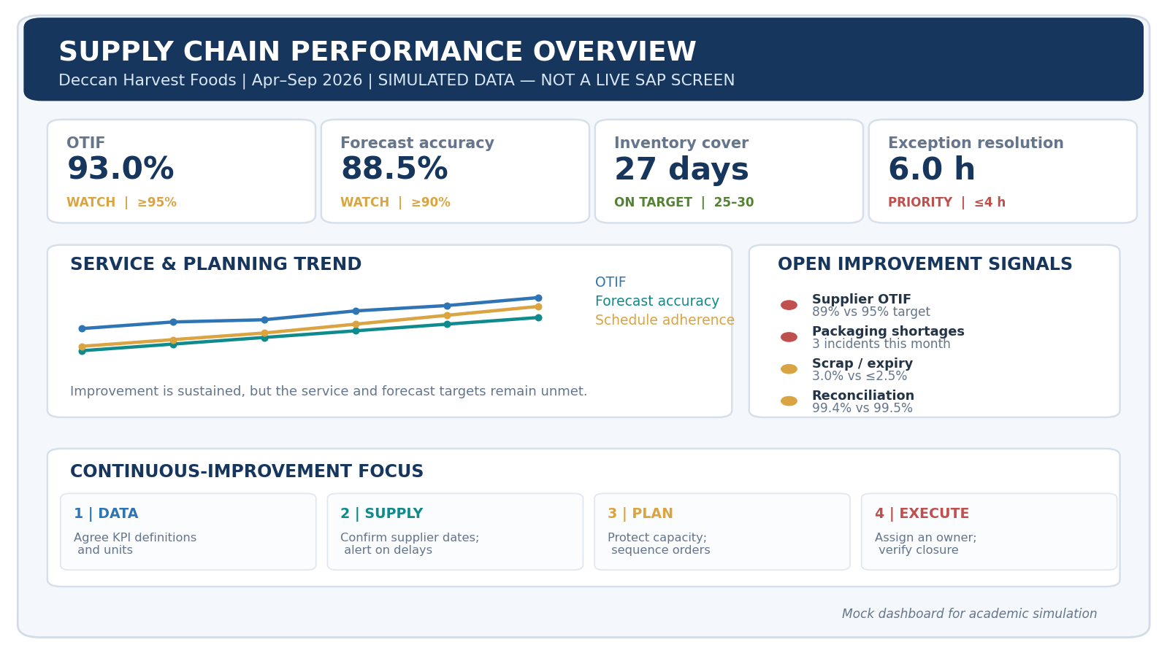
Figure 1. Illustrative performance dashboard mock-up created for this assessment; it is not a screenshot of a live SAP system.
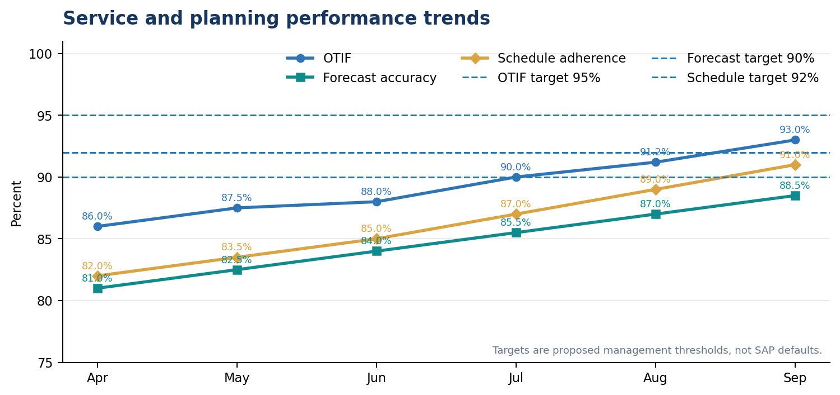
Figure 2. Simulated OTIF, forecast accuracy and schedule-adherence trends; targets are proposed scenario thresholds.
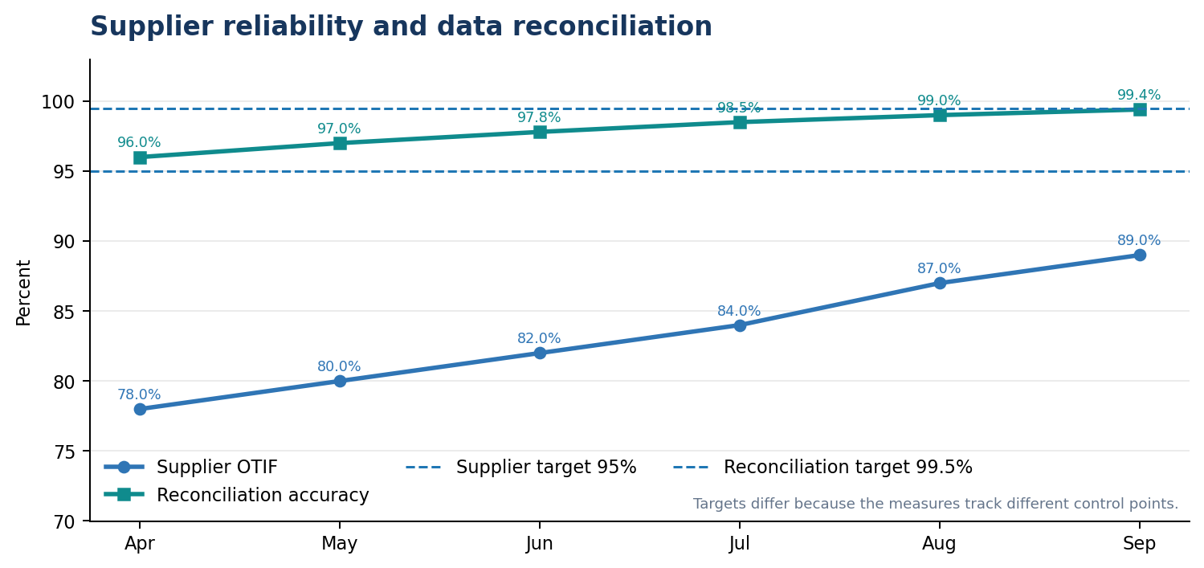
Figure 3. Simulated supplier OTIF and source/target reconciliation trends.
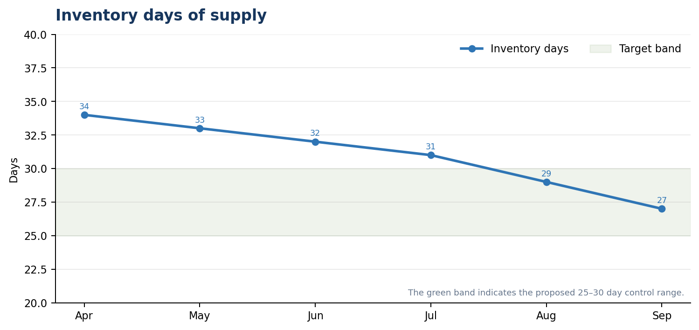
Figure 4. Inventory days of supply move into the proposed 25–30 day control band by August.
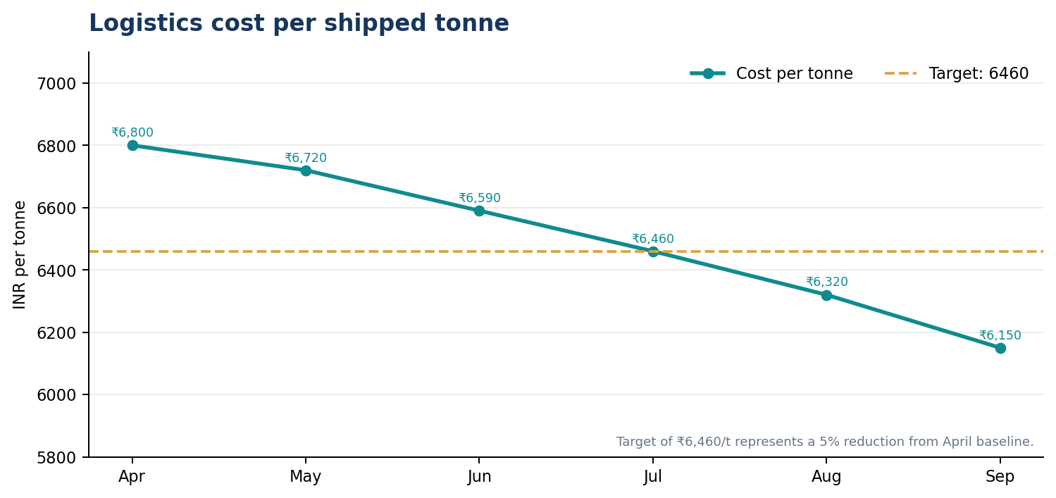
Figure 5. Simulated logistics cost per shipped tonne compared with the proposed ₹6,460/t threshold.
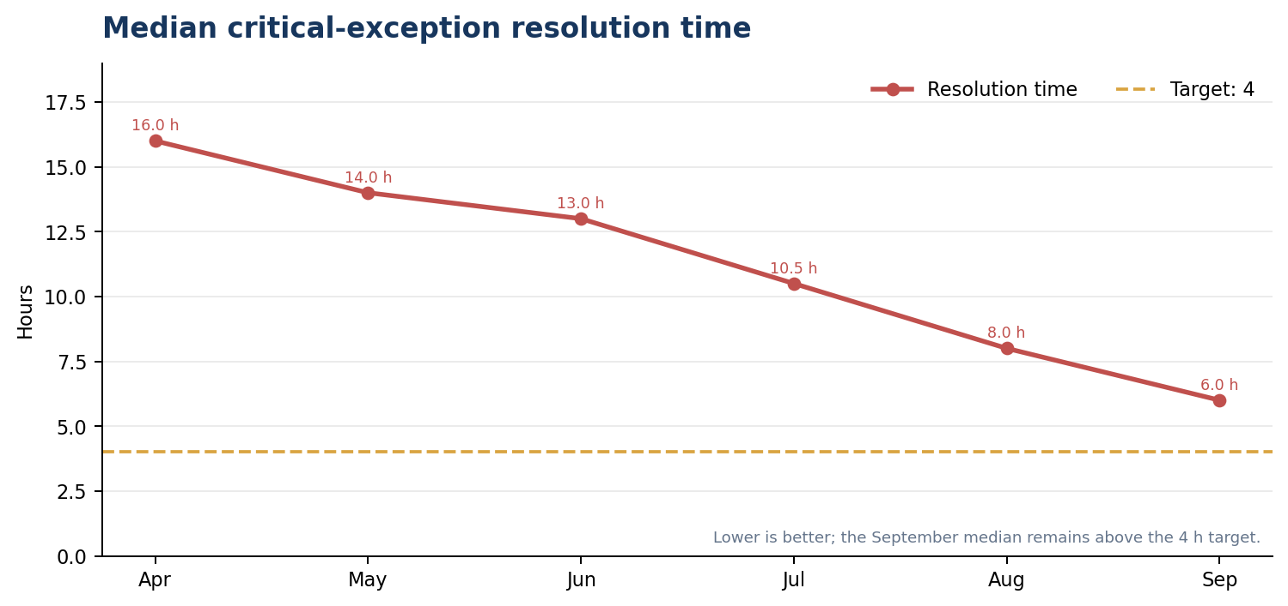
Figure 6. Median critical-exception resolution improves substantially but remains above the proposed four-hour target.
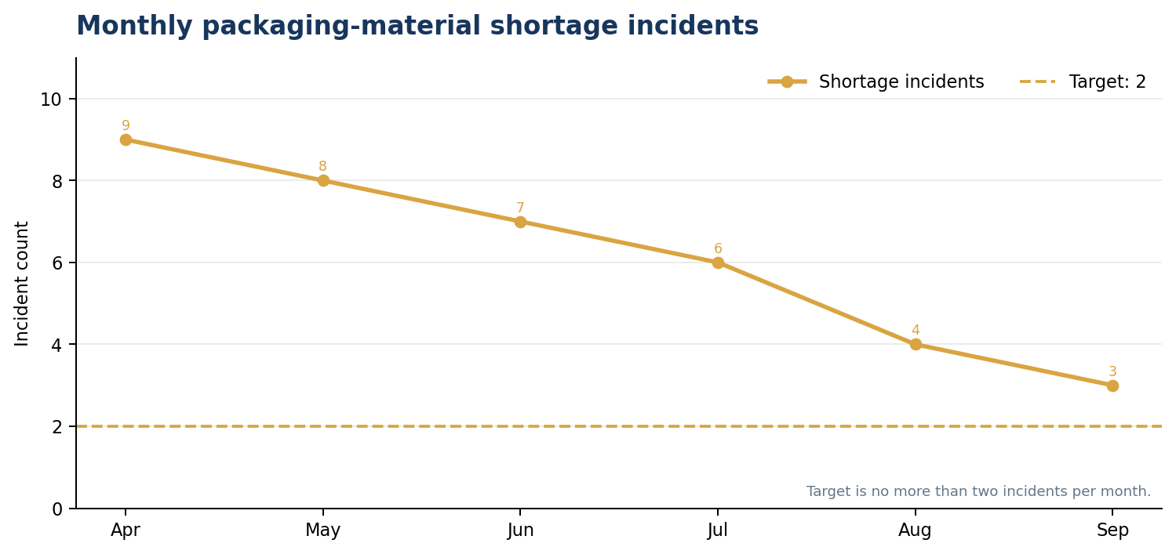
Figure 7. Packaging-material shortage incidents fall from nine to three per month but remain above target.
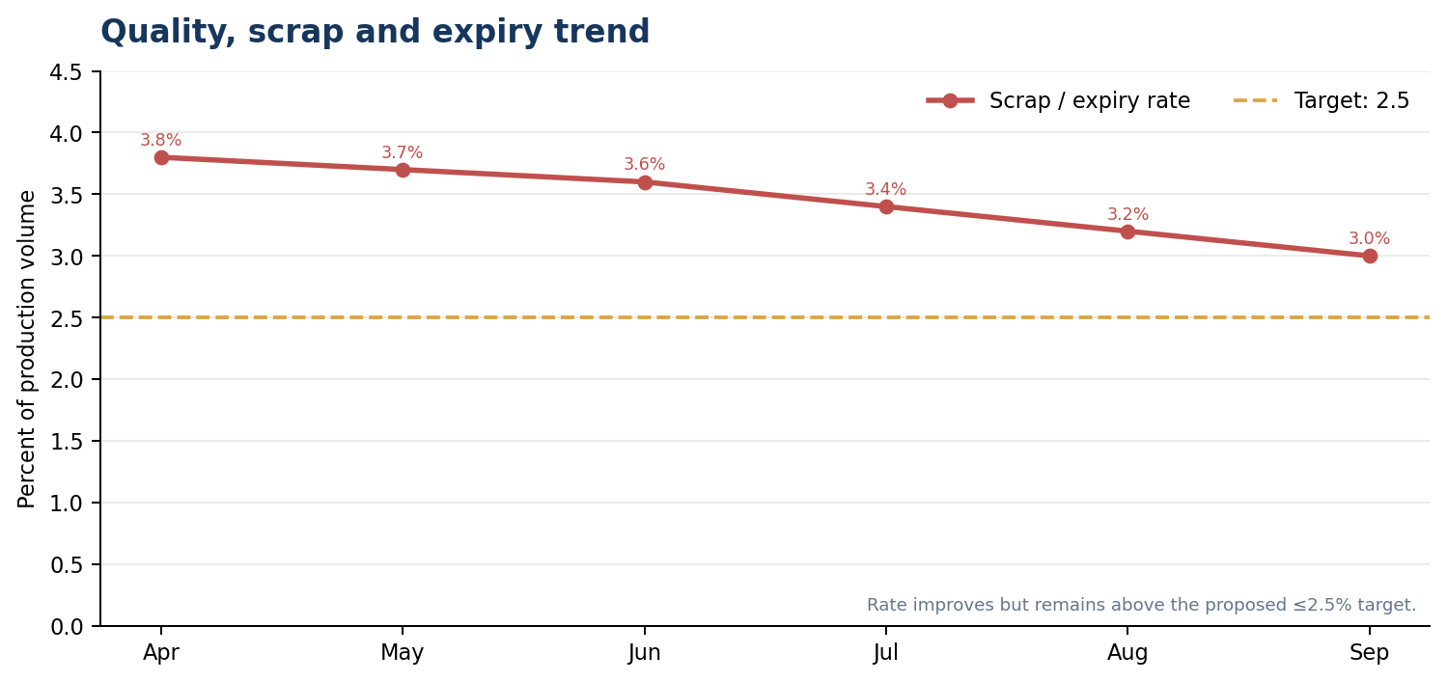
Figure 8. Simulated scrap/expiry rate improves but has not reached the proposed 2.5% ceiling.

9. Root-Cause Analysis and Prioritized Findings
Finding A — Supplier reliability is the largest unresolved service risk. Supplier OTIF reaches only 89% against a proposed 95% target, and shortage incidents remain at three per month. Likely contributors include unconfirmed promise dates, short shipment, late advance shipping otifications, supplier capacity variability and packaging-specific lead time. These are hypotheses to test, not confirmed causes. The analysis should compare promise date, confirmed date, actual receipt, accepted quantity, inspection release and the production order that consumed the material.
Finding B — Customer OTIF remains below target despite better volume fill. This may indicate that tonnes shipped are available but are delivered late, split across multiple deliveries, or not complete at the order level. The business should inspect failed OTIF order lines and classify failures by supply, production, warehouse, transport, data and customer changes. An order-level Pareto is more actionable than making a general statement that logistics is weak.
Finding C — Response time improved but is not yet fast enough for near-term operations. A six-hour median can still leave high-priority exceptions unresolved across a production shift or dispatch cut-off. Measure P90/P95 age alongside the median, time-to-detect, time-to-assign and time-to-business-recovery. Define severity and escalation thresholds for events such as a packaging receipt delay that could affect the following day's schedule.
Finding D — The final capacity-utilization level is at the upper control limit. Improvement should focus on reducing avoidable setup and changeover loss, leveling the plan and protecting maintenance windows rather than attempting to raise utilization indefinitely. When a single constrained resource regularly approaches the upper boundary, the team needs capacity alternatives, an order-priority rule and a documented promise-date decision.
Finding E — Quality loss and reconciliation are close to target but not closed. Scrap/expiry at 3.0% is a cost and service issue. Reconciliation accuracy at 99.4% is close to 99.5% but means unresolved mismatches still exist in the simulated sample. A mismatch can propagate stale stock or duplicate demand into planning; each exception therefore needs a business-owner closure check.

10. Continuous-Improvement Plan
The improvement plan uses Plan–Do–Check–Act (PDCA), with each intervention connected to a baseline, a responsible role and a measurable exit condition. The order of work is deliberate: data and definitions first, process controls second, then optimization and automation. Advanced alerts will not correct an ambiguous KPI formula, inaccurate material conversion or a supplier date that was never maintained at source.
Workstream 1 — KPI and master-data governance. During days 1–30, agree definitions for OTIF, WAPE/forecast accuracy, schedule adherence, supplier OTIF, inventory days, logistics cost and exception ageing. Define source fields, numerator/denominator, units, calendar, exclusions, refresh schedule, target, accountable owner and audit sample. Fix duplicate material/location/supplier keys and unit-of-measure mappings. Exit condition: at least 99.5% matching in a controlled reconciliation sample, with all critical KPI definitions signed off.
Workstream 2 — Supplier and packaging resilience. In days 1–60, create a daily watch list for confirmed receipts whose delay intersects a planned production order. Use supplier scorecards by PO line and distinguish late, short, rejected and unconfirmed receipts. Agree confirmation cadence and escalation with critical suppliers. Reassess safety-stock parameters using demand variability and lead-time variability; do not increase all buffers indiscriminately. Consider an approved alternate source or packaging spec only after quality, procurement and regulatory review. Exit condition: reduce packaging shortage events from three to no more than two per month and supplier OTIF to at least 93% within the first 90-day cycle.
Workstream 3 — Demand and production planning. Segment forecast errors by SKU/location/customer and classify promotions, seasonal effects and one-off orders. Review forecast bias with sales and planners each week. Use a controlled planning freeze window for firm orders, identify constrained resources, sequence products to reduce changeovers, and retain approved maintenance and cleaning windows in the resource calendar. Separate planned capacity from actual capacity and avoid counting changeover, downtime or maintenance losses twice. Exit condition: forecast accuracy at least 90%, schedule adherence at least 92%, and packaging utilization inside the 85–92% band without increasing overdue orders.
Workstream 4 — Exception management and integration quality. In days 1–60, implement categories for stale event, missing acknowledgement, invalid master data, stock/status mismatch, late receipt, planning overload and delivery/freight mismatch. Give each item a source document, owner, severity, age, due time and next action. Allow automatic retry only for known transient technical errors and use duplicate-safe business keys. Business-data errors must be corrected at source before controlled reprocessing. Exit condition: median critical-exception resolution at or below four hours, no critical incident crossing a shift handover without a named owner, and 99.5% reconciliation accuracy.
Workstream 5 — Warehouse, transport and cost-to-serve. Review pick-ready time, staging, loading cut-offs, carrier acceptance, ETA changes and route consolidation. Use transport planning to consolidate compatible loads where service windows and product handling rules permit, rather than combining orders only to improve cost. Compare cost per tonne alongside OTIF and damage/claim rates. Exit condition: maintain the modeled logistics cost improvement while protecting 95% OTIF as the target and confirming that product freshness, customer priority and delivery windows are met.
Workstream 6 — Quality and waste. Create a Pareto of scrap/expiry by cause and product: expired finished goods, packaging damage, wrong print/label, production start-up waste, handling damage, or quality rejection. Require corrective actions for repeat causes and check FIFO/FEFO and shelf-life rules before reducing stock. Exit condition: scrap/expiry rate no greater than 2.5% and no increase in customer complaints or service failures.
Workstream 7 — Benefits validation and standardization. After the pilot, compare a defined baseline with post-action performance for the same product/location mix. Document seasonality, fuel-rate changes, volume and service-level differences. Finance validates cost benefits; operations validates adherence and quality; master-data/integration support validates reconciliation. Actions that do not improve the intended KPI or create harmful side effects are adjusted or stopped. Successful procedures become standard work and are reviewed quarterly.
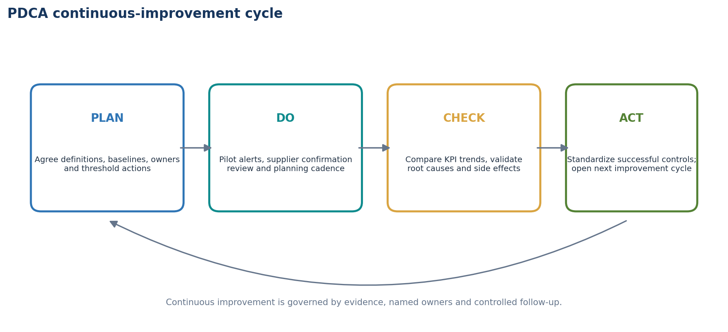
Figure 9. Proposed PDCA cycle for continuous improvement.

11. Proposed 30/60/90-Day Roadmap
Days 1–30: Stabilize definitions and visibility. Appoint a KPI owner and data steward for each measure; validate denominator rules and time zones; document source/target lineage; start a daily shortage and critical-exception review; create the baseline dashboard; capture causes for every failed OTIF order and every packaging shortage. Do not automate unreliable definitions. Deliverables are a signed KPI dictionary, data-quality baseline, top-five root-cause Pareto and action log.
Days 31–60: Pilot control changes. Pilot supplier confirmation alerts for high-impact packaging materials, planner review of shortages affecting the frozen horizon, a defined escalation path, resource calendar validation, a SKU-level forecast-error review and an exception ageing dashboard. Test duplicate messages, stale timestamps, invalid units, late receipts, quality holds and destination reconciliation in a controlled environment. Deliverables are completed test evidence, a controlled pilot log and first-cycle benefits review.
Days 61–90: Expand only after evidence. Extend to additional suppliers or product groups after the pilot passes. Adjust reorder/safety-stock settings based on lead-time and demand variability, tighten OTIF failure coding, review transport cost-to-serve and introduce a recurring scrap Pareto. Set target owners and escalation levels for misses. Deliverables are validated before/after KPI tables, updated procedures, owner training, a support handover and a next-quarter improvement backlog.
Beyond day 90: Continue quarterly PDCA. Revisit targets when product mix, demand, capacity or service agreements materially change. Keep a stable KPI definition across periods; target changes must be approved and versioned so teams cannot appear to improve by changing the formula.

12. Validation and Testing Plan
Before accepting a dashboard or a change, test calculation logic and source data, not only visual rendering. The following proposed test cases can be executed against a training environment or a controlled extract when one is available. They are not claimed as completed live SAP tests.
Test 1 — OTIF numerator/denominator: select a closed set of due order lines; verify that only orders delivered on time and in full qualify. Check partial delivery and customer-approved date changes against the agreed rule.
Test 2 — Forecast accuracy: calculate WAPE from actual and forecast values at the defined SKU/location/time level; verify that aggregation uses sums of absolute errors and actual demand rather than a simple average of percentages.
Test 3 — Volume fill rate: reconcile shipped tonnes to demand tonnes and compare to the reported 95.4% April and 98.0% September simulation calculations.
Test 4 — Inventory days of supply: confirm that usable stock excludes blocked or quality-inspection stock and that daily demand and calendar days use an agreed period.
Test 5 — Cost per tonne: reconcile logistics costs and shipped tonnes by the same scope, currency, period and inclusion rules; identify fuel surcharge, detention, returns and exceptional freight treatment.
Test 6 — Capacity utilization: reconcile scheduled load and available resource hours, including calendars, breaks, cleaning, setup, maintenance and unplanned downtime; confirm losses are not double deducted.
Test 7 — Supplier OTIF: compare promised/confirmed time and received usable quantity; test partial, late and rejected delivery lines.
Test 8 — Data quality: inject or identify invalid material, site, supplier and unit mappings; ensure the exception is visible and corrected at source before reprocessing.
Test 9 — Stale event: delay a sample data refresh and confirm freshness indicators and alerts reflect the old timestamp.
Test 10 — Threshold alert: place a controlled key figure below the material/service threshold and verify assigned owner, severity, due time and resolution state.
Test 11 — Duplicate/retry: replay a duplicate sample event and confirm that the business result is not duplicated.
Test 12 — End-to-end reconciliation: compare source transactions, KPI extract and dashboard; resolve mismatched counts/quantities before sign-off.
For each test, record test ID, setup, data version, expected result, actual result, pass/fail, evidence link, defect reference, owner and retest date. A KPI should not be certified simply because a chart appears plausible.

Validation Checklist Summary
ID | Test | Test approach | Expected evidence
VT-01 | OTIF formula and edge cases | Order sample includes on-time complete, late complete, on-time partial and changed promise date | Formula is repeatable and documented
VT-02 | Forecast accuracy / WAPE | Recompute numerator and denominator by SKU/location | Dashboard agrees to approved calculation
VT-03 | Volume fill rate | Reconcile demand vs shipped tonnes | 95.4% April and 98.0% September match the simulation
VT-04 | Inventory days | Exclude blocked and quality-inspection stock | Only usable stock included
VT-05 | Cost per tonne | Align logistics cost scope with shipped tonnes | Same period, unit, currency and cost elements
VT-06 | Capacity utilization | Validate resource calendar, setups and available hours | No double-counted losses
VT-07 | Supplier OTIF | Validate planned/confirmed date, received quantity and acceptance | Late/short/rejected lines treated consistently
VT-08 | Master-data validation | Test wrong material, site and unit mappings | Invalid records create assigned exceptions
VT-09 | Data freshness | Test a delayed refresh or stale timestamp | Dashboard shows freshness gap and alert
VT-10 | Threshold alert | Simulate a shortage or KPI breach | Correct owner/severity/due time created
VT-11 | Duplicate/retry behavior | Replay an identical event in a controlled test | No duplicate business result
VT-12 | End-to-end reconciliation | Compare source, analytics layer and dashboard samples | Mismatches resolved or tracked with owner

13. Governance, Roles and Review Cadence
A lightweight governance model is enough to begin, provided responsibility is explicit. The supply-chain performance owner chairs the monthly review and removes cross-functional blockers. Planning owns forecast accuracy, schedule adherence and capacity-related action. Procurement owns supplier confirmation quality, supplier OTIF and alternate sourcing. Inventory/warehouse owns stock status, inventory cover, pick/ready events and outbound execution. Transport owns freight planning, cost data and carrier status. Quality owns release rules and scrap/expiry analysis. Data/integration support owns mapping, refresh, queue status, event timestamps and reconciliation defects. Finance validates cost methodology and benefit claims. Sales/customer service owns customer promise-date communication and OTIF failure classification.
Daily cadence: a 15-minute meeting on critical shortages, supplier-date changes, production constraints, overdue orders, and any unowned exception. Weekly cadence: review demand changes, supplier performance, resource capacity, inventory risks, dispatch readiness and top repeat causes. Monthly cadence: publish the scorecard, explain variance to target, approve countermeasures and review previous action effectiveness. Quarterly cadence: revisit thresholds and business priorities, test whether benefits persisted and retire obsolete controls.
A simple RACI rule applies: one role is accountable for the KPI definition and outcome, one or more roles are responsible for source data and action, and affected teams are consulted/informed. A ticket or meeting note should not count as closure unless the expected business-state change is verified.

14. Risk Register and Control Measures
Risk: KPI definitions differ between functions. Impact: reports conflict and teams optimize different values. Control: signed KPI dictionary with effective date, owner and formula version.
Risk: stock is shown as available even though it is blocked or in quality inspection. Impact: plan feasibility is overstated and customer commitments are missed. Control: preserve stock-status semantics and validate quality release before ATP/availability use.
Risk: capacity utilization improves while schedule resilience worsens. Impact: the line cannot absorb small stops or a changed order mix. Control: use the 85–92% control band together with downtime, overtime, adherence and due-date metrics.
Risk: alert overload causes users to ignore critical issues. Impact: real shortages remain unresolved. Control: prioritize by business impact, severity and age; group duplicate alerts; tune thresholds only after monitoring false positives and false negatives.
Risk: attempts to reduce logistics cost damage service or freshness. Impact: late deliveries, claims or expired goods. Control: pair cost per tonne with OTIF, damage, delivery-window compliance and shelf-life controls.
Risk: stale, missing or duplicate data makes dashboard results unreliable. Impact: action is taken from an inaccurate state. Control: refresh timestamp, source lineage, duplicate-safe reprocessing, sample reconciliation and audit trail.
Risk: projected savings are claimed without a comparable baseline. Impact: overstated benefits. Control: use comparable volume/product mix, finance-reviewed cost inclusions, documented assumptions and a measurement period.
Risk: SAP product-version assumptions do not match the deployed landscape. Impact: users look for a monitor, app or functionality that is not installed. Control: confirm release, deployment model, licensing, roles and configured analytics before translating this blueprint into system steps.

15. Illustrative Benefits and Business Case
The simulated trend provides several signals for prioritizing work. The cost-rate comparison falls by ₹650 per tonne between April and September. Applying that rate difference to September's illustrative shipped volume of 610 tonnes gives ₹3,96,500 for a same-volume comparison. This is not booked savings; it is a simple comparison whose attribution would require unchanged cost scope, product mix, distance, service requirements and external rates. Finance should validate any formal claim.
Inventory days decline by 7 days while volume fill rate improves from 95.4% to 98.0%. This suggests the simulation does not require an indiscriminate stock increase to support better fill; however, item-level service and safety stock must be checked before reducing inventory. OTIF remains lower than volume fill because it uses order-level punctuality and completeness. This distinction demonstrates why a portfolio should monitor both outcomes.
Exception resolution time and shortage events improve but remain above target. The business case for monitoring is to reduce time spent identifying the right owner and prevent a late supplier change from propagating into missed production or dispatch. The benefit should be measured in avoided expedite cost, fewer schedule changes, reduced shortage incidents, and improved OTIF—not simply in the number of alerts created.

16. Learning Outcomes and Conclusion
This final assessment consolidated the previous topics into an operating-performance framework. The key learning is that good performance management starts with definitions and trusted data, then uses a balanced set of customer, planning, inventory, cost, supplier, quality and integration measures. Trend improvement is useful, but each measure must also be checked against a target and interpreted with its side effects.
The six-month simulation improves in every tracked KPI, but several measures miss their proposed September targets. The leading priorities are supplier reliability, critical-exception response, packaging shortages, forecast accuracy, OTIF and scrap/expiry. Capacity utilization at the upper edge of the control band warns against equating higher utilization with better performance. A PDCA approach converts these findings into a structured action backlog with validated measurements and clear ownership.
SAP APO KPI reporting, planning books/key figures and the Plan Monitor can support historical and plan-version comparison in the relevant legacy landscape. Other SAP ERP/S/4HANA or IBP analytics and alerting capabilities may apply depending on deployment. The practical requirement is not a particular screen alone; it is a governed chain from reliable transactions to transparent KPIs, prioritized exceptions, accountable corrective actions and verified outcomes.
All six-month values, dashboard indicators, targets and benefit calculations in this report are simulated for academic and internship learning. No live SAP configuration, production transaction, dashboard or test execution is claimed. The next step in a real environment would be to replace these assumptions with an approved extract, validate formulas with process owners, capture real authorized system evidence and run the proposed tests in a controlled environment.

17. References
[1] SAP Help Portal. “Performance Measurement with KPIs.” SAP Supply Chain Management documentation. Defines SAP APO KPI usage for comparison of planning and execution performance, including quality/service, production control, supply chain flexibility and inventory control. Open source
[2] SAP Help Portal. “Planning Book.” SAP Advanced Planning and Optimization 7.0 EHP3 documentation. Explains planning-book views, key figures, characteristics and user-specific planning layouts. Open source
[3] SAP Help Portal. “Plan Monitor.” SAP Advanced Planning and Optimization 7.0 EHP2 documentation. Describes evaluation of key figures for planning objects, versions and periods, with tabular and graphical outputs. Open source
[4] SAP Help Portal. “Custom Alerts.” SAP Integrated Business Planning documentation, version 2605. Describes threshold-based alerts for critical supply-chain situations such as shortages and supply-demand imbalance; relevant only where the corresponding IBP applications are deployed. Open source
[5] SAP Help Portal. “Key Performance Indicators in SAP Supply Chain Info Center.” Lists example KPIs including forecast accuracy, weighted forecast error, resource utilization, free capacity, stock coverage and projected service level. Open source
[6] Internship assignment brief. “Week 6 Task: Performance Evaluation and Continuous Improvement in SAP SCM.” User-provided assignment text; requirements include a minimum 2,000-word report, KPI performance evaluation, charts/dashboard, SAP-based monitoring/reporting approach, and actionable continuous-improvement plan.
Reference note: SAP Help Portal pages span specific product/version documentation. They are used to support the concepts described; they should not be interpreted as evidence that the fictional case has those products, transactions, roles or applications configured.

Appendix A. Portal Submission Description
This Week 6 report presents a Performance Evaluation and Continuous Improvement Analysis in SAP SCM using a six-month simulated supply-chain scenario for the fictional Deccan Harvest Foods Pvt. Ltd., a manufacturer of millet-based ready-to-cook food products. The objective is to evaluate operational performance through a balanced set of key performance indicators (KPIs), identify persistent bottlenecks, and propose actions that can be monitored and validated over time. The report draws on SAP Help Portal documentation for KPI measurement, planning books and key figures, the SAP APO Plan Monitor, and threshold-based alerts where SAP Integrated Business Planning is deployed. The actual reporting tools would depend on the organization's SAP release and system architecture.
The assessment includes simulated monthly data from April to September 2026 for customer on-time-in-full (OTIF), forecast accuracy, production schedule adherence, supplier OTIF, inventory days of supply, logistics cost per shipped tonne, critical-exception resolution time, packaging-material shortage incidents, resource utilization, scrap/expiry rate, data reconciliation accuracy, demand tonnes, and shipped tonnes. The simulated results show OTIF improving from 86.0% to 93.0%, forecast accuracy from 81.0% to 88.5%, schedule adherence from 82.0% to 91.0%, and supplier OTIF from 78.0% to 89.0%. Inventory cover reduces from 34 to 27 days, logistics cost declines by approximately 9.6% per tonne, and median exception-resolution time falls from 16 to 6 hours. However, several values remain outside proposed targets, including supplier OTIF, customer OTIF, exception response time, packaging shortages and scrap/expiry.
The report contains a performance dashboard mock-up, monthly trend charts, KPI definitions and formulas, root-cause analysis, a proposed 30/60/90-day improvement roadmap, a Plan-Do-Check-Act cycle, governance responsibilities, risk controls and twelve validation test cases. Recommendations focus on supplier reliability, demand-forecast segmentation, finite-capacity planning, data reconciliation, exception ownership, inventory control, cost-to-serve, and quality loss reduction. All scenario figures, trends, targets and benefit calculations are illustrative. The report is a learning simulation and configuration blueprint; it does not claim execution or measured output from a live SAP production system.
End of report.

