Bandit-Based Material Screening

1. Abstract
This project studies how a researcher with a limited testing budget can decide which candidate alloy to test next. The problem is modelled as a multi-armed bandit with 60 candidate steels sampled with a fixed seed from the 312-steel experimental yield strength dataset distributed with matminer (steel_strength). The reported yield strengths (MPa) are treated as the hidden true mean of each arm, and each test returns that value plus simulated Gaussian noise (SD 100 MPa) over a budget of 300 tests. Random selection, Epsilon-Greedy, UCB1 and Thompson Sampling are compared over 30 independent seeds using cumulative reward, regret, best-material identification and discovery speed. Thompson Sampling gave the highest cumulative reward (685,205 MPa summed over tests), followed by Epsilon-Greedy (656,257). Standard UCB1 (c = 1) was only slightly better than Random (434,094 vs 422,827). Best-material identification did not separate the methods on this pool (Random, Epsilon-Greedy and UCB1 all reached 100%), while Thompson Sampling identified it in 93% of runs. The material values are real; the measurement noise and the bandit setting are simulated.

2. Introduction
Finding a high-performing alloy usually means testing many candidates, and every test costs time, material and money. Testing candidates uniformly wastes budget on poor materials, while committing early to one apparently good material risks missing a better one. This exploration versus exploitation trade-off is exactly what bandit algorithms address. The project builds a simulated screening environment and compares standard bandit methods under identical conditions.

3. Original problem statement
“A multi-armed or contextual bandit that chooses which candidate alloys or compounds to 'test' next from a public dataset (e.g., Matbench).”
This wording is reproduced exactly as assigned. The implementation uses the multi-armed variant. A contextual extension is discussed as future work.

4. Objectives
- Build a simulated material-screening environment with hidden true properties and noisy observations.
- Implement Random, Epsilon-Greedy, UCB1 and Thompson Sampling with identical budgets.
- Compare them across many seeds with reward, regret, identification and discovery metrics.
- Document data provenance, assumptions, limitations and ethics honestly.

5. Background on multi-armed bandits
A multi-armed bandit has K arms. At each step t the agent picks an arm a_t and receives a reward drawn from that arm's unknown distribution. There is no state transition, so the only difficulty is learning which arm is best while still earning reward. Performance is measured by cumulative regret:
R_T = Σ_{t=1..T} ( μ* − μ_{a_t} ), μ* = max_a μ_a
Good algorithms achieve regret that grows slowly (sub-linearly) in T. Random selection has regret that grows linearly.

6. Material-screening application
Each candidate alloy is an arm. Testing an alloy (for example a tensile test) is a pull and returns a noisy measurement of its yield strength. The primary target property is yield strength in MPa. It was chosen because it is a real engineering objective where higher is better, it is continuous and positive, it is available as a numerical label in the Matbench steels task, and repeat measurements are noisy, which justifies a stochastic reward.

7. Dataset description and source
Data used: matminer steel_strength. The notebook loaded the steel_strength dataset programmatically through the matminer package (Ward et al., 2018). It contains 312 steels with composition and experimentally reported yield strength in MPa. 60 steels were sampled with a fixed seed (42) to form the candidate pool. The Matbench steels task (Dunn et al., 2020) is a benchmark of the same size (312 steels). The direct Matbench download link returned an HTTP error when tried, so matminer was used instead. The original source of the measurements is documented in the matminer and Matbench references; it was not independently verified in this project.
Preprocessing: the composition column was renamed material and the yield strength column true_strength_MPa (units MPa); missing-value and duplicate checks were run; and the high-performing set was defined as the top 10% of the pool (6 steels, true strength of at least 1,798 MPa). The pool mean is 1,409 MPa and the best steel is 2,487 MPa.
Important distinction: the strengths in the pool are real reported values, but treating each as the exact hidden mean and adding Gaussian noise on top is a modelling assumption. The dataset contains no replicate measurements, so the noise level is not derived from data.
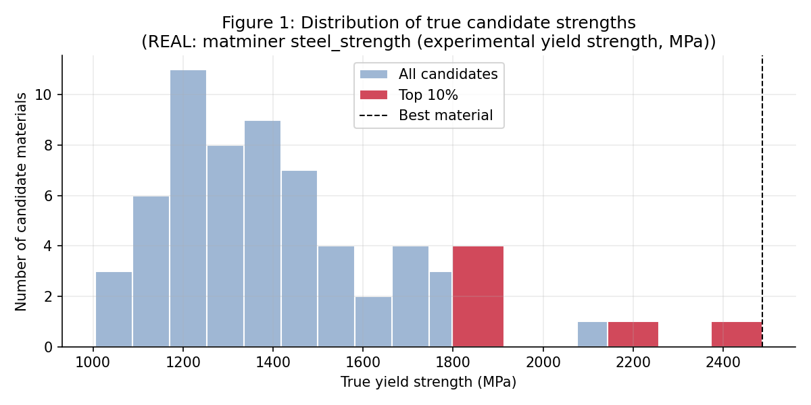
Figure 1: Distribution of true candidate strengths (real matminer steel_strength sample).

8. Problem formulation
Element | Definition
Environment | Pool of 60 candidate alloys with hidden mean yield strengths. Each test returns a noisy value.
State | Stateless bandit. The agent's information is the history of (arm, reward) pairs, summarised by counts N(a) and mean estimates.
Action | Choose which alloy to test next, a_t in {1, ..., K}.
Reward | r_t = μ_{a_t} + ε_t with ε_t ~ Normal(0, 100²), in MPa.
Horizon | T = 300 tests (experimental budget).
Objective | Maximise cumulative reward, equivalently minimise cumulative regret, and identify the best alloy.

Reward model assumptions: noise is Gaussian, independent across tests and equal for all arms. The noise level is an assumption, not estimated from data, and the pool values are used as the hidden true means. The agents never see the true means. The environment returns only noisy rewards, so no information leaks. For fairness, the noise for the n-th test of an arm is pre-drawn per seed, so all algorithms face the same noise table (common random numbers).

9. Algorithm methodology

9.1 Random baseline
Choose an arm uniformly: P(a_t = a) = 1/K. No learning. Pure exploration.

9.2 Epsilon-Greedy
With probability 1 − ε test the arm with the highest estimated mean, otherwise test a random arm (ε = 0.1). Each arm is tested once first. Update:
N(a_t) ← N(a_t) + 1, Q(a_t) ← Q(a_t) + (r_t − Q(a_t)) / N(a_t)
Exploration is constant, so about 10% of tests stay random for the whole budget.

9.3 UCB1
Pick the arm with the highest upper confidence bound on its mean (Auer et al., 2002), with rewards scaled to [0, 1] by a fixed physical bound of 2500 MPa:
a_t = argmax_a [ Q(a) + c √( 2 ln t / N(a) ) ]
Rarely tested arms receive a larger bonus, so exploration is driven by uncertainty and shrinks as counts grow. Standard UCB1 uses c = 1. Because the scaled noise (0.04) is small relative to the bonus, c = 1 keeps exploring broadly at this budget, so a sensitivity variant c = 0.1 is also reported and labelled as an extra.

9.4 Thompson Sampling
Keep a Gaussian posterior for each arm's mean (prior mean 1000 MPa, prior SD 500 MPa, known noise SD). After N tests with reward sum S:
λ = 1/τ₀² + N/σ², m = ( m₀/τ₀² + S/σ² ) / λ, μ_a | data ~ Normal(m, 1/λ)
Draw one sample from each posterior and test the arm with the largest sample. Exploration happens naturally where posteriors are wide and fades as they narrow. Note that this version assumes the noise SD is known to the agent.

10. Experimental setup
Setting | Value
Candidate pool | 60 steels sampled from matminer steel_strength (312 steels), pool seed 42
Budget | 300 tests per run, identical for all algorithms
Noise | Gaussian, SD 100 MPa (assumption)
Independent runs | 30 seeds (0 to 29), same pool and same noise tables across algorithms
Epsilon-Greedy | ε = 0.1
UCB1 | c = 1 (standard); c = 0.1 (sensitivity variant)
Thompson Sampling | Prior Normal(1000, 500²) MPa, known noise SD
High-performing set | Top 10% of pool (6 materials)

Metrics: cumulative observed reward; average reward per test; cumulative regret using true means of chosen arms; simple regret of the recommended material (best empirical mean among tested arms); best-material identification at T; tests until a top-10% material is first tested; distinct materials tested; and the share of tests that matched the agent's greedy choice. Observed (noisy) rewards and true underlying strengths are kept separate throughout: reward metrics use observations, regret metrics use hidden truth. Sanity checks in the notebook verify equal budgets, uniform Random selection, initial coverage of arms, non-negative regret, correct noise level, absence of leakage, reproducibility, and a worked Thompson posterior example.

11. Results and visualizations
All values are means over 30 seeds. Reward units are MPa summed over 300 tests. An oracle that always tested the best material would collect about 746,190. The plus-minus values are 95% confidence intervals across seeds.
Algorithm | Cumulative reward | Cumulative regret | Final simple regret (MPa) | Best-material ID (%) | Top-10% share, last 100 tests (%)
Random | 422,827 ± 2007 | 323,156 ± 1824 | 0.0 ± 0.0 | 100 | 10.3
Epsilon-Greedy | 656,257 ± 1562 | 89,898 ± 1401 | 0.0 ± 0.0 | 100 | 91.4
UCB1 | 434,094 ± 652 | 312,026 ± 227 | 0.0 ± 0.0 | 100 | 13.7
Thompson Sampling | 685,205 ± 13991 | 60,954 ± 13795 | 22.0 ± 30.0 | 93 | 96.8
UCB1 (c=0.1) | 673,483 ± 860 | 72,594 ± 504 | 0.0 ± 0.0 | 100 | 98.3

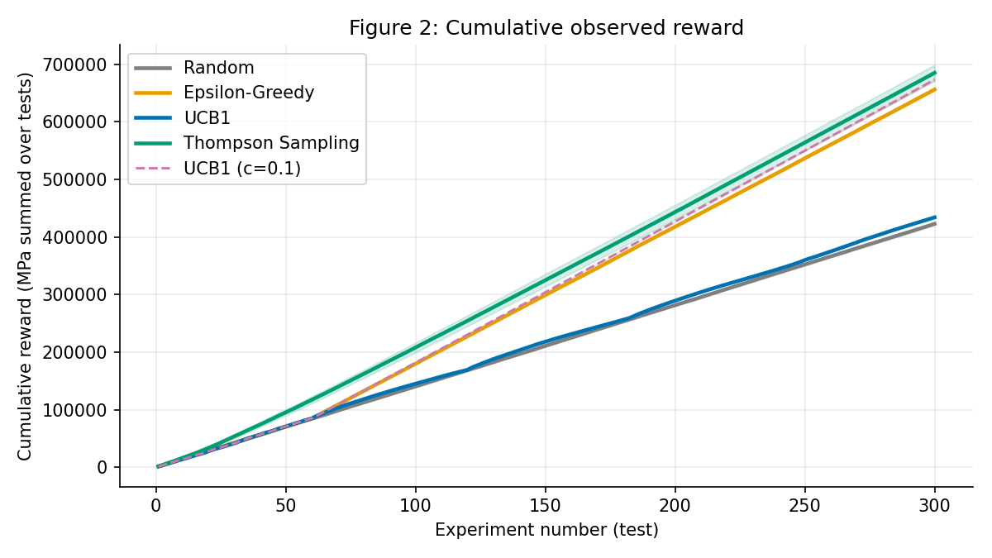
Figure 2: Cumulative observed reward (mean and 95% CI over seeds).
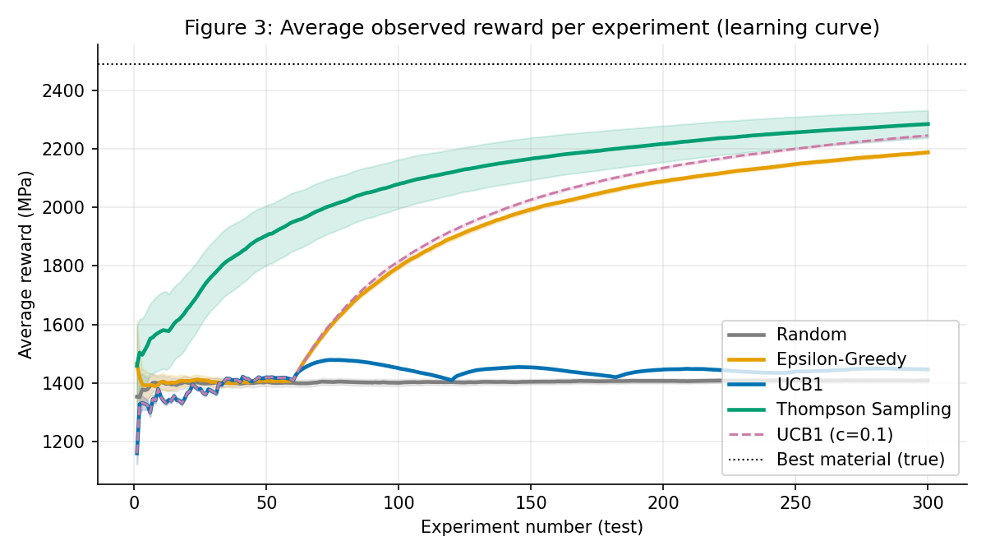
Figure 3: Average observed reward per experiment (learning curves).
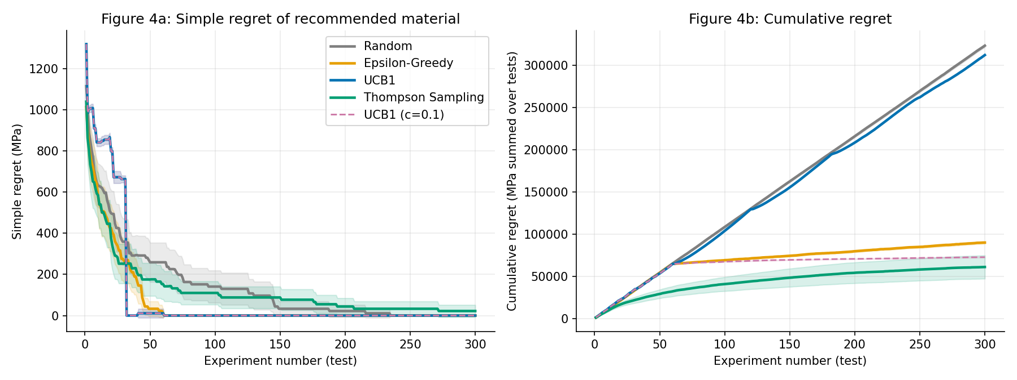
Figure 4: Simple regret of the recommended material (a) and cumulative regret (b).
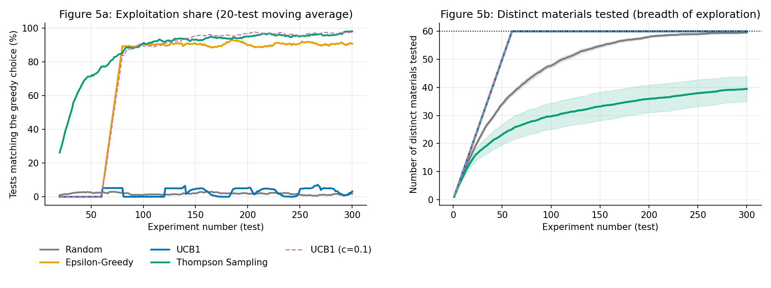
Figure 5: Exploitation share (a) and breadth of exploration (b).
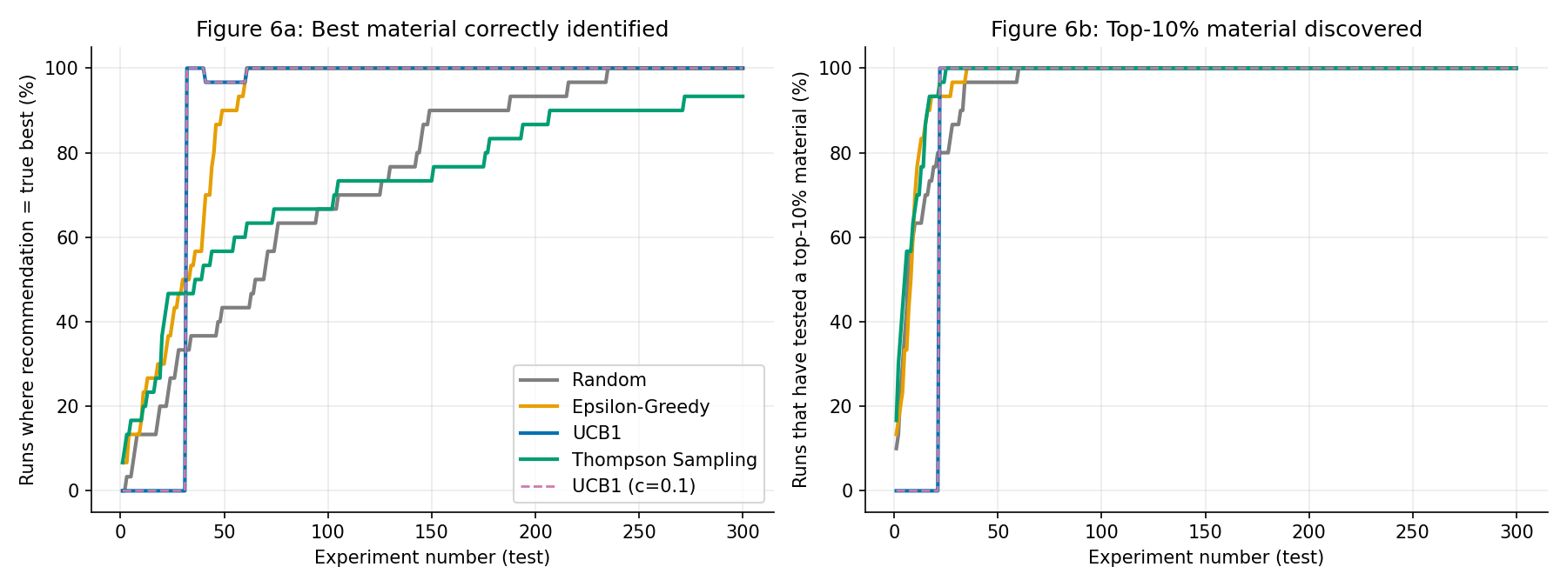
Figure 6: Best-material identification (a) and discovery of a top-10% material (b).
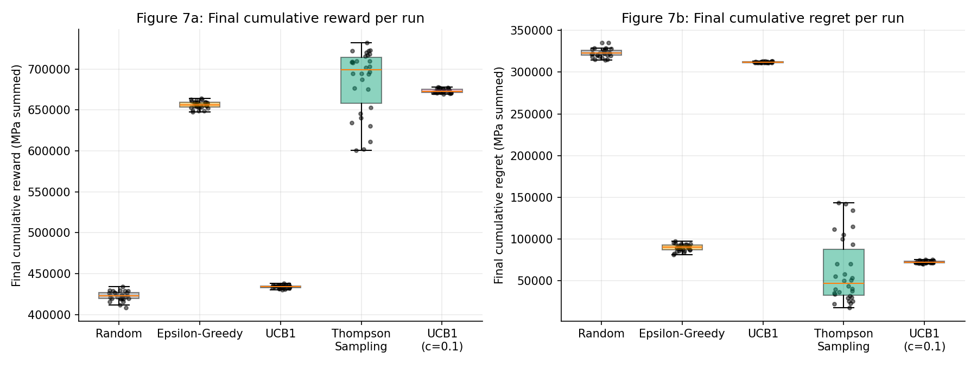
Figure 7: Final cumulative reward and regret across the independent runs.
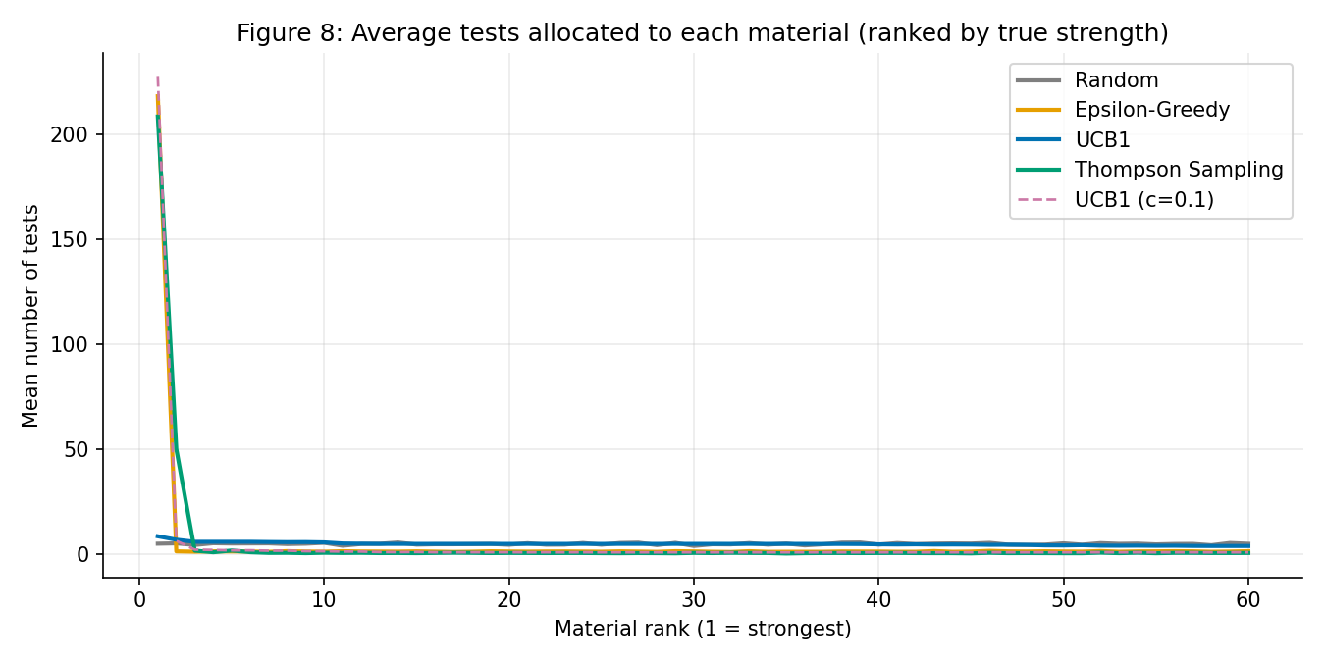
Figure 8: Average tests allocated to each material, ranked by true strength.

12. Comparative analysis
Because every algorithm sees the same noise per seed, paired differences are informative. Compared with Random, the gain in cumulative reward (MPa summed over tests, mean ± 95% CI) was 262,378 ± 15,063 for Thompson Sampling, 250,656 ± 2,160 for UCB1 with c = 0.1, 233,430 ± 2,359 for Epsilon-Greedy, and only 11,267 ± 1,914 for standard UCB1.
- Thompson Sampling had the highest reward (685,205) and lowest regret (60,954), and spent 96.8% of its last 100 tests on top-10% steels. Its run-to-run variation was the largest (wide interval), and it identified the best steel in only 93% of runs, with a final simple regret of 22.0 ± 30.0 MPa. It tested only 39.5 of 60 steels on average, so in some runs it settled on a strong steel without ever testing the very best one.
- UCB1 with c = 0.1 (reward 673,483) was within the uncertainty of Thompson Sampling's reward and identified the best steel in 100% of runs, because it tests every steel at least once.
- Epsilon-Greedy reached 656,257 with 100% identification. Its regret keeps growing slowly because it never stops exploring (greedy share about 72.6%).
- Standard UCB1 (c = 1) stayed close to random: greedy share 2.6% and top-10% share in the last 100 tests 13.7%. With 60 arms and 300 tests each arm gets about 5 tests on average, which is still the exploration phase.
- Random identified the best steel in 100% of runs even though it earned the least reward. So on this pool, best-material identification does not distinguish the methods. Reward and regret do.
- Median tests until a top-10% steel was first tested: Random 7, Thompson Sampling 5.5, Epsilon-Greedy 8.5, and 22 for both UCB1 variants. UCB1 tests arms in index order in its initial pass, so its discovery time mostly reflects where top steels fall in the pool order.

13. Discussion
Algorithms that concentrate tests on promising steels earn far more reward and incur far less regret than uniform sampling, as bandit theory predicts. Thompson Sampling's strength is that it focuses quickly (Figure 8). That focus has a cost: arms that look unpromising early may never be tested, which is the likely reason it missed the best steel in some runs. Its prior (mean 1000 MPa, SD 500 MPa) is also lower than the pool mean (about 1409 MPa), and a steel near 2487 MPa lies about three prior standard deviations above it, so an untested arm is rarely sampled that high. This explanation is consistent with the results but was not tested separately. UCB1 with c = 0.1 and Epsilon-Greedy keep testing every steel at least once, which protects identification at the price of a little reward. Thompson Sampling also benefits from being given the noise level.

14. Limitations
- Noise is simulated (Gaussian, SD 100 MPa, equal for all arms and known to Thompson Sampling). The dataset has no replicate measurements, so the noise level is an assumption.
- Each reported strength is treated as a hidden true mean. Real values carry their own measurement and compilation error.
- Only 60 of the 312 steels were used, with a single pool seed, budget and noise setting.
- The Thompson Sampling prior was not matched to the pool. Rewards above 2500 MPa are clipped for UCB1 (the best steel is 2487 MPa, close to that scaling bound).
- Arms are independent. Composition features could act as context for a contextual bandit (not implemented).
- One objective only. Real alloy selection also weighs cost, ductility, corrosion resistance and manufacturability.
- Hyperparameters were not tuned apart from the labelled UCB1 c = 0.1 variant.
- The original provenance of the steel measurements was not independently verified.

15. Ethical considerations
- Honesty about data: simulated values must never be presented as measurements of real materials.
- Over-trust: a bandit recommendation is a screening aid. Safety-critical materials need standards-compliant validation.
- Dataset bias: literature-compiled data over-represents well-studied systems, so screening may keep favouring familiar alloys.
- Resources and environment: fewer experiments save material and energy, but optimising one property can hide drawbacks such as scarce or toxic elements.
- Human oversight: domain experts should review favoured candidates before budget is committed.

16. Conclusion
On a pool of 60 real steels with simulated measurement noise, learning-based bandit methods clearly outperformed random testing. Thompson Sampling earned the most reward and had the lowest regret but sometimes missed the single best steel (93% identification). Epsilon-Greedy was a solid alternative that never converges fully, and standard UCB1 needed a smaller exploration scale to be competitive at a budget of only 300 tests across 60 steels. The study runs from one reproducible notebook with fixed seeds, equal budgets and no information leakage. Natural next steps are using composition features as context and testing other pool sizes and budgets.

