**Insurance Claims Fraud Detection Using Machine Learning.**

**Problem Definition:**

Business case: Insurance fraud is a huge problem in the industry. It's difficult to identify fraud claims. Machine Learning is in a unique position to help the Auto Insurance industry with this problem.

In this project, you are provided a dataset which has the details of the insurance policy along with the customer details. It also has the details of the accident on the basis of which the claims have been made.

In this example, you will be working with some auto insurance data to demonstrate how you can create a predictive model that predicts if an insurance claim is fraudulent or not.

**Data Analysis:**

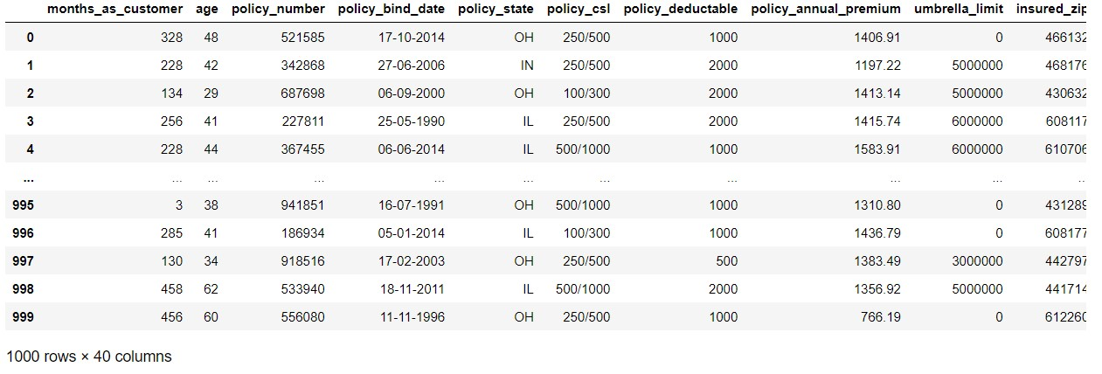

**There are 1000 rows and 40 columns in the dataset.**

The Independent Feature columns in the dataset are as follows:

months_as_customer: How many months the person is a customer

age: Age of the Customer

policy_number: Unique number of policies

policy_bind_date: Time period between effective date of coverage and policy insurance.

Policy_state: The state where policies are active

Policy_csl: Policy Combined Single limit

Policy_deductable: Amount paid before insurance company starts paying up.

Policy_annual_premiun: Annually paid premium

Umbrella_limit: Provides excess limits and gives additional excess coverage

Insured_zip: Zip code of the insured address

Insured_sex: Gender

Insured_education_level: Education of the insured

Insured_occupation: Occupation of the insured

Insured_hobbies: Hobbies of the insured

Insured_relationship: Relationship of the insured

Capital_gains: Capital gains made from insurance

Capital_loss: Capital loss incurred

Incident_date: Date of the incident

Collision type: Which type of collision

Incident_severity: Severity of the incident

Authorities_contacted: whether authorities were contacted

Incident_state: state where incident occure

Incident_city: City where incident occure

Incident_location: location of the incident

Incident_hour_of_the_day: Time on which incident occure

Number_of_vehicles_involved: Number of vehicles involved in the incident.

Property_damaged: Property is damaged or not

Bodily_injuries: Severity of bodily injuries.

Witnesses: Number of witnesses

Police_report_available: Whether police report is available or not

Total_claim_amount: Total amount of claim

Injury_claim: Injury claim amount

Property_claim: Property claim amount

Vehicle_claim: Vehicle claim amount

Auto_make: Make of vehicle

Auto_model: Model of vehicle

Auto_year: Manufacturing year of vehicle

The target variable In the dataset are as follows:

Fraud Reported: Whether fraud reported as Yes or No

* **Next step is checking for null values:**

_c39 has no usable data. Other columns appear to have no null values. So we will drop it.

* **Next step Is checking for unique numbers**

we can observe the column policy_number and incident_location have thousand unique values which means they have only one value count. So it is not required for prediction and we can drop it.

* **Next step is checking for value counts of each columns**

By looking at the value counts of each column we can realize that the columns umbrella_remit, capital_gain and capital_loss contains more zero values around 79.8%, 50.8% and 47.5% respectively. I'm keeping the zero values in a capital gain and capital loss columns as it is since umbrella limit column has more than 70% of 0 values less drop it.

* **Next step is checking for datatypes**

we have extracted the month and year corner from both policy blind date and incident date so we can drop this column

* **Next step is checking for categorical columns**

The categorical columns are

'policy_state', 'insured_sex', 'insured_education_level', 'insured_occupation', 'insured_hobbies', 'insured_relationship', 'incident_type', 'collision_type', 'incident_severity', 'authorities_contacted', 'incident_state', 'incident_city', 'property_damage', 'police_report_available', 'auto_make', 'auto_model', 'fraud_reported'

* **Next step is checking for numerical columns**

The numerical columns are

'months_as_customer', 'age', 'policy_deductable', 'policy_annual_premium', 'capital-gains', 'capital-loss', 'incident_hour_of_the_day', 'number_of_vehicles_involved', 'bodily_injuries', 'witnesses', 'total_claim_amount', 'injury_claim', 'property_claim', 'vehicle_claim', 'policy_bind_day', 'policy_bind_month', 'policy_bind_year', 'incident_day', 'incident_month', 'csl_per_person', 'csl_per_accident', 'Vehicle_Age'

* **Next step is checking the describtion of the dataset**

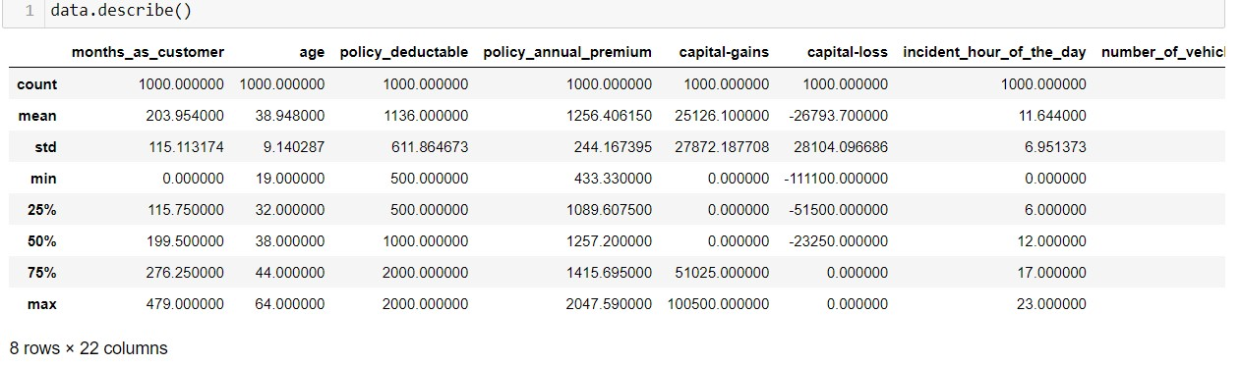

These give the statistical summary of the dataset

* Here the count of all columns is equal which means there are no missing values in dataset.
* In some of the columns like policy_deductable, capital_gain, injury_clain etc we can observe the mean value is greater than the median which means the data inj those columns are skewed to the right.
* And in some of the columns like total_claim_amount, vehicle_claim etc we can observe the median is greater than the mean which means the data in the columns are skewed to the left.
* And some of the columns have equal mean and median that means the data symmetric and is normally distributed and so skewness present.
* There is a huge difference in 75% and max it shows that huge outliers present in the columns.
* **Next step is Data Visualization**

In this step we will visualize different types of visualization for better understanding. In this step we will visualize the features with respect to target variable and features with respect to features.

* **Next step is checking for outliers**

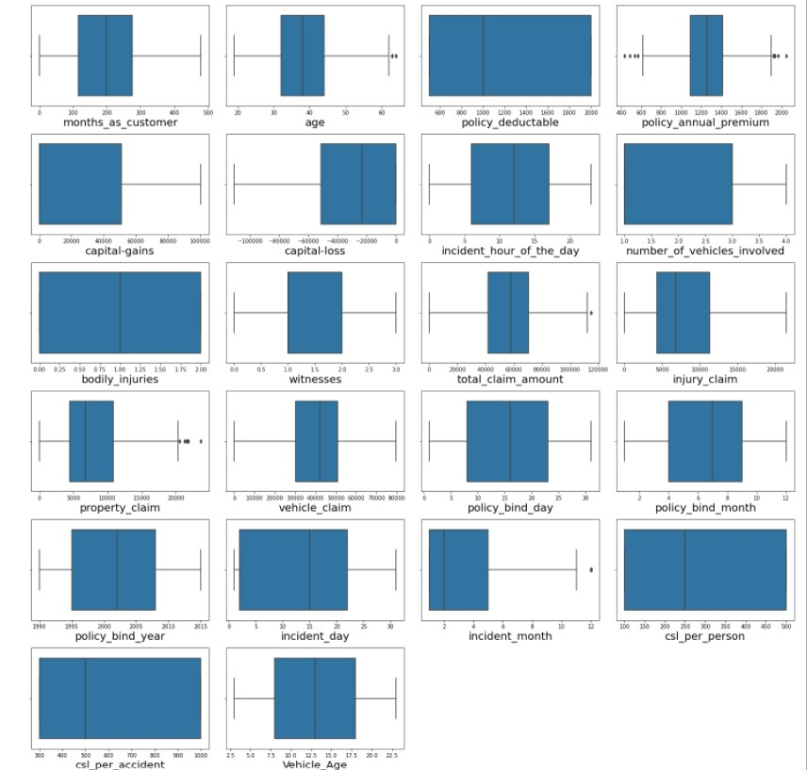

We can find the outliers in the following columns.

* age
* policy_annual_premium
* total_claim_amount
* property_claim
* incident_month
* **Next step is Removing outliers**

In this step we remove outliers using zscore method and IQR method.  
We notice that using zscore we loose very less data so we consider zscore

* **Next step is checking for skewness**

The following features contain skewness:

* total_claim_amount
* vehicle_claim
* incident_month
* csl_per_accident
* **Next step is removing skewness**

We removed the skewness by yeo-jonhson method and after that plotted the distribution graph the graph looks almost natural after removing the skewness.

* **Next step is checking for correlation**

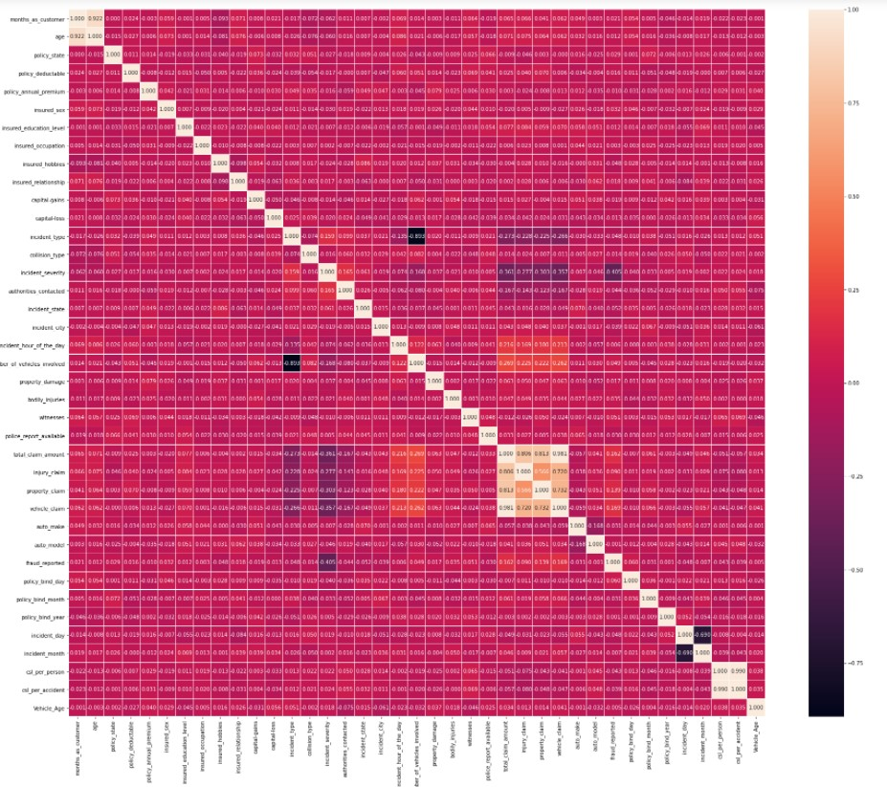

This heatmap shows the correlation matrix by visualizing the data. We ccan observe the relation between one feature to other.

* This heatmap contain both positive and negative correlation
* We can observe the most of the columns ahe highly correlated with each other which vreates multicolinerity problem.
* We will check thew VIF value to overcome with this multicolinearity problem.

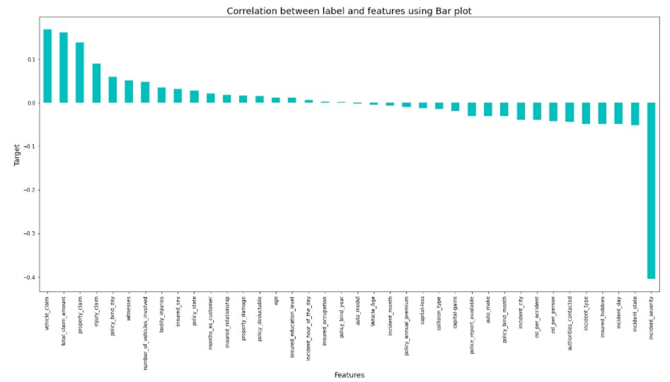

* **Next step is separating features and labels**

In this step we separate the feature columns and target columns.

* **Next step is standard scaler**

In this step we scaled the data

* **Next step is checking for VIF values**

In this step we will check that any multicollinearity exists in the data or not.  
As there is multicollinearity problem is present in few of columns, we solved it by dropping few of them.

* **Next step is Oversampling**

In this step we balanced the data using oversampling method and processed for modeling.

* **Next step is modelling**

In modeling we get 90.88% accuracy on the random state of 80

* **Next step is finding the best model**

1. By RandomForestClassifier we get 91.55% accuracy
2. By SVC we get 86.66% accuracy
3. By GradientBoostingClassifier we get 90.22% accuracy
4. By AdaBoostClassifier we get 88% accuracy
5. By BaggingClassifier we get 88% accuracy
6. By ExtraTreeClassifier we get 91.11% accuracy

* **Next step is checking for cross validation**

1. Cross_validation_Score Of RandomForestRegressor is: 0.868
2. Cross_validation_Score Of SVC is: 0.858
3. Cross_validation_Score Of GradientBoostingClassifier is: 0.8460000000000001
4. Cross_validation_Score Of AdaBoostClassifier is: 0.8460000000000001
5. Cross_validation_Score Of BaggingClassifier is: 0.8699999999999999
6. Cross_validation_Score Of ExtraTreeClassifier is: 0.9153333333333334

**The ExtraTreeClassifier is our Best Fit Model**

* **Next step is Hyper parameter Tuning**

After tuning we get89.11% Accuracy

* **Next step is plotting ROC AUC curve**

We plotted the ROC AUC curve

* **Next step is saving the model**

In this step finally we save the model