Debugging

1. Found a bug : Here first we did a false Owner login, It said Login Failed.

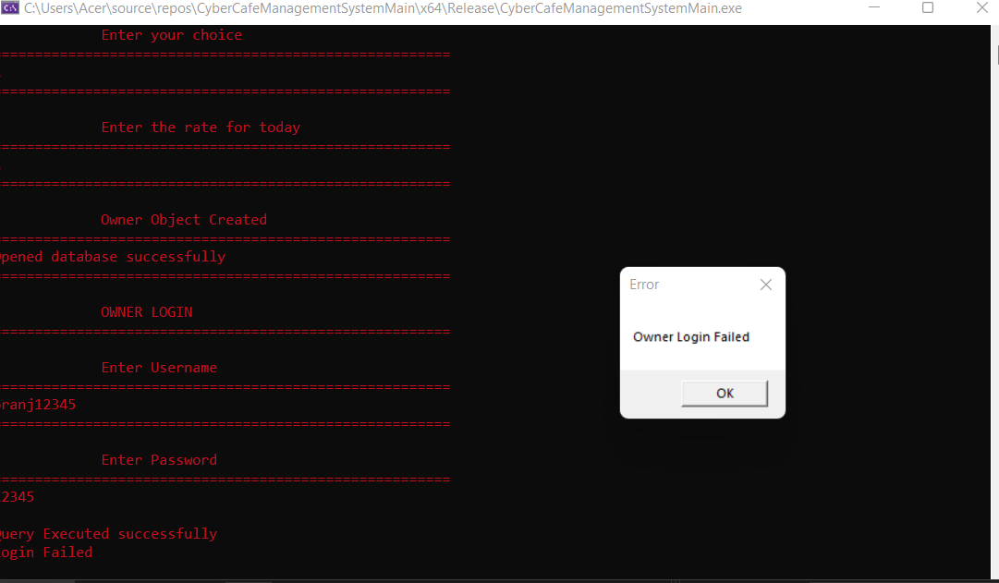

1. Then After login failed it goes to the home Page. If After trying to login again. It says login failed without even asking the username and password.

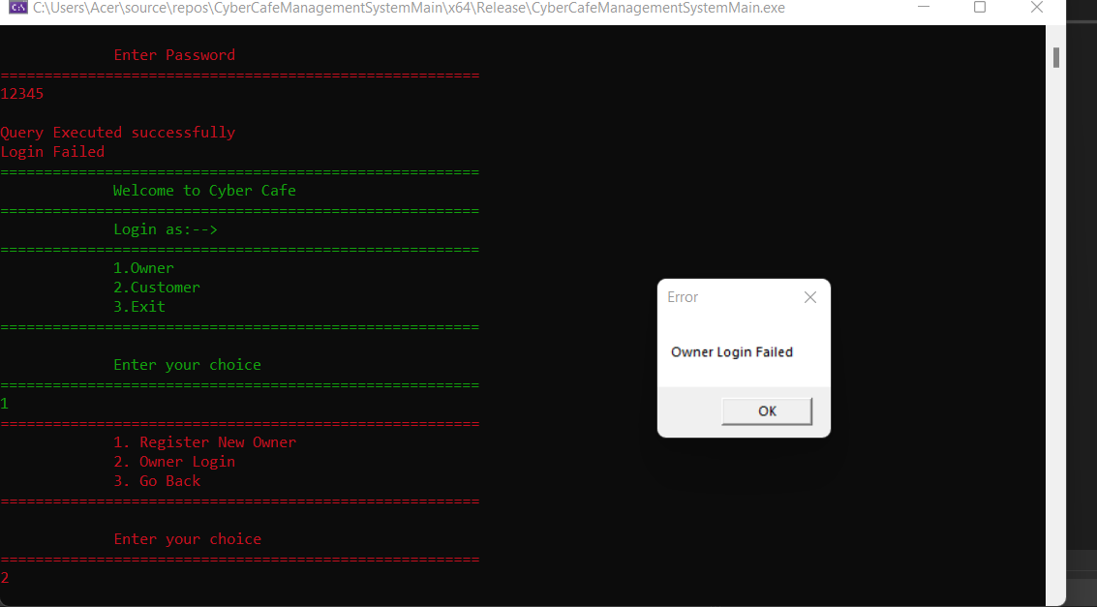

3)Starting to Debug: Breakpoint at main.



4)started Debugging: Started watching gpOwner

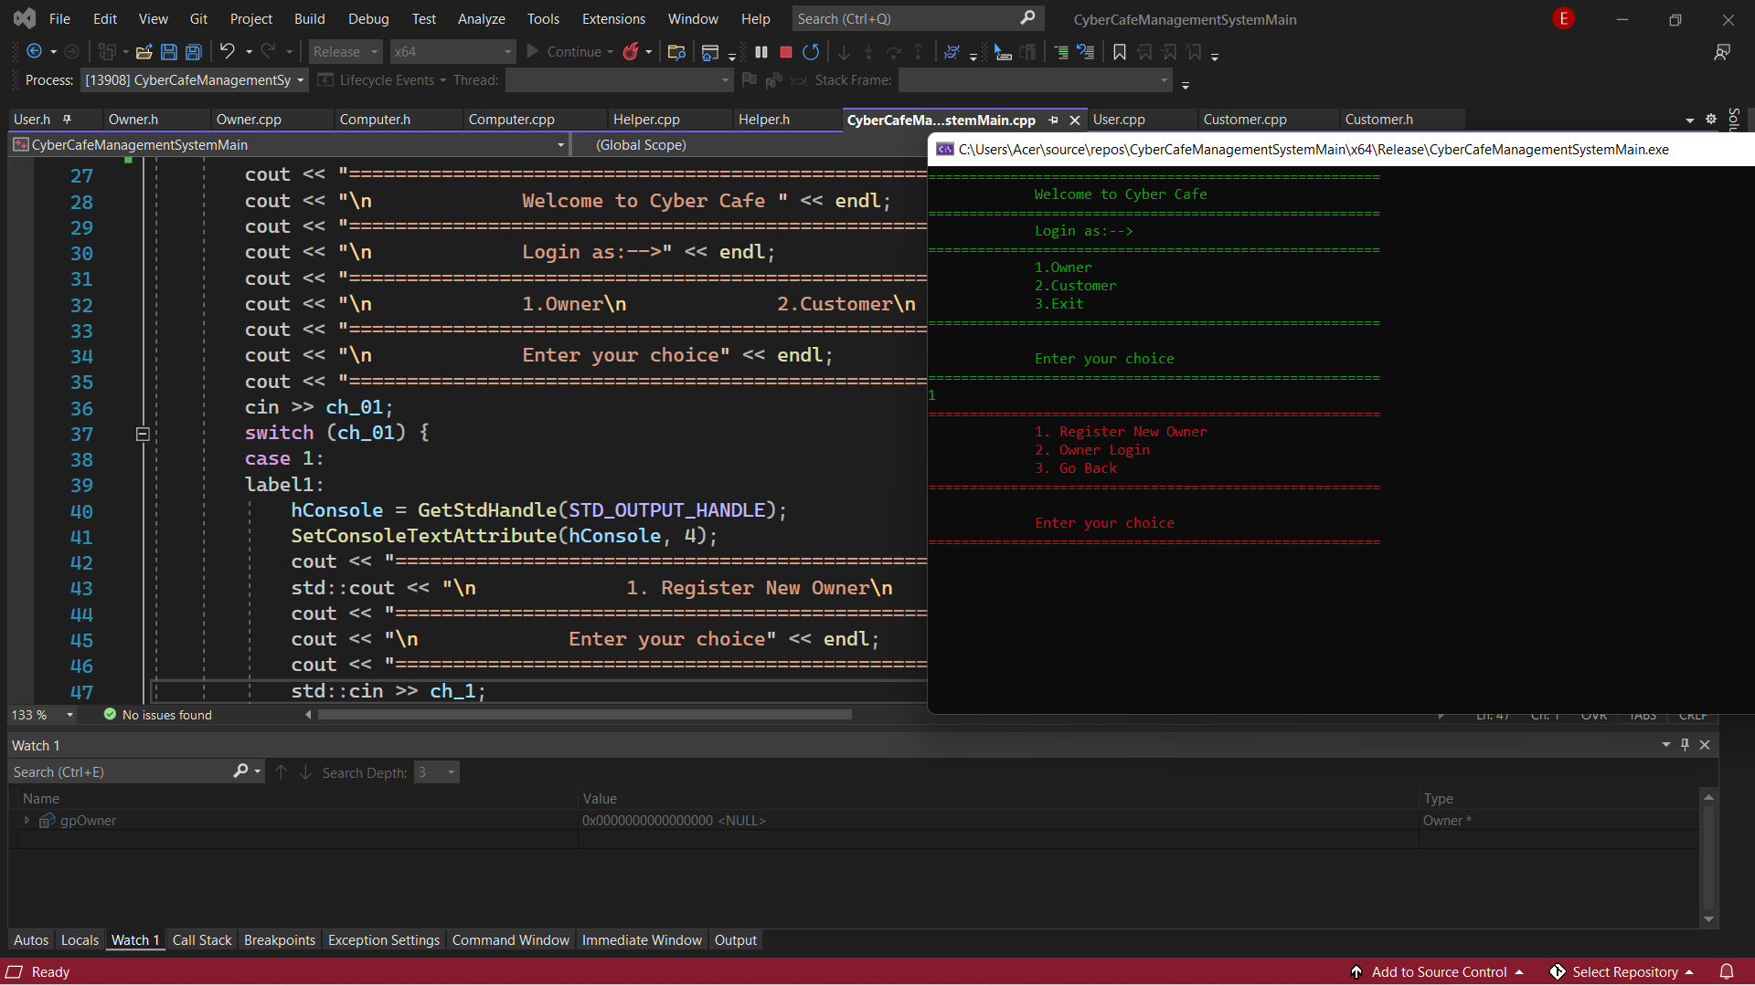

5)Entered 1 to login as Owner.

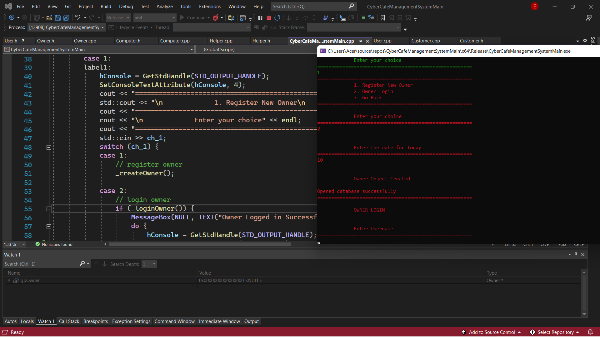

6) Entered 2 to Owner Login and entered the rate_per_min.

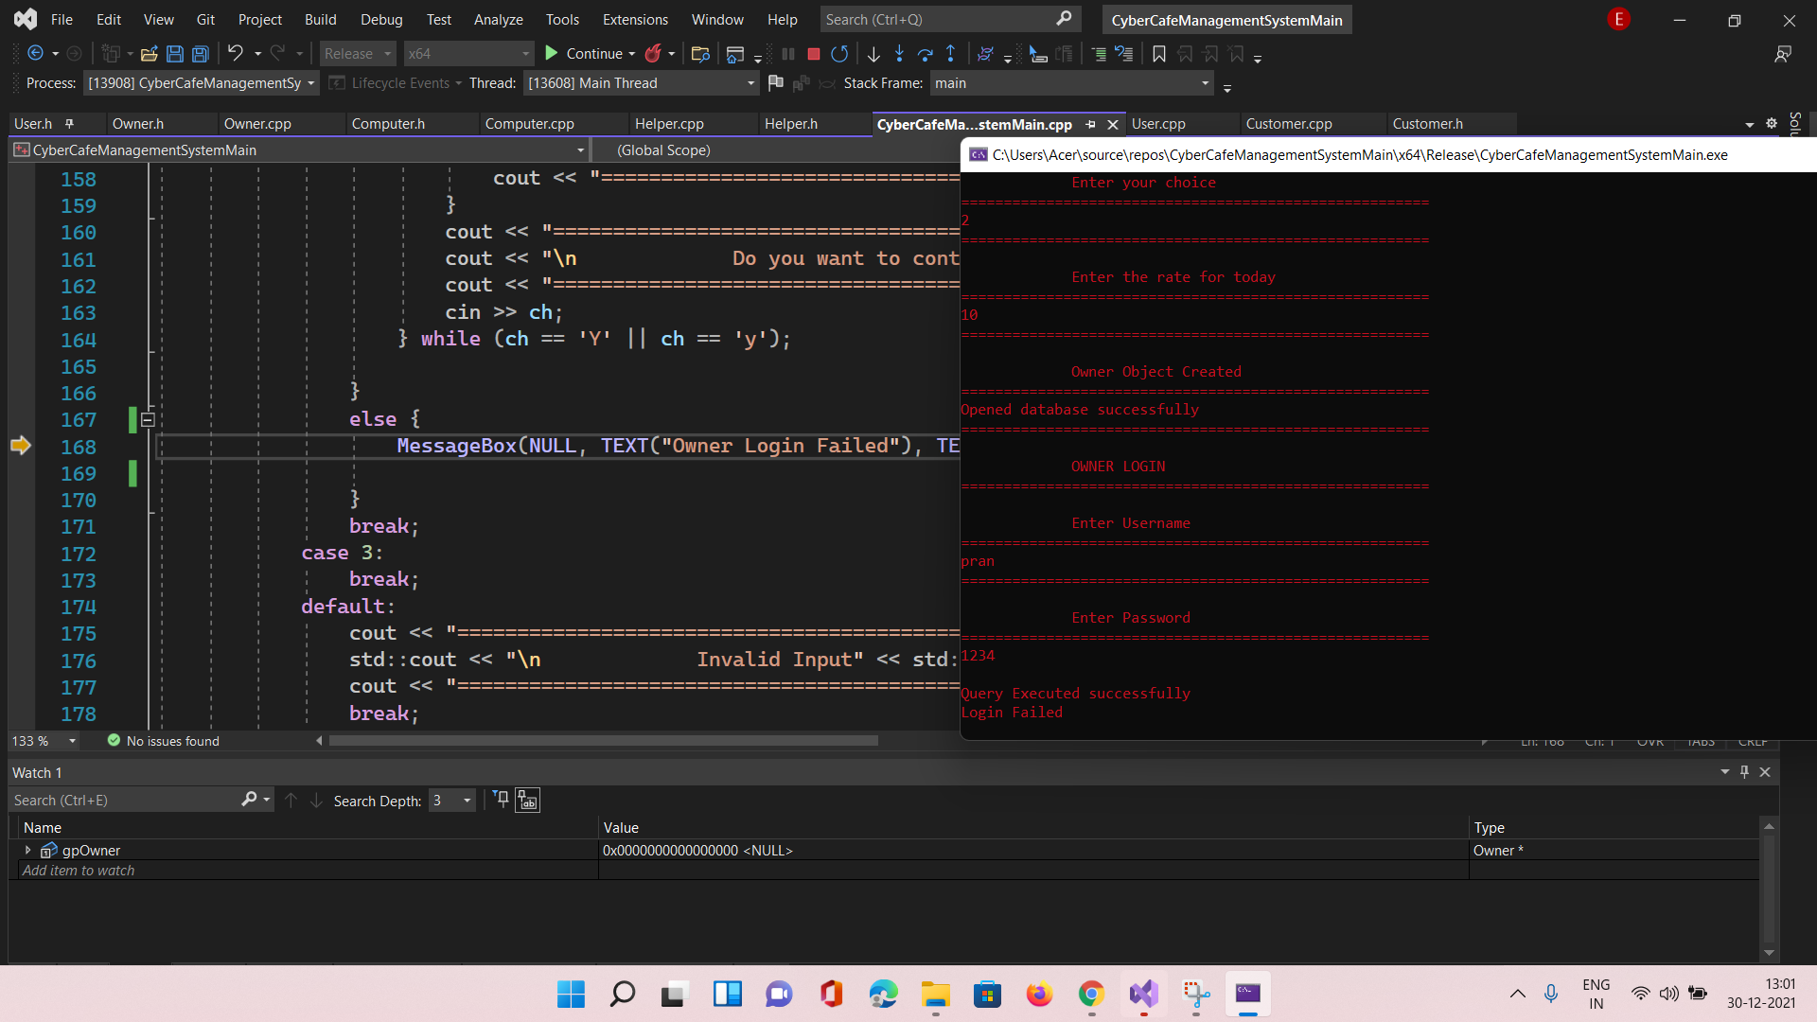

7)Entered Wrong Credentials For First Login.

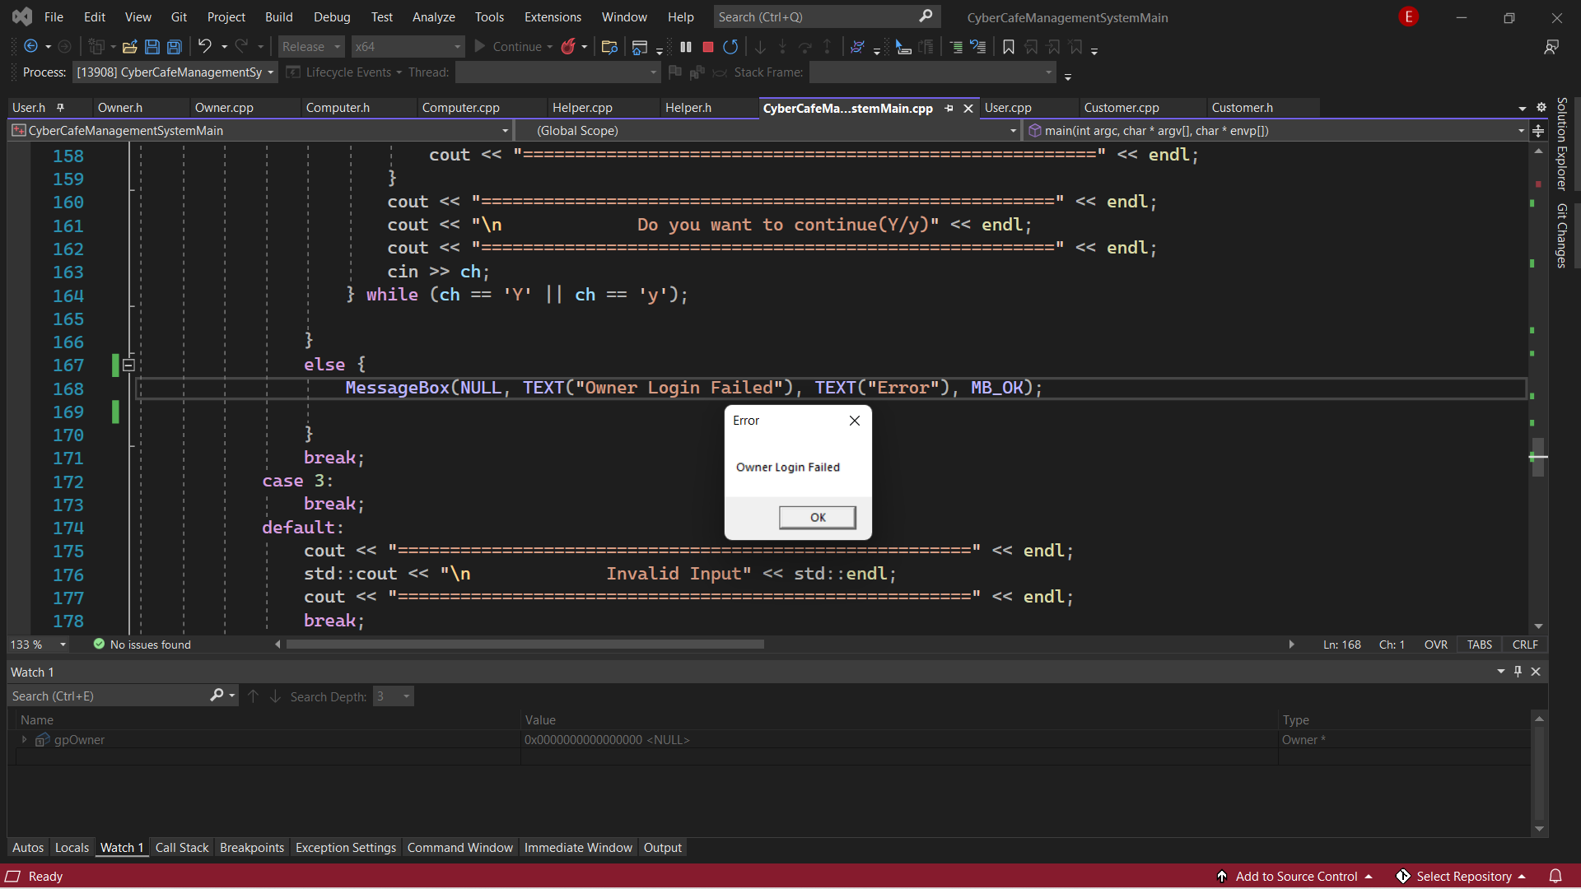

8)Login Failed.

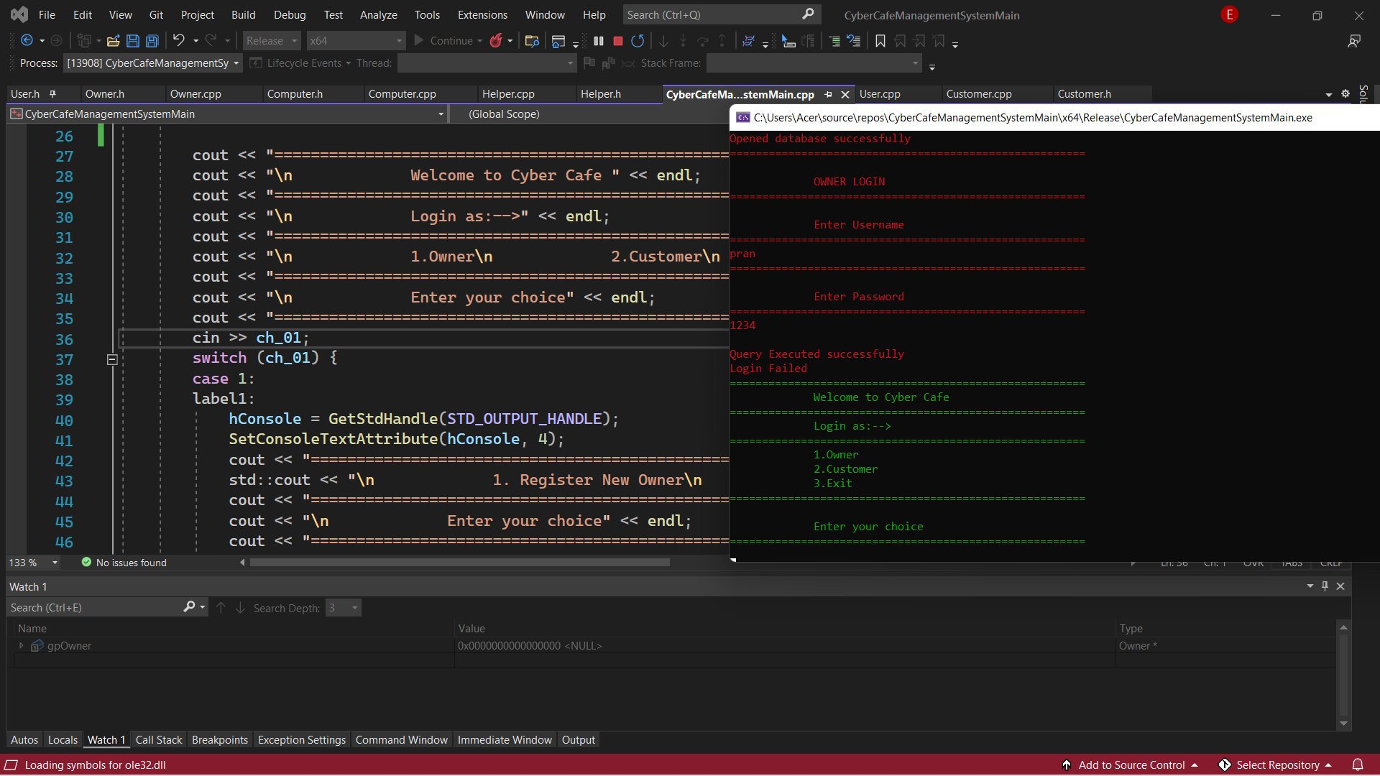

9) Went to homepage.

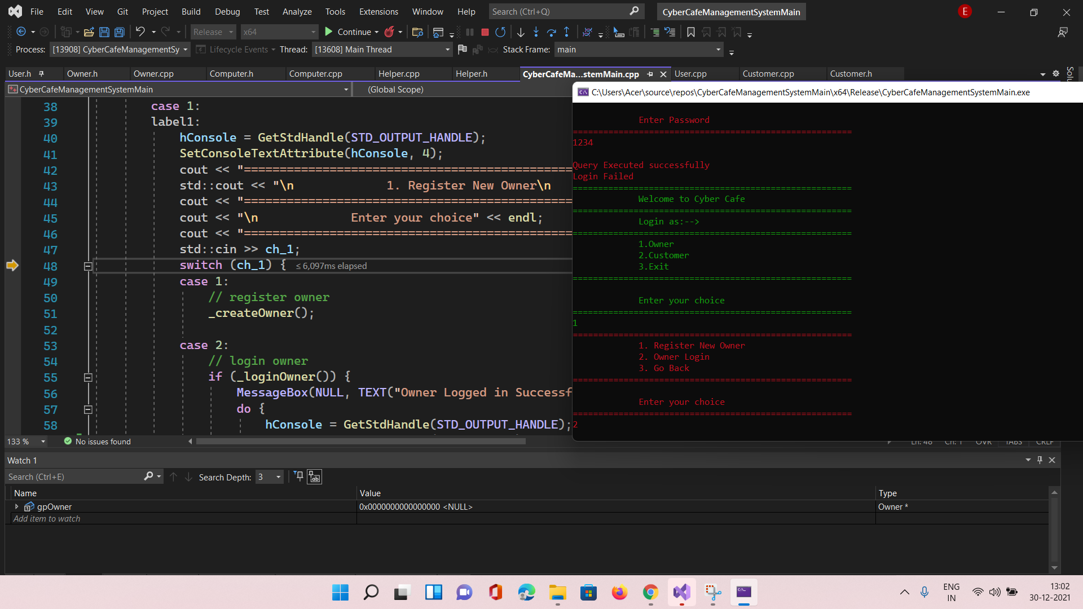

10)Entered 1 for Login as Owner. And entered 2 for Owner Login.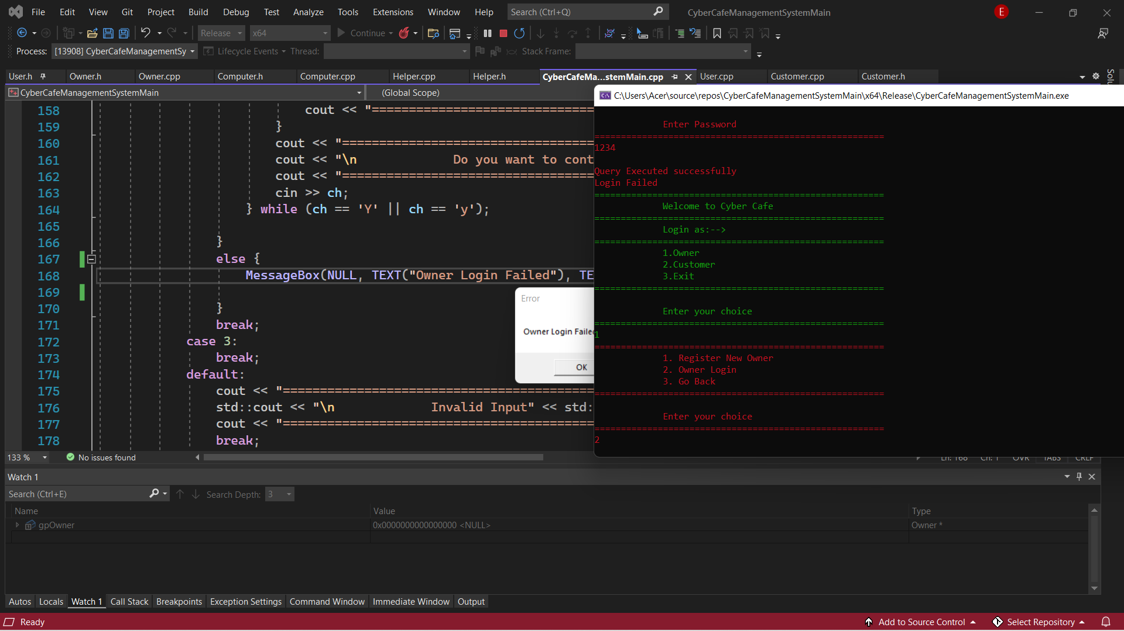

11) Without asking the username and password it says Login Failed and the gpOwner values still doesn’t change. It Remains Null.

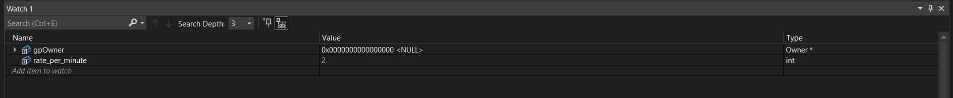

12)Tried Watching rate_per_miniute as well.

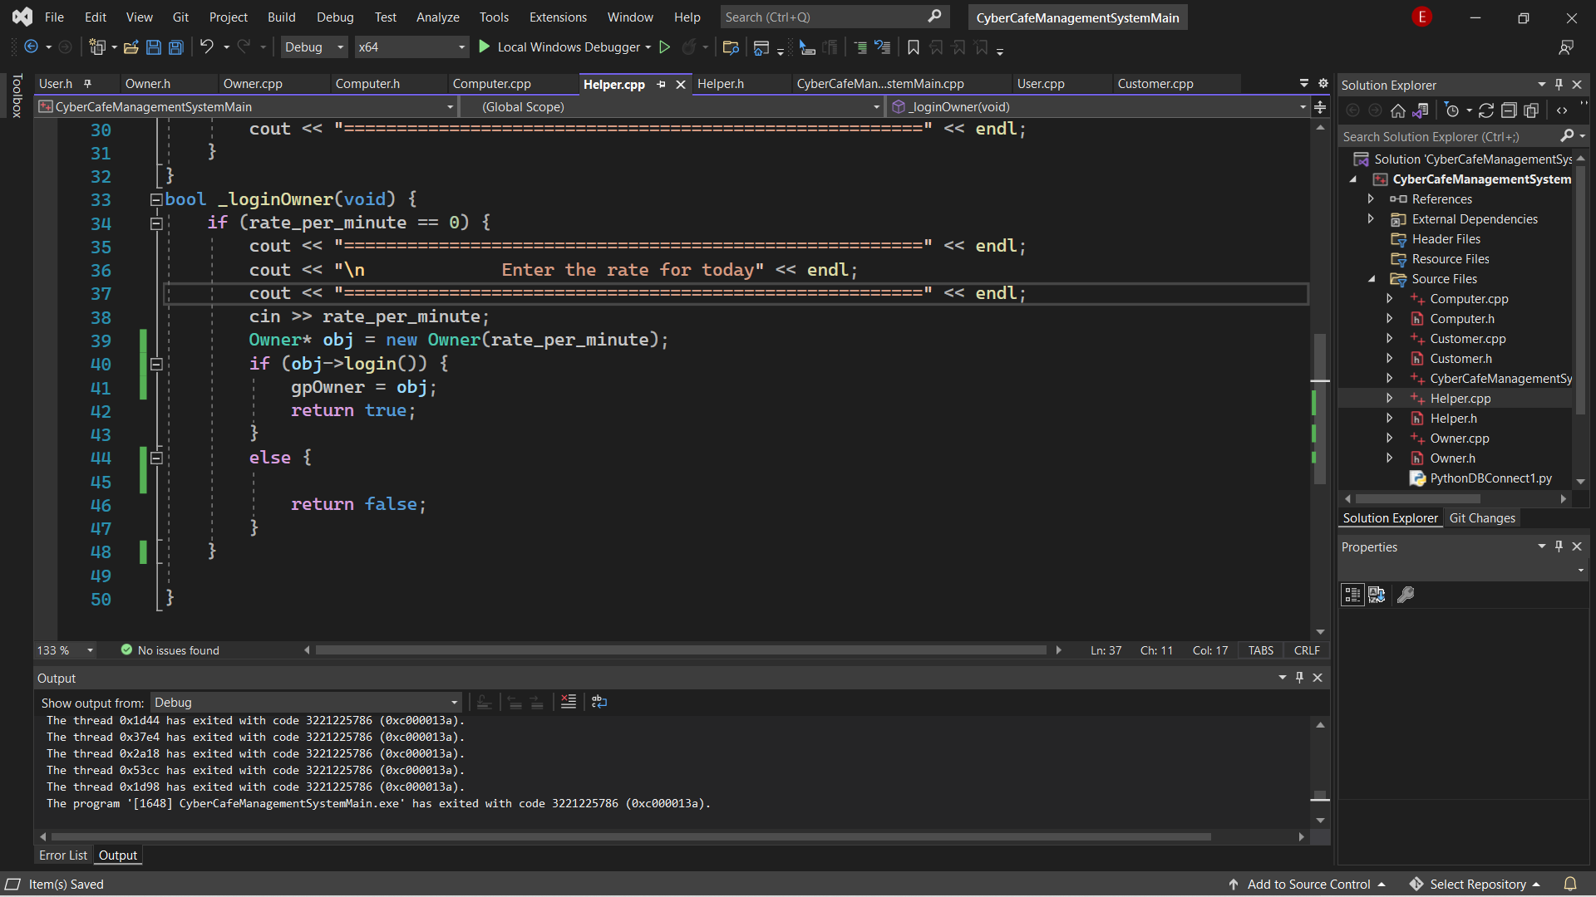

13)First Time Rate_per_miniute was initialized to 2. But when login failed it was not reinitialized to 0. Which was a important condition for owner Login.

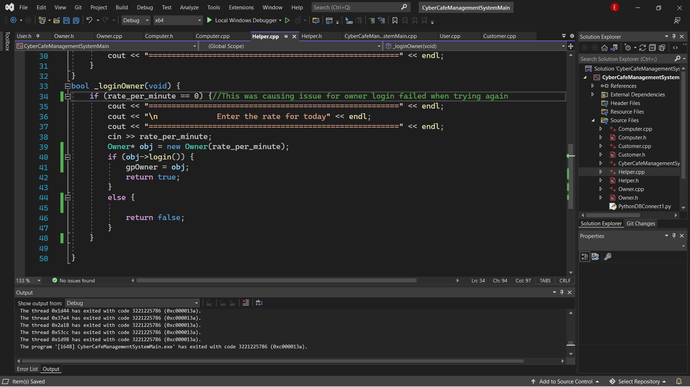

14) Reinitialized rate_per_minitue to 0 when login failed.

