**What is Debug and Release Mode?**

Visual Studio projects have separate release and debug configurations for your program. You build the debug version for debugging and the release version for the final release distribution.

In debug configuration, your program compiles with full symbolic debug information and no optimization. Optimization complicates debugging, because the relationship between source code and generated instructions is more complex.

The release configuration of your program has no symbolic debug information and is fully optimized. For managed code and C++ code, debug information can be generated in .pdb files, depending on the compiler options that are used. Creating .pdb files can be useful if you later have to debug your release version.

You can change the build configuration from the **Build** menu, from the toolbar, or in the project's property pages. Project property pages are language-specific. The procedure below shows how to change the build configuration from the menu and the toolbar.

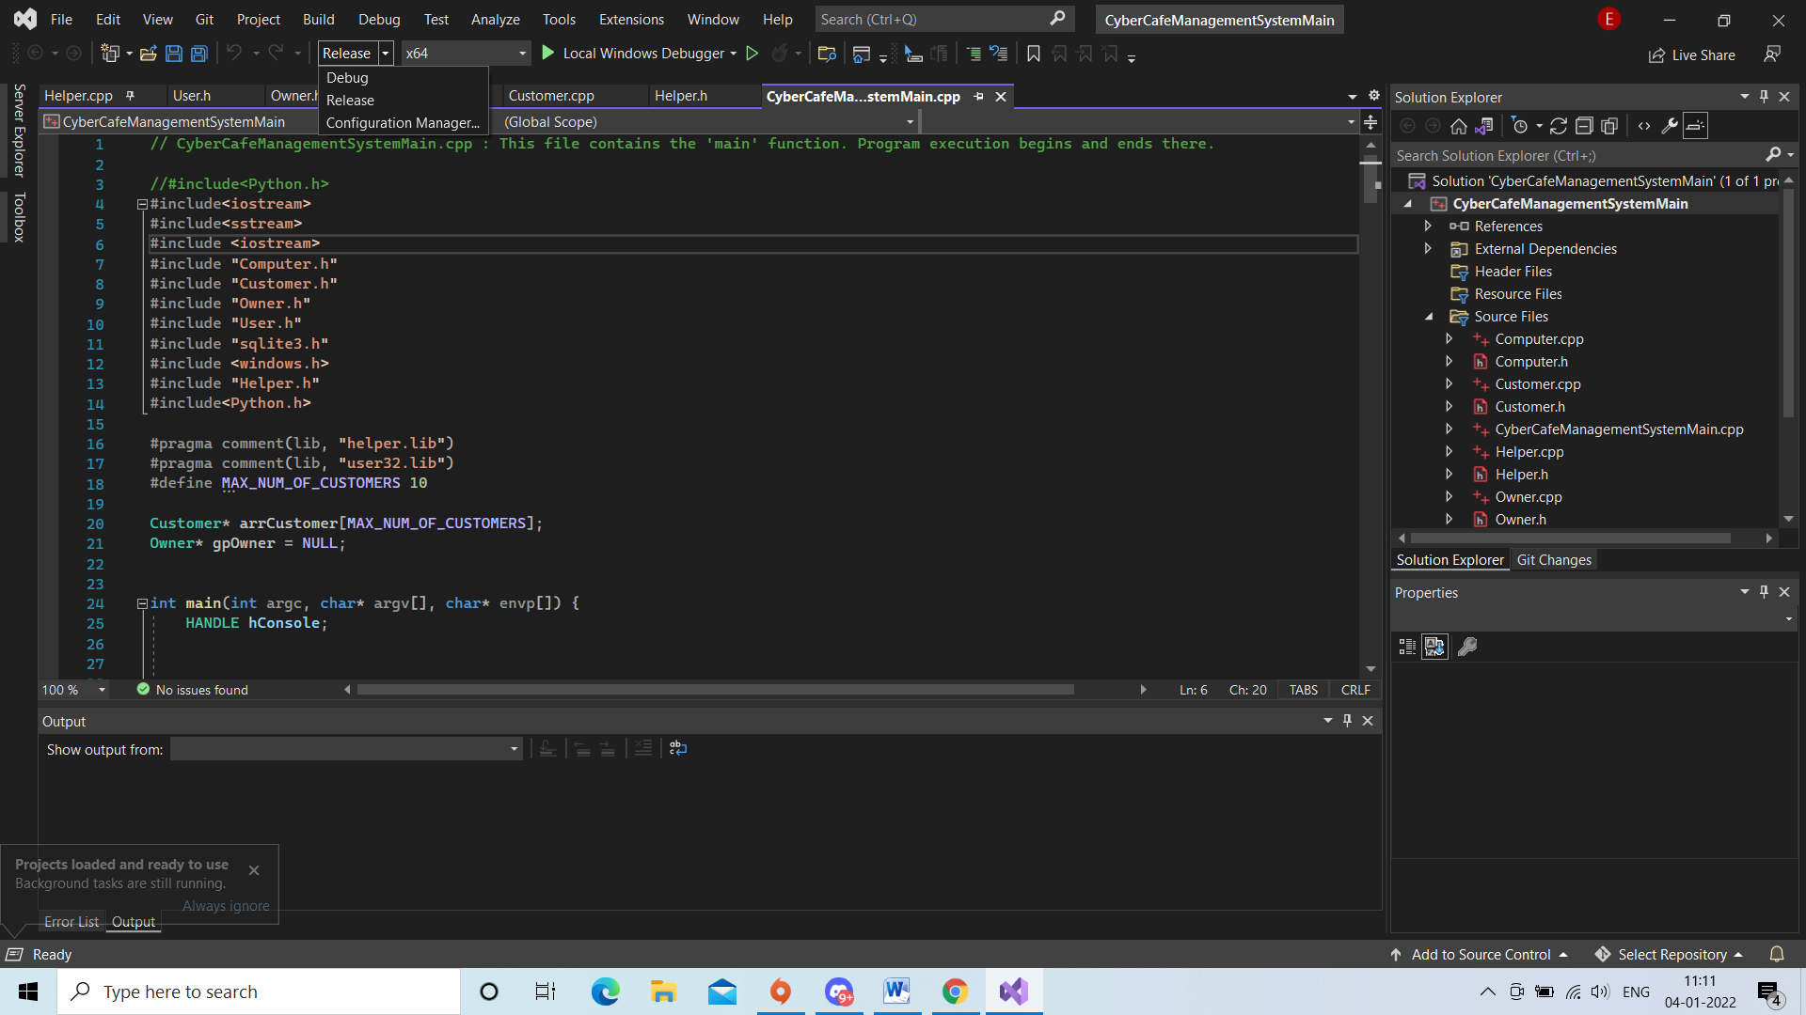

**Configuration Manager**

The configuration and the platform control where built output files are stored. Normally, when Visual Studio builds your project, the output is placed in a project subfolder named with the active configuration (for example, bin/Debug/x86), but you can change that.

You can create your own build configurations at the solution and project level. The solution configuration determines which projects are included in the build when that configuration is active. Only the projects that are specified in the active solution configuration will be built. If multiple target platforms are selected in Configuration Manager, all projects that apply to that platform are built. The project configuration determines what build settings and compiler options are used when you build the project.

To create, select, modify, or delete a configuration, you can use the **Configuration Manager**. To open it, on the menu bar, choose **Build** > **Configuration Manager**, or just type **Configuration** in the search box. You can also use the **Solution Configurations** list on the **Standard** toolbar to select a configuration or open the **Configuration Manager**.

