Execution of project

1)

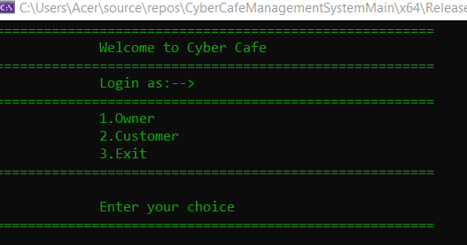

First screen of the Cyber Cafe Management System which show Login as either an Owner or

Customer.

2)

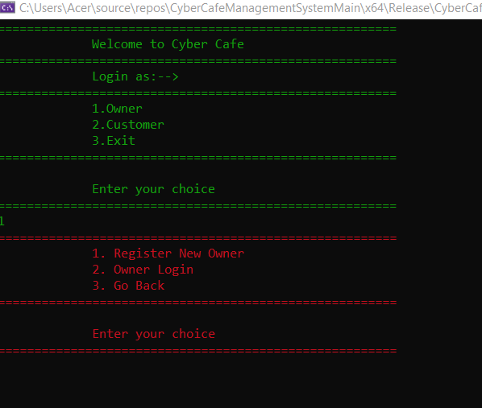

Here, after entering choice of 1 i.e continue as owner next screen is owner authentication where

Owner can register or login.

3)

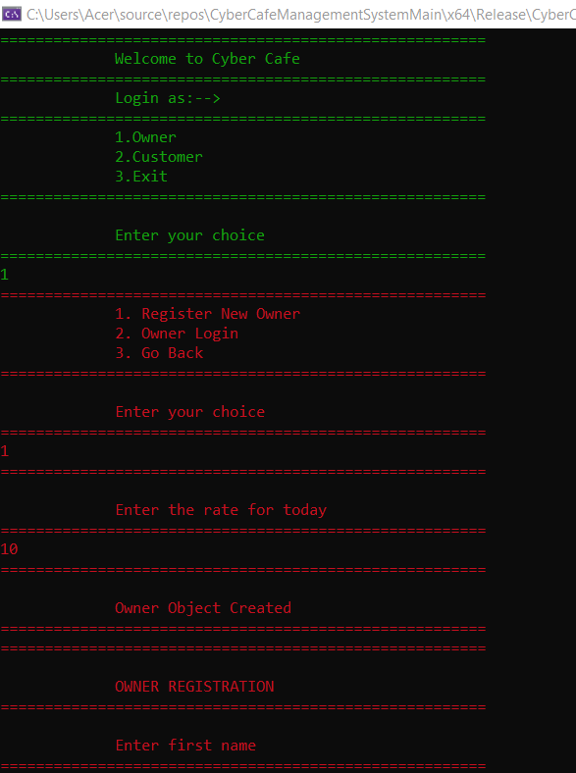

After entering choice 1 i.e registration owner can put its details in order to register itself.

4)

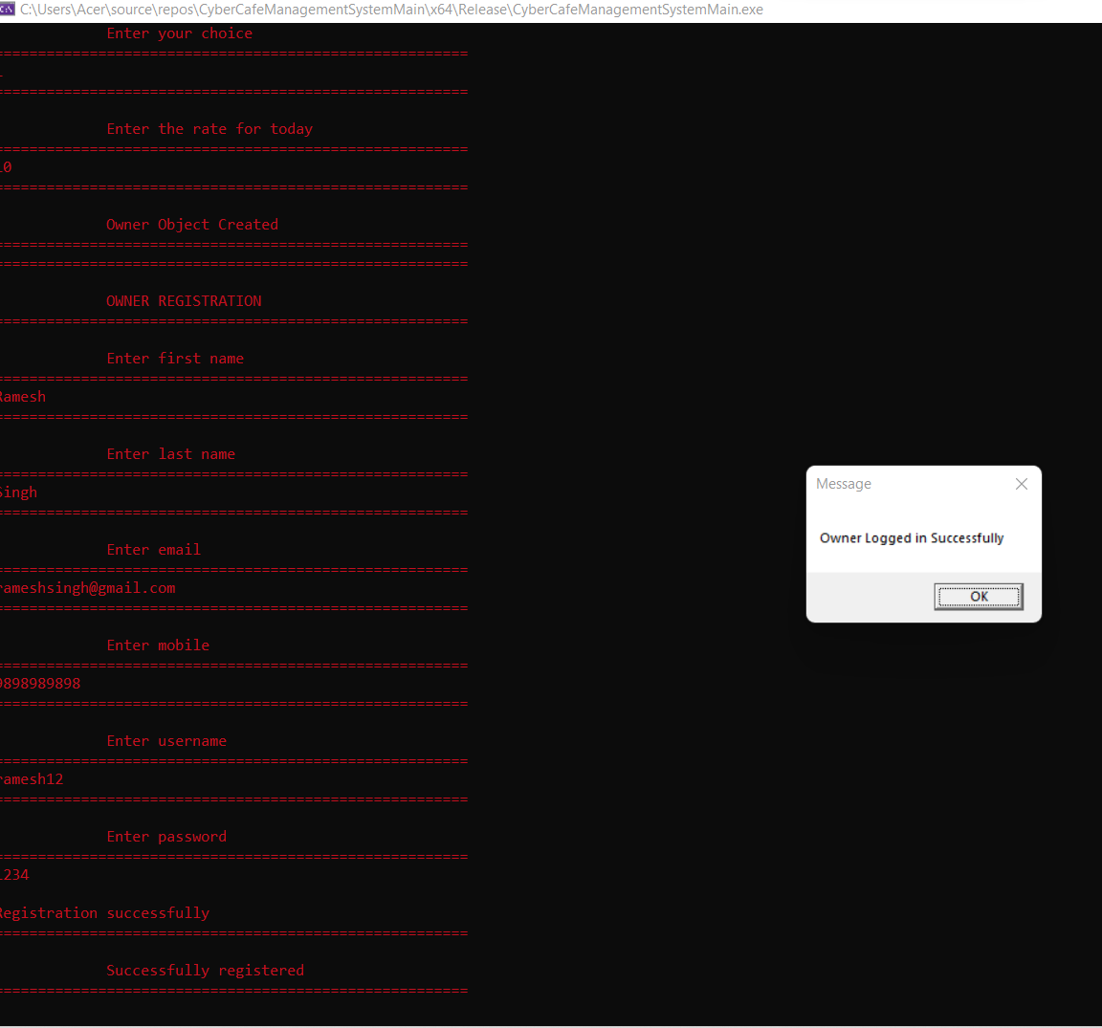

After entering all the valid details i.e unique username and email of owner successful registration window will pop up.Click OK to continue.

5)

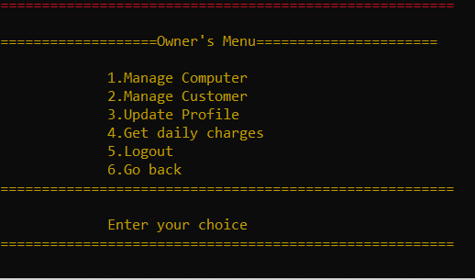

After successful registration next window will be owner’s menu where owner can Manage computer, customer as well as he can update its profile.

6)

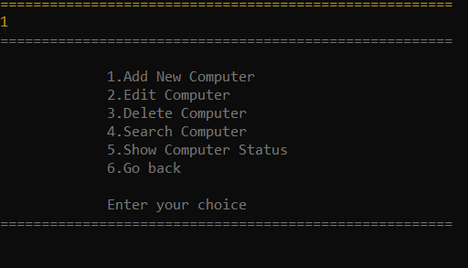

After entering choice of 1 i.e Manage Computer, Menu for computer manipulation will open.

Here owner can add, edit , delete, search computer as well as can view status of all computer.

7)

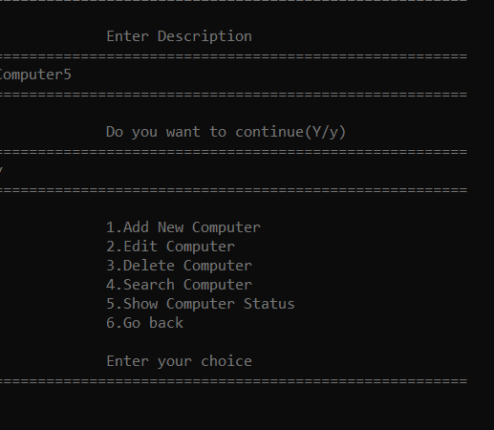

In order to add new computer enter choice 1 then put computer description in order to add new computer in database.

8)

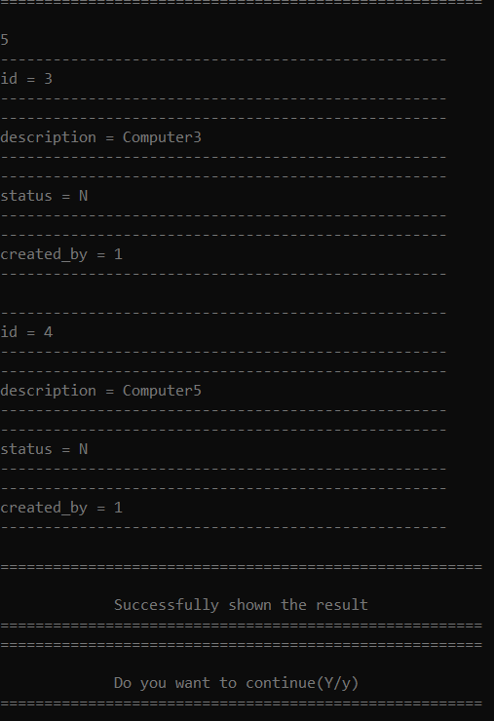

In order to view status of all computer enter choice of 5 which will show list of all computers.

9)

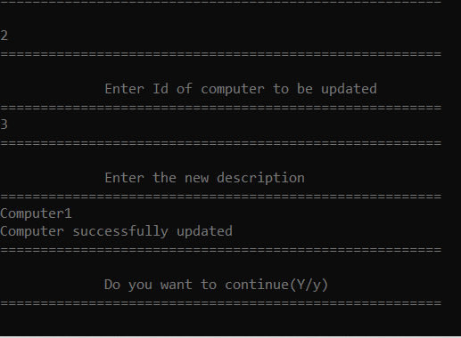

To update the description of added computer enter choice 3 after that put new description

In order to update that entry in database. Click Y to continue.

10)

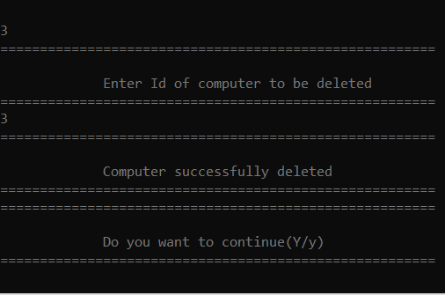

To delete an existing computer from database enter choice 4 which will delete computer from database.

11)

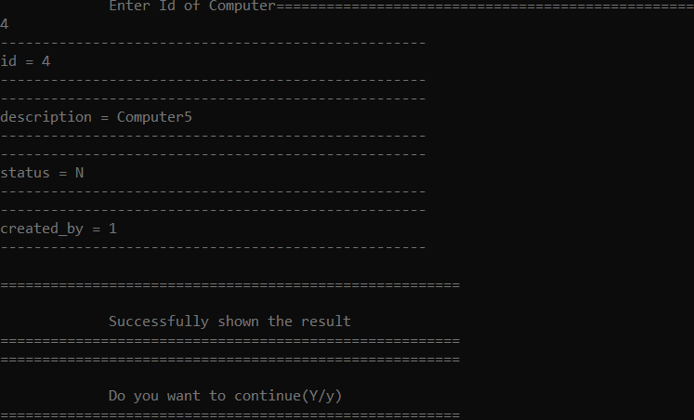

To search computer from the list of computer enter choice of 4.

12)

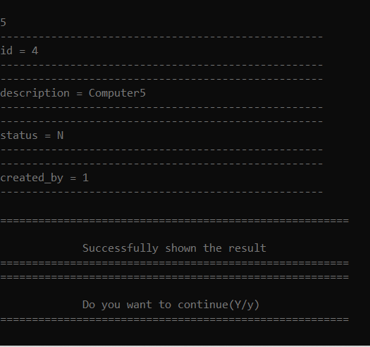

Enter choice 5 to list all the computer in order to check weather computer is deleted or not.

13)

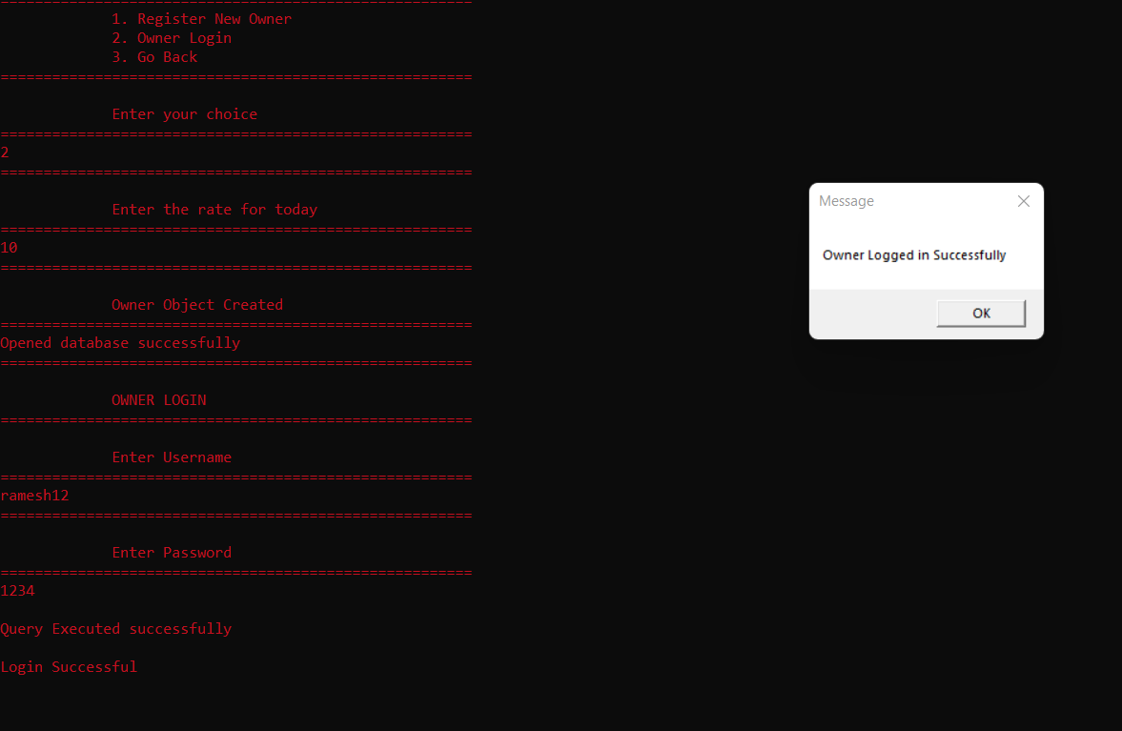

If the owner is already registered, enter choice 2 to login as owner after successful login owner can view the Owner menu.

14)

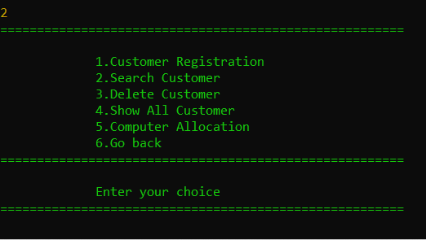

In order to manage customers enter choice 2 from the owner menu.

16)

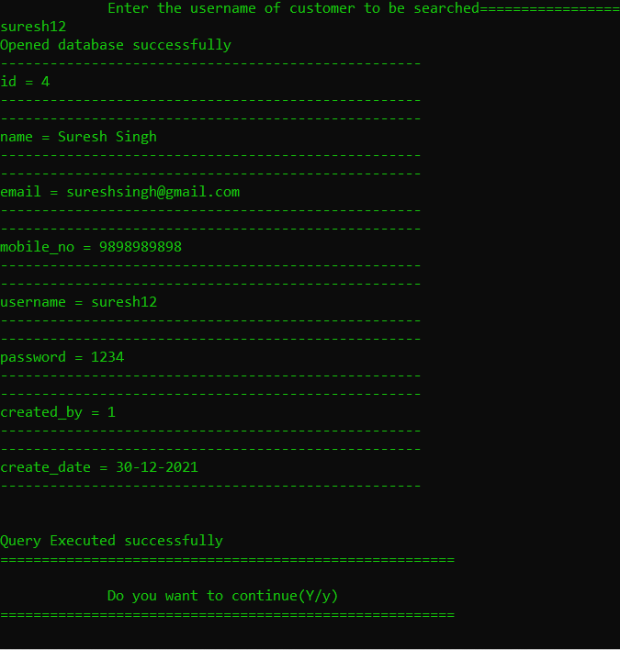

To register a new customer, the system owner will enter choice of 1 after that owner will put all the details of the customer.

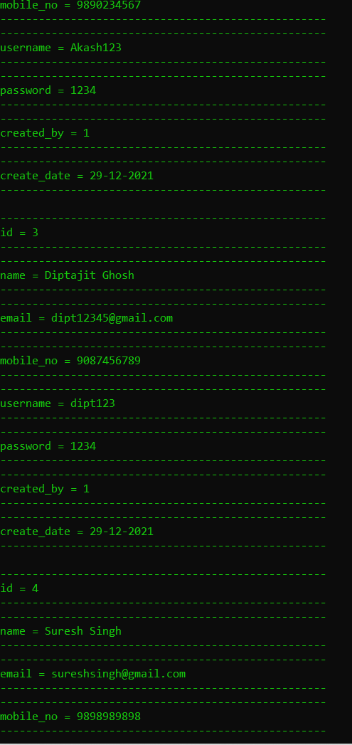

18)

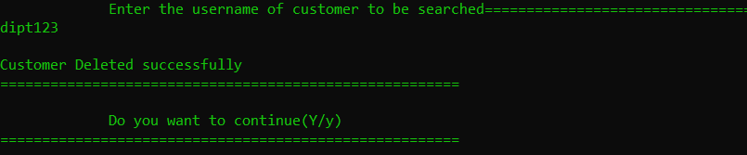

Used to delete the username from the database

19)

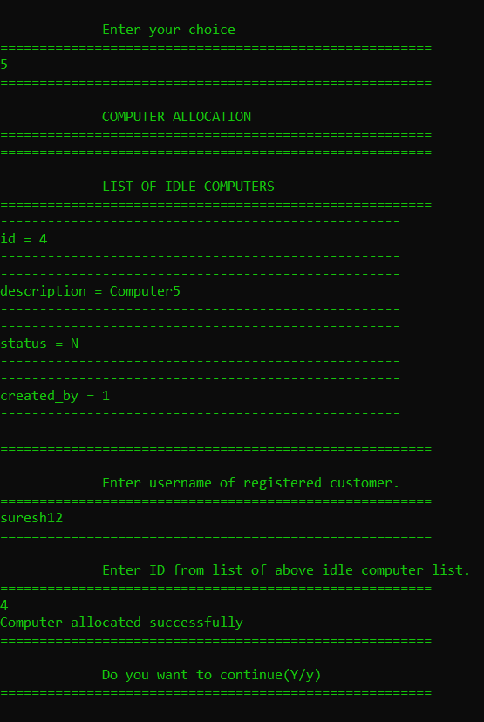

Updated list of customers after deletion

20)

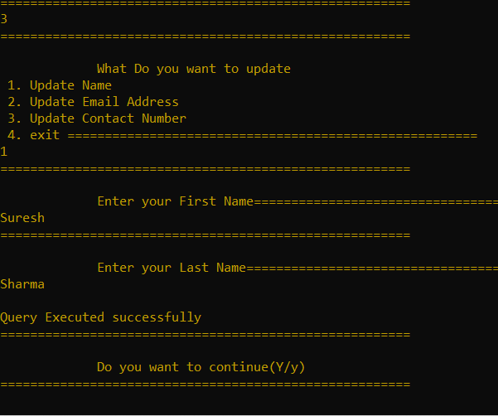

Updating the profile for the customer

21)

Fu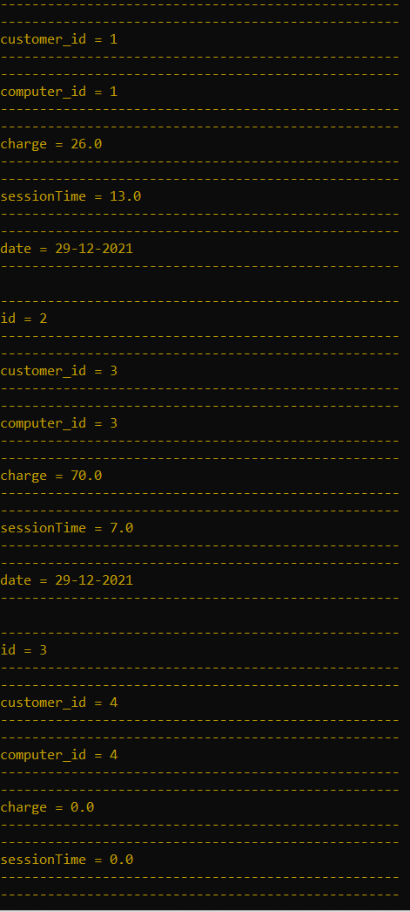

Functionality to check the charges per user.

22)

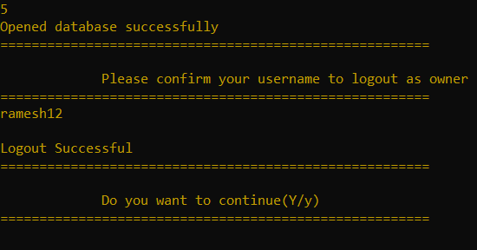

Logout to out of the system.

23)

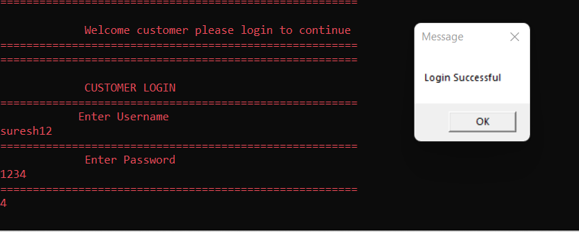

Customer logs in the system.

24)

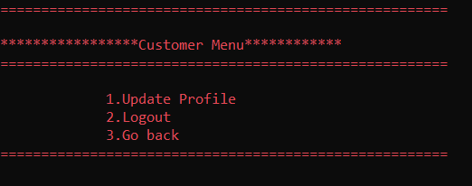

We can log out of the system

25)

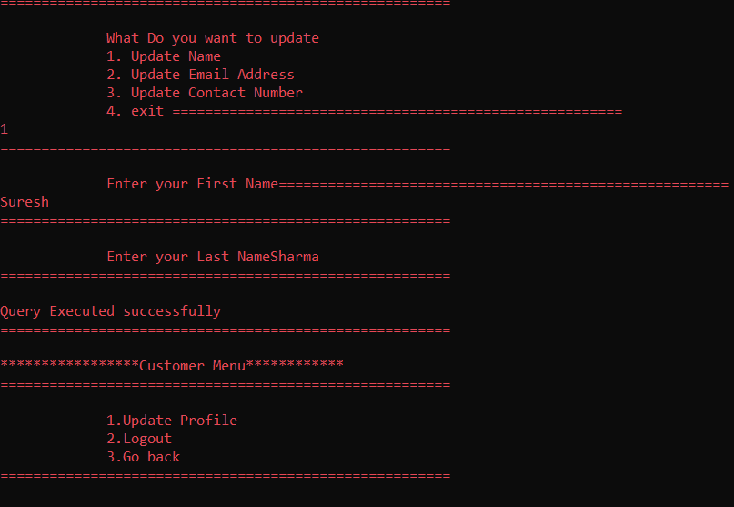

Updating the details of section

26)

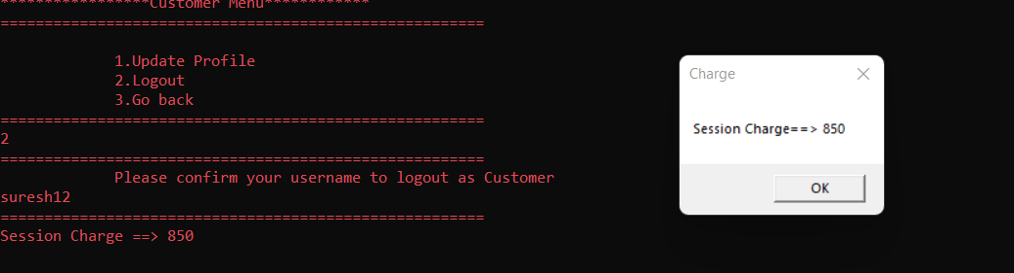

Session Charges is calculated accordingly.

27)

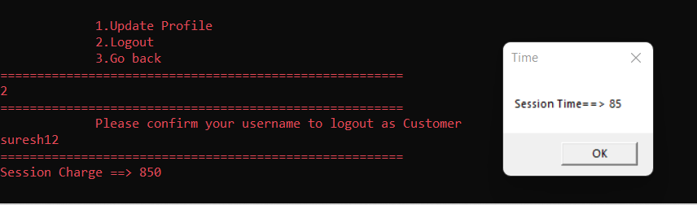

Also time calculated is shown.

28)

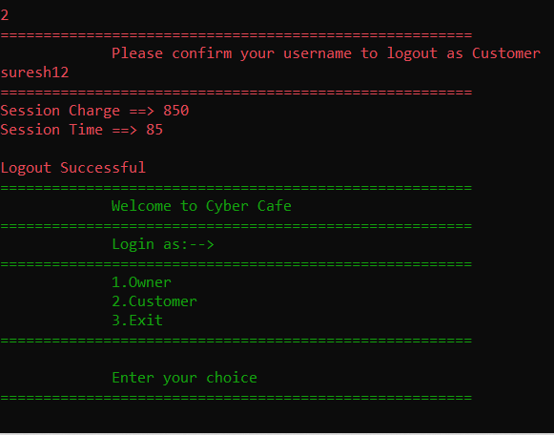

Logging out as the customer.