Week_4
Task 1: Write a C program where a parent process creates multiple child processes and synchronizes their completion using wait() and waitpid(). Compare the behavior of both functions.

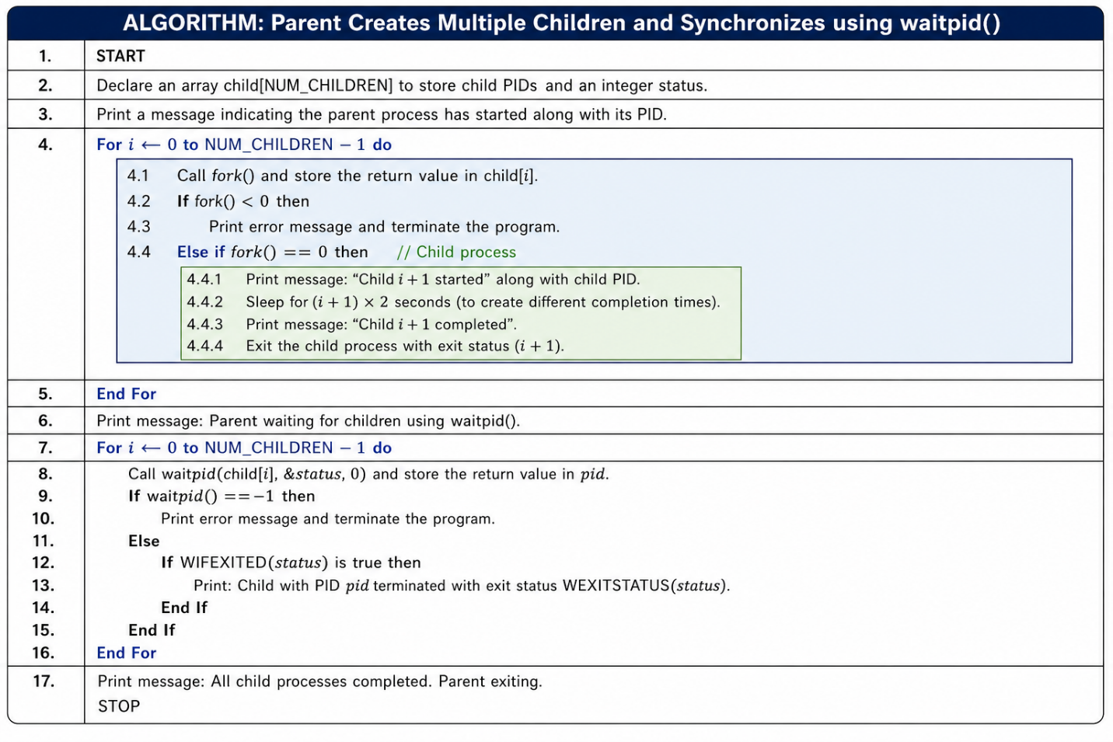
Sample Output:
Parent Process Started
Parent PID: 4521

Child 1 started. PID = 4522, Parent PID = 4521
Child 2 started. PID = 4523, Parent PID = 4521
Child 3 started. PID = 4524, Parent PID = 4521

All 3 child processes have been created.

Using wait():

Child 1 completed. PID = 4522
wait() detected child PID 4522 finished with exit status 10

Using waitpid():

Child 2 completed. PID = 4523
Child 3 completed. PID = 4524
waitpid() detected child PID 4522 finished with exit status 10
waitpid() detected child PID 4523 finished with exit status 11
waitpid() detected child PID 4524 finished with exit status 12

Parent process completed.

#include <stdio.h>
#include <stdlib.h>
#include <unistd.h>
#include <sys/types.h>
#include <sys/wait.h>

int main() {
pid_t pid1, pid2, pid3;
pid_t wpid;
int status;

printf("Parent Process Started\n");
printf("Parent PID: %d\n", getpid());

// ---- Create Child 1 ----
pid1 = fork();
if (pid1 == 0) {
printf("Child 1 started. PID = %d, Parent PID = %d\n", getpid(), getppid());
sleep(1);
exit(10); // exit status 10
}

// ---- Create Child 2 ----
pid2 = fork();
if (pid2 == 0) {
printf("Child 2 started. PID = %d, Parent PID = %d\n", getpid(), getppid());
sleep(2);
exit(11); // exit status 11
}

// ---- Create Child 3 ----
pid3 = fork();
if (pid3 == 0) {
printf("Child 3 started. PID = %d, Parent PID = %d\n", getpid(), getppid());
sleep(3);
exit(12); // exit status 12
}

printf("All 3 child processes have been created.\n");

// ---- Using wait() to reap Child 1 (first to finish, order not guaranteed) ----
printf("\nUsing wait():\n");
wpid = wait(&status);
if (WIFEXITED(status)) {
printf("Child completed. PID = %d\n", wpid);
printf("wait() detected child PID %d finished with exit status %d\n",
wpid, WEXITSTATUS(status));
}

// ---- Using waitpid() to reap remaining children in a specific order ----
printf("\nUsing waitpid():\n");
wpid = waitpid(pid2, &status, 0);
if (WIFEXITED(status))
printf("waitpid() detected child PID %d finished with exit status %d\n",
wpid, WEXITSTATUS(status));

wpid = waitpid(pid3, &status, 0);
if (WIFEXITED(status))
printf("waitpid() detected child PID %d finished with exit status %d\n",
wpid, WEXITSTATUS(status));
printf("\nParent process completed.\n");
return 0;
}

Task 2: Create a scenario where a child process becomes a zombie process. Investigate the process table and then modify the program to eliminate zombie processes using proper synchronization techniques.

Flow Chart:
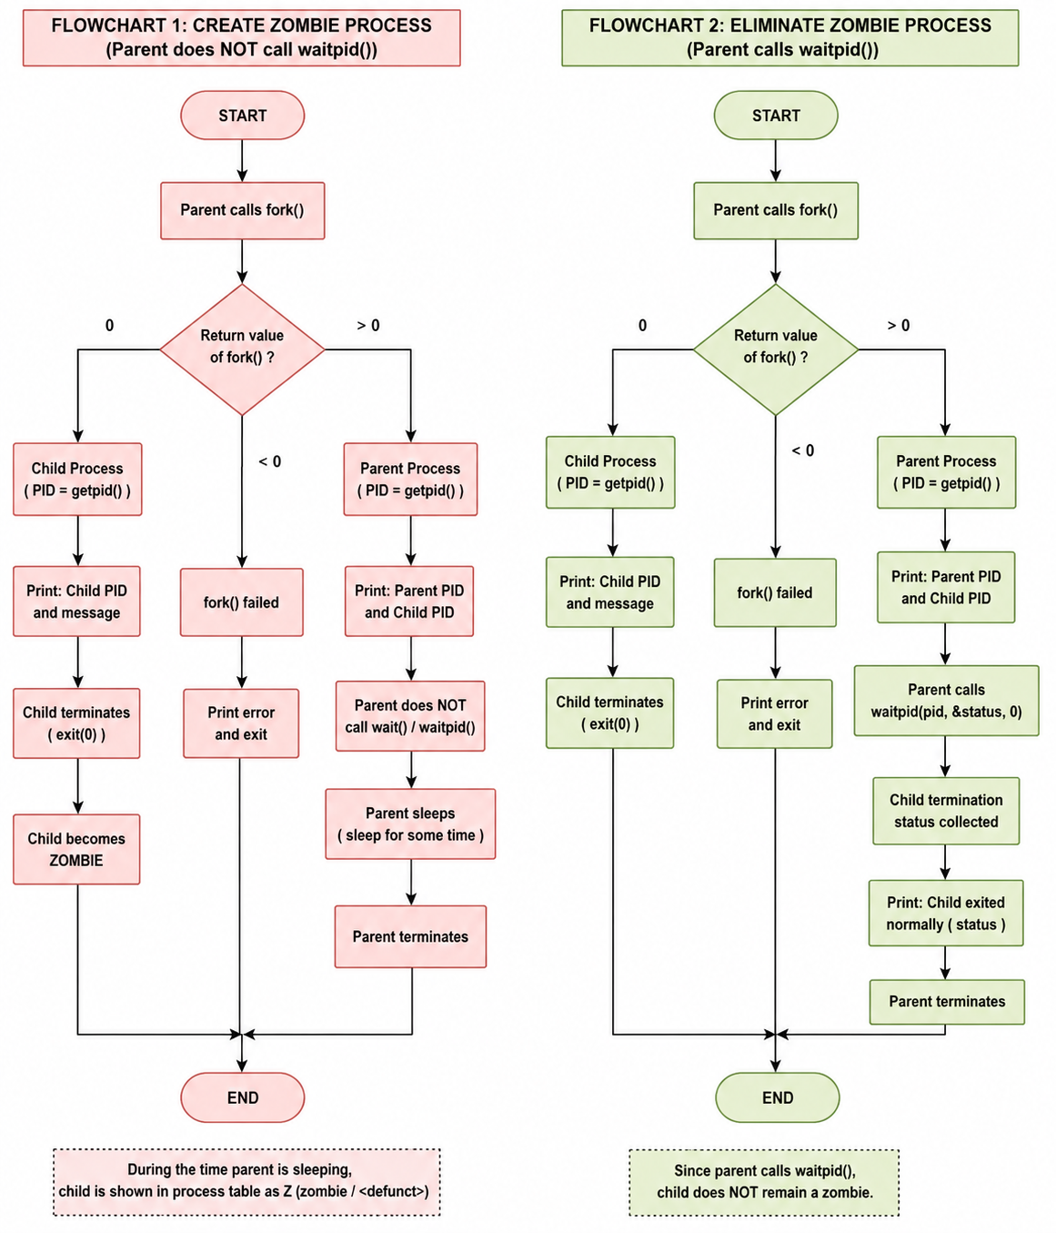

Sample Output:

Parent process: PID = 158
Child process: PID = 159
Child PID = 159
Child process terminating...
Parent sleeping...
Parent terminating...

Ps -el
F S UID PID PPID C PRI NI ADDR SZ WCHAN TTY TIME CMD
0 S 0 1 0 0 80 0 - 2238 ? ? 00:00:00 init
0 S 0 8 1 0 80 0 - 2238 ? tty1 00:00:00 init
0 S 1000 9 8 0 80 0 - 3590 ? tty1 00:00:00 bash
0 S 0 141 1 0 80 0 - 2238 ? tty2 00:00:00 init
0 S 1000 142 141 0 80 0 - 3527 ? tty2 00:00:00 bash
0 S 1000 158 9 0 80 0 - 2680 ? tty1 00:00:00 week4_T2
0 Z 1000 159 158 0 80 0 - 0 ? tty1 00:00:00 week4_T2
0 R 1000 160 142 0 80 0 - 4086 ? tty2 00:00:00 ps
Code:
#include <stdio.h>
#include <stdlib.h>
#include <unistd.h>
#include <sys/types.h>

int main() {
pid_t pid;

printf("Parent process: PID = %d\n", getpid());

pid = fork();

if (pid == 0) {
// Child process
printf("Child process: PID = %d\n", getpid());
printf("Child PID = %d\n", getpid());
printf("Child process terminating...\n");
exit(0); // Child exits immediately
} else {
// Parent process — deliberately does NOT call wait()
printf("Parent sleeping...\n");
sleep(30); // During this time, the child is a ZOMBIE
printf("Parent terminating...\n");
}

return 0;
}

