WEEK 5 PRACTICAL
QUESTION 1
Implement a producer-consumer communication system using anonymous pipes where the parent process generates data and the child process consumes it. Measure the communication efficiency.
Aim
To implement communication between a parent and child process using an anonymous pipe and measure the communication time.
Program
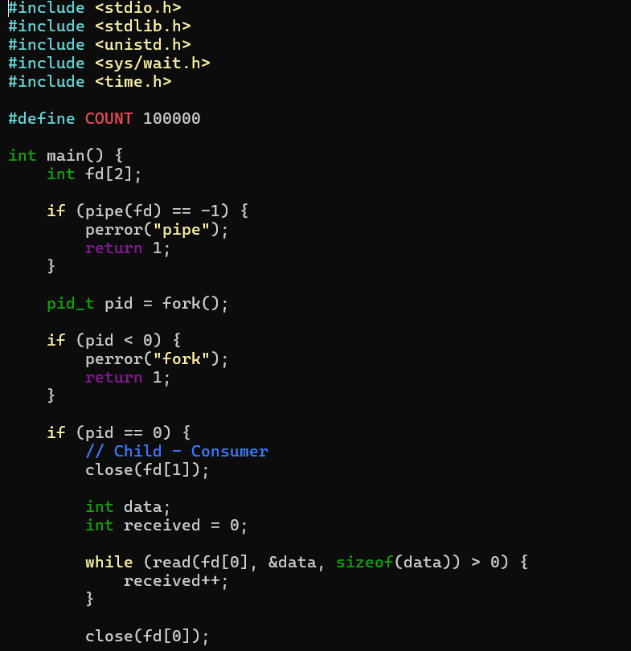

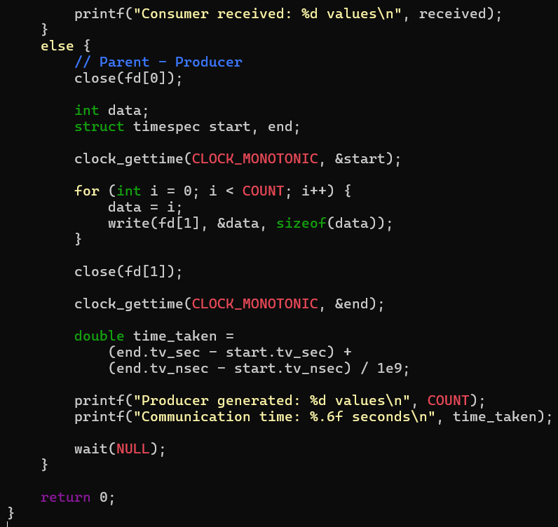

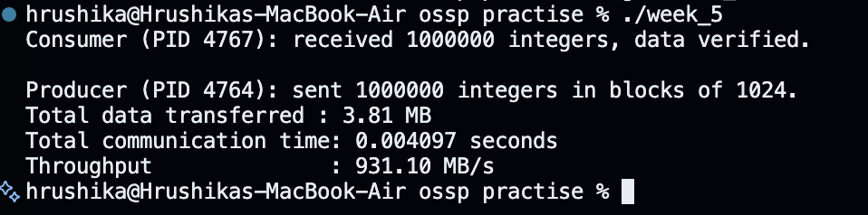
Output

Observation
The parent process generated data and sent it through the pipe. The child process successfully received the data, and the communication time was measured.

Result
The producer-consumer communication system was successfully implemented using an anonymous pipe.

QUESTION 2
Develop a program that executes the equivalent of the shell command ls -l | grep ".c" using fork(), pipe(), dup2(), and exec() system calls.
Aim
To implement a pipeline between two commands using fork(), pipe(), dup2() and exec().
Program
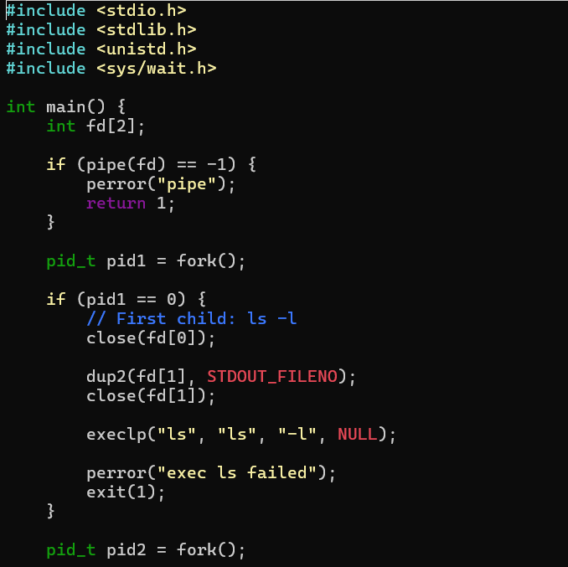
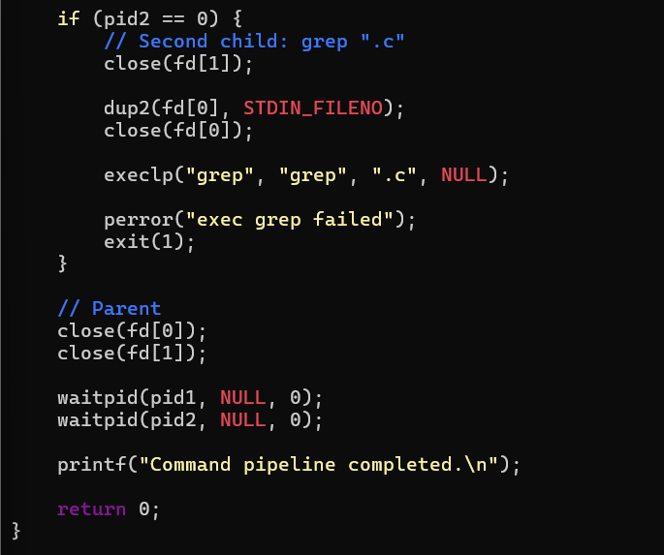

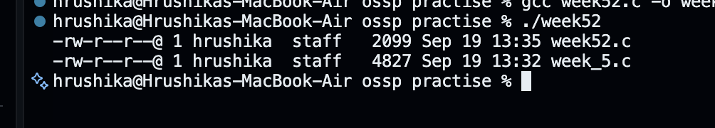
Output
Observation
The output of ls -l was passed through the pipe to grep ".c", which displayed the matching C files.
Result
The shell command ls -l | grep ".c" was successfully implemented using system calls.

