QUESTION 1
Develop a program using malloc(), calloc(), realloc(), and free(). Monitor memory allocation behavior and identify memory leaks using Valgrind.
Aim
To implement dynamic memory allocation using malloc(), calloc(), realloc(), and free(), and detect memory leaks using Valgrind.
Program
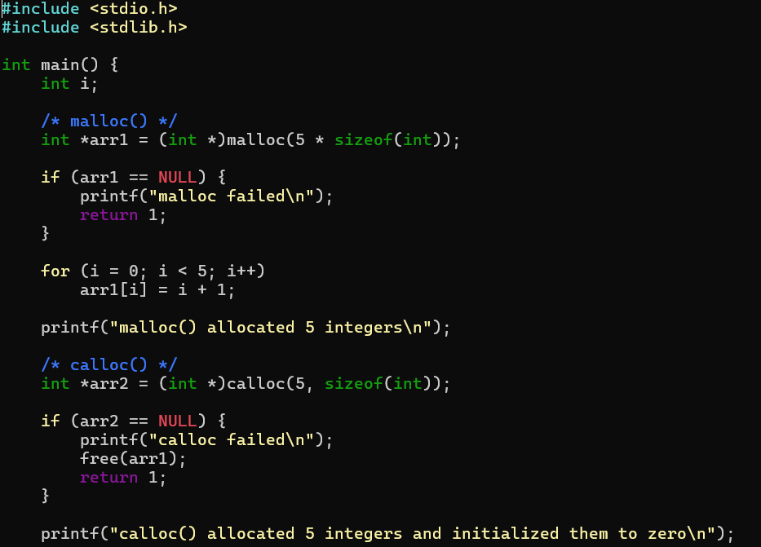
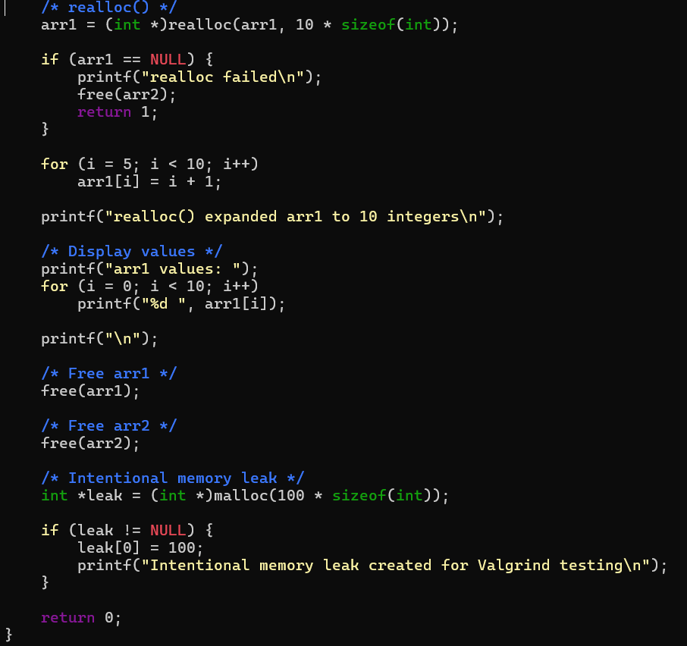

Output
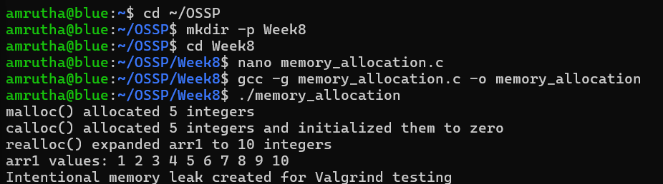

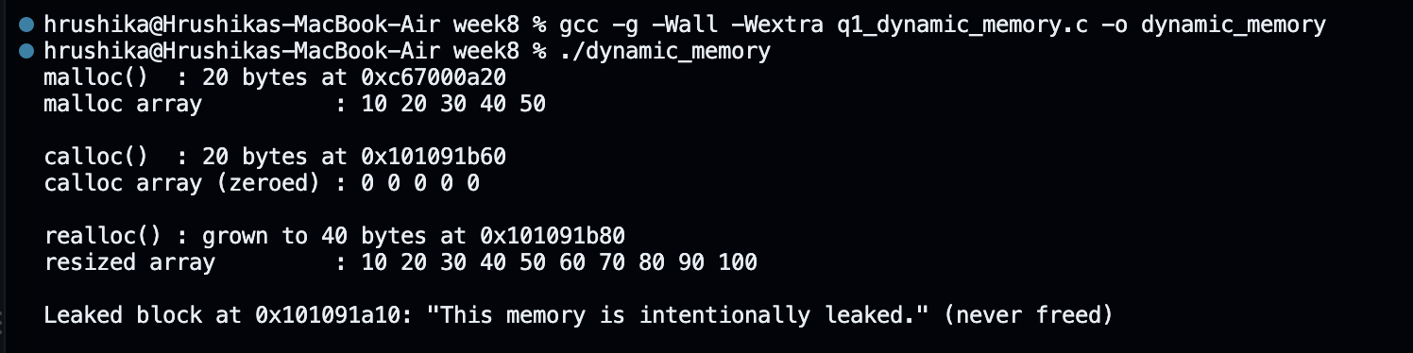
Valgrind Analysis

Observation
The program demonstrates four dynamic memory management functions:
- malloc() — allocates a block of memory without initialization.
- calloc() — allocates memory and initializes it to zero.
- realloc() — changes the size of an already allocated memory block.
- free() — releases dynamically allocated memory.
Valgrind reports the intentionally unfreed leak pointer as memory that is definitely lost.
Result
The program was successfully implemented using malloc(), calloc(), realloc(), and free(). Valgrind was used to monitor heap memory and successfully identify the intentionally created memory leak.

QUESTION 2
Develop a program that demonstrates Copy-on-Write behavior after a fork(). Analyze memory usage before and after modifying data in the child process.
Aim
To demonstrate Copy-on-Write (COW) behavior after fork() and analyze memory usage before and after the child process modifies shared data.
Program
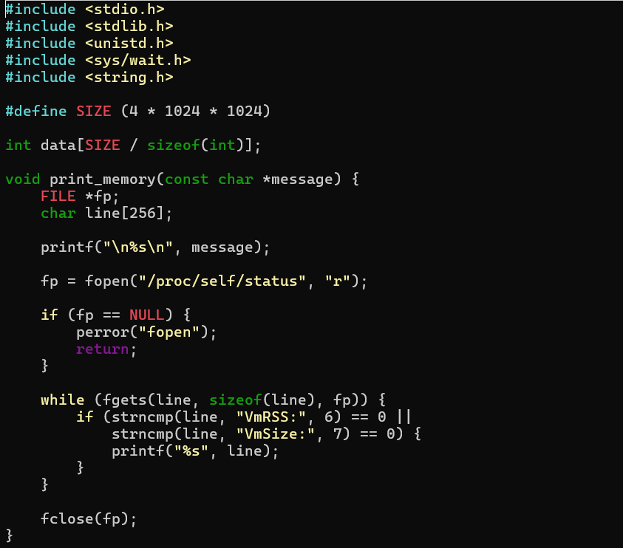

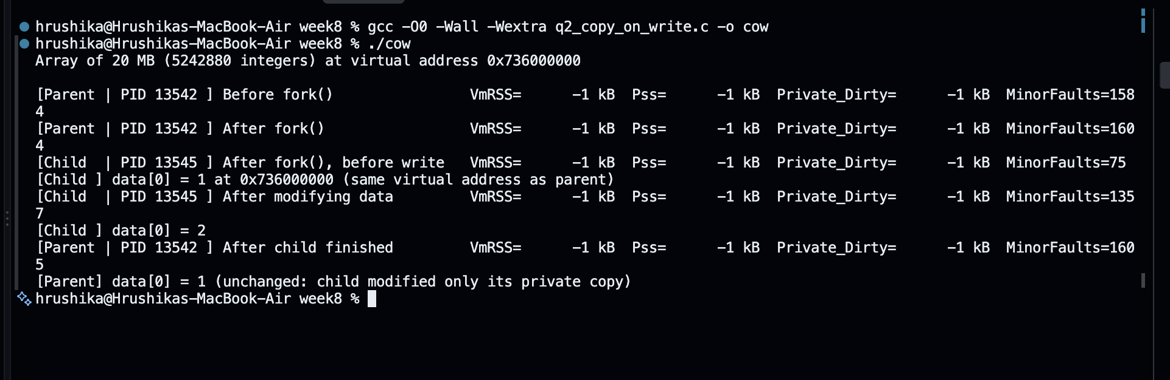
Output

Observation
Before fork(), the parent process has its own memory. After fork(), the parent and child initially share the same physical memory pages using Copy-on-Write.
When the child modifies the data array, the operating system creates private copies of the affected memory pages for the child. In this experiment, the VmRSS value does not show a visible increase after the modification. This is because VmRSS does not directly distinguish between shared and private memory pages.
The child modifies its own copy of the data, while the parent continues to use its original memory pages.

Memory Behavior
Stage | Parent | Child
Before fork() | Owns memory | Does not exist
Immediately after fork() | Shares pages | Shares pages
Child modifies data | Keeps original pages | Gets private copies
After modification | Original data remains | Modified copy is used

Result
The Copy-on-Write mechanism after fork() was successfully demonstrated. The child initially shares memory pages with the parent, and when the child modifies the data, private copies of the affected pages are created, demonstrating efficient memory management in Linux.

