Task 3: Develop a C program using fork() that creates a parent and child process. Display the Process ID (PID), Parent Process ID (PPID), and process states at different stages of execution.
Flow Chart
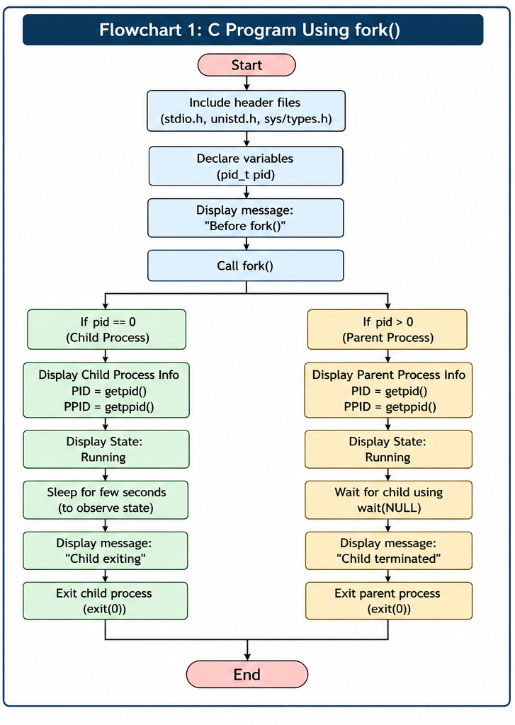
#include <stdio.h>
#include <stdlib.h>
#include <unistd.h>
#include <sys/types.h>
#include <sys/wait.h>

int main() {
pid_t pid;

printf("Before fork():\n");
printf("Process PID = %d, PPID = %d\n", getpid(), getppid());

pid = fork();

if (pid < 0) {
// Fork failed
fprintf(stderr, "Fork failed\n");
exit(1);
}
else if (pid == 0) {
// Child process
printf("\n[CHILD] Process created.\n");
printf("[CHILD] PID = %d, PPID = %d\n", getpid(), getppid());
printf("[CHILD] State: Running\n");
sleep(2); // Simulate work
printf("[CHILD] Terminating.\n");
exit(0);
}
else {
// Parent process
printf("\n[PARENT] Child created with PID = %d\n", pid);
printf("[PARENT] PID = %d, PPID = %d\n", getpid(), getppid());
printf("[PARENT] State: Waiting for child to terminate\n");

int status;
waitpid(pid, &status, 0); // Parent waits (Waiting state)

printf("[PARENT] Child (PID = %d) has terminated.\n", pid);
printf("[PARENT] State: Running -> Terminated\n");
}

return 0;
}
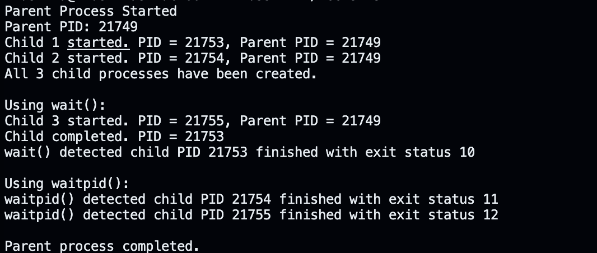
Execution:

Task 4: Design an experiment to observe process state transitions (Ready, Running, Waiting, Terminated) using Linux monitoring tools such as ps, top, and /proc. Document the observations.
Flow Chart:
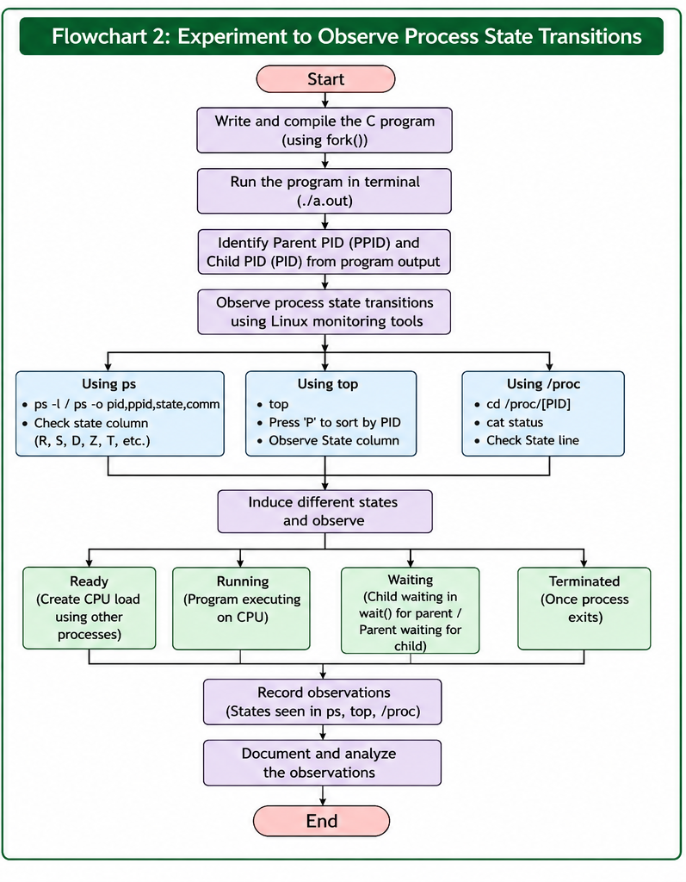

#include <stdio.h>
#include <stdlib.h>
#include <unistd.h>

int main() {
printf("PID = %d : Running (CPU-bound work)\n", getpid());
for (long i = 0; i < 2000000000; i++); // busy-loop -> Running

printf("PID = %d : Going to sleep -> Waiting/Blocked state\n", getpid());
sleep(15); // sleep() -> Waiting (Interruptible sleep, state 'S')

printf("PID = %d : Woke up, finishing -> Terminated\n", getpid());
return 0;
}
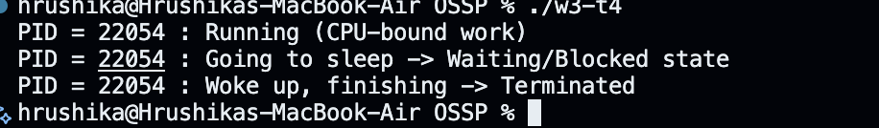
Execution:

