

STUDENT CASE STUDY EXECUTION REPORT

Department | FED
Subject | DSA-2
Academic Year | I-III Semester (2025-26)
Faculty Name | NM Deepika
Student Name | Mahitha Reddy
Roll Number | 2520030469
Branch | CSE
Course Outcome | CO-2
Case Study Topic: Weather Data Analysis using Segment Tree Work Done Summary:
In this case study, we implemented a Segment Tree to answer temperature range queries efficiently. A weather station records daily temperatures for 8 days. Instead of calculating minimum and maximum temperatures repeatedly, a Segment Tree was constructed to perform range queries in logarithmic time.

Implementation Details:
- Stored daily temperatures in an array.
- Constructed a Segment Tree.
- Performed range minimum and maximum queries.
- Updated temperatures when corrections were received.
- Compared performance with brute-force traversal.
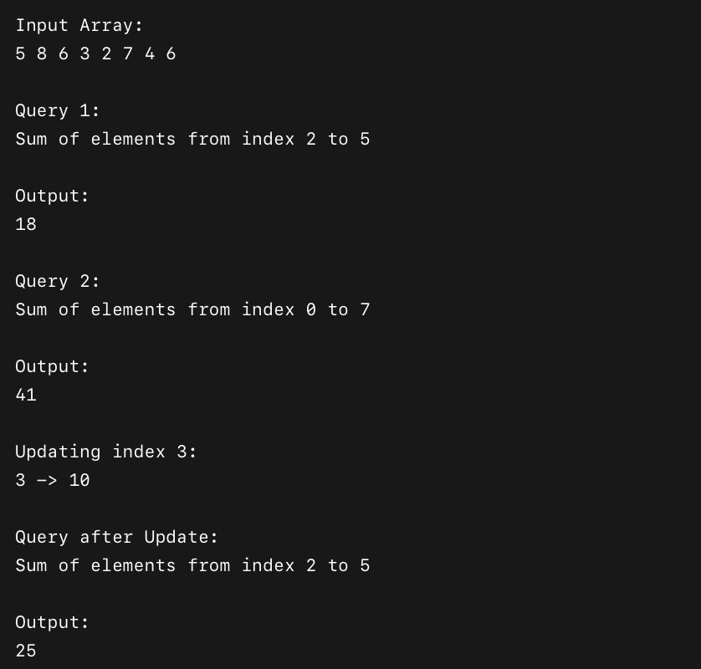
Result: Screenshots / Output

The Segment Tree answered range queries efficiently without scanning the entire array.

Time Complexity:
- Tree Construction: O(n)
- Range Query: O(log n)
- Update: O(log n)
Compared to brute force O(n), Segment Tree provides faster performance for multiple queries.

GitHub Link: https://github.com/shortwhale/DSA_2_CaseStudies.git

Student Signature | Faculty Signature

