**Experiment No:3 BANKING APP**

**ALGORITHM**

**STEP 1:** Start

**STEP 2:** Structure is defined for storing account information like a/c number, name of a/c holder, type of a/c and initial balance

**STEP 3:** Corresponding information is initialised using a variable defining data types of size 5.

**STEP 4:** Declaration of a/c number as int type.

**STEP 5:** Read the a/c number from customer and using **for** loop check for the existence of account.

**STEP 6: if** statement inside for loop is used to compare entered a/c number and initialized a/c numbers. If not found print invalid a/c number.

**STEP 7:** Switch statement is called as switch(ch) to check for the option called as

case 1 for balance

case 2 for deposit

case 3 for withdraw

default statement for exit

**STEP 8:** For the choice entered, corresponding used defined function is called, executed and printed

**STEP 9:** Available balance for the transactions done is printed

**STEP 10:** Stop

**PROGRAM:**

#include<stdio.h>

#include<stdlib.h>

typedef struct { int acc_no; //structure to define list which includes account number,type,name and balance

char acc_type;

char name[10];

float balance;

}account;

account customer[10];

account customer[]={{100,'S',"Amy",1000.9},{101,'R',"Gail",3000.50},{102,'S',"Marc",5000},{103,'S',"Garry",4000.80},{104,'S',"Cathy",6000.3}};//Predefined list

float amt;

int arrayindex;

void balance()//display the balance of customer

{

printf("\nThe balance is :%0.2f\n",customer[arrayindex].balance);

}

void deposit()//function to deposit amount

{

printf("Enter the amount to be deposited\n");

scanf("%f",&amt);

customer[arrayindex].balance+=amt;//adding deposited amount

printf("Rs.%0.2f is deposited in your account\n",amt);

printf("\nThe current balance is %0.2f",customer[arrayindex].balance);

}

void withdraw()//function for withdrawing the amount from account

{

printf("\nEnter the amount to be withdrawn\n");

scanf("%f",&amt);

if(amt>customer[arrayindex].balance)

printf("\nNo Sufficient Balance\n");

else{

customer[arrayindex].balance-=amt;//subtracting the amount

printf("please Collect the cash\nThe current Balance is %0.2f\n",customer[arrayindex].balance);

}

}

int main()

{

int acctnum,choice;

int i,flag=0;

printf("\nWelcome to SBI Bank\n");

printf("Enter your Account Number\n");

scanf("%d",&acctnum);

for(i=0;i<5;i++)

{

if(customer[i].acc_no==acctnum)//checking the acc no in prefined list

{

flag=1;

break;

}

else

continue;

}

if(flag==0)

{

printf("\nInvalid ACC No\n");

exit(0);

}

arrayindex=acctnum %100;

printf("\n ACC No:%d\t Acc Type:%c\t Name:%s\n",customer[arrayindex].acc_no,customer[arrayindex].acc_type,customer[arrayindex].name);

do{

printf("\n Please enter the choice\n");

printf("\n1.Balance Enquiry 2.Deposit Balance 3.Withdraw 4.Exit: ");//selecting the required operation

scanf("%d",&choice);

switch(choice)

{

case 1:balance();

break;

case 2:deposit();

break;

case 3:withdraw();

break;

default:exit(0);

};

}while(1);

return 0;

}

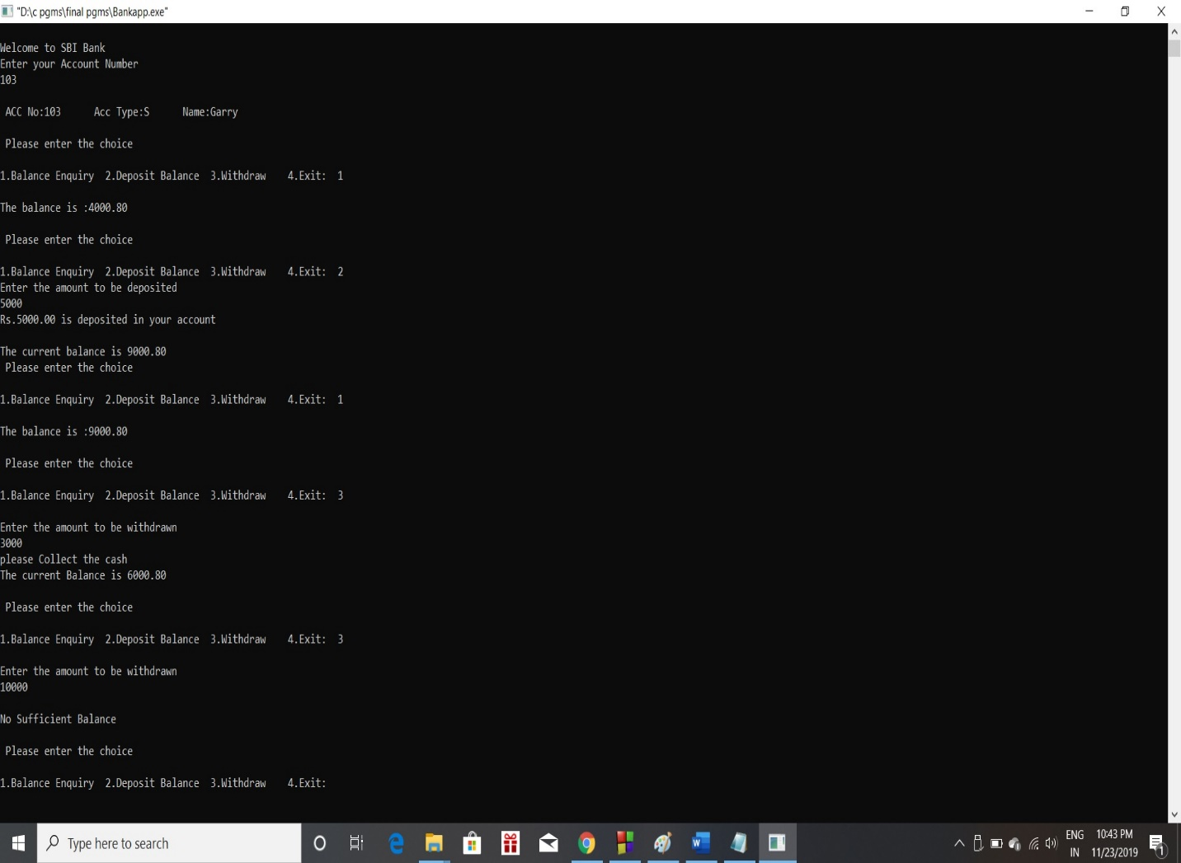**OUTPUTS:**