Experiment:4 Inventory

ALGORITHM

**STEP 1:** Start

**STEP 2:** Create inventory structure which consist of asset_no, name, price of asset.

**STEP 3:** fopen function is used to create a file Inventory.txt which is of write type.

**STEP 4:** In the do-while loop we enter the details of the material(asset_no, asset_name, asset_price) that get saved in the Inventory.txt file.

**STEP 5:** Check if you want to enter another asset. If No come out of the loop.

**STEP 6:** STOP.

PROGRAM:

#include<stdio.h>

FILE *p;

struct inventory{

int asset_no;

char name[10];

float price;

};

int main()

{

struct inventory i;

char choice;

int loop;

p=fopen("Inventory.txt","w");

if(p==NULL)

{

printf("FILE DOESNOT EXIST\n");

}

do

{

printf("Enter the asset number :");

scanf("%d",&i.asset_no);

fprintf(p,"Asset Number : %d\n",i.asset_no);

printf("Enter the asset name :");

getchar();

scanf("%s",&i.name);

fprintf(p,"Asset Name : %s\n",i.name);

printf("Enter the asset price :");

scanf("%f",&i.price);

fprintf(p,"Asset Price : %.2f\n",i.price);

printf("Do you want to add another asset :");

getchar();

scanf("%c",&choice);

if(choice=='y'||choice=='Y')

{

loop=1;

}

else

{

loop=0;

}

}while(loop);

printf("*******Thank You********");

}

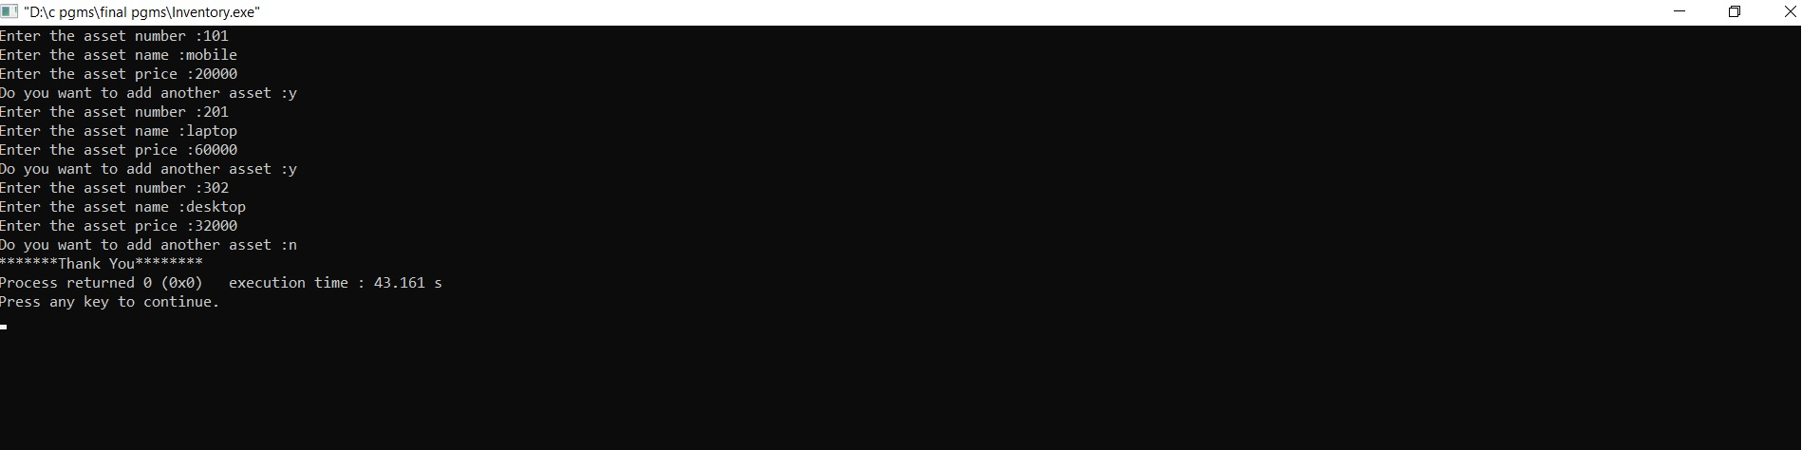OUTPUTS:

