**Experiment :8 CLASS HIERARCHY**

**ALGORITHM**

**STEP 1:** Start the program.

**STEP 2:** Declare the data members.

**STEP 3:** Define the data members outside of the class.

**STEP 4: Write a function to accept emoloyee details.**

**STEP 5: Declaring of a member function setbonus, which argument is bonus for each department.**

**STEP 6:** Declaring member function display , **which argument is number of employees.**

**STEP 7:** Creating a sub-class prodman, access mode is public, calls is manager

**STEP 8:** Creating salesman inheriting from class manager .

**STEP 9** : Initializing the objects of class prodman and salesman

**STEP 10** : Calling of above functions

**PROGRAM:**

#include<iostream>

using namespace std;

class Manager{ //Defining Class user defined name-Manager

protected : //Protected access specifier

string name; //data Members

string dept;

int empid;

int bonus;

public : //Public Access Specifiers

void getdata() //To accept the employee details

{

cout<<"Enter name : "<<endl;

cin>>name;

cout<<"Enter Department : "<<endl;

cin>>dept;

cout<<"Enter empid : "<<endl;

cin>>empid;

}

void setbonus(int b) //member function setbonus ,which argument is bonus for each department

{

bonus=b;

cout<<"\nDepartment : "<<dept<<"\nBonus : "<<bonus<<endl;

}

void display(int n) //member function display, which argument is number of employees

{

cout<<"\n Name : "<<name<<endl;

cout<<"\n Department : "<<dept<<endl;

cout<<"\n No. of employees : "<<n<<endl;

cout<<"\n Bonus : "<<bonus<<endl;

}

};

class prodman : public Manager{ //subclass prodman, access mode is public, class is Manager(subclass salesman inheriting from class Manager)

int noOfsup;

public :

void manageprod(int n)

{

noOfsup=n;

cout<<"\nNo. of supervisors : "<<noOfsup<<endl;

display(noOfsup);

}

};

class salesman : public Manager{ //subclass salesman inheriting from class Manager

int noOfsalesmen;

public :

void managesales(int n)

{

noOfsalesmen=n;

cout<<"\nNo. of salesmen : "<<noOfsalesmen<<endl;

display(noOfsalesmen);

}

};

int main()

{

prodman p; //object of class prodman

salesman s; //object of class salesman

p.getdata();

s.getdata();

p.setbonus(5000); //bonus for prodman is 5000

s.setbonus(3000); //bonus for salesman is 3000

p.manageprod(100); //Number of employees in prod unit 100

s.managesales(50); //Number of employees in sales unit 50

}

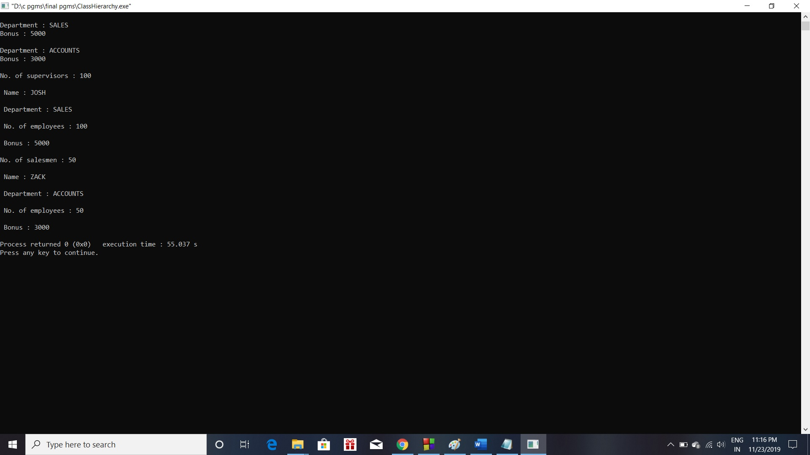**OUTPUT:**