1. Clean Build the project and generate the WAR file.
2. Put the WAR file on the shared Drive location. Create a separate folder for each WAR deployed to have a backup of previous WAR if needed.
3. Login to the Azure portal using below link - [**https://portal.azure.com/#home**](https://portal.azure.com/#home)

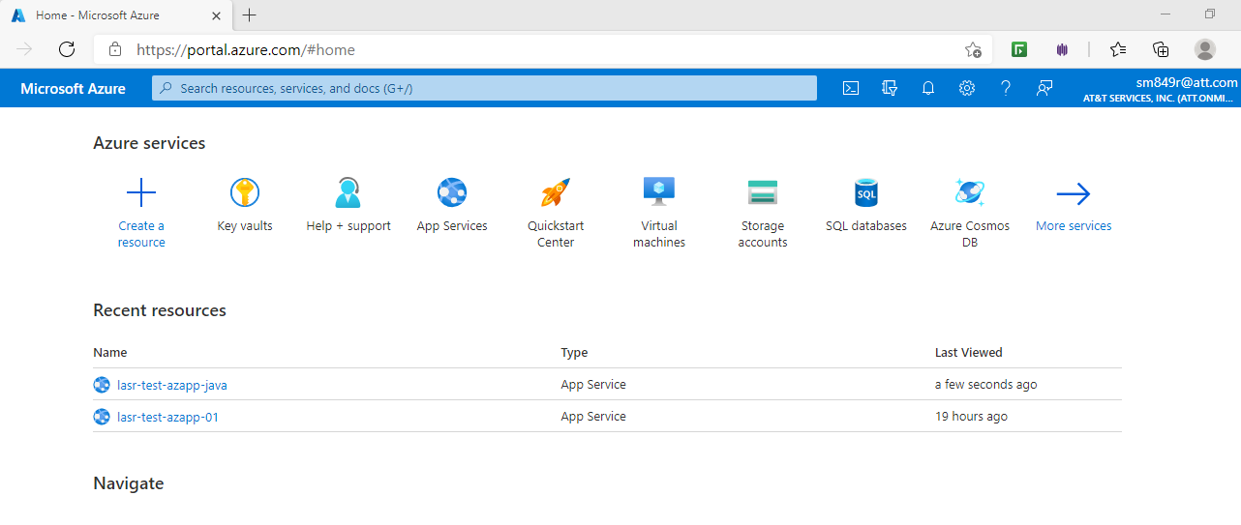

1. Select the corresponding web app service on which the code is to be deployed.

**DEV(lasr-test-azapp-java)** or **TEST(lasr-test-azapp-01)**

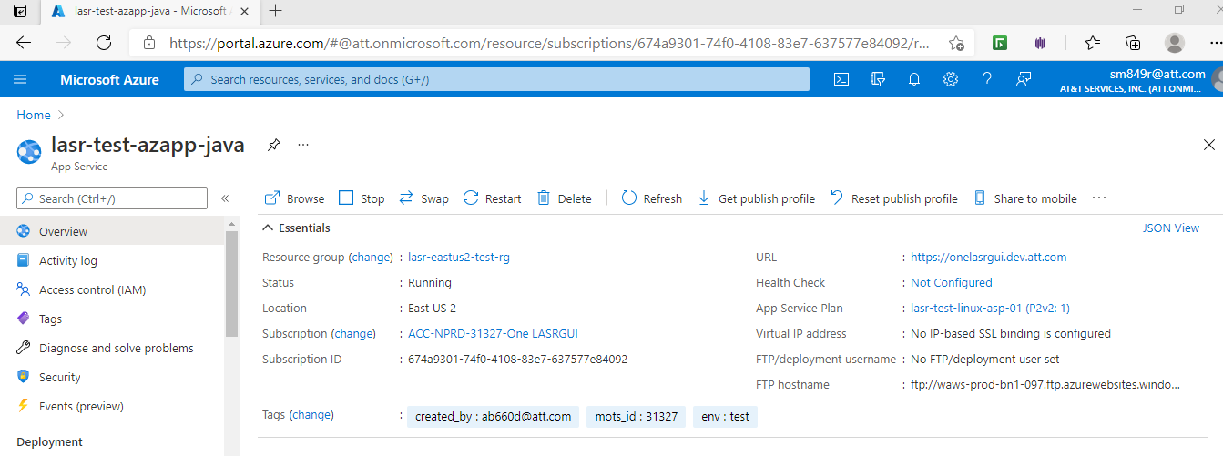

1. Login to the Linux server using the SSH option.

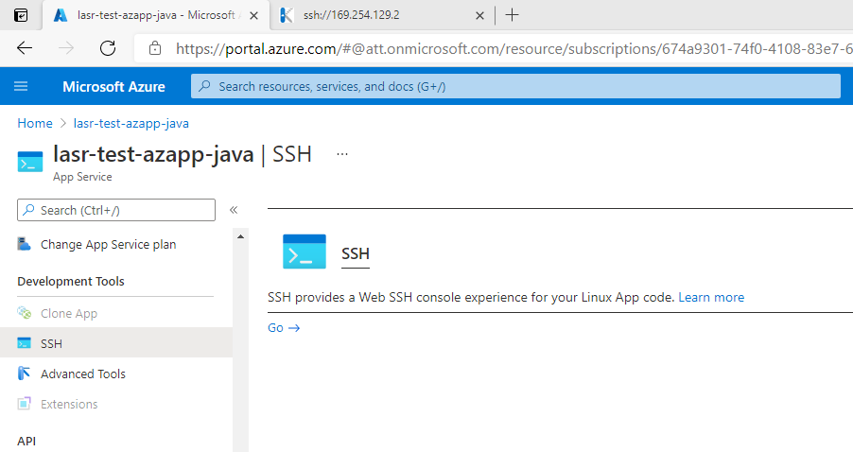

1. You need to copy the WAR to the server. Open Winscp.

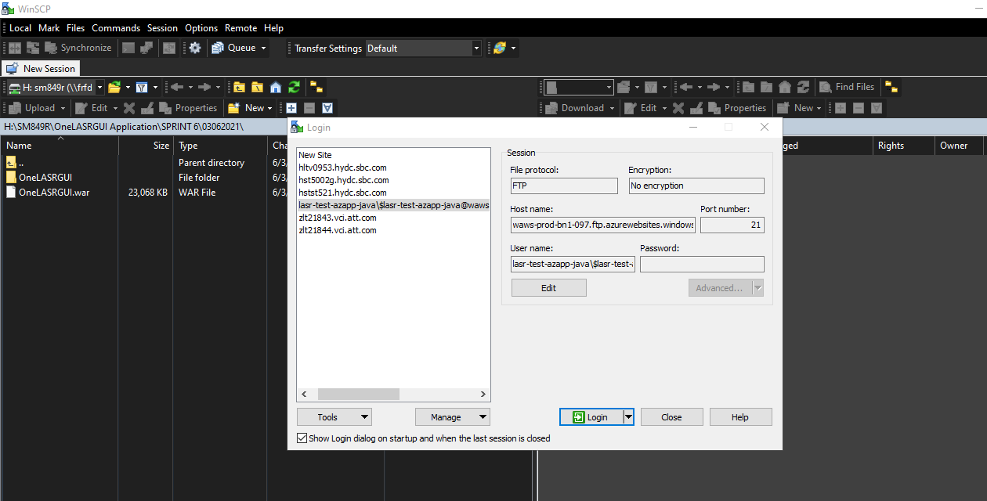

1. Hostname can be copied from the Overview option. Username and Password can be copied from the

Deployment Center -> Ftp Credentials option.

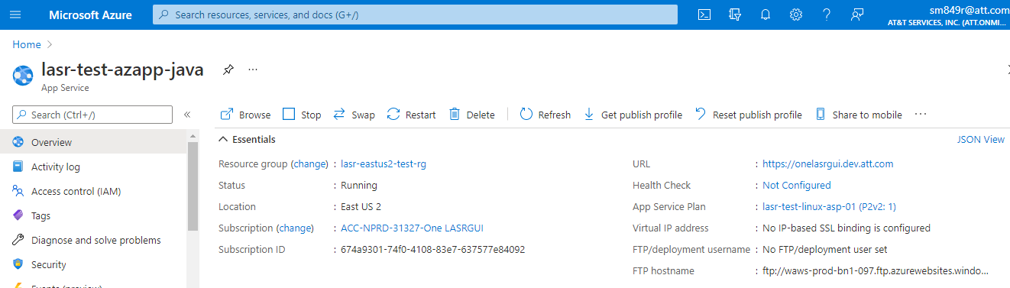

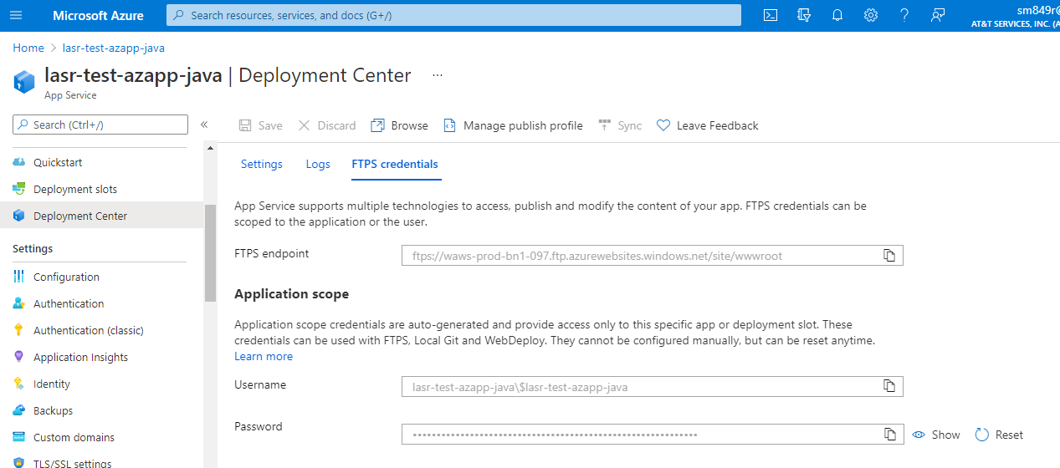

1. Copy the WAR from your local path to the server’s webroot folder path**(/site/wwwroot/webapps/)**

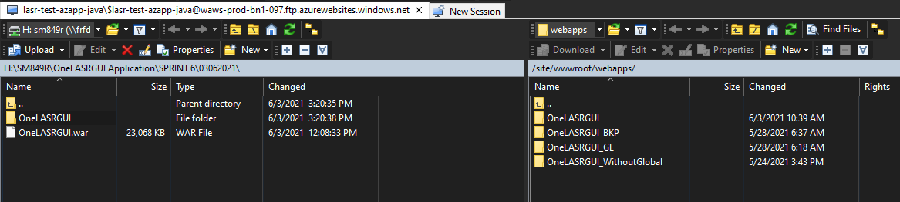

1. Open the Linux server and navigate to the webroot folder path**(/home/site/wwwroot/webapps)**.

The copied war will be reflected.

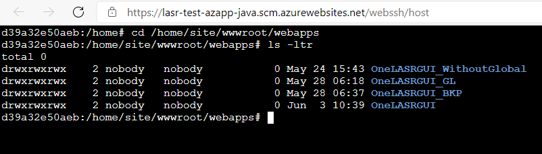

1. Copy the war from the webroot folder to Tomcat webapps folder**(/usr/local/tomcat/webapps) cp -r**

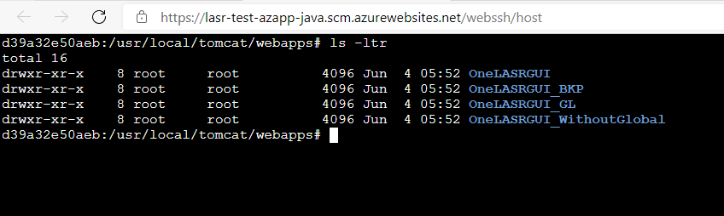

1. Make sure on the tomcat webapps path there should be only folder with name **OneLASRGUI**

Remove rm -r

Rename mv file name

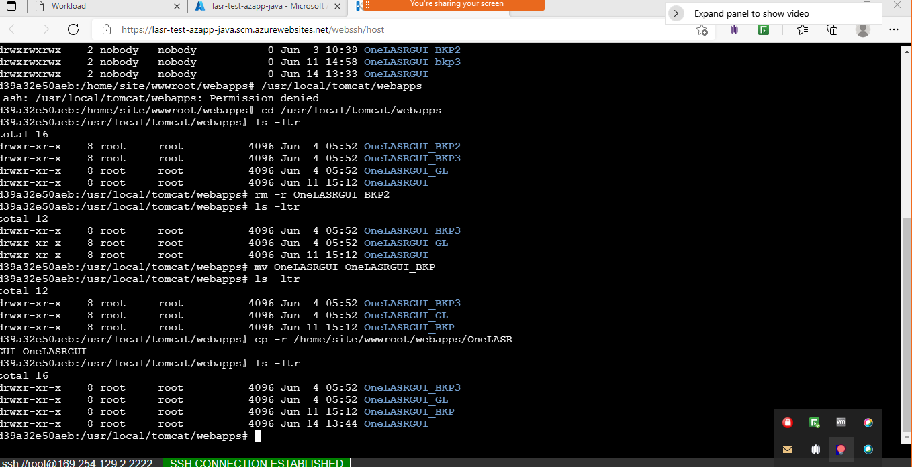

1. Go to the browser and try to access the **DEV(https://onelasrgui.dev.att.com/OneLASRGUI/)** or **TEST(https://onelasrgui.test.att.com/OneLASRGUI/)** environment based on the deployment performed.

