✅ STEP 1 — EC2 Setup (Already Done in Your Case)
You should have:
- 1 Control Node (Ansible installed here)
- 2 Worker Nodes
- Same Key Pair used for all instances
- Security Group allows SSH (port 22)
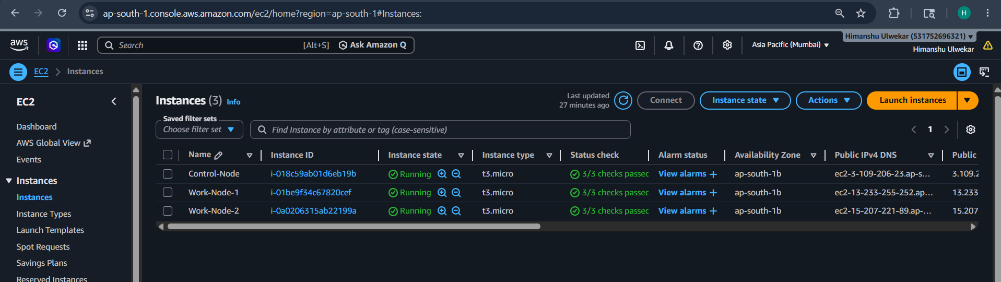

✅ STEP 2 — Install Ansible (Control Node)
sudo yum update -y
sudo yum install ansible -y
Check:
ansible --version

✅ STEP 3 — Install AWS dependencies
sudo yum install python3-pip
pip3 install boto3 botocore
ansible-galaxy collection install amazon.aws

✅ STEP 4 — Configure AWS credentials
aws configure

✅ STEP 5— Fix PEM file on control node
Copy key (if not already there):
It is better to copy pem file in ansible directory.
On control node:
sudo chown ec2-user:ec2-user /etc/ansible/dynamic.pem
chmod 400 /etc/ansible/dynamic.pem

✅ STEP 7 — Go to the ansible directory

cd ansible

✅ STEP 8 — Create AWS Dynamic Inventory file
plugin: amazon.aws.aws_ec2

regions:
- ap-south-1

hostnames:
- private-ip-address

filters:
instance-state-name: running

compose:
ansible_host: private_ip_address
ansible_user: ec2-user
ansible_ssh_private_key_file: /etc/ansible/dynamic.pem

keyed_groups:
- key: tags.Name
prefix: ""

✅ STEP 9 — Create ansible.cfg
Sudo vi ansible.cfg
Paste:
[defaults]
inventory = aws_ec2.yml
private_key_file = /etc/ansible/dynamic.pem
host_key_checking = False
[inventory]
enable_plugins = amazon.aws.aws_ec2

✅ STEP 10 — Test inventory discovery
ansible-inventory --graph
Expected:
_Work_Node_1
_Work_Node_2
_Control_Node

✅ STEP 11 — Test SSH connectivity

Single node:
ansible -i aws_ec2.yml _Work_Node_1 -m ping

OR all workers:
ansible -i aws_ec2.yml _Work_Node_* -m ping

🎯 FINAL EXPECTED OUTPUT
SUCCESS => {
"ping": "pong"
}

🚀 WHAT YOU HAVE NOW
✔ Fully working AWS dynamic inventory
✔ Auto-discovered EC2 instances
✔ Tag-based grouping
✔ SSH working with PEM
✔ Ansible remote execution ready

⚠️ IMPORTANT RULES (don’t break it again)
- ❌ Don’t use root user
- ❌ Don’t hardcode workers group unless you define it properly
- ❌ Don’t rely on inventory for key file alone
- ✔ Always ensure ec2-user + correct .pem

